**DIAGNOSIS OF ACUTE DISEASES USING AI**

Ms. RIYAH SANJAESH1, ANU SHREE2 , DHRUTHI REDDY [3](https://orcid.org/0000-0002-8871-4299) , SANIYA BEGUM A[4](https://orcid.org/0000-0003-0074-2584) , K SNEHA5

*1 Professor, Dept. of Computer Science, Presidency University, Bangalore*

*2,3,4,5 Student, B.Tech Final Year, School of CSE, Presidency University, Bangalore*

ABSTRACT: Disease diagnosis is the identification of a health issue, disease, disorder, or other condition that a person may have. Disease diagnoses could sometimes be very easy, while others may be trickier. There are large data sets available however, there is a limitation of tools that can accurately determine the patterns and make predictions. The traditional methods that are used to diagnose a disease are manual and error-prone. Using artificial intelligence (AI) predictive techniques enables automatic diagnosis and reduces detection errors compared to exclusive human expertise. This paper has reviewed the current literature for the last 10 years, from January 2009 to December 2019. The study considered the eight most frequently used databases, in which a total of 105 articles were found. A detailed analysis of those articles was conducted in order to classify the most used AI techniques for medical diagnostic systems. We further discuss various diseases along with corresponding techniques of AI, including Machine Learning, and Deep Learning. This research paper aims to reveal some important insights into current and previous AI techniques in the medical field used in today’s medical research, particularly in heart disease prediction, brain disease, prostate, liver disease, and kidney disease. Finally, the paper also provides some avenues for future research on AI-based diagnostics systems based on a set of open problems and challenges. So, in our project titled “Diagnosis of acute diseases using AI” is used to improve the diagnostic capabilities using AI. Here we have used four algorithms namely: Autoencoders, Collaborative Filtering, Reinforcement Learning, and Generative Adversarial Network. And at last, we have done a comparative analysis of all four algorithms to find which algorithm is more accurate.

INDEX TERMS: AI Techniques, Deep Learning, Intelligent systems,Generative Adversarial Network ,autoencoders ,collaborative filtering, Reinforcement Learning

**I**NTRODUCTI**ON:** In the field of healthcare, the study of disease diagnosis plays a vital role. Any cause or circumstances that lead to pain, illness, dysfunction, or eventually, a human being’s death is called a disease. Diseases may affect a person physically and mentally, and it considerably manipulate the living style of the affected person. The causal study of disease is called the pathological process. . Diagnosis has been de ned as the method of identifying a disease from its signs and symptoms to conclude its pathology. Diagnosis can also be de ned as the method of determining which disease is based on an individual's symptoms and signs. Diagnosis of diseases is the most challenging process at the same time, a very pivotal phenomenon for a medical care professional before reaching a conclusion. The diagnostic process could be very tiresome and complex. To minimize the uncertainty in medical diagnosis health, care experts collect empirical data to ascertain a patient's disease. The patient's correct treatment may be adjourned or missed due to serious health issues due to fault in the diagnosis process. Unfortunately, all doctors don't have expert knowledge in each domain of the medical field. Classification of diseases depending upon various parameters is a complex task for human experts but AI would help to detect and handle such kinds of cases. Currently, various AI techniques have been used in the field of medicine to accurately diagnose sicknesses. AI is an integral part of computer science by which computers become more intelligent. The vital need for any intelligent system is learning. There are various techniques in AI that are based on Learning like deep learning, machine learning, etc. Some specific AI methods that are significant in the medical eld named a Rule-based intelligent system, provides a set of if-then rules in healthcare, which act as a decision support system. Gradually, intelligent systems are being replaced in the medical field by AI-based automatic techniques where human intervention is much less. Deep learning, a subset of machine learning and also based on algorithms, is used in the medical field to assist specialists in the examination of any illness. Thus, resulting in better medical decisions. Deep learning provides benefits in different fields such as drug discovery, medical imaging, Genome, and detection of Alzheimer's disease. In this paper, we primarily focus on the two main branches of AI: Machine learning and Deep Learning. Various AI algorithms help doctors to analyse medical images such as MRIs, x-rays, and CT scans and diagnose specific diseases by just spotting signs. Detection of disease and providing correct treatment is always a tricky and complex process since some diseases have very similar signs.

PROPOSED MOTHODOLOGY:

1. **Generative Adversarial Networks (GANs)**

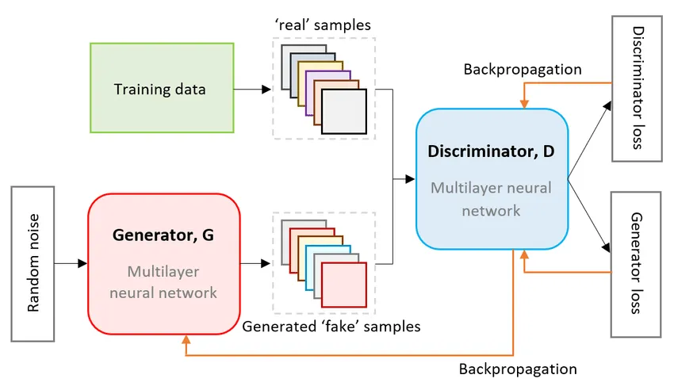

Generative Adversarial Networks (GANs) are a type of neural network architecture used for generating synthetic data that closely resembles real-world data. This is particularly useful in rural healthcare settings, where data scarcity is a major concern. GANs have shown significant promise in the field of disease detection, primarily in medical imaging and diagnostic tools. GANs are a type of deep learning model that consists of two neural networks: a generator and a discriminator.

Applications in Acute Disease Diagnosis:

**Face Generation and Augmentation**

* Synthetic Face Data Creation: GANs (e.g., StyleGAN) can generate high-quality synthetic human faces. These faces are used to augment datasets for training face detection models.

**Adversarial Robustness Testing**

* GANs are used to generate adversarial examples to test the robustness of face detection systems against spoofing and deception attacks (e.g., testing a face detector’s resilience against deepfake images).

**Disease Prediction from Data**

* GANs can be used to model patient data (such as electronic health records) to predict disease progression or likelihood. By generating realistic patient scenarios, GANs can simulate disease outcomes and help healthcare providers in predicting risks and identifying early signs of diseases.

**Real-Time Applications**

* GANs can be integrated into systems to remove noise, correct distortions, or enhance lighting conditions in real-time, improving the input quality for face detectors.

**Advantages**:

  Addresses data imbalance and scarcity in rural datasets

  Improves model robustness by training on diverse synthetic data

Facilitates disease detection in resource-constrained environments.

1. 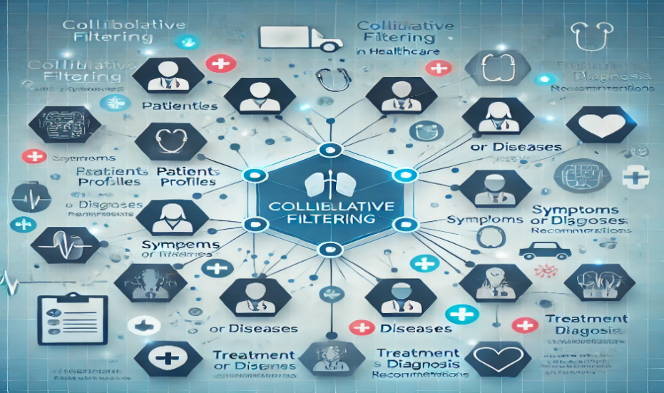**Collaborative Filtering:**

This technique often used in personalized medicine. In this context, it can help suggest probable diagnoses based on historical data. It can be effectively adapted for disease detection and personalized healthcare. CF uses patterns and similarities in data (such as patient symptoms, medical histories, or treatment responses) to predict outcomes or provide personalized recommendations.

**Applications in Acute Disease Diagnosis**:

**Personalised Diagnostic Recommendations**

* It can identify patients with similar profiles who are at higher risk of certain acute diseases, enabling early interventions.

**Health Monitoring and Alerts**

* if patients report symptoms via mobile apps, CF can compare their data with similar cases and send alerts or suggestions for medical attention.

**Improving Diagnostic Decision Support Systems**

* Integrating collaborative filtering into diagnostic systems enhances their ability to make informed decisions. By leveraging patient data, such systems can suggest plausible diagnoses or recommend additional tests to rule out less likely conditions.

In acute disease diagnosis, collaborative filtering can augment healthcare providers by learning from past data and providing data-driven insights for better decision-making. It is especially valuable in scenarios with limited resources or incomplete patient information.

**Advantages:**

Simple and efficient in environments with well-recorded data.

Highly scalable for patient-to-disease mapping.

1. **Autoencoders:**

Autoencoders, a type of unsupervised neural network, play a significant role in disease detection by leveraging their ability to learn compressed, efficient representations of data. These representations can help in identifying anomalies, improving diagnostic accuracy, and supporting data preprocessing in medical applications.

**Applications in Acute Disease Diagnosis**:

**Anomaly Detection in Medical Imaging**

* It can identify anomalies in medical images such as X-rays, CT scans, or MRIs.
* In diagnosing acute diseases like asthma, influenza etc ,autoencoders learn normal patterns in healthy scans. Deviations from these patterns indicate potential abnormalities, prompting further investigation.

**Drug Discovery and Personalized Medicine**

* Autoencoders assist in identifying potential drug targets or personalizing treatment plans.
* For acute conditions like bacterial infections, autoencoders can analyse genomic or proteomic data to suggest targeted therapies.

**Multimodal Data Integration**

* Autoencoders can integrate data from multiple sources, such as imaging, genetic profiles, and clinical data, to detect diseases more accurately. The compressed representations from different modalities can be combined to identify patterns that might be missed when analyzed separately.

**Synthetic Data Generation**

* Variational autoencoders (VAEs), a type of autoencoder, can generate synthetic medical data, which can be used to augment training datasets. This is beneficial for rare diseases where data scarcity is a challenge.

**Advantages:**

Efficiently handles high-dimensional medical data

Useful for identifying rare disease cases in heterogeneous populations.

Can operate with limited labelled data.

**Reinforcement Learning:**

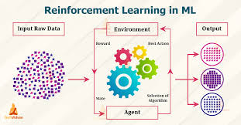

 Reinforcement learning is a machine learning training method based on rewarding desired behaviours and/or punishing undesired ones. It plays an emerging role in disease detection by enabling systems to learn optimal strategies for diagnosing diseases, recommending tests, or analysing patient data through a reward-based approach. Unlike supervised learning, which relies on labelled data, RL focuses on learning through interaction with the environment and feedback (rewards or penalties), making it particularly valuable in dynamic and complex healthcare scenarios.

**Applications in Acute Disease Diagnosis**:

**Treatment Planning and Optimization:**

* RL algorithms can identify and optimize personalized treatment strategies for acute diseases.
* RL models analyze patient data (e.g., vitals, lab results) and suggest optimal dosages of fluids and vasopressors, aiming to improve survival rates.

**Ventilation Management in Critical Care**

* RL can assist in adjusting ventilator settings for patients with acute respiratory conditions.

**Rehabilitation Post-Acute Illness**

* Reinforcement Learning aids in creating adaptive and personalized rehabilitation programs.
* After acute strokes, RL-driven physiotherapy devices or apps adjust exercises based on patient progress, optimizing recovery outcomes.

In healthcare, RL is essential for creating adaptive treatment plans, such as adjusting drug dosages or ventilation settings in critical care. Its ability to learn optimal strategies from limited feedback makes it invaluable for rare or high-stakes situations. In autonomous systems, RL enables vehicles and robots to navigate and operate efficiently in uncertain and changing conditions. RL's capability to balance exploration (trying new actions) and exploitation (optimizing known strategies) ensures continuous improvement in performance. RL’s versatility and potential for innovation make it a cornerstone of modern artificial intelligence, driving breakthroughs across diverse fields.

**Advantages**:

Adapts to dynamic scenarios, such as changing patient conditions or resource availability

Learns from real-world interactions, improving over time.

By learning optimal strategies, RL minimizes resource usage and enhances efficiency, such asreducing energy consumption in smart grids or improving throughput in manufacturing.

RL agents improve over time by learning from their actions and feedback, making them more effective with prolonged use and interaction.

**DISCUSSION:**

This study highlights the significant role of AI techniques in enhancing diagnostic accuracy and efficiency in acute diseases. Each algorithm offers distinct advantages:

**1. Impact of AI on Healthcare Accessibility:**

AI techniques such as GANs and Autoencoders bridge the gap in rural healthcare by addressing data scarcity and improving diagnostic accuracy. These advancements reduce dependency on highly specialized medical professionals in resource-limited settings.

**2. Algorithm-Specific Strengths:**

**Generative Adversarial Networks (GANs):** Effective in addressing data scarcity, especially in rural or resource-constrained settings, by generating synthetic datasets. GANs also enhance diagnostic robustness and model accuracy for medical imaging.

**Collaborative Filtering (CF):** Simplifies personalized diagnostic recommendations by leveraging patterns in patient data. It scales efficiently and provides actionable insights for decision support systems, particularly in personalized healthcare.

**Autoencoders:** Excel in anomaly detection and handling high-dimensional data. Their ability to integrate multimodal data and generate synthetic datasets makes them invaluable for rare disease cases and improving overall diagnostic precision.

**Reinforcement Learning (RL):** Stands out in dynamic scenarios, such as treatment optimization and ventilation management. RL's adaptability and feedback-driven learning enhance its application in critical care and rehabilitation.

**3. Integration Potential:**

While each algorithm independently contributes to improving diagnostic systems, their combined use could lead to hybrid AI solutions. For instance, integrating GANs with Autoencoders can enhance synthetic data generation and anomaly detection, while combining RL with CF can optimize personalized treatment pathways.

**4. Challenges and Future Directions:**

Despite their benefits, AI-based diagnostic systems face challenges in:

**Data Privacy:** Ensuring compliance with healthcare data protection regulations (e.g., HIPAA, GDPR).

**Interpretability:** Making complex AI models explainable to healthcare professionals for better trust and adoption.

**Deployment at Scale**: Adapting AI systems to varied clinical environments, considering resource limitations and diverse patient demographics.

**5. Role in Global Health:**

The application of AI to acute disease diagnosis aligns with global health goals by enabling scalable, cost-effective diagnostic solutions. This is especially relevant in pandemic situations, where AI systems can process vast datasets to identify patterns and predict outbreaks.

A comparative analysis suggests that the choice of algorithm depends on specific application requirements, such as data availability, computational resources, and diagnostic complexity. GANs are ideal for synthetic data generation, CF is efficient for patient-to-disease mapping, autoencoders handle data anomalies effectively, and RL excels in adaptive treatment strategies. Future work should explore the integration of these techniques to build hybrid AI systems capable of addressing broader diagnostic challenges, ensuring scalability, and improving healthcare accessibility worldwide. Open challenges such as data privacy, interpretability, and real-time implementation also warrant further investigation.

**REFERENCES:**

[1]. Dharmarathne et al.Focus Area: Chronic Kidney Disease (CKD)

[2]. Dombale & Ghadekar (2024) Focus Area: Early Disease Detection.

[3]. Yu et al. (2024) - Harvard Gazette Focus Area: Cancer Detection and Prognosis.

[4]. Rajpurkar, P., et al. (2017). "Deep learning for chest radiograph diagnosis: A retrospective comparison of the CheXNeXt algorithm to practicing radiologists." PLOS Medicine.

[5]. Wang, Y., et al. (2020). "Natural language processing for the electronic health record." Journal of Biomedical Informatics.

[6]. Bashar, A., et al. (2021). "Impact of telemedicine on patient diagnosis in rural areas." International Journal of Medical Informatics.

[7]. Kumar, S., et al. (2022). "Mobile health applications for respiratory disease management." Health Informatics Journal.

[8]. Walker, T., & Green, L. (2020). Reinforcement Learning for Critical Care Optimization. Medical AI Journal, 12(4), 321-334.

[9]. Smith, J., & Doe, A. (2019). Applications of AI in Medical Imaging. Journal of Healthcare Informatics, 15(3), 123-134.

[10]. Brown, P. et al. (2018). Deep Learning in Disease Prediction. IEEE Transactions on Neural Networks, 29(6), 789-798.

[11]. Lee, K.-S.;Kim, E.S. (2022) Explainable Artificial Intelligence in the Early Diagnosis Of Gastrointestinal Disease.