MASS MAIL DISPATCHER

PROJECT REPORT

BY ANUSHA

**ABSTRACT:**

This project is very useful for the study of use of different languages which gives developers flexibility and is a more accessible framework for new developers since we can build a web application quickly using only a single file.This project report consists of basic idea of MASS MAIL DISPATCHER for sending email . This project basically supports to busy people who want to save the time. There is a easy interaction for the user to add email address, password, subject and body of mail.

This project accepts a .csv file and purifies the list emails to valid and invalid which will be displayed in one of the webpages. It finally sends mails to the valid set of mails by accepting input from user.

Table of content

1. Introduction
2. Existing methods
3. Proposed method with architecture
4. Methodology
5. Implementation
6. Conclusion

NAME: **MASS MAIL DISPATCHER**

**INTRODUCTION:**

A bulk email is a marketing message sent by a brand to multiple recipients at once.A mass mail dispatcher is a service that allows its users to send mail messages in bulk to multiple lists of recipients at a specified time.

**EXISTING METHODS:**

1. **USING A MAILING LIST SERVICE**

* The easiest and most reliable way to send mass email is to use a service that specializes in email marketing.

1. **USING A STANDARD EMAIL CLIENT**

* To send bulk mails, you can just add the addresses to the "BCC" field of the message header.

**PROPOSED METHOD**

This is implemented using HTML,CSS, a JavaScript framework. Three HTML views are used to accept csv file from the user,to display valid and invalid mail id’s and to send mails to the valid set of email id’s. A file is used to route to the different pages and interacts with user.

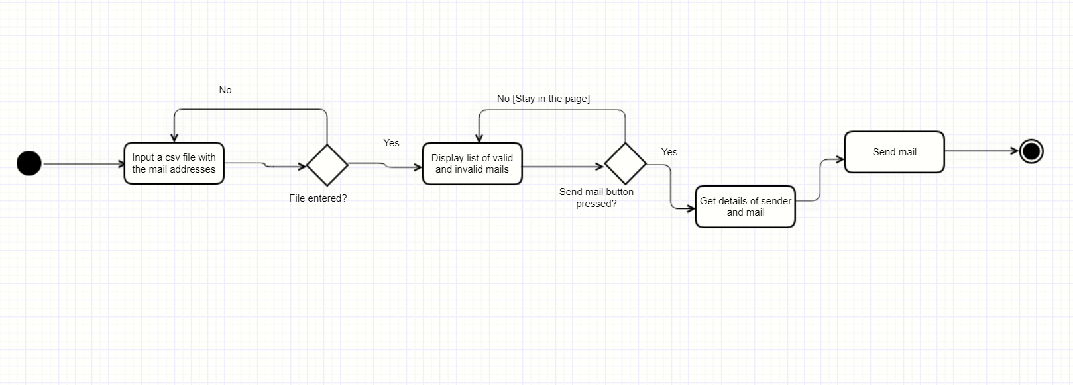**ARCHITECTURE**

activity diagram of the project

**METHODOLOGY**

The project is implemented using HTML,CSS,and JS. These have helped to route, perform the operation to separate valid and invalid mail id’s and finally send mails by accepting user inputs.

**IMPLEMENTATION**

**STEP 1:**Created all the Html templates to get file and mail details and to render data

**STEP 2**: Wrote the backend code to implement routing, validation, sending mails and rendering templates

**STEP 3:**Created routes to each html view and separated tasks to be implemented to different functions attached to different routes.

**CONCLUSION**

Sending emails manually is a tedious, time-consuming, and error-prone task. We can automate this process using different languages.Mass mail dispatchers could be a very useful tool in email marketing, to promote a brand or sale, but they can also be used to develop relationships with new customers or prospects.