**EMPLOYEE,USER and ROLE Operation which is performed as below:**

**EMPLOYEE Operation which is performed as below:**

Display all employee : <http://localhost:8080/api/employee/list>

Display in asec order by using firstname : <http://localhost:8080/api/employee/sort>

Display in desc order by firstname : <http://localhost:8080/api/employee/sort?order=DESC>

Display Employee details by using its employee id : <http://localhost:8080/api/employee/getEmployeeById/1>

Display employee details using firstname : <http://localhost:8080/api/employee/search/Shekhar>

Add new Employee : <http://localhost:8080/api/employee/addNewEmployee>

Edit employee details using its id : <http://localhost:8080/api/employee/editEmployeeById/1>

Delete employee id using emp id : <http://localhost:8080/api/employee/deleteEmployee/12>

**USER Operation which is performed as below:**

Display user list : <http://localhost:8080/api/user/list>

Display user by its user id: <http://localhost:8080/api/user/getUserById/1>

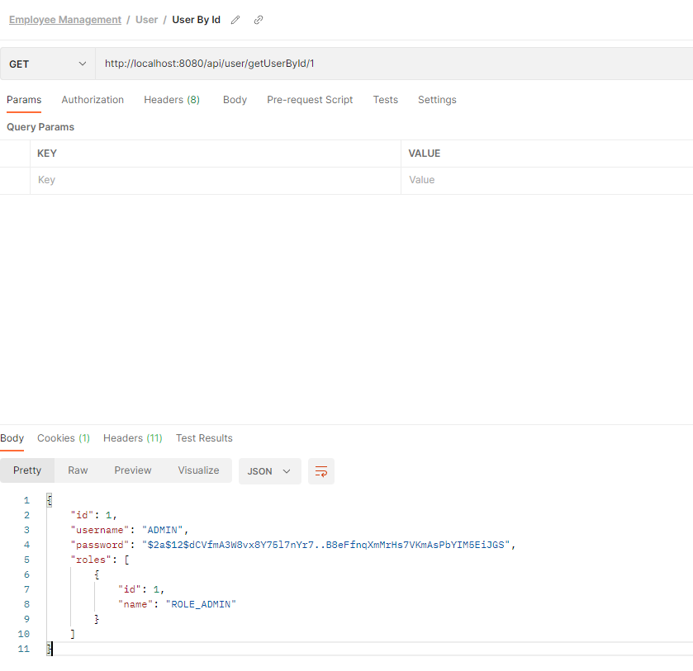

Add new user : <http://localhost:8080/api/user/addNewUser>

Deleted by user by its user id : <http://localhost:8080/api/user/deleteUserById/3>

**ROLE Operation which is performed as below:**

Display role list : <http://localhost:8080/api/role/list>

Display role by using its id : <http://localhost:8080/api/role/getRoleById/1>

Add new role : <http://localhost:8080/api/role/addNewRole>

Edit role : http://localhost:8080/api/role/editRoleById/3

Delete Role : <http://localhost:8080/api/role/deleteRoleById/3>

