**Name:** Mugdha Dhanraj Patil

**Seat Number:** T191234331

**Examination In:** Laboratory Practice-I

**Semaphore:**

**import java.util.concurrent.Semaphore;**

**public class SemaphoreTest {**

**// max 4 people**

**static Semaphore semaphore = new Semaphore(4);**

**static class MyATMThread extends Thread {**

**String name = "";**

**MyATMThread(String name) {**

**this.name = name;**

**}**

**public void run() {**

**try {**

**System.out.println(name + " : acquiring lock...");**

**System.out.println(name + " : available Semaphore permits now: "+ semaphore.availablePermits());**

**semaphore.acquire();**

**System.out.println(name + " : got the permit!");**

**try {**

**for (int i = 1; i <= 5; i++) {**

**System.out.println(name + " : is performing operation " + i + ", available Semaphore permits : "**

**+ semaphore.availablePermits());**

**// sleep 1 second**

**Thread.sleep(1000);**

**}**

**} finally {**

**// calling release() after a successful acquire()**

**System.out.println(name + " : releasing lock...");**

**semaphore.release();**

**System.out.println(name + " : available Semaphore permits now: "+ semaphore.availablePermits());**

**}**

**} catch (InterruptedException e) {**

**e.printStackTrace();**

**}**

**}**

**}**

**public static void main(String[] args) {**

**System.out.println("Total available Semaphore permits : "+ semaphore.availablePermits());**

**MyATMThread t1 = new MyATMThread("A");**

**t1.start();**

**MyATMThread t2 = new MyATMThread("B");**

**t2.start();**

**MyATMThread t3 = new MyATMThread("C");**

**t3.start();**

**MyATMThread t4 = new MyATMThread("D");**

**t4.start();**

**MyATMThread t5 = new MyATMThread("E");**

**t5.start();**

**MyATMThread t6 = new MyATMThread("F");**

**t6.start();**

**}}**

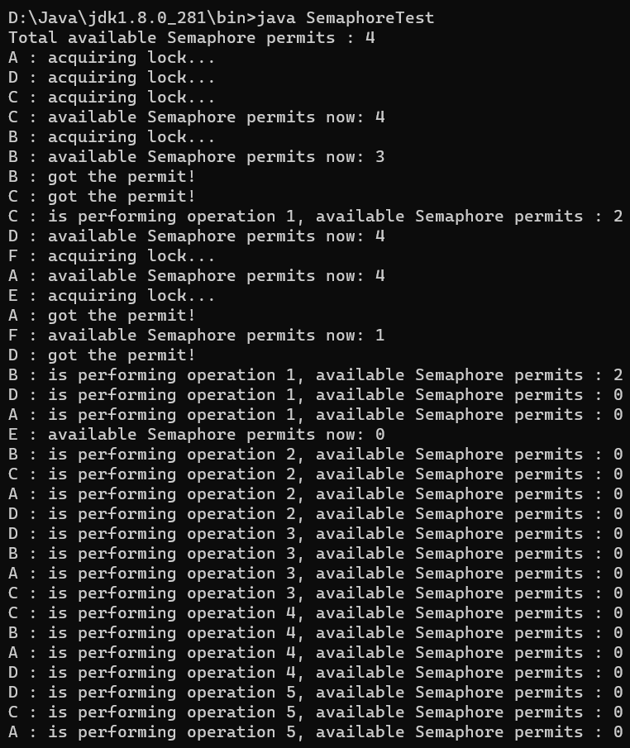**OUTPUT:**

