Indian Sweets Admin Console

🧁 Indian Sweets Admin Console
> Modern Dashboard for Indian Sweets Management — built with precision and a dark cyan theme.
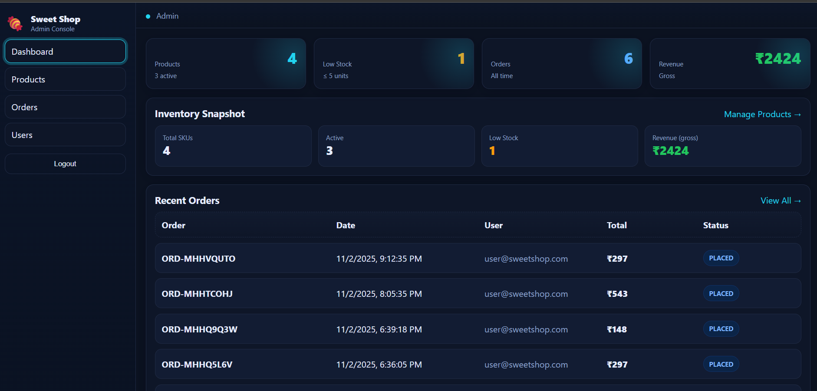

🎯 Overview

The “Indian Sweets Admin Console” is a refined, modern management dashboard designed for handling sweet shop operations efficiently. It’s tailored for administrators with a completely new “navy + cyan interface”, distinct from the user storefront.
This console enables inventory management, sales tracking, and order insights with real-time data visualizations and responsive layouts.

⚙️ Core Stack
| Layer | Technology |
| Frontend | React (Vite) |
| Styling | Custom CSS (Navy + Cyan theme) |
| Backend | Node.js + Express |
| Database | MongoDB |
| Auth | JSON Web Token (JWT) |
| Deployment | Render (API) + Vercel (Frontend) |

🧠 Features at a Glance

👑 Admin Control
- Secure login and role-based access.
- Sidebar navigation for dashboard, products, orders, and users.
- Dark-mode interface with glowing cyan accents.

📊 Dashboard Analytics
- Dynamic KPI cards (Orders, Revenue, Products, Stock Levels).
- Visual representation of store health and recent activity.
- Inventory Snapshot grid showing stock performance.
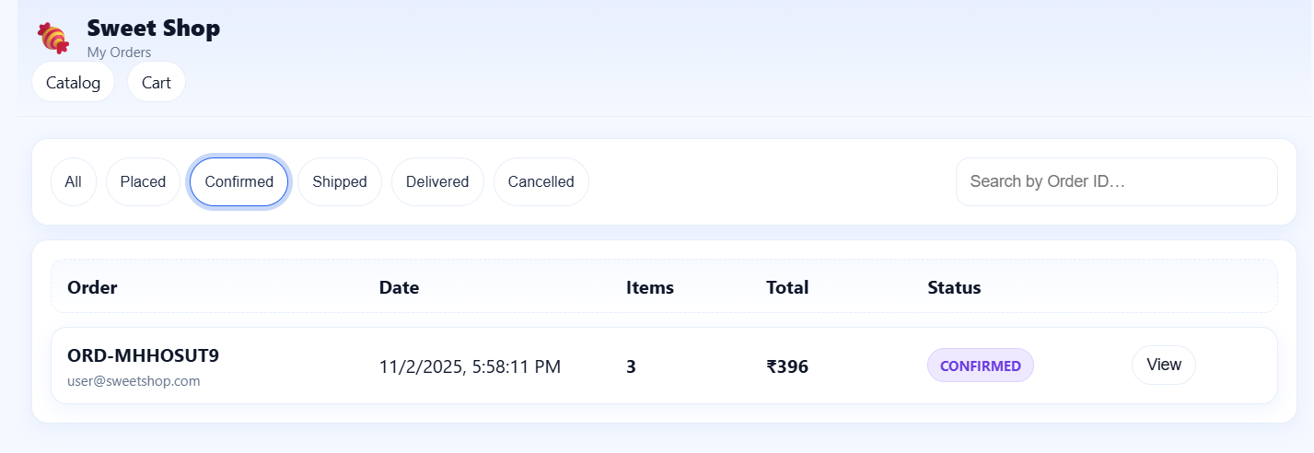

🧾 Orders Management
- View and update order statuses in real time.
- Filter and review customer activity efficiently.

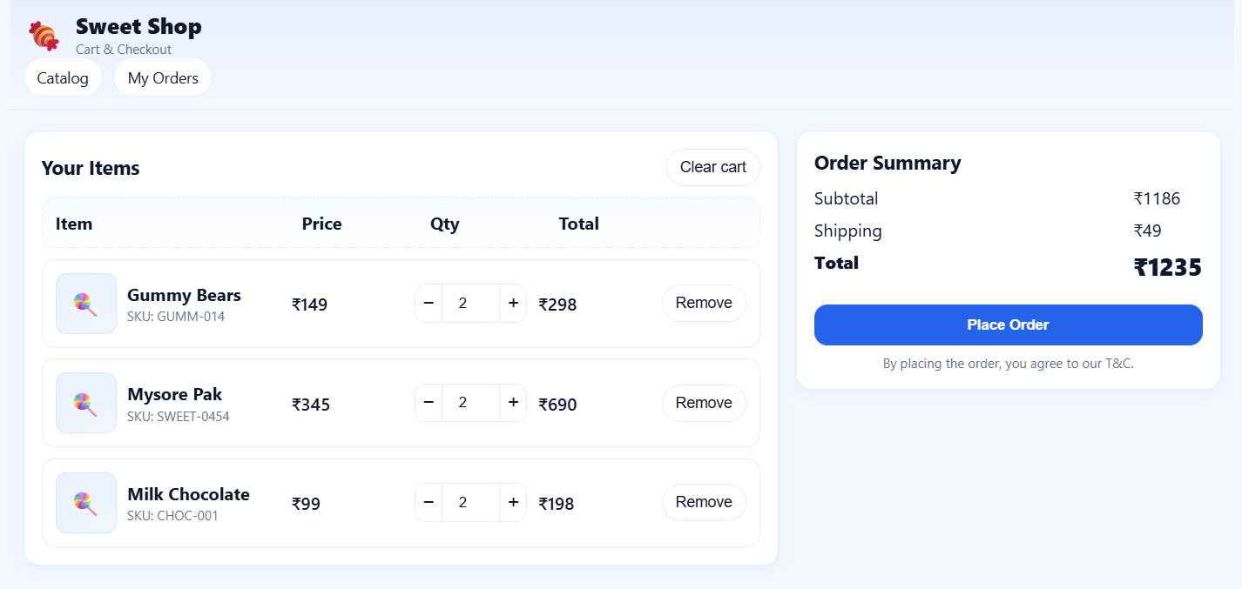

🍬 Product Management
- Add, edit, or remove sweet items with instant feedback.
- Low-stock detection with highlighted warnings.
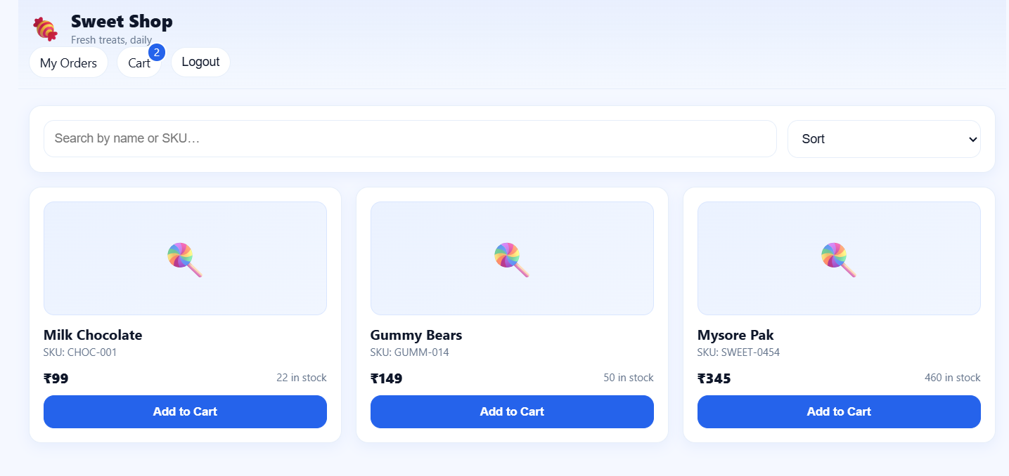

📁 Folder Structure

IndianSweetAdmin/
├── backend/
│ ├── server.js
│ ├── routes/
│ └── controllers/
│
└── frontend/
├── src/
│ ├── App.jsx
│ ├── main.jsx
│ ├── api/
│ ├── pages/
│ │ ├── admin/
│ │ │ ├── AdminLayout.jsx
│ │ │ ├── AdminDashboard.jsx
│ │ │ ├── AdminOrders.jsx
│ │ │ └── AdminProducts.jsx
│ │ ├── user/
│ │ └── styles/
│ │ └── admin.css
└── package.json

🧩 Installation

Backend Setup

cd backend:
npm install

Create `.env`:

MONGO_URI=your_mongo_uri
JWT_SECRET=secretkey

PORT=5000

Run server:
npm run dev

Frontend Setup
cd frontend
npm install
npm run dev
Frontend runs at `http://localhost:5173`.

🔐 Login Info (Demo)

| Role | Email | Password |
| Admin | admin@sweetshop.com | admin123 |

💎 Visual Theme

The Admin Console uses a Navy Base with Cyan Highlights for better contrast and visual separation from the customer storefront.

- Primary color: `#22d3ee`
- Background: `#0b1220`
- Accent: `#0891b2`
- Text: `#e5ecff`
- Shadow: `rgba(2,6,23,0.35)`

This ensures a premium, futuristic aesthetic suited for dashboards.

🧪 Testing & Validation

Run tests (if configured):
npm test
Code Block for Readability:
Each API and UI component is tested manually and validated for responsiveness across devices.

🚀 Deployment Instructions

Backend (Render)
1. Push to GitHub.
2. Create a new Render service.
3. Add env variables from `.env`.
4. Deploy and note your API URL.

Frontend (Vercel)
1. Import project to Vercel.
2. Add `VITE_API_BASE` env variable.
3. Deploy frontend build.

🤖 Role of AI in Development

AI (ChatGPT & Copilot) assisted in:
- Designing dark theme tokens and component hierarchy.
- Refactoring layout for better maintainability.
- Enhancing UI/UX interactions with animations and shadows.

All logic, state handling, and deployment configuration were reviewed and customized manually.

🧑‍💻 Developer

Anushree S
📍 Manipal Institute of Technology
240970110

🪪 License

MIT License © 2025 Anvith Shetty
You are free to adapt, modify, and build upon this project with proper credit.

