Sweet Shop Management System

🍬 Sweet Shop Management System
An AI-assisted full-stack application for managing a modern confectionery business.*

🧭 Overview

The “Sweet Shop Management System” is a responsive, full-stack web application that helps manage a sweet shop’s daily operations — inventory, customer orders, and admin workflows — through a unified dashboard and customer storefront.

It demonstrates “AI-augmented software development” using modern technologies like React (Vite), Node.js + Express, and MongoDB.

👥 User Roles

| Role | Capabilities |
| Admin | Manage sweets (CRUD), view all orders, monitor inventory. |
| User | Browse sweets, add to cart, checkout, and track order status. |

⚙️ Tech Stack

| Layer | Tools & Frameworks |
| Frontend | React (Vite), React Router DOM, Custom CSS (pastel theme) |
| Backend | Node.js, Express.js |
| Database | MongoDB (Mongoose ORM) |
| Auth | JWT (JSON Web Token) |
| Testing | Jest + Supertest |
| Deployment | Vercel (Frontend) • Render / Railway (Backend) |
| AI Tools | ChatGPT (GPT-5) • GitHub Copilot |

🧩 Features

🧑‍💻 Authentication
- Role-based login for Admin / User.
- LocalStorage + JWT token system.
- Protected Routes on frontend.

🍭 Sweet Management (Admin)
- Add / Edit / Delete sweets.
- Real-time stock tracking.
- Order overview with status filters.

🛍️ Customer Experience (User)
- Product catalog with search + sort.
- Cart with quantity management.
- Clean checkout + order summary.
- Pastel theme UI with subtle animations.

📊 Orders
- Filter by status (Placed, Confirmed, Shipped, Delivered, Cancelled).
- Expand rows to view ordered items.
- Compact cards for mobile view

🧱 Project Structure

Sweetshop/
── backend/
│ ── server.js
│ ── package.json
│ ── routes/
│ │ ── auth.js
│ │ ── sweets.js
│ │ └── orders.js
│ ── controllers/
│ ── models/
│ └── config/
│
└── frontend/
── src/
│ ── App.jsx
│ ── main.jsx
│ ── ProtectedRoute.jsx
│ ── api/index.js
│ ── pages/
│ │ ── AdminLogin.jsx
│ │ ── UserLogin.jsx
│ │ ── admin/
│ │ │ ── AdminDashboard.jsx
│ │ │ ── AdminProducts.jsx
│ │ │ └── AdminOrders.jsx
│ │ └── user/
│ │ ── UserHome.jsx
│ │ ── Cart.jsx
│ │ └── Orders.jsx
│ └── pages/styles.css
── vite.config.js
└── package.json

⚡ Installation & Setup

1️⃣ Backend

cd backend:
npm install

Create a `.env` file:

MONGO_URI=mongodb+srv://<your-uri>
JWT_SECRET=supersecret
PORT=5000

Run development server:
npm run dev
> backend runs at `http://localhost:5000`

2️⃣ Frontend
cd frontend
npm install
npm run dev
> frontend runs at `http://localhost:5173`

🧪 Testing

📍 Tools
- “Jest” – Unit & Integration Tests
- “Supertest” – API Endpoint Testing

🧱 Example Test: `tests/sweets.test.js`
import request from "supertest";
import app from "../server.js";

describe("Sweet API", () => {
it("should fetch all sweets", async () => {
const res = await request(app).get("/api/sweets");
expect(res.statusCode).toBe(200);
expect(Array.isArray(res.body)).toBe(true);
});
});
[Code Block Omitted for Readability]

Run all tests:
[Code Block Omitted for Readability]
npm test
[Code Block Omitted for Readability]

✅ Tests cover endpoints, model validation, and auth flows.

-

🧱 API Endpoints

| Method | Endpoint | Description | Access |
| `POST` | `/api/auth/login` | Login (Admin/User) | Public |
| `GET` | `/api/sweets` | Get all sweets | Public |
| `POST` | `/api/sweets` | Add sweet | Admin |
| `PUT` | `/api/sweets/:id` | Update sweet | Admin |
| `DELETE` | `/api/sweets/:id` | Delete sweet | Admin |
| `GET` | `/api/orders/user` | Fetch user orders | User |
| `GET` | `/api/orders` | Fetch all orders | Admin |
| `POST` | `/api/orders` | Place order | User |

🌐 Deployment Guide

🧱 Backend (Render / Railway)
1. Push backend folder to GitHub.
2. Create new service in “Render”.
3. Add environment variables (same as `.env`).
4. Deploy – API base URL → `https://sweetshop-api.onrender.com`.

🧩 Frontend (Vercel)
1. Push frontend folder to GitHub.
2. Import project on “Vercel”.
3. Set env variable:
VITE_API_BASE=https://sweetshop-api.onrender.com
4. Deploy – App URL → `https://sweetshop.vercel.app`.

📸 Screenshots
User Catalog:
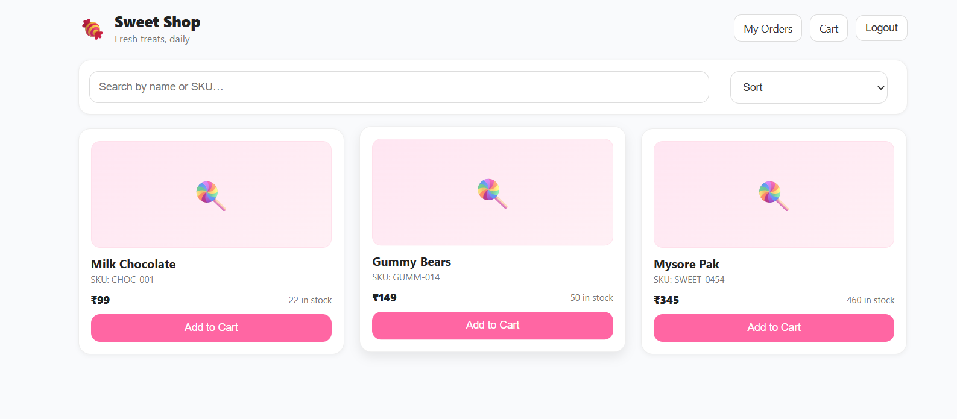

Cart & Checkout:
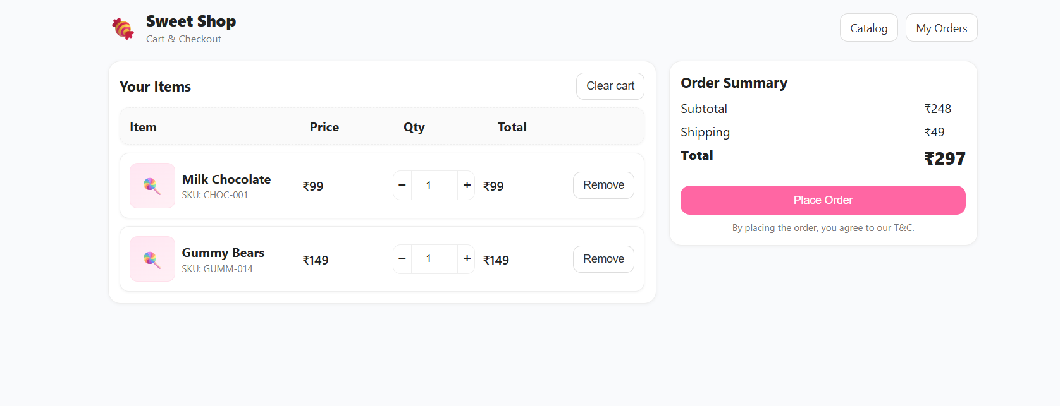

Orders Page:

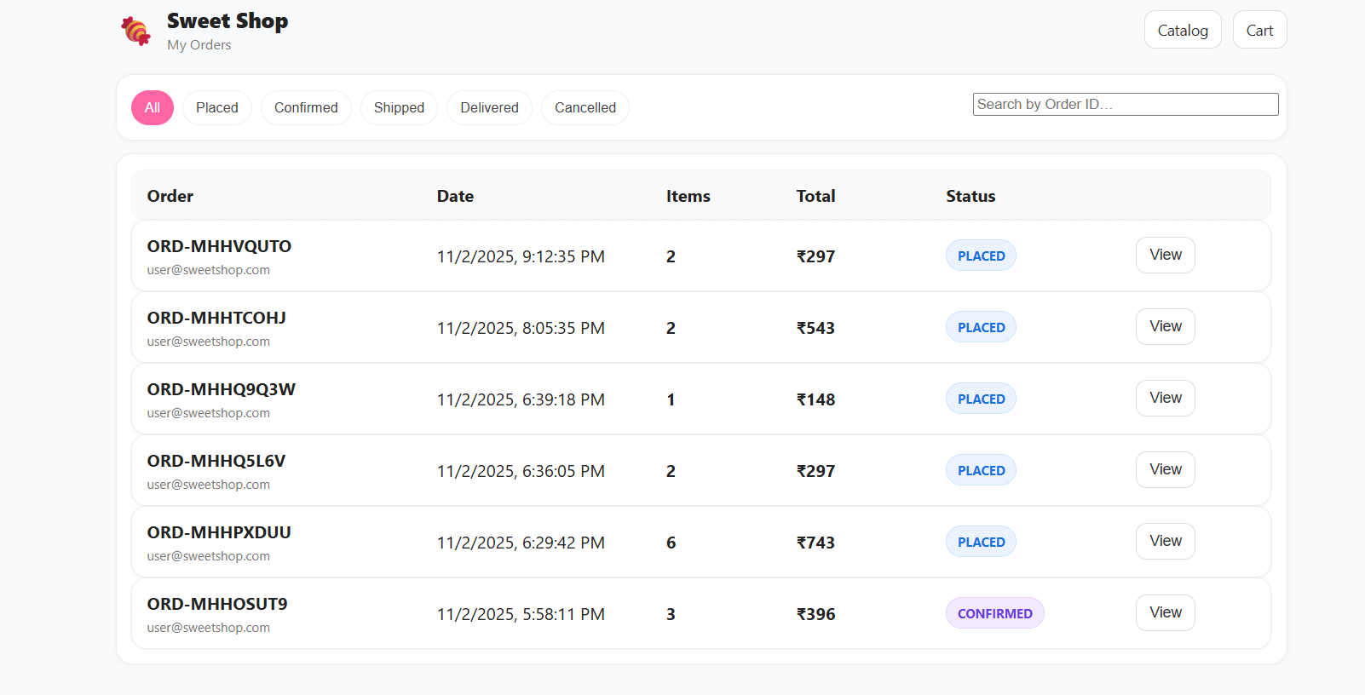

Admin Dashboard:
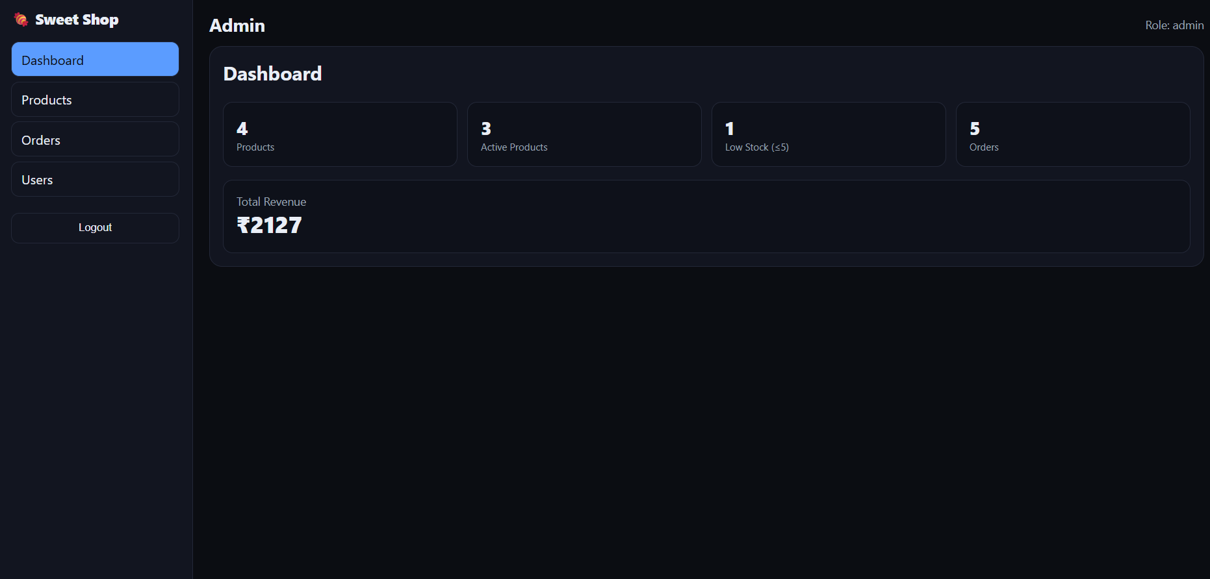
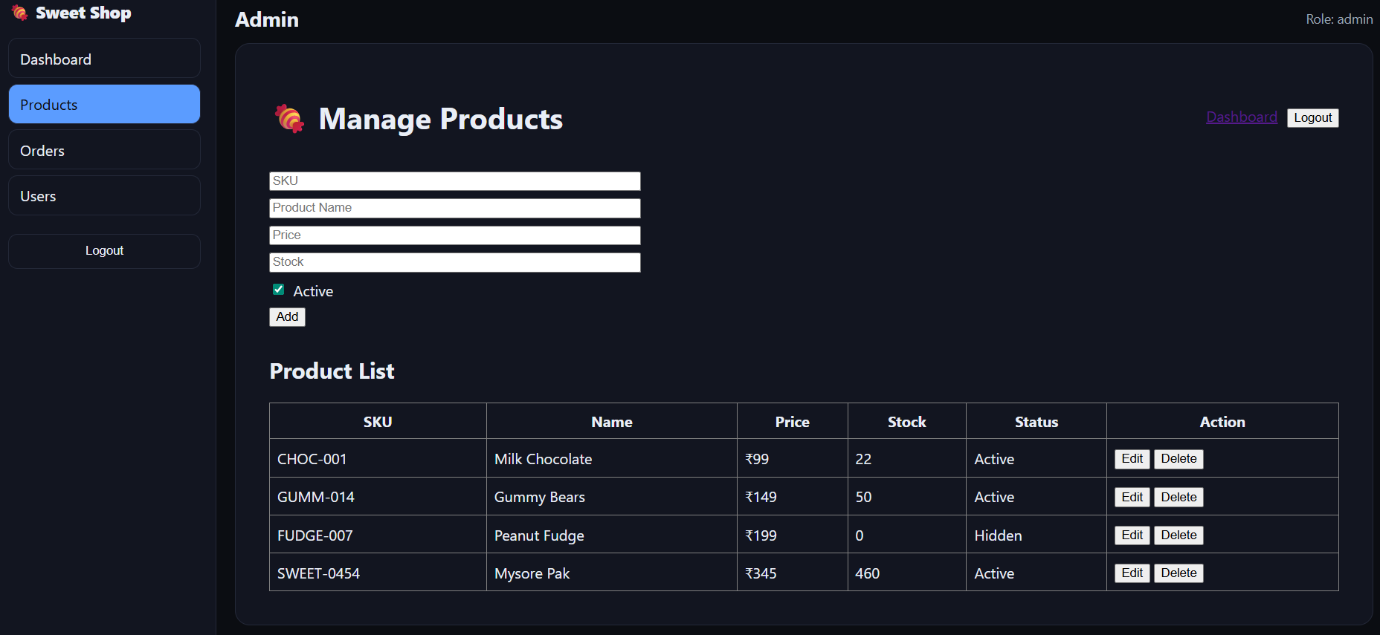
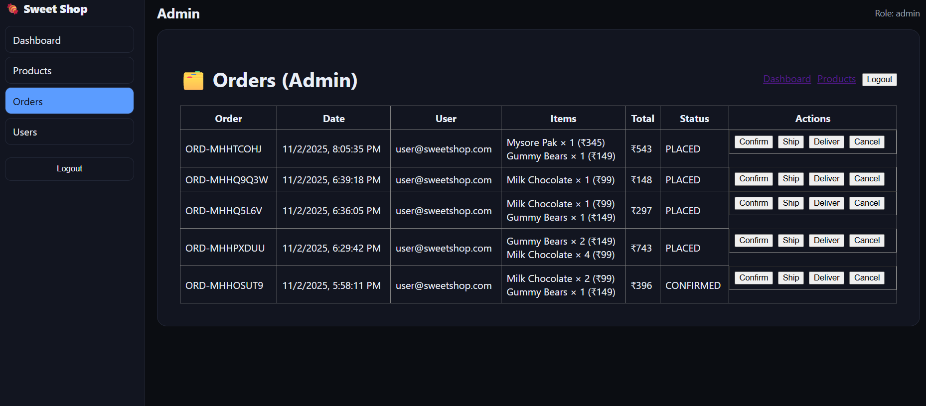
Login Pages:
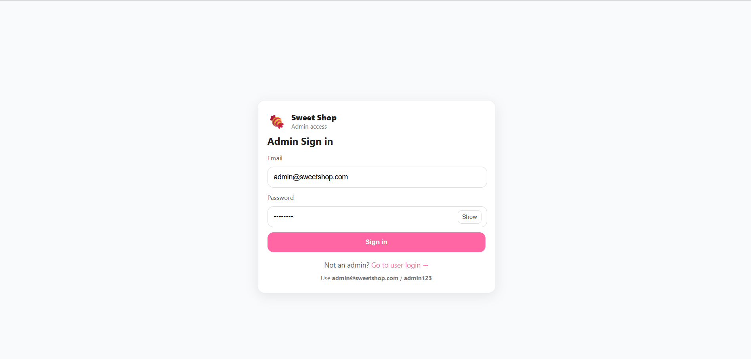
---

🤖 AI Usage & Reflection

🧠 Tools Used
- ChatGPT (GPT-5) – UI design, code refactoring, documentation.
- GitHub Copilot – Inline completions and boilerplate suggestions.

💡 How AI Helped
- Generated frontend structure and CSS layout.
- Created React components for Cart, Orders, and Login.
- Helped debug Vite and import path errors.
- Suggested API endpoint schemas and REST patterns.

⚖️ Reflection
> AI tools were used as assistants, not as autonomous developers.
> I actively reviewed, refined, and customized the generated code.
> This workflow boosted productivity and helped maintain consistent style throughout the project.

Example AI-assisted commit:
git commit -m "feat: add responsive orders page using ChatGPT-generated layout"
Co-authored-by: ChatGPT <ai@openai.com>

🔮 Future Enhancements

- 💳 Payment Gateway integration (Razorpay / Stripe)
- 🔔 Push notifications for order status
- 📈 Admin analytics dashboard with charts
- ☁️ Full CI/CD Pipeline (GitHub Actions + Docker)
- 📱 Progressive Web App (PWA) support

🧑‍💻 Author

Anvith Shetty
🎓 Manipal Institute of Technology
📧 anvithshetty9481@gmail.com

🏁 License

MIT License © 2025 Anvith Shetty
Feel free to use and adapt for academic or educational purposes.

