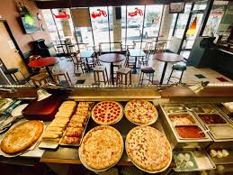

**About Dataset**

One of the most popular foods worldwide is Pizza, with millions of pizzas being sold every day. The following dataset analysis will help to provide valuable insights of this thriving pizza industry. This dataset comprises of information on sales volume, revenue, and customer preferences.

**1. Data Collection and Acquisition**

**1. 1 Data Source and Structure**

I got this dataset from [**Kaggle**](https://www.kaggle.com/datasets/shilongzhuang/pizza-sales/data), the data is scattered among 4 tables namely

* *Orders* = Column names “order_id, date, time”
* *Order*_details = Column names “order_details_id, order_id, pizza_id, quantity”
* *Pizzas* = Column names “pizza_id, pizza_type_id, size, price”
* *Pizza_types* = Column names “pizza_type_id, name, category, ingredients”

This dataset contains detailed information about pizza orders from a specific restaurant or vendor. It captures various aspects of each pizza order, including details about the pizzas, quantities, pricing, order dates, and categorization details`.

**Connections Between Tables** The connections between these tables are crucial for accurate analysis. Here’s how they are linked:

* The orders table connects to the order_details table through the order_id.
* The order_details table connects to the pizzas table through the pizza_id.
* The pizzas table connects to the pizza_types table through the pizza_type_id

**1.2 Tool**

We’ll utilize **Microsoft SQL Server (MS SQL Server)** as our primary data tool for the process of data cleaning, analysis.

**Problem Statement**

I aim to address the following questions:

*1. What is my total revenue over a specific period?  
2. How many pizzas have I sold in total?  
3. What is the average order amount?  
4. Which pizza names are the most and least popular by order?  
5. Which pizza names have the highest and lowest quantity sold?  
6. Which pizza sizes are most preferred by our customers?  
7. Which pizza categories generate the most sales?  
8. What are the daily and monthly sales trends?  
9. How do sales vary across pizza categories and sizes?*

**Data Exploration**

***Total Revenue:****We calculate the total revenue, which gives the owner an overview of her earnings.****Total Pizza Sold:****This metric tells me the total number of pizzas the store has sold.* ***Total Orders:****It provides the count of distinct orders, giving owner an idea of her order volume.****Average Order:****The average order amount helps owner understand the spending patterns of her store’s customers* ***Average No of Orders*** *: This helps the owner understand how many orders to expect on a daily basis.* ***Top 5 pizzas ordered*** *: gives the owner an account of which of his products are liked the most.* ***Distribution of orders by hour of the day****: This helps owner understand which hour of the day her business receives most orders.*

*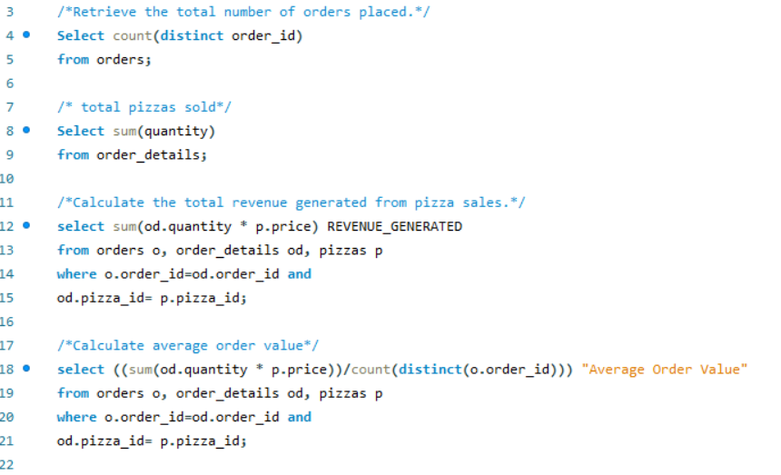.*

**Results**

The following are some of the key findings from the analysis:

* The total number of pizza orders was approximately **21,350.**
* The total sales of pizza were approximately **49574.**
* The total revenue from pizza sales was **$817860.045**
* The average order value was approximately **$38.**

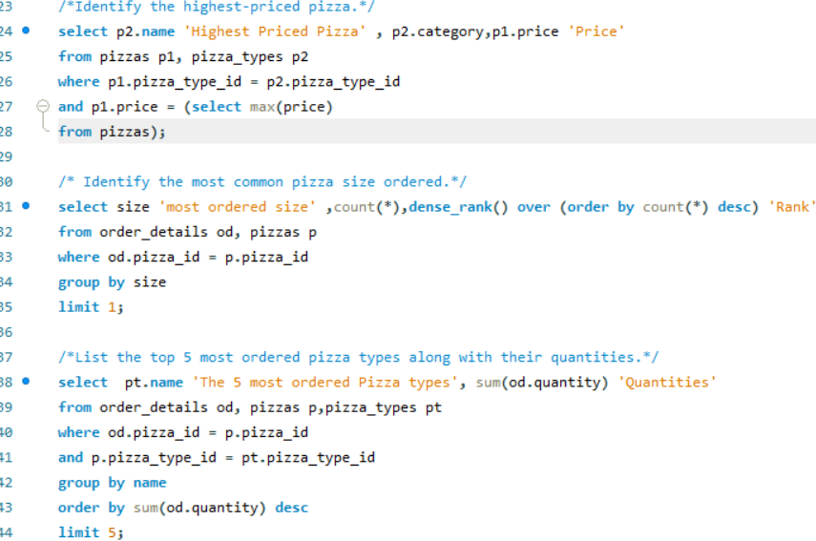

**Results**

* The highest-priced pizza at **dollar 35.95** is **‘*The Greek Pizza*’** in the category **‘*Classic*.’**
* The most common Pizza size ordered is ***‘L.’***
* The top 5 most ordered pizza types along with their quantities are as follows:

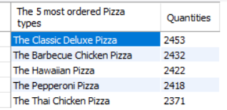

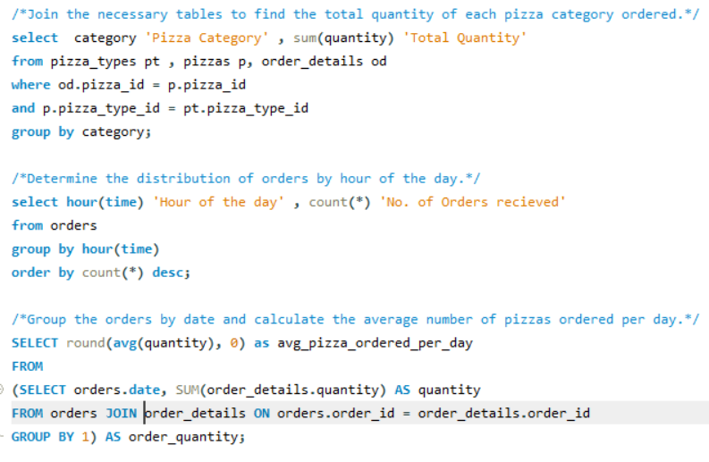

**Result:**

* The total quantity of each pizza category ordered is as follows:

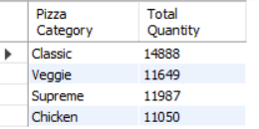

* The distribution of the orders by hour of the day is as follows:

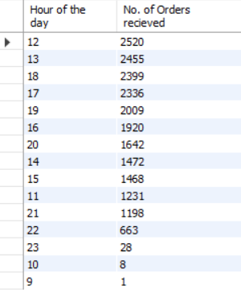

* The average number of pizzas ordered per day are **138.**

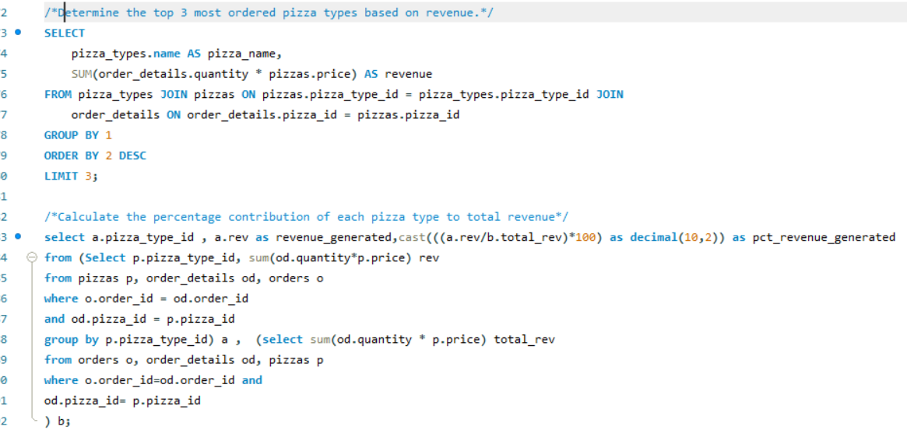

**Result**

* The top 3 most ordered pizza types based on revenue.

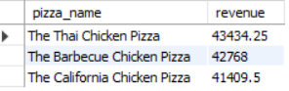

* The percentage contribution of each pizza type to total revenue

