**Data Analysis of Supply Chain of a Cosmetic Company**

Supply chain analytics refers to the processes organizations use to gain insight and extract value from the large amounts of data associated with the procurement, processing, and distribution of goods.

***Supply Chain Analysis: Dataset***

The dataset is based on the supply chain of Makeup products. Below are all the features in the dataset:

1. Product Type
2. SKU
3. Price
4. Availability
5. Number of products sold
6. Revenue generated
7. Customer demographics
8. Stock levels
9. Lead times
10. Order quantities
11. Shipping times
12. Shipping carriers
13. Shipping costs
14. Supplier name
15. Location
16. Lead time
17. Production volumes
18. Manufacturing lead time
19. Manufacturing costs
20. Inspection results
21. Defect rates
22. Transportation modes
23. Routes
24. Costs

I have done the Supply Chain Analysis using the Python programming language.

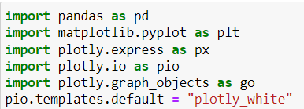

***Supply Chain Analysis using Python***

* ***Let’s begin by analysing the Supply Chain by looking at the relationship between the price of the products and the revenue generated by them:***

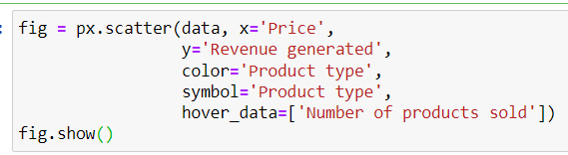s

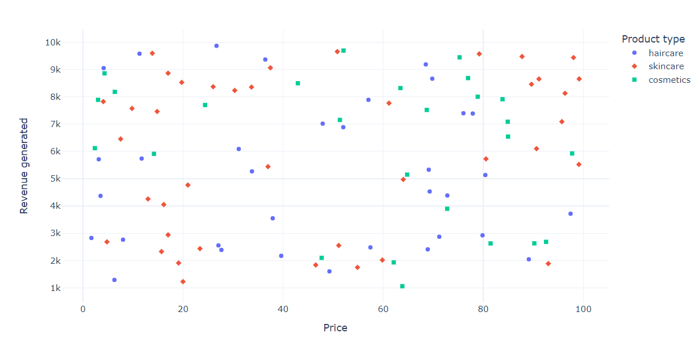

***Thus, the company derives more revenue from skincare products, and the higher the price of skincare products, the more revenue they generate.***

* ***Let’s find out sales by product types***:

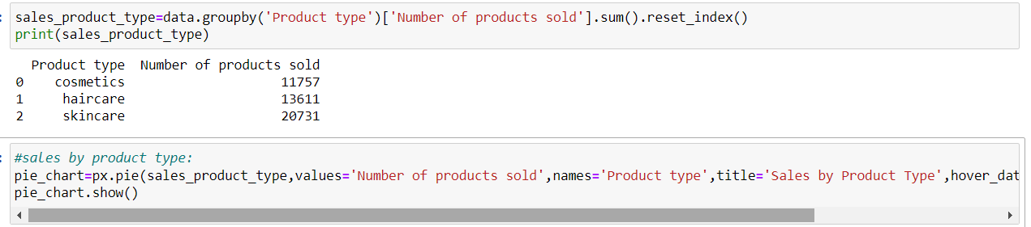

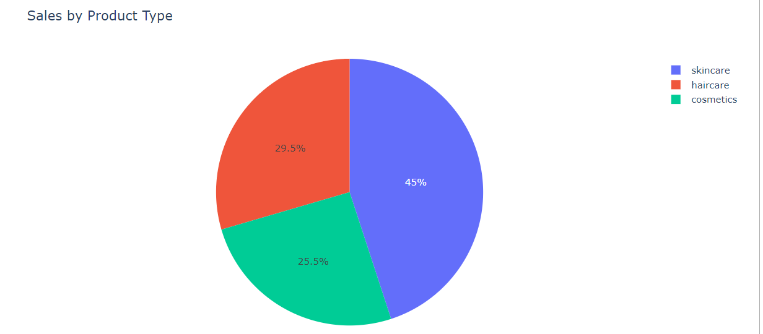

***So, 45% of the business comes from skincare products, 29.5% from haircare, and 25.5% from cosmetics***

* ***Let us have a look at the total revenue generated from shipping carriers:***

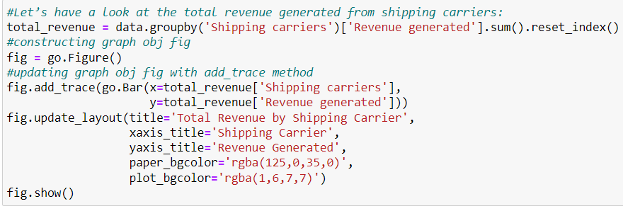

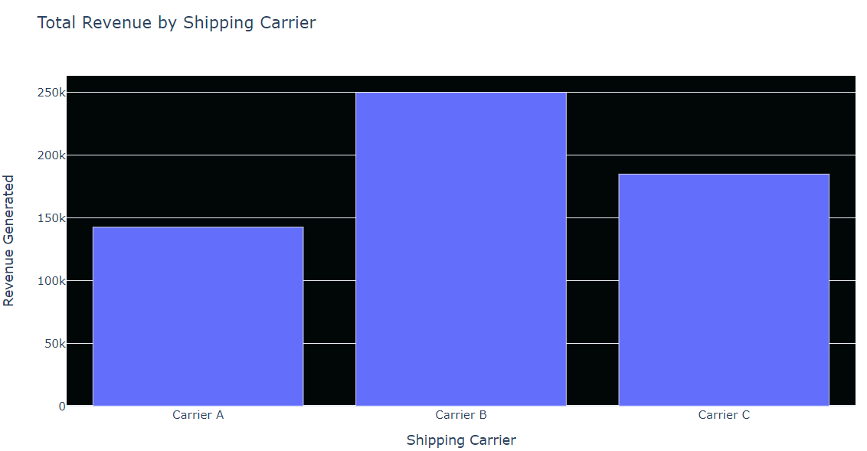

***The conclusion we can draw from above analysis is that out of the three carriers used by the company , carrier B generates more revenue for the company.***

* ***Let’s have a look at the cost distribution by transportation mode***



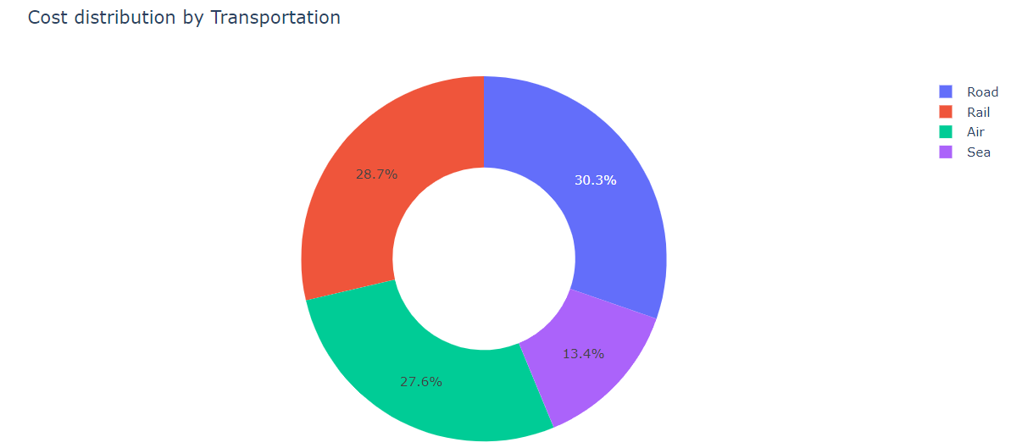

***The company spends more on rail and road modes of transportation for transportation of goods.***

* ***Now let’s find out the Average lead time and Average Manufacturing Costs for all products of the company:***

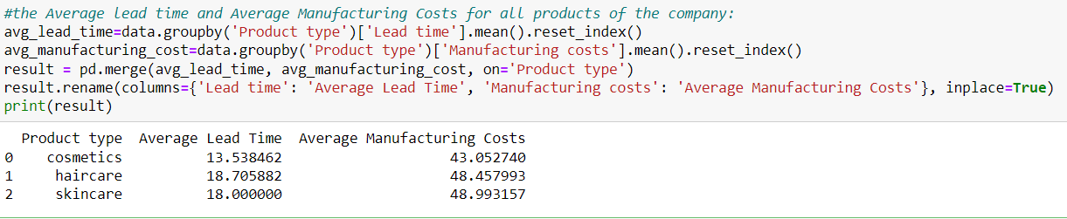

* ***Let us analyse the revenue generated by each SKU. SKU is a unique code, like a secret number only the store knows.***



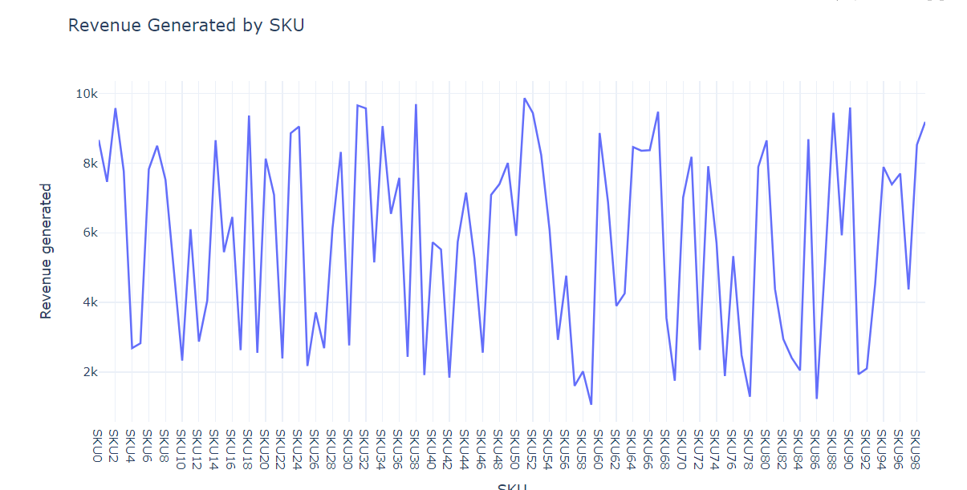

* ***Now let’s have a look at the stock levels of each SKU:***

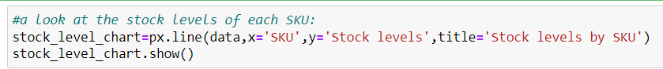

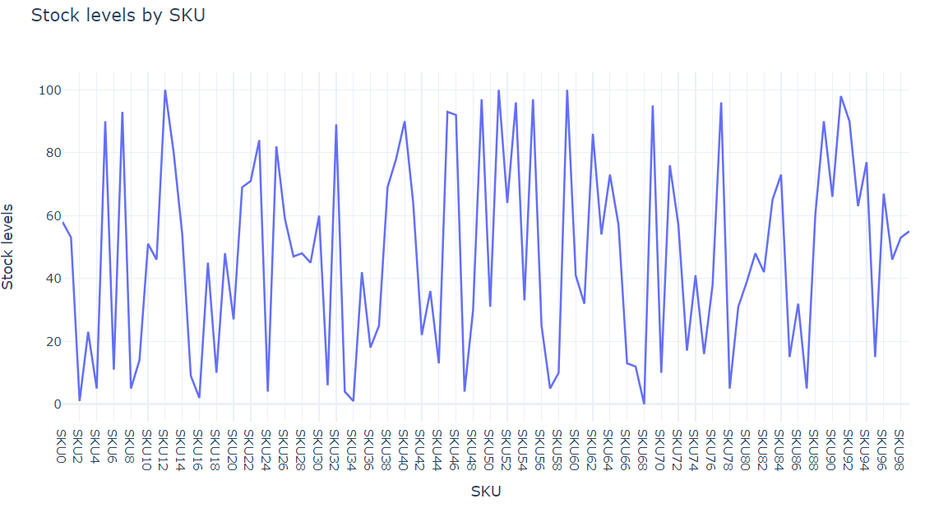

* ***Now let’s have a look at the order quantity of each SKU:***

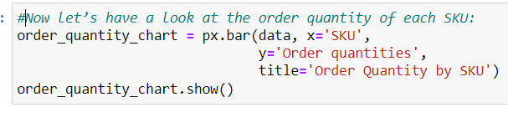

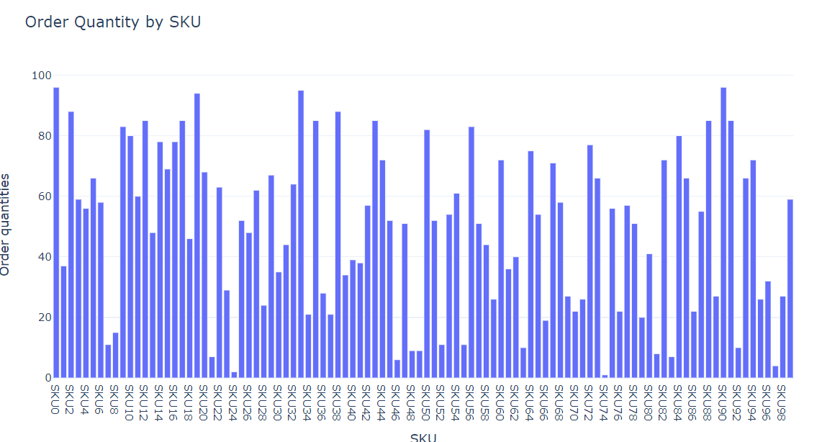

* ***Let’s analyse the shipping cost of Carriers:***

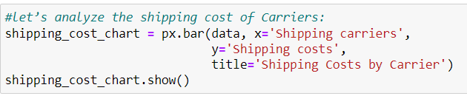

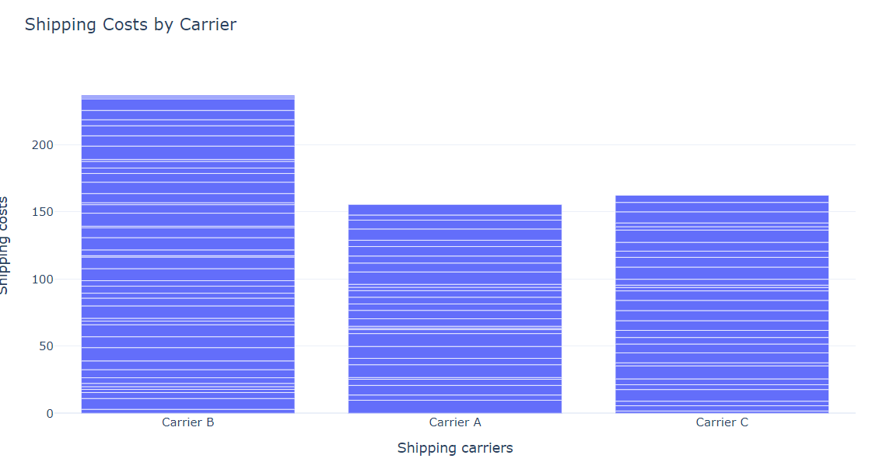

* ***Let us now find out the average defect rate of all product types:***



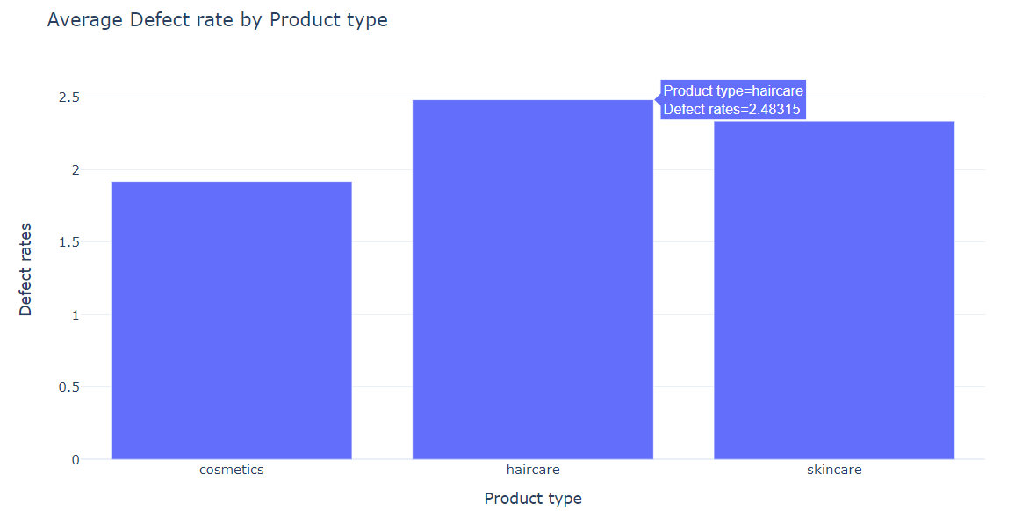

* ***What are the defect rates per mode of transportation:***

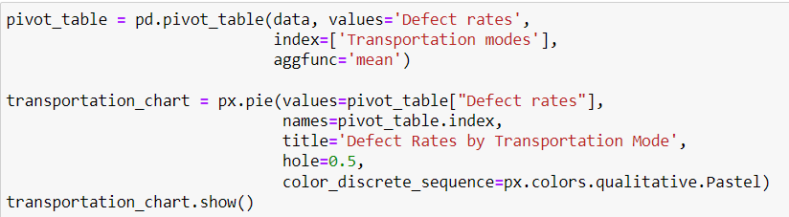

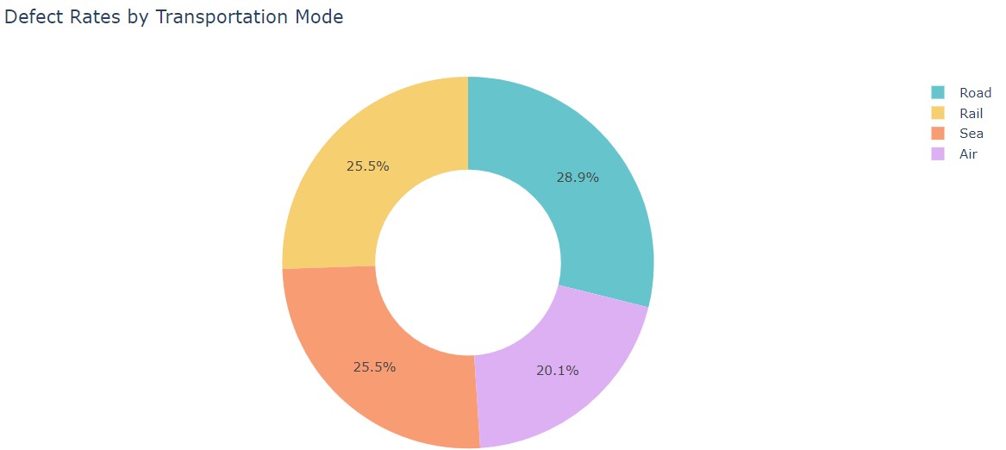

***So it is evident that air transportation resulted in lowest defect rates.***