CMPE – 202
Personal Project – UML Parser

This document contains the following –
- Youtube Link generated by me (Anushree Sinha)
- Dropbox link for the folder containing the jar file and the source code zip.
- Steps for running the jar file.
- 281 teammate details and their youtube video links.

- Youtube video available at - https://youtu.be/QrIvBY1nlRU

- Dropbox Link for the jar and source code zip folder–
https://www.dropbox.com/s/f0foqutqk3kzlzq/Anushree_Sinha_Personal_Project.zip?dl=0

Click on the above dropbox link. Following screen will open –

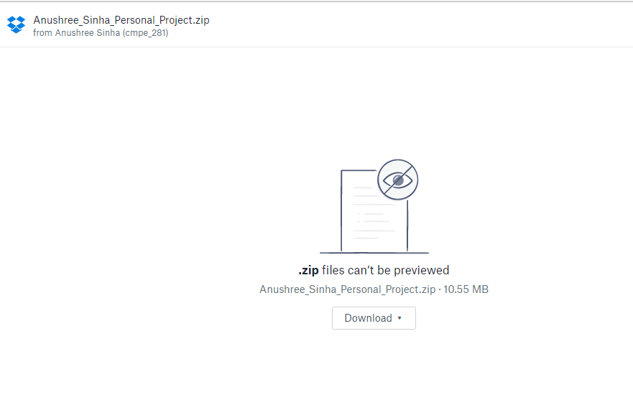
  - Click on Download-> Direct Download

- Steps to run the jar file -

  - Extract Anushree_Sinha_Personal_Project.zip
  - The extracted folder – Anushree_Sinha_Personal_Project contains two files one
zip file and one jar file.

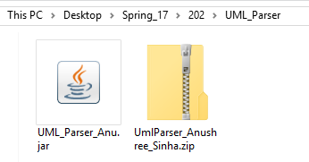

UmlParser_Anushree_Sinha.zip contains the source code.

  - Download the test cases available at –
    - Test Case #1: https://github.com/paulnguyen/cmpe202/tree/master/umlparser/uml-parser-test-1

    - Test Case #2: https://github.com/paulnguyen/cmpe202/tree/master/umlparser/uml-parser-test-2

    - Test Case #3:

https://github.com/paulnguyen/cmpe202/tree/master/umlparser/uml-parser-test-3

    - Test Case #4 :
https://github.com/paulnguyen/cmpe202/tree/master/umlparser/uml-parser-test-4

    - Test Case #5:
https://github.com/paulnguyen/cmpe202/tree/master/umlparser/uml-parser-test-5

  - Open command prompt.
  - Goto the folder Anushree_Sinha_Personal_Project where we have the jar - UML_Parser_Anu.jar
  - Type the following command –

java -jar UML_Parser_Anu.jar <test_case folder> output.jpg
Where “test_case folder” is the folder containing the test cases and “output.jpg” is the output file.
For example, in the below screen shot, “C:\Users\anush\cmpe_202\test\test1” is the folder path which contains all the java files for testcase 1.

    - Test case -1

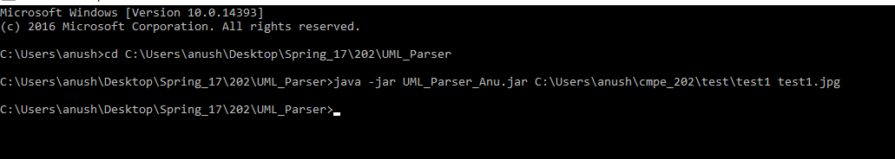

test1.jpg -

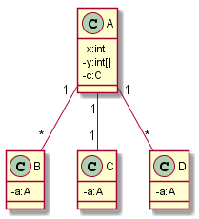

    - Test case -2

test2.jpg -

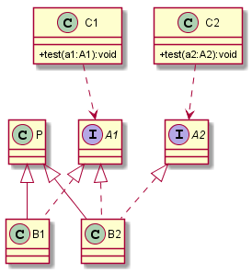

    - Test case - 3

test3.jpg –

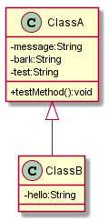

    - Test Case -4

test4.jpg –

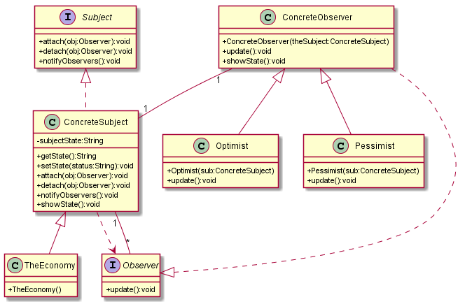

    - Test case – 5

test5.jpg

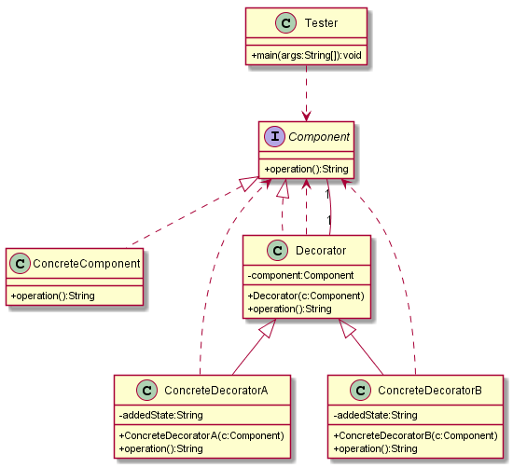

  - All the images will be stored in the folder where the jar was unzipped –

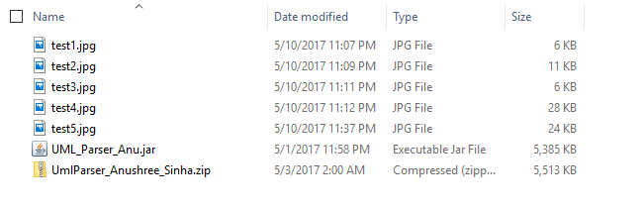

- 281 teammates –
  - Srinivas S. Annapantula - SJSU ID – 011049844 - Youtube – video link - https://www.youtube.com/watch?v=OYdjXdo_tyc
  - Khoa Le – SJSU ID – 009301968 - Youtube video Link –
https://www.youtube.com/watch?v=rGyd0Y1JqJI&feature=youtu.be

