ONLINE QUIZ MANAGEMENT

ENTITY RELATIONSHIP DIAGRAM:

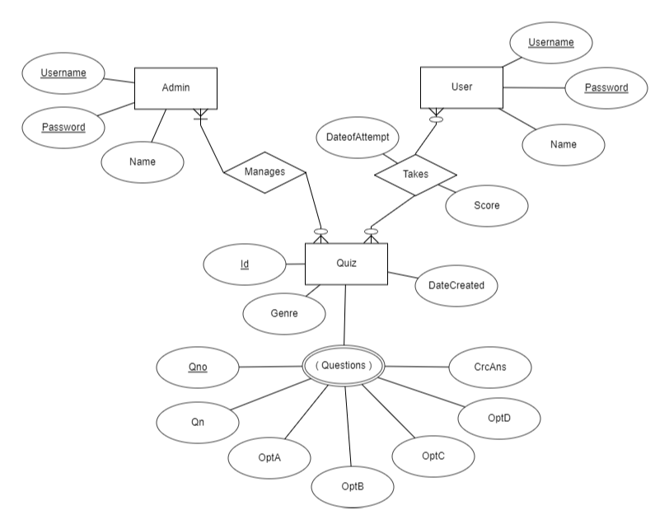

RELATION SCHEMA:

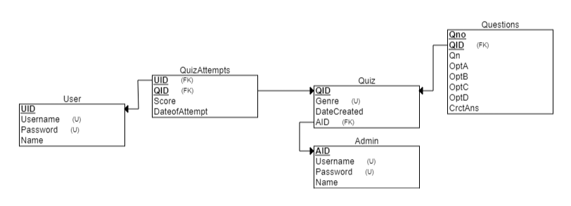

**IDENTIFYING NORMAL FORMS**

1. **ADMIN**

FUNCTIONAL DEPENDENCIES:

**{ AID -> Username , AID -> Password , AID - > Name ,**

**Username -> AID , Username -> Password , Username -> Name ,**

**Password -> AID , Password -> Username , Password -> Name }**

The LHS of all functional dependencies are candidate keys. The ADMIN relation is in **BCNF**.

1. **USER**

FUNCTIONAL DEPENDENCIES:

**{ UID -> Username , UID -> Password , UID - > Name ,**

**Username -> UID , Username -> Password , Username -> Name ,**

**Password -> UID , Password -> Username , Password -> Name }**

The LHS of all functional dependencies are candidate keys. The USER relation is in **BCNF**.

1. **QUIZ**

FUNCTIONAL DEPENDENCIES:

**{ QID -> Genre , QID -> AID , QID -> Date }**

The QUIZ relation is in **BCNF** as QID is the primary key.

1. **QUIZATTEMPTS**

FUNCTIONAL DEPENDENCIES:

**{ QID,SID -> Score ,**

**QID,SID -> Date }**

The relation QUIZATTEMPTS is in **BCNF.**

1. **QUESTIONS**

FUNCTIONAL DEPENDENCIES:

**{** **QID, QNo -> Qn ,**

**QID, QNo -> OptA ,**

**QID, QNo -> OptB ,**

**QID, QNo -> OptC ,**

**QID, QNo -> OptD**

**QID, QNo -> CrctAns }**

The relation QUESTIONS is in **BCNF**.

**Hence, the highest normal form of all tables in the database is BCNF.**

**SQL**

**CREATION OF TABLES**

**USER**

CREATE TABLE USR

(

USRID NUMBER PRIMARY KEY,

USERNAME VARCHAR(20) UNIQUE,

PWD VARCHAR(20) UNIQUE,

UNAME VARCHAR(20) NOT NULL

);

**ADMIN**

CREATE TABLE ADM

(

AID NUMBER PRIMARY KEY,

USERNAME VARCHAR(20) UNIQUE,

PWD VARCHAR(20) UNIQUE,

ANAME VARCHAR(20) NOT NULL

);

**QUIZ**

CREATE TABLE QUIZ

(

QID NUMBER PRIMARY KEY,

GENRE VARCHAR(15) NOT NULL,

DATECREATED DATE,

AID NUMBER,

FOREIGN KEY (AID) REFERENCES ADM(AID)

);

**QUIZ ATTEMPTS**

CREATE TABLE QUIZATTEMPTS

(

USRID NUMBER,

QID NUMBER,

SCORE NUMBER CHECK(SCORE BETWEEN 0 AND 5) NOT NULL,

DATEATTEMPT DATE,

PRIMARY KEY (USRID,QID),

FOREIGN KEY (USRID) REFERENCES USR(USRID),

FOREIGN KEY (QID) REFERENCES QUIZ(QID)

);

**QUESTIONS**

CREATE TABLE QUESTIONS

(

QID NUMBER,

QNO NUMBER,

QN VARCHAR(150) NOT NULL,

OPTA VARCHAR(40),

OPTB VARCHAR(40),

OPTC VARCHAR(40),

OPTD VARCHAR(40),

CRCTANS CHAR(1) CHECK(CRCTANS IN ('A','B','C','D')),

PRIMARY KEY(QID,QNO),

FOREIGN KEY (QID) REFERENCES QUIZ(QID)

);

**INSERTION OF RECORDS**

**USER**

INSERT INTO USR VALUES(101,'ank001','ank001','Ankush');

INSERT INTO USR VALUES(102,'d2002','d2002','Diya');

INSERT INTO USR VALUES(103,'cat123','cat123','Cathy');

INSERT INTO USR VALUES(104,'tnt555','tnt555','Trinita');

INSERT INTO USR VALUES(105,'mnj123','mnj123','Manoj');

INSERT INTO USR VALUES(106,'ry888','ry888','Riya');

SELECT * FROM USR;

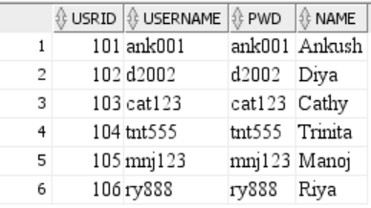

**ADMIN**

INSERT INTO ADM VALUES(1001,'ADMIN101','1234pq','Kumar Gupta');

INSERT INTO ADM VALUES(1002,'ADMIN102','abc456','Samuel Jason');

INSERT INTO ADM VALUES(1003,'ADMIN103','987xyz','Ashish Sharma');

SELECT * FROM ADM;

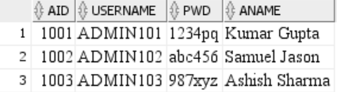

**QUIZ**

INSERT INTO QUIZ VALUES(1,'Sports','18-jun-22','1001');

INSERT INTO QUIZ VALUES(2,'Film','10-may-22','1003');

INSERT INTO QUIZ VALUES(3,'Science','9-jun-2022','1001');

SELECT * FROM QUIZ;

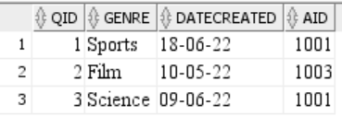

**QUESTIONS**

INSERT INTO QUESTIONS VALUES(1,1,'Who is known as the Flying Sikh?','Michael Johnson','Usain Bolt','Milkha Sing','Carl Lewis','C');

INSERT INTO QUESTIONS VALUES(1,2,'Which player has scored highest number of sixes in his career in ODIs?','Sachin Tendulkar','Shahid Afridi','Chris Gayle','Sanath Jayasurya','B');

INSERT INTO QUESTIONS VALUES(1,3,'Which among the following is the first country to win the World Cup on home soil?','Australia','India','England','West Indies','B');

INSERT INTO QUESTIONS VALUES(1,4,'Which country’s cricket team won the Women’s T20 World Cup 2020?','India','England','Australia','South Africa','C');

INSERT INTO QUESTIONS VALUES(1,5,'Which Country won the first FIFA World Cup?','Argentina','Uruguay','Italy','Brazil','B');

INSERT INTO QUESTIONS VALUES(2,1,'Which was the first Indian movie nominated for Oscar?','Mother India','Salaam Bombay','Lagaan','Mr. India','A');

INSERT INTO QUESTIONS VALUES(2,2,'Which actor has won the most national awards in India?','Amitabh Bachchan','Salman Khan','Aamir Khan','Shah Rukh Khan','D');

INSERT INTO QUESTIONS VALUES(2,3,'Satyajit Ray win Oscar in the year','1992','1994','1986','1990','A');

INSERT INTO QUESTIONS VALUES(2,4,'Which was the first south Indian film released in Japan?','Muthu','Padaiyappa','Batcha','Veera','A');

INSERT INTO QUESTIONS VALUES(2,5,'The biggest film studio of India is _____','Ramoji Film Studio','AVM Studio','Volvo Studio','Indian artist Studio','A');

INSERT INTO QUESTIONS VALUES(3,1,'Which among the following hormone can be used as a drug to treat cardiac arrest and some other cardiac problems?','Thyroxin','Epinephrine','Calcitonin','Insulin','B');

INSERT INTO QUESTIONS VALUES(3,2,'In human body, where do you find the Cone cells and Rod cells?','Retina of the eye','Gallbladder','Esophagus','Villi in the small intestine','A');

INSERT INTO QUESTIONS VALUES(3,3,'Which of these processes is responsible for the energy released in an atom bomb?','Nuclear Fission','Nuclear Fusion','Gamma decay','None','A');

INSERT INTO QUESTIONS VALUES(3,4,'Who recognized and named Oxygen?','Antoine Lavoisier','Henry Cavendish','Alessandro Volta','Louis Claude Cadet de Gassicourt','A');

INSERT INTO QUESTIONS VALUES(3,5,'Which of the following is not an example of an amphibian?','Sea horse','Alligator','Frog','Toad','A');

SELECT * FROM QUESTIONS;

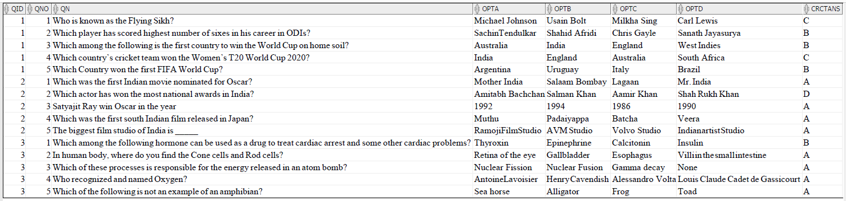

**QUIZATTEMPTS**

INSERT INTO QUIZATTEMPTS VALUES(101,2,3,'4-jun-22');

INSERT INTO QUIZATTEMPTS VALUES(103,1,4,'6-jun-22');

INSERT INTO QUIZATTEMPTS VALUES(104,3,5,'28-may-22');

INSERT INTO QUIZATTEMPTS VALUES(101,1,2,'30-may-22');

INSERT INTO QUIZATTEMPTS VALUES(105,2,5,'15-jun-22');

INSERT INTO QUIZATTEMPTS VALUES(104,2,4,'23-may-22');

INSERT INTO QUIZATTEMPTS VALUES(103,3,3,'25-may-22');

INSERT INTO QUIZATTEMPTS VALUES(101,3,2,'17-jun-22');

INSERT INTO QUIZATTEMPTS VALUES(106,1,1,'9-jun-22');

SELECT * FROM QUIZATTEMPTS;

