CVML Assignment – I

Aim of the assignment was to classsify MNIST sample images into one of the 10 possible classes (0-9 numbers), which we were to perform using the softmax regression with and without convolution layers.

The training data is represented by the following vectors:
Feature matrix, which is the vector of 55000 images of size 28x28 (784) unrolled.
Target matrix, same no.of images into given 10 classes.
Represented as a one-hot encoding for each image.

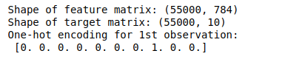

Input images are shown as a subplot, taken for 100 images.
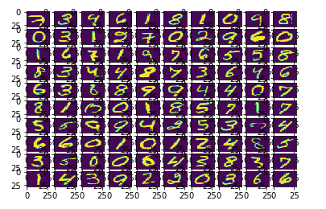

For the first part of the assignment softmax regression without convolution layers.

The parameters of softmax regression are set as follows:

- The number of features is the number of pixels in the 28x28 image which is 784.
- learning rate is the step size for the gradient descent.

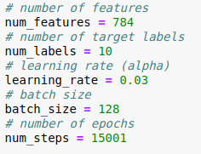
- batch size is the number of training examples taken at a time for doing stochastic gradient descent.

Instead of using traditional gradient descent method we used stochastic gradient descent. Here instead of using the entire training data to calculate the loss and then updating the weights we use some k training examples at a time to calculate the loss and then update the weights. So, the k training examples taken during training at any time is called the minibatch. In every iteration, a minibatch is selected by choosing a random offset value.
The benefit of using stochastic gradient descent is that we get better time complexity however the accuracy is bit degraded as we are not considering all the training examples all at the same time instead using minibatch to update weights. In contrast to traditional gradient descent which converges to a more accurate point, stochastic gradient descent may jump between values near the convergence point.

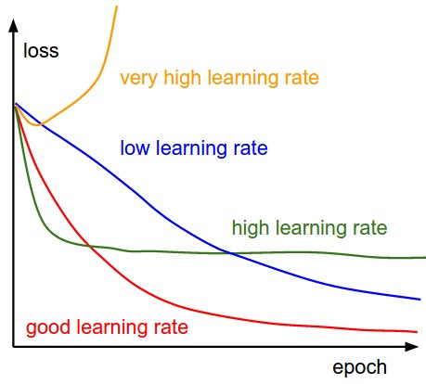
Relationship between epochs vs loss with different learning rates.

EPOCH | LEARNING RATE | ACCURACY(%)
15001 | 0.3 | 88.6
15001 | 0.9 | 90.3
15001 | 0.5 | 92.0
15001 | 1.0 | 90.4
15001 | 10 | 82.9
30000 | 0.5 | 92.0

It is observed that 15001 epochs, the highest accuracy is achieved at 92.0% with learning rate 0.5. So even on increasing the number of epochs there is no considerable change in the accuracy with the same learning rate (0.5).
So, we are not getting better accuracy than ~92.0% using just soft max regression.

Softmax regression with convolution

Relationship between type of activation function and accuracy
ACTIVATION FUNCTION | ACCURACY(%)
Softmax | 97.04
Sigmoid | 90.31
Relu | 98.68
Tanh | 97.14
elu | 97.14
Selu | 97.27
Softplus | 93.41
Softsign | 97.57

Relationship between no of kernel channels and accuracy:
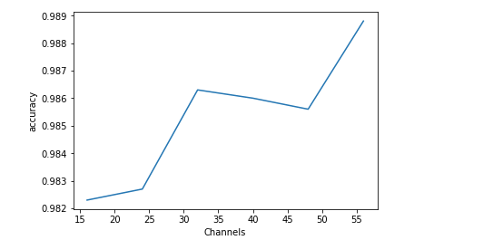

Relationship between size of convolution kernels and accuracy
