Cricket Player Performance TrackingApplication : CRICKSTATS

DEVELOPED BY | SUBMITTED BY
KEERTHANA K - 24131210500122020 | ANUPRIYA V
BHAVANA D - 24131210500122009 | ANUPRIYA V
ANUPRIYA V - 24131210500122005 | ANUPRIYA V
RAGAVI V - 24131210500122034 | ANUPRIYA V

User Story:
As a Salesforce Admin, I want to create a comprehensive player performance tracking application within Salesforce to capture and analyze detailed match-by-match information of cricket players. This application will include custom objects such as Player and Match Performance with carefully defined fields and relationships to ensure data integrity and accessibility.
By leveraging master-detail and lookup relationships, the application will enable robust tracking of individual and team performances, facilitate insightful reporting and analytics, and support the overall management of player statistics.
1. INTRODUCTION
1.1 Project Overview
CRICKSTATS is a Salesforce-based application designed to track, manage, and analyze cricket players’ performance on a match-by-match basis. The system uses custom objects, relationships, dashboards, and automation tools to provide structured performance insights.
It enables coaches, analysts, and administrators to record player statistics, generate reports, and support strategic decision-making.
1.2 Purpose
To digitize player performance records
To improve accuracy and accessibility of cricket statistics
To provide real-time analytics
To support player development and team planning
To automate data management using Salesforce

2. IDEATION PHASE
2.1 Problem Statement (Customer Problem Statement Template)
PS-1: A cricket team coach is trying to track player performance across matches. Accurate statistics are not easily available because data is stored in different files and formats. This can make the coach frustrated and unsure about team selection.
PS-2: A team manager is trying to maintain complete player records. It takes too much time to update and verify data because most records are maintained manually.
PS-3: A sports analyst is trying to analyze player trends and generate reports. Comparing performances is difficult because there is no centralized analytics system.

2.2 Empathy Map Canvas
Target Users
Team Managers
Coaches
Analysts
Salesforce Admins
Empathy Analysis
Think & Feel: Need accurate data, better insights
Hear: Feedback from management
See: Multiple data sources
Say & Do: Collect statistics manually
Pain: Data errors, delays
Gain: Faster decisions, automation

2.3 Brainstorming
Brainstormed Ideas
Web-based player management system
Mobile statistics tracker
Salesforce-integrated CRM
AI-based performance prediction
Dashboard-based analytics
Selected Idea: Salesforce-based performance tracking platform (CRICKSTATS)

3. REQUIREMENT ANALYSIS PHASE
3.1 Customer Journey Map
Journey Stages:
Login
Enter Player Data
Record Match Performance
Generate Reports
Analyze Results
Decision Making

3.2 Solution Requirements
Functional Requirements
FR-1 Player Registration
FR-2 Match Performance Entry
FR-3 Dashboard Generation
FR-4 Report Creation
FR-5 Flow Automation

Non-Functional Requirements (NFRs) – CRICKSTATS
NFR-1: Usability
The system should be easy to understand and use by coaches, managers, analysts, and admins without requiring technical training.
Simple and intuitive user interface
Clear navigation menus
Easy-to-read dashboards
Minimal learning curve
Example: A new coach should be able to log in, enter match data, and view player reports within a few minutes without special training.

NFR-2: Security
The system must protect sensitive player data from unauthorized access.
Role-based access control
Secure authentication
Encrypted data storage
Regular backups
Examples: Coaches can view player statistics. Managers can edit records. Analysts can generate reports. Only admins can modify system settings.
NFR-3: Reliability
The system should function correctly without failure and store data accurately.
No data loss
Automatic backups
Error handling
System stability

NFR-4: Performance
The system should respond quickly and handle large volumes of data efficiently.
Fast page loading
Quick report generation
Smooth dashboard rendering
Minimal response time
Example: When an analyst generates a performance report for 100+ players, the report should load within 2–3 seconds.
NFR-5: Availability
The system should be accessible whenever users need it.
24/7 system availability
Minimal downtime
Cloud-based access
Disaster recovery

NFR-6: Scalability
The system should support increasing numbers of users, players, and records.
Handle growing datasets
Support more teams and leagues
Expand storage capacity
Maintain performance under load
Example: If CRICKSTATS is extended from one team to 50 teams, the system should still perform smoothly.
3.3 Data Flow Diagram
Data Flow: User → Salesforce UI → Player Object → Match Performance → Reports → Dashboard

3.4 Technology Stack
Frontend: Salesforce Lightning
Analytics: Reports & Dashboards
Automation: Salesforce Flows
Backend: Salesforce Objects
Database: Salesforce Cloud
4. PROJECT DESIGN PHASE
4.1 Problem–Solution Fit
The CRICKSTATS system effectively addresses the key challenges faced in traditional cricket performance management. Earlier, most player and match data were maintained using manual records, which were time-consuming and prone to errors. This issue is addressed by implementing an automated system through Salesforce, which ensures accurate and efficient data entry and management.
The problem of data loss is addressed through secure cloud storage. Poor analysis of player performance due to scattered and unorganized data is addressed through dashboards and reports. Real-time reporting features help users access performance information more easily.

4.2 Proposed Solution
CRICKSTATS provides:
Custom objects (Player, Match Performance)
Master-detail relationships
Roll-up summaries
Lightning App
Automated flows
Interactive dashboards
Key Features
Centralized database
Live statistics
Secure access
Scalable design
Easy reporting

4.3 Solution Architecture
Architecture Layers
Presentation Layer (Lightning UI)
Application Layer (Flows, Logic)
Data Layer (Objects)
Analytics Layer (Reports)

5. PROJECT PLANNING & SCHEDULING
5.1 Project Planning
Agile-based execution
Object creation → automation → reporting
Sprint-wise development
Product Backlog, Sprint Schedule, and Estimation
Sprint-1 Developer Setup – USN-1: As an admin, I want to create a Salesforce developer account so that I can configure and deploy the CRICKSTATS system. Points: 1. Priority: High.
Sprint-1 Data Modeling – USN-2: As an admin, I want to create Player and Match Performance objects so that player and match data can be stored systematically. Points: 3. Priority: High.
Sprint-2 Navigation – USN-3: As a user, I want separate tabs for each object so that I can easily navigate and manage records within the application. Points: 3. Priority: High.

Project Planning – Continued
Sprint-2 UI Design – USN-4: As a coach, I want a dedicated Lightning App so that all performance tracking features are accessible from one dashboard. Points: 3. Priority: High.
Sprint-2 Data Structure – USN-5: As an admin, I want to create player and match fields so that complete performance details can be captured accurately. Points: 5. Priority: Medium.
Sprint-2 Data Structure – USN-6: As a user, I want customized page layouts so that only relevant fields are displayed during data entry. Points: 5. Priority: High.
Sprint-2 Automation – USN-7: As a system, I want to validate player and match inputs so that incorrect data entries are prevented. Points: 3. Priority: High.
Sprint-3 Automation – USN-8: As a system, I want automated flows to update player statistics so that performance data remains accurate. Points: 5. Priority: High.
Project Tracker
Sprint-1: 20 points, 6 Days, 24 Oct 2022 – 29 Oct 2022.
Sprint-2: 20 points, 6 Days, 31 Oct 2022 – 05 Nov 2022.
Sprint-3: 20 points, 6 Days, 07 Nov 2022 – 12 Nov 2022.
Sprint-4: 20 points, 6 Days, 14 Nov 2022 – 19 Nov 2022.

6. PROJECT DEVELOPMENT PHASE
Project Flow
Milestone 1 : Creation of developer account
Milestone 2 : Object Creation
Milestone 3 : Tabs
Milestone 4 : The Lightning App
Milestone 5 : Fields & Relationships
Milestone 6 : Roll-up Summary
Milestone 7 : Flows
Milestone 1 - Salesforce developer account creation
Activity 1: Creating Developer Account
Creating a developer org in Salesforce.
Go to https://developer.salesforce.com/signup
On the sign up form, enter First name & Last name

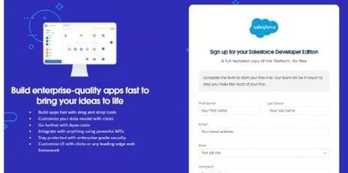

Enter Email
Role : Developer
Company : College or Company Name
Country : India
Postal Code : pin code
Username : should be a combination of your name and company
Username can be in the format username@organization.com
Click on Sign Me Up after filling these.

Activity 2: Account Activation
- 1.Go to the inbox of the email that you used while signing up.
- Click on the Verify Account link to activate your account. The email may take 5–10 minutes.
- 2. Click on Verify Account.

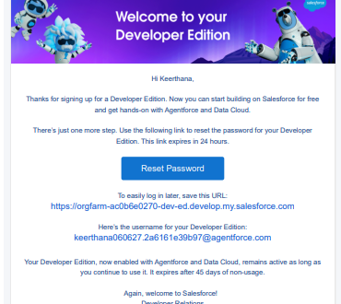

- 3.Give a password and answer a security question and click on Change Password.

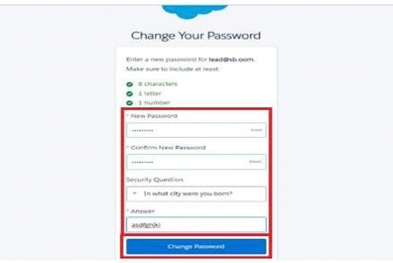

- 4.Then you will be redirected to your Salesforce Setup page.

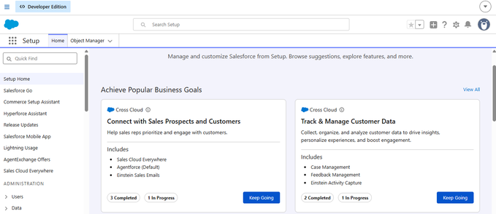

Milestone 2 - Object Creation
Activity 1 : Player Object
- 1.In your Salesforce org, click gear icon on the top left and select Setup.

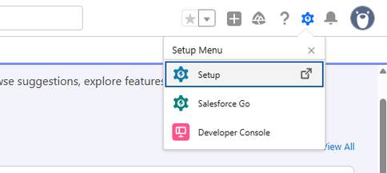

- 2.Click the Object Manager tab. If you don’t see it, enter Object Manager in the Quick Find box.

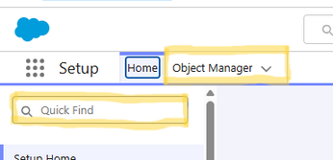

- 3.On the Object Manager page, click Create | Custom Object.

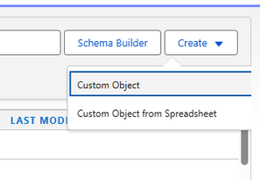

- Player Object configuration:
Label : Player
Plural Label : Players
Record Name : Player Name
Data Type : Text
Optional features: Allow Reports | Allow Activities | Track Field History
Search Status: Allow Search
Save

Activity 2 : Match Performance Object
From the setup page → Click on Object Manager → Click on Create → Click on Custom Object.
Label : Match Performance
Plural Label : Match Performances
Record Name : Customer Account Name
Data Type : Text
Optional features: Allow Reports | Allow Activities | Track Field History
Search Status: Allow Search
Save

Milestone 3 - Tabs
Activity 1 : Custom tabs creation
- 1.Go to setup page → type Tabs in Quick Find bar → click on Tabs → New (under custom object tab).
- 2.Select Object (Player) → Select the tab style → Next.
- 3.On Add to Profiles page keep it as default → Next.
- 4.On Add to Custom App uncheck the Include Tab option.
- Make sure that Append tab to users' existing personal customizations is checked.
- 5.Click Save.
- 6.Repeat the same steps for Match Performances.

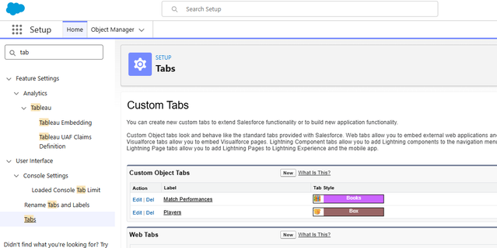

Milestone 4 - The Lightning App
Activity 1 : Create a Lightning App
- 1.Go to setup page → search App Manager in Quick Find → select App Manager → click on New Lightning App.

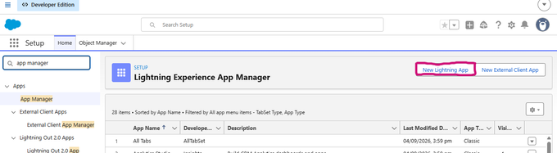

- 2.Fill the app name in App Details and Branding.
- 3.App Name : CRICKSTATS
- 4.Developer Name : Auto Populates
- 5.Add image is optional. Add Primary Color Hex or leave it to default.
- 6.Then click Next.

Lightning App – App Options
3. In App Options
Navigation style : Standard navigation
Setup experience : setup
Supported form factors : Desktop and phone
Then click Next.
4. In Utility Items
Utility Bar alignment : Default
Then click Next.
5. Navigation Items
Select the created Custom Objects and required standard objects.
Players
Match Performances
Reports
Dashboards

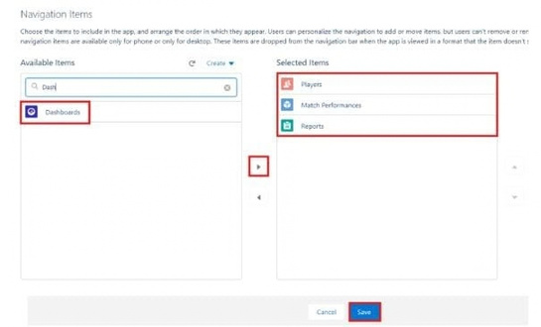

Lightning App – User Profile
6. To Add User Profiles
- System Administrator

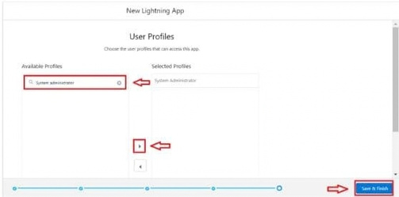

7. Click Save & Finish.
Milestone 5 : Fields & Relationships
Activity 1 : Create Custom fields for Player object
- 1.In your Salesforce org, click gear icon on the top left and select Setup.
- 2.Click the Object Manager tab. If you don’t see it, enter Object Manager in the Quick Find box.
- 3.From the Object Manager page, in the Quick Find box, search for the custom object you just created: Player.
- 4.From the sidebar, click Fields & Relationships. Notice that there are already some fields there. Those are the standard fields.
- 5.Click New to create a custom field. Before creating a new field, do a quick search to make sure a similar
- One doesn’t already exist.

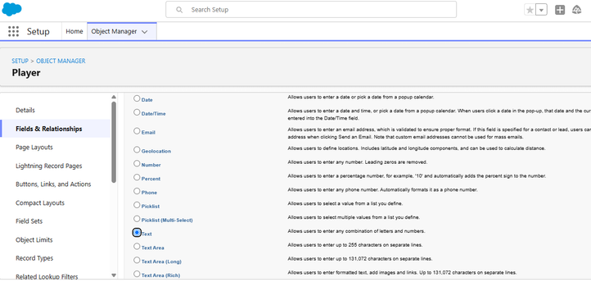

Player Object – Fields
Data Type : Text
Field Label: Player Name
Field Name : Auto Populates
Length : 50
Click on Next → Next → Save and New.
Repeat the same steps for remaining fields.
Data Type : Text | Field Label: Player Number | Length: 3
Data Type : Rich Text Area | Field Label: Profile Picture
Data Type : Date | Field Label: Date of Birth
Role
Data Type : Picklist
Field Label: Role
Batsman
Bowler
Batsman & Wicket Keeper
All Rounder

Player Object – Picklist Fields
Batting Style
Data Type : Picklist
Field Label: Batting Style
Right- Handed
Left - Handed
Bowling Style
Data Type : Picklist
Field Label: Bowling Style
Right-Arm Fast
Left-Arm Fast
Right-Arm Medium
Left-Arm Medium
Right-Arm Spin
Left-Arm Spin
Nationality
Australia
Bangladesh
England
India
New Zealand
Pakistan
South Africa
Sri Lanka
West Indies
Afghanistan
Zimbabwe
Ireland
Scotland
Netherlands
United Arab Emirates
Nepal
United States of America

Player Object – Team, Formula and Relationship
Team
Data Type : Picklist
Field Label: Team
Chennai Super Kings (CSK)
Delhi Capitals (DC)
Kolkata Knight Riders (KKR)
Mumbai Indians (MI)
Punjab Kings (PBKS)
Rajasthan Royals (RR)
Royal Challengers Bangalore (RCB)
Sunrisers Hyderabad (SRH)
Gujarat Titans (GT)
Lucknow SuperGiants (LSG)
AVG Score
Data Type : Formula
Field Label : AVG Score
Formula Return : Number

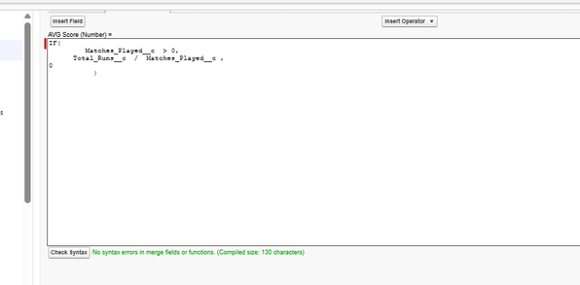

Formula: IF( Matches_Played__c > 0, Total_Runs__c / Matches_Played__c, 0 )
Lookup Relationship
Data Type : Lookup Relationship
Related To : Match Performance
Field Label : Match Performance

Activity 2 : Create Custom fields for Match Performance object
Data Type : Text | Field Label: Match Performance Name | Length : 80
Data Type : Checkbox | Field Label: Player of the Match
Data Type : Picklist | Field Label: Match Result | Values: WON, LOST, DRAW
Data Type : Number | Field Label: Runs Scored
Data Type : Number | Field Label: Balls Faced
Data Type : Number | Field Label: Fours
Data Type : Number | Field Label: Sixes
Data Type : Number | Field Label: Overs Bowled
Data Type : Number | Field Label: Wickets Taken
Click on Next → Next → Save and New as required.

Match Performance – Remaining Fields
Data Type : Number | Field Label: Runs Conceded
Data Type : Number | Field Label: Maiden Overs
Data Type : Number | Field Label: Stumpings
Data Type : Number | Field Label: Catches
Player Relationship
Data Type : Master - Detail Relationship
Related To : Player
Field Label : Player
Field Name : Auto Populates
Click on Next → Next → Save.
Milestone 6 : Roll-up Summary
Note: Roll-up Summary can only be created on the parent object in a Master-Detail Relationship.

Activity 1 : Create Roll-up Summary for Player object
In your Salesforce org, click gear icon on the top left and select Setup.
Click the Object Manager tab. If you don’t see it, enter Object Manager in the Quick Find box.
From the Object Manager page, in the Quick Find box, search for the custom object you just created: Player.
From the sidebar, click Fields & Relationships.
Click New to create a custom field. Before creating a new field, do a quick search to make sure a similar one doesn’t already exist.
Choose a data type as Roll-up Summary. Click Next.
Matches Played
Field Label: Matches Played
Summarized Object: Match Performances
Roll-up Type: COUNT
Filter Criteria: All records should be included in the calculation.

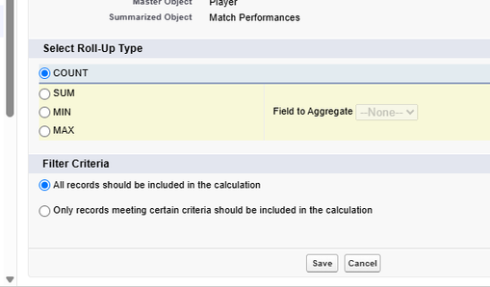

Roll-up Summary – Half-centuries and Centuries
Number of 50’s
Data Type : Roll-up Summary
Field Label: Number of 50’s
Summarized Object: Match Performances
Roll-up Type: COUNT
Filter Criteria: Only records meeting certain criteria should be included in the calculation.

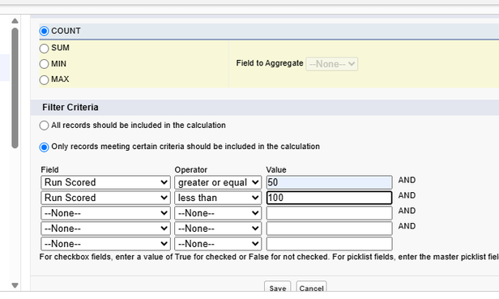

Number of 100’s
Data Type : Roll-up Summary
Field Label: Number of 100’s
Summarized Object: Match Performances
Roll-up Type: COUNT
Filter Criteria: Only records meeting certain criteria should be included in the calculation.

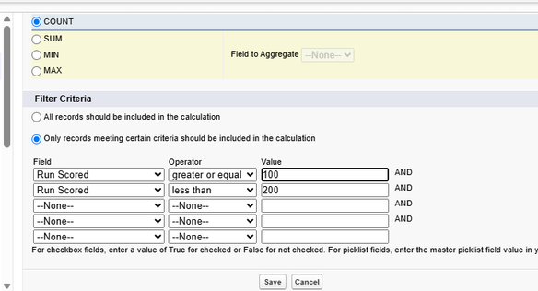

Roll-up Summary – Boundaries and Runs
Total 4’s
Data Type : Roll-up Summary
Summarized Object : Match Performances
Select Roll-up Type : SUM
Field To Aggregate : Fours
Filter Criteria : All records should be included in the calculation.
Total 6’s
Data Type : Roll-up Summary
Summarized Object : Match Performances
Select Roll-up Type : SUM
Field To Aggregate : Sixes
Filter Criteria : All records should be included in the calculation.
Total Runs
Data Type : Roll-up Summary
Summarized Object : Match Performances
Select Roll-up Type : SUM
Field To Aggregate : Runs Scored
Filter Criteria : All records should be included in the calculation.

Roll-up Summary – Bowling and Fielding
Total Overs
Data Type : Roll-up Summary
Summarized Object : Match Performances
Select Roll-up Type : SUM
Field To Aggregate : Overs Bowled
Filter Criteria : All records should be included in the calculation.
Total Wickets
Data Type : Roll-up Summary
Summarized Object : Match Performances
Select Roll-up Type : SUM
Field To Aggregate : Wickets Taken
Filter Criteria : All records should be included in the calculation.
Total Stumpings
Data Type : Roll-up Summary
Summarized Object : Match Performances
Select Roll-up Type : SUM
Field To Aggregate : Stumpings
Filter Criteria : All records should be included in the calculation.
Total Catches
Data Type : Roll-up Summary
Summarized Object : Match Performances
Select Roll-up Type : SUM
Field To Aggregate : Catches
Filter Criteria : All records should be included in the calculation.

Milestone 7 : Flows
Activity 1 : Screen Flow
- 1.Go to Setup, type Flow in Quick Find box → Click on Flow and Select New Flow.

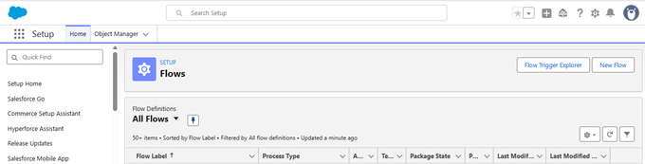

- 2.Select Screen Flow and click Create.

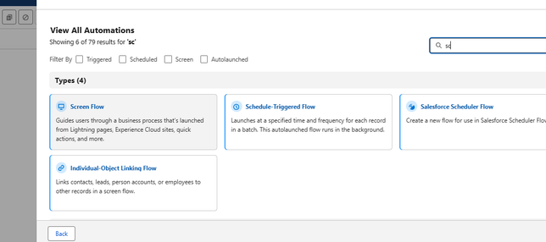

- 3.Click (+) Icon on the flow builder and Select Screen Component.
- Label : Players screen
- API : Players_screen
- Select the Picklist component and place it on the screen.
- Label : Team
- API : Team

Screen Flow – Team Picklist
From Component Pane
Component Type : Picklist
Data Type : Text
Choice : Click New Choice Resources
Resource Type : Picklist Choice Set

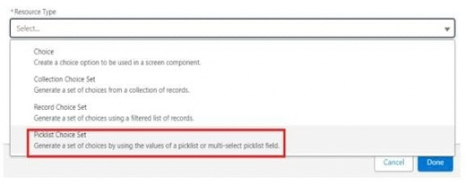

API Name : Team
Object : Player
Data Type : Picklist
Field : Team
Click Done.

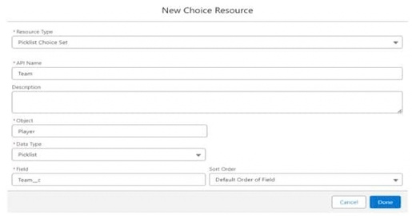

Get Records Component
Click (+) Icon on the flow builder and Select Get Records Component.
Label : Players
API Name : Players
Object : Player
Filter player records : Field = Team
Operator : Equals

Screen Flow – Dynamic Variable and Player Information
Value
Click New Resource
Resource Type : Variable
API Name : Dynamic
Data Type : Text
Default Value : Screen component : Team (Picklist)

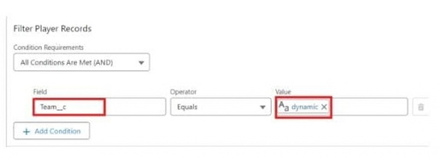

Player Information Screen
Click (+) Icon on the flow builder and Select Screen Component.
Label : Player_info
API Name : Player_info
From Component Pane on the left side select Component Type : Data table
API Name : Player_info_table
Label : Data Table
Configure Data Source : Source Collection : Players from players (Player__c)

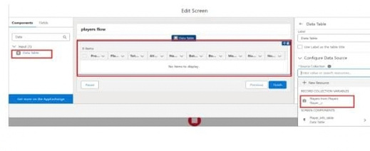

Screen Flow – Data Table Columns
In Configure Columns, add all the required Columns:
Profile Picture
Player Name
Total Runs
AVG Score
Batting Style
Bowling Style
Matches Played
Number of 50’s
Number of 100’s
Click Done.
Click Save.
Flow Label : Player Flow
Flow API Name : Player_Flow

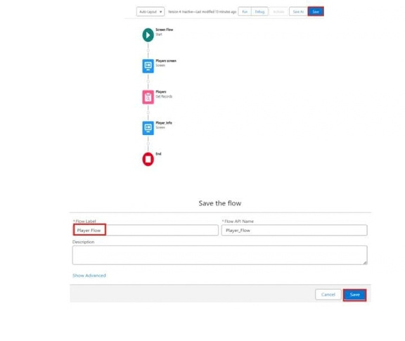

Activity 2 : Flow on Home Page
- 1.On your CRICKSTATS Application on the top right of the Navigation Bar click on Personalize your nav bar icon (Pencil Icon) and Add Home Page and click Save.
- 2.Remove all other components and Add FLOW component from the standard components on the left side.
- 3.Flow : Players Flow

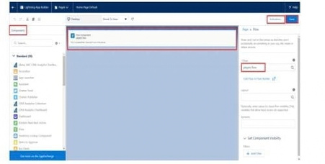

- 4.Click Save and Activation.
- 5.Click on App Default and select Assign to Apps.
- 6.Select CRICKSTAS App and Click Next and then click Save.

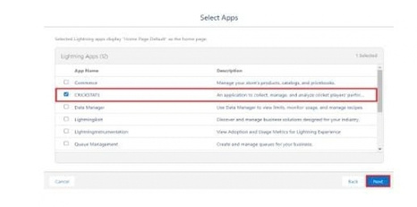

- 7. FUNCTIONAL & PERFORMANCE TESTING
During the testing phase, screenshots were captured from the Salesforce Lightning user interface to verify the correct functioning of all implemented features in the CRICKSTATS system. These include record creation for Player and Match Performance objects; validation rule checks for mandatory fields, score limits, and input constraints; verification of record type behavior for Domestic and International match categories; and flow execution for automatic updating of player statistics and data consistency.
The functionality of roll-up summary fields was also tested to ensure accurate calculation of total runs, wickets, averages, and performance metrics. System performance was evaluated by monitoring response time during data entry, report generation, and dashboard loading.

7. FUNCTIONAL & PERFORMANCE TESTING – Continued
The application was tested under multiple user interactions to ensure stable performance without delays. Screenshots of generated reports and interactive dashboards were documented to confirm accurate data visualization, real-time updates, and reliable performance tracking.
These testing activities ensured that the CRICKSTATS platform met both functional and performance requirements and was ready for deployment.
NOTE : Enter some records in the Player Object and Match Performance Object to get the results.
- Select one Team from the Picklist and Click Next.

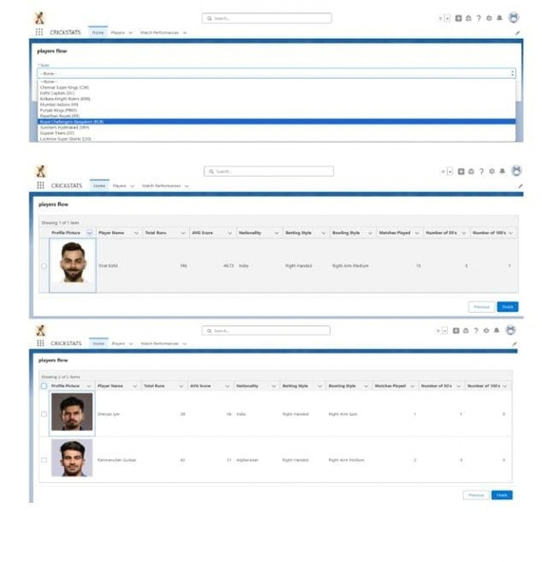

8. ADVANTAGES & DISADVANTAGES
Advantages
Centralized system
Real-time analytics
Secure platform
Scalable design
Reduced manual work
Disadvantages
Requires Salesforce license
Internet dependency
Limited offline access
9. Conclusion
CRICKSTATS successfully implements a cloud-based cricket performance tracking system using Salesforce. The system automates data management, improves reporting accuracy, and supports informed decision-making. The project demonstrates practical application of SDLC, Agile methodology, and CRM-based development.
10. FUTURE SCOPE
Mobile application integration
AI-based performance prediction
Video analysis integration
Player ranking system
Public statistics portal
Multi-league support
11. APPENDIX
Salesforce Objects & Fields
Manual match statistics
Flow Configurations
Thank You

