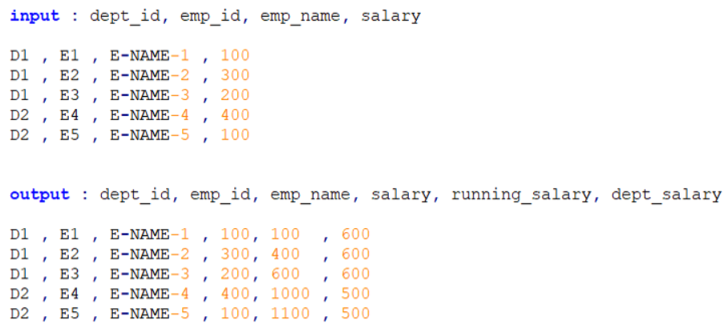

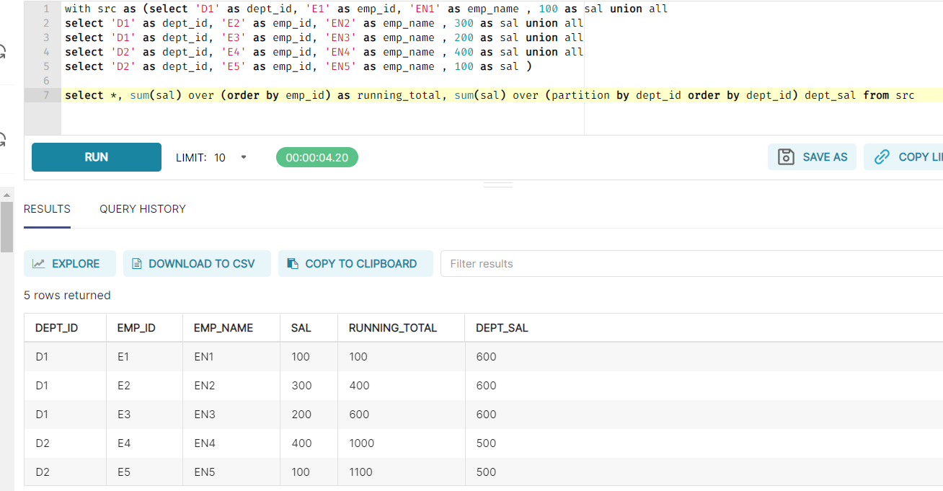

with src as (select 'D1' as dept_id, 'E1' as emp_id, 'EN1' as emp_name , 100 as sal union all

select 'D1' as dept_id, 'E2' as emp_id, 'EN2' as emp_name , 300 as sal union all

select 'D1' as dept_id, 'E3' as emp_id, 'EN3' as emp_name , 200 as sal union all

select 'D2' as dept_id, 'E4' as emp_id, 'EN4' as emp_name , 400 as sal union all

select 'D2' as dept_id, 'E5' as emp_id, 'EN5' as emp_name , 100 as sal )

select *, sum(sal) over (order by emp_id) as running_total, sum(sal) over (partition by dept_id order by dept_id) dept_sal from src

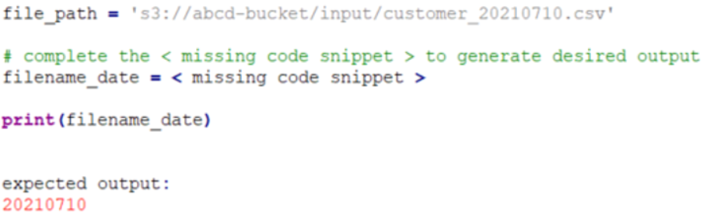

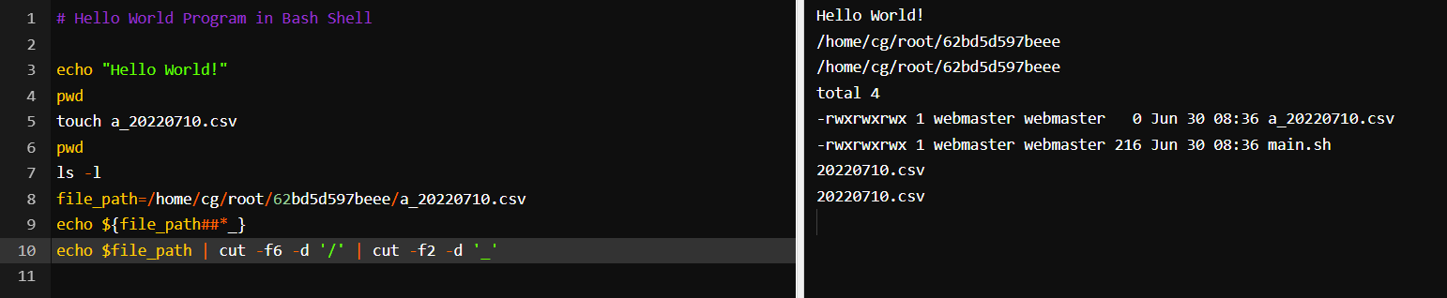

# Hello World Program in Bash Shell

echo "Hello World!"

pwd

touch a_20220710.csv

pwd

ls -l

file_path=/home/cg/root/62bd5d597beee/a_20220710.csv

echo ${file_path##*_}

echo $file_path | cut -f6 -d '/' | cut -f2 -d '_'

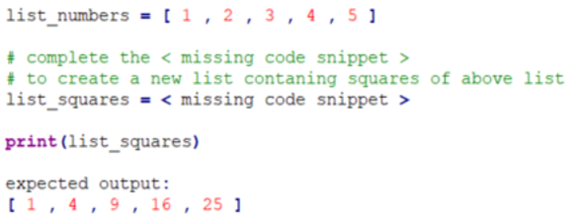

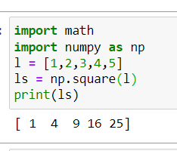

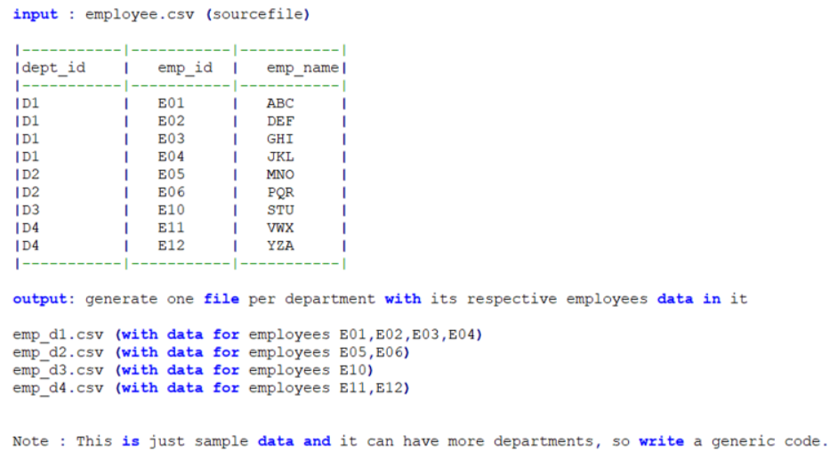

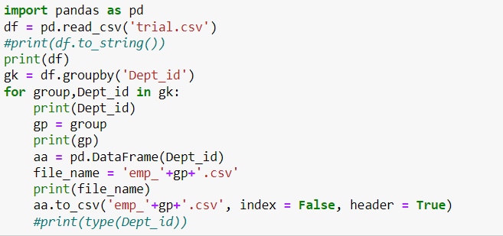

import pandas as pd

df = pd.read_csv('trial.csv')

#print(df.to_string())

print(df)

gk = df.groupby('Dept_id')

for group,Dept_id in gk:

print(Dept_id)

gp = group

print(gp)

aa = pd.DataFrame(Dept_id)

file_name = 'emp_'+gp+'.csv'

print(file_name)

aa.to_csv('emp_'+gp+'.csv', index = False, header = True)

#print(type(Dept_id))

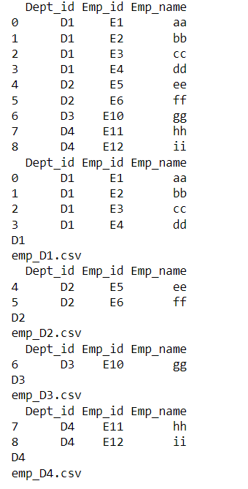

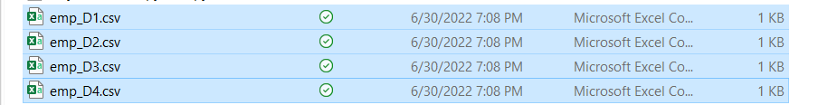

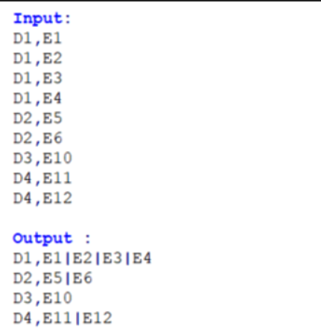

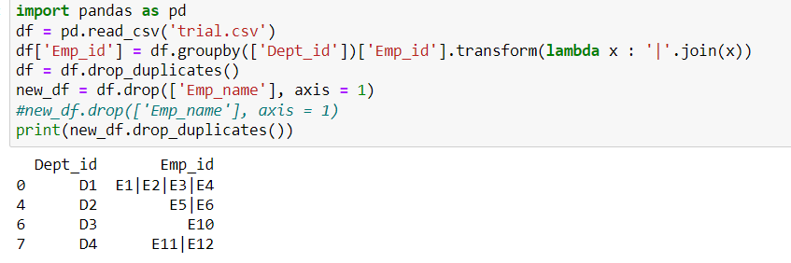

import pandas as pd

df = pd.read_csv('trial.csv')

df['Emp_id'] = df.groupby(['Dept_id'])['Emp_id'].transform(lambda x : '|'.join(x))

df = df.drop_duplicates()

new_df = df.drop(['Emp_name'], axis = 1)

#new_df.drop(['Emp_name'], axis = 1)

print(new_df.drop_duplicates())