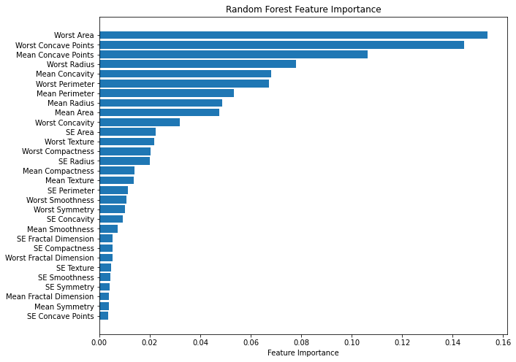

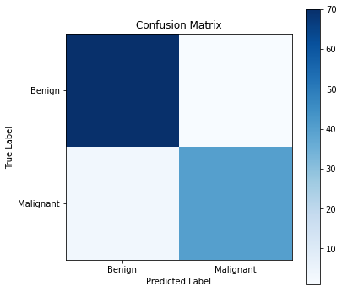

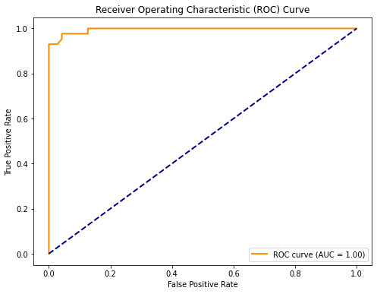

import numpy as np

import pandas as pd

import matplotlib.pyplot as plt

from sklearn.model_selection import train_test_split

from sklearn.ensemble import RandomForestClassifier

from sklearn.metrics import confusion_matrix, roc_curve, auc, roc_auc_score

from sklearn.preprocessing import label_binarize

from sklearn.multiclass import OneVsRestClassifier

from itertools import cycle

# Load the breast cancer dataset

url = "https://archive.ics.uci.edu/ml/machine-learning-databases/breast-cancer-wisconsin/wdbc.data"

column_names = ['ID', 'Diagnosis', 'Mean Radius', 'Mean Texture', 'Mean Perimeter', 'Mean Area', 'Mean Smoothness',

'Mean Compactness', 'Mean Concavity', 'Mean Concave Points', 'Mean Symmetry', 'Mean Fractal Dimension',

'SE Radius', 'SE Texture', 'SE Perimeter', 'SE Area', 'SE Smoothness', 'SE Compactness', 'SE Concavity',

'SE Concave Points', 'SE Symmetry', 'SE Fractal Dimension', 'Worst Radius', 'Worst Texture',

'Worst Perimeter', 'Worst Area', 'Worst Smoothness', 'Worst Compactness', 'Worst Concavity',

'Worst Concave Points', 'Worst Symmetry', 'Worst Fractal Dimension']

data = pd.read_csv(url, header=None, names=column_names)

# Drop unnecessary columns (e.g., ID column)

data = data.drop(['ID'], axis=1)

# Convert categorical diagnosis labels to numerical (Malignant: 1, Benign: 0)

data['Diagnosis'] = data['Diagnosis'].map({'M': 1, 'B': 0})

# Separate features (X) and target variable (y)

X = data.drop('Diagnosis', axis=1)

y = data['Diagnosis']

# Split the data into training and testing sets

X_train, X_test, y_train, y_test = train_test_split(X, y, test_size=0.2, random_state=42)

# Initialize the Random Forest classifier

rf_classifier = RandomForestClassifier(n_estimators=100, random_state=42)

# Train the classifier on the training data

rf_classifier.fit(X_train, y_train)

# Feature Importance Plot

feature_importance = rf_classifier.feature_importances_

feature_names = X.columns

sorted_idx = np.argsort(feature_importance)

plt.figure(figsize=(10, 8))

plt.barh(range(len(sorted_idx)), feature_importance[sorted_idx], align="center")

plt.yticks(range(len(sorted_idx)), feature_names[sorted_idx])

plt.xlabel("Feature Importance")

plt.title("Random Forest Feature Importance")

plt.show()

# Confusion Matrix Plot

y_pred = rf_classifier.predict(X_test)

conf_matrix = confusion_matrix(y_test, y_pred)

plt.figure(figsize=(6, 6))

plt.imshow(conf_matrix, interpolation='nearest', cmap=plt.cm.Blues)

plt.title('Confusion Matrix')

plt.colorbar()

classes = ['Benign', 'Malignant']

tick_marks = np.arange(len(classes))

plt.xticks(tick_marks, classes)

plt.yticks(tick_marks, classes)

plt.xlabel('Predicted Label')

plt.ylabel('True Label')

plt.show()

# ROC Curve

y_score = rf_classifier.predict_proba(X_test)[:, 1]

fpr, tpr, _ = roc_curve(y_test, y_score)

roc_auc = auc(fpr, tpr)

plt.figure(figsize=(8, 6))

plt.plot(fpr, tpr, color='darkorange', lw=2, label=f'ROC curve (AUC = {roc_auc:.2f})')

plt.plot([0, 1], [0, 1], color='navy', lw=2, linestyle='--')

plt.xlabel('False Positive Rate')

plt.ylabel('True Positive Rate')

plt.title('Receiver Operating Characteristic (ROC) Curve')

plt.legend(loc="lower right")

plt.show()