Launch jenkins and explore creating projects and users.

DEFINITION OF JENKINS:

Jenkins is an open-source tool that automates various stages of the software development lifecycle. It supports building, testing, and deploying applications across multiple environments, making it a critical component in CI/CD pipelines.

Automation: Automates repetitive tasks such as builds, tests, and deployments.
Extensibility: Over 1,800+ plugins to integrate with various tools like Docker, Kubernetes, Selenium, and Git.
Technology Agnostic: Supports multiple programming languages and tech stacks, including Java, Python, JavaScript, and more.
Ease of Setup: Provides a user-friendly web-based GUI for configuration.
Master-Slave Architecture: Enables distributed builds for improved performance and scalability.

Benefits of Jenkins

Automation of Repetitive Tasks

- Automates builds, tests, and deployments, reducing manual effort.
- Supports scheduling jobs to run at specific intervals.

Extensive Plugin Ecosystem

Plugins for building, testing, reporting, and deployment.
Integrates seamlessly with popular tools like Maven, TestNG, and Cucumber.

Ease of Use

- Simple installation with a web-based interface.
- Minimal setup required for basic configurations.

Distributed Builds

Master-slave architecture allows workload distribution across multiple nodes.
Improves build speed and scalability.

Flexibility and Customization
- Open-source nature allows creating custom plugins if required.

Jenkins Architecture and Core Concepts

Jenkins follows a master-slave architecture, where the Jenkins server (master) manages build jobs and delegates their execution to agent nodes (slaves). This setup ensures efficient resource utilization and parallel execution.

Master Slave Architecture

- JENKIN CONTROLLER (FORMELY MASTER)

The Jenkins Controller serves as the central system for managing a Jenkins instance, often referred to as its "heart." It oversees agents and their connections, determining the tasks they should perform. Additionally, the Jenkins Controller loads plugins and ensures that jobs run in the correct sequence.

2. Jenkins Agent(Formerly Slave)
Jenkins Agent is a machine that performs tasks like running scripts, executing tests, or building components, etc. These tasks are assigned by the Jenkins Controller. Each agent can have its setup, like different operating systems, software, or hardware. This helps Jenkins handle many types of tasks and work faster by spreading the load.

There are two main types of agents:

Permanent Agents: These are always ready and connected to Jenkins. They’re like dedicated workers who are always on standby.

Ephemeral Agents: These are temporary. Jenkins starts them only when needed, usually in the cloud or using tools like Docker. When the job is done, they’re shut down.

3. Jenkins Node
A Jenkins Node is a term that is used in Jenkins 2.0 to mean any system that can run Jenkins jobs. This is mainly used in Controllers and Agents and sometimes used instead of those terms. A node is a machine that Jenkins uses to run jobs like building and testing projects. If a node isn’t performing well or its health drops below a certain threshold level, Jenkins will take that node offline to prevent any problems.

4. Jenkins Job
Jenkins jobs are used to perform the work in the Jenkins system. A jenkins jobs is an automated job that you set up in jenkins to do things like build, test or deploy your code. Instead of doing these steps manually every time, Jenkins can do them for you whenever there’s a change in your code. This helps save time and reduces mistakes.

5. Jenkins Plugins
Jenkins provides 2000+ community contributed Jenkins plugins which developers can use for building, deploying and automating any project. You can connect to GitHub, Slack, AWS, Docker, and more—instantly amplifying Jenkins’ power.. You can easily install and upgrade these available plugins easily from the Jenkins Dashboard.

6. Jenkins Pipeline
DevOps professionals mostly work with pipelines because pipelines can automate the processes like building, testing, and deploying the application. With the help of Continuous Integration / Continuous Deployment (CI/CD) Pipeline scripts we can automate the whole process which will increase productivity and save lots of time for the organization and can deliver quality applications to the end users.

Jenkins Workflow
Jenkins automates the entire CI/CD process through pipelines, which are structured as a series of stages.

Code Commit
Developers push changes to a version control system like Git.

Build
Jenkins compiles the code and generates artifacts.

Testing
Executes automated tests (unit, integration, or system tests).

Deployment
Deploys the tested build to staging or production environments.

Quality Gates
Verifies code quality at each stage to ensure standards are met.

Key Features of Jenkins

1. Pipelines
Automate CI/CD workflows with declarative or scripted pipelines.
Ensure smooth transitions from code commit to production deployment.

Plugin Support
Plugins for source control (Git), build tools (Maven), and cloud integrations (AWS, Docker, Kubernetes).

Cross-Platform Compatibility

Works across operating systems (Linux, Windows, macOS).
Supports integration with cloud-based services.

Master-Slave Setup
Ensures distributed execution for improved performance.

Support for Multiple Languages
Compatible with Java, Python, Node.js, and more.

Scalability
Efficient for both small projects and enterprise-level applications.

Jenkins Use Cases

Build Automation
Compile code, create build artifacts, and package applications.

Test Automation
Integrates with Selenium, TestNG, JUnit, and other tools to run automated tests.

Continuous Deployment
Automates the deployment process to various environments, including staging and production.

Reporting
Generates reports for test results, code coverage, and build statuses.

Integration with Cloud Services
Supports AWS, Azure, and Google Cloud for scalable CI/CD workflows.

How Jenkins Integrates into CI/CD

Jenkins plays a pivotal role in CI/CD pipelines by enabling teams to automate and streamline the entire software delivery process.

1. Continuous Integration
Merges code changes frequently and triggers automated builds and tests.

2. Continuous Delivery
Keeps the code in a deployable state with manual approval for production deployment.

3. Continuous Deployment
Fully automates deployment to production upon successful test completion.

Jenkins is primarily used for continuous integration and continuous delivery on a platform. It is a Java application that has multiple plugins for automating all components at an infrastructure level. These plugins are responsible for all the different functionalities of Jenkins.

Steps for Installing Jenkins on Windows

Step 1. Download the Jenkins WAR File.
Click on the Jenkins download for Windows.

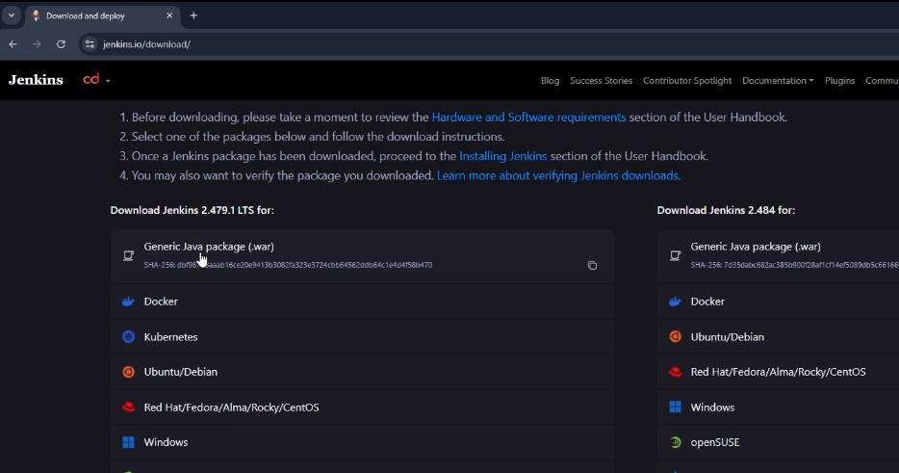

Step 2. Start Jenkins Using the WAR File.
Once you have downloaded the jenkins.war file, the next step is to execute it and start Jenkins. Place the jenkins.war file in a folder on your local machine.

Open the terminal or command prompt and navigate to the folder where the jenkins.war file is located.

Run the following command:
java -jar jenkins.war

Jenkins will initialize and start up, printing logs to the console. Here are the one time password will be generate to login the System which is :

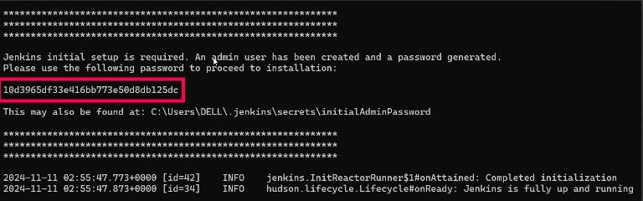

Step 3. Access Jenkins on Your Browser.
Open your web browser and navigate to the following URL:
http://localhost:8080

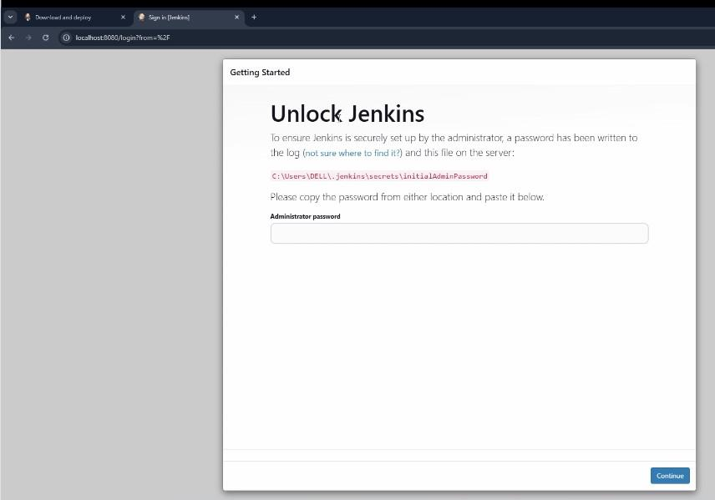

By default, Jenkins runs on port 8080. If port 8080 is unavailable, Jenkins will automatically suggest an alternate port in the terminal output.

Step 4. Unlock Jenkins.
During the setup, Jenkins will generate a one-time admin password. Retrieve the password from the console logs or the initialAdminPassword file located in:

C:\Users\<YourUsername>\.jenkins\secrets

Enter the password on the Jenkins unlock page to proceed.

Step 5. Install Suggested Plugins.
Jenkins will now prompt you to install plugins. Plugins in Jenkins provide extended functionality, allowing you to integrate with various tools and platforms.

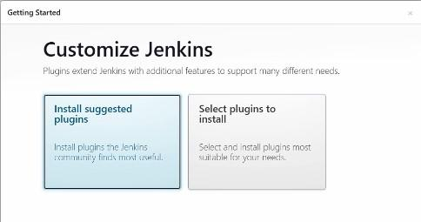

Choose Install Suggested Plugins for a quick setup. This will install commonly used plugins like Git, Pipeline, and Email Notification.
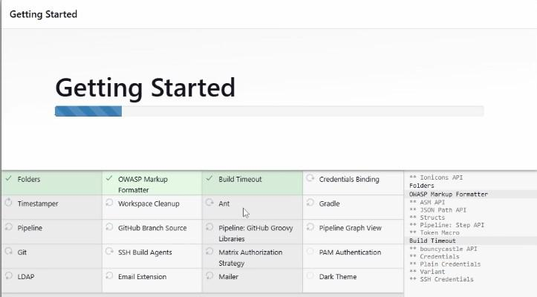

Step 6. Create an Admin User
Set up an admin user with a username, password, and email.

This user will be used for future logins.

Step 7. Complete Installation
After setting up your admin user, Jenkins will finalize the installation and redirect you to the Jenkins dashboard.

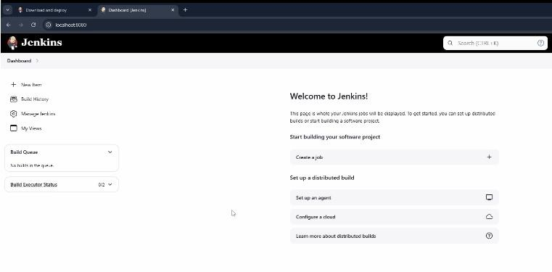

Here are we successfully installed Jenkins on your Windows machine. You are now ready to start creating and automating your continuous integration (CI) and continuous delivery (CD) pipelines.

CI-CD Pipeline in Jenkins

A CI/CD pipeline in Jenkins automates the process of building, testing, and deploying code. It helps developers integrate changes and deploy them quickly and reliably. Jenkins makes this automation easy and efficient.

Create CI-CD Pipeline in Jenkins

Step 1: Log In to Jenkins
Log in to your Jenkins account. This is where all your Jenkins jobs and pipelines will be configured and monitored.

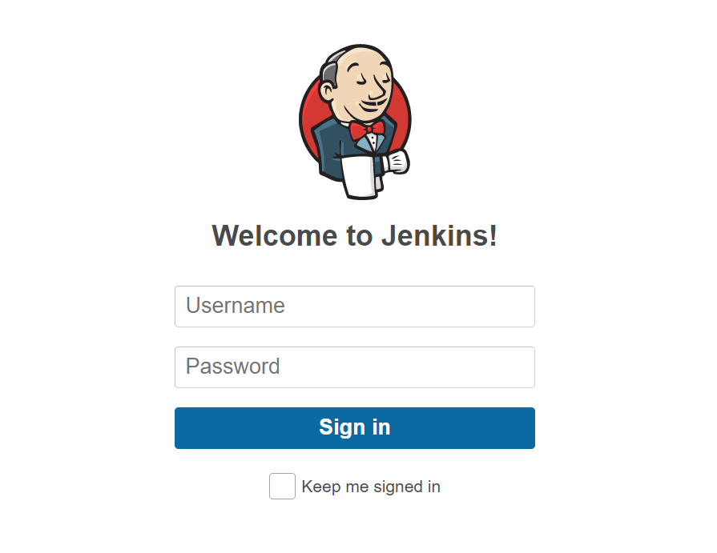

Step 2: Redirected to the Jenkins Dashboard
When you logged in, you will be redirected to the Jenkins console or dashboard. This is where you can manage all your Jenkins jobs, pipelines, and settings.

Step 3: Create a New Project
On the Jenkins dashboard, click on the "New Item" option to create a new project select the option available in the Dashboard.

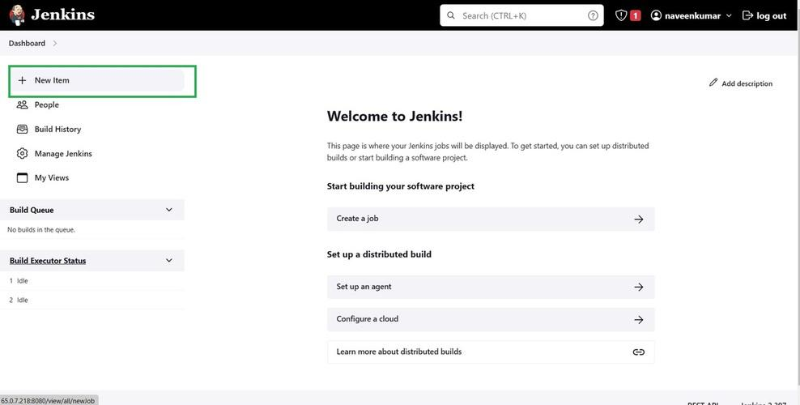

Step 4: Configure the Project Type
On the next screen, list of options will be visible, along with a field to name the pipeline. Add a suitable name and select the "Pipeline" option to proceed.

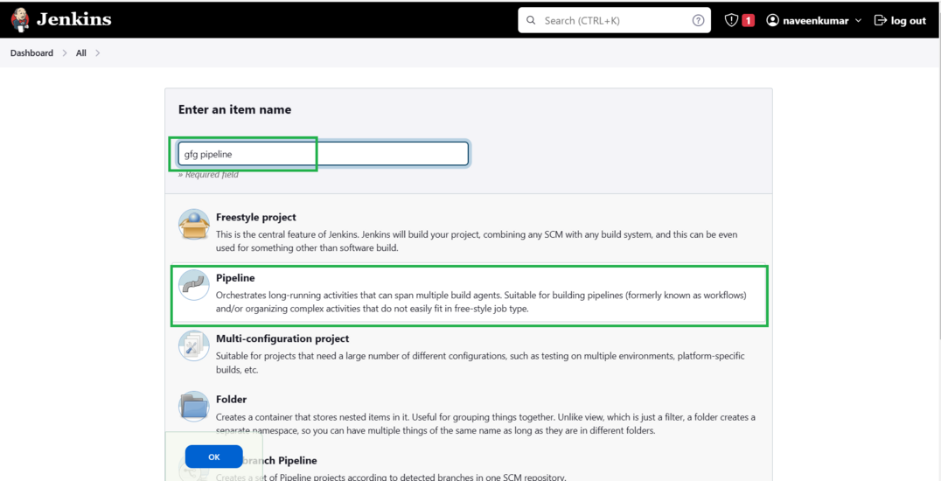

Step 5: Configure the General Section
The pipeline configuration page will open. In the General section:

Provide a description of the pipeline, describing the purpose or what it will do.
Establish the connection to the repository where Jenkins can access the project to trigger the pipeline.
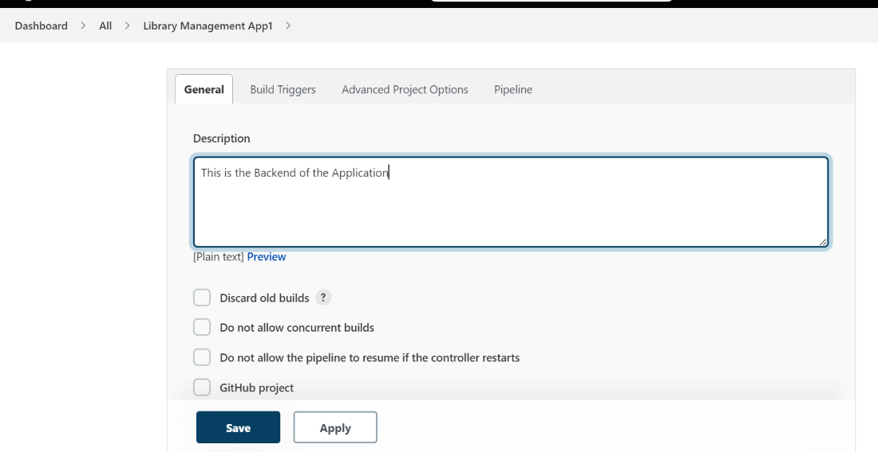

Step 6: Set Build Triggers
We need to specify the branch and repository and give the credentials too. And add additional behaviors if required so far. Refer to the screenshot to have a better understanding.
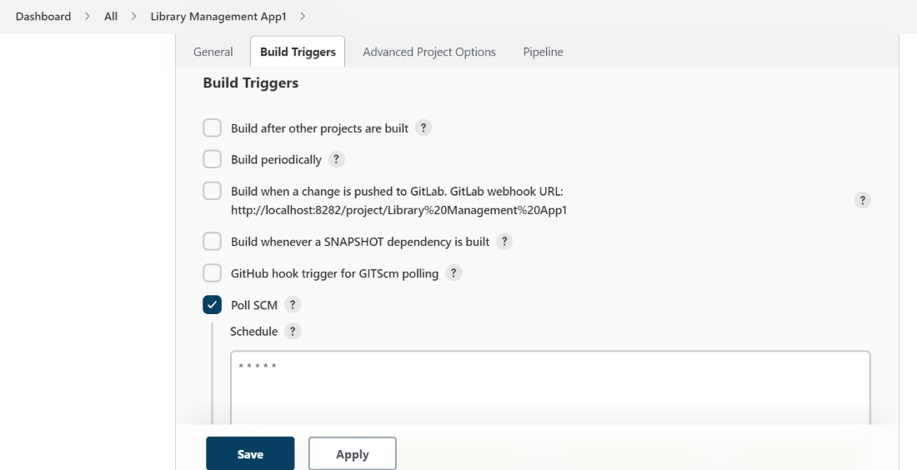

Step 7: Advanced Project Options
In the Advanced Project Options section:

This section is primarily used for advanced configurations and special pipeline settings.
For simpler projects, no configuration is required in this section, so you can leave it as is or adjust it based on your project's needs.
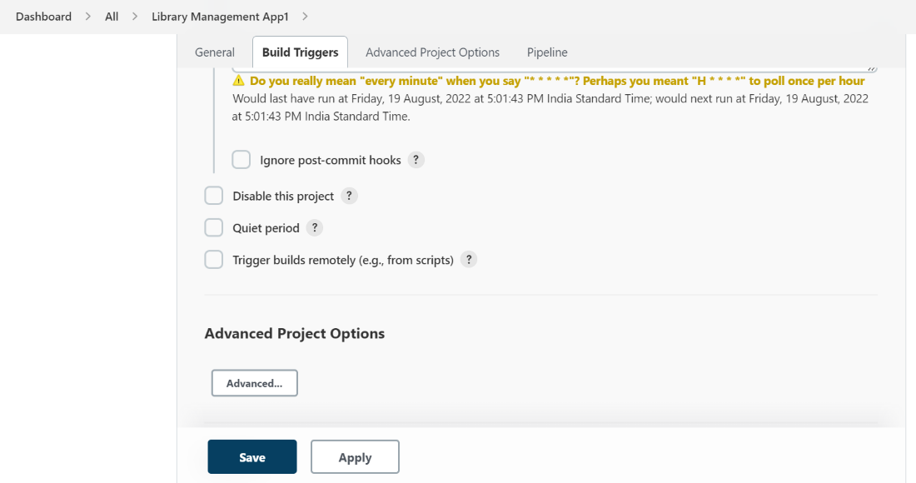

Step 8: Configure the Pipeline Section
Define the Jenkinsfile that Jenkins will use to build and deploy your application. The Jenkinsfile contains the pipeline script with all the stages and steps for the CI/CD process.
Specify where Jenkins should retrieve the pipeline script (either from the repository or from a file stored locally).
Provide any required credentials or paths to the Jenkinsfile.

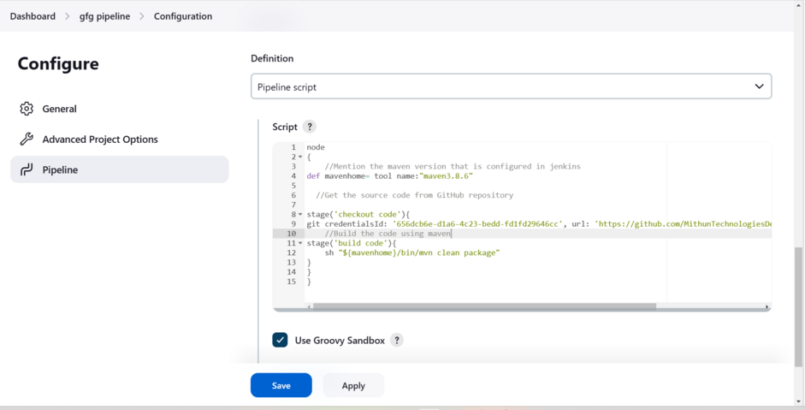

Step 9: Save the Pipeline and Run It
After writing the pipeline is done click on save it will be directly redirected to the Dashboard of the project there we can use, the "Build Now" option to run the pipeline and check if it is successful or not, by using stage view or console output.
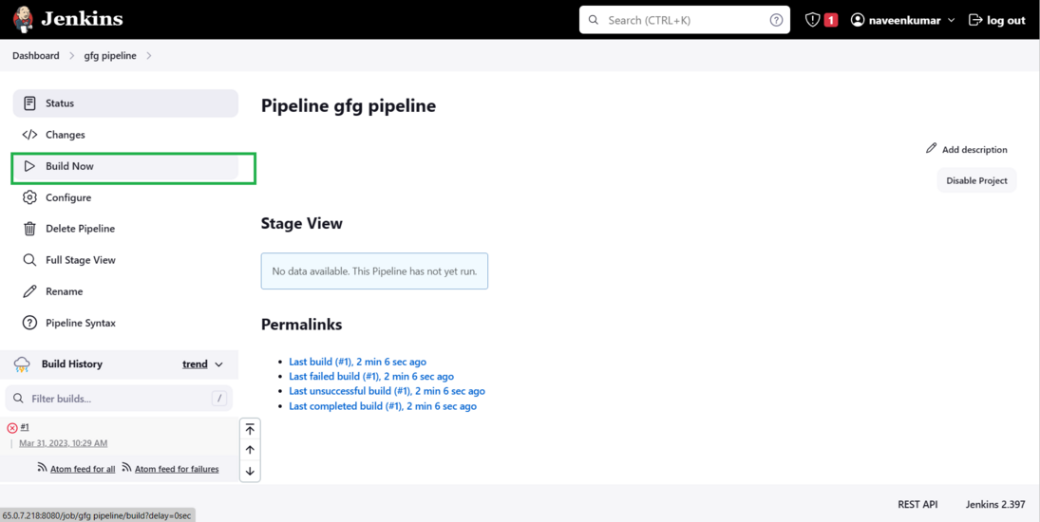

Step 10: Monitor the Pipeline Execution
Once the pipeline is triggered, you can monitor its progress:
Go to the Jenkins dashboard and click on your project.
Under Build History, click on the build you just triggered.
You can monitor the pipeline using the Stage View or Console Output.
Stage View: Provides a visual representation of the pipeline stages and their status (success, failure, etc.).
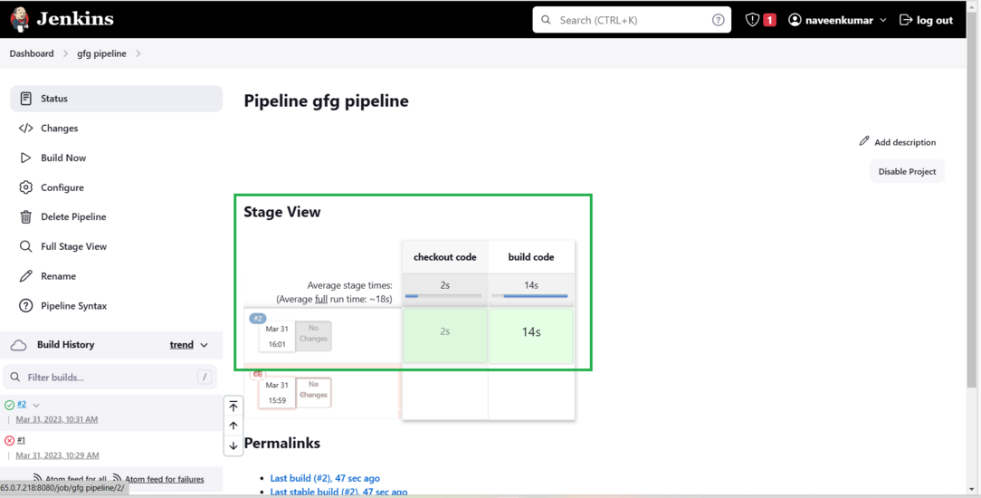

Console Output: Displays the detailed logs of each stage. This is useful for debugging any issues that may occur during the pipeline execution.

Step 11: Review the Build Status
At the bottom of the Console Output or Stage View, you will see the status of the pipeline:

Success: If all stages are completed without errors, you will see "Finished: Success."

Failure: If any stage fails, you will see error messages in the logs, which can help in debugging the issue.

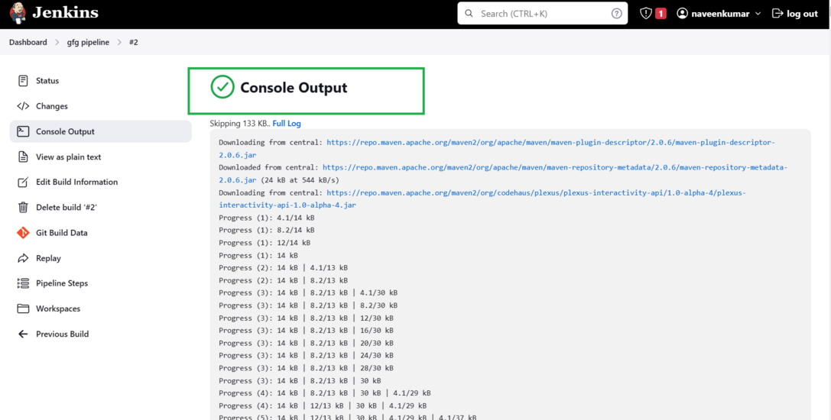

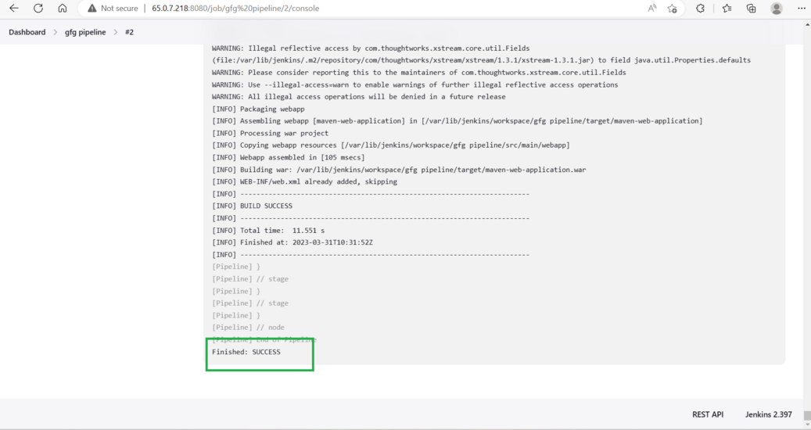

Installing Jenkins on Windows

Jenkins is primarily used for continuous integration and continuous delivery on a platform. It is a Java application that has multiple plugins for automating all components at an infrastructure level. These plugins are responsible for all the different functionalities of Jenkins.

Steps for Installing Jenkins on Windows

Step 1. Download the Jenkins WAR File.
Click on the Jenkins download for Windows.

Step 2. Start Jenkins Using the WAR File.
Once you have downloaded the jenkins.war file, the next step is to execute it and start Jenkins. Place the jenkins.war file in a folder on your local machine.

Open the terminal or command prompt and navigate to the folder where the jenkins.war file is located.

Run the following command:

java -jar jenkins.war

Jenkins will initialize and start up, printing logs to the console. Here are the one time password will be generate to login the System which is :

Step 3. Access Jenkins on Your Browser.
Open your web browser and navigate to the following URL:
http://localhost:8080

By default, Jenkins runs on port 8080. If port 8080 is unavailable, Jenkins will automatically suggest an alternate port in the terminal output.

Step 4. Unlock Jenkins.
During the setup, Jenkins will generate a one-time admin password. Retrieve the password from the console logs or the initialAdminPassword file located in:
C:\Users\<YourUsername>\.jenkins\secrets

Enter the password on the Jenkins unlock page to proceed.

Step 5. Install Suggested Plugins.
Jenkins will now prompt you to install plugins. Plugins in Jenkins provide extended functionality, allowing you to integrate with various tools and platforms.

Choose Install Suggested Plugins for a quick setup. This will install commonly used plugins like Git, Pipeline, and Email Notification.

Step 6. Create an Admin User
Set up an admin user with a username, password, and email.

Step 7. Complete Installation
After setting up your admin user, Jenkins will finalize the installation and redirect you to the Jenkins dashboard.

How To Build Java Application In Jenkins

In the software development lifecycle, building and testing applications are basic steps toward ensure code quality and dependability. Jenkins, an open-source automation server, plays a vital role in automating these cycles, especially for Java applications. Java, being one of the most generally utilized programming languages, benefits extraordinarily from Jenkins' capacities in automating builds, tests, and deployments.

Step-By-Step Process to build Java application in Jenkins

Step 1: Launch an Instance

Launch EC2 Instances with specifications AMI Amazon Linux 2 kernel, port number 22,8080 for Jenkins because our Jenkins runs on port 8080

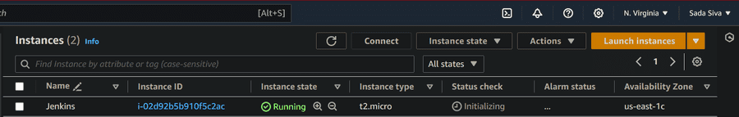

Now, connect it to the instance with SSH command.

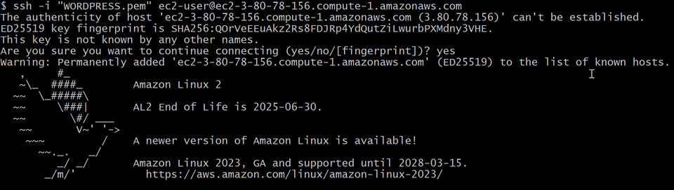

Step 2: Install Java and Jenkins

Before going to install jenkins packages we need to install jenkins runtime that is JAVA. Without java jenkins cannot run. Install by using following command

sudo yum -y install java-17*

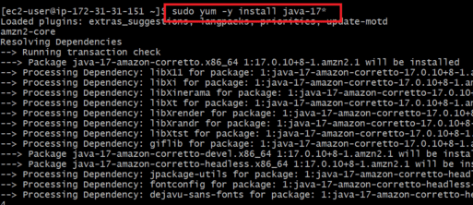

Now install jenkins packages from official website or follow below commands

sudo wget -O /etc/yum.repos.d/jenkins.repo \
https://pkg.jenkins.io/redhat-stable/jenkins.repo
sudo rpm --import https://pkg.jenkins.io/redhat-stable/jenkins.io-2023.key
sudo yum upgrade

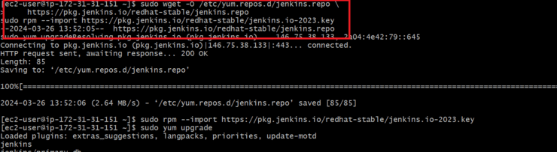

After installing packages now install jenkins by using following command

sudo yum -y install jenkins

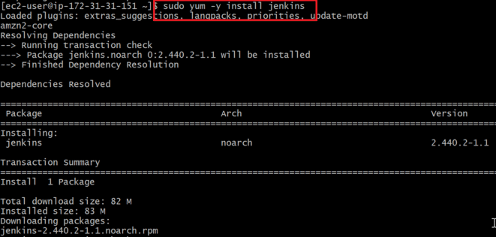

Now start and enable our jenkins by using following commands
sudo systemctl start jenkins
sudo systemctl enable jenkins
sudo systemctl status jenkins

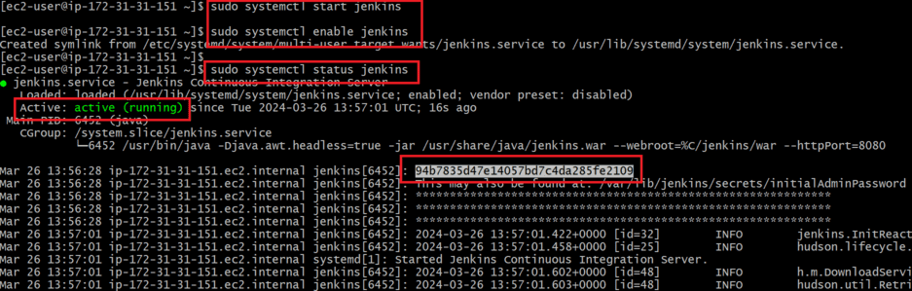

While we check jenkins status it gives administration password. Copy that password and paste it on jenkins unlock page.

Now, copy paste the public IP address along with port 8080 and unlock Jenkins with admin password.
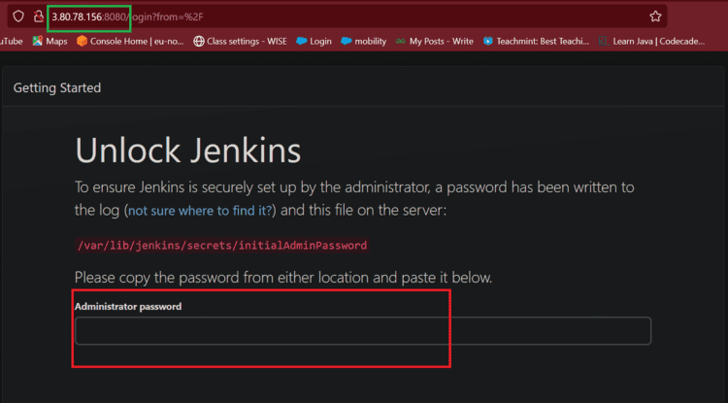

Official page of Jenkins
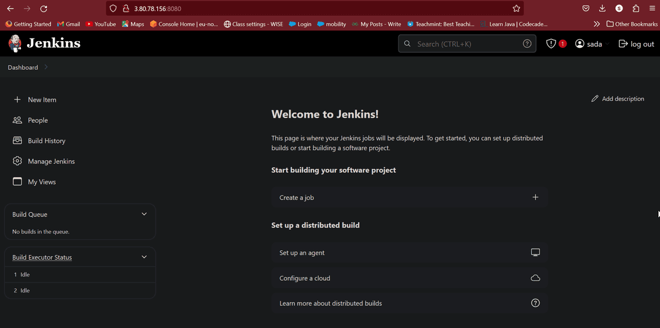

Step 3: Creating Jobs
Now click on new item, enter item name it is like title and select freestyle.
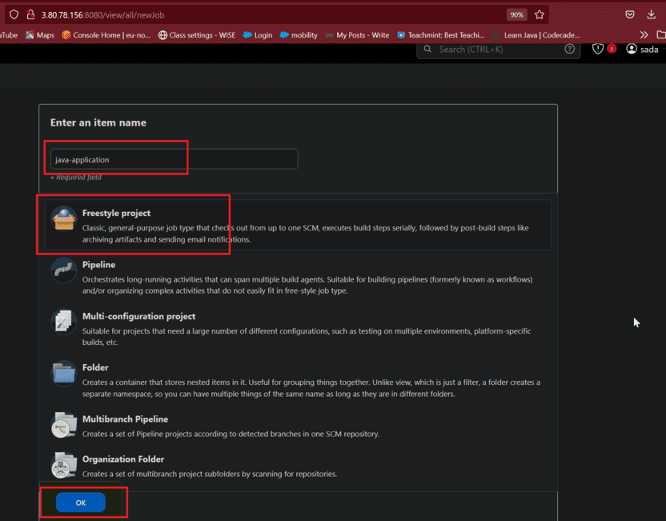

Create a clone-build-job for cloning the repo and build the application related code to build with the help of triggers/plugins.
Manage Jenkins --> available plugins --> maven integration
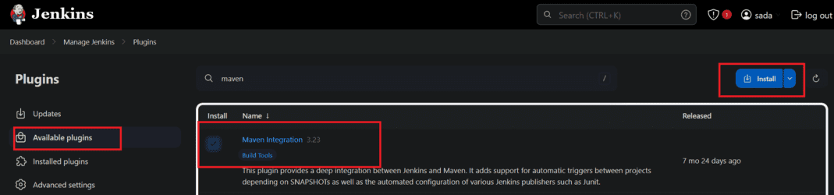

Now in source code management give GitHub URL to clone from GitHub account of the application.

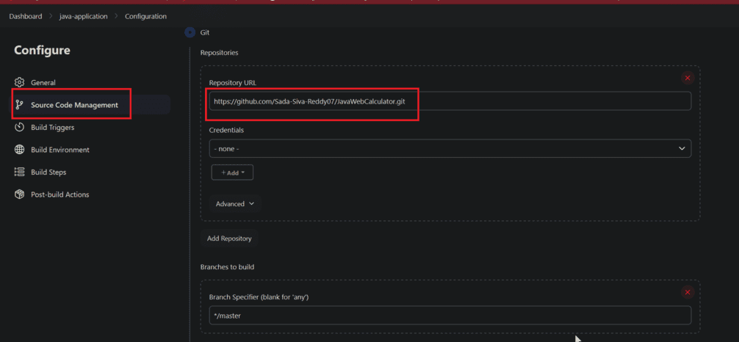

Now in build steps there is a option Invoke top-level Maven targets in that select maven integration

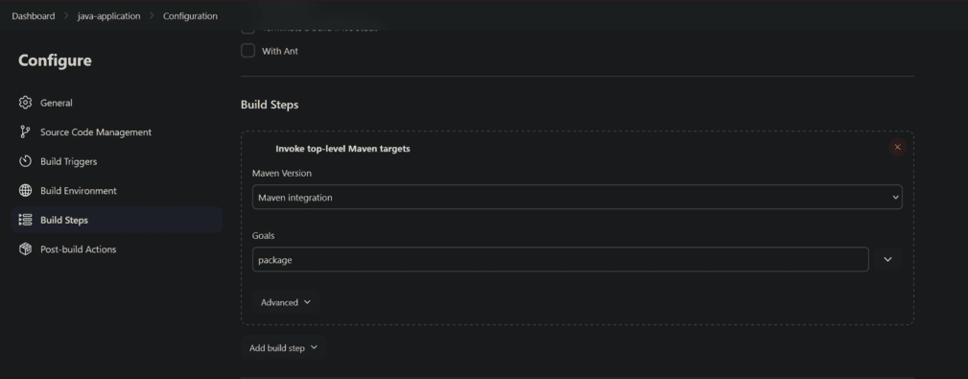

In build steps select execute shell in that execute shell write a script to install tomcat to host our java application
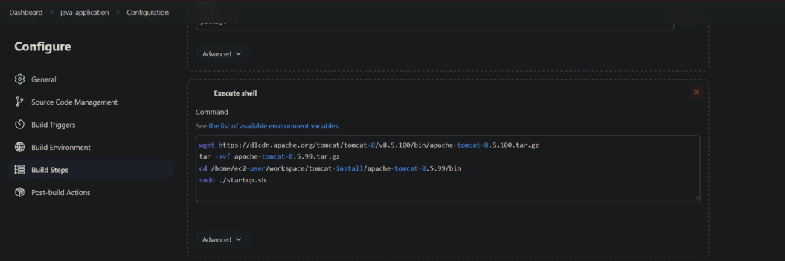

Manage Jenkins --> Available --> deploy to container
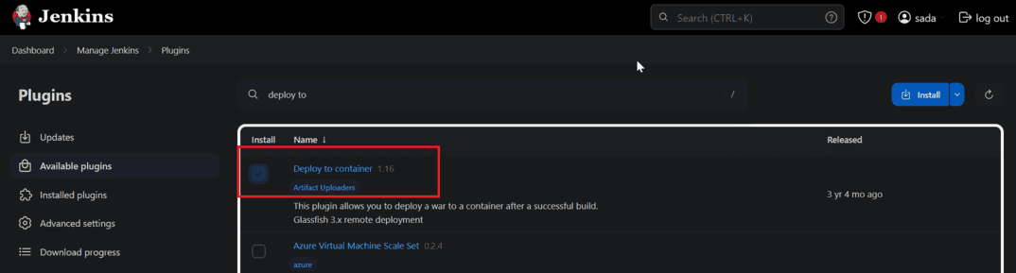

War/ear files to deploy. Relative to the workspace root. You can also specify Ant-style GLOBs, like "**/*.war"

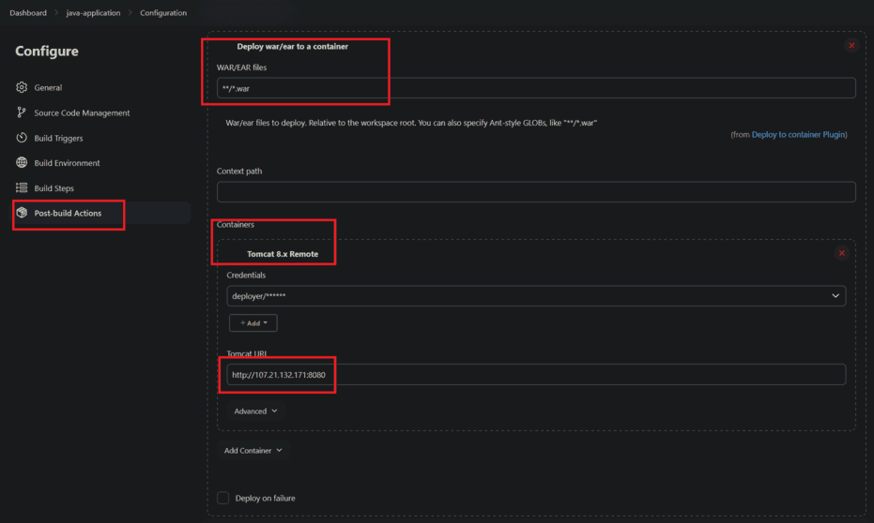

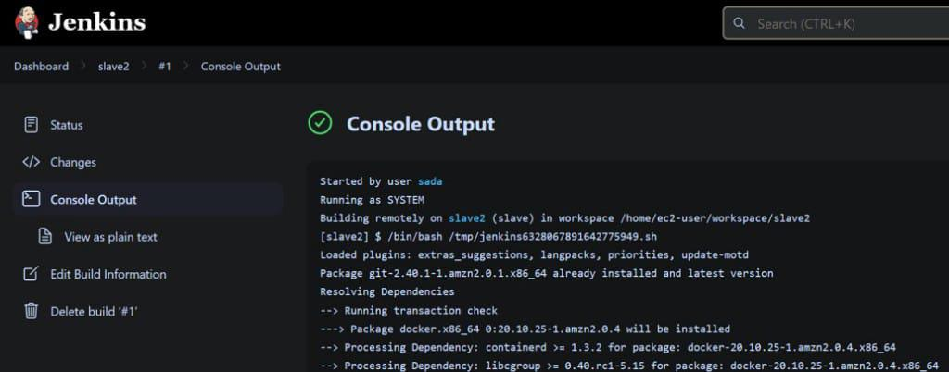

Now copy Public IP and browse it along with port 8080 you can see tomcat page in that tomcat page our application was hosted.
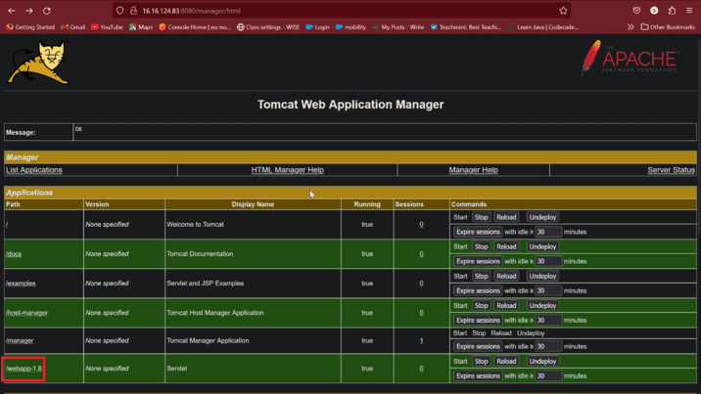

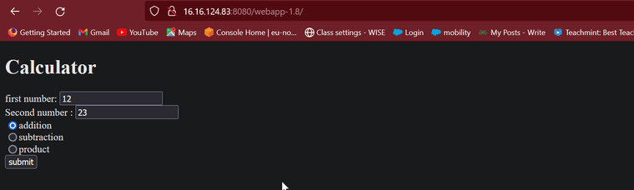

Deploying An Application Using Jenkinsfile

Deploying an application with a Jenkinsfile automates building, testing, and deploying the app. It ensures consistent and repeatable deployments, making CI/CD more efficient. Jenkins Pipeline Components:

Pipeline: A series of stages and tasks for automated CI/CD defined in a Jenkinsfile.
Stage: A part of the pipeline representing a phase, like build, test, or deploy.
Trigger: An event, like a commit or manual action, that starts the pipeline.
Workspace: A directory on the Jenkins agent for executing code, building artifacts, and storing temporary files.

Step 1: Log in to an AWS Account
Navigate to AWS Console and login in with your credentials.
Click on EC2 to go for EC2 Dashboard.

Step 2: Navigate to EC2 Dashboard

Click on Running Instance to create a running instance.
After landing, click on Create Instance.

Step 3: Launch Instance
Define the sections such as providing the instance name as "my_jenkins_server" , no of instance as 1 and Choose the AMI as Amazon Linux 2 latest AMI.

Step 4: Configure Instance
Choose the instance type as t2.micro and choose the existing key pair.
If you don't have any key pair, click on create key pair and choose the key pair format type.

Step 5: Configure Network Security Groups

Provide the network security groups by configuring them with allowing all traffic, so that they will no restrict of traffic from AWS. The following screenshot clearly illustrates that.

Step 6: Connect To Instance
Review the provided definition and value. Once you confirmed with defined value click on Launch Instances.

Step 7: Connect To EC2 Console
Wait till the instance come to running state, Once it been into the running state, Go through it and navigate to EC2 Console section.
In the EC2 Console section click on connect.

Step 8: Install Jenkins
Now Install the jenkins and Java, with the following commands:
sudo wget -O /etc/yum.repos.d/jenkins.repo \
https://pkg.jenkins.io/redhat-stable/jenkins.repo
sudo rpm --import https://pkg.jenkins.io/redhat-stable/jenkins.io-2023.key
sudo yum upgrade
# Add required dependencies for the jenkins package
sudo yum install java* -y
sudo yum install jenkins
sudo systemctl daemon-reload

Step 9: Verify Java And Jenkins
Verify the successful installation of jenkins and java with following commands:
java --version
jenkins --version

Step 10: Start Jenkins Server

Now, start the jenkins server with the following command:
systemctl enable jenkins --now

Step 11: Access Jenkins Server
After successfully starting the jenkins server, go to the browser and enter the following url, you will the see the below jenkins server page.
http:[IP_Address]:8080

Step 12: Copy Jenkins Password
The jenkins server asks for password as for authentication, go through provided directory in the console and copy the password from their and paste in this url.
After successful authentication, you will landed to Inside the Jenkins Server.

Step 13: Install Suggested Plugins
Click on Install Suggest Plugins options, so it will help you in installing the required plugins already pre available before going for the jobs.

Step 14: Installation Of Plugins Completely
The installation of suggested plugins takes some time, In the above page you can see the what are the plugins you are installing.

Step 15: Using Default Admin User

After successfully installing the suggested plugins, It will ask for creating Admin user or go with default admin user. Here we are going with default admin user.

Step 16: Instance Configuration
In the Instance Configuration page, you will see the url of the jenkins server page. With that provided url you can open the jenkins server from anywhere publicly.

Step 17: Create A Job
Now, create an item clicking on New Item in this Jenkins Web page.

Step 18: Configure The Job
Now, Configure the jenkins item with defining the values such as Item name, And style such Pipeline project.

Step 19: Configure The Pipeline Job
After navigating to Configure page, Enter into the Pipeline and then provided your application code their.
Here, We are using the following code as a Jenkinsfile code. This code contains the stages such as Build, Test, Deploy Stages. After the execution of stages it mails status of pipeline whether it is successful or failure.
pipeline {
agent any
stages {
stage('Build') {
steps {
sh 'echo "Building..."'
sh 'mvn clean package'
}
}
stage('Test') {
steps {
sh 'echo "Testing..."'
sh 'mvn test'
}
}
stage('Deploy') {
steps {
sh 'echo "Deploying..."'
// Add deployment steps here
}
}
}
post {
always {
sh 'echo "Cleaning up..."'
}
success {
mail to: 'developer@example.com',
subject: 'Pipeline Succeeded',
body: 'Your Jenkins Pipeline has completed successfully.'
}
failure {
mail to: 'admin@example.com',
subject: 'Pipeline Failed',
body: 'Your Jenkins Pipeline has failed. Please investigate.'
}
}
}

Once you configured the Jenkinfile application code, click on apply button.

Step 20: Successfully Jenkins Build
After building the created jenkin job, you can see the successful running of the job with the below screenshot.

