Setup minikube at your local and explore creating namespaces (Go through official documentation).

Kubernetes Minikube

Minikube is a one-node Kubernetes cluster where master processes and work processes both run on one node. Minikube is local Kubernetes, focusing on making it easy to learn and develop for Kubernetes.

A prerequisite to use Minikube is a Docker container or a Virtual Machine environment. Minikube provides you a way to easily deploy application on Kubernetes for learning and developing purposes even if you don't have enough resources like memory, CPU etc.

Install Minikube on Linux

Step 1. Download the latest Minikube binary:

curl -LO https://storage.googleapis.com/minikube/releases/latest/minikube-linux-amd64

Step 2. Install Minikube to your system path:

sudo install minikube-linux-amd64 /usr/local/bin/minikube

Step 3. Verify the installation:

minikube version

This will give you a similar output if Minikube is installed. If you face any other issues, checkout the official website of Minikube for resolving it.

Minikube is a one node Kubernetes cluster that runs in VirtualBox on your local machine in order to test Kubernetes on your local set up. In order to setup a production cluster, we need multiple master notes and multiple worker nodes. Master nodes and worker nodes have their own separate responsibilities. In order to test something on our local environment for example - deploying a new application or a new component and to test it on our local machine, it will be very difficult and would consume a lot of resources like CPU, memory etc.

Minikube comes into play here. Minikube is an open-source tool that is basically like a one node cluster where the master processes and the work processes both run on one node. This node must have a Docker container runtime pre-installed to run the containers or pods with containers on this node.

Deploying a Service Using Minikube and Kubectl

Kubectl is the Kubernetes CLI tool. To know more about Kubectl, read the following article on GeeksforGeeks - Kubernetes - Kubectl. Follow these steps to deploy a service using Minikube and Kubectl:

Step 1. Enter the following command to start the Kubernetes cluster:

minikube start

If you are logged in as a root user you might get an error message:
Exiting due to DRV_AS_ROOT: The "docker" driver should not be used with root privileges.

This is because the default driver in the Docker driver and it should not be used with root privileges. For fixing this we should log in as a different user that the root user.

Enter the following command to add a new user

adduser [USERNAME]

Now enter the following command to login as a new user

su - [USERNAME]

Now upon entering the same minikube start command

minikube start

Step 2. Now if we check the number of nodes running, we will get the minikube node running.

kubectl get nodes

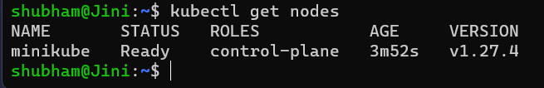

or you can also check the status by running the following command:

minikube status

you will get a similar output on the terminal:

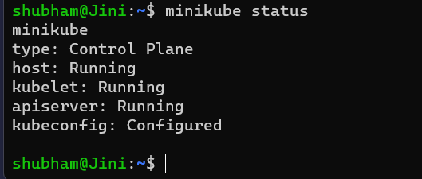

Step 2. To find out the services that are currently running on Kubernetes enter the following command:

kubectl get services

Step 3. Enter the following command on your terminal to create a deployment

kubectl create deployment ANU THANGAPANDI --image=kicbase/echo-server:1.0

Step 4. Enter the following command to expose the deployment to the port 6000:
kubectl expose deployment ANU THANGAPANDI --type=NodePort --port=6000

Step 5. Now when you check out the list of services

kubectl get services

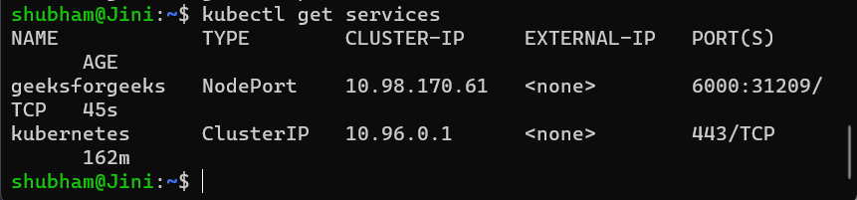

Step 6. Now to run the service, enter the following minikube command:

minikube service geeksforgeeks

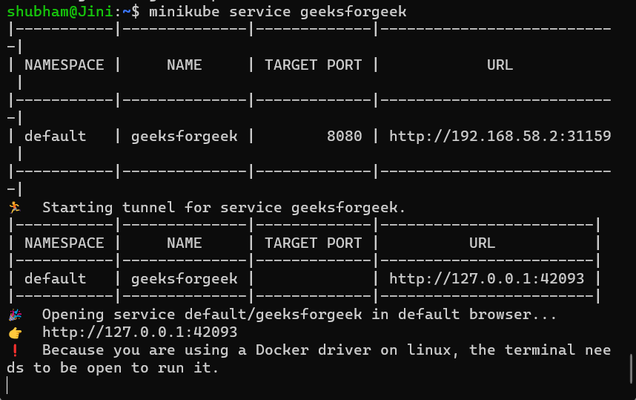

You have to just copy the address (http://127.0.0.1:42093/ for me) and paste it to your browser to see the application website.

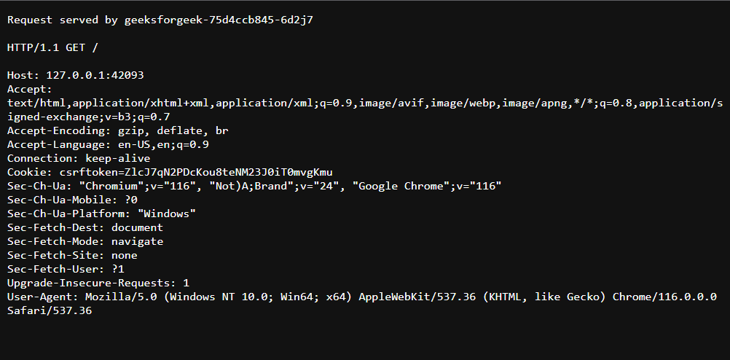

Some common Minikube command

1. Deleting The Minikube Cluster

You just have to simply enter the following command to delete the minikube cluster.

minikube delete

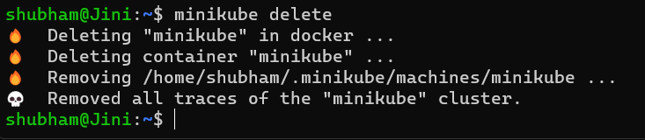

2. To Pause Kubernetes Without Impacting Deployed Applications.

minikube pause

3. To Unpause The Instance

minikube unpause

4. To Stop The Cluster

minikube stop

5. To Delete All Minikube Clusters

minikube delete --all
THERSE ARE THE COMMANDS ARE USED IN THE MINIKUBE

How to set up Kubernetes cluster on local machine using minikube

Creating a Kubernetes cluster on AWS, Google Cloud, etc, can be a little difficult and cost you a pretty decent amount of money. If you have a Windows machine or a mac then it is easy to create a multi-container cluster using Docker Desktop for windows/mac and use Kubernetes to manage the cluster.

Perquisites: Have some basic knowledge of Docker and Kubernetes.

But for Linux bases system, you have to either go for a cloud-based solution which is costly. So we can create our own cluster on our local machine using minikube. It is local Kubernetes, focusing on making it easy to learn and develop for Kubernetes. You just need docker installed or any Virtual machine environment. In the following example, we have used the virtual box.

Installing Minikube: To install minikube on Linux, use the following command:

curl -LO https://storage.googleapis.com/minikube/releases/latest/minikube-linux-amd64 sudo install minikube-linux-amd64 /usr/local/bin/minikube

Github link of Repo: Use the https://github.com/afif1400/gittix link to fork the project.

minikube start --driver="virtualbox"

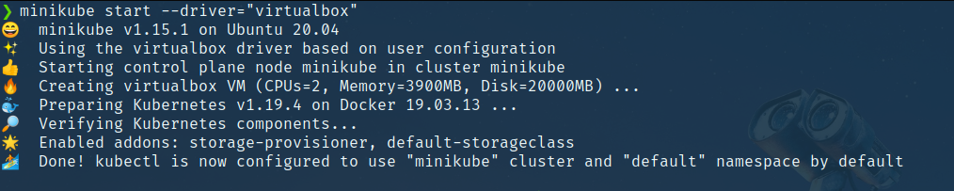

We need to enable a couple of add-ons on minikube to run the application. First is the dashboard which is a GUI to monitor cluster deployment services etc and the second add-on is ingress.

Command for enabling dashboard:

minikube addons enable dashboard

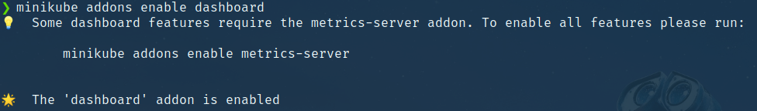

Command for enabling ingress:

minikube addons enable ingress

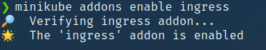

Now we need to expose the ingress-nginx deployment so that it can be reached from the outer world. Use the following command to do so:

kubectl expose deployment ingress-nginx-controller --target-port=80 --type=NodePort -n kube-system

kubectl get services -n kube-system

Step to run the application:

skaffold dev

When you run this command all the dependencies for each of the services will be installed and build the image, starting the cluster. If skaffold fails in between just re-run the above command.

Output:

Stop minikube: Following is the command to stop minikube:

Delete the cluster: Following is the command to delete the cluster:

minikube delete

Kubernetes Namespaces

In Kubernetes, namespaces provide a mechanism for isolating groups of resources within a single cluster. Within a Kubernetes Namespace, resources must have unique names, but across different Namespaces, you can have resources with the same name.

When you create a Kubernetes cluster, by default Kubernetes gives you 4 Namespaces out of the box:

default

kube-node-lease

kube-public

kube-system

Default Namespaces

Default Namespaces are the four Namespaces that are present by default in any Kubernetes Cluster. To see these in your Namespaces you can simply enter this command:

kubectl get namespaces

And you will see that we have 4 default namespaces:

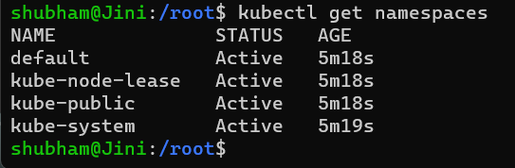

Before learning about the 4 default Namespaces, let's first briefly discuss kubernetes dashboard namespace, which is a Namespace that comes built-in with Minikube.

kubernetes dashboard namespace:

"kubernetes dashboard namespace" is shipped automatically in Minikube. So it is specific to Minikube installation. We will not have this namespace in a standard Cluster.

1. kube-system

kube-system is the namespace that includes objects created by the Kubernetes system. The components that are deployed in this Namespace are the system processes - they are from Master managing processes or Kubectl etc. kube-system Namespace is not meant for our (developer's) use. so we do not have to create anything or modify anything in this namespace.

2. kube-public

kube-public contains the publicly accessible data. It has a config map that contains the Cluster information which is accessible even without authentication.

kubectl cluster-info

You will get the data stored in kube-public namespace.

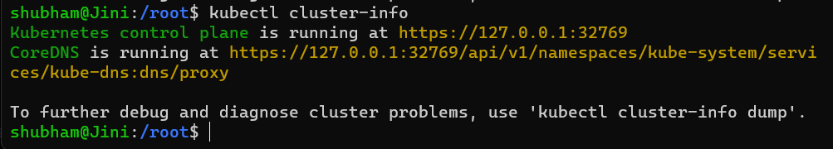

3. kube-node-lease

kube-node-lease Namespace is a new addition to Kubernetes. The purpose of this namespace is that it holds information about the heartbeats of Nodes. So each Node basically gets its own lease object in the Namespace. This object contains the information about that nodes availability.

4. default

default Namespace is the Namespace that we use in order to create the resources when we create a Namespace in the beginning.

Creating Namespaces

1. CLI Commands

Namespaces can be added to your Cluster by CLI commands. You can simply enter the following command to create a new Namespace:

kubectl create namespace my-ns

This will create a new Namespace called "my-ns". And we can simply checkout our namespaces by the following command:

kubectl get namespaces

We can see that the "my-ns" Namespace was created.

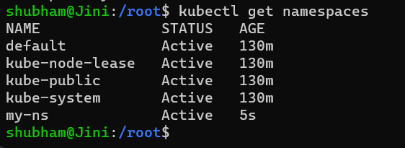

2. Configuration file

Another better way to create a Namespace is creating a Namespaces configuration file. You can call it a better way of creating Namespaces because you have a history in your Configuration File Repository of what resources you created in the Cluster. Here is how a sample Namespace configuration file would appear to be:

apiVersion: v1
kind: Namespace
metadata:
name: development
labels:
name: development

kubectl create -f [FILE_NAME]

Creating Components in the default Namespace

By default if you do not provide a Namespace to a component, then it creates them in a default namespace

apiVersion: v1
kind: ConfigMap
metadata:
name: my-configmap
data:
db_url: my-service.database

If we apply this Config Map file:

kubectl apply -f my-config-map.yaml

And check the namespace it belongs to by this command, actually this command will list down all the Config Maps within the Namespace default:

kubectl get configmap -n default

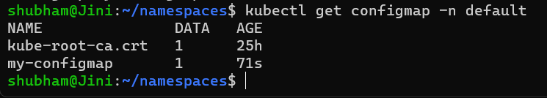

Or you can also check it by getting details about my-configmap using the following command:

kubectl get configmap -n default -o yaml

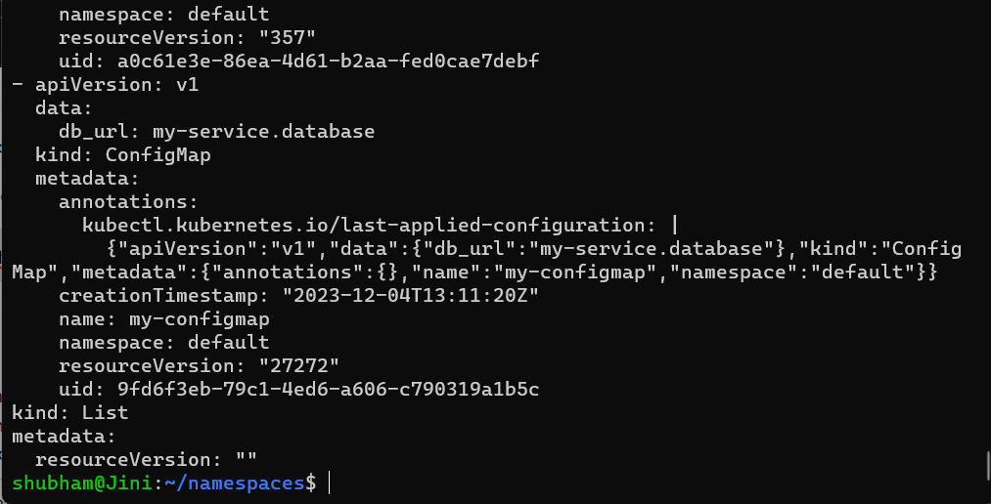

Creating Components in a new Namespace

There are two ways of creating components, we can either do it in the CLI or we configure it in the Configuration file itself:

1. Specifying Namespace in the CLI

This can be done by specifying the name of the Namespace while applying the Config Map:

kubectl apply -f my-config-map.yaml --namespace=my-

2. Specifying Namespace in the Configuration file

We can simply specify which namespace we want the component to be a part of it's configuration file. For that we can simply take our my-configuration.yaml file and edit it. We are simply adding the line "namespace: my-ns"

apiVersion: v1
kind: ConfigMap
metadata:
name: my-configmap
namespace: my-ns
data:
db_url: my-service.database

kubectl apply -f my-config-map.yaml

and if we check out our Config Map:

kubectl get configmap -n my-ns -o yaml

We will get that same long output, but this would also include a line which says that the Namespace is now my-ns.

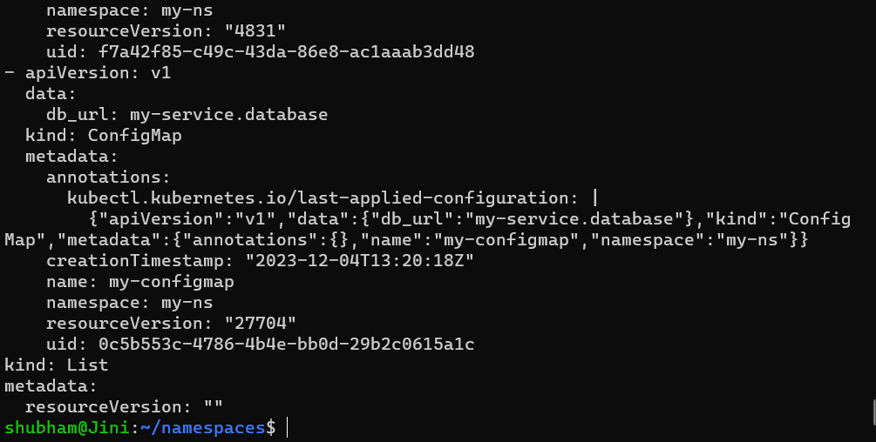

Changing the Active Namespace

The default namespace is our active namespace. In order to change the active namespace to any other namespace we can use kubens from kubectx. For that we will have to download kubectx by entering the following command

sudo snap install kubectx --classic

now if we enter the command

kubens

we will get the list of namespaces present and the active namespace will be highlighted in green:

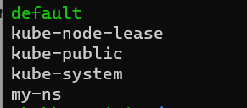

and then simply use kubens for changing the active namespace.

kubens my-ns

Now the active namespace has been changed to kubens. This means that by default if we do not specify the namespace the components will be created in the my-ns namespace.

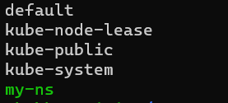

Use Kubernetes Namespaces

Kubernetes Namespaces allows us to share the cluster with multiple teams or projects without impacting others' work. They are logically separated from each other and within a namespace, you can't create any two resources of the same name but you can create the same resource in a different namespace. While most types of resources are namespace, a few aren't, for example, the Node resource which is global and not tied to a single namespace.

Setup

First of all, start the cluster (minikube)

$ minikube start

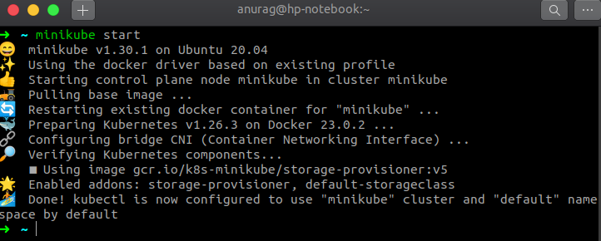

and set k as an alias to kubectl so that we've to type less.

$ alias k="kubectl"

Let's check all the namespaces the cluster has

$ k get ns

(ns is shorthand for namespace)

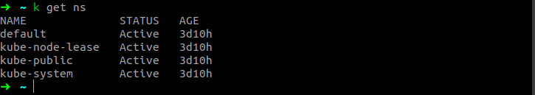

Creating a Namespace

A namespace is like any other Kubernetes resource, so we can create it either Imperatively or declaratively. We'll see both ways. Declarative means we describe the desired state of our cluster in the manifests file without specifying procedures for how that state will be achieved. We can create these manifests either in YAML or JSON format, since YAML is more human-readable we'll write our files in YAML. Imperative management means creating Kubernetes objects directly at the command line against a Kubernetes cluster. It is suitable for development projects but not recommended for Production projects.

Imperative way

$ k create ns test

Declarative way

Create a manifest file test-ns.yaml for our namespace

apiVersion: v1
kind: Namespace
metadata:
name: dev

$ k create -f test-ns.yaml

and check that namespace

$ k get ns

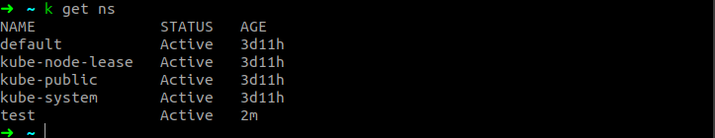

Managing resources in a namespace

To create a resource in a namespace we can either specify the namespace when creating the resource with the kubectl create command or by adding an entry in the metadata section, let's see both ways. For our demo purpose, I'll create a deployment resource you can create any other resource.

By specifying the --namespace or -n flag in the command

$ k create deploy webserver --image=nginx:1.23-alpine --namespace=test

By adding an entry in the metadata section of a resource (highlighted in bold)

apiVersion: apps/v1
kind: Deployment
metadata:
labels:
app: webserver
name: webserver namespace: test
spec:
replicas: 1
selector:
matchLabels:
app: webserver
template:
metadata:
labels:
app: webserver
spec:
containers:
- image: nginx:1.23-alpine
name: nginx

now create the deployment

$ k create -f deploy.yaml

and check our deployment

$ k get deploy --namespace=test

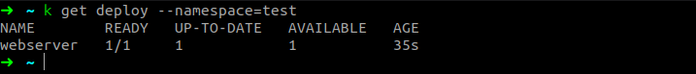

Deleting resources

To describe, modify, or delete a resource we've to specify the --namespace or -n flag in the same way as we've done while creating a new resource. If you don't specify the namespace kubectl will perform the requested action in the default namespace.

$ k delete deploy webserver

we get an error which is expected because we haven't specified the namespace and we know that kubectl will perform the requested action in the default namespace, let's try again by specifying the namespace

$ k delete deploy webserver -n test

(n is a shorthand for namespace)

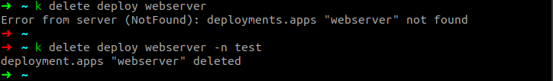

Deleting namespace

When we delete a namespace all the resources under it will be deleted as well. Let's see:Quickly create a resource in a namespace

$ k create deploy webserver --image=nginx:1.23-alpine -n test

and check the deployment status

$ k get deploy --all-namespaces | grep webserver

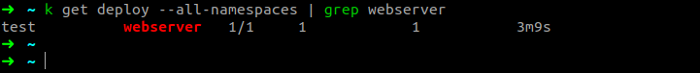

we searched our deployment across all namespaces and found our deployment.

Now delete the test namespace

$ k delete ns test

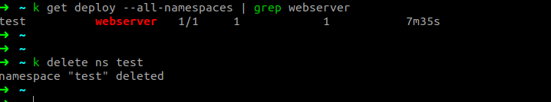

as we can see above we've successfully deleted the test namespace.

$ k get deploy --all-namespaces | grep webserver

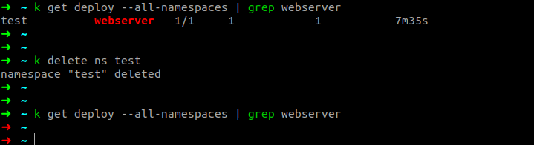

Deploying Application Using Kubernetes

In this we will walk through the process of deploying separate frontend and backend applications, and then exposing the frontend to be accessible. We'll be using fundamental Kubernetes objects like Deployments to manage our application pods and Services to provide stable network access.

Prerequisites

A running Kubernetes cluster (like the one you set up with kubeadm or yoou can also use minikube that spins up the cluster by itself).

kubectl command-line tool configured to communicate with your cluster.

Basic understanding of Docker containers and images.

1. Overview of the Deployment Workflow

The deployment of a distributed application in a cloud-native ecosystem involves two primary stages.

The first is containerization, where the application and its dependencies are packaged into a lightweight, standalone, executable unit known as a container image. This ensures environmental consistency and portability.

The second stage is orchestration, where these containers are deployed, scaled, and managed at scale.

2. Phase 1: Application Containerization with Docker

The foundational step is to containerize each tier of the application. Docker is utilized for this purpose, with a Dockerfile for each component defining the build instructions.

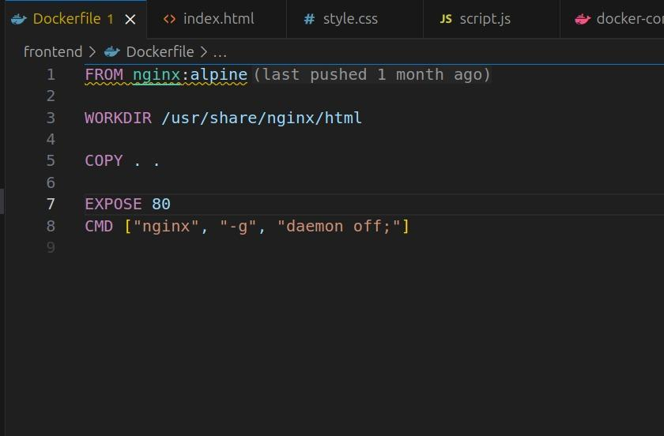

The backend, a Python-based Flask application, is containerized to package the application code and its library dependencies into a single portable image.

Dockerfile Analysis: The Dockerfile for the backend is structured to create an optimized and reproducible environment for the Python application.

FROM python:3.10-slim: It begins with a slim official Python base image to reduce the overall size.
COPY requirements.txt .: The dependencies file is copied into the image first.

RUN pip install -r requirements.txt: Leveraging Docker's layer caching, dependencies (which change infrequently) are installed in a separate step.
This step is only re-run if requirements.txt changes.

COPY . .: The application source code (app.py) is copied into the image.

CMD ["python", "app.py"]: This defines the default command to execute when a container is started from this image, launching the Flask application.

The Backend Dockerfile:

# Use a slim Python image as the base
FROM python:3.10-slim

# Set the working directory inside the container
WORKDIR /app

# Copy the requirements file and install dependencies
COPY requirements.txt .
RUN pip install --no-cache-dir -r requirements.txt

# Copy the application code into the container
COPY . .

# Expose the port the app runs on
EXPOSE 5000

# Define the command to run the application
CMD ["python", "app.py"]

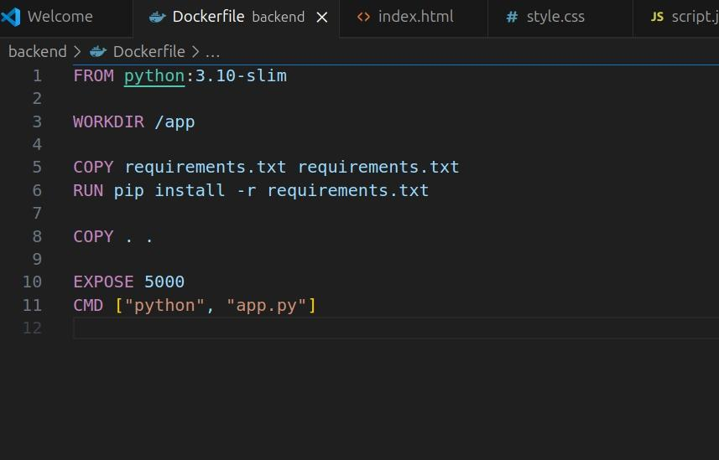

Once both Dockerfiles are created, the images are built using docker build and subsequently pushed to a container registry, such as Docker Hub, making them accessible to the Kubernetes cluster.

# Build and push the frontend image
docker build -t your-username/notes-frontend:latest .
docker push your-username/notes-frontend:latest

# Build and push the backend image
docker build -t your-username/notes-backend:latest .
docker push your-username/notes-backend:latest

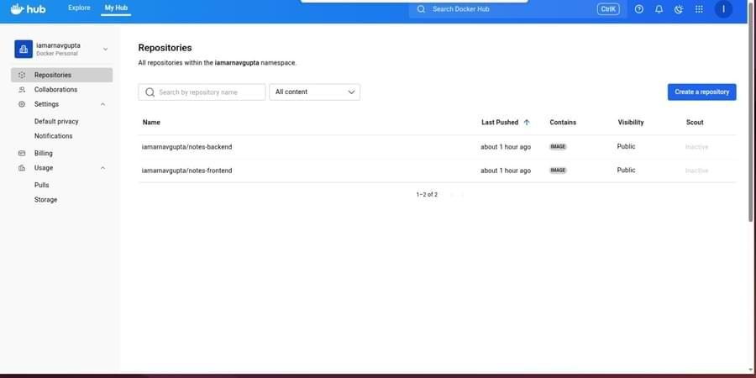

3. Phase 2: Orchestration with Kubernetes

With the container images available in a registry, the next phase is to deploy them in a Kubernetes cluster.

alias k=kubectl

Step 1: Deploying the Backend Application

create the backend of our application. A Kubernetes Deployment is the perfect tool for this. It ensures that a specified number of replica Pods are always running. If a Pod crashes, the Deployment controller replaces it automatically.

We will create a deployment named backend using a pre-built Docker image, with three replicas for high availability.

kubectl create deployment backend --image=iamarnavgupta/notes-backend:latest --replicas=3

This command tells Kubernetes to:

Create a new object of type deployment.

Name it backend.

Use the Docker image iamarnavgupta/notes-backend:latest for the containers.
Maintain 3 running replicas of the pod.

To verify that the deployment was successful, let's check the status of our deployments and pods.

kubectl get deploy

kubectl get pods --show-labels

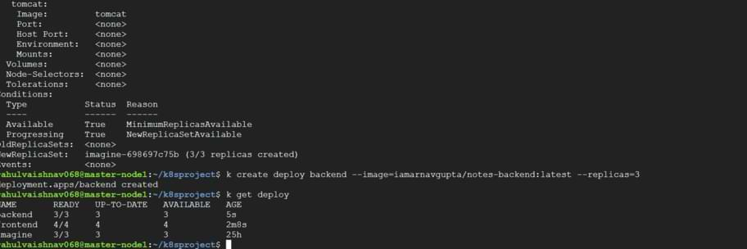

Step 2: Deploying the Frontend Application

Next, we'll deploy our frontend application in the same way. This time, we'll create a deployment named frontend with four replicas.

kubectl create deployment frontend --image=iamarnavgupta/notes-frontend:latest --replicas=4

Verify the frontend development

kubectl get deploy frontend

kubectl describe deploy frontend

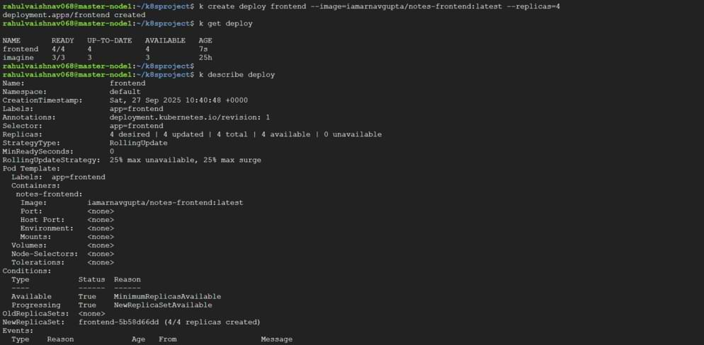

Step 3 : Exposing the frontend with a service

Pods are running but they are not accessible from outside the cluster, it their own ip address they can change if a pod is recreated.to provide a stable network endpoint for our frontend, to create an kubernetes services.

To use nodepod services, it exposes the service on a static port on each cluster node

apiVersion: v1
kind: Service
metadata:
name: myapp-service
spec:
type: NodePort
ports:
- targetPort: 80
port: 80
nodePort: 30002
selector:
run: testp

- Kind service : it defines the object as a service

- Name : myapp services : the name of our service

- Type : nodeport : the type of services

- Port 80: the port service will be available within the cluster

- Target port 80 : the port on the pod that the service will forward traffic to

- Node port 30002: the static port on the network node where this service will be exposed.

- Selector : runtest : this service will automatically finds all pods that have the label run=test and send the traffic to them.

To apply the cluster :

kubectl apply -f node.yaml

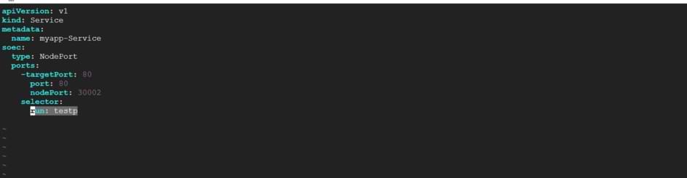

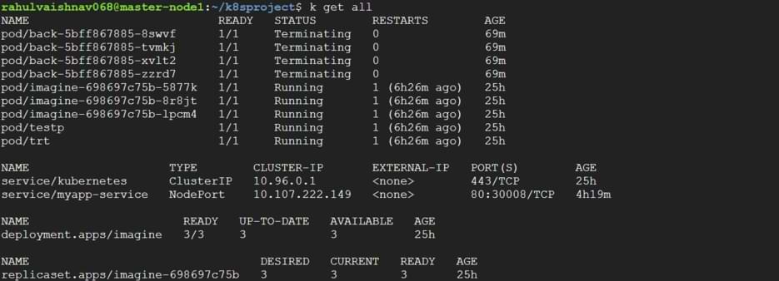

Step 4: Connecting the Service to the Pods with Labels

If you inspect the service now, you'll notice it doesn't have any endpoints. That's because no pods currently have the run=testp label. The power of Kubernetes is this loose coupling: a Service finds its Pods using labels, and we can add or remove these labels at any time.

Let's label one of our frontend pods so that our service can forward traffic to it.

kubectl get pods --show labels

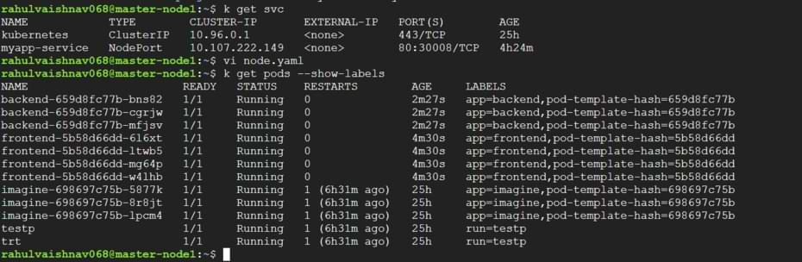

Now, apply the label:

kubectl label pod frontend-5b58d66dd-mg64p run=testp

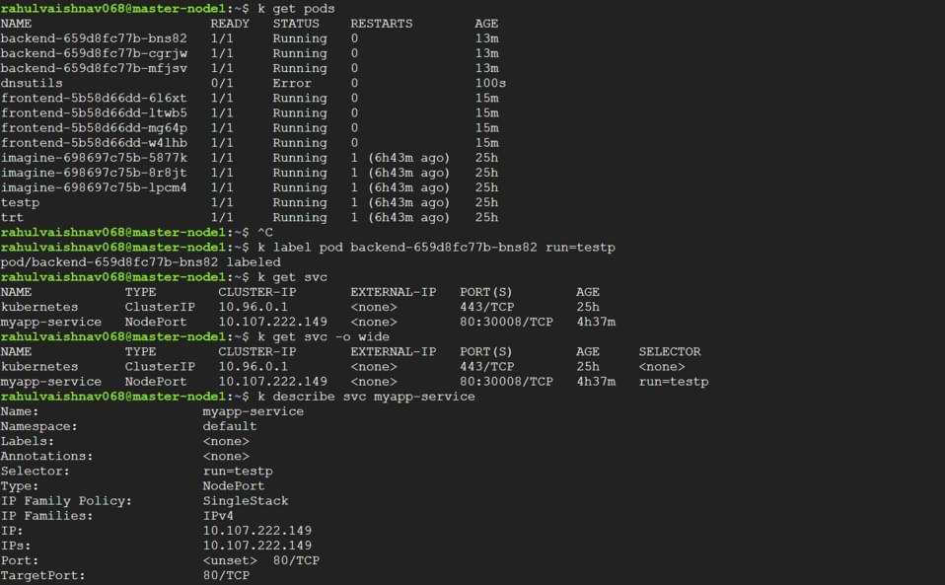

Step 5: Verifying Connectivity

kubectl describe svc myapp-service

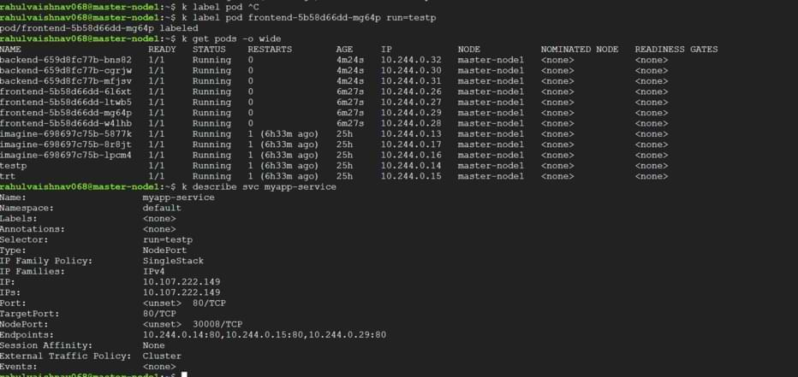

curl 10.244.0.29:80

The HTML output from the "Notes App" is returned, confirming that our Deployment is running and our Service is correctly routing traffic to it. You can also access this application from outside the cluster by navigating to <your-node-ip>:30002.

