1. **Experimental operation of wing mechanism**
   1. **Experimental set-up for force measurement**

We conducted force measurement experiments to verify the performance of flapping motion and flapping-folding motion patterns. The experimental set-up is shown in Figure 7. The Robo-Bat is mounted on a movable support at the top of the bracket, which can adjust the angle of attack. Six load cells (model # ZNLBS-VII) are positioned at the bottom of the bracket. The BSQ-JN-P8 I/O box records signals from the weighing sensors, which are then stored on a desktop computer with a BSQ-JN-P8 R&D controller board. The signals are sampled at a frequency of 1000 Hz. A fixed voltage of 11.0 V powers the speed controller that drives the brushless DC motor.

For data analysis, we limit the input range of the motor from 58% to 86%. Flapping motion can operate below 50%,

but flapping-folding motion cannot initiate operation below 50%. Additionally, we prevent overloading of the driving motor by limiting the maximum motor input to 86%. The calculation formulas for lift and thrust are as follows:



Where, and represent the indication of vertical and horizontal pressure sensors respectively.  represents the label of each sensor.

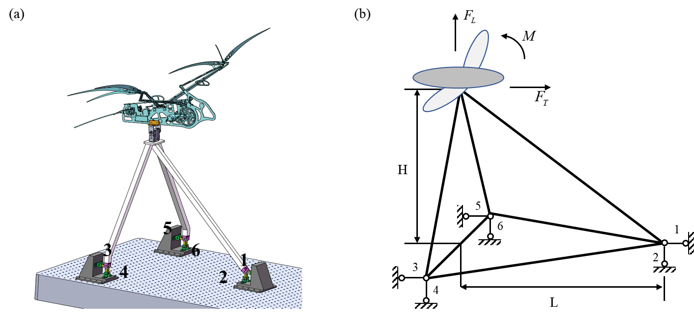

**Fig. 7** Experimental setup (a, b) 3D model and schematic of the experimental set-up. (c) Aerodynamic forces test platform.

* 1. **Experimental Result of force measurement**

To demonstrate the effectiveness of morphing membrane wings in improving lift, we examined two wing motion patterns: flapping-folding motion with a coupling mechanism, and pure flapping motion with fully extended wings. Under conditions without free flow, we conducted measurements of the aerodynamic forces on flapping wings. The motor input was increased in 4% intervals from 58% to 86%, resulting in a total of 7 datasets for each wing motion pattern. In each test, the Robot was positioned at five angles of attack, and the recorded time duration was 3 seconds. To ensure consistent results, we reset all sensors before each test, setting the tension or pressure indication to 0.

Representative results depicting the flapping motion and flapping-folding motion, with input levels of 58%, 70%, and 86%, are presented in Figure 9. For the flapping motion pattern, we plotted the lift of multiple wingbeat periods across three tests over a three-second interval (Figure 9a). The peak lift reading denotes the start of each test, ensuring accurate data alignment. Similarly, the results of the test on the flapping-folding motion pattern are shown in Figure 10b. Both plots clearly show the wingbeat period, although they exhibit low-frequency oscillations within these periods. We observed that under the same input conditions, the speed of upward movement in the flapping-folding motion is significantly faster than that in the flapping motion, Additionally, the wing frequency of the flapping-folding motion pattern is higher compared to that of another pattern. At an 86% motor input, the wing frequency for the flapping motion pattern is approximately 0.3 Hz, while the wing frequency for the flapping-folding motion pattern is approximately 0.6 Hz.

By comparing the results shown in Figure 9, several significant observations can be made. These plots provide support for the hypothesis that folding a bat’s wings during the upstroke portion of the wingbeat period effectively reduces negative lift [31]. Furthermore, these findings complement previous studies on robotic bat wing folding that have investigated this phenomenon [32]. When a bat folds its wings during the upstroke, both wing inertia and negative lift are minimized. This reduction in negative lift is beneficial as it leads to an overall net gain in lift. Clearly, when the wings are folded during the upstroke, Robo-Bat experiences a decrease in negative lift. The lift measurements decrease to approximately -3 N for extended flapping, whereas the readings for folding have minima of around -2 N.

C:\Users\Jinghu Li\Desktop\lift force.tif

**Fig. 9** Time history of measurement results during three seconds. The green area is downstroke and the white area is upstroke, so the sum of each interval becomes a wing stroke. (a) Flapping Motion, (b) Flapping-Folding Motion, (top, middle, bottom): 58%, 70%, and 86% input.

C:\Users\Jinghu Li\Desktop\average.tif

**Fig. 10** Measurement results during one wing stroke with respect to the motor inputs from 58% to 86%. (a) Force amplitude (b) Average force



Figure 10 illustrates the force amplitude  and average force  for each motion pattern across various motor inputs. The values of force amplitude and average force are derived using Eq. (2). In this equation,  represents a specific time instant during a wing stroke, while  represents the period of a complete wing stroke.