机械工程系工学硕士研究生论文工作

中期检查报告

姓名：Anuar Santoyo Alum 安武
学号：2022280136
导师： 张云
入学年月：2022-09
一、已取得的学分、课程名称及成绩：
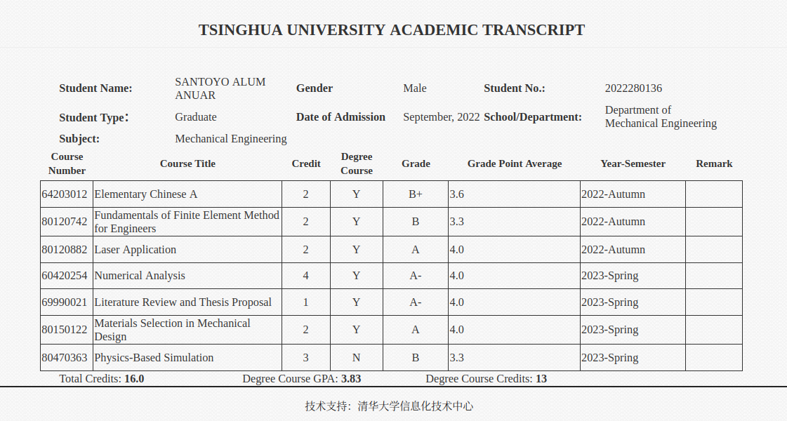

课程名称 | 学分 | 成绩 | 是否学位课
已修学位课学分：
二、开题报告拟定的研究工作主要内容及完成情况（列表给出）
- Development of a static test bench (accomplished)
- Development of dynamic test bench (accomplished)
- Development of optimization algorithm using CMA (accomplished)
- Reasearch and implementation of controlling algorithm for hindleg (accomplished)
- current state: hand control and hover test in outdoor environment
- remaining: refinement of hand control using developed optimization algorithm. Implementation of accelerometer and gyroscope to attempt self sustained hovering.
三、科研工作情况与课题进展（按以下提纲撰写）：
1、研究工作进展和主要结果(不少于10000字；图表为必须，但不包含在字数计算之内)
Found in attached midterm report
2、已获得科研成果（若有）
No publications yet
3、论文工作中遇到的困难：
My biggest difficulty was encountered at the beginning when enabling communication between the different components of this project, as most components come with a specialized software to use them, I encountered the difficulty of needing to learn how to communicate with all the components to a bit and byte level, as my project required an integrated communication between the computer, sensors and robot.
四、自我评价（工作态度、工作能力、学术水平、科研工作中的作用等，100－300字）：
I have enjoyed my stay in the research team since the first day, I believe to have spend a reasonable amount of time doing my research. I am particularly happy for the communication developed with the Professor as it has allowed for a quicker progress of the project. Even when being exposed to problems that were outside the scope of my knowledge or expertise I did my best to quickly gain the new knowledge needed, which allowed me to solve the problem at hand whilst giving me the opportunity to further obtain knowledge of areas outside of my capabilities.
五、导师意见（前期工作评价、是否同意进行中期检查等）：

导师签名：
时间： 年 月 日

