@article{bahlman_2013,
doi = {10.1088/1748-3182/8/1/016009},
url = {https://dx.doi.org/10.1088/1748-3182/8/1/016009},
year = {2013},
month = {feb},
publisher = {IOP Publishing},
volume = {8},
number = {1},
pages = {016009},
author = {Joseph W Bahlman and Sharon M Swartz and Kenneth S Breuer},
title = {Design and characterization of a multi-articulated robotic bat wing},
journal = {Bioinspiration & Biomimetics},
abstract = {There are many challenges to measuring power input and force output from a flapping vertebrate. Animals can vary a multitude of kinematic parameters simultaneously, and methods for measuring power and force are either not possible in a flying vertebrate or are very time and equipment intensive. To circumvent these challenges, we constructed a robotic, multi-articulated bat wing that allows us to measure power input and force output simultaneously, across a range of kinematic parameters. The robot is modeled after the lesser dog-faced fruit bat, Cynopterus brachyotis, and contains seven joints powered by three servo motors. Collectively, this joint and motor arrangement allows the robot to vary wingbeat frequency, wingbeat amplitude, stroke plane, downstroke ratio, and wing folding. We describe the design, construction, programing, instrumentation, characterization, and analysis of the robot. We show that the kinematics, inputs, and outputs demonstrate good repeatability both within and among trials. Finally, we describe lessons about the structure of living bats learned from trying to mimic their flight in a robotic wing.}
}

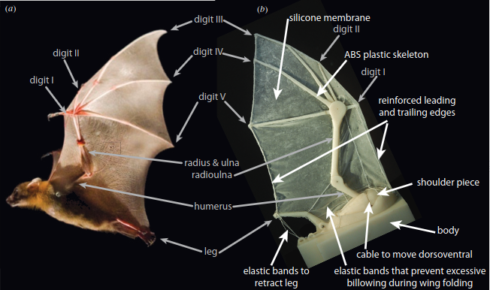

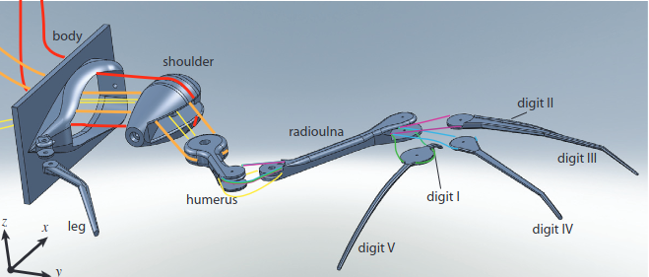

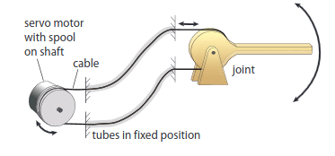

@article{multimo-bat,
author = {Matthew A. Woodward and Metin Sitti},
title ={MultiMo-Bat: A biologically inspired integrated jumping–gliding robot},

journal = {The International Journal of Robotics Research},
volume = {33},
number = {12},
pages = {1511-1529},
year = {2014},
doi = {10.1177/0278364914541301},

URL = {

https://doi.org/10.1177/0278364914541301

},
eprint = {

https://doi.org/10.1177/0278364914541301

}
,
abstract = { This paper presents the design, development, and verification of a miniature integrated jumping and gliding robot, the MultiMo-Bat, which is inspired by the locomotion strategy of vampire bats. This 115.6 g robot exhibits high jumping and gliding performance, reaching heights of over 3 m, to overcome obstacles in the environment. The MultiMo-Bat was developed by a novel integrated design strategy that combines jumping and gliding locomotion modes and minimizes the necessary actuation and structural components by sharing a significant portion of the components required for each mode; nearly 70\% of the total robot mass is utilized by both modes. This results in overall low mass, low volume, and high co-operation between the modes which allows for the preservation of over 80\% of the performance of the independent jumping locomotion mode when combined. This not only allows for two high-performance locomotion modes, but also for all of the necessary actuation components to be on board. Key considerations and components of the design are discussed in the context of the integrated design approach. A prototype of the system is constructed and experimentally tested in various configurations to elucidate the overall system and integration performance. Finally, metrics are developed to begin to quantify the level and performance of the integrated approach as well as allow it to be compared to other mechanical and biological systems. This type of jumping and gliding robot can be used to explore, inspect, and monitor unstructured environments for security and environment monitoring applications. }
}

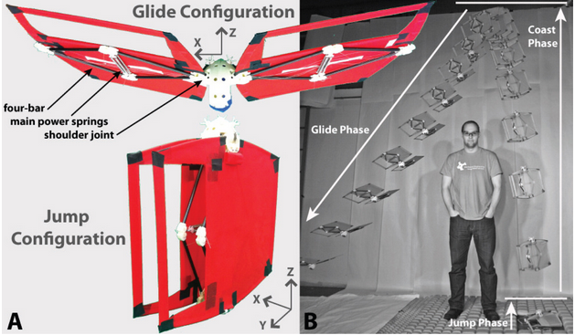

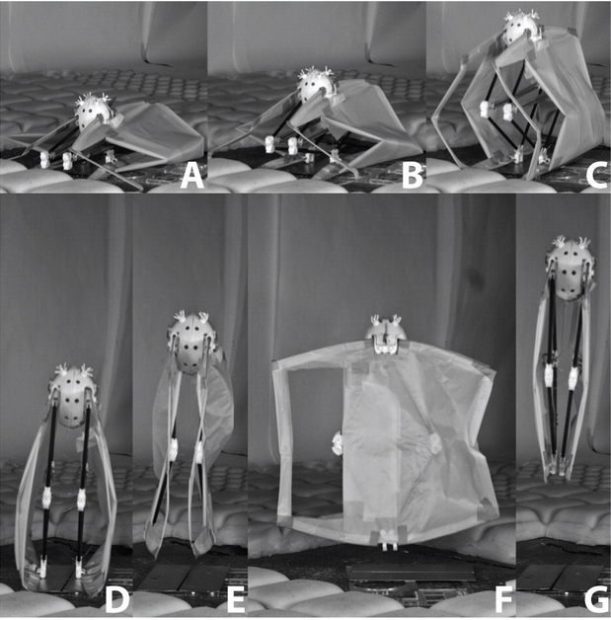

@INPROCEEDINGS{ramezani_2015,
author={Ramezani, Alireza and Shi, Xichen and Chung, Soon-Jo and Hutchinson, Seth},
booktitle={2015 IEEE/RSJ International Conference on Intelligent Robots and Systems (IROS)},
title={Lagrangian modeling and flight control of articulated-winged bat robot},
year={2015},
volume={},
number={},
pages={2867-2874},
keywords={Aerodynamics;Kinematics;Mathematical model;Robots;Vehicle dynamics;Manifolds},
doi={10.1109/IROS.2015.7353772}}

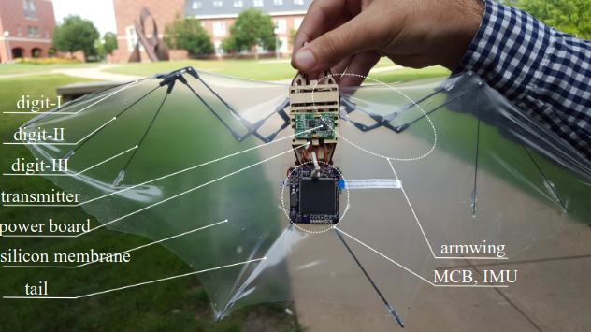

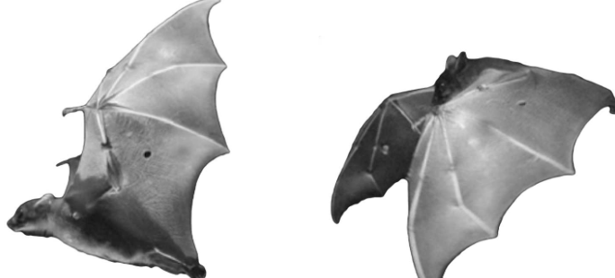

@INPROCEEDINGS{ghanbari_2013,
author={Ghanbari, Ahmad and Mottaghi, Ebrahim and Qaredaghi, Ehsan},
booktitle={2013 First RSI/ISM International Conference on Robotics and Mechatronics (ICRoM)},
title={A new model of bio-inspired bat robot},
year={2013},
volume={},
number={},
pages={403-406},
keywords={Robots;Educational institutions;Biomechanics;bat flying robot;flying robots;bat;4-bar mechanism},
doi={10.1109/ICRoM.2013.6510141}}

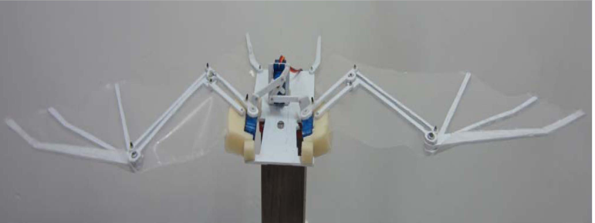

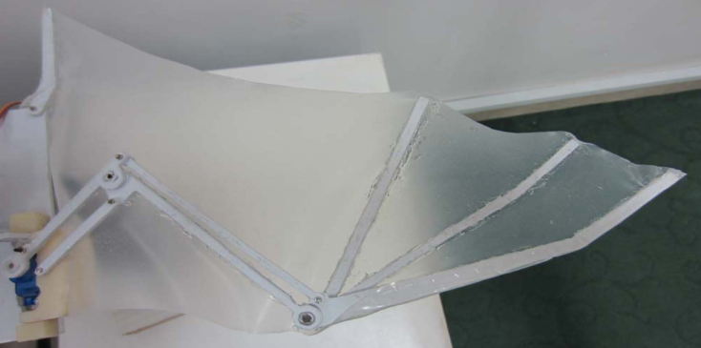

@INPROCEEDINGS{ramezani_2016,
author={Ramezani, Alireza and Shi, Xichen and Chung, Soon-Jo and Hutchinson, Seth},
booktitle={2016 IEEE International Conference on Robotics and Automation (ICRA)},
title={Bat Bot (B2), a biologically inspired flying machine},
year={2016},
volume={},
number={},
pages={3219-3226},
keywords={Aerodynamics;Kinematics;Joints;Robot kinematics;Morphology},
doi={10.1109/ICRA.2016.7487491}}

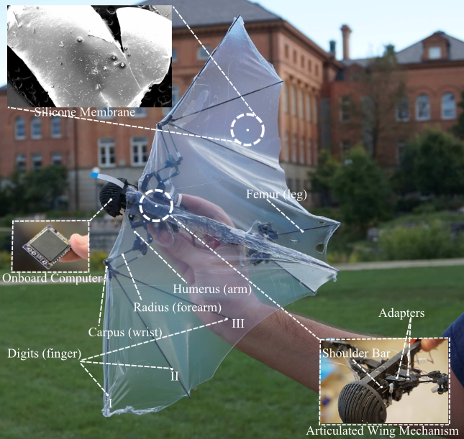

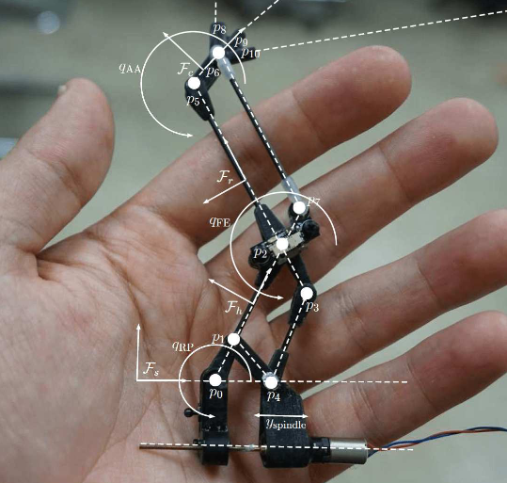

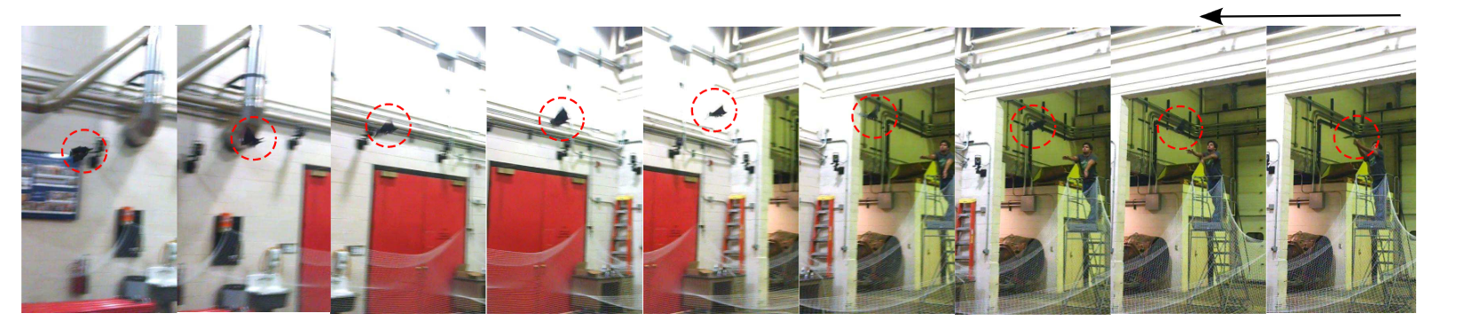

@ARTICLE{sui_2022,
author={Sui, Tingting and Zou, Ting and Riskin, Daniel},
journal={IEEE Robotics and Automation Letters},
title={Optimum Design of a Novel Bio-Inspired Bat Robot},
year={2022},
volume={7},
number={2},
pages={3419-3426},
keywords={Robots;Elbow;Kinematics;Biology;Optimization;Wrist;Principal component analysis;Biologically-inspired robots;mechanism design;kinematics;optimization and optimal control},
doi={10.1109/LRA.2022.3146536}}

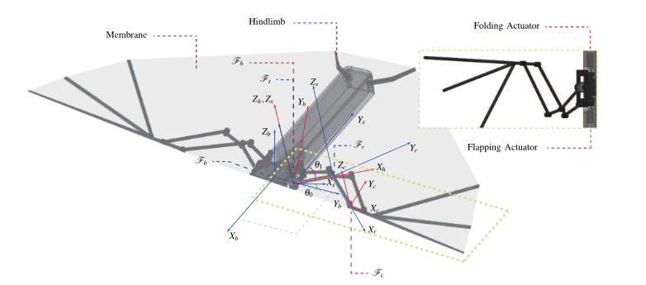
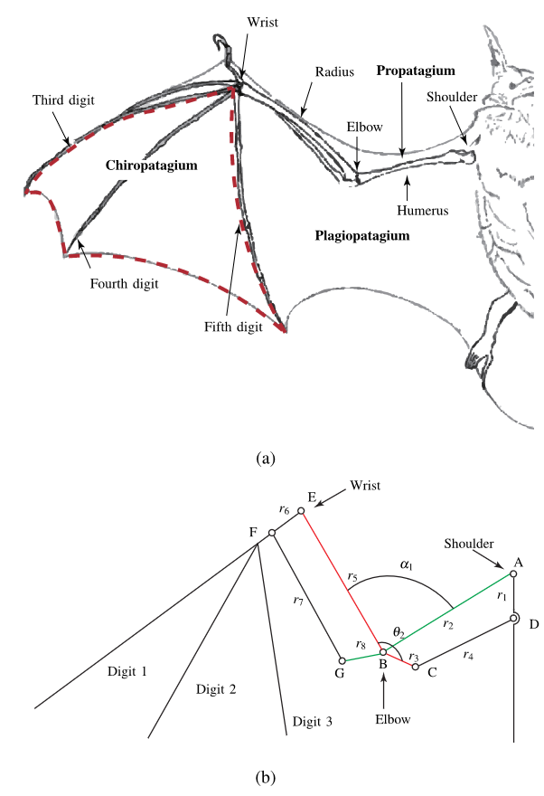

@INPROCEEDINGS{hoff_2019,
author={Hoff, Jonathan and Syed, Usman and Ramezani, Alireza and Hutchinson, Seth},
booktitle={2019 IEEE/RSJ International Conference on Intelligent Robots and Systems (IROS)},
title={Trajectory planning for a bat-like flapping wing robot},
year={2019},
volume={},
number={},
pages={6800-6805},
keywords={},
doi={10.1109/IROS40897.2019.8968450}}

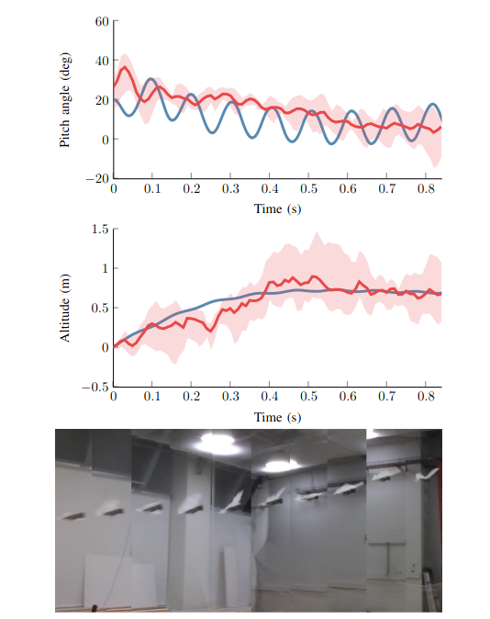

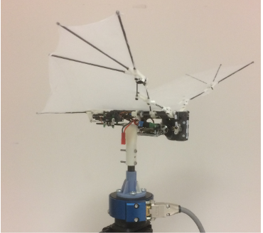

@article{hedenstrom_2013,
author = {Hedenström, Anders and Johansson, L. Christoffer},
title = "{Bat flight: aerodynamics, kinematics and flight morphology}",
journal = {Journal of Experimental Biology},
volume = {218},
number = {5},
pages = {653-663},
year = {2015},
month = {03},
abstract = "{Bats evolved the ability of powered flight more than 50 million years ago. The modern bat is an efficient flyer and recent research on bat flight has revealed many intriguing facts. By using particle image velocimetry to visualize wake vortices, both the magnitude and time-history of aerodynamic forces can be estimated. At most speeds the downstroke generates both lift and thrust, whereas the function of the upstroke changes with forward flight speed. At hovering and slow speed bats use a leading edge vortex to enhance the lift beyond that allowed by steady aerodynamics and an inverted wing during the upstroke to further aid weight support. The bat wing and its skeleton exhibit many features and control mechanisms that are presumed to improve flight performance. Whereas bats appear aerodynamically less efficient than birds when it comes to cruising flight, they have the edge over birds when it comes to manoeuvring. There is a direct relationship between kinematics and the aerodynamic performance, but there is still a lack of knowledge about how (and if) the bat controls the movements and shape (planform and camber) of the wing. Considering the relatively few bat species whose aerodynamic tracks have been characterized, there is scope for new discoveries and a need to study species representing more extreme positions in the bat morphospace.}",
issn = {0022-0949},
doi = {10.1242/jeb.031203},
url = {https://doi.org/10.1242/jeb.031203},
eprint = {https://journals.biologists.com/jeb/article-pdf/218/5/653/2076803/jeb031203.pdf},
}



