Notes on scientific papers:

https://esajournals.onlinelibrary.wiley.com/doi/full/10.1002/bes2.1258

-The purpose of science writing is not explaining what you did or what you learned, but rather what you want your audience to understand.
- Start by asking: What message do I want them to take away from my writing?

Introduction:
The Introduction sets the tone of the paper by providing relevant background information and clearly identifying the problem you plan to address. Think of your Introduction as the beginning of a funnel: Start wide to put your research into a broad context that someone outside of the field would understand, and then narrow the scope until you reach the specific question that you are trying to answer.
Upon narrowing the background information presented to arrive at the specific focus of your research, clearly state the problem that your paper addresses. The problem is also known as the knowledge gap.
Explicitly state how your work will contribute to filling that knowledge gap.

Materials and Methods:
The aim of the this section is to demonstrate that you used scientifically valid methods and provide the reader with enough information to recreate your experiment
It is important to provide enough information that the reader can follow your methods without referring to the original source.

Results:
The Results section provides a space to present your key findings in a purely objective manner.
Identify which graphs, tables, and data are absolutely necessary for telling your story.

Discussion

The Discussion section usually requires the most consideration, as this is where you interpret your results. Your Discussion should form a self-contained story tying together your Introduction and Results sections (Schimel 2012). One potential strategy for writing the Discussion is to begin by explicitly stating the main finding(s) of your research (Cals and Kotz 2013). Remind the reader of the knowledge gap identified in the Introduction to re-spark curiosity about the question you set out to answer. Then, explicitly state how your experiment moved the field forward by filling that knowledge gap.
After the opening paragraph of your Discussion, we suggest addressing your question and hypotheses with specific evidence from your results. If there are multiple possible interpretations of a result, clearly lay out each competing explanation.

Conclusion

represents your final opportunity to state the significance of your research. Rather than merely restating your main findings, the conclusion should summarize the outcome of your study in a way that incorporates new insights or frames interesting questions that arose as a result of your research. Broaden your perspective again as you reach the bottom of the hourglass .
You want your take-home sentences to focus on what you have accomplished and the broader implications of your study, rather than your study's limitations or shortcomings (Schimel 2012). End on a strong note.

Notes:
- Yet, when training students to be scientists, we often focus exclusively on the scientific method and the work of data collection. We rarely talk about the equally important topic of writing about science (Reynolds and Thompson 2011, Turbek et al. 2016).
-For instance, the active voice is good for the introduction, results, and discussion sections of the manuscript where you are laying out complex concepts. However, in the methods section, the passive voice works better because the steps you took to carry out your research matter more than who conducted them.
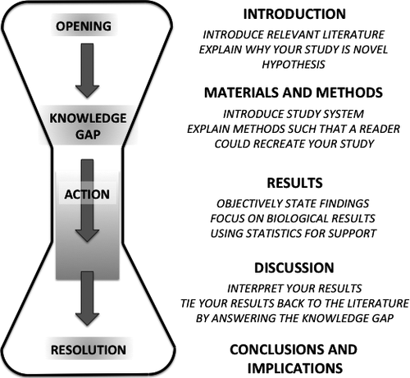

https://esajournals.onlinelibrary.wiley.com/doi/full/10.1002/bes2.1800

We rarely talk about the equally important topic of writing about science (Reynolds and Thompson 2011, Turbek et al. 2016).
The goal of a research publication is communicating what you have discovered, at the very limits of our collective knowledge, to those who were not with you on the journey.

Tips:
- The ability to write is not an innate talent, but rather a skill you develop and practice, just like any sport or hobby you want to master.
- Content generation is getting words on the page without worrying about word choice or flow, whereas copyediting is polishing the text you've written (Wilke 2013a). When you try to generate and edit content simultaneously, you end up in the “Perfect Sentence Vortex, a never ending cycle of incremental improvements that means you write excruciatingly slowly, and are never satisfied with what you write”
- Careful with the perfect citation rabbit hole. Avoid going to the hole in the middle of a writing session.

https://www.otago.ac.nz/hedc/otago615367.pdf

Introduction
This section should contain two key things:
1. An introduction to the science that was carried out. This is usually
structured as a literature review in a paper or larger report. In an
undergraduate science report you should explain the motivation for
your current experiment or study and reference relevant
background readings or articles. You should also provide a clear
statement of the research questions and describe how these link to
the study background or context.
2. An overview of what is included in the report including a brief
overview of the methods used and the expected results

Abstract
Does your abstract describe the background for your study, clearly state
the research problem, briefly describe the methods used to investigate the
problem, state the results obtained, and summarise your conclusions and
link these back to the study context? In a nutshell, the abstract should say
what your study is about and explain why it matters. Different disciplines
may expect abstracts to be written in a particular style. For example, in
some Health Sciences, sub-headings are used in abstracts. Sub-headings
are not commonly used in the Social Sciences. Be sure to check your lab
manual or with departmental staff for guidance

Materials and methods
This section is the ‘recipe’. It describes what you did and how you did it.
For the report to be a practical and useful document and for the results to
be reproducible, make sure you check that:
• It is possible for a trained person reading your report to replicate
your study from the information you have provided.
• You have accurately and fully described your experimental
procedure.
• You have not included results or discussion in the materials and
methods section

Results
In this section you report what you found in your investigation. Do check
that you have:
1. Correctly formatted, labelled and captioned all tables and figures.
Check your lab manual for specific instructions but refer to the
introduction to tables and figures in the next section for general
advice
2. Correctly reported descriptive and inferential statistics and used
tables and/or graphs to support clear communication of your
results. Try to ensure that tables and figures are located soon after
the text in which they are introduced.
3. Not referred to the experimental methods used. These should be
included in the methods section.
4. Not discussed the results of similar research. This belongs in the
discussion section

Discussion
This is where you fully discuss and interpret your results, and comment
on whether your research supports your original hypotheses or answers
your research questions. If your results do not fully answer your original
questions, or fail to support a hypothesis, you should try to explain why
this might be the case. It is important to acknowledge any limitations to
your study design in this section. You can also use this section to
speculate on future research that may be helpful to answer unresolved
issues, or point out new research questions that have arisen out of your
research. Finally, ensure that you link you findings back to the original
context or motivation for your study or experiment. It may be a very
small contribution but it is important to explain how your study adds to
or supports, existing knowledge.

- Clear message
- Result in global context, why are results original or significant
- Future plan important
- Clear key message
- What did you do should be answered throughout the paper
- Always think your reader is tired and busy
- make it for everybody to understand, also accesible to non-speciallist
- from text I most be able to replicate study
- Abreviate only if you use 5 times or more

