**Gluster volumes and nomenclature**

Gluster volumes are represented in the form of replicates and bricks. Given the number of bricks and replica count, Gluster creates volumes by grouping the bricks in a certain way to create subvolumes, also known as, replicate volumes.

Let's take for instance something called a **3x2** Gluster volume.

This volume is made up of **3** replicate volumes that use **2** bricks each. To understand what this means, let's look at the following diagram:

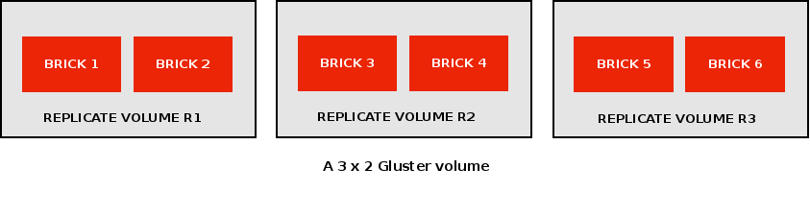

Here, R1, R2 AND R3 are called replicate volumes and these are made up of 2 bricks each.

A file written to this Gluster volume will get replicated twice i.e. a file “a” will reside on both the bricks of either R1 or R2 or R3. Similarly, a file “b” may reside on both the bricks of either R1 or R2 or R3. This way, we'll have 2 replicas of every file on our volume, as desired.

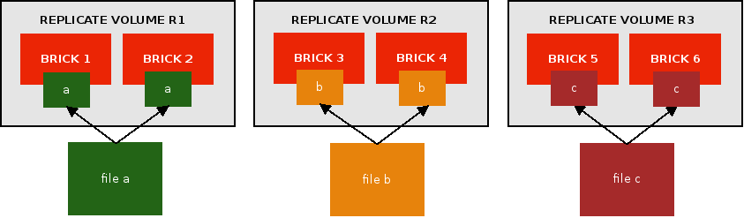

It is recommended that **bricks belonging to one replicate volume reside on different machines**. This is so that in the unfortunate event of a server going down, data can be retrieved from other bricks on different, alive servers.

**Useful to know:**

A) **The number of bricks should be a multiple of the replica count.**

Our **3x2** Gluster volume has **2 replicas** of each file in one replicate volume and a **total of 6 bricks**. 6 is a multiple of 2. So, when a user creates 6 bricks and enters replica count as “2”, there will be no errors trying to create this volume.

If a user enters replica count as “3”, there will still be no error as 6 is also a multiple of 3. Gluster will simply create a 2x3 volume in this case, where there are 6 bricks in total and 2 replicate volumes. This way, there will be 3 bricks each on the 2 replicate volumes. A file will be replicated thrice on each of those 3 bricks, inside one replicate volume. Thus, there will be 3 replicas of a file, just as the user requires.

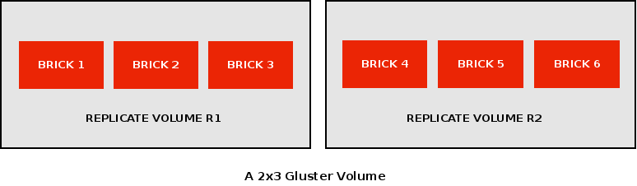

However, if the user enters replica count as “4” while creating only 6 bricks, the volume creation will fail. As 6 is not a multiple of 4, Gluster won't be able to create volumes containing 4 bricks in each replicate volume, with having just 6 bricks in total.

**B)The number of bricks on one replicate volume is equal to the replica count.**

Our 3x2 Gluster volume 3 replicate volumes and 2 bricks on each replicate volume. One file will have 2 replicas in total.. Hence, number of bricks on one replicate volume is equal to the replica count.

There are many such combinations of replicates and bricks in a Gluster volume.

**Some combinations:**

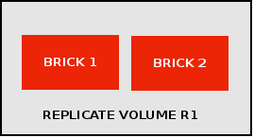

**1 x 2**

**2 x 2**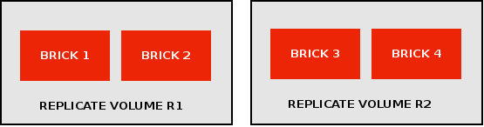

**3 x 2**

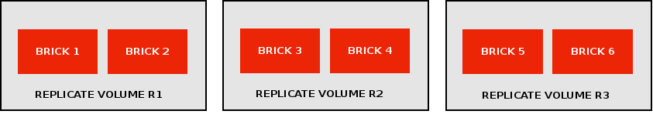

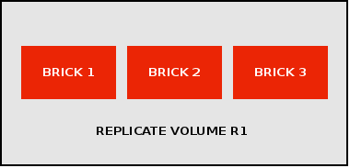

**1x3**

**2 x 3**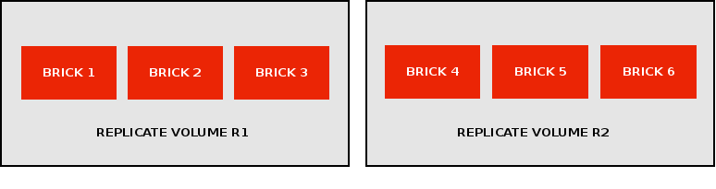

**3 x 3**

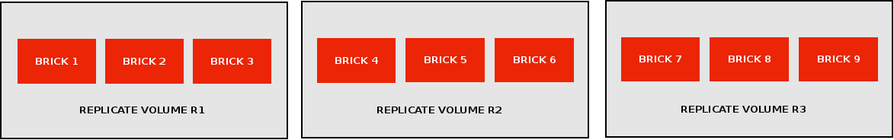

**4 x 3**

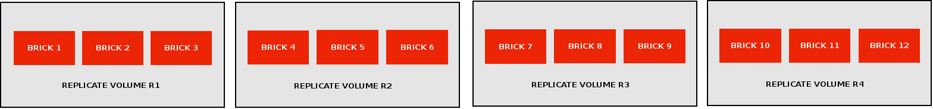

Gluster does not yet support 4 replica counts.