Project Report
Hostel Mess Fee Calculator

Name: Anubhab Saha
Course: Fundamentals in AI and ML
Course Code: CSA2001
Registration No.: 25BAS10062
Department: Aerospace Engineering
Institution: VIT BHOPAL UNIVERSITY
Year: 2025-2029
Semester: 2nd

Introduction
The Hostel Mess Fee Calculator is a Python-based project designed to simplify and automate the process of determining monthly hostel mess fess for students. Since mess charges vary depending on food preference-based discounts, manual calculation often becomes confusing and error prone. This project provides an efficient and interactive way to compute fees by integrating predefined mess categories, optional services, and discount criteria. The system outputs a detailed summary showing all components contributing to the final fee. This enhances transparency for students and reduces workload for hostel administrators.

Problem Statement
Hostel mess fees differ for student to student based on various factors such as mess type, additional services and institutional performance discount. Performing this calculation manually every month leads to errors, inconsistencies, and lack of clarity. Student also lack the knowledge how their mess fee is calculated. Therefore, there is a need for a simple and automated program that accurately calculates mess fees based on user inputs.

Functional Requirements

- The system must allow the user to select a mess type – Veg, Non-Veg or Jain
- The system must allow optional add-ons such as milk or special meals
- The system must apply performance-based discounts:
- Excellent 20%
- Good 10%
- Average 0%
- The system must calculate-
- Base fee
- Add-on fee
- Discount amount
- Final payable fee
- The system must display a clear summary of all calculated values.

Non-Functional Requirements

1: Usability – User-friendly input prompts and readable output formatting
2: Performance – Calculation must be instantaneous
3: Accuracy – Computation must always return correct values
4: Portability: Program should run on any system with Python installed
5: Maintainability – Code should be readable, modular and easy to update

System Architecture

- Input Layer
User Selects Mess Type
user select add-ons
User selects performance Category

- Processing Layer
Calculate Gross Fee
Apply Discount
Generate Summary

- Output Layer
Display detailed fee breakdown

Design Diagrams

Start
|
Select Mess Types
|
Select Add-ons
|
Select Performance Category
|
Calculate Fees
|
Display Fees
|
End

Design Decisions & Rationale

- A simple input-driven structure was chosen instead of a menu-driven model to keep the program user friendly

- Fixed fee values were hard-coded to resemble real hostel fee structures

- Conditional statements were used to handle choices cleanly

- A straightforward arithmetic calculation ensures transparency and ease of debugging

Implementation Details

The program is implemented in Python using:
- Variables for strong fee values
- input () function for user interaction
- if-elif-else conditions for logic
- Arithmetic operations for fee calculation
- Print statements for displaying formatted output

The code is structured in clear logical sections:
- Fee Definitions
- Mess Selections
- Add-on Selection
- Discount Selection
- Final Calculation
- Summary Display

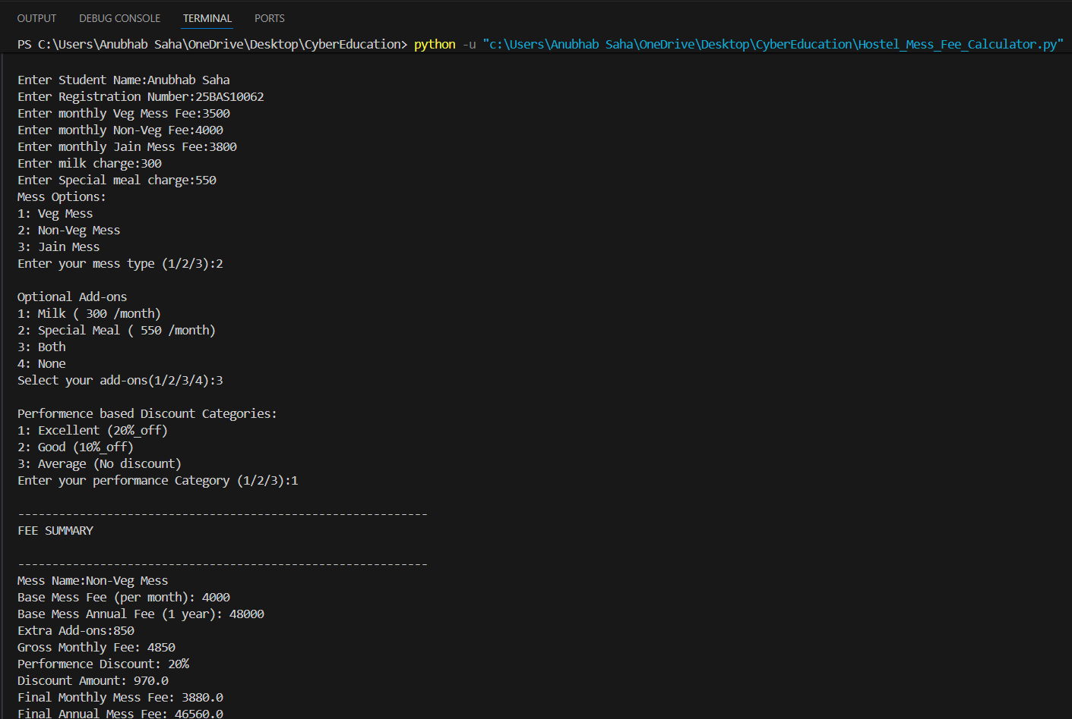
Screenshots

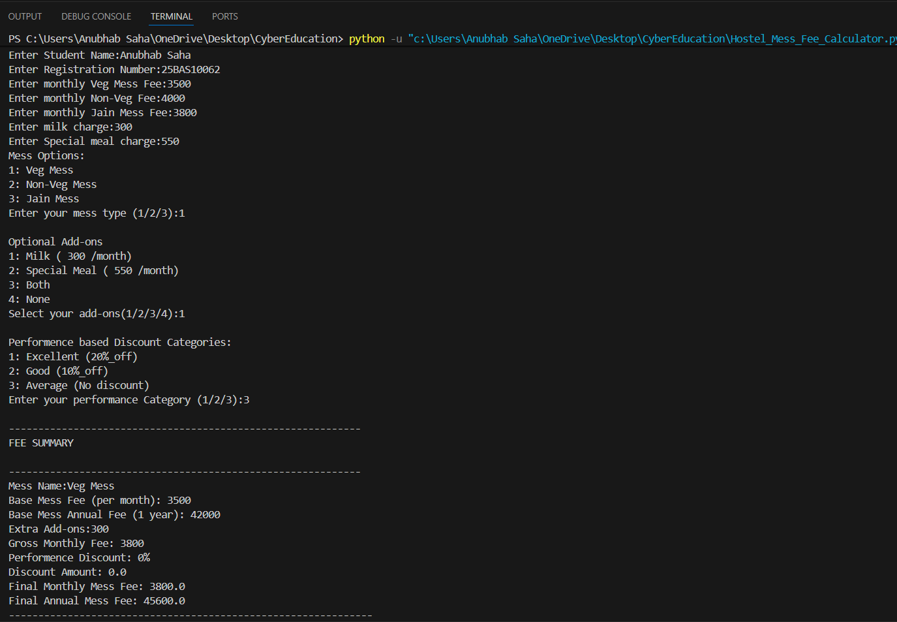

Testing Approach

- Input Testing: Verified that all menu inputs (1/2/3/4) work correctly

- Boundary Testing: Tested Cases with no add-ons and maximum add-ons.

- Discount Testing: Verified Discount calculations for all performance categories

- Error Testing: Ensured invalid inputs show correct error messages (optional)

Challenges faced

- Designing a clean and readable calculation

- Ensuring user inputs were validated properly

- Structuring output so that it looks professional and easy to understand

Learning and Key Takeaways

- Improved understanding of Python Programming
- Better understanding of conditional Logic and decision-making
- Learned how to break down a real-life scenario into functional programming steps
- Learned to document and structure a project like a real-world software system

Future Enhancements

- Menu-driven multi-student system
- Use of OOP concepts for cleaner structure
- Database integration for storing monthly records
- Exporting fee receipts as PDF
- Adding error-handling and validation features

References

- W3 Schools Python Tutorial
- Geeksforgeeks Python Basics
- Vityarthi Lessons
- Hostel mess fee structure from academic institutions

