**Product Design**

|  |  |
| --- | --- |
| **Team** | **SSAD 03, Anubhab Sen, Vighnesh Chenthil Kumar, Ananya Trivedi** |

# **Design Model**

Draw a simple class diagram and describe the classes in the table in this section. This diagram should represent the classes and their relationships. It is only necessary to show methods that are publically accessible by other classes. Only show an instance variable of a class if it is publically accessible. The diagram and the table should be consistent with each other.

Identify the classes (logical groupings of software methods that provide a related set of services). Make sure the design conforms to good design principles.

For each class, specify the information it maintains and the functionality it provides. Provide sufficient detail so that the purpose of each class in the design is clear.

|  |  |
| --- | --- |
| <Class No. 1> | eClass state  · What information is the class responsible for maintaining?  · E.g., a printing subsystem might hold the current status of all the printers it controls as well as the queue of print jobs waiting to be printed.  Class behavior  · What methods does the class implement?  · E.g., classes related to the printing subsystem might support the queuing up of new jobs, estimating the time until a given job completes, or emailing status information at the end of a job. |
| <Class No. 2> | Class state  · What information is the class responsible for maintaining?  Class behavior  · What methods does the class implement? |
| <Class No. 3>  add more rows as needed. | Class state  · Etc.  Class behavior  · Etc. |

.

# **Sequence Diagram(s)**

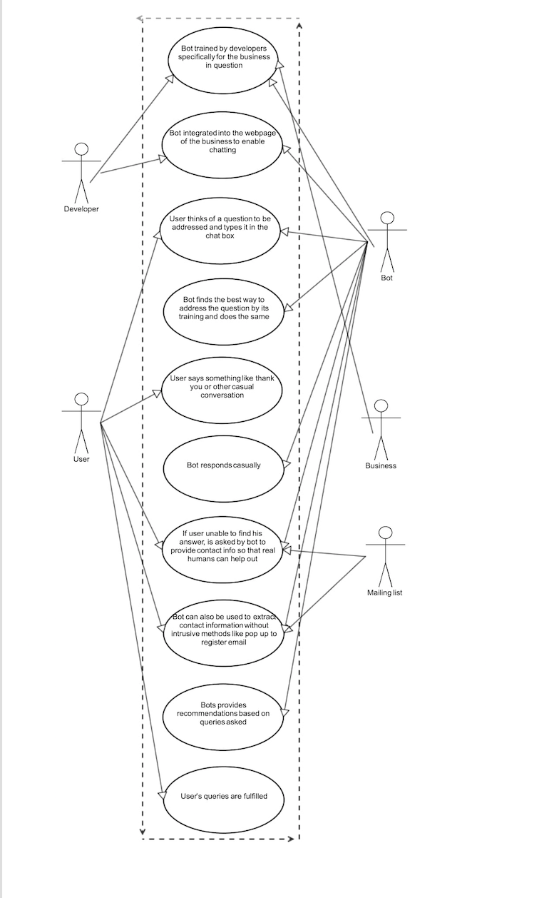

**Design Rationale**

Our objective was to make a chat bot to replace FAQ sections of web pages. It had been ascertained by our client that lots of major businesses have archaic help sections in their web pages. It didn’t help that these sections skipped some questions, which the consumers might have, and so she would have no way to get an answer to that other than calling up the customer care. This process is often tiresome and sometimes doesn’t resolve the problem quick enough for it to be of any value to the consumer.

Our bot comes in here and replaces the entire mess the help sections are with a simple chat box interface. The business gives a set of pre decided questions and answers to us and we train the bot with well enough so that it understands the questions even when asked in a different way.

Sometimes a business cares about the amount of time a person spends on their website and want to maximize it. This could be to increase revenue flow from ads or any other thing. To facilitate this, we also trained the bot extensively to be able to converse casually. We have given the bot human attributes such as a name, age, nationality etc to give it a more humane feel. It can hold conversation with a person without getting repetitive for a long time. One thing our bot can’t do is use crowd sourced information or current affairs. So if we were to ask it about the scores of a football match last night, it would be clueless. But we figured this wouldn’t be necessary since the primary reason for the bot would be answering pre determined questions not dynamic ones.

Also we will have a database which will store all the questions asked to the bot, this way in case new questions are asked which the bot can’t answer, can be recovered from the database and can be added to the bot’s knowledge base i.e. trained.

Also a big red button will be added which can be used by the user as a escape route when the bot isn’t able to answer their question, the button will link to a messenger live chat with a real company representative who can answer the question immediately.

We have also added inappropriate filters so that the bot cant be used to talk about stuff the site owners won’t approve of. This can easily be reverted if the owner wants to.

Overall this would be a beautiful replacement for clumsy current help sites and make it really easy for the end users.