**Software Requirements Specification (SRS)**

|  |  |
| --- | --- |
| **Project number** | **SSAD03** |
| **Project Title** | **Artificial Intelligence Bot for FAQ**  **Code Name: Raphael** |
| **Document** | **SSAD Software Requirements Specification Document** |
| **Creation date** | **12 - 09 - 2016** |
| **Created By** | **Vighnesh Chenthil Kumar, Anubhab Sen**  **(Other Members: Ananya Trivedi)** |
| **Client** | **Jayanth Rasamsetti, Gibbr** |

# Brief Problem Statement

Searching for answers to all our questions on the FAQ section of most websites can be quite a tiring process. Users have to scroll through a long list of questions and answers, whether relevant or irrelevant. This can prove quite laborious and frustrating, especially in times of dire need.

This process of searching for answers can be automated by using a smart bot, powered by AI, which could be fed with a set of predetermined questions and answers, and programmed to provide the most relevant answer to the questions asked by the user.

# System Requirements

The following are the system requirements for the project as of 12-09-2016:

1. Pandora Bots
2. Webpack
3. Node.js
4. Express.js
5. Jade
6. Pug
7. Body Parser
8. jQuery
9. React.js
10. Babel
11. Git, Gitlab (Version Control)
12. Sublime Text (IDE)
13. Textedit, Google Docs, Pages, Microsoft Word (Word Processing)

# Users Profile

This product is targeted in the market for all enterprises which need a sophisticated and automated FAQ page, to ease the user experience of surfing for answers, thus increasing their traffic, and thereby boosting their business.

# Feature requirements (described using use cases)

|  |  |  |  |
| --- | --- | --- | --- |
|  | **Use Case Name** | **Description** | **Release** |
| 1 | Embed | The FAQ bot can be embedded in the website | R1 |
| 2 | Train | The FAQ bot can be trained and customised uniquely to cater to the requirements of particular customers. | R1/R2 |
| 3 | Chat | The bot can make casual conversations with its customers, in addition to answering queries to the FAQ. | R1 |
| 4 | Extract | The bot can extract contact information in a user friendly manner | R2 |
| 5 | Recommend | The bot can provide recommendations, in addition to answers to the FAQs asked by the customers | R2 |

**Use case diagram**

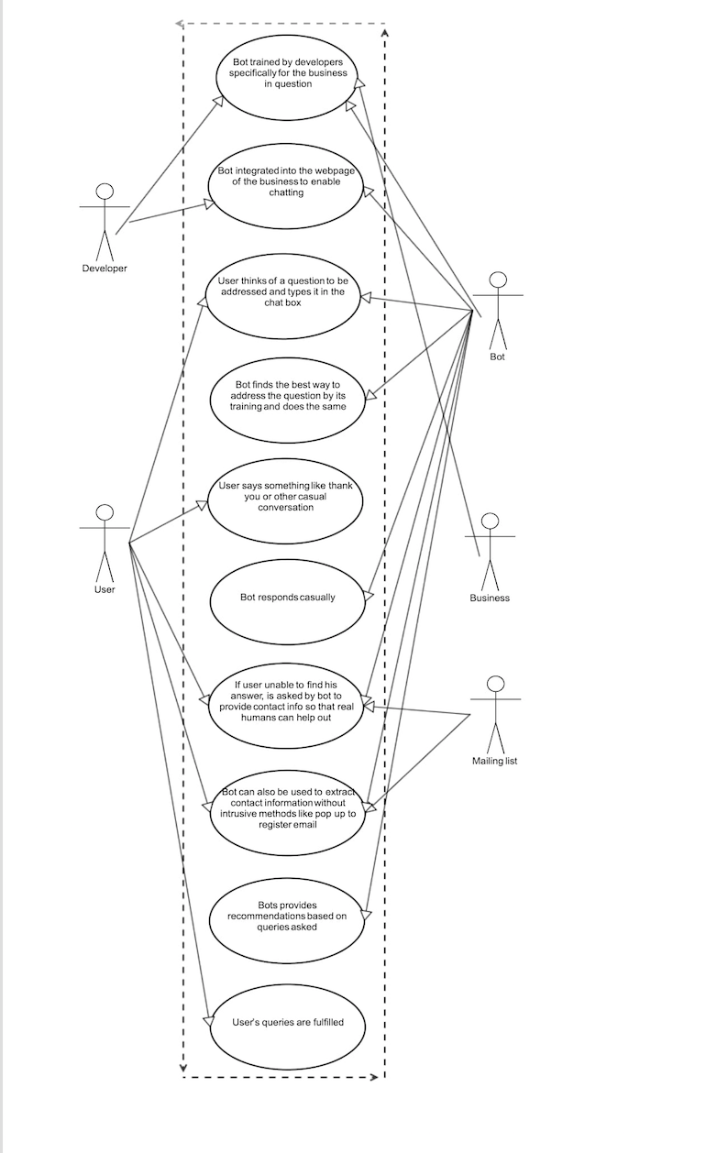

**Use case description**

|  |  |
| --- | --- |
| **Use Case Number:** | UC - 01 |
| **Use Case Name:** | Train |
| **Overview:** | The FAQ bot can be trained and customised uniquely to cater to the requirements of particular customers. |
| **Actors:** | User, Developer, Bot, Business, Mailing list |
| **Pre condition:** | Short list one bot among the wide range of bots, and explore the functionalities of the bot, ensuring that they match with our project requirements |
| **Flow:** | 1. Train the bot in the AI Markup Language (AIML) to answer questions, bot casual as well as domain specific FAQs. |
| **Post Condition:** | None |

|  |  |
| --- | --- |
| **Use Case Number:** | UC - 02 |
| **Use Case Name:** | Embed |
| **Overview:** | The FAQ bot can be embedded in the website |
| **Actors:** | User, Developer, Bot, Business, Mailing list |
| **Pre condition:** | Decide which is the most suitable platform to implement the plugin, like HTML or Python or Ruby or Javascript |
| **Flow:** | 1. Find a suitable plugin online for the required platform and tweak it to suit our needs. |
|  | Alternate Flows: If the plugin is not compatible with a certain platform, switch to the next most feasible platform |
| **Post Condition:** | None |