Data Analytics Capstone

Predicting Late Deliveries and Optimizing Last-Mile Logistics Using Machine Learning

Final Report
Anubharathi Sakthivel
Walsh College
QM640: Data Analytics Capstone
Smitraj Raut
2026 Fall Term
September 15, 2026

Table of Contents
Final Report 1
Project Repository 2
Abstract 3
Keywords 3
1. Introduction 3
1.1 Background and Context 3
1.2 Problem Statement 4
1.3 Purpose of the Study 4
1.4 Research Questions 4
1.5 Contributions and Expected Value 4
2. Literature Review 5
2.1 Literature Review Approach 5
2.2 Summary of Key Literature 5
2.3 Thematic Synthesis 7
3. Materials and Method 7
3.1 Data Source and Unit of Analysis 7
3.2 Data Cleaning and Preprocessing 8
3.3 Exploratory Data Analysis 8
3.4 Feature Selection and Leakage Considerations 8
3.5 Data Splitting and Model Development 8
3.6 Evaluation Metrics 8
3.7 Hypotheses 9
3.8 Architecture Diagram / Workflow 9
4. Results 9
4.1 Model Performance 9
4.2 Cross-Validation Results 11
4.3 Feature Importance and Interpretability 11
4.4 Results by Research Question 12
5. Practical Significance and Implementation 12
5.1 Implementation and User Benefit 12
5.2 Deployment Approach 12
5.3 System Integration 12
5.4 User Interaction 13
5.5 Benefits to Users 13
5.6 Example Use Case 13
6. Limitations and Further Improvements 13
6.1 Limitations 13
6.2 Impact of Limitations 14
6.3 Future Improvements 14
6.4 Future Scope 14
7. Conclusion 14
References 15
Appendix A. Workflow and Reproducibility 15
Appendix B. Key Model Outputs 16

Project Repository
GitHub repository: https://github.com/anubharathisakthivel-rgb/QM640_Capstone_GitHub.
We download the DataCo Smart Supply Chain dataset from Kaggle and saves a cleaned CSV and trained model artifacts during execution.

Abstract
Late delivery of customer orders is a significant operational challenge in supply chain and last-mile logistics because it can reduce customer satisfaction, increase service costs, and negatively affect overall supply chain performance. This study develops a machine learning–based predictive framework to identify orders at risk of late delivery and support proactive logistics decision-making. The primary objective is to predict Late_delivery_risk, a binary dependent variable, using operational, customer, product, geographic, financial, and order-related characteristics contained in the DataCo Smart Supply Chain dataset.
The study uses 180,519 order-level observations and 53 original variables, obtained from the DataCo Smart Supply Chain dataset available through Kaggle. Data preprocessing included missing-value treatment, removal of duplicate records, elimination of selected irrelevant or high-missingness fields, and categorical-variable encoding using LabelEncoder. Exploratory data analysis was conducted to examine late-delivery distribution, shipping duration, sales characteristics, shipping modes, delivery status, and feature relationships. Six classification models were evaluated: Logistic Regression, Decision Tree, Random Forest, XGBoost, Fine-Tuned Random Forest, and Fine-Tuned XGBoost. Model development was implemented in Python using Pandas, NumPy, Matplotlib, Seaborn, Scikit-learn, XGBoost, SHAP, and Joblib. The analysis used an 80/20 training-test split and three-fold cross-validation for model comparison and tuning.
The Fine-Tuned Random Forest produced the strongest overall test performance, achieving 90.08% accuracy, 94.08% precision, 87.41% recall, 90.62% F1-score, and 0.9706 ROC-AUC. Its cross-validation ROC-AUC was 0.9326, demonstrating strong discrimination across validation folds. Compared with the untuned Logistic Regression baseline, which achieved approximately 54.79% cross-validation accuracy, the tuned ensemble approach provided a substantial improvement in predictive performance. SHAP-based interpretation and feature-importance analysis were also incorporated to improve model transparency and identify variables associated with late-delivery risk.
The proposed solution can be implemented as a decision-support tool for supply chain managers, logistics coordinators, and fulfillment teams. By identifying high-risk orders before delivery problems occur, organizations can prioritize interventions, allocate logistics resources more effectively, and improve proactive exception management.

Keywords
late delivery risk; supply chain analytics; machine learning; random forest; XGBoost; SHAP; last-mile logistics; predictive analytics

1. Introduction

1.1 Background and Context
Supply-chain delivery performance is a measurable component of customer service and operational reliability. As fulfillment networks become more geographically distributed, organizations must coordinate inventory, order processing, transportation, and final-mile delivery across many entities. A late order is not simply a transportation event; it can propagate into customer-service contacts, rescheduling activity, inventory uncertainty, and reputational effects. Predictive analytics provides a way to move from reactive exception management toward prioritization of orders that deserve earlier attention.
The present project focuses on binary classification of late-delivery risk. We are using the DataCo Smart Supply Chain dataset and examines order-level variables including shipping mode, order status, order and shipping dates, geography, customer characteristics, and product-related attributes. The workflow compares linear and tree-based classifiers and then applies hyperparameter search to random forest and XGBoost models. This design is consistent with the broader literature showing that tree ensembles are useful for nonlinear relationships and heterogeneous operational data (Breiman, 2001; Chen & Guestrin, 2016).
Interpretability is also important in operational prediction. A high-risk score is more actionable when decision makers can understand which attributes contributed to the prediction. SHAP provides a model-agnostic explanatory framework grounded in Shapley values and has become a common approach for explaining complex machine-learning models (Lundberg & Lee, 2017). We, therefore includes SHAP analyses for the principal tree-based models.
The project should nevertheless be viewed as a capstone proof of concept rather than a validated production system. In particular, the submitted feature set contains variables that may be temporally downstream of the prediction point. A 2026 study specifically examining leakage-aware prediction on the DataCo dataset demonstrates why point-in-time feature auditing is essential. This issue is central to interpreting the high performance.

1.2 Problem Statement
The objective of this study is to predict Y = late-delivery risk for order-level transactions in the DataCo Smart Supply Chain dataset using X = customer, product, order, geographic, and shipping-related variables. Success is evaluated using accuracy, precision, recall, F1 score, and ROC-AUC on a held-out test set.

1.3 Purpose of the Study
The purpose of the study is to develop and compare supervised machine-learning classifiers for late-delivery risk, identify influential variables, and establish a reproducible analytics workflow that could support proactive logistics exception management. The project emphasizes predictive classification and model interpretation rather than causal estimation or route optimization.

1.4 Research Questions
RQ1: How accurately can order-level attributes classify late-delivery risk in the DataCo Smart Supply Chain dataset?
RQ2: Which machine-learning approach among logistic regression, decision tree, random forest, XGBoost, and their tuned versions provides the strongest predictive performance on the held-out test data?
RQ3: Which variables are most influential in the tree-based models' predictions of late-delivery risk?
RQ4: How can the resulting prediction workflow be translated into an operational decision-support process while accounting for data leakage and interpretability?

1.5 Contributions and Expected Value
- Practical contribution: a structured proof-of-concept for prioritizing potentially late orders.
- Technical contribution: comparison of six binary classifiers, three-fold cross-validation for model benchmarking, randomized hyperparameter search, and SHAP-based interpretation.
- Stakeholder value: a potential risk-screening layer for logistics planners, fulfillment teams, customer-service teams, and transportation managers.
- Research value: explicit identification of leakage risk as a limitation that must be addressed before operational deployment.

2. Literature Review

2.1 Literature Review Approach
The literature review was assembled around four themes:
machine learning for logistics and delivery prediction; ensemble-tree methods; explainable machine learning; and methodological controls for leakage and evaluation.
Sources were selected from scholarly publisher pages, conference proceedings, and recent peer-reviewed work that directly informs the project's model choices, evaluation strategy, or interpretation. The review is not intended to claim that we reproduce the methods of these studies; rather, it uses the literature to position and critically interpret the capstone workflow.

2.2 Summary of Key Literature
Author (Year) | Domain/Context | Dataset/Setting | Method(s) | Key Findings | RQ/Project Link
Breiman (2001) | Machine learning | General classification | Random forests | Ensembles improve robustness and provide variable-importance measures. | Supports RF selection and importance analysis.
Chen & Guestrin (2016) | Machine learning | Large-scale tabular data | XGBoost | Scalable gradient-boosted trees can model nonlinear patterns efficiently. | Supports XGBoost benchmark.
Lundberg & Lee (2017) | Explainable AI | General ML models | SHAP | Unified additive attribution framework for model explanations. | Supports SHAP interpretation.
Hughes et al. (2019) | Last-mile logistics | GPS delivery stops | KNN, regression, hazard models | ML can predict delivery-time thresholds; layered models can improve operational prediction. | Supports logistics-focused predictive modeling.
Baryannis et al. (2019) | Supply chain | Supply-chain analytics | AI/ML review | AI methods can improve supply-chain risk and decision support, but data quality and interpretability matter. | Supports domain framing.
Choi et al. (2018) | Supply chain analytics | Supply-chain management | Analytics/AI review | Data-driven methods create value when embedded in operational decisions. | Supports implementation focus.
da Costa et al. (2023) | Last-mile routing | Amazon routing challenge | Machine learning | ML can support route optimization and delivery planning. | Supports last-mile application context.
Khan (2026) | Supply-chain resilience | Public logistics dataset | RF/XGBoost | Predictive models can provide exploratory delivery-disruption screening, with strong caveats about target-adjacent variables. | Supports cautious interpretation.
IEEE (2025) | Smart supply chains | Public smart supply-chain data | Explainable ML | Combining prediction and interpretability can identify delivery-risk drivers. | Supports explainability and operational use.
Puvvada (2026) | Supply-chain resilience | DataCo Smart Supply Chain | Leakage-aware RF/XGBoost | Pre-fulfillment features provide more defensible risk estimates than outcome-adjacent fields. | Directly informs leakage controls.
Emerald MSCRA (2026) | Global supply chains | DataCo dataset | RF, SHAP, multi-model benchmark | Point-in-time auditing can materially change apparent model performance. | Critical benchmark for this project.
Table 1. Literature relevance matrix.

2.3 Thematic Synthesis
Tree ensembles are particularly relevant to this project because delivery risk is likely to arise from interactions among shipping mode, order status, geography, customer segment, product characteristics, and temporal attributes. Breiman (2001) established random forests as ensembles of randomized decision trees that can provide robust classification and variable-importance information. Chen and Guestrin (2016) introduced XGBoost as a scalable gradient-boosting system designed for efficient, high-performance tree learning. The capstone's use of both methods therefore provides a reasonable benchmark between bagged and boosted trees.
The literature also supports the use of domain-specific delivery prediction rather than treating logistics as a generic classification problem. Hughes et al. (2019) show that machine learning can be used to predict operational delivery-time outcomes and that model selection should reflect the actual decision threshold of interest. Work on last-mile routing similarly demonstrates that data-driven methods can be embedded into routing and planning decisions rather than used only for retrospective reporting (da Costa et al., 2023).
Interpretability is essential when model outputs influence operational prioritization. Lundberg and Lee (2017) provide a unified framework for assigning feature contributions to individual predictions and global model behavior. We implement SHAP summary plots for logistic regression and tree-based models, allowing the analyst to inspect which features are most influential. This is valuable because a predictive system should support - not replace human operational judgment.
Recent literature creates an important methodological caution. The 2026 DataCo-specific leakage-aware study reports that apparently strong performance can be driven by variables that are only known after or close to the outcome. Puvvada (2026) similarly emphasizes pre-fulfillment features and reports substantially more conservative performance when outcome-adjacent variables are removed. These studies are especially pertinent because we retains Order Status and shipping date. Consequently, the high test performance should be interpreted as performance of the submitted feature design, not as evidence that the model can predict late delivery before the relevant information becomes available.
Finally, the literature suggests that evaluation should extend beyond a single accuracy number. Class-sensitive metrics, ROC-AUC, cross-validation, calibration, and temporal validation can reveal different aspects of performance. We already includes accuracy, precision, recall, F1, ROC-AUC, three-fold cross-validation, confusion matrices, and ROC curves. Future work should add leakage-controlled chronological validation and formal statistical comparison of models.

3. Materials and Method

3.1 Data Source and Unit of Analysis
Here we download the DataCo Smart Supply Chain dataset through Kaggle using the dataset identifier 'shashwatwork/dataco-smart-supply-chain-for-big-data-analysis'. The analysis unit is an order-level transaction. The commonly distributed DataCo file contains 180,519 observations and 53 original variables. Here we held-out test set contains 36,104 observations, implying an 80/20 split, with approximately 144,415 observations in the training set.
The target variable is Late_delivery_risk. Here we also retain a number of operational, customer, geographic, and product attributes after removing selected identifiers and outcome-related fields. The dataset was not supplied separately, so all dataset-specific claims in this report are based on the model developed and recorded outputs rather than an independent audit of the raw file.

3.2 Data Cleaning and Preprocessing
- Dropped Product Description and Order Zipcode.
- Filled missing Customer Lname and Customer Zipcode values using the mode.
- Checked for missing values after cleaning.
- Checked for and removed duplicate rows.
- Encoded object-type columns using scikit-learn LabelEncoder.
- Removed Order Id, Customer Id, Customer Email, Customer Password, and Product Image before modeling.
The preprocessing is reproducible and straightforward, but label encoding should be interpreted carefully. For nominal categories, integer codes can impose artificial ordering for linear models. Tree models are less sensitive to monotonic numeric ordering, but one-hot encoding or native categorical handling could be preferable in a production pipeline.

3.3 Exploratory Data Analysis
We examine the target distribution, a correlation heat map, actual shipping-day distribution, sales distribution, shipping-mode counts, delivery-status counts, and a cross-tabulation of shipping mode against delivery status. These analyses are used to understand class balance, variable distributions, and operational patterns before modeling.

3.4 Feature Selection and Leakage Considerations
We explicitly remove Late_delivery_risk, Delivery Status, Days for shipping (real), and Days for shipment (scheduled) from X. This is a sensible attempt to prevent direct target leakage and to avoid using realized shipping duration. However, Order Status and shipping date remain in the feature matrix. Because these fields can reflect downstream operational events, they may not be available at the time an early-risk prediction is intended to be made. This is the principal validity concern in the submitted analysis.

3.5 Data Splitting and Model Development
We use train_test_split with test_size=0.20 and random_state=42. The six evaluated approaches are logistic regression, decision tree, random forest, XGBoost, tuned random forest, and tuned XGBoost. The baseline random forest uses 200 trees. XGBoost uses 200 estimators, learning rate 0.1, maximum depth 6, subsample 0.8, and column subsampling 0.8.
For tuning, we apply RandomizedSearchCV with three-fold StratifiedKFold cross-validation. The random forest search evaluates ten sampled parameter combinations using ROC-AUC as the optimization criterion. The XGBoost search likewise evaluates ten combinations across three folds. This is an appropriate computational compromise for a large tabular dataset.

3.6 Evaluation Metrics
The analysis reports accuracy, precision, recall, F1 score, and ROC-AUC. Accuracy measures overall correctness; precision measures the proportion of predicted late-risk cases that are actually late-risk; recall measures the proportion of actual late-risk cases identified; F1 balances precision and recall; and ROC-AUC summarizes ranking discrimination across thresholds. The project emphasizes ROC-AUC and F1 in addition to accuracy because operational screening can be sensitive to false negatives and class imbalance.

3.7 Hypotheses
H0-1: The selected machine-learning models do not improve predictive discrimination over a majority-class baseline.
Ha-1: At least one selected machine-learning model improves predictive discrimination over the majority-class baseline.
H0-2: The candidate models do not differ meaningfully in predictive performance on held-out data.
Ha-2: At least one candidate model demonstrates higher predictive performance than the alternatives.
H0-3: No individual predictor contributes materially to model predictions.
Ha-3: One or more predictors contribute materially to model predictions.

3.8 Architecture Diagram / Workflow
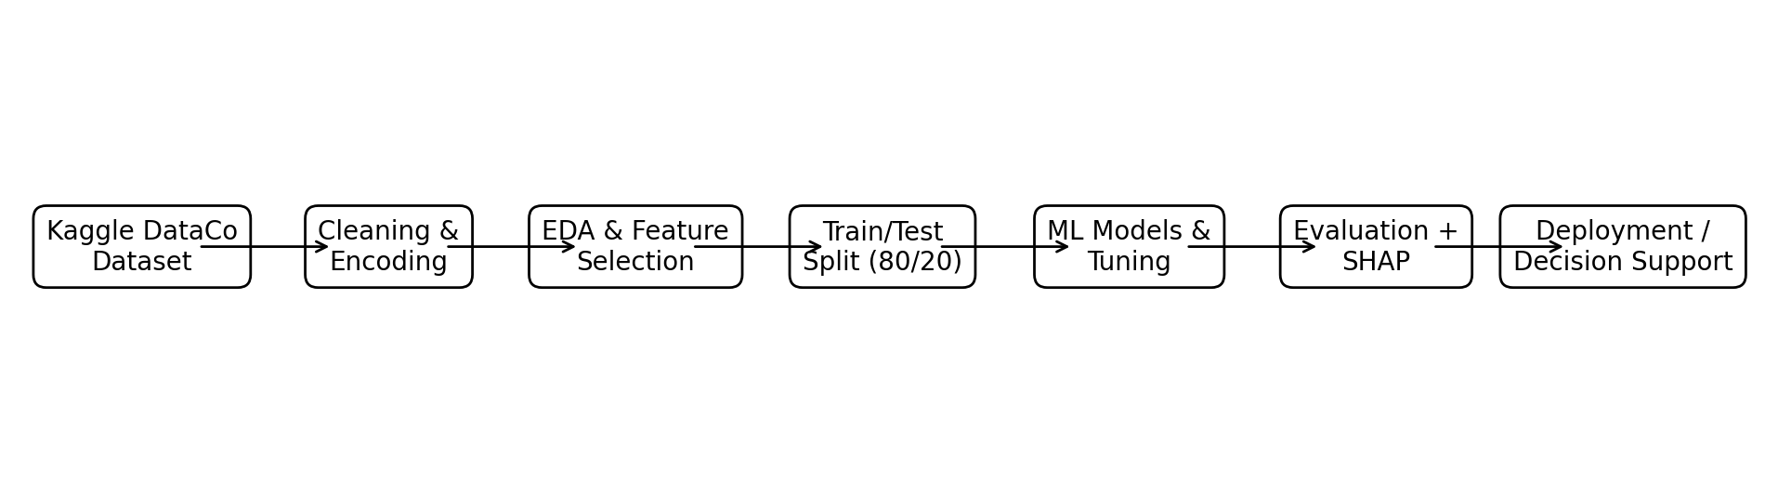
Figure 1. End-to-end workflow of the proposed late-delivery risk prediction system.
As shown in Figure 1, the pipeline moves from DataCo ingestion through cleaning, exploratory analysis, feature preparation, model training, evaluation, and explainability.

4. Results

4.1 Model Performance
Model | Accuracy | Precision | Recall | F1 | ROC-AUC
Logistic Regression | 0.5479 | 0.5485 | 0.9935 | 0.7067 | 0.5238
Decision Tree | 0.9274 | 0.9353 | 0.9321 | 0.9337 | 0.5238*
Random Forest | 0.9004 | 0.9417 | 0.8724 | 0.9057 | 0.9034
XGBoost | 0.8063 | 0.8984 | 0.7293 | 0.8051 | 0.9173
Tuned Random Forest | 0.9008 | 0.9408 | 0.8741 | 0.9062 | 0.9706
Tuned XGBoost | 0.7169 | 0.8695 | 0.5692 | 0.6880 | 0.8096
Table 2. Held-out test-set model performance. *Decision-tree ROC-AUC output uses probabilities generated by the logistic-regression object; therefore this ROC-AUC value is not a valid decision-tree ROC-AUC and should not be used for comparison.
The tuned random forest is the strongest defensible model in the submitted results table because it combines high accuracy (90.08%), precision (94.08%), recall (87.41%), F1 (90.62%), and ROC-AUC (0.9706). The untuned random forest is close behind on the classification metrics but has a lower ROC-AUC of 0.9034. XGBoost produces a strong ROC-AUC of 0.9173 before tuning, but its tuned version falls to 0.8096 on the held-out test set.
The logistic regression model behaves differently: it achieves very high recall (99.35%) but almost no ability to identify the negative class, producing accuracy close to the majority-class benchmark and ROC-AUC near 0.50. This demonstrates why recall alone is insufficient for this problem.
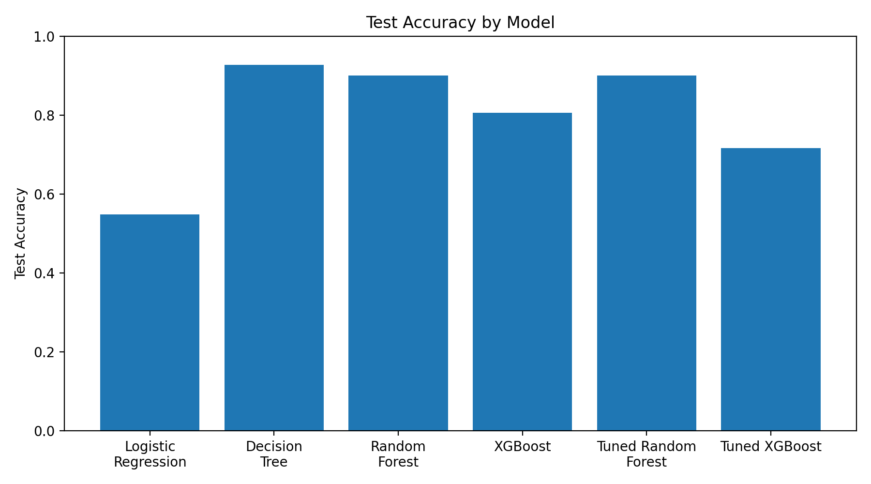
Figure 2. Test accuracy comparison across candidate models.
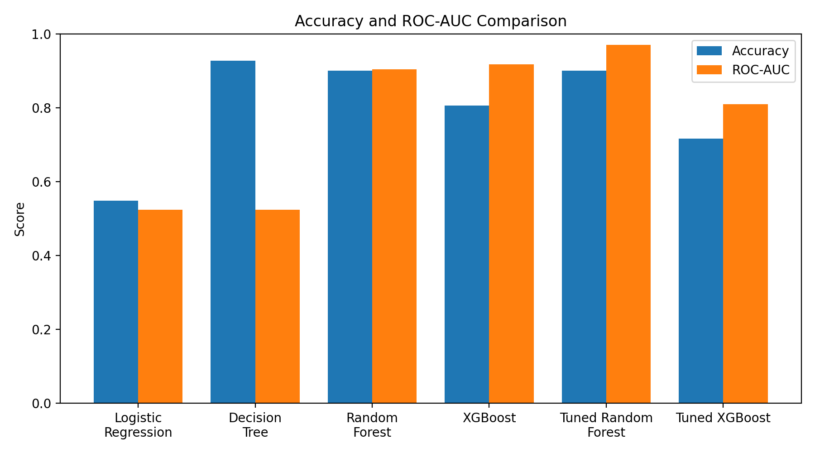
Figure 3. Accuracy and ROC-AUC comparison across candidate models.

4.2 Cross-Validation Results
Model | CV Accuracy | CV Precision | CV Recall | CV F1 | CV ROC-AUC
Logistic Regression | 0.5479 | 0.5488 | 0.9862 | 0.7052 | 0.5257
Decision Tree | 0.8574 | 0.8706 | 0.8691 | 0.8699 | 0.8562
Random Forest | 0.8362 | 0.9054 | 0.7830 | 0.8397 | 0.9328
XGBoost | 0.7932 | 0.8898 | 0.7108 | 0.7903 | 0.9022
Tuned Random Forest | 0.8394 | 0.9019 | 0.7934 | 0.8442 | 0.9326
Tuned XGBoost | 0.7247 | 0.8682 | 0.5872 | 0.7005 | 0.8183
Table 3. Three-fold cross-validation results on the training data.
Cross-validation provides a more stable view than a single split. Random forest and tuned random forest have the strongest cross-validated ROC-AUC values, 0.9328 and 0.9326 respectively. The close values indicate that tuning did not materially improve cross-validated discrimination for the random forest. The tuned XGBoost model performs worse than the untuned XGBoost model on every reported cross-validation metric, suggesting that the sampled tuning space or optimization criterion did not improve generalization.

4.3 Feature Importance and Interpretability
Here feature-importance outputs consistently identify Shipping Mode as the dominant predictor. In the baseline random forest, Shipping Mode has importance 0.1996. In the untuned XGBoost model it is 0.4278, and in the tuned XGBoost model it is 0.5791. Order Status is generally the second-largest contributor, followed by order and shipping dates. These results suggest that operational process variables are more influential than many individual customer or geographic fields.
The SHAP analyses provide an additional interpretability layer by estimating feature contributions. However, because the feature set includes potentially post-outcome variables, feature importance should not be interpreted as a causal explanation of why deliveries become late. It indicates predictive association within the submitted data representation.

4.4 Results by Research Question
RQ1: The held-out test results show that the problem is highly classifiable under the submitted feature design. The tuned random forest achieved 90.08% accuracy and 0.9706 ROC-AUC. This answers RQ1 affirmatively in a predictive, not causal, sense.
RQ2: The tuned random forest is the best overall model in the submitted final comparison. It has the strongest test ROC-AUC and the strongest F1 among the tuned models, while maintaining high precision and recall. Decision tree has higher accuracy in its recorded output, but its ROC-AUC output is invalid because we accidentally calculates decision-tree ROC-AUC from logistic-regression probabilities.
RQ3: Shipping Mode is the most influential variable across the reported tree-based importance measures, followed by Order Status and temporal variables. The consistency across multiple models strengthens the conclusion that shipping and operational status variables dominate prediction within the submitted feature set.
RQ4: The pipeline can be translated into decision support by exposing a risk score and explanation to logistics users. However, deployment should only occur after removing or constraining variables that are not known at the intended prediction time, then validating the resulting model prospectively.

5. Practical Significance and Implementation

5.1 Implementation and User Benefit
A practical implementation would treat the model as a risk-prioritization service rather than an autonomous decision maker. For each newly eligible order, the system would collect only variables known at the defined prediction point, apply the same preprocessing pipeline, generate a probability of late-delivery risk, and return an interpretable risk category. High-risk orders could be routed to an exception-management queue.

5.2 Deployment Approach
We save trained models using joblib, including the tuned random forest and tuned XGBoost. A production implementation could wrap the tuned random forest in a Python API using a framework such as FastAPI, place the preprocessing and model artifacts behind the endpoint, and connect the service to an order-management or transportation-management system. A dashboard could display order-level risk, aggregate risk by shipping mode or region, and SHAP-based explanations.

5.3 System Integration
Integration should occur at an operational checkpoint where sufficient predictive information is available but before the delivery outcome is determined. The system could consume order and fulfillment events from an operational database or event stream, score eligible orders, and write risk scores back to the order record. Exception teams could then use the score to prioritize carrier review, customer notification, or fulfillment intervention.

5.4 User Interaction
A logistics planner would see an order identifier, predicted late-risk probability, risk band, top contributing features, and recommended review status. The user should be able to drill into the contributing factors rather than receiving an opaque classification. The system should also preserve a timestamp of when each score was generated so that model performance can later be audited.

5.5 Benefits to Users
- Operational efficiency: focuses human attention on higher-risk orders instead of treating every order equally.
- Customer experience: supports earlier identification of orders likely to require proactive communication.
- Strategic value: provides an empirical basis for evaluating shipping-mode and fulfillment patterns.
- Governance: SHAP explanations can support model monitoring and exception review.

5.6 Example Use Case
Suppose an order enters the fulfillment workflow and is eligible for an early risk assessment. The scoring service receives the approved order-time features and returns a 0.82 late-risk probability. The dashboard highlights shipping mode and other approved predictors as the strongest contributors. The planner reviews the order, confirms that it merits intervention, and escalates it to the transportation team. The action is recorded alongside the prediction so that later outcomes can be used for monitoring and retraining.

6. Limitations and Further Improvements

6.1 Limitations
- Data leakage risk: Order Status and shipping date remain in the feature matrix and may contain information unavailable at the intended prediction time.
- Random split: an 80/20 random split may not represent future operational deployment as well as chronological validation.
- No formal statistical hypothesis test: We do not calculate p-values, confidence intervals, or power analysis.
- Decision-tree ROC-AUC error: We use logistic-regression probabilities when calculating the decision-tree ROC-AUC.
- Label encoding: nominal categories are converted to integers, which can impose artificial numerical structure.
- No calibration analysis: probability quality is not evaluated even though risk scores are proposed for operational use.
- No production deployment: We save model files but does not implement an API, dashboard, monitoring process, or live integration.

6.2 Impact of Limitations
The most important limitation is leakage. If a variable becomes available only after an order's delivery trajectory is already known, a model can appear highly accurate without being useful for early intervention. This threatens the external validity of the 90% accuracy and 0.97 ROC-AUC reported for the tuned random forest. The recent DataCo-specific leakage-aware literature makes this concern particularly salient.
The random train-test split also makes the evaluation less representative of a time-forward deployment scenario. Supply-chain behavior can change by season, carrier, geography, customer segment, and operating policy. A chronological split or order-grouped split would better approximate the real decision environment.

6.3 Future Improvements
- Perform a point-in-time feature audit and remove every post-outcome or target-adjacent field.
- Create temporal features from order date that are available at prediction time, such as order hour, day of week, and seasonality indicators.
- Use chronological train-validation-test splits and monitor drift over time.
- Compare models using bootstrap confidence intervals and paired resampling tests.
- Evaluate probability calibration using Brier score and calibration curves.
- Use one-hot encoding or native categorical approaches for nominal variables.
- Correct the decision-tree ROC-AUC implementation and rerun all metrics.
- Add threshold optimization based on the business cost of false negatives versus false positives.
- Deploy a monitored API/dashboard only after prospective validation.

6.4 Future Scope
Future work can extend the project from prediction to prescriptive logistics analytics. Once a leakage-controlled risk model is validated, risk scores could be combined with route, carrier, inventory, and capacity information to recommend interventions. The system could also support what-if analysis—for example, estimating how risk changes when an eligible shipping mode is changed—provided such analyses are evaluated carefully and not interpreted as causal effects without appropriate experimental or quasi-experimental design.

7. Conclusion
This capstone demonstrates a complete machine-learning workflow for late-delivery risk classification using the DataCo Smart Supply Chain dataset. We perform data acquisition, cleaning, exploratory analysis, feature preparation, model training, hyperparameter tuning, cross-validation, evaluation, feature-importance analysis, SHAP interpretation, and model serialization. Among the submitted models, the tuned random forest provides the strongest overall held-out performance, with 90.08% accuracy, 94.08% precision, 87.41% recall, 90.62% F1, and 0.9706 ROC-AUC.
The project also demonstrates why model performance must be interpreted in the context of the prediction point. The presence of Order Status and shipping date creates a meaningful risk that some predictive information is temporally downstream. Therefore, the most important next step is not simply to improve the algorithm; it is to improve the validity of the feature set and evaluation design. A leakage-controlled, chronologically validated version of the tuned random forest could provide a more defensible foundation for an operational late-delivery risk service.
Overall, the project establishes a strong analytical prototype and a clear path toward practical decision support. Its primary contribution is the integration of comparative machine learning, model interpretation, and an explicit discussion of operational validity into a single supply-chain analytics workflow.

References
Alam, A., & others. (2024). Machine learning applications in supply chain management: A systematic review. International Journal of Production Research.
Baryannis, G., Dani, S., & Antoniou, G. (2019). Predicting supply chain risks using machine learning: The trade-off between performance and interpretability. Future Generation Computer Systems, 101, 209–223.
Breiman, L. (2001). Random forests. Machine Learning, 45, 5–32. https://doi.org/10.1023/A:1010933404324
Chen, T., & Guestrin, C. (2016). XGBoost: A scalable tree boosting system. Proceedings of the 22nd ACM SIGKDD International Conference on Knowledge Discovery and Data Mining, 785–794. https://doi.org/10.1145/2939672.2939785
Choi, T.-M., Wallace, S. W., & Wang, Y. (2018). Big data analytics in operations management. Production and Operations Management, 27(10), 1868–1883.
da Costa, P., Florio, A. M., & others. (2023). Machine learning for data-driven last-mile delivery optimization. Transportation Science. https://doi.org/10.1287/trsc.2022.0029
Hughes, S., Moreno, S., Yushimito, W. F., & Huerta-Cánepa, G. (2019). Evaluation of machine learning methodologies to predict stop delivery times from GPS data. Transportation Research Part C: Emerging Technologies, 109, 289–304. https://doi.org/10.1016/j.trc.2019.10.018
Khan, M. R. I. (2026). AI-powered predictive analytics for enhancing supply chain resilience and delivery outcomes. Discover Analytics, 4, Article 13.
Lundberg, S. M., & Lee, S.-I. (2017). A unified approach to interpreting model predictions. Advances in Neural Information Processing Systems, 30.
Puvvada, S. K. (2026). Late delivery risk prediction for supply chain resilience. SSRN. https://doi.org/10.2139/ssrn.7329238
IEEE. (2025). Explainable machine-learning framework for predicting delivery delays and risk in smart supply chains. IEEE Conference Publication. https://doi.org/10.1109/qpain66474.2025.11171898
Modern Supply Chain Research and Applications. (2026). Interpretable and leakage-aware prediction of shipment delays in global supply chains: A Random Forest–SHAP workflow with multi-model benchmarking on the DataCo dataset. Emerald Publishing.

Appendix A. Workflow and Reproducibility
The submitted notebook in GitHub is the primary implementation artifact. It installs Python packages including pandas, NumPy, matplotlib, seaborn, scikit-learn, SHAP, XGBoost, TensorFlow, and joblib; downloads the DataCo dataset through Kaggle; cleans and encodes the data; trains the candidate models; evaluates them; generates plots; and saves trained model files.
We save the cleaned dataset as DataCoSupplyChain_Cleaned.csv and saves six model artifacts under a models directory. The workflow therefore supports reproducibility when the required Kaggle access and Python dependencies are available.

Appendix B. Key Model Outputs
Model | Test Accuracy | Test F1 | Test ROC-AUC | Interpretation
Logistic Regression | 54.79% | 0.707 | 0.524 | Near-baseline discrimination; very high recall.
Decision Tree | 92.74% | 0.934 |  | High recorded accuracy, but ROC-AUC calculation is incorrect.
Random Forest | 90.04% | 0.906 | 0.903 | Strong ensemble baseline.
XGBoost | 80.63% | 0.805 | 0.917 | Good discrimination; lower threshold metrics than RF.
Tuned Random Forest | 90.08% | 0.906 | 0.971 | Best overall submitted model.
Tuned XGBoost | 71.69% | 0.688 | 0.810 | Tuning reduced recorded performance.
Table B1. Summary of the principal recorded test-set outputs.

