# PROJECT REPORT

**ON**

# Software

**Online Ration Shop Ordering System**

**SUBMITTED IN PARTIAL FULFILLMENT OF THE REQUIREMENT FOR THE AWARD OF THE DEGREE OF**

**BACHELOR OF ENGINEERING**

#### IN

**COMPUTER SCIENCE AND ENGINEERING**



##### FEB-JULY,2023

**SUBMITTED BY:**

1. **ANUJ PATWAL - 21BCS3315**
2. **HARDIK NITIN BARHATE - 21BCS3183**
3. **YASH DUBEY - 21BCS3064**
4. **ANUBHAV BINDAL - 21BCS8860**

# BONAFIDE CERTIFICATE

### Certified that this project report “Online Ration Shop Ordering System” is the bona fide work of our team of four members who carried out the project work under my supervision.

**SIGNATURE OF HOD SIGNATURE OF SUPERVISOR**

**HEAD OF THE DEPARTMENT SUPERVISOR**

CSE Mr. Navdeep Singh

CSE

### Submitted for the project viva-voce examination held on –

**Signature of Internal Examiner Signature of External Examiner**

# TABLE OF CONTENTS

List of Figures …………………………………………………………………………………...5

List of Tables ................................................................................................................................6

List of Standards ...........................................................................................................................7

**CHAPTER 1. INTRODUCTION ………………………………………………………………….8**

1.1. Identification of Client/ Need/ Relevant Contemporary issue ......................................

1.2. Identification of Problem ...............................................................................................

1.3. Identification of Tasks ....................................................................................................

1.4. Timeline .........................................................................................................................

1.5. Organization of the Report .............................................................................................

**CHAPTER 2. LITERATURE REVIEW/BACKGROUND STUDY .............**

2.1. Timeline of the reported problem ...................................................................................

2.2. Existing solutions ...........................................................................................................

2.3. Bibliometric analysis ......................................................................................................

2.4. Review Summary ...........................................................................................................

2.5. Problem Definition .........................................................................................................

2.6. Goals/Objectives ............................................................................................................

**CHAPTER 3. DESIGN FLOW/PROCESS .......................................................**

3.1. Evaluation & Selection of Specifications/Features ........................................................

3.2. Design Contraints .........................................................................................................

3.3. Analysis of Features and finalization subject to contraints ..........................................

3.4. Design Flow ...................................................................................................................

3.5. Design selection .............................................................................................................

3.6. Implémentation plan/methodology ................................................................................

**CHAPTER 4. RESULTS ANALYSIS AND VALIDATION ..........................**

4.1. Implémentation of solution ............................................................................................

**CHAPTER 5. CONCLUSION AND FUTURE WORK ..................................**

5.1. Conclusion ......................................................................................................................

5.2. Future work ....................................................................................................................

**REFERENCES .......................................................................................................**

**APPENDIX .............................................................................................................**

**1. Plagiarism Report ...............................................................................................................**

**2. Design Checklist ................................................................................................................**

**USER MANUAL ...................................................................................................**



List of Figures



Figure 1.1 ..............................................................................................



Figure 1.2 ..............................................................................................



Figure 1.3 ..............................................................................................



List of Tables



Table 3.1 ..............................................................................................



Table 3.2 ..............................................................................................



Table 4.1 ..............................................................................................

# ABSTRACT

The Indian E-commerce market has undergone exhaustive changes in the recent times. E-commerce has reached the doorstep of a common individual in India. It has broken the technological and geographical barriers over the years and has got huge amount of success. The E-Retailing form of market was something unheard of to the Indian consumer in 2007.Many Indians today are embracing e-retailing with enthusiasm. Popular portals such as Flipkart, Amazon, Jio mart, Alibaba are spearheading the conversion of offline shoppers into online bargain hunters. In the same way the online ration ordering system can make a huge impact in the growth of local retailers and FPS (fair price shops) market, and they will be able to make their place in this market. This software will mainly aim towards such mid-sized shops and their easy growth in this market over large scale with proper system. This report is written keeping that need of customers and need of client in mind to develop that desired and deployable software.

**CHAPTER 1.**

# INTRODUCTION

## Identification of Client /Need / Relevant Contemporary issue

* **Scope of Project: -**

1. The ration ordering app is mainly focused on the supply of daily necessities like day-to-day products, and food products from a ration shop through this application.
2. Application is countering the problem that customers are facing like delivery time and local brand product availability.
3. It is creating a seamless experience of buying and selling goods on the online platform. Through this application, many small rations shop again will be able to operate and exists in this business which was once disrupted by a large online store like Amazon, Flipkart and Jio mart.

* **Client provision for service: -** This applicationwill mainly be serving.

1. Local mid-sized departmental stores.
2. Convenience stores.
3. 5,38,660 Fair Price Shop (according to government data).
4. Beauty product shops.

* **Application Need in Market: -**

1. Benefits of this project is that it is serving the growing need of technology in the supermarket sector which rapidly growing.
2. local brand product availability in big markets are not cater with effective delivery time.
3. It will be creating a significant impact in previous supply chain which was once not able to cope with technology.

## Identification of Problem

* **Core Problem: -** The main problem for the ration shops or department shop are they are not able to create their standing in the market where big companies (like Amazon, Flipkart and Jio mart) are creating such fierce challenge. The small stores have a advantage over these brands are that they have local brand availability which have high demand and the delivery time can be easily be shorten using the network and availability of the local store. For example when you need a tea pack of a local brand what a person do they order it through other application but that order delivery will take at least 1 day delivery time but when that person order through our application he/she can easily able to get access to product as it is locally available plus as the store is near you can get delivery in shortest period of time(depends on delivery network).
* **Side Problem: -** It also able to make whole process digitalize according to the growing need of industry and we will also be benefiting the delivery sector by making it more active and needed. Same time of customer while keeping his needs in mind.

## Identification of Task

1. **Data review and existing model study: -** 
   * 1. Market needs and client requirements.
     2. Study of previous established application, their growth, SWOT.
     3. User requirements and needs.
2. **Application Requirements identification and Development: -**
   1. We will identify our application needs software, platform, server, and design.
   2. Features of application like

* Elaborated product distribution.
* Quick and correct search option
* An Easy and Simple application Navigation
* Well Specified delivery address
* Multiple Payment Methods
* The Feedback/Suggestion Corner
* Delivery and Returns Data
* Clean Appearance and Style
  1. Software Requirements Firebase (for database management), PHP (for backend development), Flutter (for frontend development)
  2. Designing user friendly and interactive frontend using flutter.
  3. Backend development using php and database connectivity for real time project testing.
  4. Data flow diagram
  5. Testing of software and improving using feedback.
  6. Deployment of application.

## Timeline:

1. Research and gather data: (ongoing)
   * Review of previously stablished model such Blink it and Flipkart.
   * Gathering of user experience on other application data.
   * Expected client study to know on which scale it can launch and accordingly selecting development model.
2. Model and Architecture design: (12 days)
   * Firstly, developing the interactive and user-friendly frontend according to gather data like user and client need.
   * Making website more engaging and interactive for better traffic.
3. Backend Design: (15-20 days)
   * Development of application interaction and response using php.
   * Making a database and making connectivity with application for user data entry and saving.
4. Testing and Feedback: (5-7 days)
   * Testing of application for accuracy, user interaction, client interface, payment gateway.
   * Compare the application with already existing product and feedback analysis.

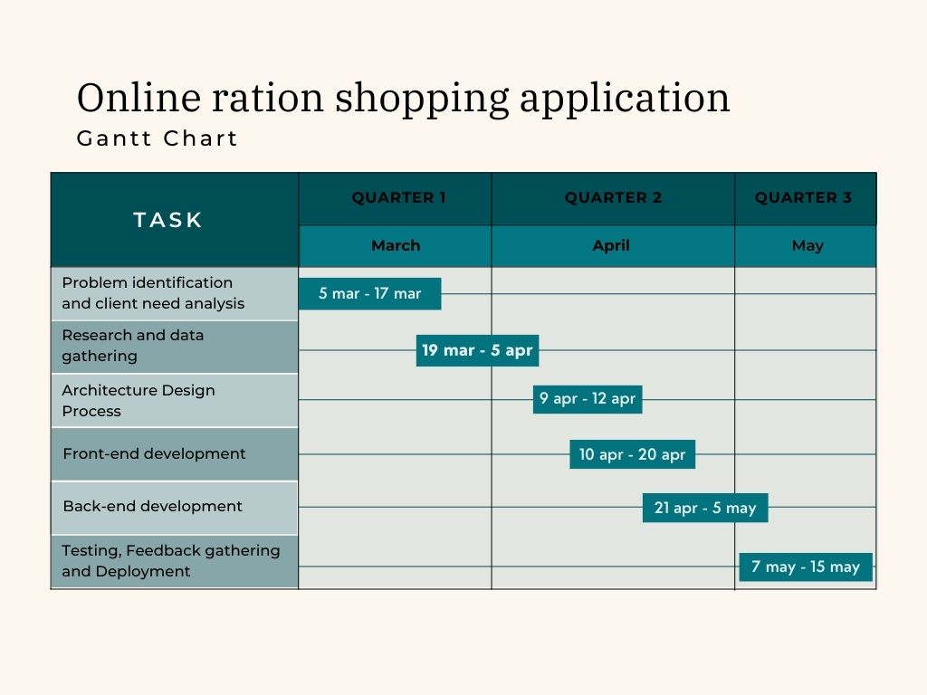

## Oorganization of the Report

**Project Scope, Planning and task Definition:**

This phase comprises of the defining of the scope of the project, recognition and knowledge of relevant issues.

**Literature review and problem identification**:

This includes the explanation of how the literature review section are related to the topic and defines the problem with excellent degree of accuracy, clarity and concision.

**PRELIMINARY DESIGN**:

Multiple approaches, solutions exist, comparison based on advantages and disadvantages done to choose the best feasible model.

**DETAILED SYSTEM DESIGN/TECHNICAL DETAILS**:

Process followed in completing project is well defined and clear. Convey information in structured way with relevant instances/examples. Successful execution from concept to completion.