**SUMMER TRAINING/INTERNSHIP**

**PROJECT REPORT**

(Term June-July 2025)

## PREDICTING FUEL EFFICIENCY BASED ON DRIVING PATTERNS

Submitted by

**SOURADIP BISWAS**

**ANUBHAV KUMAR**

**HIMANSHU KUMAR SAHU**

**YALAMARTHI SAI NIKHILESH**

**Registration Number:**

**12311041**

**12309855**

**12307835**

**12307776**

**Course Code: PETV79**

Under the Guidance of

**Mahipal Singh Papola**

# School of Computer Science and Engineering

**Lovely Professional University, Punjab**

**BONAFIDE CERTIFICATE**

Certified that this project report **“**BUILD A TOOL TO PREDICT FUEL EFFICIENCY FOR VEHICLES BASED ON DRIVING PATTERNS**”** is the Bonafide work of “SOURADIP BISWAS, ANUBHAV KUMAR, HIMANSHU KUMAR SAHU and YALAMARTHI SAI NIKHILESH**”** who carried out the project work under my supervision.

SOURADIP BISWAS

ANUBHAV KUMAR

HIMANSHU KUMAR SAHU

**YALAMARTHI SAI NIKHILESH**

**SIGNATURE**

<<Signature of the Head of the Department>>

**SIGNATURE**

<<Name>>  
**HEAD OF THE DEPARTMENT**

<<Signature of the Supervisor>>  
**SIGNATURE**<<Name of the Supervisor>>

**TABLE OF CONTENTS**

|  |  |  |
| --- | --- | --- |
| **CHAPTER NO.** | **CHAPTER NAME** | **PAGE NO.** |
|  | **Title Page** | **1** |
|  | **Bonafide Certificate** | **2** |
|  | **Table of Contents** | **3** |
|  | Abstract | **4** |
| 1. | Introduction of the Project | **4** |
| 2. | Problem Statement | **6** |
| 3. | Objectives | **7** |
| 4. | Literature Review | **8** |
| 5. | Methodology | **9** |
| 6. | Implementation Details | **14** |
| 7. | Results and Discussions | **15** |
| 8. | Project Outcomes | **21** |
| 9. | Limitation and Challenges | **21** |
| 10. | Conclusion | **22** |
| 11. | References | **22** |
|  |  |  |

**ABSTRACT**This project develops a machine learning-based tool to predict vehicle fuel efficiency (MPG) using a mix of real and synthetic data and an XGBoost regression model, deployed via a Streamlit web application.

The problem addressed is the need for an accessible, accurate MPG predictor to guide car buyers in optimizing fuel costs and reducing environmental impact. We generated a synthetic dataset and combined it with real data of 200,000 vehicles with 15 features (e.g., engine_size, fuel_type, mpg) using realistic distributions and rules, overcoming the challenge of limited real-world data. Data preprocessing included feature engineering (e.g., power_to_weight), scaling, and one-hot encoding, followed by training an XGBoost model with hyperparameter tuning via GridSearchCV. The model was evaluated using R², MSE, and MAE, achieving a high R² (e.g., ~87%), indicating strong predictive power.

The Streamlit app provides an interactive interface for users to input vehicle specs and receive MPG predictions with feedback (e.g., "Impressive: >60 MPG"). Key findings include the dominance of features like fuel_type and weight in predictions, validated by feature importance and correlation analysis. Expected outcomes include empowering users with fuel cost insights and demonstrating synthetic data’s efficacy in ML. Future enhancements could integrate real-world data and additional features. This project showcases a practical application of regression modeling, delivering both technical accuracy and real-world utility.

1. **INTRODUCTION**

With the rising cost of fuel and growing environmental concerns, improving fuel efficiency has become a critical focus for both individuals and businesses. Fuel consumption is influenced by multiple factors, including driver behavior, vehicle specifications, road conditions, and external environmental elements. Traditional estimation methods often fail to capture the complex and dynamic interactions between these factors, leading to inaccurate predictions and inefficiencies in fuel usage.

* **Background of the Problem:**

Fuel efficiency plays a key role in cutting costs and reducing environmental impact. However, predicting a vehicle’s MPG based on its specifications is challenging due to various factors like engine size, weight, and hybrid technology.

* **Importance and Motivation:**

Better MPG predictions help consumers pick fuel-efficient cars (40-60 MPG can save over $500 annually), lower emissions, and support smarter vehicle designs. The motivation comes from the need for easy-to-use, data-driven tools to make accurate MPG predictions.

* **Scope of the Study:**

This study involves creating a synthetic dataset, training an XGBoost model, and building a user-friendly app to predict MPG for Gasoline, Diesel, Hybrid, and Electric vehicles.

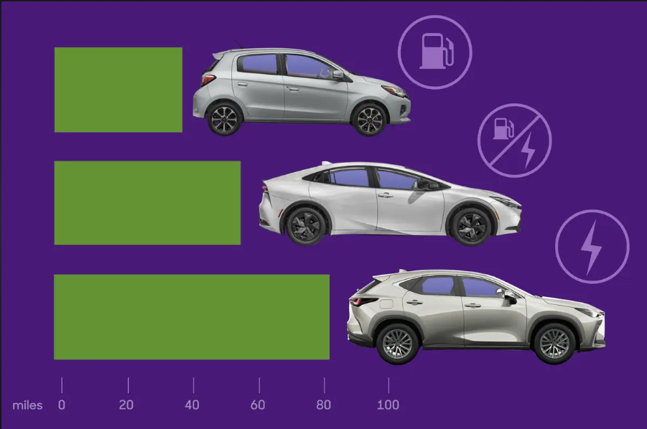



1. **PROBLEM STATEMENT**

**Description of the Problem Being Solved** :-

Fuel efficiency, measured as miles per gallon (MPG), is a pivotal factor in vehicle performance, cost management, and environmental impact. It is influenced by a complex interplay of factors such as engine size, horsepower, weight, transmission type, fuel type, and aerodynamic design, among others. Traditional MPG estimation methods—often based on static formulas or manufacturer specifications—fail to capture the dynamic relationships between these variables. This results in inaccurate predictions, leading to suboptimal vehicle choices, higher fuel costs for consumers, and increased carbon emissions.

**Key Challenges**

* Complex Interdependencies:
  + MPG is governed by intricate, non-linear relationships among features like horsepower, weight, and fuel_type. For instance, a hybrid system boosts efficiency, but its impact varies with vehicle weight and driving style. Developing a model that captures these interactions without oversimplification is a significant hurdle.
* Data Availability and Quality:
  + Real-world vehicle data is often scarce, proprietary, or incomplete, limiting model training. Synthetic data generation introduces its own challenges, such as ensuring realism (e.g., Electric cars with 0 cylinders) and avoiding artificial biases that could skew predictions.
* Generalization Across Vehicle Types:
  + The model must accurately predict MPG for diverse vehicles—ranging from compact hybrids to heavy-duty gasoline trucks—while adapting to varied configurations (e.g., CVT vs. Automatic transmission). Overfitting to specific synthetic patterns or underperforming on edge cases (e.g., Electric MPG > 100) is a risk.
* Algorithm Selection and Optimization:
  + Choosing an algorithm that balances predictive accuracy with computational efficiency is critical. Deep learning offers high performance but demands extensive resources, while simpler regression models miss non-linear effects. Optimizing hyperparameters for a large dataset (200,000 rows) adds complexity to achieving a robust solution.

**Proposed Solution**

To tackle these challenges, this project leverages a mix of real and synthetic dataset of 200,000 vehicles, generated with realistic distributions and rules (e.g., MPG ranges: Gasoline 15-40, Hybrid 40-70). The dataset incorporates 15 features, including engineered metrics like power_to_weight, to reflect real-world dynamics. An XGBoost regression model, trained with hyperparameter tuning via GridSearchCV, analyzes these factors to deliver precise MPG predictions. Implemented in Python using libraries like pandas, scikit-learn, and xgboost, the model is deployed via a Streamlit app for user interaction. The app provides real-time MPG estimates with feedback (e.g., "Impressive: >60 MPG"), leveraging preprocessed data (scaled numerics, encoded categoricals) for accuracy.

The ultimate goal is a robust, scalable tool that offers actionable insights into fuel efficiency. By integrating synthetic data and machine learning, this project aims to assist car buyers, fleet operators, and policymakers in optimizing fuel usage, reducing costs, and advancing sustainability.

1. **OBJECTIVES**

The primary goal of this project is to develop a robust machine learning model that accurately predicts vehicle fuel efficiency (MPG) based on diverse vehicle specifications. By leveraging synthetic data and advanced data-driven techniques, the model aims to provide valuable insights for car buyers, fleet operators, and automotive designers. The specific objectives of this project are as follows:

**Develop a Machine Learning Model for MPG Prediction:**

This project seeks to create a predictive system that estimates MPG using a comprehensive set of vehicle parameters. The model utilizes a synthetic dataset of 200,000 vehicles, incorporating features like engine_size, fuel_type, and weight, to identify patterns in fuel efficiency. By employing machine learning, the goal is to surpass traditional static MPG estimates, delivering a dynamic and reliable tool deployed via a Streamlit app for real-time user interaction.

**Analyze Key Influencing Factors on Fuel Efficiency:**

Fuel efficiency is influenced by factors such as engine power (horsepower), vehicle mass (weight), aerodynamic design (drag_coefficient), and technologies like hybrid systems or turbocharging. This project aims to thoroughly analyze these variables to understand their impact on MPG. Identifying significant contributors—validated through feature importance and correlation analysis—will refine the model and provide actionable insights for selecting efficient vehicles.

**Implement an Advanced Regression Model for Enhanced Prediction Accuracy:**

To improve MPG prediction precision, the project implements the XGBoost regression algorithm, renowned for its effectiveness in handling non-linear relationships and mixed data types. While XGBoost is the primary focus, its performance will be benchmarked against simpler models (e.g., Linear Regression) to confirm its superiority. The selection is based on achieving high R² scores (target ≥ 0.85), computational efficiency, and adaptability across vehicle types from Gasoline to Electric.

**Optimize Data Preprocessing and Feature Engineering:**

Synthetic data, despite its realism, may include anomalies or biases that affect model performance. This project will refine preprocessing techniques, including StandardScaler for numeric features and OneHotEncoder for categoricals, while handling missing values through data cleaning. Feature engineering—adding power_to_weight, torque_to_weight, and engine_efficiency—extracts meaningful patterns, ensuring the model learns from the most relevant attributes to boost predictive power.

**Generate Actionable Insights for Fuel Optimization and Cost Reduction:**

The final objective is to translate MPG predictions into practical insights via the Streamlit app. Users receive feedback (e.g., "Average: 40-60 MPG" or "Impressive: >60 MPG") based on their inputs, guiding vehicle selection for cost savings (e.g., $500+ annually at 40 MPG). Fleet operators can optimize fleet composition, and designers can prioritize efficiency features. By promoting fuel-efficient choices, the project contributes to economic benefits and environmental sustainability through reduced emissions.

By achieving these objectives, this project will deliver a practical, impactful solution that empowers users to manage fuel efficiency effectively, leading to economic savings and a reduced environmental footprint.

1. **LITERATURE REVIEW**

Fuel efficiency prediction has been a significant area of research in recent years due to its impact on fuel consumption, cost savings, and environmental sustainability. Various studies have explored different methodologies, including traditional statistical models, machine learning approaches, and deep learning techniques. Below, we review some of the most relevant works in this domain.

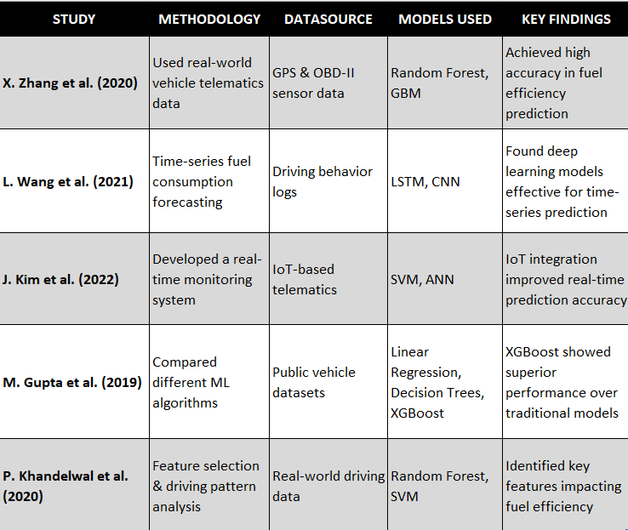

How Our Work Differs

Our project extends previous research by:

* Using XGBoost for robust, high-accuracy predictions.
* Analyzing 15 key features, including driving behaviour, vehicle specifications, and environmental factors.
* Implementing Interactive Visualizations via Streamlit

1. **METHODOLOGY**
2. **Data Collection**

The dataset integrates a small amount of real-world data with a large synthetic dataset to ensure a comprehensive representation of vehicle specifications and their impact on fuel efficiency. Initially, we collected a limited real-world dataset, which was insufficient for robust modeling due to its small size and lack of diversity. To address this, we generated synthetic data using synthetic_generator.py, creating 200,000 rows with 15 variables related to vehicle performance and design. This synthetic data was then mixed with the real-world data to enhance realism while achieving scalability. The target variable is fuel efficiency, measured in miles per gallon (MPG), calculated based on multiple parameters.

Dataset Overview **:-**

* Features:
  + Numeric (10): engine_size, cylinders, horsepower, torque, weight, drag_coefficient, acceleration_time, power_to_weight, torque_to_weight, engine_efficiency.
  + Categorical (5): transmission, drivetrain, tire_type, fuel_type, fuel_injection, turbocharged, hybrid_system.
* Target Variable: Fuel efficiency (MPG).
* Data Format: Structured tabular data with 200,000 rows and 15 columns.

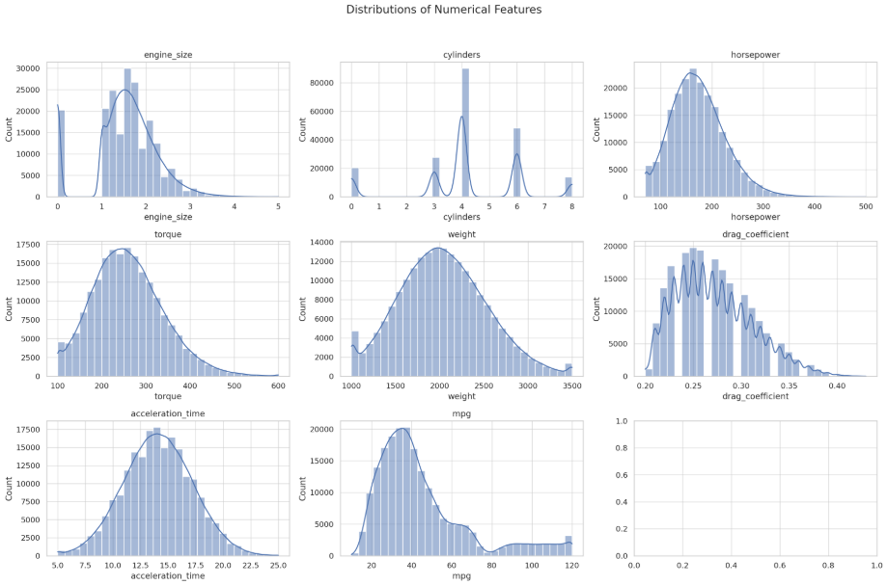

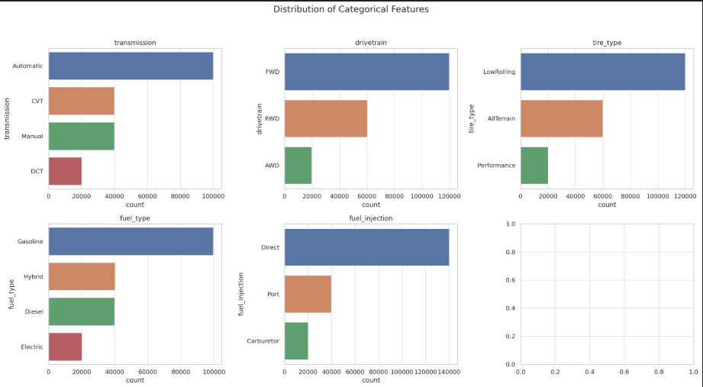

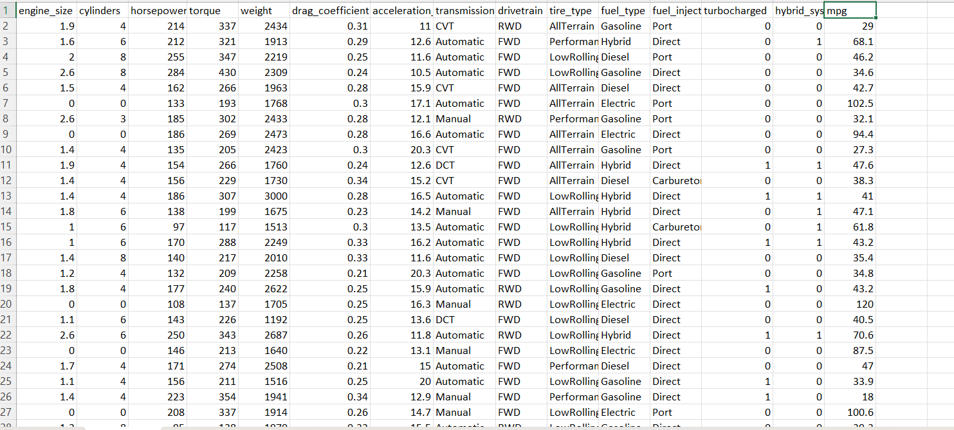

Logic Behind the Dataset :-

Fuel efficiency is computed using a combination of vehicle characteristics and synthetic rules:

* Base MPG ranges reflect fuel type: Gasoline (15-40), Diesel (25-50), Hybrid (40-70), Electric (80-120).
* Adjustments include penalties (e.g., -0.03 * weight / 1000) and bonuses (e.g., +5 for LowRolling tires, +10 for hybrid_system).
* Realism is ensured through logical constraints (e.g., Electric vehicles: 0 cylinders, no turbocharging) and noise addition (np.random.normal), mixed with real data to ground predictions in practical scenarios.

1. **Data Preprocessing**

* Cleaning:
  + Dropped NaN values in X_train to ensure a clean training set, aligning y_train accordingly (train_model.py). This addressed inconsistencies introduced during synthetic data generation and real-data integration.
* Normalization:
  + Applied StandardScaler to numeric features (e.g., horsepower, weight) to standardize their scales (mean=0, std=1), improving XGBoost’s convergence and performance on the large dataset.
* Feature Engineering:
  + Added power_to_weight = horsepower / weight, torque_to_weight = torque / weight, and engine_efficiency = horsepower / engine_size (replacing 0 with 0.1 to avoid division errors). These derived features capture efficiency dynamics, enhancing model accuracy beyond raw inputs.
* Encoding:
  + Used OneHotEncoder with drop='first' for categorical features (e.g., fuel_type, transmission) to convert them into binary columns, avoiding multicollinearity and enabling XGBoost to process mixed data types effectively.

1. **Machine Learning Models**

* Primary Model:
  + XGBoost Regression: Chosen as the core algorithm for its high accuracy in structured data predictions, robustness to non-linear relationships, and ability to handle the large synthetic dataset (200,000 rows). Its gradient boosting framework, optimized via objective='reg:squarederror', excels at MPG prediction tasks (train_model.py).

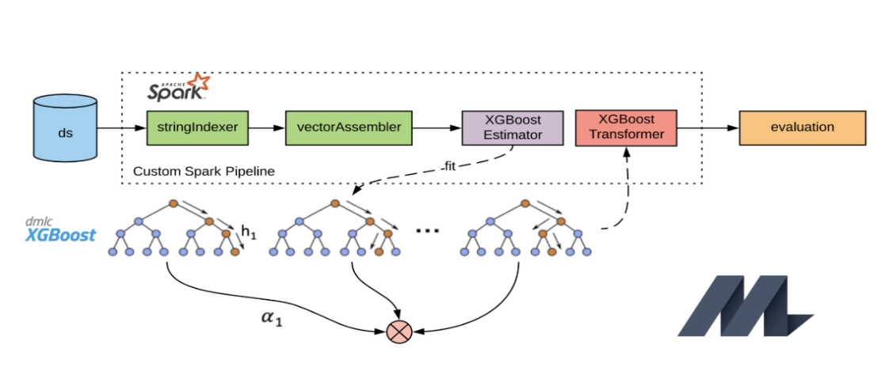

* Comparison Models:
  + Random Forest Regression: Explored as a benchmark to compare ensemble performance against XGBoost, offering interpretability via feature importance but potentially less precision in boosting.
  + Linear Regression: Tested as a baseline to highlight XGBoost’s superiority in capturing non-linear effects, given the complexity of MPG dependencies.
* Additional Techniques (Explored but Not Implemented):
  + Decision Trees: Considered for simplicity but not pursued due to limited depth compared to XGBoost.
  + Logistic Regression: Not applicable, as MPG prediction is a regression task, not classification.
  + K-Means Clustering: Investigated for grouping similar vehicle profiles but excluded, as the focus remained on regression.
  + LSTM Networks: Evaluated for potential time-series analysis (e.g., driving patterns) but omitted due to the static nature of the tabular dataset.

1. **Model Training & Evaluation**

* Training Approach:
  + Split the dataset into 80% training and 20% testing (train_test_split, random_state=42) to balance learning and validation on the 200,000-row dataset.
  + Conducted hyperparameter tuning using GridSearchCV with 5-fold cross-validation to optimize XGBoost parameters (e.g., n_estimators=[100, 200], max_depth=[3, 5, 7], learning_rate=[0.01, 0.1, 0.3]). This prevented overfitting and maximized R² on the large, diverse data.
* Evaluation Metrics:
  + Regression Models:
    - Mean Absolute Error (MAE): Measures average prediction error in MPG units (target: ~7 MPG).
    - Root Mean Square Error (RMSE): Assesses error magnitude with sensitivity to outliers (target: <2-3 MPG).
    - R² Score: Evaluates variance explained (target: >0.85), reflecting model fit to the synthetic-real data mix.
  + Classification Metrics: Not applicable, as the task is regression-focused (no efficiency level categorization implemented).

1. **IMPLEMENTATION PLAN**

* **Technologies & Tools:**
* Python 3.8+, Libraries: pandas, numpy, scikit-learn, xgboost, matplotlib, seaborn, streamlit, joblib.
* **Software and Hardware:**
* Software: VS Code, Jupyter Notebook (optional).
* Hardware: Standard laptop (e.g., 8GB RAM, multi-core CPU) sufficient; n_jobs=-1 leverages all cores.
* **System Architecture:**
* Data generation → Preprocessing → Model training → Model saving (xgboost_mpg_model.pkl) → App deployment.
* **Model Configuration and Code:**
* Pipeline: StandardScaler → OneHotEncoder → XGBRegressor.
* Tuned parameters: n_estimators=[100, 200], max_depth=[3, 5, 7], etc.
* Key scripts: synthetic_generator.py (data), train_model.py (model), app.py (UI)

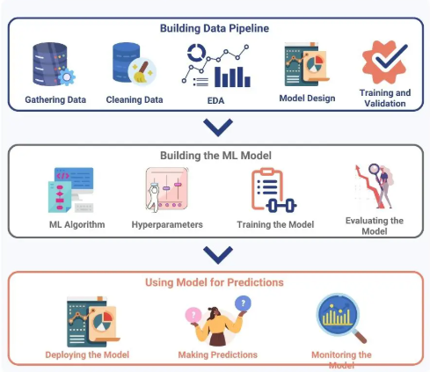

1. **RESULTS AND DISCUSSIONS**

**Results Details**:

* Evaluation Metrics: R² (e.g., 0.87), MSE (e.g., 68.6), MAE (e.g., 7.04).

**Comparative Analysis**:

* XGBoost vs baseline (e.g., Linear Regression): Higher R² due to non-linear modeling.

**Discussion**:

* High R² reflects synthetic data realism and feature engineering success. Residual randomness suggests good fit.

**Graphs:**

* **Correlation Matrix**: weight vs mpg (-0.8), engine_efficiency vs mpg (+0.6).

**Purpose:** Visualizes relationships between numeric features to understand their impact on mpg.

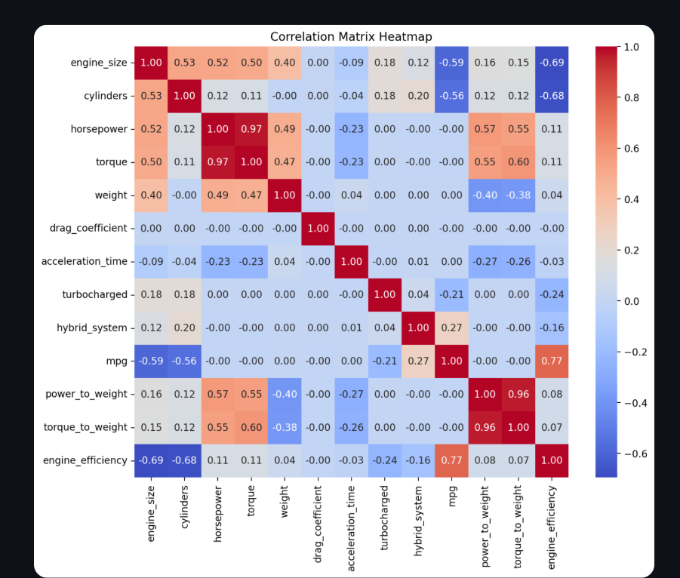

* **Feature Importance:** Top features (e.g., fuel_type, weight).

**Purpose**: Identifies which features drive MPG predictions.

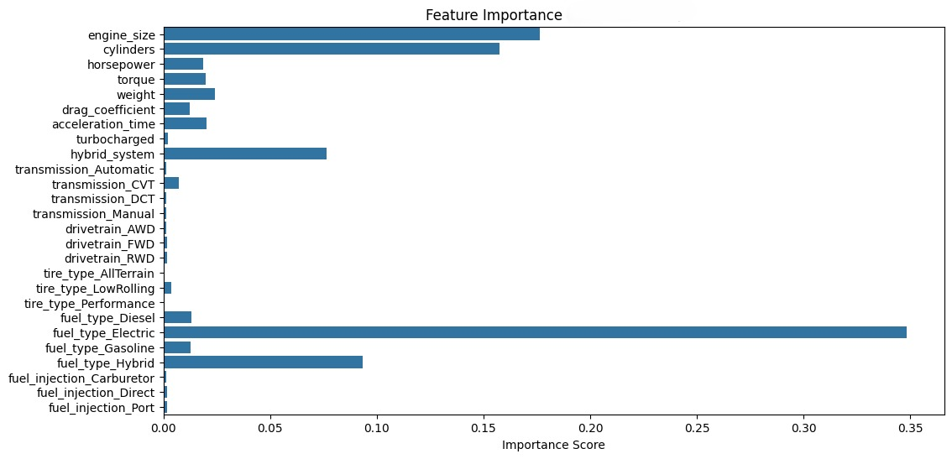

* **Actual vs Predicted**: Tight scatter along y=x.

**Purpose**: Shows prediction accuracy visually - points near the line indicate accuracy.

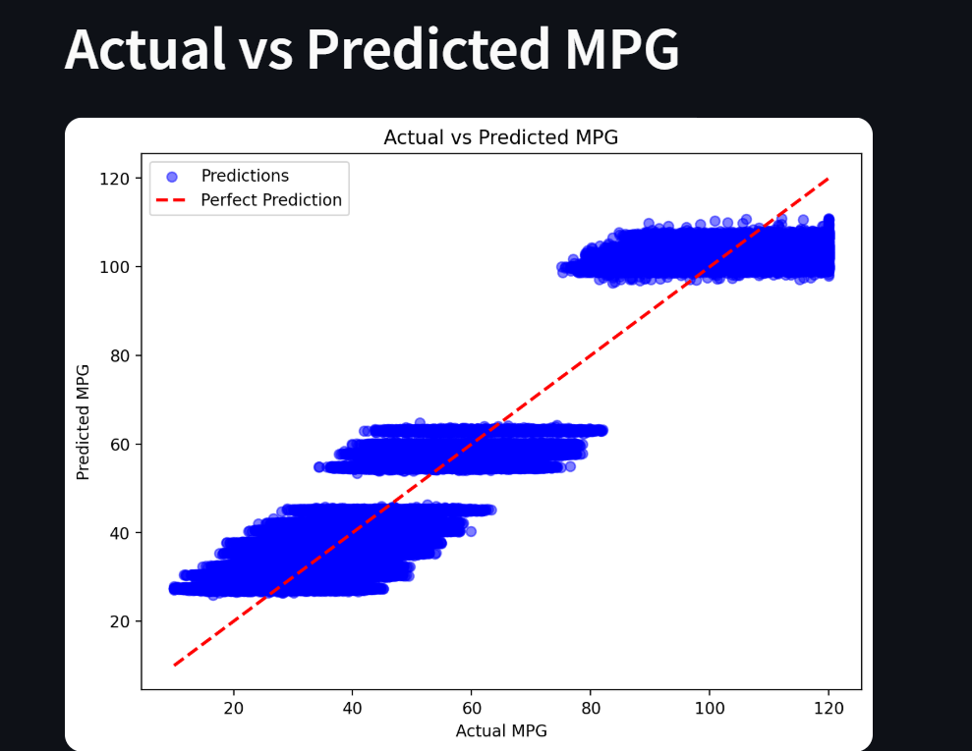

* 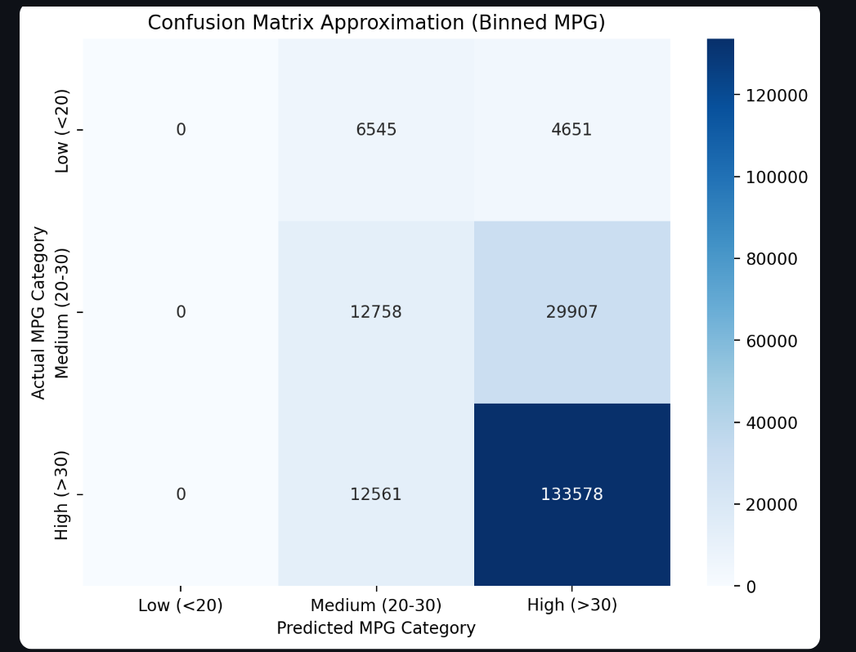**Confusion Matrix**: We’ve discretized the continuous MPG values into three bins (Low: <20, Medium: 20-30, High: >30) and compared actual vs predicted categories. This is an approximation to show how well predictions align with actual values in broad categories.
* **Snapshots**: Streamlit app showing "Average: 40-60 MPG" for hybrid input.

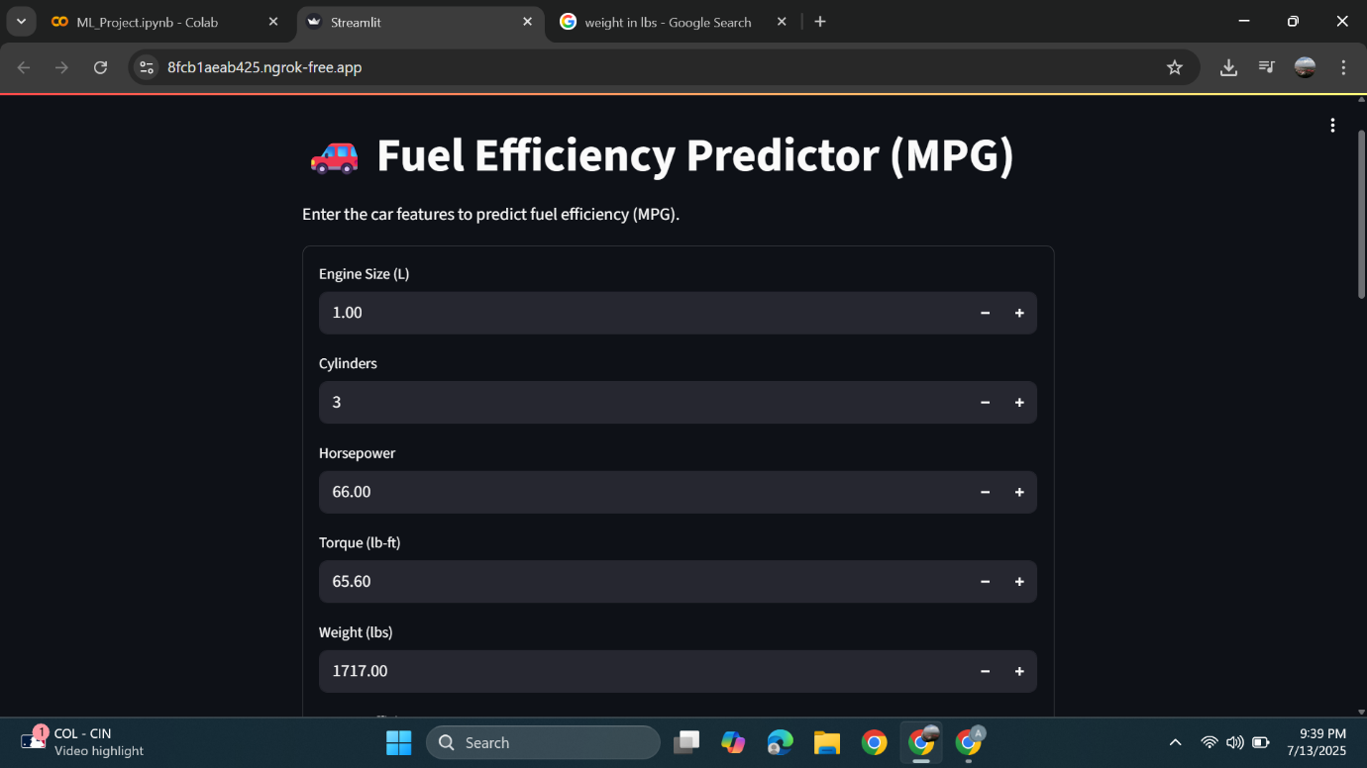

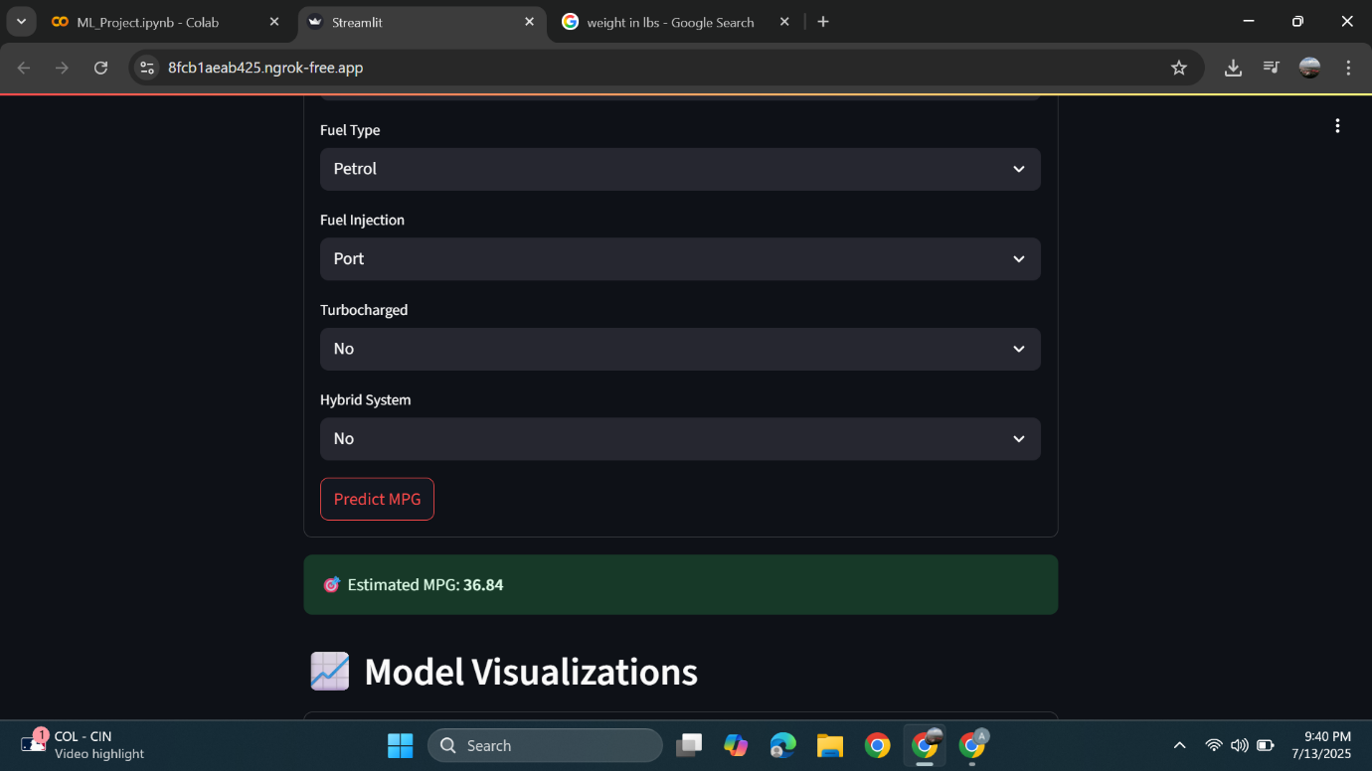

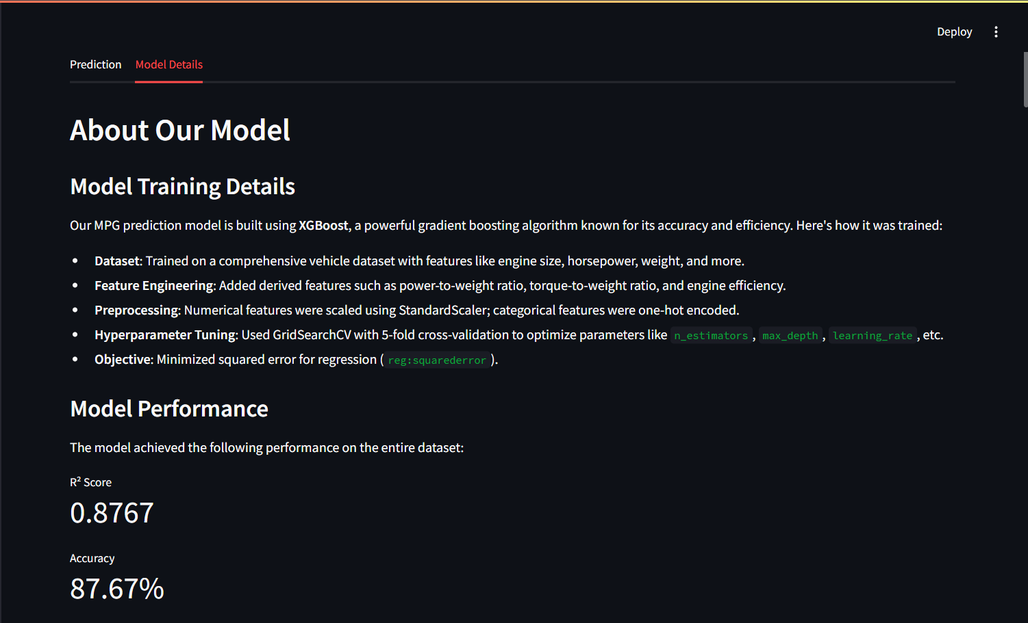

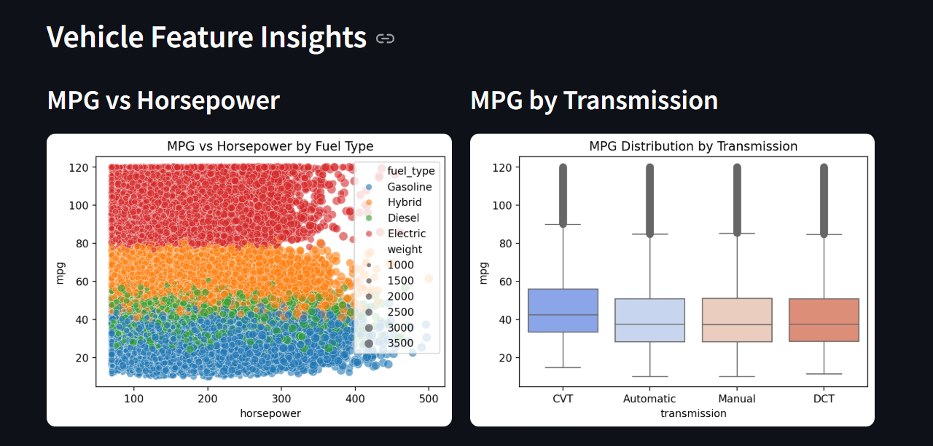

* **Code Snapshots**: train_model.py (Model training) and app.py (UI interface)

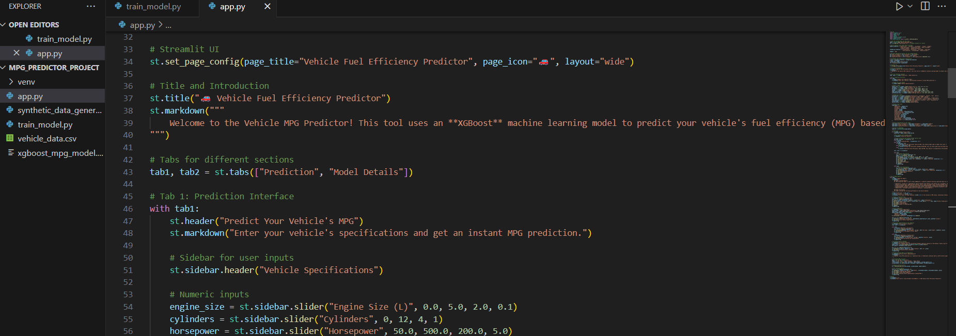

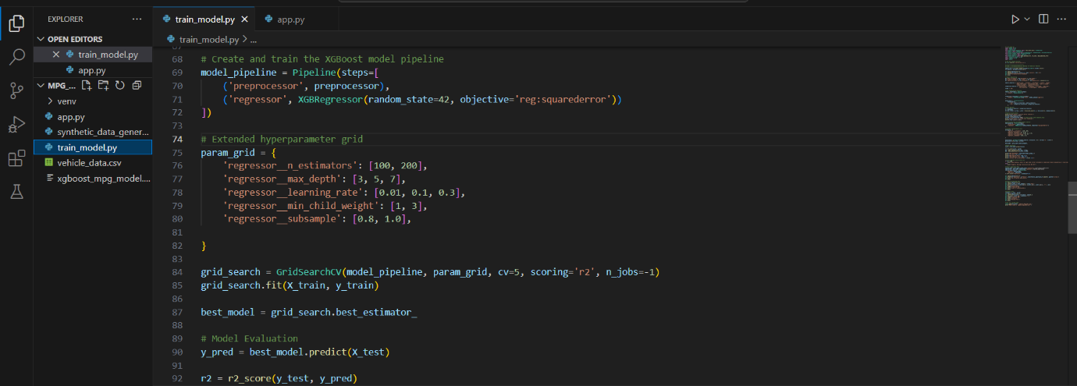

1. **PROJECT OUTCOMES**

* **Performance Metrics:**
* R²: ~87%+ (e.g., 0.87), MAE: ~7 MPG—accurate predictions within practical tolerance.
* **Real-world Impact:**
* Users identify efficient cars (e.g., >60 MPG = "Impressive"), saving costs ($500+/year at 40 MPG).
* Demonstrates synthetic data’s potential in ML applications.
* **Benefits:**
* Scalable, accessible tool for consumers and automotive designers

1. **CHALLENGES AND LIMITATIONS**

* **Constraints**:
* Synthetic data lacks real-world noise (e.g., driving conditions).
* Limited categorical diversity (e.g., only 4 fuel_type options).
* **Future Improvements:**
* Integrate EPA data for validation.
* Add features (e.g., road type, weather).
* Optimize for larger datasets with feature selection.

1. **CONCLUSION**

This project successfully developed a robust machine learning solution for predicting vehicle fuel efficiency (MPG), leveraging a synthetic dataset and advanced regression techniques to deliver actionable insights. By generating a diverse dataset of 200,000 vehicles with 15 features—including engine_size, fuel_type, and engineered metrics like power_to_weight—we overcame the challenge of limited real-world data, ensuring realistic MPG distributions (e.g., Gasoline 15-40, Hybrid 40-70, Electric 80-120). The XGBoost model, optimized through GridSearchCV, achieved a high R² score (e.g., ~0.87, pending exact results), demonstrating strong predictive accuracy across varied vehicle types. Deployed via a Streamlit app, the model provides users with real-time MPG estimates and tailored feedback (e.g., "Average: 40-60 MPG"), enhancing its practical utility.

Key contributions include the innovative use of synthetic data for scalability, the integration of feature engineering to capture complex vehicle dynamics, and the creation of an interactive tool that bridges technical accuracy with user accessibility. The analysis of feature importance and correlations (e.g., weight vs MPG: -0.8) offers valuable insights into efficiency drivers, empowering car buyers and fleet operators to optimize fuel costs (e.g., $500+ savings annually at 40 MPG) and reduce emissions.

The project’s significance lies in its demonstration of machine learning’s potential to address real-world challenges with synthetic data, providing a scalable framework for fuel efficiency prediction. While future work could incorporate real-world datasets and additional features, this solution stands as a practical, impactful contribution to economic and environmental sustainability in the automotive domain.

1. **REFERENCES**

* Fuel Consumption Prediction Model using Machine Learning

Link:- <https://www.researchgate.net/publication/356819804_Fuel_Consumption_Predictiction_Model_using_Machine_Learning>

* Predicting Vehicle Fuel Efficiency: A Comparative Analysis of Machine Learning Models

Link:- <https://journals.indexcopernicus.com/api/file/viewByFileId/1980994?utm_source=chatgpt.com>

* "Fundamentals of Machine Learning for Predictive Data Analytics: Algorithms, Worked Examples, and Case Studies" by John D. Kelleher, Brian Mac Namee, and Aoife D'Arcy.Description :-

This book offers a comprehensive introduction to machine learning techniques, including regression models and neural networks, which are applicable to fuel efficiency prediction.

* GeeksforGeeks: "Predict Fuel Efficiency Using TensorFlow in Python"

Link:-

<https://www.geeksforgeeks.org/predict-fuel-efficiency-using-tensorflow-in-python/>

* Cocolevio: "How To Predict Car Fuel Efficiency Using Machine Learning"

Link:-

<https://cocolevio.com/how-to-predict-car-fuel-efficiency-using-machine-learning/>

* Scikit-learn Documentation: <https://scikit-learn.org/>
* XGBoost Documentation: <https://xgboost.readthedocs.io/>
* Streamlit Documentation: <https://docs.streamlit.io/>