Supplementary Information:

How much gut content data is required to predict trophic

interactions?

Anubhav Gupta Eoin O’ Gorman other authors Owen L. Petchey

25 May 2022

# Supplementary Information

## Gut content data simulation

We simulated a food web using the ADBM for a given set of parameters. For a given set of predators, we subset the diet from the simulated food web. Then using a probability mass function (distribution), we sampled the gut content data from predators’ diet thereby incorporating the uncertainty in the gut content data. We repeated this process multiple number of times for every predator in the food web.

*Input:*

* Predators whose diet are to be simulated *P* = *{p*1*,...,pn}*
* A simulated food web *ADBM*(*θi*) = *{dp*1*,dp*1*,...,dpk}*, where *dpk* is a one-dimensional diet matrix of predator *k* containing ones and zeros.
* A function which describes uncertainty in the diet *U*(*d*)
* Number of independent guts to be simulated for a predator *pi* : *ngut Sampling:*
* for *pi ∈ P*
  + for *j* = 1*,...,ngut*, where *ngut* is the number of guts to be simulated

∗ Simulate a single gut of a predator *pi* : *g*(*pi*) = *dpi ∗ U*(*dpi*)

* + Set of gut of a predator *pi* : *G*(*pi*) = *{g*(*pi*) : *g*(*pi*) = *dpi ∗ U*(*dpi*)*}*

*Output:*

* We simulated a pool of gut content data which contains simulated gut content data *G*(*pi*) for every predator *pi*

## Prediction using gut content data from a simulated food web

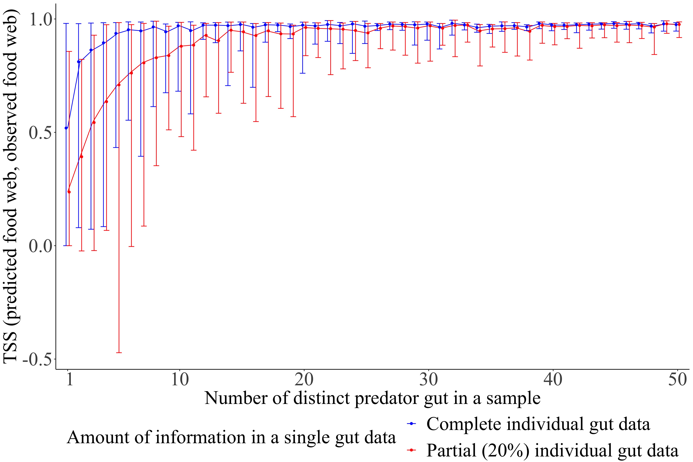

Figure S1: True skill statistics between predicted food web and observed food web for a simulated small reef food web estimated for distinct predator guts in a sample. The observed simulated food web consists of 50 species and ...links. The vertical bars correspond to the prediction intervals of the true skill statistics with filled circles representing the corresponding mean. A prediction interval of the TSS is formed using a set of 100 accepted TSS values using the ABC method.

The true skill statistics (TSS) between the predicted food web and simulated observed food web saturated with an increasing number of distinct predator guts in a sample (Fig. S1). The TSS of the predicted food webs estimated using the complete individual gut data had narrower prediction intervals resulting in less uncertainty, and higher mean TSS than that using the partial individual gut data. The maximum limit of the prediction interval of TSS estimated using the complete gut data and the partial gut data were almost equal, with the minimum limit of the prediction interval of TSS using partial gut data being lower than that from the complete gut data. Eventually, the gap between the mean TSS using the partial gut data and the complete gut data reduced with an increasing number of distinct predator guts. This suggests that when there is enough predator species’ gut data, the achieved TSS was almost constant and hence independent of the amount of gut data.

The maximum TSS estimated using the complete gut data was very close to one and almost remained constant with an increasing number of different predator species sampled. With the gut data sample of only five distinct predator species, 95% of the maximum mean TSS was achieved when complete individual gut data was used, while the same was achieved with 15 predator species for partial gut data. This shows that one does not need to know the gut data of all the species to predict the food web and the accuracy is dependent on the completeness of an individual gut data.

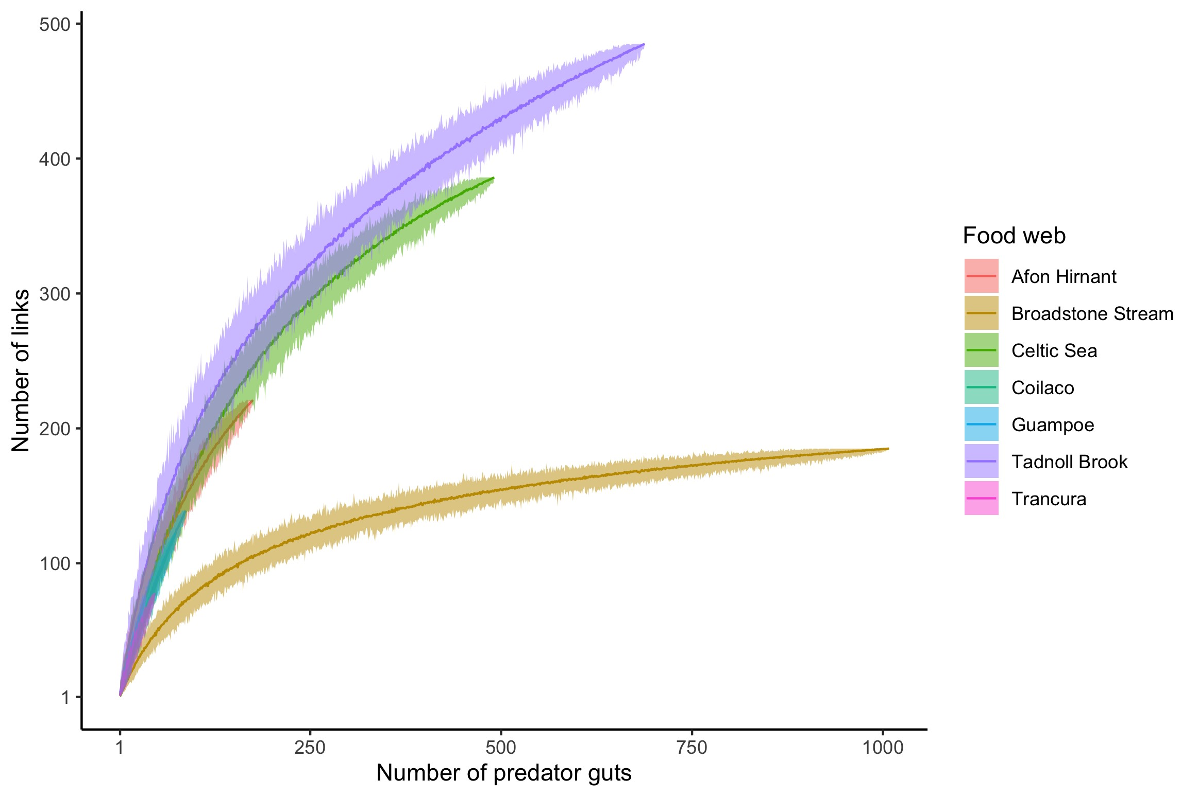

Figure S2: Link accumulation curve of the food web constructed using gut content data plotted against number of gut content data.