Effect of the amount of gut content data on the accuracy and precision of food web prediction

# Alternate titles

* Predicting trophic interactions using incomplete gut content data
* Optimal amount of gut content data required to predict trophic interactions

# Introduction

## Why knowing trophic interactions is important?

Knowledge about the trophic interactions in a food web can be used to answer crucial ecological questions: Which species is a keystone species in a food web (Jord’an 2009)? How would a food web respond if the top predators are removed (Knight et al. 2005)? Which species should be given priority when conservation efforts are implemented (McDonald-Madden et al. 2016)? How robust is a food web to extinctions (Dunne, Williams, and Martinez 2002)?

## What are the methods for knowing interactions?

Species interactions can be inferred from different types of methods such as gut content analysis (Peralta-Maraver, Lopez-Rodriguez, and de Figueroa 2017), stable isotope ratio analysis of tissues (Layman et al. 2007), experimentation (Warren 1989) and DNA metabarcoding (Roslin and Majaneva 2016). The types of information extracted from these methods vary. E.g. Gut content analysis of a predator results in the identification of prey species fed upon by that predator, while the stable isotope ratio analysis of the organism’s tissue can help us infer the approximate trophic position of that species in the food web.

## Gut content analysis

Gut content data have been used to predict the diet of a predator in a food web (Eitzinger et al. 2018; O’NAMalley et al. 2017; Dixon et al. 2017; McClain-Counts, Demopoulos, and Ross 2017; Peralta-Maraver, Lopez-Rodriguez, and de Figueroa 2017). A single gut content data of a predator gives the information what the predator has consumed recently. The diet of that individual can be inferred from the items in the stomach. There is considerable uncertainty involved in this method (Baker, Buckland, and Sheaves 2014). E.g. In fish, there is ambiguity while separating prey items in the gut. There are loose tissues that are not identifiable and cannot be assigned to a specific prey item with certainty. There are factors such as sample size of consumers, mechanical prey handling, differential digestion and evacuation rates of different types of different prey types and volumes, and the ingestion order that in combination result in an unquantifiable error which is difficult to interpret in the predator diet (Hyslop 1980; Rindorf and Lewy 2004; Baker, Buckland, and Sheaves 2014).

## Why inferring interactions is not easy?

As a food web can be quite complex with many species and trophic interactions (Williams and Martinez 2000; Berlow et al. 2009), inferring these trophic interactions with high accuracy and low uncertainty would require a large amount of food web data (citreqd). E.g. One would need to sample many individuals for gut content data, and processing these guts require a large amount of effort and time as well.

Gut content data might only be used to infer the partial diet of a predator individual because gut content data only provides the information of the prey individuals that have been foraged by the predator recently. There is also a possibility that some of the information provided by these types of food web data are redundant i.e. taking into account any further food web data does not necessarily increase the food web prediction significantly. E.g. This can happen if the guts of two predator individuals give the same information about the prey the predator has consumed.

## Undersampled food web

When interactions are difficult to observe in a food web, this results in an undersampled food web i.e there are missing links in the food web. Limitations of resources and time can also lead to an undersampled food web because collecting and analysing gut content data is tedious and expensive task (citreqd). It is crucial to have well sampled food web because food web properties are highly sensitive to varying levels of sampling effort (Goldwasser and Roughgarden 1997). It is important to predict food web properties with high accuracy and high precision.

## What is a food web model and how can it be used to compensate for undersampling?

When we have an undersampled food web, food web models can be used to predict which trophic interactions are feasible and which are not (Allesina, Alonso, and Pascual 2008; Cohen, Newman, and Steele 1985; Gravel et al. 2013; Petchey et al. 2008; Tamaddoni-Nezhad et al. 2013). Food web model are set of rules governed by ecological theory which defines trophic interactions in a food web. For example, Petchey et al. (2008) based on foraging traits allometrically scaled using body size data of species predicted trophic interactions where the model was parameterised using known presence and absence of trophic interactions.

## Explain oversampling/diminishing returns when using a food web model

One of a common method of knowing trophic interactions is gut content analysis, which can be used to parameterise these model. When one has a well sampled food web constructed with information from gut content data, using a food web model might not result in any further improvement in food web prediction. It is crucial to know at what amount of gut content data this occurs because we do not want to spend resources on sampling any further.

## Research question

How much gut content data is required when a food web model is used to predict trophic interactions? We are interested in maximizing the accuracy and precision of the predicted food web and simultaneously minimizing the amount of gut content data used.

## What we do in our study and how?

In this paper, we answer how much gut content is optimal to predict a food web with high accuracy and high precision and until what quantity of gut content data it is advantageous to use a food web model. We predict the trophic interactions using allometric diet breadth model (ADBM) and use incomplete gut content data to parameterise the ADBM using approximate Bayesian computation (ABC).

# Materials and Methods

In the upcoming sections, we present the gut content data and the allometric diet breadth model (ADBM) used to infer trophic interactions. We also give a detailed account of using partial gut content data to parameterise the ADBM using approximate Bayesian computation (ABC). We assessed model predictions using true skill statistic and various structural food web properties for comparison across food webs.

## Broadstone Stream food web

Broadstone Stream (51 05’ N 0 03’ E; 120 m above sea-level) is a second-order tributary of the River Medway in south-east England. It is dominated by invertebrates as the acidity of the stream (pH 4.7-6.6) excludes fish. The stream consists of 25 common invertebrate species (Woodward, Speirs, and Hildrew 2005a). Among the predators, the three large species are *Cordulegaster boltonii* Donovan, *Sialis fuliginosa* Pict. and *Plectrocnemia conspersa* [Curtis] and the three small species are the larvae of the tanypod midges *Macropelopia nebulosa* [Meigen], *Trissopelopia longimana* [Staeger], and *Zavrelimyia barbatipes* [Kieffer]. Broadstone Stream food web is one of the most completely described food webs for any system (Schmid-Araya et al. 2002; Hildrew 2009; Layer et al. 2010; and Woodward, Speirs, and Hildrew 2005b).

The Broadstone Stream food web in our study was constructed by aggregating by size (Woodward et al. 2010a) i.e a node is defined as collection of individuals within a specified size range. There were a total of 1008 gut content data. The number of prey items in predator’s gut varied within a predator size class (Fig. ). A single gut did not give complete information about the diet of a predator as can be observed from the species accumulation curves (Fig. ).

## Celtic Sea food web

Description of Celtic Sea food web here

## Allometric Diet Breadth Model (ADBM)

The allometric diet breadth model (ADBM) is based on optimal foraging theory, specifically the contingency foraging model (MacArthur and Pianka 1966). The ADBM predicts the set of prey species a consumer should feed upon to maximise its rate of energy intake (Petchey et al. 2008). The foraging variables in the model: energy content of the resources, handling times of the prey, space clearance rate and prey densities are allometrically scaled to the body sizes of the species.

The model correctly predicted a greater proportion of links when the trophic interactions were more strongly dependent on size (Petchey et al. 2008). Indeed, constructing a food web based only on body size (i.e. ignoring taxonomy) resulted in almost twice the number of correctly predicted links, i.e. 83%, in contrast to taxonomy (Woodward et al. 2010b). The goodness of fit of the ADBM’s predictions depends on the types of interactions in the food webs (Petchey et al. 2008), because some of the interactions are more size structured than other interactions. For instance, predacious and aquatic herbivore interations were predicted better than parasitoid and herbivory ones (Petchey et al. 2008).

## Inferring food web using gut content data

From a pool of gut content data, we draw a set of gut content data randomly. Then we used the rejection ABC to accept a parameter value which would have resulted in the minimum distance, where distance = 1 - True skill statistic and the true skill statistic was computed between the predators’ diet predicted from the ADBM and the sampled gut content data. We repeated this process for number of times for every number of guts, where lies between 1 and total number of gut content data in the pool.

*Input:*

* Predators
* A pool of gut content data , where is a one-dimensional matrix containing ones and zeros.
* A model prediction , where is a one-dimensional diet matrix of predator containing ones and zeros.
* A summary statistic
* A distance function
* An observed food web

*Sampling:*

for where is the total number of gut content data in the pool

* for where is the number of independent samples to be drawn
  + Draw a set of gut content data from the pool of gut content data
  + for where is the number of parameter values to be sampled
    - Draw a set of parameter values from the prior distribution
    - Compute the model result
    - Compute and
  + Accept , which results in the
* Compute using the accepted

*Output:*

A prediction interval containing between observed and predicted food webs for every number of gut content data drawn from the pool of gut content data.

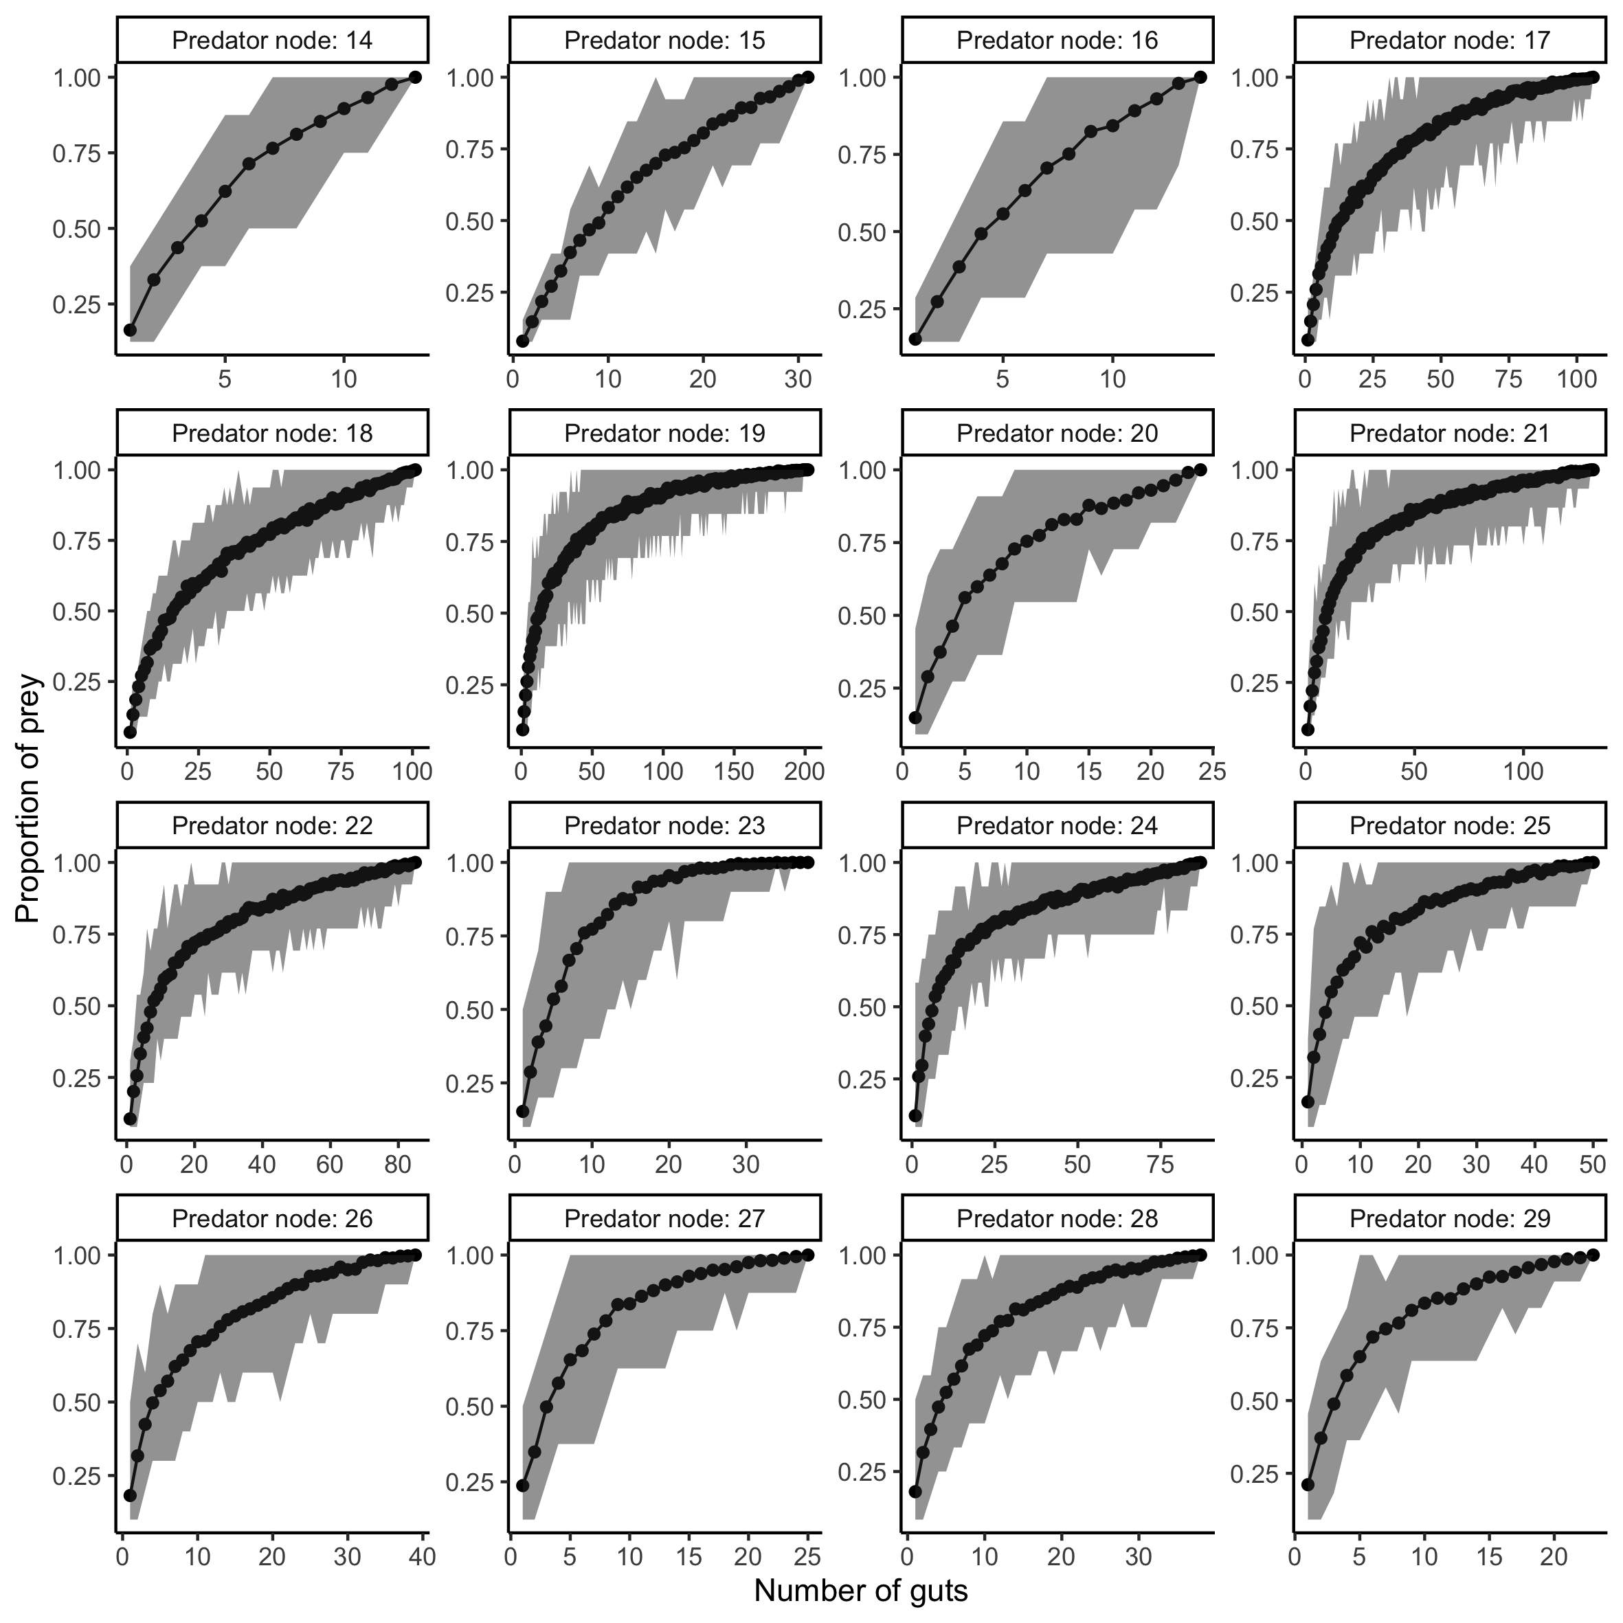

Species accumulation curve of diets of the predators belonging to a size class in Broadstone Stream food web. Each panel represents diet of predators belonging to different size classes. The grey region represents the prediction interval of proportion of prey for the 1000 independent samples drawn from a pool of gut content data.

## Assessment of prediction

The accuracy of the predicted diet of the predators was defined using true skill statistic (TSS) which takes into account the true and false predictions of both the presence and absence of links defined as:

where is the number of observed links that are predicted by the model (true positives), is the number of observed absences of links that are correctly predicted (true negatives), is the number of false positives, and is the number of false negatives.

The ranges from to , where +1 indicates a perfect prediction. A value of zero or less indicates a performance no better than random.

## Positive returns and negative returns

We compared the food web prediction from the model and gut content data with food web constructed using gut content data. If the food web prediction from the model and gut content data are better compared to that constructed using gut content data, then we call it positive returns else negative returns.

# Results

We first present the accuracy of the ADBM in predicting food web structure when the ADBM is parameterised using incomplete gut content data. Then, we present the upper limit of the amount of gut content data where using the ADBM results in positive returns. We also compute the structural properties and compare the predicted structural properties from the model with that obtained using only gut content data.

## Inferring trophic interactions using ADBM and incomplete gut content data

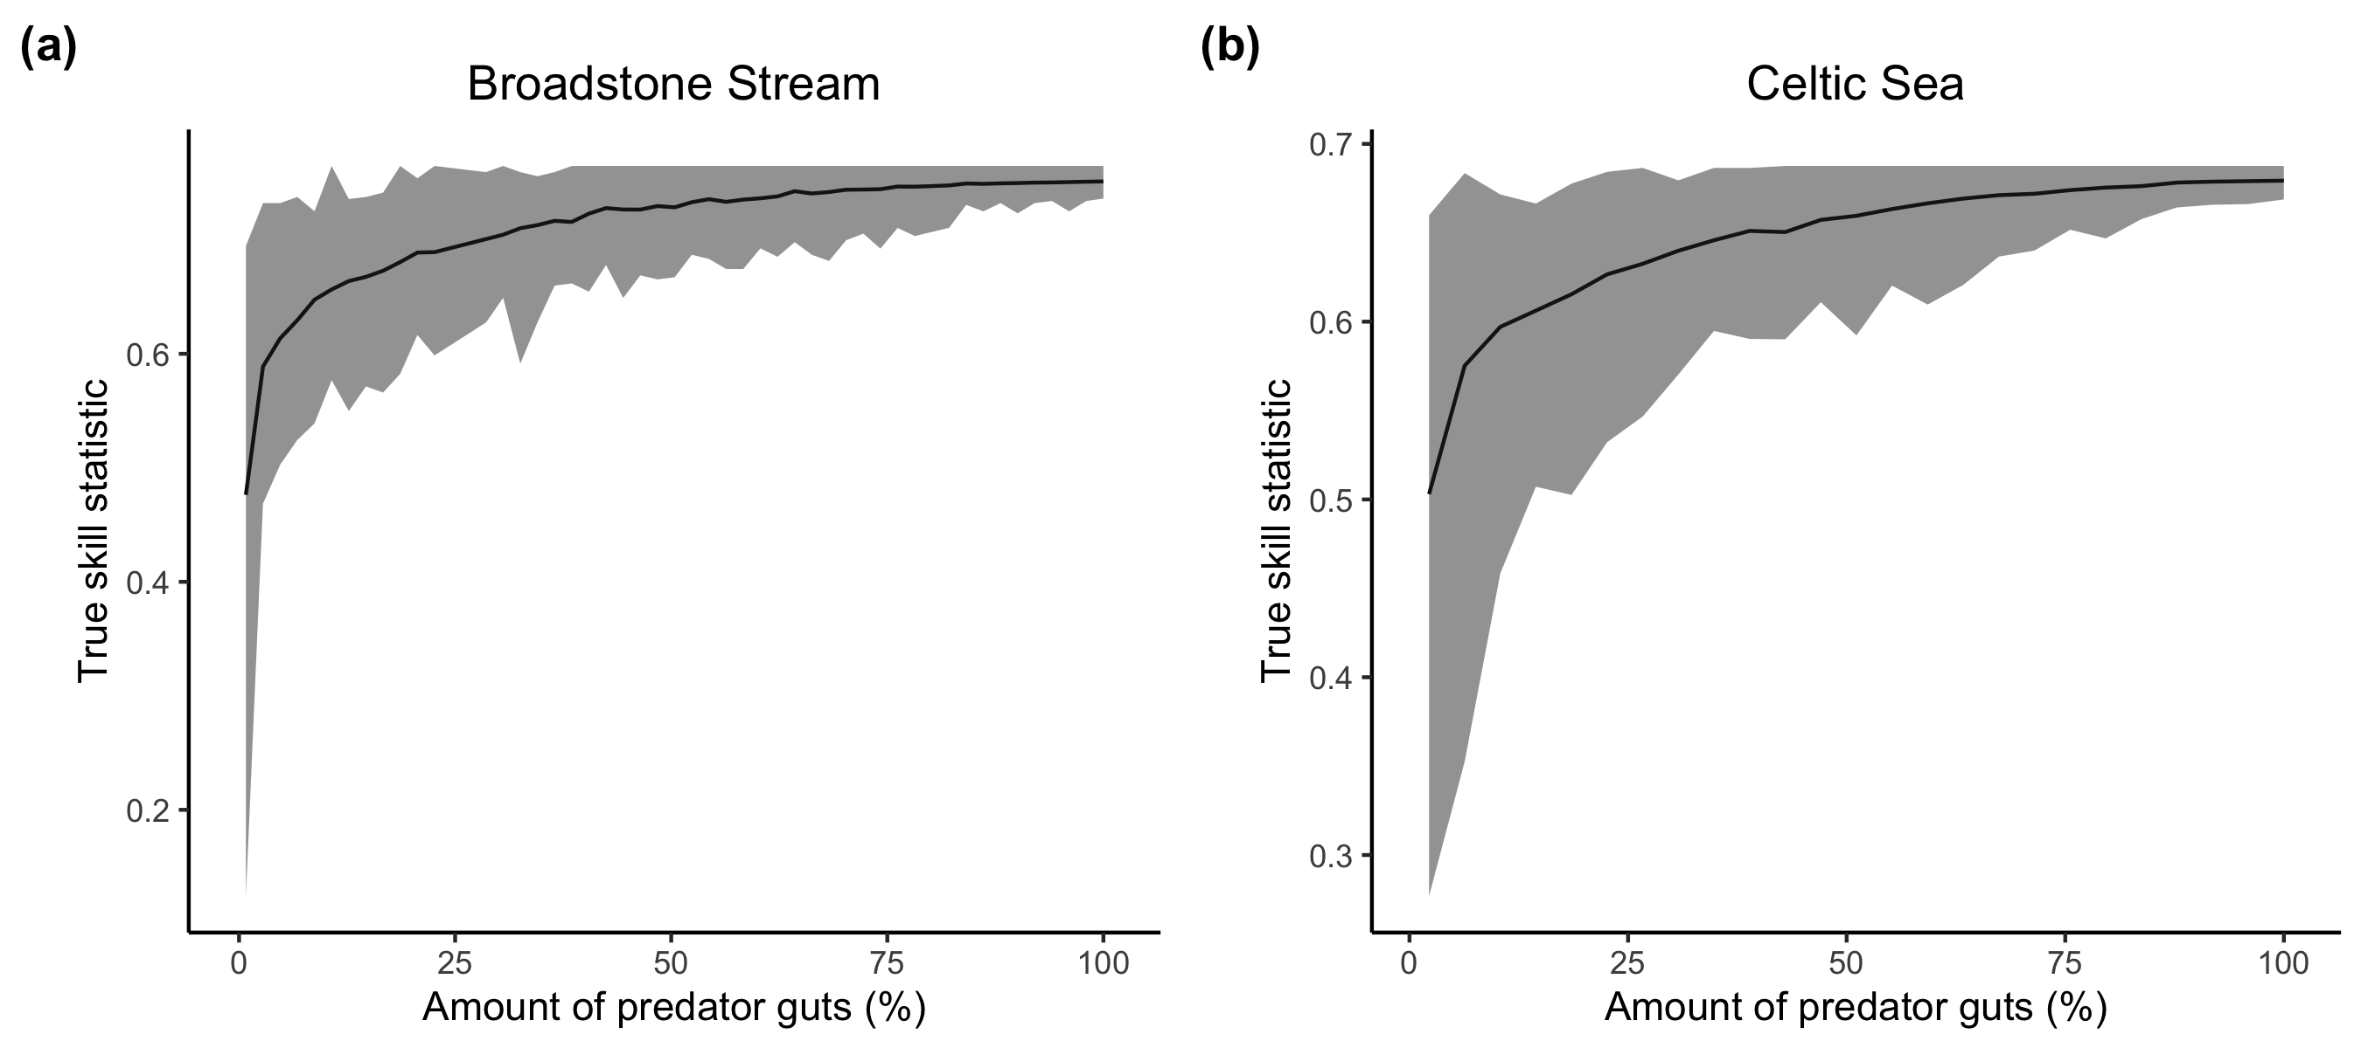

True skill statistics between the predicted and observed predation matrices for Broadstone Stream and Celtic Sea food web computed for different amount of predator guts. Line and shaded region represents the mean and the prediction interval of 100 independent samples respectively.

The value of true skill statistics between the predicted food web from the ADBM and the observed food web saturated quickly with the increasing number of predator guts (Fig. ). The uncertainty in the TSS reduced with the increasing number of predator guts. With only 23% of the total gut content data, the ADBM was able to achieve 0.69 TSS which was 91% of the mean TSS (0.75) achieved using complete gut content data by the ADBM for Broadstone Stream food web (Fig. (a)). In case of the Celtic Sea food web using only 23% of the complete gut content data, the ADBM achieved a TSS of 0.63 which was 92% of the mean TSS (0.68) obtained by the ADBM when we used the complete gut content data (Fig. (b)).

## Accuracy of food web constructed using model parameterised with data vs accuracy of food web constructed using gut content data only

It was advantageous to use the ADBM for predicting trophic interactions when we have a low amount of gut content data (Fig. ) i.e less than 30-40% of the total gut content data because we achieve a higher TSS when we use a model as compared to when we would have only used the gut content data. However, at a higher gut content data using the ADBM did not result in better prediction when compared to predictions from only the gut content data. For Broadstone Stream food web, it was better to use the ADBM when we have gut content data less than around 30% (Fig. (a)).

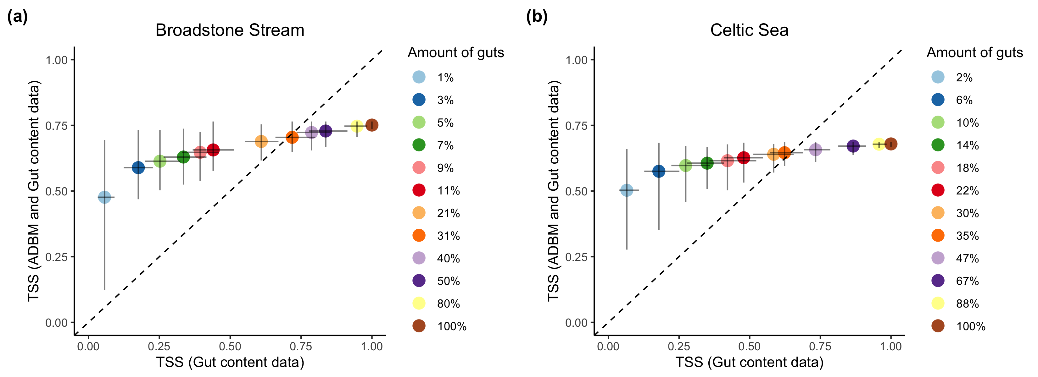

True skill statistic between predicted food web using ADBM and incomplete gut content data, and observed food web against the true skill statistic between food web constructed using incomplete gut content data, and observed food web. Error bars represent prediction intervals of 100 independent samples. Dashed line is 1:1 line for reference.

## Mean standardised error in food web properties

The ADBM’s prediction of structural properties of the food web compared to prediction using only gut content data was better when we used a lower amount of gut content data to parameterise the ADBM (Fig. ). While at a higher amount of gut content data, the (Fig. ) structural properties of food web constructed using only gut content data was predicted better when compared to prediction from the ADBM parameterised using the gut content data.

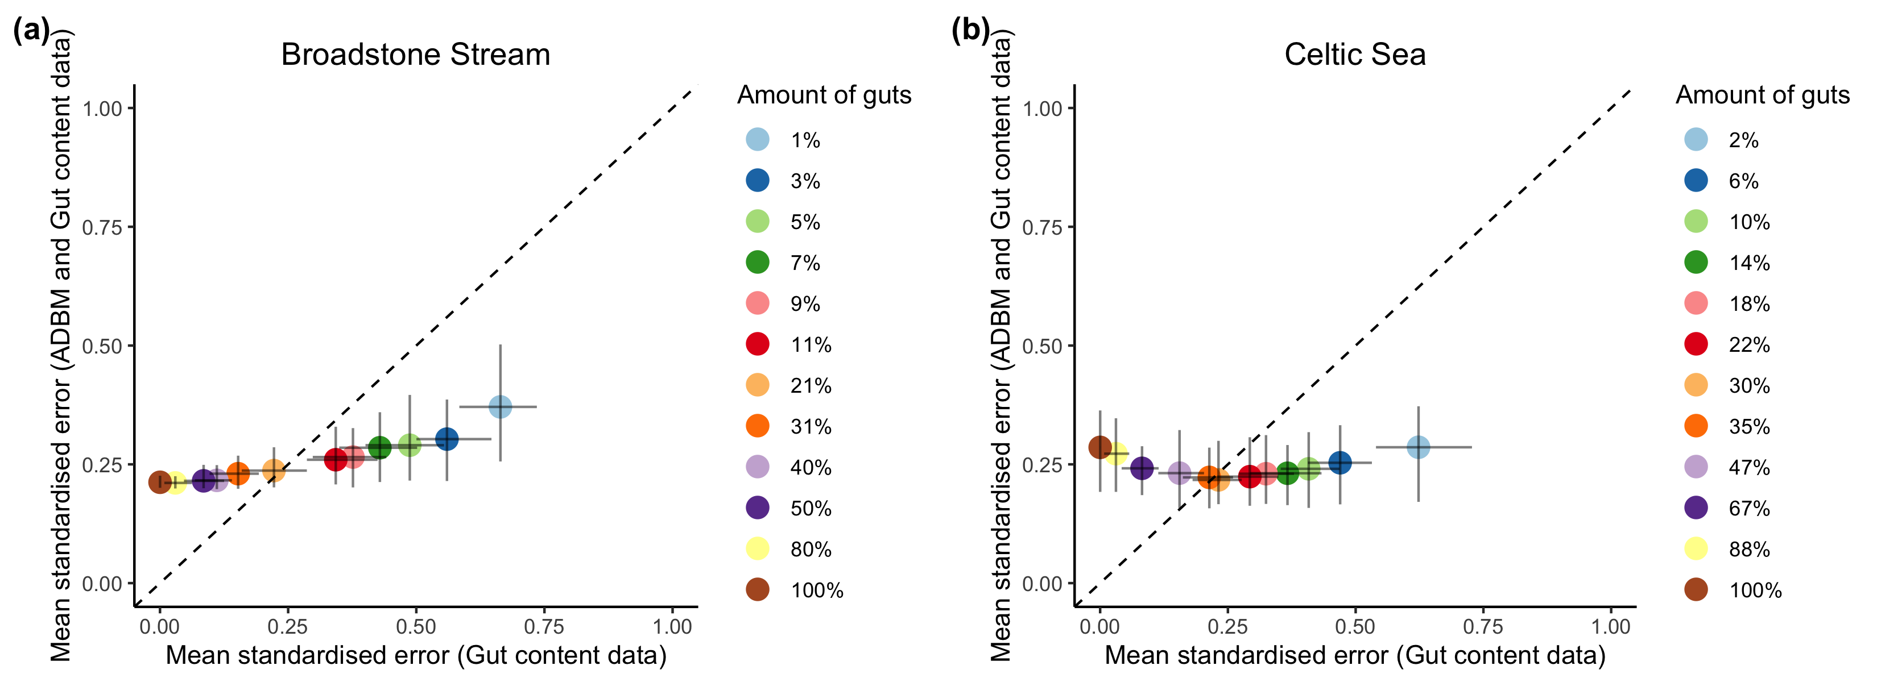

Mean standardised error in structural properties in the food web predicted using ADBM and incomplete gut content data against structural properties in the predicted food web constructed using incomplete gut content data. Error bars represent prediction intervals of 100 independent samples. Dashed line is 1:1 line for reference.

# Discussion

We have demonstrated how a food web model can be used to predict food web in the availability of incomplete data. At lower amount of gut content data, ADBM is quite better at predicting trophic interactions. We also compute the upper limit of amount of gut content data till when it is advantageous to use the ADBM. This can help us decide how much gut content data to actually collect when we are using a food web model to infer trophic interactions.

## Why incomplete gut content data can be used to infer trophic interactions?

* Model fills up the missing interactions
* Partial data helps to constrain the parameter space

Food web model is set of rules based on ecological theory which defines trophic interactions in a food web. A food web model does better in predicting trophic interactions provided the trophic interactions in an ecosystem is governed by these rules.

## Other studies and how is our study different than theirs?

Some studies have presented how the accuracy of food web prediction change when we vary the amount of food web data (Gray et al. 2015).

## How much generalisable are our results?

* Dependent on how size structured a food web is, how the food web is aggregated, the type of interactions

## Assumption that the food web constructed with the total gut content data is the true food web

Our study is based on the assumption that the food web constructed using the complete gut content data is the true food web. However, it might not be the case as the links are still under-sampled for many nodes (Woodward et al. 2010a). This could result in a lower TSS of the predicted food web from the model which can lead to a higher upper limit on the amount of gut content data.

## How can we include other food web data type?

* experimentation (feeding trials)
* DNA Metabarcoding

## Extending the approach to other food web models

* Current approach could be implemented with other food web models

We have used rejection ABC to make use of incomplete gut content data to parameterise the ADBM. In theory, the ADBM could be replaced with any other food web models that predicts presence and absence interactions.

# Conclusion

# Supplementary Information

## Gut content data simulation

We simulated a food web using the ADBM for a given set of parameters. For a given set of predators, we subset the diet from the simulated food web. Then using a probability mass function (distribution), we sampled the gut content data from predators’ diet thereby incorporating the uncertainty in the gut content data. We repeated this process multiple number of times for every predator in the food web.

*Input:*

* Predators whose diet are to be simulated
* A simulated food web , where is a one-dimensional diet matrix of predator containing ones and zeros.
* A function which describes uncertainty in the diet
* Number of independent guts to be simulated for a predator

*Sampling:*

* for
  + for , where is the number of guts to be simulated
    - Simulate a single gut of a predator
  + Set of gut of a predator

*Output:*

* We simulated a pool of gut content data which contains simulated gut content data for every predator

## Prediction using simulated gut content data from a simulated food web

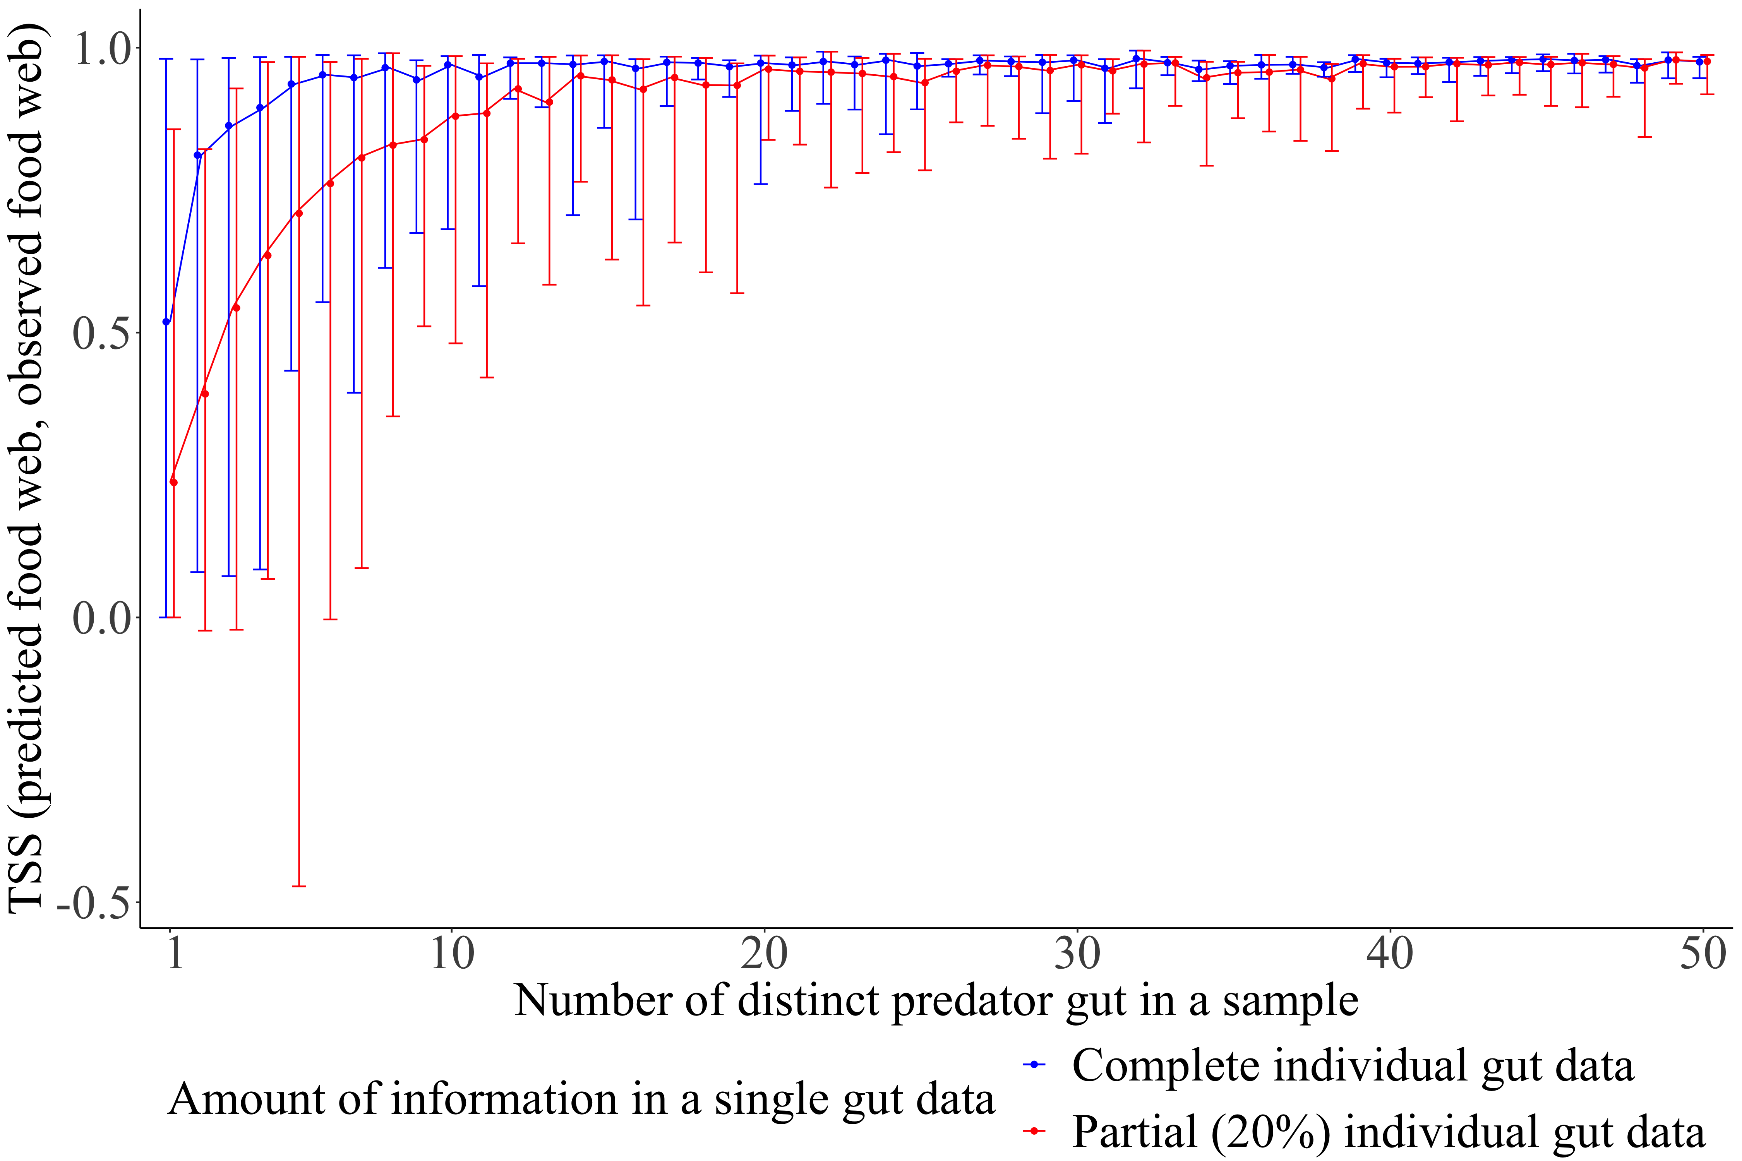

True skill statistics between predicted food web and observed food web for a simulated small reef food web estimated for distinct predator guts in a sample. The observed simulated food web consists of 50 species and links. The vertical bars correspond to the prediction intervals of the true skill statistics with filled circles representing the corresponding mean. A prediction interval of the TSS is formed using a set of 100 accepted TSS values using the ABC method.

The true skill statistics (TSS) between the predicted food web and observed food web saturated with an increasing number of distinct predator guts in a sample (Fig. ). The TSS of the predicted food webs estimated using the complete individual gut data had shorter prediction intervals resulting in less uncertainty, and higher mean TSS than that using the partial individual gut data. The maximum limit of the prediction interval of TSS estimated using the complete gut data and the partial gut data were almost equal, with the minimum limit of the prediction interval of TSS using partial gut data being lower than that from the complete gut data. Eventually, the gap between the mean TSS using the partial gut data and the complete gut data reduced with an increasing number of distinct predator guts suggesting when we have enough predator species’ gut data, the achieved TSS was almost constant and hence independent of the amount of gut data.

The maximum TSS estimated using the complete gut data was very close to one and almost remained constant with an increasing number of different predator species sampled. With the gut data sample of only five distinct predator species, 95% of the maximum mean TSS was achieved when complete individual gut data was used, while the same was achieved with 15 predator species for partial gut data. This shows that one does not need to know the gut data of all the species to predict the food web and the accuracy is dependent on the completeness of an individual gut data.

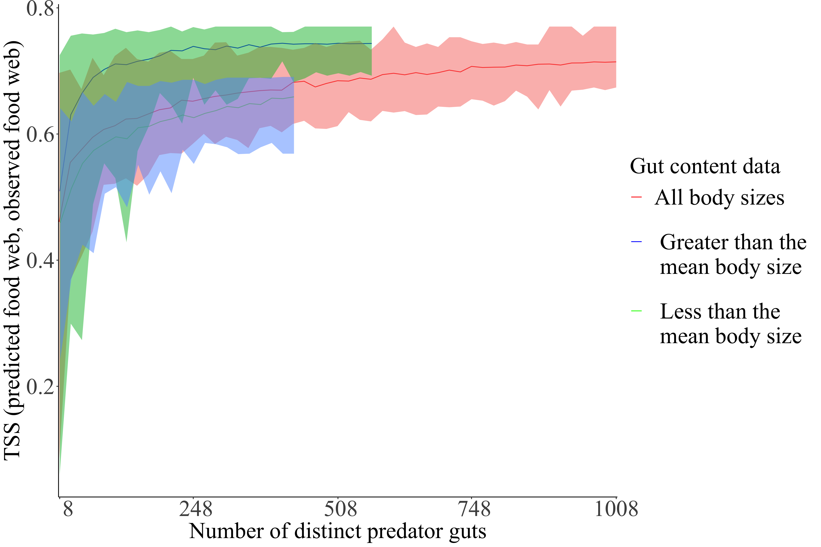

True skill statistics between predicted food web and observed food web estimated for different number of distinct predator guts. The estimation is done for three sets of gut data: gut content data of predators whose body sizes are smaller than the mean body size, larger than the mean body size, and all the gut content data.

# Acknowledgements

# Author contributions

# References

Allesina, Stefano, David Alonso, and Mercedes Pascual. 2008. “A General Model for Food Web Structure.” *Science* 320 (5876). American Association for the Advancement of Science: 658–61. <https://doi.org/10.1126/science.1156269>.

Baker, Ronald, Amanda Buckland, and Marcus Sheaves. 2014. “Fish Gut Content Analysis: Robust Measures of Diet Composition.” *Fish and Fisheries* 15 (1): 170–77. <https://doi.org/10.1111/faf.12026>.

Berlow, E. L., J. A. Dunne, N. D. Martinez, P. B. Stark, R. J. Williams, and U. Brose. 2009. “Simple Prediction of Interaction Strengths in Complex Food Webs.” *Proceedings of the National Academy of Sciences* 106 (1): 187–91. <https://doi.org/10.1073/pnas.0806823106>.

Cohen, Joel E., C. M. Newman, and John Hyslop Steele. 1985. “A Stochastic Theory of Community Food Webs I. Models and Aggregated Data.” *Proceedings of the Royal Society of London. Series B. Biological Sciences* 224 (1237). Royal Society: 421–48. <https://doi.org/10.1098/rspb.1985.0042>.

Dixon, Heather J., J. Brian Dempson, Timothy F. Sheehan, Mark D. Renkawitz, and Michael Power. 2017. “Assessing the Diet of North American Atlantic Salmon (Salmo Salar L.) Off the West Greenland Coast Using Gut Content and Stable Isotope Analyses.” *Fisheries Oceanography* 26 (5): 555–68. <https://doi.org/10.1111/fog.12216>.

Dunne, Jennifer A., Richard J. Williams, and Neo D. Martinez. 2002. “Network Structure and Biodiversity Loss in Food Webs: Robustness Increases with Connectance.” *Ecology Letters* 5 (4): 558–67. <https://doi.org/10.1046/j.1461-0248.2002.00354.x>.

Eitzinger, Bernhard, Björn C. Rall, Michael Traugott, and Stefan Scheu. 2018. “Testing the Validity of Functional Response Models Using Molecular Gut Content Analysis for Prey Choice in Soil Predators.” *Oikos* 127 (7): 915–26. <https://doi.org/10.1111/oik.04885>.

Goldwasser, Lloyd, and Jonathan Roughgarden. 1997. “Sampling Effects and the Estimation of Food-Web Properties.” *Ecology* 78 (1): 41–54. <https://doi.org/10.1890/0012-9658(1997)078[0041:SEATEO]2.0.CO;2>.

Gravel, Dominique, Timoth’ee Poisot, Camille Albouy, Laure Velez, and David Mouillot. 2013. “Inferring Food Web Structure from Predator-Prey Body Size Relationships.” Edited by Robert Freckleton. *Methods in Ecology and Evolution* 4 (11): 1083–90. <https://doi.org/10.1111/2041-210X.12103>.

Gray, Clare, David H. Figueroa, Lawrence N. Hudson, Athen Ma, Dan Perkins, and Guy Woodward. 2015. “Joining the Dots: An Automated Method for Constructing Food Webs from Compendia of Published Interactions.” *Food Webs* 5 (December): 11–20. <https://doi.org/10.1016/j.fooweb.2015.09.001>.

Hildrew, Alan G. 2009. “Chapter 4 Sustained Research on Stream Communities.” In *Advances in Ecological Research*, 41:175–312. Elsevier. <https://doi.org/10.1016/S0065-2504(09)00404-8>.

Hyslop, E. J. 1980. “Stomach Contents Analysis—a Review of Methods and Their Application.” *Journal of Fish Biology* 17 (4): 411–29. <https://doi.org/10.1111/j.1095-8649.1980.tb02775.x>.

Jord’an, Ferenc. 2009. “Keystone Species and Food Webs.” *Philosophical Transactions of the Royal Society B: Biological Sciences* 364 (1524): 1733–41. <https://doi.org/10.1098/rstb.2008.0335>.

Knight, Tiffany M., Michael W. McCoy, Jonathan M. Chase, Krista A. McCoy, and Robert D. Holt. 2005. “Trophic Cascades Across Ecosystems.” *Nature* 437 (7060): 880–83. <https://doi.org/10.1038/nature03962>.

Layer, Katrin, Jens O. Riede, Alan G. Hildrew, and Guy Woodward. 2010. “Food Web Structure and Stability in 20 Streams Across a Wide pH Gradient.” In *Advances in Ecological Research*, 42:265–99. Elsevier. <https://doi.org/10.1016/B978-0-12-381363-3.00005-8>.

Layman, Craig A., D. Albrey Arrington, Carmen G. Montaña, and David M. Post. 2007. “Can Stable Isotope Ratios Provide for Community-Wide Measures of Trophic Structure?” *Ecology* 88 (1): 42–48. <https://doi.org/10.1890/0012-9658(2007)88[42:CSIRPF]2.0.CO;2>.

MacArthur, Robert H., and Eric R. Pianka. 1966. “On Optimal Use of a Patchy Environment.” *The American Naturalist* 100 (916): 603–9.

McClain-Counts, Jennifer P., Amanda W.J. Demopoulos, and Steve W. Ross. 2017. “Trophic Structure of Mesopelagic Fishes in the Gulf of Mexico Revealed by Gut Content and Stable Isotope Analyses.” Journal Article. *Marine Ecology* 38 (4). <https://doi.org/10.1111/maec.12449>.

McDonald-Madden, E., R. Sabbadin, E. T. Game, P. W. J. Baxter, I. Chad‘es, and H. P. Possingham. 2016. “Using Food-Web Theory to Conserve Ecosystems.” *Nature Communications* 7 (1, 1). Nature Publishing Group: 10245. <https://doi.org/10.1038/ncomms10245>.

O’NAMalley, Brian P., Lars G. Rudstam, James M. Watkins, Toby J. Holda, and Brian C. Weide. 2017. “Effects of Food Web Changes on Mysis Diluviana Diet in Lake Ontario.” *Journal of Great Lakes Research*, Special Section on Lake Ontario CSMI 2013, 43 (5): 813–22. <https://doi.org/10.1016/j.jglr.2017.02.003>.

Peralta-Maraver, I., M. J. Lopez-Rodriguez, and J. M. Tierno de Figueroa. 2017. “Structure, Dynamics and Stability of a Mediterranean River Food Web.” *Marine and Freshwater Research* 68 (3). CSIRO PUBLISHING: 484–95. <https://doi.org/10.1071/MF15154>.

Petchey, Owen L., A. P. Beckerman, J. O. Riede, and P. H. Warren. 2008. “Size, Foraging, and Food Web Structure.” *Proceedings of the National Academy of Sciences* 105 (11): 4191–6. <https://doi.org/10.1073/pnas.0710672105>.

Rindorf, A, and P Lewy. 2004. “Bias in Estimating Food Consumption of Fish by Stomach-Content Analysis” 61: 12.

Roslin, Tomas, and Sanna Majaneva. 2016. “The Use of DNA Barcodes in Food Web Construction—Terrestrial and Aquatic Ecologists Unite!” Edited by Elizabeth Clare. *Genome* 59 (9): 603–28. <https://doi.org/10.1139/gen-2015-0229>.

Schmid-Araya, J. M., A. G. Hildrew, A. Robertson, P. E. Schmid, and J. Winterbottom. 2002. “The Importance of Meiofauna in Food Webs: Evidence from an Acid Stream.” *Ecology* 83 (5): 1271–85. <https://doi.org/10.1890/0012-9658(2002)083[1271:TIOMIF]2.0.CO;2>.

Tamaddoni-Nezhad, Alireza, Ghazal Afroozi Milani, Alan Raybould, Stephen Muggleton, and David A. Bohan. 2013. “Construction and Validation of Food Webs Using Logic-Based Machine Learning and Text Mining.” In *Advances in Ecological Research*, 49:225–89. Elsevier. <https://doi.org/10.1016/B978-0-12-420002-9.00004-4>.

Warren, Philip H. 1989. “Spatial and Temporal Variation in the Structure of a Freshwater Food Web.” *Oikos* 55 (3): 299. <https://doi.org/10.2307/3565588>.

Williams, Richard J., and Neo D. Martinez. 2000. “Simple Rules Yield Complex Food Webs.” *Nature* 404 (6774, 6774). Nature Publishing Group: 180–83. <https://doi.org/10.1038/35004572>.

Woodward, Guy, Julia Blanchard, Rasmus B. Lauridsen, Francois K. Edwards, J. Iwan Jones, David Figueroa, Philip H. Warren, and Owen L. Petchey. 2010a. “Individual-Based Food Webs.” In *Advances in Ecological Research*, 43:211–66. Elsevier. <https://doi.org/10.1016/B978-0-12-385005-8.00006-X>.

———. 2010b. “Chapter 6 - Individual-Based Food Webs: Species Identity, Body Size and Sampling Effects.” In *Advances in Ecological Research*, edited by Guy Woodward, 43:211–66. Integrative Ecology: From Molecules to Ecosystems. Academic Press. <https://doi.org/10.1016/B978-0-12-385005-8.00006-X>.

Woodward, Guy, Dougie C. Speirs, and Alan G. Hildrew. 2005a. “Quantification and Resolution of a Complex, Size-Structured Food Web.” In *Advances in Ecological Research*, 36:85–135. Elsevier. <https://doi.org/10.1016/S0065-2504(05)36002-8>.

———. 2005b. “Quantification and Resolution of a Complex, Size-Structured Food Web.” In *Advances in Ecological Research*, 36:85–135. Elsevier. <https://doi.org/10.1016/S0065-2504(05)36002-8>.