Missing links and the topological robustness of food webs

A Preprint

**Anubhav Gupta** *[1]*

Department of Evolutionary Biology and Environmental Studies

University of Zurich

8057 Zurich, Switzerland anubhav.gupta@ieu.uzh.ch

**Owen L. Petchey**

Department of Evolutionary Biology and Environmental Studies

University of Zurich

8057 Zurich, Switzerland owen.petchey@ieu.uzh.ch

September 23, 2022

# Abstract

1. Undersampling can lead to missing trophic interactions in recorded food webs, with potential consequences for the perceived functioning and stability of the food webs. Undersampling can be compensated for by using food web models such as the allometric diet breadth model (ADBM) to predict missing links. Simultaneously, models might predict links which cannot occur, i.e., false positives.
2. Previous research shows that (i) food web robustness (the inverse of the number of secondary extinctions occurring due to primary extinctions) increases with connectance

(the number of realised trophic links divided by the number of possible links), and (ii) that model predicted food webs usually have greater connectance than observed ones. Thus, we expect that predicted food webs are more robust than observed ones. This expectation has never, to our knowledge, been tested, nor has the effect size been

quantified.

1. We fill this research gap by comparing the robustness of observed food webs to the robustness of food webs predicted by a model (the ADBM) that can account for missing links, but does not predict all links correctly. We did this for 12 different food webs from a wide variety of ecosystems. We used three extinction scenarios: random, most connected, and least connected.
2. We found, as expected, that the predicted food webs were more robust than the observed food webs, and this can be attributed to the higher connectance of the predicted food webs. On average, for every one unit of increase in connectance, we found the food webs to be robust by 0.52 units in the most connected extinction scenarios and by 0.04 units in the random species extinction scenarios. We saw no effect of increased connectance in the least connected species extinction scenario.
3. These results show that undersampling can lead to large underestimates of food web robustness that can be compensated for by filling in missing links with food web models. Nevertheless, increased connectance may contribute to lower dynamical stability, and so it would be interesting to compare the dynamical stability of observed and predicted food webs, as well as the topological stability that we have focused on.

***K*eywords** connectance *·* ABC *·* ADBM *·* food web *·* extinction *·* uncertainty

# 1 Introduction

Anthropogenic changes such as climate change and habitat destruction are a threat to biodiversity and can lead to food web collapse (Ullah et al. 2018). This food web collapse is due to the cascades of secondary extinctions in a food web because of the primary loss of species, for example due to habitat destruction and climate change (Pimm et al. 2006; J. A. Thomas et al. 2004; C. D. Thomas et al. 2004). An example of a secondary extinction is when a consumer goes extinct because its sole resource species goes extinct. Therefore, research focused on cascading secondary extinctions also known as ‘community viability analysis’ have been performed extensively in the past few decades to quantify how robust are food webs to species extinction (Jennifer A. Dunne, Williams, and Martinez 2002b; Jennifer A. Dunne and Williams 2009; Berg et al. 2011; Ebenman, Law, and Borrvall 2004; Ebenman and Jonsson 2005). This research revealed that the rate of collapse of a food web is dependent on its structure and complexity (Jennifer A. Dunne, Williams, and Martinez 2002b; Jennifer A. Dunne and Williams 2009).

Simulation of primary species loss has been conducted in observed food webs and model food webs from terrestrial and aquatic ecosystems, where robustness was measured in terms of secondary extinctions (Jennifer A. Dunne, Williams, and Martinez 2002b; Jennifer A. Dunne and Williams 2009). Primary species loss is considered to be extinction of a species due to causes external to the food web. In research with models, the specific cause or causes are usually not specified. Overharvesting of a population which causes extinction could be considered a driver of a primary extinction. A secondary extinction is an extinction caused by a previous extinction (either primary or secondary). Numerous studies have used a topological criteria for assigning a secondary extinction to a species, i.e., if an extinction is of the last resource species of a consumer species, then the consumer species suffers secondary extinction.

When there are few primary extinctions, and these cause many secondary extinctions, a food web is said to be fragile or not robust. In contrast, if there are only a few secondary extinctions, a food web is said to be robust. Several simulation studies have shown that the robustness of the food webs increases with food web connectance (citation). Additionally, simulations have demonstrated that the removal (primary extinction) of the most connected species causes considerably more secondary extinctions than the random removals of species (Jennifer A. Dunne, Williams, and Martinez 2002a; Sol’e and Montoya 2001). Simulation studies like these, which investigate the impact of primary extinctions in a food web to quantify robustness based on its topological structure, provide an alternate solution to canonical experiments in natural ecosystems which are not possible or very difficult to conduct (Jennifer A. Dunne and Williams 2009).

Along with quantifying food web robustness based on its topological structure, studies such as Williams

(2008), Brose, Williams, and Martinez (2006) and Martinez, Williams, and Dunne (2006) have quantified robustness based on the abundance dynamics of a food web. The topological approach of quantifying a food web robustness only requires the food web structure whereas the dynamical approach not only requires the food web structure but also the temporal dynamics of abundance of species in that food web. For example: Williams (2008) combined models of network structure with models of bioenergetic dynamics to study the role of food web topology and nonlinear dynamics on species coexistence in complex ecological networks.

A key assumption of the observed food webs is that they are very well sampled i.e. all the links that in reality can occur are represented. However, it is known that not all food webs are very well sampled and then do not represent all of the feeding links that can occur (Caron et al. 2022; Patonai and Jord’an 2017; Jordano 2016). Some rare trophic links require more sampling effort as compared to others, whereas some trophic links remain unobserved because of linkage constraints irrespective of sufficient sampling effort (Jordano 2016). Previous studies such as Caron et al. (2022) and Gupta, Furrer, and Petchey (2022) have shown that the predicted food webs from these models usually have greater connectance than the observed ones. One solution to compensate for undersampling is to use a food web model such as the Allometric Diet Breadth

Model (ADBM) (citation). The ADBM can be used to predict links that are missing from observed food webs, and measure the robustness of the predicted food web (e.g. citation). The ADBM is a mechanistic model constructed using foraging rules based on the body sizes of prey and predator where trophic interactions satisfying those rules would be predicted by the model which are perhaps not observed because those interactions are rare. However, this solution is not infallible, as it is likely that the food web model might still miss some links, and also may predict some links that could not, in fact occur. You could address Romana’s comments here with a couple of sentences about what can go wrong if you incorrectly estimate the number of links (i.e. robustness).

In our study, we investigate the topological robustness of the ADBM predicted food webs and compare it to that of the observed food webs. We expect the ADBM predicted food webs to be more robust as compared to the observed food webs, and for the greater robustness to be related to the amount by which the ADBM overestimates connectance. We do this by simulating primary species loss in 12 food webs predicted from the ADBM to quantify the secondary loss of extinctions. We use three different approaches of primary species removal: (i) most connected species, (ii) random species and (iii) least connected species to understand if the outcome varies among these approaches.

# 2 Materials and methods

In the upcoming sections, we present a detailed account of the implementation of simulation of primary extinctions for three different extinction scenarios on 12 food webs predicted by the ADBM from a wide variety of ecosystems and compute the resultant secondary extinctions. We then describe a robustness metric of those predicted food webs and how we compare to properties of the food webs.

## 2.1 Allometric Diet Breadth Model (ADBM)

The allometric diet breadth model (ADBM) is based on optimal foraging theory, specifically the contingency model (MacArthur and Pianka 1966). We chose this model because it is known to over overestimated connectance when used to predict missing links in observed food webs (Gupta, Furrer, and Petchey 2022). The ADBM predicts the set of prey species a consumer should feed upon to maximise its rate of energy intake (Petchey et al. 2008). The foraging variables used in the model are the energy content of prey, handling times of the predator on prey, space clearance rate i.e. how fast a predator searches space, and prey densities. Each of these variables is derived from the allometric scaling relationship using the body sizes of species. More details on the foraging rules defined in the ADBM and ADBM’s predictive power across different food webs can be found in Petchey et al. (2008).

## 2.2 Food web data

The observed food webs that we fit the ADBM to belong to marine, freshwater and terrestrial ecosystems (Table

1). We considered these food webs because they belong to diverse ecosystems and follow FAIR (Findable Accessible Interoperable Reusable) principles. These food webs contain primary producers, herbivores, carnivores, parasites, and parasitoids and also contain various types of feeding interactions, including predation, herbivory, bacterivory, parasitism and pathogenic. The observed connectance of these food webs varies from 0.03 to 0.24 and the number of species varies from 29 to 239 species.

The goodness of fit of the ADBM’s predictions depends on the interaction types in the food webs. Those with size-structured interactions, such as herbivory in aquatic ecosystems interactions being better predicted when compared to less size-structured ones such as parasitoids and terrestrial herbivory ones (Petchey et al.

2008).

Table 1: Information about the food webs predicted using the ADBM.

Apreprint-September23,2022

6

|  |  |  |  |  |  |
| --- | --- | --- | --- | --- | --- |
| Common food web name  (Original Publication) | Predation matrix source | General ecosystem | Number of  species | Observed connectance (units?) | 95% prediction interval of predicted connectance of the ADBM (Gupta et al. 2022) |
| Benguela Pelagic (Yodzis 1998) | Brose et al. (2005) | Marine | 30 | 0.21 | 0.26 - 0.59 |
| Broadstone Stream (taxonomic aggregation) (Woodward and  Hildrew 2001; Woodward et al.  2005) | Brose et al. (2005) | Freshwater | 29 | 0.19 | 0.18 - 0.72 |
| Broom (Memmott et al. 2000) | Brose et al. (2005) | Terrestrial | 60 | 0.03 | 0.12 - 0.89 |
| Capinteria (Lafferty et al. 2006) | Hechinger et al. (2011) | Marine (Salt Marsh) | 88 | 0.08 | 0.11 - 0.80 |
| Caricaie Lakes (Cattin et al.  2004) | Brose et al. (2005) | Freshwater | 158 | 0.05 | 0.11 - 0.81 |
| Grasslands (Dawah et al. 1995) | Brose et al. (2005) | Terrestrial | 65 | 0.03 | 0.03 - 0.44 |
| Mill Stream (Ledger, Edwards,  Woodward unpublished) | Brose et al. (2005) | Freshwater | 80 | 0.06 | 0.08 - 0.60 |
| Skipwith Pond (Warren 1989) | Brose et al. (2005) | Freshwater | 71 | 0.07 | 0.17 - 0.90 |
| Small Reef (Opitz 1996 Table  8.6.2) | Alyssa R. Cirtwill and  Anna Eklöf (2018) | Marine (Reef) | 239 | 0.06 | 0.07 - 0.66 |
| Tuesday Lake (Jonsson et al.  2005) | Brose et al. (2005) | Freshwater | 73 | 0.08 | 0.09 - 0.57 |
| Ythan (Emmerson and Raffaelli  2004) | Alyssa R. Cirtwill and  Anna Eklöf (2018) | Marine (Estuarine) | 85 | 0.04 | 0.13 - 0.84 |
| Broadstone Stream (size aggregation) (Woodward et al.  2010) | Guy Woodward (2021) | Freshwater | 29 | 0.24 | 0.25 - 0.47 |

## 2.3 Model parameterisation using approximate Bayesian computation

The ADBM was parameterised using approximate Bayesian computation (ABC) where a set of parameter values were sampled from the prior distributions. That set of parameter values was either accepted or rejected based on how close the predicted food web is to the observed food web using an accuracy metric – true skill statistic (TSS). The accepted parameter values then formed a posterior distribution. Further, prediction intervals of the true skill statistic and connectance of the predicted food webs were computed. In our study, we considered model predicted food webs where the predicted connectance lay within the 95% prediction interval of all model predicted food webs. A detailed explanation of the parameterisation method can be found in Gupta, Furrer, and Petchey (2022).

## 2.4 Extinction scenarios and robustness

We implemented the primary species removal method from Jennifer A. Dunne and Williams (2009) by sequentially removing species using one of the three criteria: removal of (i) the most-connected species, (ii) the least-connected species and (iii) randomly chosen species. The most-connected and least-connected criteria are based on the degree (i.e. the total number of links to resources and from consumers) of species. We considered these three criteria because the random extinction scenario takes into account all the theoretically possible extinction sequences of species that can occur in a food web and the extinction of most-connected species and least-connected species takes into account the two opposite extreme scenarios. These extinction scenarios have been widely used in studying species extinctions and collapse of food webs and other networks (Jennifer A. Dunne, Williams, and Martinez 2002b; Sol’e and Montoya 2001; J. Dunne, Williams, and Martinez 2004; Jennifer A. Dunne and Williams 2009; Albert and Barab’asi 2002).

Given a primary removal of species in a food web, if any remaining species lost all of their resource species, or any cannibalistic species lost all of their resource species except the cannibalistic links, they are removed from the web and a secondary extinction was recorded. Secondary extinctions may cause further secondary extinctions, which were also checked for and recorded. Once no more secondary extinctions occurred, then another primary extinction was made, of the next appropriate species depending on the extinction scenario. This process was carried out until all the species were extinct from the food web.

The robustness (R) of a food web was defined as the proportion of species subjected to primary removals that resulted in extinction (primary and secondary extinctions) of some specified proportion of the species. In our study, we use *R*50, the number of primary extinctions divided by the total number of species, which results in at least 50% of total species loss (Jennifer A. Dunne, Williams, and Martinez 2002b; J. Dunne, Williams, and Martinez 2004; Jonsson et al. 2015; Jennifer A. Dunne and Williams 2009). Therefore, if primary extinctions never cause any secondary extinctions, the food web is maximally robust and (*R*50 = 0*.*50). Whereas in a minimally robust community (*R*50 = 1*/S*), the first primary extinction causes a cascade of secondary extinctions of at least nearly half of the species in the food web (i.e. at least *S/*2 *−* 1).

## 2.5 Simulating species extinctions

First, we simulated primary species loss in food webs predicted by the ADBM which had the maximum true skill statistics and compared it to primary species loss in observed food webs. Second, to take into account the uncertainty in robustness in the ADBM predicted food webs we simulated primary species loss and thereby computed robustness for all the ADBM predicted food webs corresponding to the 95% prediction interval of the predicted connectance. Furthermore, in the case of the random extinction scenario, we simulated 1000 random extinction sequences in a single ADBM predicted food web.

## 2.6 Analysis

In the random extinction scenario, we computed robustness *R*50 for all 1000 independent random extinction sequences and calculated the median as a summary statistics to quantify the average robustness of a single food web to random extinction. To quantify the effect of undersampling,

i.e. overestimation of connectance, we compute the ratio of the difference in normalised robustness between the ADBM predicted food webs and observed food webs to the difference in their normalised connectance, where normalisation was performed by dividing the variables by their maximum possible values (I.e 0.5 for *R*50 and 1 for connectance). However, we did not perform any statistical significance test because we work with simulated food webs and therefore the p-values of these tests are influenced by the number of model simulations (White et al. 2014).

# 3 Results

We first present the secondary extinction curves of the ADBM predicted food webs which had the maximum true skill statistics and of the observed food webs for 12 food webs under three different extinction scenarios. We then compare the robustness of all the ADBM predicted food webs within the 95% prediction interval against that of the observed food webs to take into account uncertainty in the robustness across food webs predictions. Finally we quantify the effect of overestimation of connectance on the difference in their robustness estimates.

## 3.1 Secondary extinctions

In the most-connected extinction scenario, the cumulative secondary extinction curves started to rise steeply in the observed food webs at a lower number of primary species removal as compared to the ADBM predicted food webs for nine food webs (Fig. 1 (a, c, d, e, f, g, h, j, l)). However, there were higher number of cumulative secondary extinctions occurring in the ADBM predicted food webs when compared to that of the observed food webs at a high number of primary species removal in five food webs (Fig. 1 (a, f, g, h, k)). In the Skipwith Pond food web, there were no secondary extinctions for any number of primary removal of species (Fig. 1 (i)), whereas in the Broadstone Stream (taxonomic aggregation) food web the same was true only for the observed food web but in the ADBM predicted food web there was a steep rise in the cumulative secondary extinctions (Fig. 1 (b)).

In Fig. 2, we present the cumulative secondary extinctions in the ADBM predicted and the observed food webs for five (out of 1000) independent random extinction sequences to show example variation caused by different random primary extinction orders. The secondary extinction curves of the ADBM predicted food webs were steeper as compared to that of the observed food webs i.e. primary removal of some species in an extinction sequence can lead to complete collapse of the remaining food web in the ADBM predicted food webs. Could point out that in terrestrial systems have different response than aquatic (i.e. the observed food web has 2nd extinction earlier than ADBM).

Compared to the most-connected and random extinction scenarios, there were fewer secondary extinctions in the least-connected extinction scenario and therefore the secondary extinction curves were flat for many of the food webs (Fig. 3). In some of the food webs, the extinction curves of the

ADBM predicted food webs overlapped with the observed food webs (Fig. 3 (b, c, g, h, i, k, l)}). In

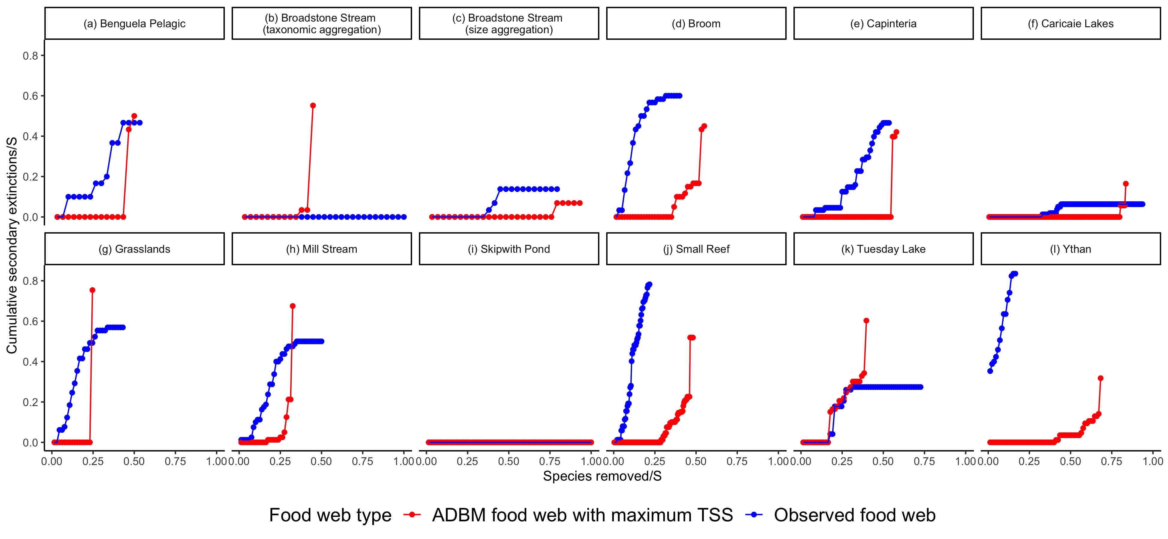

Figure 1: Cumulative secondary extinctions of species resulting from the primary removals of the **most connected species** in the ADBM predicted food webs corresponding to the maximum TSS and observed food webs. S denotes the number of species in a food web. The cumulative secondary extinctions of species and the number of species removed have been normalised by the number of species.

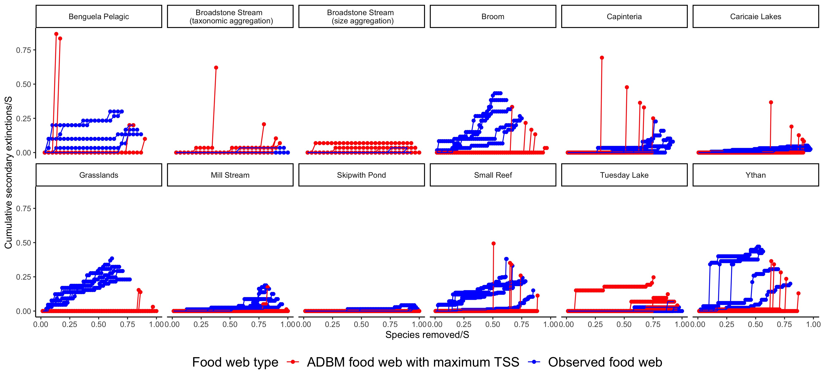

Figure 2: Cumulative secondary extinctions of species resulting from the primary removals of **random species** in the ADBM predicted food webs corresponding to the maximum TSS and observed food webs for five independent random extinction sequences. S denotes the number of species in a food web. The cumulative secondary extinctions of species and the number of species removed have been normalised by the number of species.

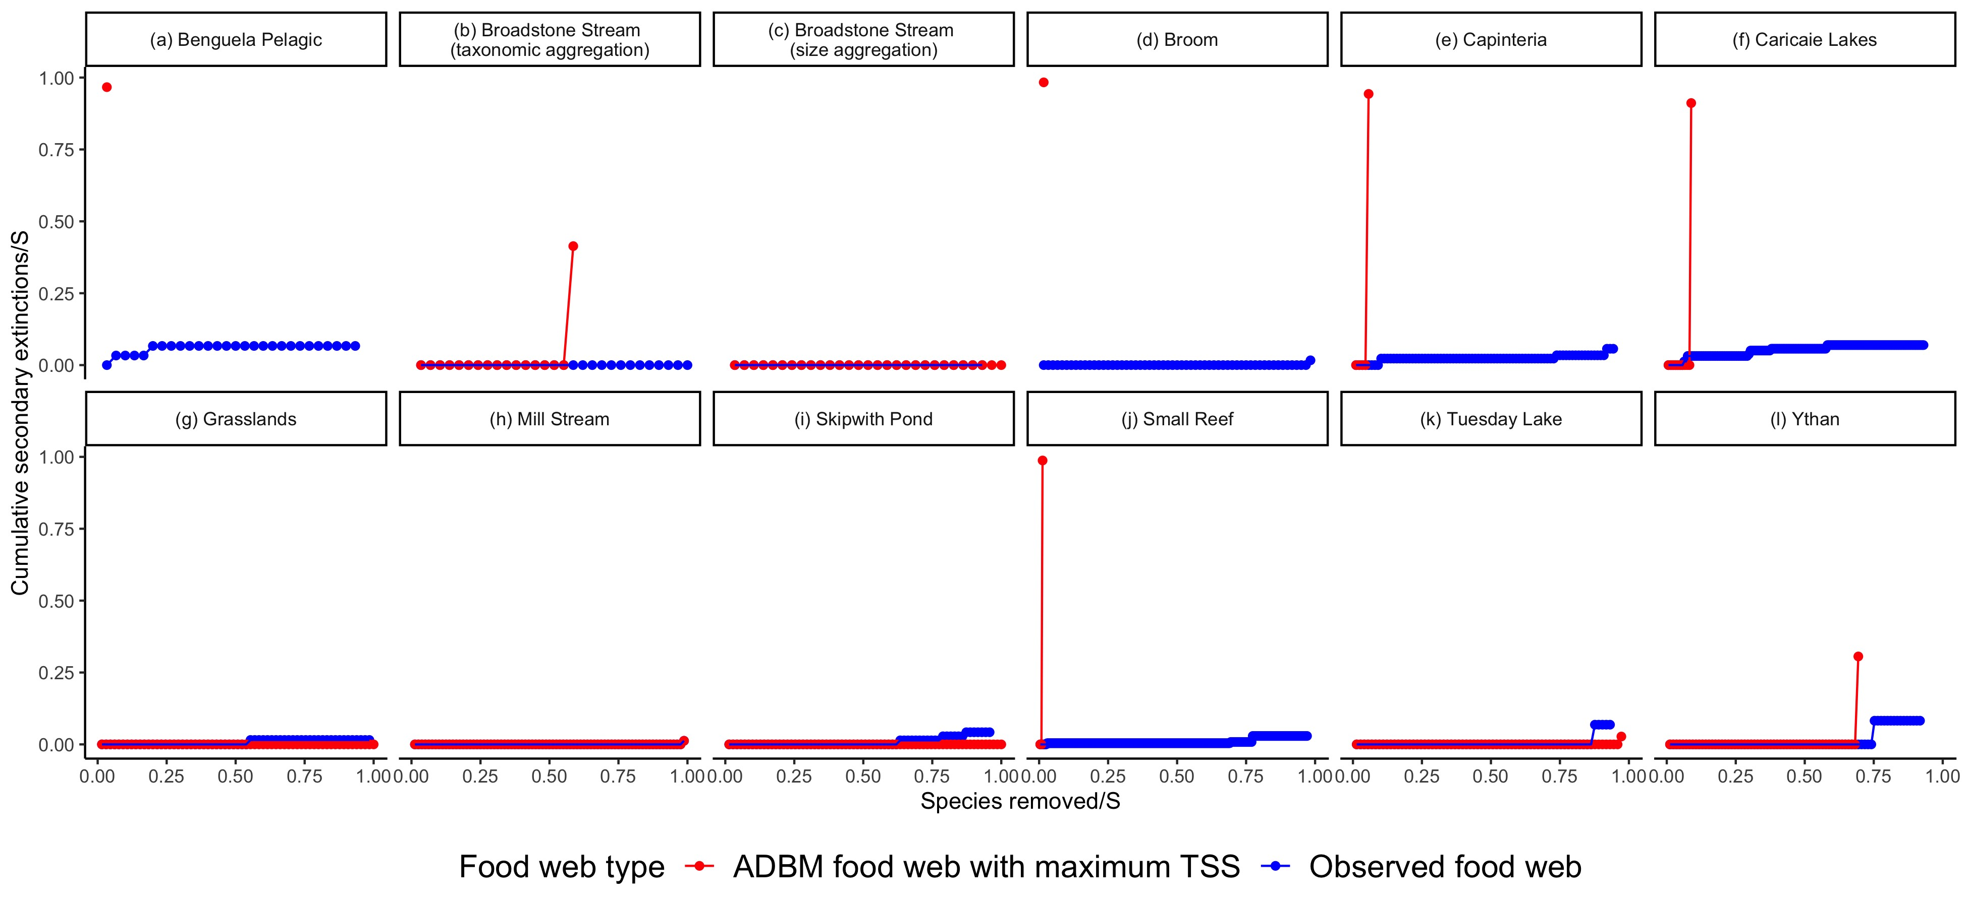

Figure 3: Cumulative secondary extinctions of species resulting from the primary removals of the **least connected species** in the ADBM predicted food webs corresponding to the maximum TSS and observed food webs. S denotes the number of species in a food web. The cumulative secondary extinctions of species and the number of species removed have been normalised by the number of species.

five of the food webs, a very high number of secondary extinctions occurred at very low number of primary species removal (Fig. 3 (a, d, e, f, j)).

## 3.2 Robustness

The ADBM predicted food webs were more robust than the observed food webs on average in the most-connected and random extinction scenarios (Fig. 4 (a, b)). However, there were large variations in the robustness within the ADBM predicted food webs in the most-connected extinction scenario (Fig. 4 (a)). For example, the ADBM predicted Caricaie Lakes food web was more robust than the observed food web on average but had a larger variation in the robustness within the ADBM predicted food webs compared to other food webs.

The food webs were more robust to the random extinction scenario than the most-connected scenario (Fig. 4 (a, b)). Small Reef and Benguela Pelagic food webs had more variations in robustness within the ADBM predicted food webs as compared to the other food webs (Fig. 4 (b)). Skipwith Pond, Broadstone Stream (taxonomic aggregation) and Broadstone Stream (size aggregation) food webs were the most robust (Median *R*50 = 0*.*5) for both ADBM predicted and observed food webs.

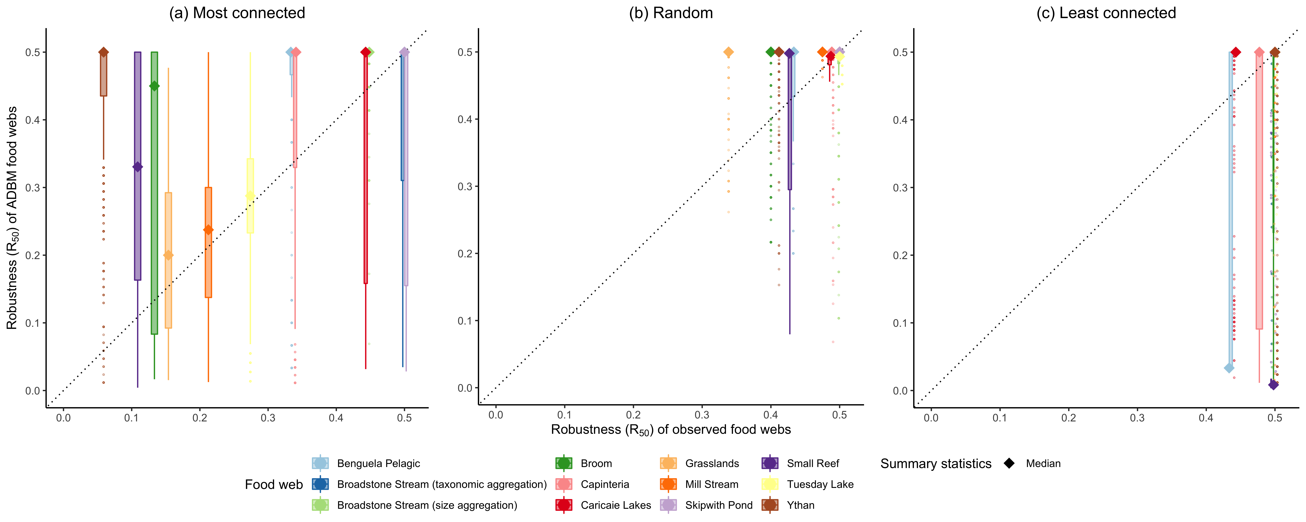

Figure 4: Robustness comparison between the ADBM predicted food webs and the observed food webs for 12 food webs across different ecosystems. Here, *R*50 is the proportion of species that have to be removed to achieve a total loss of at least 50% of total species (primary removals and secondary extinctions). Box represent 25th and 75th percentile; solid diamond represent median; whisker represent outlier limits; the outlier coefficient used was 1.5. Some points are not visible due to perfect overlap in b and c. Refer to Fig. 7 in the Supplementary Information for a faceted visualisation. The dashed black lines are the 1:1 relationships for reference.

Although there were few less robust ADBM predicted food webs in the Broadstone Stream (size aggregation) as shown by the outliers.

In the least-connected extinction scenario, the food webs had a very high robustness (Median *R*50 = 0*.*5) for most of the food webs (Fig. 4 (c)), however there were some exceptions. The ADBM predicted food webs for Small Reef and Benguela Pelagic had very low median robustness. Benguela Pelagic, Broom and Capinteria food webs from the ADBM had larger variations in robustness when compared to that of the others.

In all of the food webs except Small Reef and Broadstone Stream (taxonomic aggregation), the effect size of connectance on robustness was positive on average in the most-connected extinction scenario (Fig. 5 (a)) i.e. overestimation of connectance had a positive effect on the robustness. In the random extinction scenario, there was a positive effect of overestimation of connectance on the robustness for Ythan, Small Reef, Mill Stream, Grasslands, Caricaie Lakes, Capinteria, Broom and Benguela Pelagic (Fig. 5 (b)). However, the effect size varied across the food webs. In the least-connected extinction scenario, the median effect sizes were zero or very close to zero for all the

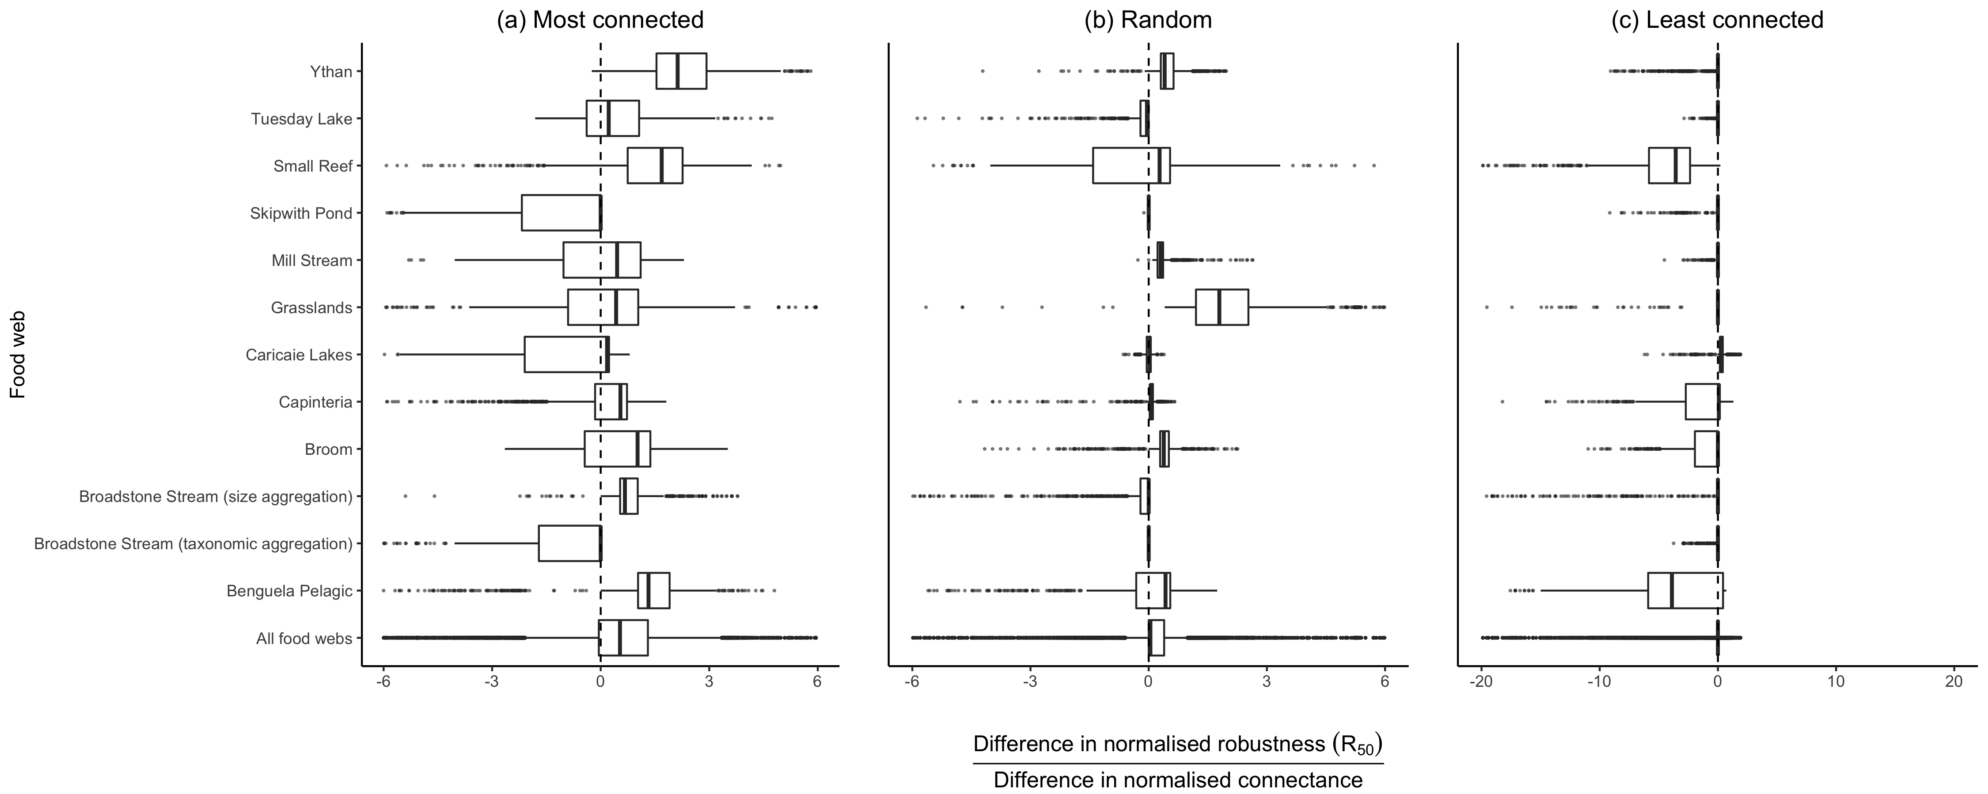

Figure 5: Effect size (i.e ratio of difference in normalised robustness between ADBM predicted food webs and observed food webs to difference in their normalised connectance) shown for the 12 food webs. Box represent 25th and 75th percentile; black bold midline represent median; whisker represent outlier limits; the outlier coefficient used was 1.5.

food webs except Benguela Pelagic and Small Reef food webs where the median effect sizes were negative (Fig. 5 (c)). However, there were lots of outlier effect sizes less than zero.

# 4 Discussion

As expected, the ADBM predicted food webs were more robust than the observed food webs on average. The considerable variation of the robustness of the ADBM predicted food webs suggests, however, that undersampling in food webs can lead to considerable uncertainty in the estimates of food web robustness, even when a model is used to compensate for undersampling. As was previously found, the food webs are least robust to primary extinction of the most connected species compared to that of least connected and random extinction scenarios on average. A future development would be to understand how undersampling, i.e. overestimation of connectance, influences the stability of the dynamics of the ADBM predicted food webs against that of the observed food webs, and compare it with the patterns in our study in which extinction occur only by topological criteria.

However one would expect a decrease in food web stability with overestimation of connectance

(Martinez, Williams, and Dunne 2006; May 1972).

As mentioned, the robustness of the ADBM predicted food webs was higher than that of the observed food webs on average (Fig. 4) for all of the 12 food web ecosystems (with some exceptions). This is likely due to the higher connectance of the ADBM predicted food webs as compared to that of the observed food webs because a species in a food web with a higher connectance has on average more trophic links as compared to a food web with a lower connectance (Fig. 5). Our study suggests that it is important to consider undersampling in observed food webs when computing their robustness.

Contrary to general expectations (Jennifer A. Dunne, Williams, and Martinez 2002a), food web robustness did not always increase with the connectance (Fig. 5). For example: the Benguela Pelagic and Small Reef food webs were surprisingly less robust to primary extinctions on average in the least-connected extinction scenario compared to… (Fig. 4 (c) and 5 (c)). In these two food webs, extinction of the least connected species could cause an almost complete, or complete collapse of the food web. We suspect this is because the ADBM is underestimating the proportion of basal species in the predicted food webs when compared to that of the observed food webs (Fig: 6 (a) in Gupta, Furrer, and Petchey (2022)). As a result, these low degree basal species are the ones to be removed at an early stage in the deletion sequence thereby resulting in an earlier food web collapse in the ADBM predicted food web as compared to that of the observed food web (Fig: 3 (a) and (j)). This suggests that the overestimation of connectance by the ADBM resulted in a more robust food web on average but differences in the predicted food web properties can lead to reduced robustness. For example… because a consumer in a food web with a higher maximum trophic level on average would have more resources and be less susceptible to extinctions as compared to consumer in a food web with lower maximum trophic level. This suggests that food web properties other than connectance play an important role in determining the robustness of a food web and therefore should be also taken into account (Binzer et al. 2011; Mendonça et al. 2022; Riede et al. 2011).

As with any food web model, we expect that there are real false positives in the food webs predicted by the ADBM. Real false positive means that the food web model predicts a link between two species that can never interact. (The other type of false positive is when the model predicts a link that was not observed but could have been observed if the food web was fully understood. In this case, further sampling should result in the link being observed and a change from false positive to true positive.) Firstly, this may be because the ADBM uses only body size as a trait. A trait uncorrelated with the body size may be influential in determining the interaction between two species (Gupta, Furrer, and Petchey 2022). Secondly, the ADBM can only predict diets that are contiguous with respect to the size of the prey. I.e. it cannot predict that the consumer will consume prey of size 1 and 3, and not consume prey of size 2. However, it is important to note that observed diets are not always contiguous when prey are ordered by their size due to some ecological differences in how predator species choose their prey (Caron et al. 2022). Hence, it would be intriguing to extend our study to use other food web models based on size-based rules such as Gravel et al. (2013) and Vagnon et al. (2021) to understand if the results are dependent on the decision of model selection. We expect to get similar result in a size-based deterministic model but a different result i.e. underestimation of robustness in a size-based stochastic model because the latter can take into account non contiguity in predator diets (Williams, Anandanadesan, and Purves 2010). It would also be interesting to use food web models which are not based on body size such as Cattin et al. (2004) and Allesina, Alonso, and Pascual (2008). We expect to have a difference in results based on whether the trophic interactions in the food webs are governed by size-structured rules or not.

It would be intriguing to know if this difference in connectance has a similar influence on the dynamical stability of the food webs as well. Hence, a prospect could be to use a dynamical model (for example bioenergetic food web model by Brose, Williams, and Martinez (2006)) to model the temporal dynamics of the ADBM predicted food webs. We expect that the overestimation of connectance will lead to reduced dynamical stability in the ADBM predicted food web as compared to that of the predicted food web and the difference in stability will be linearly related to the difference in connectance because Martinez, Williams, and Dunne (2006) have shown that food web stability linearly decreases with connectance.

Since the ADBM underestimates the proportion of basal species and overestimates the maximum trophic level in the predicted food webs compared to that of the observed food webs (Fig: 6 (a) in Gupta, Furrer, and Petchey (2022) and Fig. 6 in Supplementary Information), it would be interesting to use these properties as summary statistics to parameterise the ADBM and investigate how that influences the difference in the robustness between the ADBM predicted and the observed food webs. We would expect? more highly constrained predicted food web structure, lower variation in robustness, and a greater apparent influence of connectance on robustness.

We have used a food web model to compensate for undersampling in recorded food webs and thereby quantified the influence of missing links i.e. overestimation of connectance on the topological robustness of 12 food webs from various ecosystems. We found that the overestimation of connectance can have large impacts on the robustness of the food webs, while at the same time producing large variation in robustness among the predicted food webs. Differences in other structural food web properties between the ADBM predicted food webs and the observed food webs are responsible.

# 5 Acknowledgements

This work was supported by the University Research Priority Program Global Change and Biodiversity (Grant number: U-704-04-11) of the University of Zurich.

**6 Conflict of interest**

None declared

# 7 Author contributions

**Anubhav Gupta:** Conceptualisation; Data curation; Formal analysis; Investigation; Methodology;

Project administration; Software; Validation; Writing – original draft; Writing – review and editing. **Owen L. Petchey:** Conceptualization; Funding acquisition; Resources; Supervision; Writing – review & editing.

# 8 Data Accessibility Statement

All the data used in this study was collected in other studies and is openly available. We list those studies and the open access source in Table 1. The complete code used in the analysis is available in the repository **to be added** .

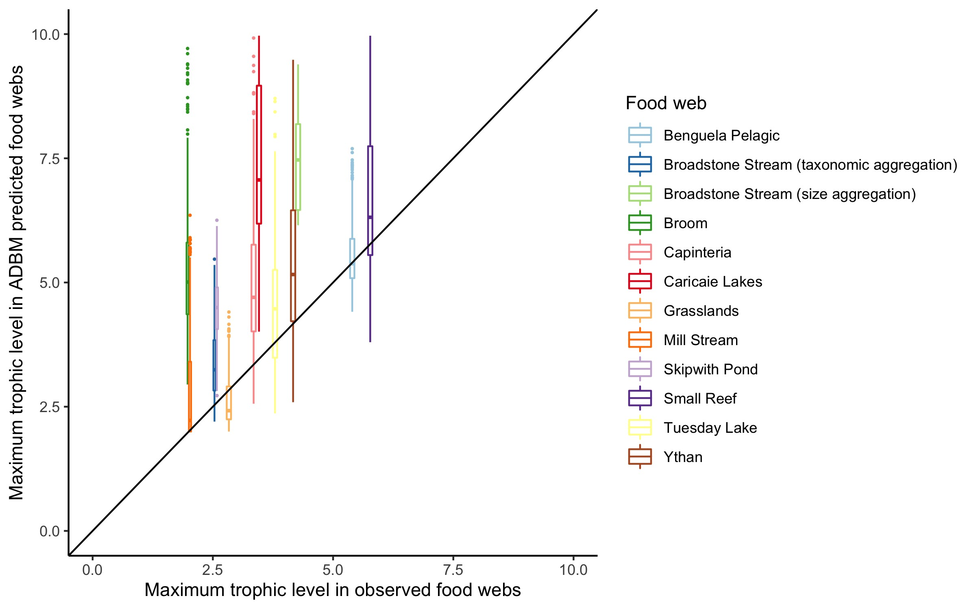

Figure 6: Maximum trophic level of ADBM predicted food webs plotted against that of the observed food webs. Box represent 25th and 75th percentile; bold midline represent median; whisker represent outlier limits; the outlier coefficient used was 1.5. The dashed black lines are the 1:1 relationships for reference.

**9 Supplementary Information**

# References

Albert, R’eka, and Albert-L’aszl’o Barab’asi. 2002. “Statistical Mechanics of Complex Networks.”

*Reviews of Modern Physics* 74 (1): 47–97. [https://doi.org/10.1103/RevModPhys.74.47.](https://doi.org/10.1103/RevModPhys.74.47)

Allesina, Stefano, David Alonso, and Mercedes Pascual. 2008. “A General Model for Food Web

Structure.” *Science* 320 (5876): 658–61. [https://doi.org/10.1126/science.1156269.](https://doi.org/10.1126/science.1156269)

Berg, Sofia, Maria Christianou, Tomas Jonsson, and Bo Ebenman. 2011. “Using Sensitivity Analysis to Identify Keystone Species and Keystone Links in Size-Based Food Webs.” *Oikos* 120 (4):

510–19. [https://doi.org/10.1111/j.1600-0706.2010.18864.x.](https://doi.org/10.1111/j.1600-0706.2010.18864.x)

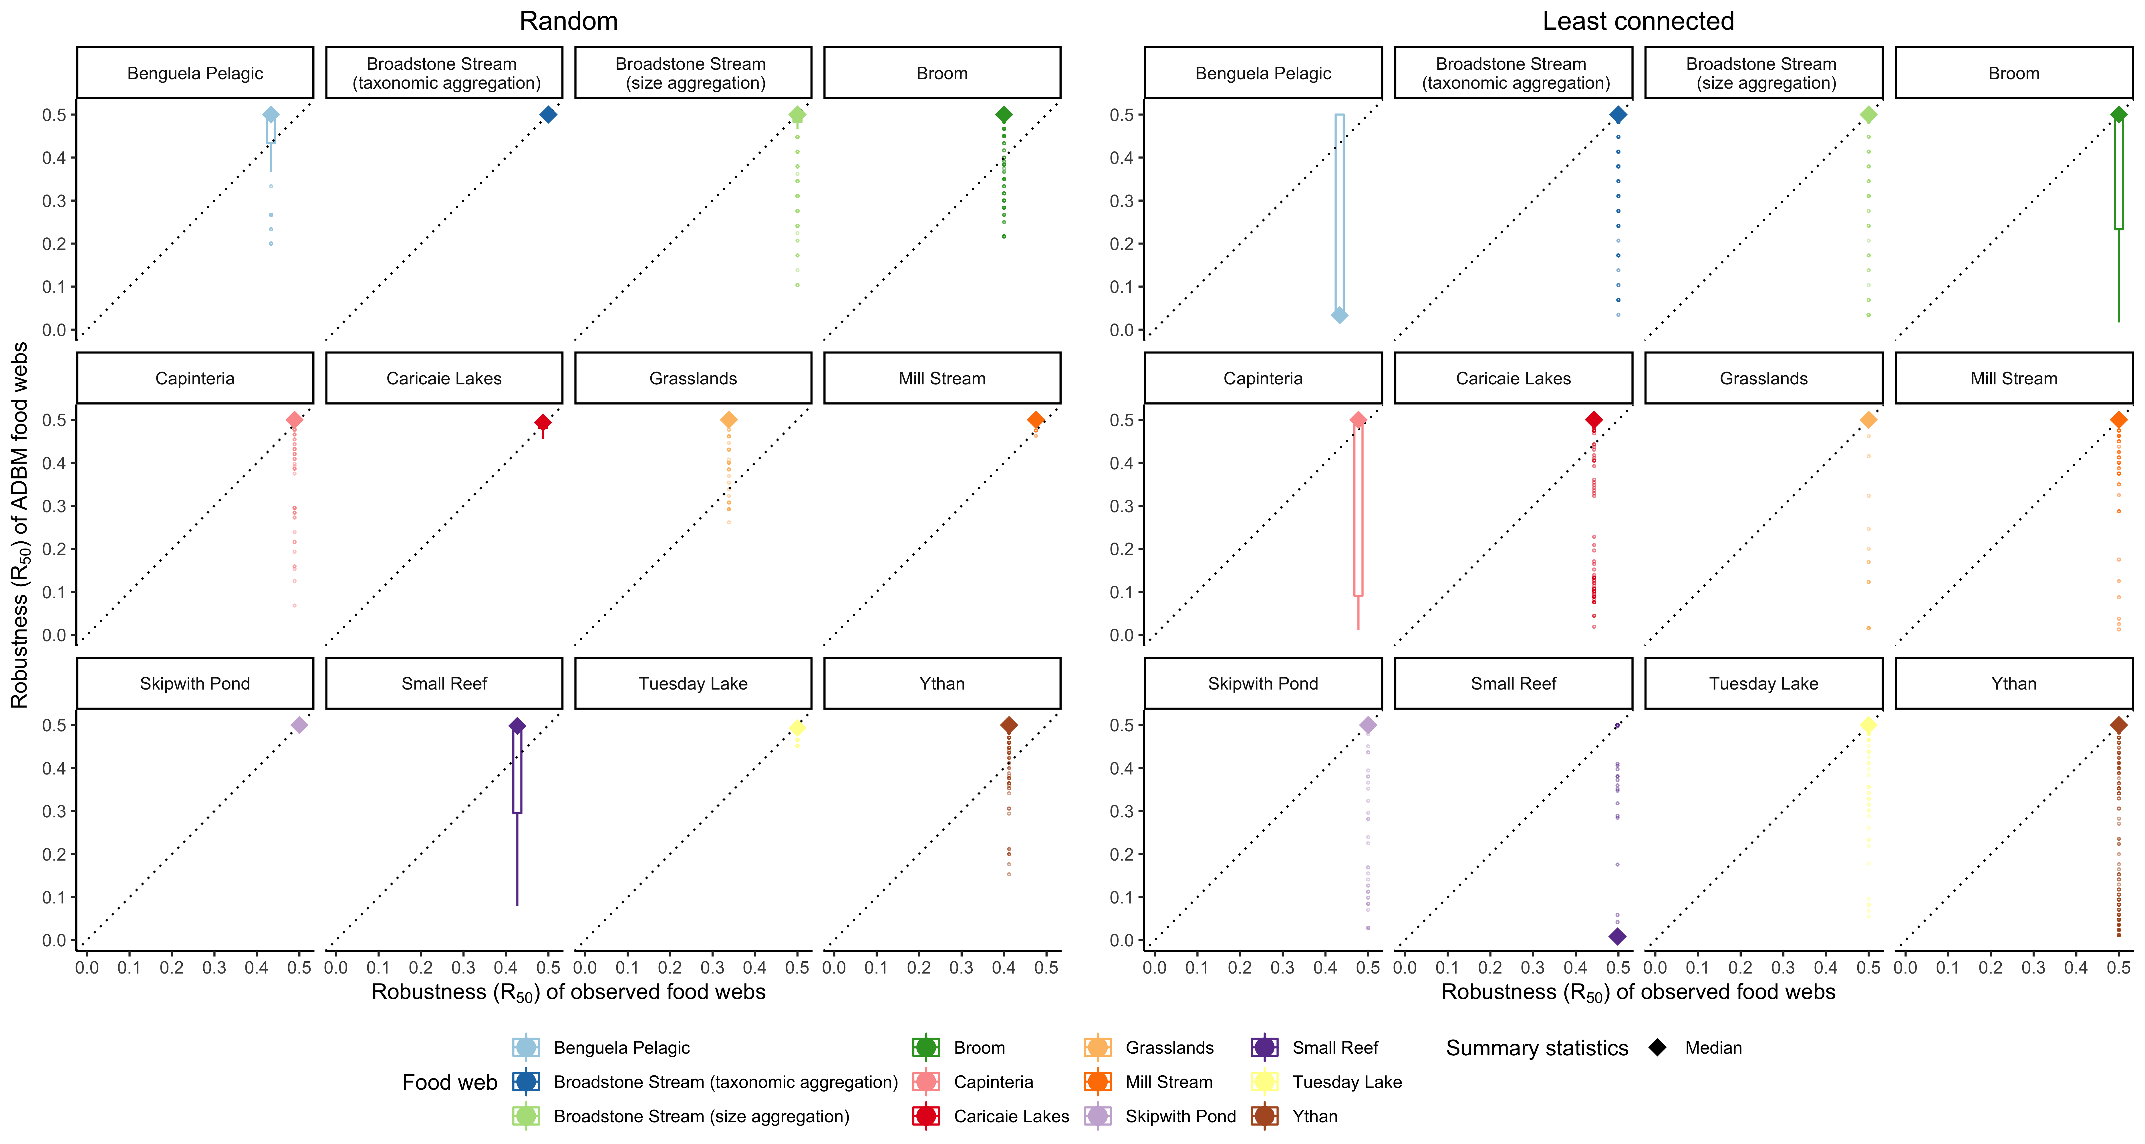

Figure 7: Robustness comparison between the ADBM predicted food webs and the observed food webs for 12 food webs across different ecosystems for random and least connected extinction scenarios. Here, *R*50 is the proportion of species that have to be removed to achieve a total loss of at least 50% of total species (primary removals and secondary extinctions). Box represent 25th and 75th percentile; solid diamond represent median; whisker represent outlier limits; the outlier coefficient used was 1.5. The dashed black lines are the 1:1 relationships for reference.

Binzer, Amrei, Ulrich Brose, Alva Curtsdotter, Anna Eklöf, Björn C. Rall, Jens O. Riede, and

Francisco de Castro. 2011. “The Susceptibility of Species to Extinctions in Model Communities.”

*Basic and Applied Ecology* 12 (7): 590–99. [https://doi.org/10.1016/j.baae.2011.09.002.](https://doi.org/10.1016/j.baae.2011.09.002)

Brose, Ulrich, Richard J. Williams, and Neo D. Martinez. 2006. “Allometric Scaling Enhances Stability in Complex Food Webs.” *Ecology Letters* 9 (11): 1228–36. [https://doi.org/10.1111/](https://doi.org/10.1111/j.1461-0248.2006.00978.x)

[j.1461-0248.2006.00978.x.](https://doi.org/10.1111/j.1461-0248.2006.00978.x)

Caron, Dominique, Luigi Maiorano, Wilfried Thuiller, and Laura J. Pollock. 2022. “Addressing the Eltonian Shortfall with Trait-Based Interaction Models.” *Ecology Letters* n/a (n/a). [https:](https://doi.org/10.1111/ele.13966)

[//doi.org/10.1111/ele.13966.](https://doi.org/10.1111/ele.13966)

Cattin, Marie-France, Louis-F’elix Bersier, Carolin Banašek-Richter, Richard Baltensperger, and

Jean-Pierre Gabriel. 2004. “Phylogenetic Constraints and Adaptation Explain Food-Web

Structure.” *Nature* 427 (6977, 6977): 835–39. [https://doi.org/10.1038/nature02327.](https://doi.org/10.1038/nature02327)

Dunne, Ja, Rj Williams, and Nd Martinez. 2004. “Network Structure and Robustness of Marine Food

Webs.” *Marine Ecology Progress Series* 273: 291–302. [https://doi.org/10.3354/meps273291.](https://doi.org/10.3354/meps273291)

Dunne, Jennifer A., and Richard J. Williams. 2009. “Cascading Extinctions and Community

Collapse in Model Food Webs.” *Philosophical Transactions of the Royal Society B: Biological*

*Sciences* 364 (1524): 1711–23. [https://doi.org/10.1098/rstb.2008.0219.](https://doi.org/10.1098/rstb.2008.0219)

Dunne, Jennifer A., Richard J. Williams, and Neo D. Martinez. 2002a. “Network Structure and Biodiversity Loss in Food Webs: Robustness Increases with Connectance.” *Ecology Letters* 5 (4):

558–67. [https://doi.org/10.1046/j.1461-0248.2002.00354.x.](https://doi.org/10.1046/j.1461-0248.2002.00354.x)

Dunne, Jennifer A, Richard J Williams, and Neo D Martinez. 2002b. “Network Structure and Biodiversity Loss in Food Webs: Robustness Increases with Connectance.” *Ecology Letters* 5 (4): 558–67.

Ebenman, Bo, and Tomas Jonsson. 2005. “Using Community Viability Analysis to Identify Fragile Systems and Keystone Species.” *Trends in Ecology & Evolution* 20 (10): 568–75.

[https://doi.org/10.1016/j.tree.2005.06.011.](https://doi.org/10.1016/j.tree.2005.06.011)

Ebenman, Bo, Richard Law, and Charlotte Borrvall. 2004. “COMMUNITY VIABILITY ANALYSIS: THE RESPONSE OF ECOLOGICAL COMMUNITIES TO SPECIES LOSS.” *Ecology* 85 (9):

2591–2600. [https://doi.org/10.1890/03-8018.](https://doi.org/10.1890/03-8018)

Gravel, Dominique, Timoth’ee Poisot, Camille Albouy, Laure Velez, and David Mouillot. 2013. “Inferring Food Web Structure from Predator–Prey Body Size Relationships.” *Methods in Ecology and Evolution* 4 (11): 1083–90. [https://doi.org/10.1111/2041-210X.12103.](https://doi.org/10.1111/2041-210X.12103)

Gupta, Anubhav, Reinhard Furrer, and Owen L. Petchey. 2022. “Simultaneously Estimating Food Web Connectance and Structure with Uncertainty.” *Ecology and Evolution* 12 (3): e8643.

[https://doi.org/10.1002/ece3.8643.](https://doi.org/10.1002/ece3.8643)

Jonsson, Tomas, Sofia Berg, Alexander Pimenov, Catherine Palmer, and Mark Emmerson. 2015. “The Reliability of R50 as a Measure of Vulnerability of Food Webs to Sequential Species

Deletions.” *Oikos* 124 (4): 446–57. [https://doi.org/10.1111/oik.01588.](https://doi.org/10.1111/oik.01588)

Jordano, Pedro. 2016. “Sampling Networks of Ecological Interactions.” *Functional Ecology* 30 (12):

1883–93. [https://doi.org/10.1111/1365-2435.12763.](https://doi.org/10.1111/1365-2435.12763)

MacArthur, Robert H., and Eric R. Pianka. 1966. “On Optimal Use of a Patchy Environment.” *The*

*American Naturalist* 100 (916): 603–9. [https://www.jstor.org/stable/2459298.](https://www.jstor.org/stable/2459298)

Martinez, Neo D, Richard J Williams, and Jennifer A Dunne. 2006. “Diversity, Complexity, and Persistence in Large Model Ecosystems,” 24.

May, Robert M. 1972. “Will a Large Complex System Be Stable?” *Nature* 238 (5364): 413. [https://doi.org/10.1038/238413a0.](https://doi.org/10.1038/238413a0)

Mendonça, V, C Madeira, M Dias, Aav Flores, and C Vinagre. 2022. “Robustness of Temperate

Versus Tropical Food Webs: Comparing Species Trait-Based Sequential Deletions.” *Marine*

*Ecology Progress Series* 691 (June): 19–28. [https://doi.org/10.3354/meps14062.](https://doi.org/10.3354/meps14062)

Patonai, Katalin, and Ferenc Jord’an. 2017. “Aggregation of Incomplete Food Web Data May Help to Suggest Sampling Strategies.” *Ecological Modelling* 352 (May): 77–89. [https://doi.org/10.](https://doi.org/10.1016/j.ecolmodel.2017.02.024)

[1016/j.ecolmodel.2017.02.024.](https://doi.org/10.1016/j.ecolmodel.2017.02.024)

Petchey, Owen L., A. P. Beckerman, J. O. Riede, and P. H. Warren. 2008. “Size, Foraging, and Food Web Structure.” *Proceedings of the National Academy of Sciences* 105 (11): 4191–96.

[https://doi.org/10.1073/pnas.0710672105.](https://doi.org/10.1073/pnas.0710672105)

Pimm, Stuart, Peter Raven, Alan Peterson, Çağan H. Şekercioğlu, and Paul R. Ehrlich. 2006. “Human Impacts on the Rates of Recent, Present, and Future Bird Extinctions.” *Proceedings of the National Academy of Sciences* 103 (29): 10941–46. [https://doi.org/10.1073/pnas.](https://doi.org/10.1073/pnas.0604181103)

[0604181103.](https://doi.org/10.1073/pnas.0604181103)

Riede, Jens O., Amrei Binzer, Ulrich Brose, Francisco de Castro, Alva Curtsdotter, Björn C. Rall, and Anna Eklöf. 2011. “Size-Based Food Web Characteristics Govern the Response to Species Extinctions.” *Basic and Applied Ecology* 12 (7): 581–89. [https://doi.org/10.1016/j.baae.](https://doi.org/10.1016/j.baae.2011.09.006)

[2011.09.006.](https://doi.org/10.1016/j.baae.2011.09.006)

Sol’e, Ricard V., and M. Montoya. 2001. “Complexity and Fragility in Ecological Networks.” *Proceedings of the Royal Society of London. Series B: Biological Sciences* 268 (1480): 2039–45. [https://doi.org/10.1098/rspb.2001.1767.](https://doi.org/10.1098/rspb.2001.1767)

Thomas, Chris D., Alison Cameron, Rhys E. Green, Michel Bakkenes, Linda J. Beaumont, Yvonne C. Collingham, Barend F. N. Erasmus, et al. 2004. “Extinction Risk from Climate Change.”

*Nature* 427 (6970, 6970): 145–48. [https://doi.org/10.1038/nature02121.](https://doi.org/10.1038/nature02121)

Thomas, J. A., M. G. Telfer, D. B. Roy, C. D. Preston, J. J. D. Greenwood, J. Asher, R. Fox, R. T.

Clarke, and J. H. Lawton. 2004. “Comparative Losses of British Butterflies, Birds, and Plants

and the Global Extinction Crisis.” *Science* 303 (5665): 1879–81. [https://doi.org/10.1126/ science.1095046.](https://doi.org/10.1126/science.1095046)

Ullah, Hadayet, Ivan Nagelkerken, Silvan U. Goldenberg, and Damien A. Fordham. 2018. “Climate Change Could Drive Marine Food Web Collapse Through Altered Trophic Flows and Cyanobacterial Proliferation.” Edited by Michel Loreau. *PLOS Biology* 16 (1): e2003446. [https://doi.org/10.1371/journal.pbio.2003446.](https://doi.org/10.1371/journal.pbio.2003446)

Vagnon, Chlo’e, Franck Cattan’eo, Chlo’e Goulon, David Grimardias, Jean Guillard, and Victor

Frossard. 2021. “An Allometric Niche Model for Species Interactions in Temperate Freshwater

Ecosystems.” *Ecosphere* 12 (3): e03420. [https://doi.org/10.1002/ecs2.3420.](https://doi.org/10.1002/ecs2.3420)

White, J. Wilson, Andrew Rassweiler, Jameal F. Samhouri, Adrian C. Stier, and Crow White. 2014.

“Ecologists Should Not Use Statistical Significance Tests to Interpret Simulation Model Results.”

*Oikos* 123 (4): 385–88. [https://doi.org/10.1111/j.1600-0706.2013.01073.x.](https://doi.org/10.1111/j.1600-0706.2013.01073.x)

Williams, Richard J. 2008. “Effects of Network and Dynamical Model Structure on Species Persistence in Large Model Food Webs.” *Theoretical Ecology* 1 (3): 141–51. [https://doi.org/10.1007/ s12080-008-0013-5.](https://doi.org/10.1007/s12080-008-0013-5)

Williams, Richard J., Ananthi Anandanadesan, and Drew Purves. 2010. “The Probabilistic Niche Model Reveals the Niche Structure and Role of Body Size in a Complex Food Web.” Edited by Louis-Felix Bersier. *PLoS ONE* 5 (8): e12092. [https://doi.org/10.1371/journal.pone.](https://doi.org/10.1371/journal.pone.0012092)

[0012092.](https://doi.org/10.1371/journal.pone.0012092)

1. Corresponding author