PROJECT REPORT
on
Android 2-D Game
(CSE IV Semester Mini project)
2020-2021


Submitted to: Submitted by:
Mr. Umang Garg Anubhav Joshi
(CC- CSE-IV-SEM) Roll. No: 1918247
Guided by: CSE-IV-Sem-A
Mr. Avnish Panwar

DEPARTMENT OF COMPUTER SCIENCE AND INFORMATION TECHNOLOGY
GRAPHIC ERA HILL UNVERSITY, DEHRADUN
CERTIFICATE

Certified that Mr. Anubhav Joshi (Roll No.- 1918247) has developed mini project on “Android 2-D game” for the CS IV Semester Mini Project in Graphic Era Hill University, Dehradun. The project carried out by Students is their own work as best of my knowledge.

Date: 22-05-2021

(Mr. Umang Garg)
Project Co-ordinator
CC-CSE-A-IV-Sem
(CSE Department)
GEHU Dehradun

(Mr. Avnish Panwar)
Project Guide
Resource Person
(CSE Department)
GEHU Dehradun

ACKNOWLEDGMENT

We would like to express our gratitude to The Almighty Shiva Baba, the most Beneficent and the most Merciful, for completion of project.
We wish to thank our parents for their continuing support and encouragement. We also wish to thank them for providing us with the opportunity to reach this far in our studies.
We would like to thank particularly our project Co-ordinator Mr. Umang Garg and our Project Guide Mr. Avnish Panwar for his patience, support and encouragement throughout the completion of this project and having faith in us.
At last but not the least We greatly indebted to all other persons who directly or indirectly helped us during this work.

Mr. Anubhav Joshi
Roll No.- 1918247
CSE-A-IV-Sem
Session: 2020-2021
GEHU, Dehradun
TABLE OF CONTENTS

CHAPTER NO. TITLE PAGE NO.
1. INTRODUCTION 01
1.1 About Project 01
1.2 Java 02
1.3 XML 02

2. PROJECT 03
2.1 Software used (IDE) 03
2.2 Requirement for game 03
2.3 How to play 03
2.4 Module 04
2.4.1 Java files used 04
2.4.2 XML files used 05
3. SCREENSHOT OF PROJECT 06
3.1 Starting Screen 06
3.2 Screen while playing 06
3.3. Game over screen 07

4. CONCLUSION 08
4.1 SUMMARY 08
4.2 FUTURE WORKS 08

REFERENCE

Introduction
Android
Android is an open source and Linux-based Operating System for mobile devices such as smartphones and tablet computers. Android was developed by the Open Handset Alliance, led by Google, and other companies.
Android offers a unified approach to application development for mobile devices which means developers need only develop for Android, and their applications should be able to run on different devices powered by Android.
The first beta version of the Android Software Development Kit (SDK) was released by Google in 2007 where as the first commercial version, Android 1.0, was released in September 2008.
On June 27, 2012, at the Google I/O conference, Google announced the next Android version, 4.1 Jelly Bean. Jelly Bean is an incremental update, with the primary aim of improving the user interface, both in terms of functionality and performance.

Introduction to 2D gamming
2D games use flat graphics, called sprites, and don’t have three-dimensional geometry. They’re drawn to the screen as flat images, and the camera (orthographic camera) has no perspective.
2D games are also called Platform game. The word platform also describes that something held on a platform. Here the player can run, jump, shoot, collect powers on a platform. Since 2D games are flat, the environment created in the games is also visually flat. They do not focus much on the environment of the game.
Benefits of 2D Design
- Simple Controls: since the controls in 2D games are simple and straight forward, it is more of a choice for the beginners. This brings them more audience.
- Easy development: The development of 2D games is much easier and cheaper. It takes less time in developing a 2-dimensional game as the design is flat. Also, it is easier to update the games later.
- Easy Instructions: 2D games are simple ‘tap to play’ games with easy instructions. It has a simple interface and flat visuals. 2D games have very limited or no plot and the size 2D game is small.

JAVA
Java is a general-purpose, class-based, object-oriented programming language designed for having lesser implementation dependencies. It is a computing platform for application development. Java is fast, secure, and reliable, therefore. It is widely used for developing Java applications in laptops, data centers, game consoles, scientific supercomputers, cell phones, etc.
Android applications are developed using the Java language. Java is a very popular programming language developed by Sun Microsystems (now owned by Oracle). Developed long after C and C++, Java incorporates many of the powerful features of those powerful languages while addressing some of their drawbacks. Still, programming languages are only as powerful as their libraries. These libraries exist to help developers build applications. Android relies heavily on these Java fundamentals. The Android SDK includes many standard Java libraries (data structure libraries, math libraries, graphics libraries, networking libraries and everything else you could want) as well as special Android libraries that will help you develop awesome Android applications.
XML
XML stands for Extensible Markup Language. XML is a markup language much like HTML used to describe data. XML tags are not predefined in XML. We must define our own Tags. Xml as itself is well readable both by human and machine. Also, it is scalable and simple to develop. In Android we use xml for designing our layouts because xml is lightweight language so it doesn’t make our layout heavy. The whole concept of Android User Interface is defined using the hierarchy of View and ViewGroup objects. A ViewGroup is an invisible container that organizes child views. These child views are other widgets which are used to make the different parts of UI. One ViewGroup can have another ViewGroup as a child element.
PROJECT
Software Used (IDE) - Android Studio
- Android Studio is the official integrated development environment (IDE) for Google's Android operating system, built on JetBrains' IntelliJ IDEA software and designed specifically for Android development. It is available for download on Windows, macOS and Linux based operating systems or as a subscription-based service in 2020. It is a replacement for the Eclipse Android Development Tools (E-ADT) as the primary IDE for native Android application development.
- Android Studio was announced on May 16, 2013 at the Google I/O conference. It was in early access preview stage starting from version 0.1 in May 2013, then entered beta stage starting from version 0.8 which was released in June 2014. The first stable build was released in December 2014, starting from version 1.0.

Requirement for game
The game requires an android device with an operating system of 4.3 jelly bean or above and minimum 20 MB of free internal storage.
How to play
For playing the game we first have to install the app.After installing and running the game player has to click on the play text shown in the screen which will launch the next screen containing player villain and the background. If we touch the upper left side of the screen the player goes up and if we touch the lower left side the player goes down for shooting a beam the player has to touch the right side of the screen the game is over if the cell crosses the screen or touches the player.
Modules of project
The java classes used in the project are
- MainActivity
This java class is used to make the starting page of the game in landscape and full screen mode. This class links the first screen to the second screen named MainActivity2.
In this we have called a onclick listener that on click takes us to the new screen and play a starting music.
- MainActivity2
This is just a in between java class that takes the user from one screen to next screen known as a surface view Viewg. We also made the upcoming screen full screen and in landscape mode.
- Viewg
This is the main java class where all functionality of game takes place. This class extends surfaceView and implements runnable which are in-built in android studio. This class is used as a surfaceview (surface view is used when the object in the screen are changing continuously). Mainly this class contains five functions resume(), run(),update(),draw() and sleep.
First resume() is called through the previous class that creates a new thread and starts the thread which calls the run() function which then calls remaining function in loop until game is finished or game over. First update() is called which updates the position of the character the obstacle and the beam shooted by the character then draw() is called which draw everything on the canvas lastly sleep() is called which stops the thread for 35 milli second when these all function works together in a loop it creates the animation for the game.
The game over condition is also made in this class i.e. when the villain(Cell) crosses the screen or touches the player the game is over and when the beam shooted by the player hits the villain the score variable is incremented and displayed on screen.
The controls of the game are also described in this class if we touch the upper left side of the screen the player goes up and if we touch the lower left side the player goes down for shooting a beam the player has to touch the right side of the screen.
- Shooted
In this class the beam of the player is created using bitmap class and the height and width of the beam is given accordingly.
- Background
In this class the background of the screen is created and the height and width of background is given according to the size of the screen in which the game is played in.
- Moving
This class is used to give animation to the beam, player and the obstacle in the game. The getmoving() function return different bitmap that creates an illusion that the player and obstacles are moving.
- Cell
In this we have created the obstacle or the villain of the game that the player will get score for destroying. The getCell() function is used to return different bitmap that creates the animation for the flying cell(villain).
There is also an XML file that is used
- MainActivity.xml
This file is used to give graphical interface to the starting screen of the game using MainActivity.java file.

SCREENSHOT OF PROJECT

Starting Screen

Screen While Playing
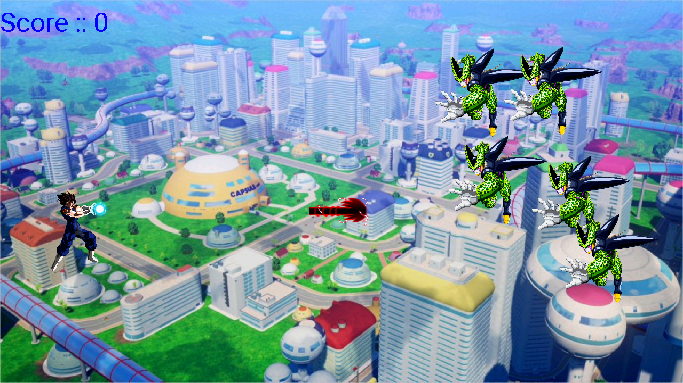
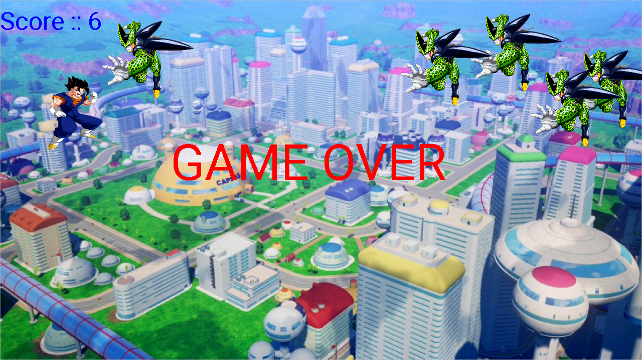
Game Over Screen

CONCLUSION

Summary
The developed game is a one player game. The player has to shoot the enemy before it crosses the screen or touches the player. The speed of enemy keeps on increasing after every 10-score obtained. The player can move up and down to shoot upcoming enemy by clicking on the right side of the screen. Learned about java programing and about how to use android studio to make a simplest 2-d game.

Future works
The game can be made more interesting by giving some powerups to the player or by giving health bar to the player we can also add some different enemies with different characteristics that will make the game more enjoyable and user friendly.

REFERENCE:
The complete reference java
Websites:
GEEKSforGEEKS.org
Programiz.com
Javapoint.com
Youtube videos
And other Google Articles.

