EMG Analysis and Application for Exoskeleton Control

***Internal Guide: Prof. M. N. Annadate***

***Sponsored/ In-house: In-House (Test components sponsored by Nasan Medical)***

***Group Members:***

|  |  |
| --- | --- |
| Name of Student | Examination Seat No. |
| Ritika Inamke | B80383064 |
| Anubhav Gupta | B80383077 |
| Dinesh Patil | B80383080 |

**Abstract:**

The aim of the project is to extract raw EMG signals from the arm and analyze them for the detection of the muscle activity apply them to real world applications such as muscle rehabilitation through the employment of a motion support exoskeleton. Another important concept that is considered while designing such a system is the relation between the EMG signal observed and the actual torque applied by the muscle. Efforts have been made to design and create a cost efficient and accurate instrumentation system for EMG analysis and exoskeleton arm control for support and movement as compared to the existing products in the market. The various elements of such an EMG system are discussed in brief providing a general idea of the application for EMG signal monitoring and exoskeleton control.

The EMG signal is a measure of the electrical activity of the muscle. The electrical activity is the result of a signal generated in the brain which is transmitted through the nervous system to the motor neuron attached to the muscle fibers in the muscle. The motor neuron fires resulting in a depolarization/ repolarization wave throughout the muscle fiber. This wave creates an action potential in the muscle fibers resulting in the movement of electric charges. This electrical activity produces an electric signal in the muscle which can be picked up by well-placed electrodes on the surface of the skin. The acquired signal is called the Electromyogram (EMG) signal. This raw EMG signal consists of a series of spikes whose amplitude depends on the amount of force delivered by the biceps – the stronger the contraction of the muscle, the larger the amplitude of the EMG signal. The frequency of the spikes is the firing rate of the motor neurons. Since the amplitude of the EMG signal is directly related to the force exerted by the muscle, it is used to determine the force signal sent to the exoskeleton.

The Basic objective and application of the project is to detect the EMG signals from a particular muscle and apply it for the control of the exoskeleton assembly for movement.

**Methodology:**

1. **Block Schematic:**

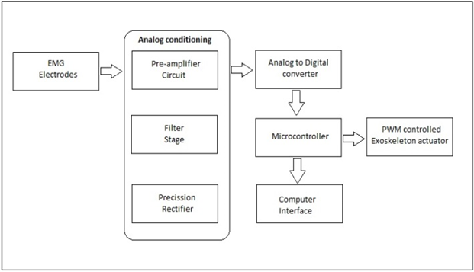

1. **Hardware Platform:**

Analog Board( OPA4227,TL064, AD8676, LME49990, AD8620)

ATmega32U4 controller with Zigbee and RS232 interface to the computer.

1. **Softwares Used:**

Eagle 6.3 : For PCB designing.

Atmel Studio 6 : For programming the ATmega32U4 controller.

**Results:**

1. EMG signal acquired. 2. PWM signal for exoskeleton control.

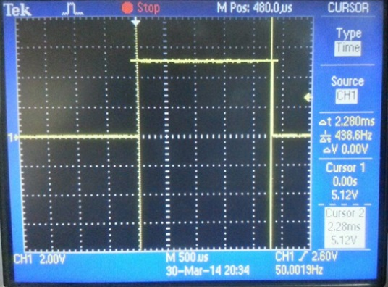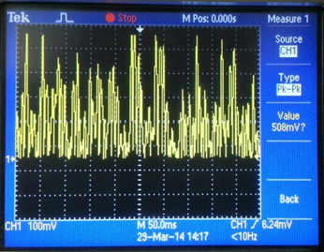

**Conclusion:**

Thus, the system has been used for acquiring the EMG signal from muscles and employed for the control of exoskeleton assembly.

**Future Scope:**

1. The system can be expanded to cover entire body movement.
2. Nano motors can be incorporated as they are more compact and have higher torque.
3. Precise and accurate active sensors can be used for total noise cancellation.
4. Mobile application can be developed for ‘on the go’ monitoring of EMG.

**Achievements:**

|  |  |  |  |  |
| --- | --- | --- | --- | --- |
| Sr. No. | Name of Event | Type of the Event (Poster / Demo / Paper Presentation) | Name of College | Award/ Participation |
| **1.** | MELANGE | Paper Presentation | VIT , Pune. | Participation. |
| **2.** | TESLA | Paper Presentation | MITCOE, Pune. | Participation. |

**References:**

[1] ‘The ABC of EMG’, A practical introduction to Kinesiological Electromyography, Peter Konrad.

[2] ‘Techniques of EMG signal analysis: detection, processing, classification and Applications’, M. B. Reaz,1* M. S. Hussain1 and F. Mohd-Yasin1.

[3] ‘Surface Electromyography’ –Carlo J.De Luca, Delsys.

[4] ‘Important Factors in Surface EMG Measurement’- Dr. Scott Day, Bortec Biomedical.

[5] Design of an Arm Exoskeleton Controlled by the EMG Signal-Mark Novak, Cornel College PHY312.

[6]Fundamental Concepts in Signal Acquisition, by Delsys.