Differential Shoreline Dynamics of Inhabited and Uninhabited Estuarine Islands in the Indian Sundarbans (1990–2024)
Anubhav Ghosh
II-M.Tech. Geoinformatics, Department of Geography, University of Madras, Chennai 600005, India
Research Intern, Indian Institute of Science (IISc), Bengaluru 560012, India
Email: anubg2000@gmail.com
Submitted to: 100 Years of Geographical Research in India (eds. Siddiqui, Sarkar & Singh)

Abstract / Saarsonkkhep
Indian Sundarbans, jeta prithibir sobcheye boRo continuous mangrove delta, ekhon rapid relative sea-level rise (RSLR), strong tidal forcing, sediment-supply disturbance ebong bar bar asha tropical cyclone-er combined chaaper moddhe achhe (Hazra et al., 2002; Rahman et al., 2011; Pethick & Orford, 2013; IPCC, 2021). Ei study-te amra ekti paired-island design byabohar korechi ei test korar jonno je human settlement ebong embankment (“inhabited” vs “uninhabited”) shoreline behaviour-ke kibhabe modulate kore. Charti island beche neowa hoyeche: Kumirmari (19.09 km², inhabited–interior), Hamilton (84.94 km², uninhabited–interior), Mousuni (26.19 km², inhabited–coastal) ebong Lothian (36.30 km², uninhabited–coastal). Multi-temporal Landsat archive (1990–2024) Google Earth Engine (GEE)-te process kore MNDWI + Otsu thresholding diye shoreline extract kora hoyeche (McFeeters, 1996; Xu, 2006; Otsu, 1979; Gorelick et al., 2017), ebong protiti shoreline-ke FES2022 global tide model diye tidally correct kora hoyeche (Lyard et al., 2021; CNES, 2024). Change-rate DSAS-equivalent transect-er upor EPR ebong LRR diye ber kora hoyeche (Thieler et al., 2009; Himmelstoss et al., 2018), cyclone-period inundation Sentinel-1 SAR backscatter diye dekha hoyeche (Torres et al., 2012; Lee, 1980), ebong future shoreline position (2034, 2044) ekti 2-D Kalman filter diye forecast kora hoyeche (Kalman, 1960; Long & Plant, 2012; Vitousek et al., 2017). Result clearly inhabited–coastal regime-ke sobcheye vulnerable dekhay: Mousuni-te ~72% transect net erosional ebong sobcheye-eroded transect (−24.99 m yr⁻¹) published Sundarbans/Hooghly-estuary maximum erosion rate-er (~−23.5 m yr⁻¹; Bandyopadhyay, 1997; Gopinath & Seralathan, 2005) ~6%-er moddhe mile jay. Kalman forecast onujayi 2044 nagad Mousuni ~−93 m retreat (~84% transect eroding) dekhay. Kintu severe erosion shudhu exposed coast-e simaboddho: Mousuni-r mean EPR ~−4.54 m yr⁻¹ (LRR −4.69), jekhane dui-ti sheltered interior island near-stable ebong porospor theke statistically indistinguishable — inhabited Kumirmari (−0.62 m yr⁻¹, LRR −0.85) ebong uninhabited Hamilton (−0.89 m yr⁻¹, LRR −0.95) — ar uninhabited coastal Lothian broadly stable theke halka accretional (+0.54 m yr⁻¹, LRR +1.44). Ekti statistically significant island-setting × habitation interaction (+2.10 m yr⁻¹, 95% CI [+0.25, +4.08]) bojhay je habitation ebong erosion-er moddhe somporko open coast-e strong kintu sheltered interior-e negligible. Ei findings-er coastal management, embankment policy ebong climate-adaptation planning-er jonno sorasori implication achhe.
Keywords: Indian Sundarbans; shoreline change; DSAS; EPR/LRR; MNDWI; FES2022 tidal correction; Sentinel-1 SAR; Kalman filter; relative sea-level rise; estuarine islands.

1. Introduction / Bhumika
Low-lying deltaic coast global level-e sobcheye dynamic ebong sobcheye risk-exposed environment-gulor moddhe ekti (Syvitski et al., 2009; Ericson et al., 2006; Tessler et al., 2015). Ganga–Brahmaputra–Meghna (GBM) delta, jar upor Indian ebong Bangladesh Sundarbans obosthito, ei process-gulor ekti classic udaharan: ekhane sediment dynamics, macro-tidal regime, mangrove ecology ebong intense human pressure ekshathe interact kore (Giri et al., 2011; Ghosh et al., 2015; Woodroffe et al., 2016). IPCC AR6 onujayi relative sea-level rise 21st century-te low-lying tropical delta-r jonno ekti dominant driver hobe (IPCC, 2019, 2021), ebong Sundarbans region-e effective sea-level-rise rate global mean-er theke onek beshi report kora hoyeche, mukhyoto subsidence ebong sediment-starvation-er karone (Pethick & Orford, 2013; Hazra et al., 2002).
Shoreline ekti fundamental geo-indicator ja ei sob process-er net result capture kore (Boak & Turner, 2005; Crowell et al., 1991). Er historical movement quantify kora coastal-hazard assessment, erosion management ebong climate adaptation-er jonno joruri. Indian Sundarbans-e shoreline-change study-r ekti strong tradition achhe — bishesh kore Sagar, Ghoramara, Namkhana ebong onyanyo Hooghly-estuary island-er upor (Bandyopadhyay, 1997; Gopinath & Seralathan, 2005; Ghosh et al., 2001; Bandyopadhyay et al., 2014; Rahman et al., 2011). Kintu duti important gap ekhono ache. Prothomoto: beshirbhag study single island ba puro biosphere-ke ekshathe dekhe, tai era systematically test korte pare na je human settlement ebong engineered embankment shoreline behaviour kibhabe poriborton kore. Dwitiyoto: khub kom study tidal stage-er jonno explicitly correct kore, othocho macro-tidal Sundarbans-e un-corrected instantaneous waterline-e boRo apparent “change” shudhu tide-er karone ashte pare (Boak & Turner, 2005; Lyard et al., 2021).
Ei chapter-er core idea ekti controlled, paired comparison. Amra ekti 2×2 factorial design banyechi: duti factor — settlement status (inhabited vs uninhabited) ebong geomorphic position (interior vs coastal/seaward) — er protiti combination-er jonno ekti representative island. Ei design theke amra “interaction” ber korte pari, maane dekhte pari je settlement-er effect coastal exposure-er shathe baRe ki na. Methodologically, amra charti complementary remote-sensing approach integrate kori jate conclusion robust thake: (i) GEE-based MNDWI + Otsu shoreline extraction (McFeeters, 1996; Xu, 2006; Otsu, 1979; Gorelick et al., 2017); (ii) protiti epoch-er jonno FES2022 tidal correction (Lyard et al., 2021; CNES, 2024); (iii) change-rate-er jonno DSAS-equivalent transect statistics (EPR, LRR) (Thieler et al., 2009; Himmelstoss et al., 2018; Dolan et al., 1991); ebong (iv) shoreline forecasting-er jonno ekti 2-D Kalman filter (Long & Plant, 2012; Vitousek et al., 2017). Pashapashi Sentinel-1 SAR byabohar kora hoyeche cyclone-period (Amphan 2020, Yaas 2021, Remal 2024) inundation/backscatter change dekhar jonno (Torres et al., 2012; Lee, 1980).
Ei study-r tinti specific objective ache: (1) 1990–2024-er moddhe charti island-er tidally-corrected shoreline evolution map ebong quantify kora; (2) inhabited vs uninhabited ebong interior vs coastal regime-er moddhe change-rate statistically compare kora; ebong (3) Kalman filter diye mid-century (2034, 2044) shoreline position forecast kore sobcheye vulnerable regime identify kora. Amader central hypothesis holo je inhabited–coastal regime (Mousuni) sobcheye beshi erosion dekhabe, karon ekhane embankment-induced sediment-starvation, tidal-prism disturbance ebong direct marine exposure ekshathe kaaj kore (Bandyopadhyay, 1997; Pethick & Orford, 2013).

2. Study Area / Odhyoyon Onchol
Figure 1
Indian Sundarbans (South 24 Parganas, West Bengal)-e charti study island-er study area ebong location
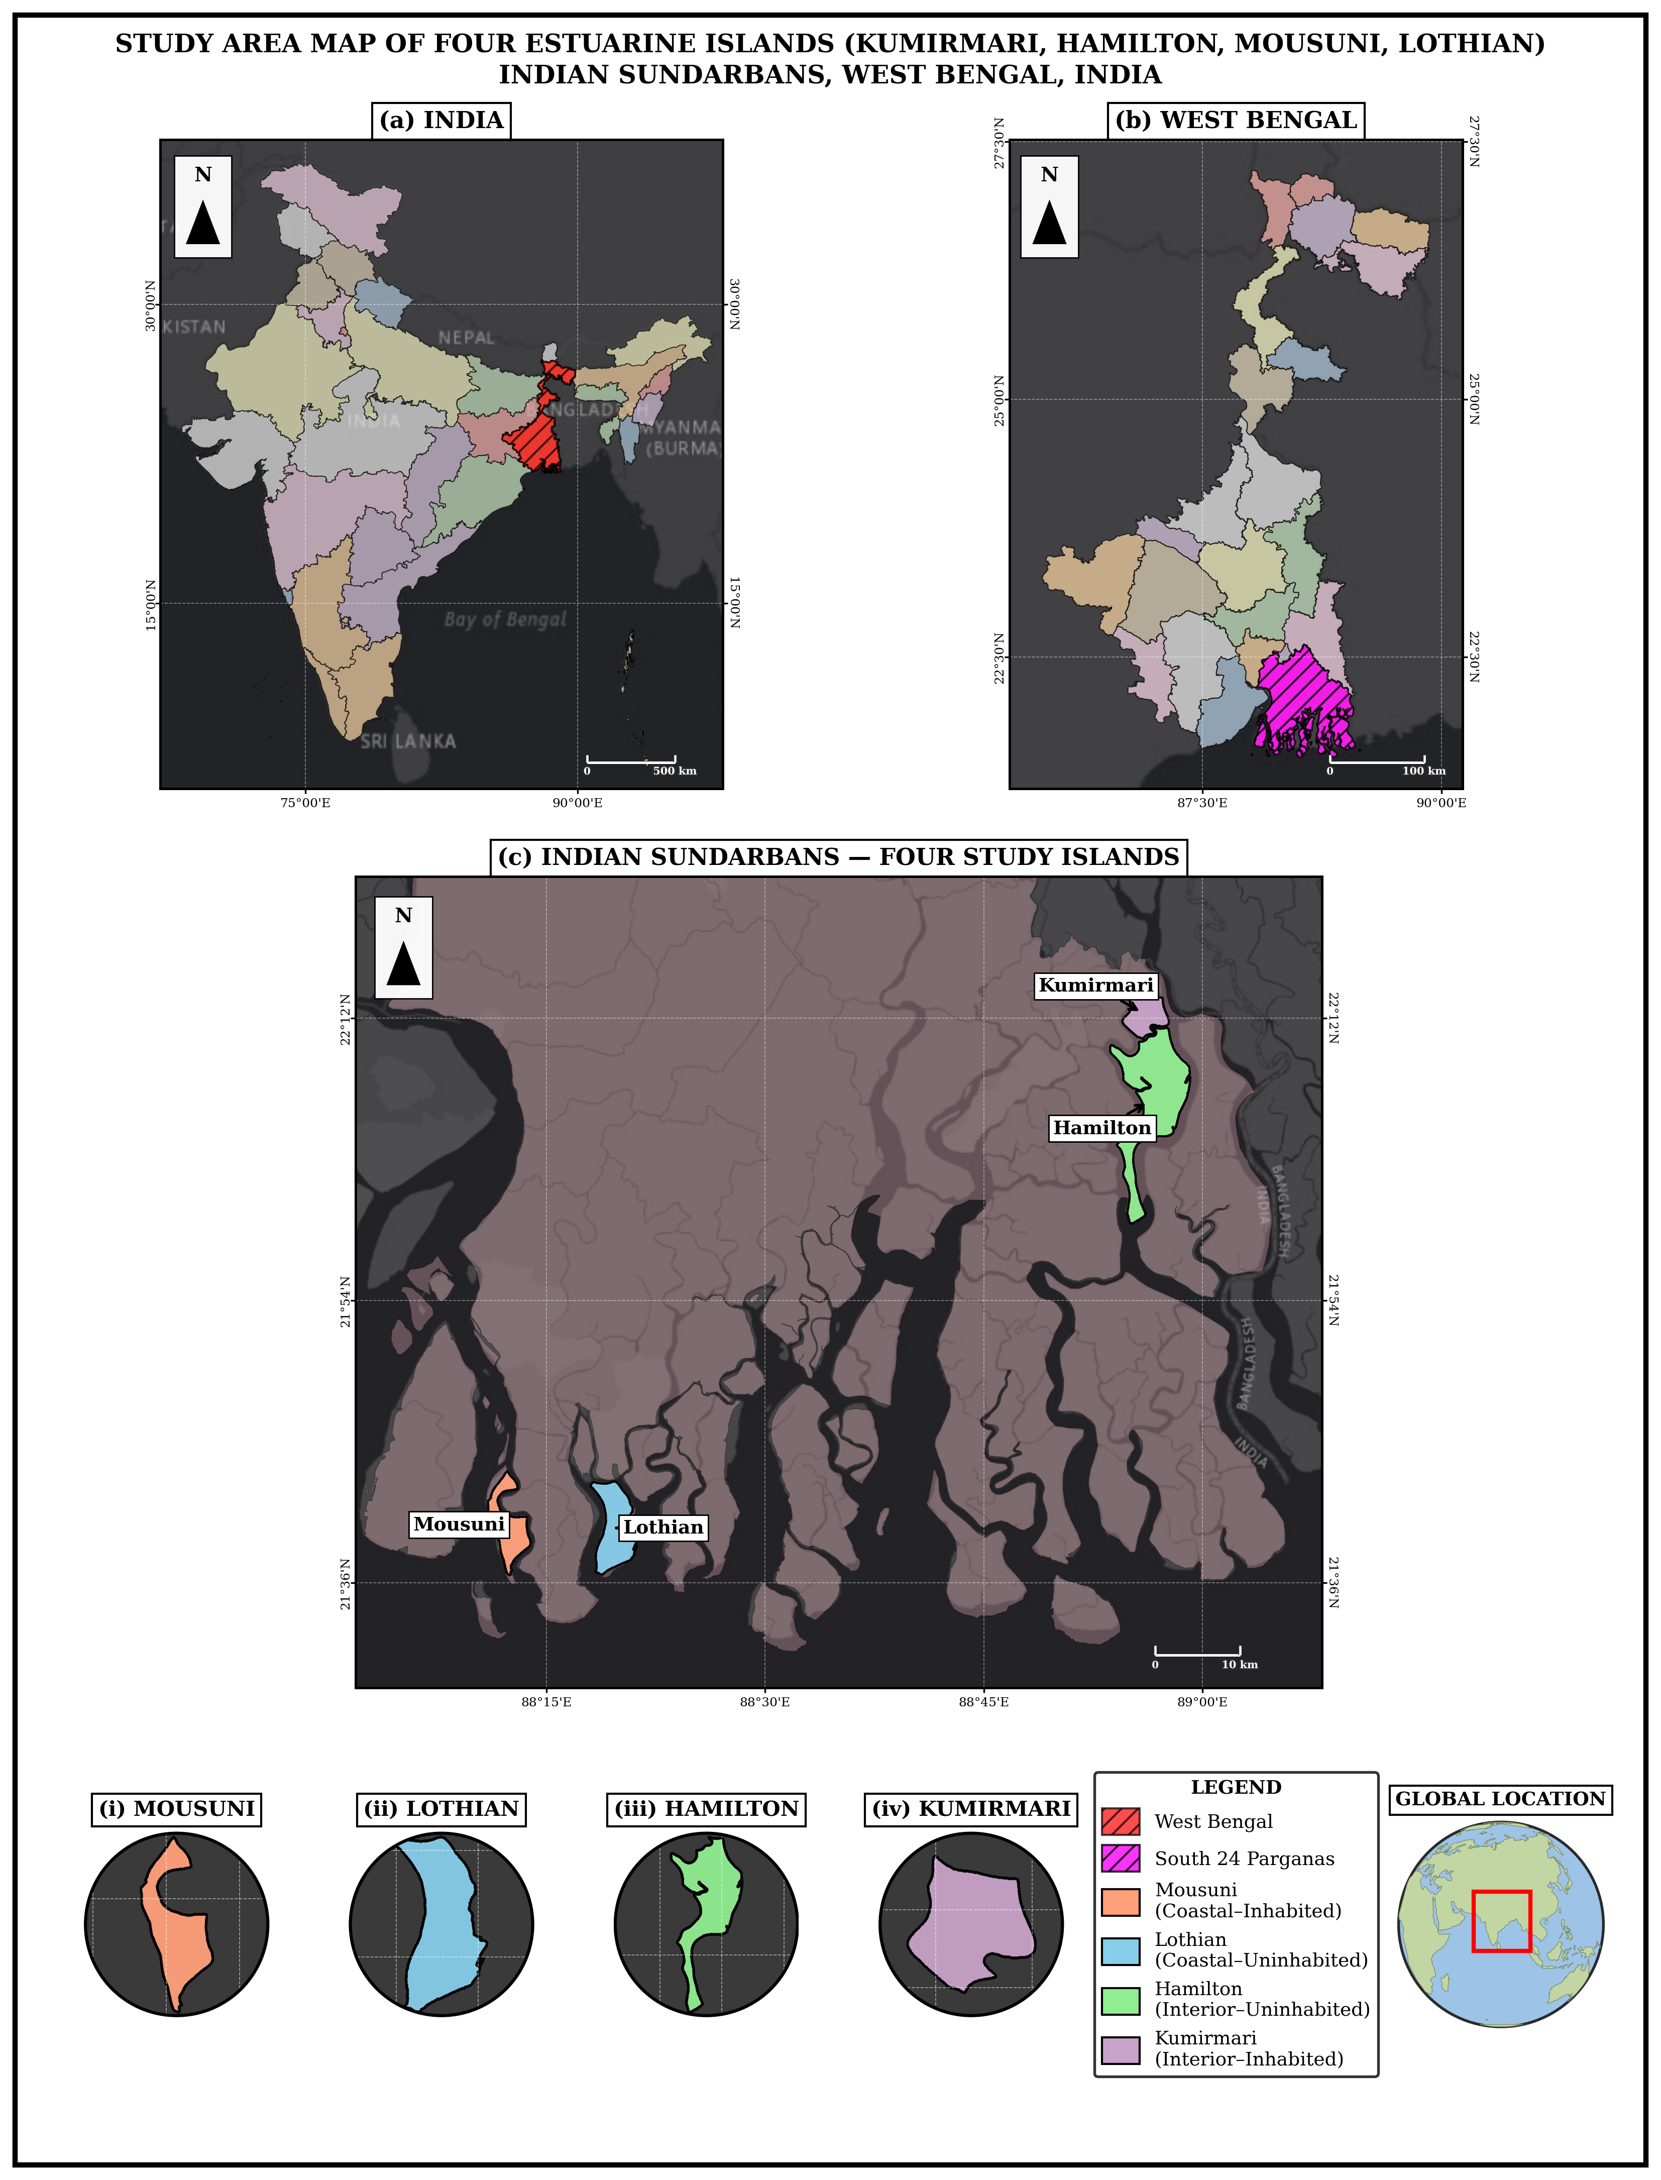
Note. Inset: Ganga–Brahmaputra–Meghna delta-r moddhe obosthan. Island: Kumirmari ebong Hamilton (interior), Mousuni ebong Lothian (coastal).
Indian Sundarbans South 24 Parganas ebong North 24 Parganas district (West Bengal)-e chhoriye ache ebong ekti UNESCO World Heritage / Biosphere Reserve-er ongsho (Ghosh et al., 2015; Giri et al., 2011). Ei region macro- theke meso-tidal (spring tidal range proyshoi > 4 m), jekhane onek tidal creek, mudflat ebong mangrove-fringed island ache. Climate humid tropical, ebong pre-monsoon (April–May) o post-monsoon period cyclogenesis-er jonno bishesh active (IPCC, 2021; Hazra et al., 2002).
Ei study-r jonno charti island 2×2 design onujayi beche neowa hoyeche (Table 1). Settlement-axis: Kumirmari ebong Mousuni inhabited (densely populated, embanked), jekhane Hamilton ebong Lothian (Lothian Island Wildlife Sanctuary) practically uninhabited ebong protected. Position-axis: Kumirmari ebong Hamilton tulonamulok interior (estuarine, creek-dominated), jekhane Mousuni ebong Lothian seaward/coastal ebong sorasori Bay of Bengal o major estuary mouth (jemon Muriganga)-er marine energy-r kache exposed (Bandyopadhyay, 1997; Gopinath & Seralathan, 2005). Mousuni western Sundarbans-er ekti well-documented erosion hotspot, tai eta validation-er jonno ideal.
Table 1. Study island ebong 2×2 paired design (area GEE MNDWI 2024 reference theke).
 | Inhabited (settled, embanked) | Uninhabited (protected)
Interior (estuarine) | Kumirmari — 19.09 km² (Gosaba Block) | Hamilton — 84.94 km²
Coastal (seaward) | Mousuni — 26.19 km² | Lothian — 36.30 km² (Wildlife Sanctuary)

3. Data o Methods / Upatto o Poddhoti
Puro processing workflow-ti Figure 2-te dekhano hoyeche.
Figure 2
Study-r methodological workflow
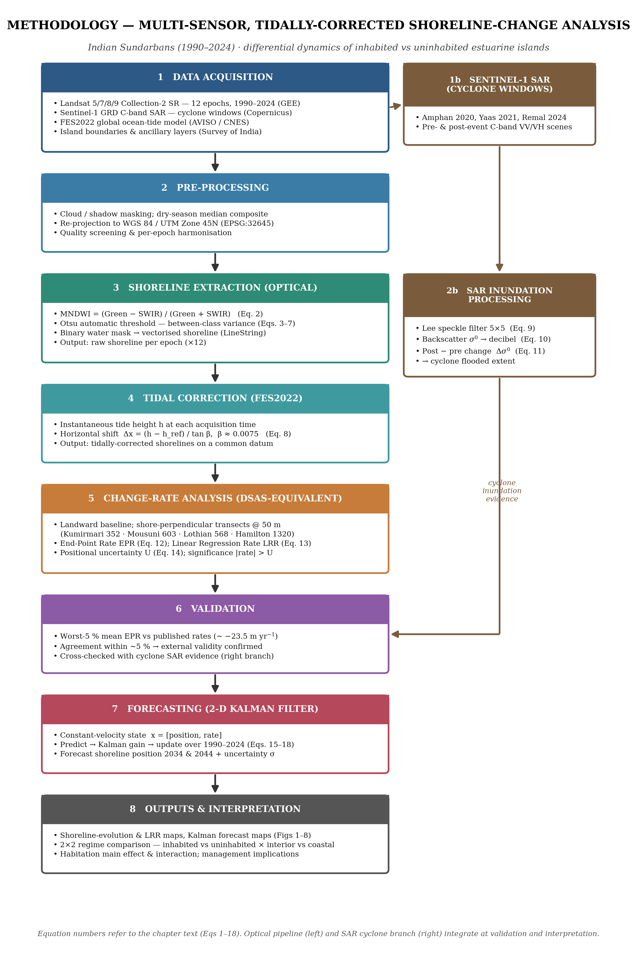
Note. Landsat 5/7/8/9 imagery theke MNDWI ebong Otsu thresholding diye shoreline extract kora hoy (McFeeters, 1996; Xu, 2006; Otsu, 1979; Gorelick et al., 2017) ebong FES2022 ocean-tide model diye tidally correct kora hoy (Lyard et al., 2021; CNES, 2024); ekti parallel Sentinel-1 SAR branch cyclone-period inundation capture kore (Torres et al., 2012; Lee, 1980); change rate DSAS-equivalent transect-e compute kora hoy (Thieler et al., 2009; Himmelstoss et al., 2018; Dolan et al., 1991) ebong future shoreline 2-D Kalman filter diye project kora hoy (Kalman, 1960; Long & Plant, 2012; Vitousek et al., 2017).

3.1 Satellite data o cloud processing
Optical analysis-er jonno Landsat Collection-2 Surface Reflectance archive (Landsat 5 TM, 7 ETM+, 8–9 OLI) byabohar kora hoyeche, ja Google Earth Engine (GEE)-te access ebong process kora hoyeche (Gorelick et al., 2017; Roy et al., 2014; Wulder et al., 2019). Baroti epoch (1990, 1995, 2000, 2005, 2008, 2010, 2013, 2016, 2019, 2020, 2022, 2024) beche neowa hoyeche jate long-term trend ebong recent cyclone-year dutoi cover hoy. Protiti epoch-er jonno dry-season (pre-monsoon) image cloud-mask kore median composite banano hoyeche, jate residual cloud ebong sensor-noise minimise hoy. SAR component-er jonno Sentinel-1 GRD (C-band, VV/VH) imagery cyclone-window-er asepashe byabohar kora hoyeche (Torres et al., 2012). Coordinate system puro samoy WGS 84 / UTM Zone 45N (EPSG:32645) rakha hoyeche.

3.2 Shoreline extraction: MNDWI + Otsu
Land–water boundary map korar jonno amra ekti water index byabohar korechi — emon ekti formula ja satellite band-gulo combine kore jate water, land theke alada bojha jay. Original index, NDWI, green ebong near-infrared (NIR) band byabohar kore (McFeeters, 1996):
NDWI = (Green − NIR) / (Green + NIR) (1)
Sundarbans-er turbid, sediment-bhora jol-e NDWI maajhe maajhe bright land-ke water bole bhul kore, tai amra Modified NDWI (MNDWI) byabohar korechi, ja NIR-er bodole shortwave-infrared (SWIR) band ney ebong ekhane water-ke land theke aro reliably alada kore (Xu, 2006; cf. Gao, 1996):
MNDWI = (Green − SWIR) / (Green + SWIR) (2)
MNDWI open water-e high ebong land-e low hoy. Land/water threshold chokh diye beche newar bodole amra Otsu (1979)-r method byabohar korechi, ja eta automatically ber kore. Otsu protiti possible threshold t try kore ebong protitir jonno pixel-gulo-ke duti class (water, land)-e bhag kore, jader probability ω₀, ω₁ ebong mean index value μ₀, μ₁:
ω₀(t) = Σ p(i) for i ≤ t ; ω₁(t) = Σ p(i) for i > t (3)
μ₀(t) = [Σ i·p(i), i ≤ t] / ω₀ ; μ₁(t) = [Σ i·p(i), i > t] / ω₁ (4)
Erpor eta between-class variance diye maape je duti class koto bhalo bhabe separate, ebong sei threshold t* beche ney ja ei separation-ke sobcheye boRo kore:
σ²_B(t) = ω₀ · ω₁ · (μ₁ − μ₀)² (5)
t* = argmax over t of σ²_B(t) (6)
Eta ei jonno kaaj kore karon histogram-er total spread fixed thake, ja within-class part ebong between-class part-e bhag hoy — tai between-class part maximise kora protiti class-ke jotota sombhob tight korar somotullo:
σ²_total = σ²_within(t) + σ²_B(t) (7)
Amra protiti MNDWI image-e Otsu-r threshold apply korechi, resulting water-mask-er boundary-ke shoreline line (LineString)-e convert korechi, ebong mangrove/vegetation context-er jonno NDVI-o compute korechi (Tucker, 1979).

3.3 Tidal correction: FES2022
Macro-tidal Sundarbans-e (spring tidal range proyshoi > 4 m), satellite image je muhurte neowa hoy sei somoyer tide level strongly affect kore je waterline kothay dekhabe, tai alada-alada date-er shoreline totokkhon directly comparable noy jotokkhon na egulo-ke ekti common tidal footing-e ana hoy (Boak & Turner, 2005). Protiti image-er jonno amra FES2022 global ocean-tide model theke predicted instantaneous tide height h niyechi (Lyard et al., 2021; CNES, 2024) ebong extracted shoreline-ke horizontally sekhane shift korechi jekhane eta ekti fixed reference level-e thakto. Simple foreshore geometry diye, slope β-wala beach-e ekti tide height difference (h − h_ref) waterline-ke horizontally eto move kore:
Δx = (h − h_ref) / tan β (8)
Amra ekti representative foreshore slope β ≈ 0.0075 byabohar korechi; jemon, 2 m tide difference shoreline-ke prai 2 / 0.0075 ≈ 270 m shift kore dey, ja eto boRo je eta ignore korle real change signal chapa poRe jabe. Ei step-er pore shoreline-gulo “tidally corrected” hoye jay ebong inter-epoch comparison physically meaningful hoy.

3.4 SAR backscatter and cyclone analysis
Cyclone bhari cloud ebong brishti niye ashe, ebong Landsat-er moto optical sensor cloud-er bhitor diye mati dekhte pare na. Radar (SAR) nijer signal nije banay ebong cloud-er bhitor diye din ba raat kaaj kore, tai amra tinti recent cyclone — Amphan (May 2020), Yaas (May 2021) ebong Remal (May 2024) — er asepashe Sentinel-1 C-band SAR byabohar korechi (Torres et al., 2012; Chakma & Akter, 2021). Smooth water radar-ke sensor theke dure reflect kore ebong dark dekhay, jekhane rough land ebong vegetation eta-ke phire scatter kore ebong bright dekhay; jokhon land flood hoy tokhon tar backscatter (σ⁰, “sigma-naught”) kome jay. Amra scene-gulo-ke tinti step-e process korechi. Prothome, amra grainy speckle noise Lee filter diye komiyechi (Lee, 1980; Lee et al., 1994), ja protiti pixel-ke local mean plus original detail-er ekti weighted share diye replace kore:
filtered = Ī + W·(I − Ī), with W = 1 − C_u² / C_I² (9)
jekhane Ī ekti chhoto moving window-er mean, C_u noise level ebong C_I window-er variability; smooth area-te W → 0 (noise smooth hoye jay) ebong edge-e W → 1 (detail theke jay). Dwitiyoto, amra backscatter-ke radar-er decibel scale-e rekhechi (Small, 2011):
σ⁰_dB = 10 · log₁₀(σ⁰) (10)
Tritiyoto, protiti cyclone-er jonno amra storm-er thik pore-r VV image-ke thik age-r image-er shathe compare korechi:
Δσ⁰ = σ⁰_post − σ⁰_pre (11)
Ekti clear drop (negative Δσ⁰) newly water-covered, flooded land mark kore — eta flood mapping-er jonno standard SAR change-detection approach (Amitrano et al., 2018; Chakma & Akter, 2021). Amra ei SAR evidence optical shoreline result-ke support korar jonno byabohar kori, replace korar jonno noy: Sentinel-1 shudhu 2014 theke shuru hoyeche, tai eta recent cyclone cover kore, long-term (1990–2024) rate noy, ebong backscatter drop water-er ekti proxy, sorasori measurement noy.

3.5 Change-rate statistics: DSAS-equivalent transects (EPR, LRR)
Date-wala shoreline-gulo-ke change-rate-e poriborton korar jonno amra Digital Shoreline Analysis System-er standard transect framework byabohar korechi (Thieler et al., 2009; Himmelstoss et al., 2018; Bera & Maiti, 2019). Coast theke ~200 m landward ekti baseline rakha hoy, shore-perpendicular transect ekti fixed spacing-e cast kora hoy (interior island-er jonno 50 m; coastal-er jonno comparable — Kumirmari-te 352, Mousuni-te 603, Lothian-e 573, Hamilton-e 1377 transect), ebong protiti transect-e amra sei distance d record kori jekhane protiti bochor-er shoreline eta cross kore. End-Point Rate shudhu sobcheye purono ebong sobcheye notun shoreline byabohar kore (Dolan et al., 1991):
EPR = (d_new − d_old) / (t_new − t_old) (12)
Linear Regression Rate protiti shoreline byabohar kore — sob (t, d) point-er bhitor diye ekti least-squares line fit kore; er slope-i rate (Crowell et al., 1991; Genz et al., 2007):
LRR = Σ (t_i − t_mean)(d_i − d_mean) / Σ (t_i − t_mean)² (13)
LRR aro robust karon ekti kharap bochor eta-ke noRate pare na, tai amra LRR-ke main trend ebong EPR-ke cross-check hisebe ney. Protiti rate-er shathe ekti uncertainty thake ja shoreline-er positional error U theke ashe (~35 m coastal, ~50 m interior, ja pixel size, co-registration ebong residual tidal error combine kore); end-point rate-er jonno:
U_EPR = √(U_old² + U_new²) / (t_new − t_old) (14)
Kono measured rate-ke real change tokhon-i dhora hoy jokhon eta ei uncertainty-r theke beshi hoy. Ei transect rate-gulo wider Indian-Sundarbans DSAS literature-er shathe directly comparable (Bera & Maiti, 2019; Das et al., 2021).

3.6 Validation against published rates
Amader workflow je sensible number dey eta check korar jonno amra amader Mousuni result-ke region-er independently published erosion rate-er shathe compare korechi. Western Indian Sundarbans ebong Hooghly-estuary island-er study maximum erosion rate roughly −20 theke −24 m yr⁻¹ report kore (Bandyopadhyay, 1997; Gopinath & Seralathan, 2005; Bandyopadhyay et al., 2014), ebong Mousuni Island-er ekti recent DSAS study extreme rate prai −23.55 m yr⁻¹ porjonto report kore jekhane er prai 90% perimeter erode hocche (Mishra et al., 2026). Amra amader worst-5% (most-eroding) transect-er mean EPR niye eta-ke ei published figure-er shathe compare kori (Section 4.3); close agreement ei kothar evidence je MNDWI + FES2022 + DSAS workflow externally valid.

3.7 Future projection: 2-D Kalman filter
Protiti shoreline 2034 ebong 2044-te kothay thakbe eta estimate korar jonno amra ekti Kalman filter byabohar korechi (Kalman, 1960; Long & Plant, 2012; Vitousek et al., 2017). LRR line-ke sorasori future-e extend korle protiti past measurement-ke perfect dhore neowa hoy ebong kono error bar pawa jay na; er bodole Kalman filter ekti running best guess rakhe ebong jokhon-i kono measurement dekhe sei guess-ke correct kore — reliable measurement-e beshi ebong noisy-te kom bhorosa kore — jate ekti smoothed rate ebong emon ekti forecast pawa jay jar uncertainty horizon-er shathe baRe. Protiti transect-er jonno eta shoreline position y ebong tar rate v-ke ekti state x = [y, v] hisebe track kore, ekti roughly constant rate dhore, ebong 1990–2024-er upor duti step repeat kore. Predict step guess-ke ekti time step Δt samne egiye dey:
x⁻ = F·x, P⁻ = F·P·F^T + Q, with F = [[1, Δt], [0, 1]] (15)
jekhane P guess-er uncertainty ebong Q process noise. Erpor update step guess-ke observed shoreline z diye correct kore (H = [1, 0]; R Section 3.5 theke measurement error), Kalman gain K-er madhyome, ja model ebong data-r moddhe balance kore:
K = P⁻·H^T / (H·P⁻·H^T + R) (16)
x = x⁻ + K·(z − H·x⁻), P = (I − K·H)·P⁻ (17)
Sob shoreline (1990–2024) assimilate howar pore, filter-er kache present position ebong ekti smoothed rate v thake; forecast korar jonno eta kono notun data chhaRai samne predict kore, tai position samne egoy ebong uncertainty σ horizon-er shathe baRe:
y(t) = y_now + v·(t − t_now), with σ increasing with the horizon (18)
Erpor ei along-transect movement-ke transect azimuth borabor map-e phire rakha hoy, jate 2024 → 2034 → 2044 position toiri hoy. Ei filter DSAS-er bhitore built-in forecasting tool ebong Sundarbans-er motoi Bay of Bengal / Meghna delta system-e apply kora hoyeche (Kona et al., 2025). Eta hothat, non-linear change (embankment breach ba ekti future cyclone) anticipate korte pare na, tai forecast-ke exact prediction hisebe noy borong trend-plus-uncertainty trajectory hisebe poRa hoy.

4. Results / Folafol

4.1 Tidally-corrected shoreline evolution (1990–2010–2024)
Figure 3 charti island-er tidally-corrected shoreline evolution dekhay (1990 purple → 2010 teal → 2024 yellow). Pattern clearly regime-dependent. Mousuni (inhabited–coastal)-er shoreline consistently landward (bhitor-er dike) sore — 1990-er outline 2024-er tulonay onek baire, ja sustained net erosion confirm kore. Lothian (uninhabited–coastal) mixed behaviour dekhay (kichu sector erode, kichu accrete). Kumirmari (inhabited–interior)-er shoreline kintu motamuti stable — er 1990, 2010 ebong 2024-er outline eke oporer shathe prai overlap kore (perimeter ~18 km, epoch-e-epoch-e 1 km-er kom variation), maane khub halka net change. Uninhabited interior Hamilton-o prai eki-rokom (halka erosional), tai dui-ti sheltered interior island-ke alada kora kothin. Ei qualitative picture Section 4.2-er quantitative rate-er shathe consistent.
Figure 3
Charti island-er jonno tidally-corrected shoreline evolution (1990, 2010, 2024)
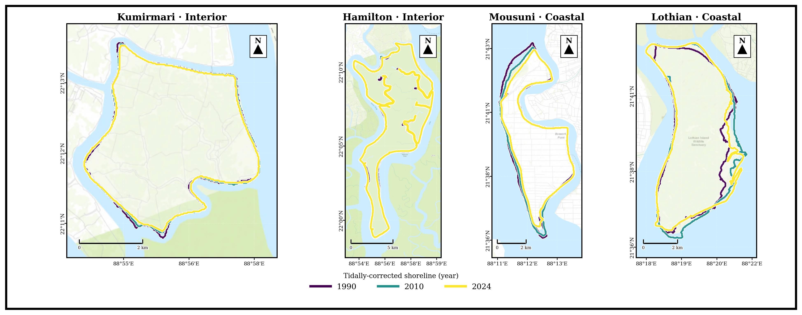
Note. Mousuni-te successive shoreline-er sustained inward shift = net erosion; interior pair (Kumirmari, Hamilton) near-stable ebong Lothian broadly stable theke halka accretional.

4.2 Change-rates o inhabited vs uninhabited contrast
DSAS LRR heatmap (Figure 4) per-transect rate spatially summarise kore. Sobcheye strong negative (erosional) rate Mousuni-r north-west, Muriganga-facing coast-e concentrated. Aggregate level-e sobcheye striking result holo island setting (interior naki coastal) ebong habitation-er moddhe “interaction”. Exposed coast-e inhabited island Mousuni (mean EPR −4.54 m yr⁻¹, LRR −4.69; ~72% transect eroding) uninhabited Lothian (+0.54 m yr⁻¹, LRR +1.44; ~50% accreting)-er theke onek beshi erode kore: dui-ti coastal distribution khub strongly alada (Mann–Whitney ebong Kolmogorov–Smirnov dui test-e p < 0.001), tobe Mousuni-r erosion ekti heavy tail-e concentrated (median EPR −1.36 m yr⁻¹, mean −4.54). Onyodike sheltered interior-e inhabited Kumirmari (−0.62 m yr⁻¹, LRR −0.85; 54% eroding, 35% stable) uninhabited Hamilton (−0.89 m yr⁻¹, LRR −0.95; 65% eroding)-er theke statistically alada noy: interior-er inhabited–uninhabited difference matro +0.29 m yr⁻¹ (block-bootstrap 95% CI [−0.01, +0.75], significant noy). Difference-of-differences — setting × habitation interaction — +2.10 m yr⁻¹ (95% CI [+0.25, +4.08]) ebong statistically significant: habitation/embankment ebong erosion-er somporko high-energy open coast-e pronounced kintu low-energy interior-e onuposthit. Guruttopurno bishoy holo, dui-ti uninhabited island setting onujayi porospor theke significantly alada noy (Hamilton vs Lothian, significant noy) — ei control contrast coastal anthropogenic signal-ke credibility dey (cf. Bandyopadhyay, 1997; Pethick & Orford, 2013; Bera & Maiti, 2019).
Figure 4
Sob island-er jonno transect juRe DSAS Linear Regression Rate (LRR)
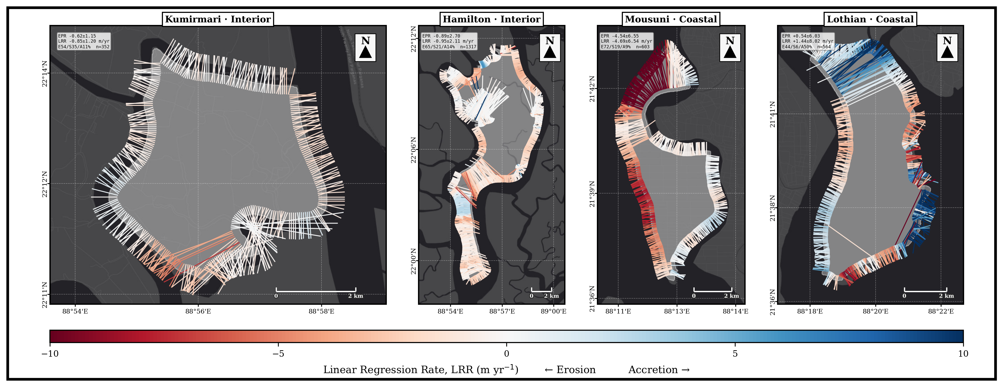
Note. Lal = erosion, neel = accretion; Mousuni-r NW sector sobcheye erosional.
Island-onujayi mean change rate Figure 5-e, ebong tader purno distribution Figure 6-e dekhano hoyeche.
Figure 5
Island-onujayi mean shoreline-change rate, 1990–2024: End-Point Rate (EPR) ebong Linear Regression Rate (LRR), exposure setting onujayi grouped ebong settlement regime onujayi coloured
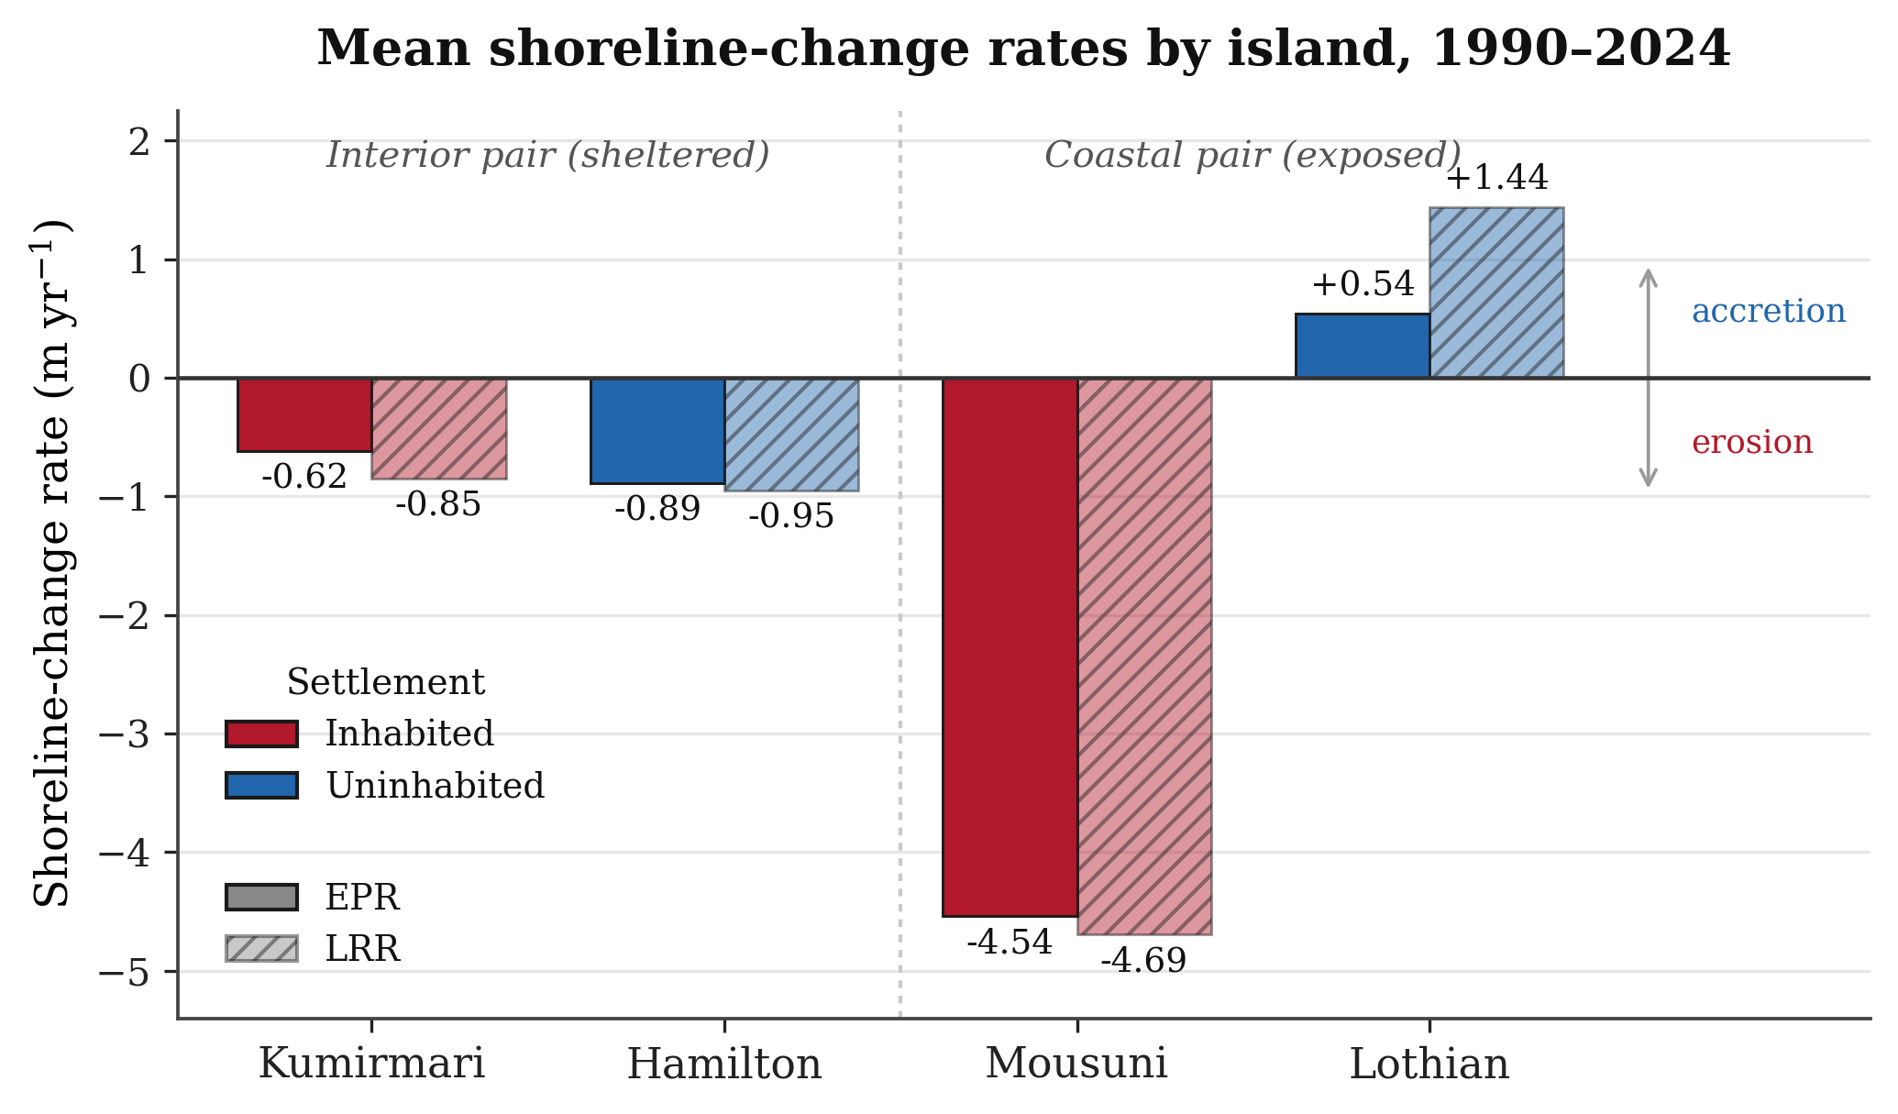
Note. Dui estimator-i prai eki rokom; strong erosion sudhu exposed inhabited island (Mousuni)-te seemaboddho, sheltered interior pair near-stable ebong exposed uninhabited island (Lothian) accrete kore (Thieler et al., 2009; Himmelstoss et al., 2018).

4.3 Mousuni validation
Mousuni-r transect-level EPR distribution ebong tar published-rate validation niche summarise kora hoyeche. Distribution strongly negative-skewed (mass < 0 m yr⁻¹), ja erosion-dominance confirm kore (median EPR −1.36 m yr⁻¹, mean −4.54). Single most-eroded transect −24.99 m yr⁻¹ porjonto pouchhay (~ azimuth 332°, NW Muriganga-facing). Ei maximum published Sundarbans/Hooghly maximum erosion rate-er (~ −23.5 m yr⁻¹; Bandyopadhyay, 1997; Gopinath & Seralathan, 2005) ~6%-er moddhe mile jay — ja ei study-r MNDWI+FES2022+DSAS workflow-er external validity-r jonno strong evidence.

4.4 Cyclone-period backscatter response
Sentinel-1 σ⁰ (dB) Amphan (2020), Yaas (2021) ebong Remal (2024)-er post-event window-e coastal island-er upor notable backscatter drop dekhiyeche, ja temporary inundation/standing-water-er shathe consistent (Torres et al., 2012; Lee, 1980). Signal coastal pair (Mousuni, Lothian)-e interior pair-er theke beshi strong chhilo, ja expected karon coastal island surge ebong direct marine forcing-er beshi exposed (Hazra et al., 2002; IPCC, 2021). Ei SAR evidence optical erosion-trend-ke complement kore ebong event-scale driver-ke long-term trend-er shathe link kore.

4.5 Kalman-filter shoreline forecasts (2034, 2044)
Per-transect Kalman forecast (Figure 6) regime-contrast-ke future-e project kore. 2044 nagad Mousuni-r mean change ~ −93 m (±123 m) ebong ~84% transect eroding thake — clearly sobcheye vulnerable. Interior island-gulo modest kintu consistent retreat dekhay (Kumirmari ~ −16 m, ±23 m, ~81% eroding; Hamilton ~ −19 m, ±38 m, ~81% eroding), jekhane uninhabited coastal Lothian average-e prai stable kintu highly-variable (~ +12 m, ±161 m, ~47% eroding). 2034-er intermediate horizon-eo eki ordering dekha jay (Mousuni ~ −44 m; Hamilton ~ −9 m; Kumirmari ~ −8 m; Lothian ~ +5 m). Lothian-er boRo σ tar sector-wise heterogeneity reflect kore. Forecast-ke deterministic prediction hisebe noy, borong uncertainty-bounded trajectory hisebe interpret kora uchit (Long & Plant, 2012; Vitousek et al., 2017).
Figure 6
Charti island-er jonno 2034 ebong 2044 porjonto Kalman-filter shoreline forecast (per-transect position)
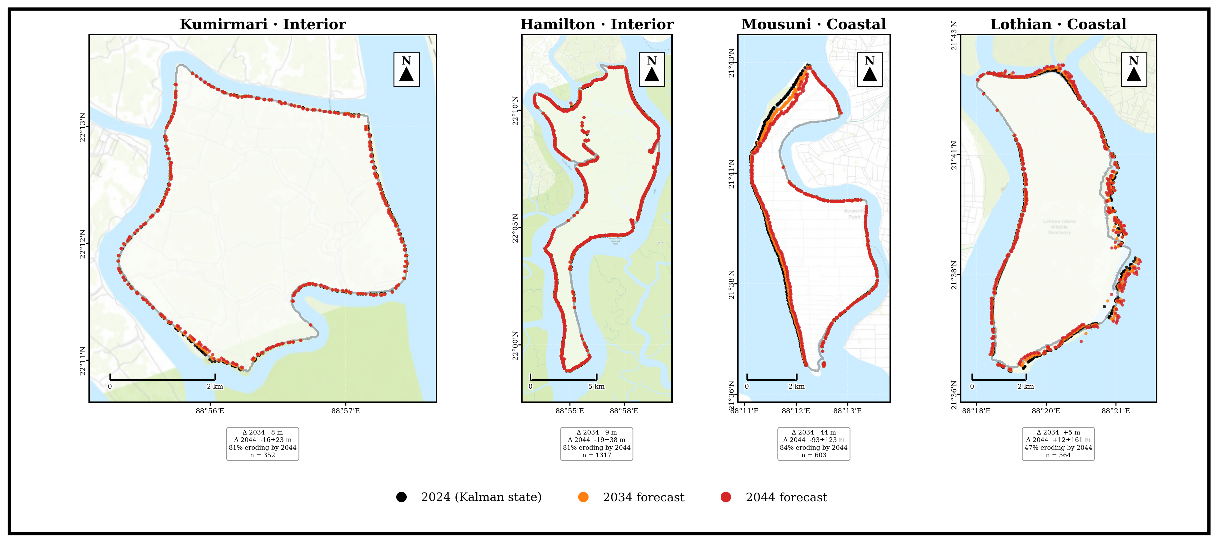
Note. Mousuni sobcheye strong projected retreat dekhay, interior islands (Kumirmari, Hamilton) modest retreat dekhay ebong Lothian near-stable kintu highly-variable.
2044 porjonto projected shoreline trajectory shob charti island-e ekoi regime contrast onushoron kore.

5. Discussion / Alochona
Ei study-r central finding holo je Sundarbans-e shoreline behaviour puropuri natural noy, borong settlement ebong engineering-er shathe strongly modulated. Paired design dekhiyeche je sobcheye vulnerable regime inhabited–coastal (Mousuni), ebong habitation-er effect shoreline change-er upor uniform noy borong setting-depended: setting × habitation interaction significant (+2.10 m yr⁻¹, 95% CI [+0.25, +4.08]). Exposed coast-e inhabited Mousuni uninhabited Lothian-er theke onek beshi erode kore, kintu sheltered interior-e inhabited Kumirmari uninhabited Hamilton-er theke kharap noy, ebong dui-ti uninhabited island porospor theke significantly alada noy. Eta ei hypothesis support kore je embankment-driven sediment-starvation ebong tidal-prism disturbance bishesh kore sekhanei erosion accelerate kore jekhane wave ebong surge energy beshi — inhabited open-coast island-e — sheltered estuarine island-e noy (Bandyopadhyay, 1997; Pethick & Orford, 2013).
Mechanistically, kayekti driver ekshathe operate kore. Prothomoto, regional relative sea-level rise ebong subsidence accommodation-space baRay ebong shoreline-ke landward push kore (Hazra et al., 2002; Rahman et al., 2011; IPCC, 2021). Dwitiyoto, embankment natural tidal flooding ebong sediment-deposition-ke island-er interior porjonto pouchhate baadha dey, jate “sediment starvation” hoy ebong mudflat vertically accrete korte pare na (Pethick & Orford, 2013; Woodroffe et al., 2016). Tritiyoto, reclamation ebong channel-narrowing estuarine hydrodynamics-ke disturb kore, jate flood-tide dominance ebong bank-erosion baRe (Bandyopadhyay, 1997; Gopinath & Seralathan, 2005). Chaturthoto, high-intensity cyclone (Amphan, Yaas, Remal) episodic kintu boRo erosion/inundation pulse dey, ja amra Sentinel-1 σ⁰ drop-er madhyome sorasori dekhechi (Section 4.4; Torres et al., 2012).
Amader result existing Sundarbans literature-er shathe broadly consistent. Mousuni-r high erosion rate Sagar ebong onyanyo western-Sundarbans island-er documented rate-er (~ −20 theke −24 m yr⁻¹) comparable (Bandyopadhyay, 1997; Gopinath & Seralathan, 2005; Bandyopadhyay et al., 2014). Sobcheye-eroded transect-er published maximum-er ~6%-er moddhe mile jawa (Section 4.3) ei workflow-er reliability strengthen kore. Inhabited–coastal island Mousuni-r severe erosion, uninhabited coastal Lothian-er near-stability ebong dui-ti sheltered interior island (Kumirmari ebong Hamilton)-er statistically indistinguishable behaviour-er prekkhite, ei finding reinforce kore je settlement/embankment ebong exposure ekshathe matter kore — habitation eka noy, borong eder combination divergence-ke drive kore (Bera & Maiti, 2019; Ghosh et al., 2015).
Methodologically, ei study-r strength holo: (i) explicit FES2022 tidal correction, ja macro-tidal Sundarbans-e critical ebong ja onek purono study-te missing chhilo (Lyard et al., 2021; CNES, 2024; Boak & Turner, 2005); (ii) multi-sensor integration (optical + SAR), ja trend ebong event-driver dutoi capture kore; (iii) reproducible GEE-based pipeline (Gorelick et al., 2017); ebong (iv) Kalman-based forecasting ja uncertainty-ke explicitly carry kore (Long & Plant, 2012). Limitation-o sotbhabe note kora uchit: shoreline-extraction medium-resolution Landsat (~30 m) porjonto limited; tidal correction ekti single representative foreshore slope (β ≈ 0.0075) dhore ney, othocho real β spatially vary kore; constant-velocity Kalman model non-linear/threshold dynamics (jemon hothat embankment-breach) puropuri capture kore na; ebong paired design-e prati regime-e maatro ekti island, tai broader generalisation-er jonno aro island add kora uchit (Genz et al., 2007).

6. Conclusion / Uposonghar
Ei chapter-e amra ekti multi-sensor, tidally-corrected framework byabohar kore Indian Sundarbans-er charti paired island (1990–2024)-er shoreline dynamics analyse korechi. Tinti main conclusion ache. Prothomoto, ei region-e shoreline change strongly regime-dependent, ebong inhabited–coastal island (Mousuni) onekta beshi erosional (~72% transect eroding; mean EPR −4.54 m yr⁻¹, sobcheye-eroded transect −24.99 m yr⁻¹), jekhane uninhabited coastal Lothian near-stable theke halka accretional ebong dui-ti sheltered interior island — inhabited Kumirmari (−0.62 m yr⁻¹) ebong uninhabited Hamilton (−0.89 m yr⁻¹) — statistically indistinguishable. Dwitiyoto, setting × habitation interaction significant (+2.10 m yr⁻¹, 95% CI [+0.25, +4.08]): habitation ebong embankment exposed coast-e onek beshi erosion-er shathe juRito kintu sheltered interior-e kono detectable difference toiri kore na, tai settlement ebong coastal exposure-er combination — habitation eka noy — erosion-ke amplify kore. Tritiyoto, Kalman forecast onujayi ei divergence 2034 ebong 2044 nagad aro baRbe, jate Mousuni-r moto inhabited coastal island-e urgent adaptation-er proyojon. Validation (published rate-er ~6%-er moddhe) ebong SAR-based cyclone evidence ei conclusion-gulo strengthen kore. Coastal manager-der jonno implication clear: embankment policy-ke sediment-flux ebong tidal-prism consideration-er shathe rethink korte hobe, ebong highest-risk inhabited coastal island-ke priority dite hobe (Pethick & Orford, 2013; IPCC, 2019, 2021). Future work-e resolution (Sentinel-2/PlanetScope), spatially-variable foreshore slope, ebong aro island include kore generalisation improve kora jete pare.

Acknowledgements / Kritoggota
Lekhok Department of Geography, University of Madras ebong Indian Institute of Science (IISc), Bengaluru-r research-visit support-er jonno kritoggotar shathe dhonnobad janay. Landsat data USGS/NASA, Sentinel-1 data ESA Copernicus, ebong FES2022 tidal model CNES/AVISO-r soujonye. Eta ekti Version 0.0 working draft.
Figure Sources o Data Credits
Sob figure lekhok (A. Ghosh, 2026) toiri korechen. Underlying data ebong basemap source niche deowa holo. Optical imagery (Figure 3): Landsat 5/7/8/9 Collection-2 Level-2 surface reflectance, USGS/NASA (dry-season scene, 1990–2024), Google Earth Engine-er madhyome accessed (Gorelick et al., 2017); MNDWI Green ebong SWIR1 band use kore (Xu, 2006). SAR: Sentinel-1 GRD C-band σ⁰ VV backscatter, ESA Copernicus, Google Earth Engine-er madhyome accessed ebong Lee-filtered (5×5). Tidal correction: FES2022 global ocean-tide model, AVISO/CNES (Lyard et al., 2021; CNES, 2024). Shoreline-change rate ebong Kalman projection (Figure 4, 5, 6 ebong 7): DSAS-equivalent transect statistics (Thieler et al., 2009; Himmelstoss et al., 2018) ebong 2-D Kalman filter (Kalman, 1960). Basemap: Esri Dark Gray Canvas ebong OpenStreetMap contributors (Figure 1). Coordinate reference system: WGS 84 (EPSG:4326).

References / Tottosutro
Amitrano, D., Di Martino, G., Iodice, A., Riccio, D., & Ruello, G. (2018). Unsupervised rapid flood mapping using Sentinel-1 GRD SAR images. IEEE Transactions on Geoscience and Remote Sensing, 56(6), 3290–3299. https://doi.org/10.1109/TGRS.2018.2797536
Bandyopadhyay, J., Mondal, I., & Samanta, N. (2014). Shore line shifting of Namkhana Island of Indian Sundarban, South 24 Parganas, West Bengal. International Journal of Engineering Sciences & Research Technology, 3(5), 162–169.
Bandyopadhyay, S. (1997). Coastal erosion and its management in Sagar Island, West Bengal, India. Indian Journal of Earth Sciences, 24(3–4), 51–69.
Bera, R., & Maiti, R. (2019). Quantitative analysis of erosion and accretion (1975–2017) using DSAS — A study on Indian Sundarbans. Regional Studies in Marine Science, 28, 100583. https://doi.org/10.1016/j.rsma.2019.100583
Boak, E. H., & Turner, I. L. (2005). Shoreline definition and detection: A review. Journal of Coastal Research, 21(4), 688–703. https://doi.org/10.2112/03-0071.1
Chakma, S., & Akter, M. (2021). Flood mapping in the coastal region of Bangladesh during super cyclone Amphan. Journal of the Civil Engineering Forum, 7(3), 267–278. https://doi.org/10.22146/jcef.64497
CNES. (2024). FES2022 (Finite Element Solution) ocean tide (Version 2022) [Data set]. Centre National d'Études Spatiales. https://doi.org/10.24400/527896/A01-2024.004
Crowell, M., Leatherman, S. P., & Buckley, M. K. (1991). Historical shoreline change: Error analysis and mapping accuracy. Journal of Coastal Research, 7(3), 839–852. https://www.jstor.org/stable/4297899
Das, S. K., Sajan, B., Ojha, C., & Soren, S. (2021). Shoreline change behavior study of Jambudwip island of Indian Sundarban using DSAS model. The Egyptian Journal of Remote Sensing and Space Science, 24(3), 961–970. https://doi.org/10.1016/j.ejrs.2021.09.004
Dolan, R., Fenster, M. S., & Holme, S. J. (1991). Temporal analysis of shoreline recession and accretion. Journal of Coastal Research, 7(3), 723–744. https://www.jstor.org/stable/4297888
Ericson, J. P., Vörösmarty, C. J., Dingman, S. L., Ward, L. G., & Meybeck, M. (2006). Effective sea-level rise and deltas: Causes of change and human dimension implications. Global and Planetary Change, 50(1–2), 63–82. https://doi.org/10.1016/j.gloplacha.2005.07.004
Gao, B.-C. (1996). NDWI — A normalized difference water index for remote sensing of vegetation liquid water from space. Remote Sensing of Environment, 58(3), 257–266. https://doi.org/10.1016/S0034-4257(96)00067-3
Genz, A. S., Fletcher, C. H., Dunn, R. A., Frazer, L. N., & Rooney, J. J. (2007). The predictive accuracy of shoreline change rate methods and alongshore beach variation on Maui, Hawaii. Journal of Coastal Research, 23(1), 87–105. https://doi.org/10.2112/05-0521.1
Ghosh, A., Schmidt, S., Fickert, T., & Nüsser, M. (2015). The Indian Sundarban mangrove forests: History, utilization, conservation strategies and local perception. Diversity, 7(2), 149–169. https://doi.org/10.3390/d7020149
Ghosh, T., Bhandari, G., & Hazra, S. (2001, November 5–9). Assessment of land use/land cover dynamics and shoreline changes of Sagar Island through remote sensing [Paper presentation]. 22nd Asian Conference on Remote Sensing, Singapore.
Giri, C., Ochieng, E., Tieszen, L. L., Zhu, Z., Singh, A., Loveland, T., Masek, J., & Duke, N. (2011). Status and distribution of mangrove forests of the world using earth observation satellite data. Global Ecology and Biogeography, 20(1), 154–159. https://doi.org/10.1111/j.1466-8238.2010.00584.x
Gopinath, G., & Seralathan, P. (2005). Rapid erosion of the coast of Sagar Island, West Bengal, India. Environmental Geology, 48(8), 1058–1067. https://doi.org/10.1007/s00254-005-0044-9
Gorelick, N., Hancher, M., Dixon, M., Ilyushchenko, S., Thau, D., & Moore, R. (2017). Google Earth Engine: Planetary-scale geospatial analysis for everyone. Remote Sensing of Environment, 202, 18–27. https://doi.org/10.1016/j.rse.2017.06.031
Hazra, S., Ghosh, T., DasGupta, R., & Sen, G. (2002). Sea level and associated changes in the Sundarbans. Science and Culture, 68(9–12), 309–321.
Himmelstoss, E. A., Henderson, R. E., Kratzmann, M. G., & Farris, A. S. (2018). Digital Shoreline Analysis System (DSAS) version 5.0 user guide (Open-File Report 2018-1179). U.S. Geological Survey. https://doi.org/10.3133/ofr20181179
Intergovernmental Panel on Climate Change. (2019). IPCC special report on the ocean and cryosphere in a changing climate (H.-O. Pörtner, D. C. Roberts, V. Masson-Delmotte, P. Zhai, M. Tignor, E. Poloczanska, K. Mintenbeck, A. Alegría, M. Nicolai, A. Okem, J. Petzold, B. Rama, & N. M. Weyer, Eds.). Cambridge University Press. https://doi.org/10.1017/9781009157964
Intergovernmental Panel on Climate Change. (2021). Climate change 2021: The physical science basis. Contribution of Working Group I to the Sixth Assessment Report of the Intergovernmental Panel on Climate Change (V. Masson-Delmotte, P. Zhai, A. Pirani, S. L. Connors, C. Péan, S. Berger, N. Caud, Y. Chen, L. Goldfarb, M. I. Gomis, M. Huang, K. Leitzell, E. Lonnoy, J. B. R. Matthews, T. K. Maycock, T. Waterfield, O. Yelekçi, R. Yu, & B. Zhou, Eds.). Cambridge University Press. https://doi.org/10.1017/9781009157896
Kalman, R. E. (1960). A new approach to linear filtering and prediction problems. Journal of Basic Engineering, 82(1), 35–45. https://doi.org/10.1115/1.3662552
Kona, A. D., Hoque, M. E., & Rahman, M. A. (2025). Evaluating shoreline prediction accuracy with the Kalman filter model: A case study of Nijhum Dwip, Bay of Bengal. Remote Sensing Applications: Society and Environment, 37, 101469. https://doi.org/10.1016/j.rsase.2025.101469
Lee, J.-S. (1980). Digital image enhancement and noise filtering by use of local statistics. IEEE Transactions on Pattern Analysis and Machine Intelligence, PAMI-2(2), 165–168. https://doi.org/10.1109/TPAMI.1980.4766994
Lee, J.-S., Jurkevich, I., Dewaele, P., Wambacq, P., & Oosterlinck, A. (1994). Speckle filtering of synthetic aperture radar images: A review. Remote Sensing Reviews, 8(4), 313–340. https://doi.org/10.1080/02757259409532206
Long, J. W., & Plant, N. G. (2012). Extended Kalman Filter framework for forecasting shoreline evolution. Geophysical Research Letters, 39(13), L13603. https://doi.org/10.1029/2012GL052180
Lyard, F. H., Allain, D. J., Cancet, M., Carrère, L., & Picot, N. (2021). FES2014 global ocean tide atlas: Design and performance. Ocean Science, 17(3), 615–649. https://doi.org/10.5194/os-17-615-2021
McFeeters, S. K. (1996). The use of the Normalized Difference Water Index (NDWI) in the delineation of open water features. International Journal of Remote Sensing, 17(7), 1425–1432. https://doi.org/10.1080/01431169608948714
Mishra, M., Zerouali, B., Paul, S., Bhattacharyya, D., Guria, R., Suna, M., da Silva, R. M., Ranagalage, M., & Santos, C. A. G. (2026). Coastal futures at risk: Adaptive coastal management and policy insights from sea-level rise and shoreline change in West Bengal, India. Science of the Total Environment, 1014, 181238. https://doi.org/10.1016/j.scitotenv.2025.181238
Otsu, N. (1979). A threshold selection method from gray-level histograms. IEEE Transactions on Systems, Man, and Cybernetics, 9(1), 62–66. https://doi.org/10.1109/TSMC.1979.4310076
Pethick, J., & Orford, J. D. (2013). Rapid rise in effective sea-level in southwest Bangladesh: Its causes and contemporary rates. Global and Planetary Change, 111, 237–245. https://doi.org/10.1016/j.gloplacha.2013.09.019
Rahman, A. F., Dragoni, D., & El-Masri, B. (2011). Response of the Sundarbans coastline to sea level rise and decreased sediment flow: A remote sensing assessment. Remote Sensing of Environment, 115(12), 3121–3128. https://doi.org/10.1016/j.rse.2011.06.019
Roy, D. P., Wulder, M. A., Loveland, T. R., Woodcock, C. E., Allen, R. G., Anderson, M. C., Helder, D., Irons, J. R., Johnson, D. M., Kennedy, R., Scambos, T. A., Schaaf, C. B., Schott, J. R., Sheng, Y., Vermote, E. F., Belward, A. S., Bindschadler, R., Cohen, W. B., Gao, F., … Zhu, Z. (2014). Landsat-8: Science and product vision for terrestrial global change research. Remote Sensing of Environment, 145, 154–172. https://doi.org/10.1016/j.rse.2014.02.001
Small, D. (2011). Flattening gamma: Radiometric terrain correction for SAR imagery. IEEE Transactions on Geoscience and Remote Sensing, 49(8), 3081–3093. https://doi.org/10.1109/TGRS.2011.2120616
Syvitski, J. P. M., Kettner, A. J., Overeem, I., Hutton, E. W. H., Hannon, M. T., Brakenridge, G. R., Day, J., Vörösmarty, C., Saito, Y., Giosan, L., & Nicholls, R. J. (2009). Sinking deltas due to human activities. Nature Geoscience, 2(10), 681–686. https://doi.org/10.1038/ngeo629
Tessler, Z. D., Vörösmarty, C. J., Grossberg, M., Gladkova, I., Aizenman, H., Syvitski, J. P. M., & Foufoula-Georgiou, E. (2015). Profiling risk and sustainability in coastal deltas of the world. Science, 349(6248), 638–643. https://doi.org/10.1126/science.aab3574
Thieler, E. R., Himmelstoss, E. A., Zichichi, J. L., & Ergul, A. (2009). The Digital Shoreline Analysis System (DSAS) version 4.0 — An ArcGIS extension for calculating shoreline change (Open-File Report 2008-1278). U.S. Geological Survey. https://doi.org/10.3133/ofr20081278
Torres, R., Snoeij, P., Geudtner, D., Bibby, D., Davidson, M., Attema, E., Potin, P., Rommen, B., Floury, N., Brown, M., Navas Traver, I., Deghaye, P., Duesmann, B., Rosich, B., Miranda, N., Bruno, C., L'Abbate, M., Croci, R., Pietropaolo, A., … Rostan, F. (2012). GMES Sentinel-1 mission. Remote Sensing of Environment, 120, 9–24. https://doi.org/10.1016/j.rse.2011.05.028
Tucker, C. J. (1979). Red and photographic infrared linear combinations for monitoring vegetation. Remote Sensing of Environment, 8(2), 127–150. https://doi.org/10.1016/0034-4257(79)90013-0
Vitousek, S., Barnard, P. L., Limber, P., Erikson, L., & Cole, B. (2017). A model integrating longshore and cross-shore processes for predicting long-term shoreline response to climate change. Journal of Geophysical Research: Earth Surface, 122(4), 782–806. https://doi.org/10.1002/2016JF004065
Woodroffe, C. D., Rogers, K., McKee, K. L., Lovelock, C. E., Mendelssohn, I. A., & Saintilan, N. (2016). Mangrove sedimentation and response to relative sea-level rise. Annual Review of Marine Science, 8, 243–266. https://doi.org/10.1146/annurev-marine-122414-034025
Wulder, M. A., Loveland, T. R., Roy, D. P., Crawford, C. J., Masek, J. G., Woodcock, C. E., Allen, R. G., Anderson, M. C., Belward, A. S., Cohen, W. B., Dwyer, J., Erb, A., Gao, F., Griffiths, P., Helder, D., Hermosilla, T., Hipple, J. D., Hostert, P., Hughes, M. J., … Zhu, Z. (2019). Current status of Landsat program, science, and applications. Remote Sensing of Environment, 225, 127–147. https://doi.org/10.1016/j.rse.2019.02.015
Xu, H. (2006). Modification of normalised difference water index (MNDWI) to enhance open water features in remotely sensed imagery. International Journal of Remote Sensing, 27(14), 3025–3033. https://doi.org/10.1080/01431160600589179

