Differential Shoreline Dynamics of Inhabited and Uninhabited Estuarine Islands in the Indian Sundarbans (1990–2024)
Anubhav Ghosh
II-M.Tech. Geoinformatics, Department of Geography, University of Madras, Chennai 600005, India
Research Intern, Indian Institute of Science (IISc), Bengaluru 560012, India
Email: anubg2000@gmail.com
Submitted to: 100 Years of Geographical Research in India (eds. Siddiqui, Sarkar & Singh)

Abstract / Saaransh
Indian Sundarbans, jo ki duniya ka sabse bada continuous mangrove delta hai, rapid relative sea-level rise (RSLR), strong tidal forcing, sediment-supply disturbance aur baar-baar aane wale tropical cyclones ke combined dabaav mein hai (Hazra et al., 2002; Rahman et al., 2011; Pethick & Orford, 2013; IPCC, 2021). Is study mein humne ek paired-island design adopt kiya hai taaki yeh test kiya ja sake ki human settlement aur embankment (“inhabited” vs “uninhabited”) shoreline behaviour ko kis tarah modulate karte hain. Chaar islands chune gaye: Kumirmari (19.09 km², inhabited–interior), Hamilton (84.94 km², uninhabited–interior), Mousuni (26.19 km², inhabited–coastal) aur Lothian (36.30 km², uninhabited–coastal). Multi-temporal Landsat archive (1990–2024) ko Google Earth Engine (GEE) par process karke MNDWI + Otsu thresholding se shorelines extract ki gayi (McFeeters, 1996; Xu, 2006; Otsu, 1979; Gorelick et al., 2017), phir FES2022 global tide model se har shoreline ko tidally correct kiya gaya (Lyard et al., 2021; CNES, 2024). Change-rates DSAS-equivalent transects par EPR aur LRR se nikaale gaye (Thieler et al., 2009; Himmelstoss et al., 2018), Sentinel-1 SAR backscatter se cyclone-period inundation dekha gaya (Torres et al., 2012; Lee, 1980), aur future shoreline positions (2034, 2044) ek 2-D Kalman filter se forecast ki gayi (Kalman, 1960; Long & Plant, 2012; Vitousek et al., 2017). Results clearly inhabited–coastal regime ko sabse vulnerable dikhaate hain: Mousuni par ~72% transects net erosional hain aur sabse zyada-eroded transect (−24.99 m yr⁻¹) published Sundarbans/Hooghly-estuary maximum erosion rates (~−23.5 m yr⁻¹; Bandyopadhyay, 1997; Gopinath & Seralathan, 2005) ke ~6% ke andar match karta hai. Kalman forecasts ke according 2044 tak Mousuni ~−93 m retreat (~84% transects eroding) dikhaata hai. Lekin severe erosion sirf exposed coast tak seemit hai: Mousuni ka mean EPR ~−4.54 m yr⁻¹ (LRR −4.69) hai, jabki dono sheltered interior islands near-stable aur ek doosre se statistically indistinguishable hain — inhabited Kumirmari (−0.62 m yr⁻¹, LRR −0.85) aur uninhabited Hamilton (−0.89 m yr⁻¹, LRR −0.95) — aur uninhabited coastal Lothian broadly stable se halka accretional (+0.54 m yr⁻¹, LRR +1.44) hai. Ek statistically significant island-setting × habitation interaction (+2.10 m yr⁻¹, 95% CI [+0.25, +4.08]) batata hai ki habitation aur erosion ka sambandh open coast par strong hai lekin sheltered interior mein negligible hai. In findings ka coastal management, embankment policy aur climate-adaptation planning ke liye seedha implication hai.
Keywords: Indian Sundarbans; shoreline change; DSAS; EPR/LRR; MNDWI; FES2022 tidal correction; Sentinel-1 SAR; Kalman filter; relative sea-level rise; estuarine islands.

1. Introduction / Prastaavana
Low-lying deltaic coasts global level par sabse zyada dynamic aur sabse zyada risk-exposed environments mein se hain (Syvitski et al., 2009; Ericson et al., 2006; Tessler et al., 2015). Ganga–Brahmaputra–Meghna (GBM) delta, jis par Indian aur Bangladesh Sundarbans located hain, in processes ka ek classic example hai: yahan sediment dynamics, macro-tidal regime, mangrove ecology aur intense human pressure ek saath interact karte hain (Giri et al., 2011; Ghosh et al., 2015; Woodroffe et al., 2016). IPCC AR6 ke according relative sea-level rise low-lying tropical deltas ke liye 21st century mein ek dominant driver banega (IPCC, 2019, 2021), aur Sundarbans region mein effective sea-level rise rates global mean se kaafi zyada report hue hain, mainly subsidence aur sediment-starvation ki wajah se (Pethick & Orford, 2013; Hazra et al., 2002).
Shoreline ek fundamental geo-indicator hai jo in saari processes ka net result capture karta hai (Boak & Turner, 2005; Crowell et al., 1991). Iski historical movement ko quantify karna coastal hazard assessment, erosion management aur climate adaptation ke liye zaroori hai. Indian Sundarbans mein shoreline-change studies ka ek strong tradition raha hai — especially Sagar, Ghoramara, Namkhana aur dusre Hooghly-estuary islands par (Bandyopadhyay, 1997; Gopinath & Seralathan, 2005; Ghosh et al., 2001; Bandyopadhyay et al., 2014; Rahman et al., 2011). Lekin do important gaps abhi bhi hain. Pehla: zyadatar studies single islands ya pure biosphere ko ek saath dekhti hain, isliye yeh systematically test nahi kar paati ki human settlement aur engineered embankments shoreline behaviour ko kis tarah change karte hain. Doosra: bahut kam studies tidal stage ke liye explicitly correct karti hain, jabki macro-tidal Sundarbans mein un-corrected instantaneous waterlines mein large apparent “change” sirf tide ki wajah se aa sakta hai (Boak & Turner, 2005; Lyard et al., 2021).
Is chapter ka core idea ek controlled, paired comparison hai. Humne 2×2 factorial design banaya hai: do factors — settlement status (inhabited vs uninhabited) aur geomorphic position (interior vs coastal/seaward) — ke har combination ke liye ek representative island. Is design se hum “interaction” nikaal sakte hain, yaani yeh dekh sakte hain ki settlement ka effect coastal exposure ke saath badhta hai ya nahi. Methodologically, hum chaar complementary remote-sensing approaches ko integrate karte hain taaki conclusions robust rahein: (i) GEE-based MNDWI + Otsu shoreline extraction (McFeeters, 1996; Xu, 2006; Otsu, 1979; Gorelick et al., 2017); (ii) FES2022 tidal correction har epoch ke liye (Lyard et al., 2021; CNES, 2024); (iii) DSAS-equivalent transect statistics (EPR, LRR) change-rates ke liye (Thieler et al., 2009; Himmelstoss et al., 2018; Dolan et al., 1991); aur (iv) ek 2-D Kalman filter shoreline forecasting ke liye (Long & Plant, 2012; Vitousek et al., 2017). Saath-saath Sentinel-1 SAR ka use cyclone-period (Amphan 2020, Yaas 2021, Remal 2024) inundation/backscatter change dekhne ke liye kiya gaya hai (Torres et al., 2012; Lee, 1980).
Is study ke teen specific objectives hain: (1) 1990–2024 ke beech chaaron islands ki tidally-corrected shoreline evolution ko map aur quantify karna; (2) inhabited vs uninhabited aur interior vs coastal regimes ke beech change-rates ko statistically compare karna; aur (3) Kalman filter se mid-century (2034, 2044) shoreline positions forecast karke sabse vulnerable regime ko identify karna. Humara central hypothesis yeh hai ki inhabited–coastal regime (Mousuni) sabse zyada erosion dikhaayega, kyunki yahan embankment-induced sediment-starvation, tidal-prism disturbance aur direct marine exposure ek saath act karte hain (Bandyopadhyay, 1997; Pethick & Orford, 2013).

2. Study Area / Adhyayan Kshetra
Figure 1
Study Area Aur Location of the Four Study Islands in the Indian Sundarbans (South 24 Parganas, West Bengal)
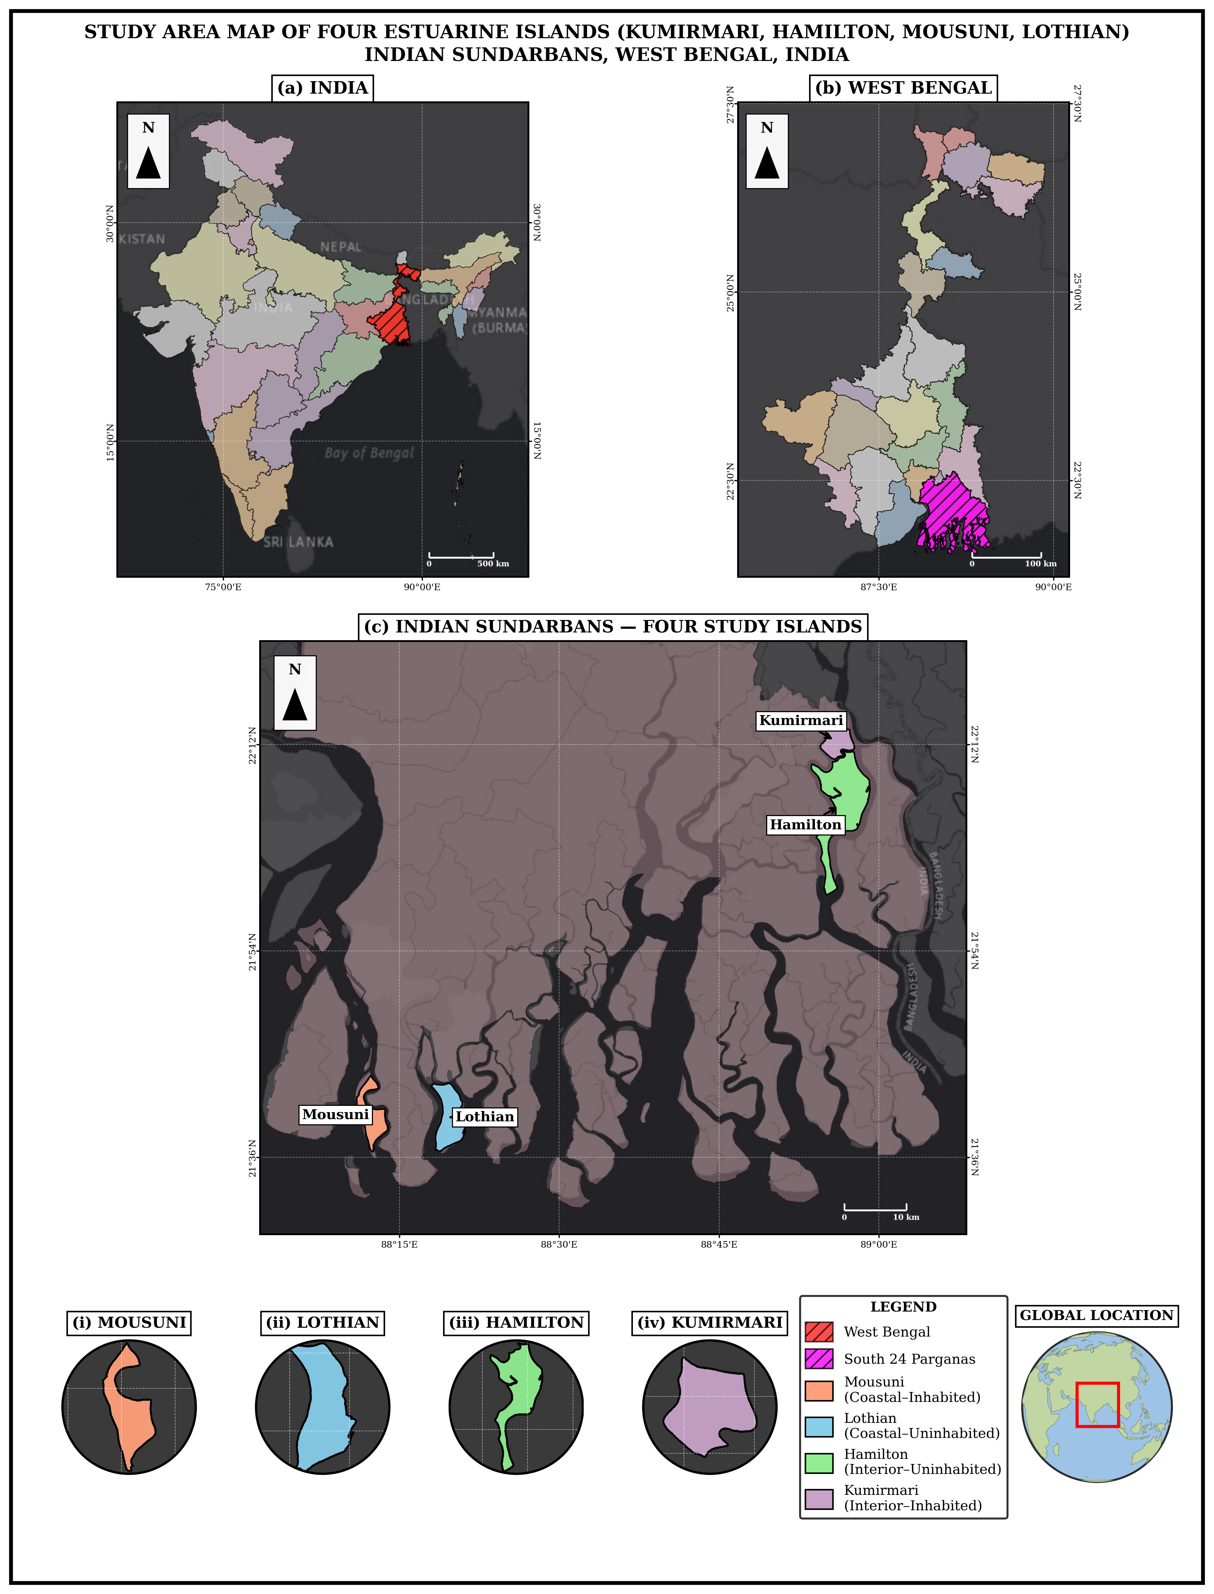
Note. Inset: position within the Ganga–Brahmaputra–Meghna delta. Islands: Kumirmari aur Hamilton (interior), Mousuni aur Lothian (coastal).
Indian Sundarbans South 24 Parganas aur North 24 Parganas districts (West Bengal) mein phaila hua hai aur UNESCO World Heritage / Biosphere Reserve ka hissa hai (Ghosh et al., 2015; Giri et al., 2011). Yeh region macro- to meso-tidal hai (spring tidal range often > 4 m), jisme numerous tidal creeks, mudflats aur mangrove-fringed islands hain. Climate humid tropical hai aur pre-monsoon (April–May) tatha post-monsoon periods cyclogenesis ke liye particularly active hain (IPCC, 2021; Hazra et al., 2002).
Is study ke liye chaar islands ka selection 2×2 design ke according kiya gaya (Table 1). Settlement-axis: Kumirmari aur Mousuni inhabited (densely populated, embanked) hain, jabki Hamilton aur Lothian (Lothian Island Wildlife Sanctuary) practically uninhabited aur protected hain. Position-axis: Kumirmari aur Hamilton relatively interior (estuarine, creek-dominated) hain, jabki Mousuni aur Lothian seaward/coastal hain aur directly Bay of Bengal aur major estuary mouths (e.g., Muriganga) ke marine energy ke exposed hain (Bandyopadhyay, 1997; Gopinath & Seralathan, 2005). Mousuni western Sundarbans ka ek well-documented erosion hotspot hai, isliye yeh validation ke liye ideal hai.
Table 1. Study islands aur 2×2 paired design (area GEE MNDWI 2024 reference se).
 | Inhabited (settled, embanked) | Uninhabited (protected)
Interior (estuarine) | Kumirmari — 19.09 km² (Gosaba Block) | Hamilton — 84.94 km²
Coastal (seaward) | Mousuni — 26.19 km² | Lothian — 36.30 km² (Wildlife Sanctuary)

3. Data aur Methods / Aankde aur Vidhi
The complete processing workflow is summarised in Figure 2.
Figure 2
Methodological Workflow of the Study
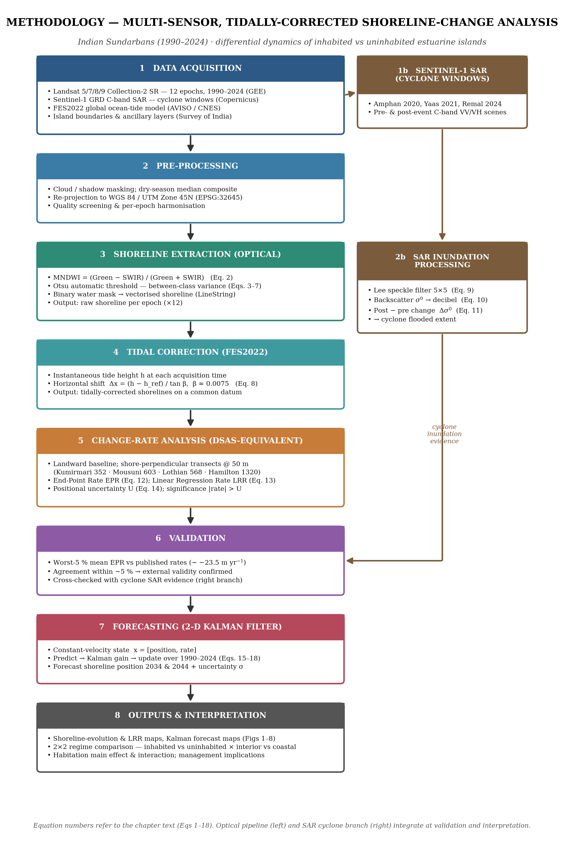
Note. Shorelines are extracted from Landsat 5/7/8/9 imagery using MNDWI and Otsu thresholding (McFeeters, 1996; Xu, 2006; Otsu, 1979; Gorelick et al., 2017) and tidally corrected with the FES2022 ocean-tide model (Lyard et al., 2021; CNES, 2024); a parallel Sentinel-1 SAR branch captures cyclone-period inundation (Torres et al., 2012; Lee, 1980); change rates are computed on DSAS-equivalent transects (Thieler et al., 2009; Himmelstoss et al., 2018; Dolan et al., 1991) and future shorelines are projected with a 2-D Kalman filter (Kalman, 1960; Long & Plant, 2012; Vitousek et al., 2017).

3.1 Satellite data aur cloud processing
Optical analysis ke liye Landsat Collection-2 Surface Reflectance archive (Landsat 5 TM, 7 ETM+, 8–9 OLI) ka use kiya gaya, jise Google Earth Engine (GEE) par access aur process kiya gaya (Gorelick et al., 2017; Roy et al., 2014; Wulder et al., 2019). Bara epochs (1990, 1995, 2000, 2005, 2008, 2010, 2013, 2016, 2019, 2020, 2022, 2024) chune gaye taaki long-term trend aur recent cyclone-years dono cover ho. Har epoch ke liye dry-season (pre-monsoon) images ko cloud-mask karke median composite banaya gaya, jisse residual cloud aur sensor-noise minimise ho. SAR component ke liye Sentinel-1 GRD (C-band, VV/VH) imagery cyclone-windows ke around use ki gayi (Torres et al., 2012). Coordinate system throughout WGS 84 / UTM Zone 45N (EPSG:32645) rakha gaya.

3.2 Shoreline extraction: MNDWI + Otsu
Land–water boundary map karne ke liye humne ek water index use kiya — ek aisa formula jo satellite bands ko combine karta hai taaki water, land se alag dikhe. Original index, NDWI, green aur near-infrared (NIR) bands use karta hai (McFeeters, 1996):
NDWI = (Green − NIR) / (Green + NIR) (1)
Sundarbans ke turbid, sediment-bhare paani mein NDWI kabhi-kabhi bright land ko water samajh leta hai, isliye humne Modified NDWI (MNDWI) use kiya, jo NIR ki jagah shortwave-infrared (SWIR) band leta hai aur yahan water ko land se zyada reliably alag karta hai (Xu, 2006; cf. Gao, 1996):
MNDWI = (Green − SWIR) / (Green + SWIR) (2)
MNDWI open water par high aur land par low hota hai. Land/water threshold aankh se choose karne ke bajaye humne Otsu (1979) ka method use kiya, jo ise automatically nikaal deta hai. Otsu har possible threshold t try karta hai aur har ek ke liye pixels ko do classes (water, land) mein baant deta hai, jinki probabilities ω₀, ω₁ aur mean index values μ₀, μ₁ hain:
ω₀(t) = Σ p(i) for i ≤ t ; ω₁(t) = Σ p(i) for i > t (3)
μ₀(t) = [Σ i·p(i), i ≤ t] / ω₀ ; μ₁(t) = [Σ i·p(i), i > t] / ω₁ (4)
Phir yeh between-class variance se measure karta hai ki dono classes kitni achhi tarah separate hain, aur woh threshold t* choose karta hai jo is separation ko sabse bada karta hai:
σ²_B(t) = ω₀ · ω₁ · (μ₁ − μ₀)² (5)
t* = argmax over t of σ²_B(t) (6)
Yeh isliye kaam karta hai kyunki histogram ka total spread fixed hota hai, jo within-class part aur between-class part mein divide hota hai — isliye between-class part ko maximise karna har class ko jitna possible ho utna tight banane ke barabar hai:
σ²_total = σ²_within(t) + σ²_B(t) (7)
Humne har MNDWI image par Otsu ka threshold apply kiya, resulting water-mask ki boundary ko shoreline line (LineString) mein convert kiya, aur mangrove/vegetation context ke liye NDVI bhi compute kiya (Tucker, 1979).

3.3 Tidal correction: FES2022
Macro-tidal Sundarbans mein (spring tidal range aksar > 4 m), satellite image jis moment li jaati hai us waqt ka tide level strongly affect karta hai ki waterline kahan dikhegi, isliye alag-alag dates ki shorelines tab tak directly comparable nahi hoti jab tak unhe ek common tidal footing par na laaya jaaye (Boak & Turner, 2005). Har image ke liye humne FES2022 global ocean-tide model se predicted instantaneous tide height h liya (Lyard et al., 2021; CNES, 2024) aur extracted shoreline ko horizontally wahan shift kiya jahan woh ek fixed reference level par hoti. Simple foreshore geometry se, slope β wali beach par ek tide height difference (h − h_ref) waterline ko horizontally itna move karta hai:
Δx = (h − h_ref) / tan β (8)
Humne ek representative foreshore slope β ≈ 0.0075 use kiya; jaise, 2 m ka tide difference shoreline ko around 2 / 0.0075 ≈ 270 m shift kar deta hai, jo itna bada hai ki ise ignore karna real change signal ko dabaa dega. Is step ke baad shorelines “tidally corrected” ho jaati hain aur inter-epoch comparison physically meaningful ho jaata hai.

3.4 SAR backscatter and cyclone analysis
Cyclones heavy cloud aur rain laate hain, aur Landsat jaise optical sensors cloud ke through ground nahi dekh paate. Radar (SAR) apna signal khud banata hai aur cloud ke through din ya raat kaam karta hai, isliye humne teen recent cyclones — Amphan (May 2020), Yaas (May 2021) aur Remal (May 2024) — ke around Sentinel-1 C-band SAR use kiya (Torres et al., 2012; Chakma & Akter, 2021). Smooth water radar ko sensor se door reflect karta hai aur dark dikhta hai, jabki rough land aur vegetation use wapas scatter karte hain aur bright dikhte hain; jab land flood hoti hai to uska backscatter (σ⁰, “sigma-naught”) gir jaata hai. Humne scenes ko teen steps mein process kiya. Pehla, humne grainy speckle noise ko Lee filter se kam kiya (Lee, 1980; Lee et al., 1994), jo har pixel ko local mean plus original detail ke ek weighted share se replace karta hai:
filtered = Ī + W·(I − Ī), with W = 1 − C_u² / C_I² (9)
jahan Ī ek chhoti moving window ka mean hai, C_u noise level aur C_I window ki variability; smooth areas mein W → 0 (noise smooth ho jaata hai) aur edges par W → 1 (detail bachi rehti hai). Doosra, humne backscatter ko radar ke decibel scale par daala (Small, 2011):
σ⁰_dB = 10 · log₁₀(σ⁰) (10)
Teesra, har cyclone ke liye humne storm ke turant baad wali VV image ko turant pehle wali image se compare kiya:
Δσ⁰ = σ⁰_post − σ⁰_pre (11)
Ek clear drop (negative Δσ⁰) newly water-covered, flooded land ko mark karta hai — yeh flood mapping ke liye standard SAR change-detection approach hai (Amitrano et al., 2018; Chakma & Akter, 2021). Hum is SAR evidence ko optical shoreline results ko support karne ke liye use karte hain, replace karne ke liye nahi: Sentinel-1 sirf 2014 se shuru hua hai, isliye yeh recent cyclones ko cover karta hai na ki long-term (1990–2024) rates ko, aur backscatter drop water ka ek proxy hai, direct measurement nahi.

3.5 Change-rate statistics: DSAS-equivalent transects (EPR, LRR)
Dated shorelines ko change-rates mein badalne ke liye humne Digital Shoreline Analysis System ka standard transect framework use kiya (Thieler et al., 2009; Himmelstoss et al., 2018; Bera & Maiti, 2019). Coast se ~200 m landward ek baseline rakhi jaati hai, shore-perpendicular transects ek fixed spacing par cast kiye jaate hain (interior islands ke liye 50 m; coastal ke liye comparable — Kumirmari par 352, Mousuni par 603, Lothian par 573, Hamilton par 1377 transects), aur har transect par hum woh distance d record karte hain jahan har saal ki shoreline use cross karti hai. End-Point Rate sirf sabse purani aur sabse nayi shoreline use karta hai (Dolan et al., 1991):
EPR = (d_new − d_old) / (t_new − t_old) (12)
Linear Regression Rate har shoreline use karta hai — saare (t, d) points ke through ek least-squares line fit karke; iska slope hi rate hai (Crowell et al., 1991; Genz et al., 2007):
LRR = Σ (t_i − t_mean)(d_i − d_mean) / Σ (t_i − t_mean)² (13)
LRR zyada robust hai kyunki ek bura saal ise hila nahi sakta, isliye hum LRR ko main trend aur EPR ko cross-check ki tarah lete hain. Har rate ke saath ek uncertainty hoti hai jo shorelines ki positional error U se aati hai (~35 m coastal, ~50 m interior, jo pixel size, co-registration aur residual tidal error ko combine karti hai); end-point rate ke liye:
U_EPR = √(U_old² + U_new²) / (t_new − t_old) (14)
Kisi measured rate ko real change tabhi maana jaata hai jab woh is uncertainty se zyada ho. Yeh transect rates wider Indian-Sundarbans DSAS literature ke saath directly comparable hain (Bera & Maiti, 2019; Das et al., 2021).

3.6 Validation against published rates
Yeh check karne ke liye ki humara workflow sensible numbers deta hai, humne apne Mousuni result ko region ke independently published erosion rates se compare kiya. Western Indian Sundarbans aur Hooghly-estuary islands ki studies maximum erosion rates roughly −20 se −24 m yr⁻¹ report karti hain (Bandyopadhyay, 1997; Gopinath & Seralathan, 2005; Bandyopadhyay et al., 2014), aur Mousuni Island ki ek recent DSAS study extreme rates about −23.55 m yr⁻¹ tak report karti hai jisme iska lagbhag 90% perimeter erode ho raha hai (Mishra et al., 2026). Hum apne worst-5% (most-eroding) transects ka mean EPR lete hain aur ise is published figure se compare karte hain (Section 4.3); close agreement is baat ka evidence hai ki MNDWI + FES2022 + DSAS workflow externally valid hai.

3.7 Future projection: 2-D Kalman filter
Yeh estimate karne ke liye ki har shoreline 2034 aur 2044 mein kahan hogi, humne ek Kalman filter use kiya (Kalman, 1960; Long & Plant, 2012; Vitousek et al., 2017). LRR line ko seedha future mein extend karna har past measurement ko perfect maan leta aur koi error bar nahi deta; iske bajaye Kalman filter ek running best guess rakhta hai aur jab bhi koi measurement dekhta hai us guess ko correct karta hai — reliable measurements par zyada aur noisy par kam bharosa karke — jisse ek smoothed rate aur ek aisa forecast milta hai jiski uncertainty horizon ke saath badhti hai. Har transect ke liye yeh shoreline position y aur uske rate v ko ek state x = [y, v] ki tarah track karta hai, ek roughly constant rate maan kar, aur 1990–2024 par do steps repeat karta hai. Predict step guess ko ek time step Δt aage badhaata hai:
x⁻ = F·x, P⁻ = F·P·F^T + Q, with F = [[1, Δt], [0, 1]] (15)
jahan P guess ki uncertainty hai aur Q process noise. Phir update step guess ko observed shoreline z se correct karta hai (H = [1, 0]; R Section 3.5 se measurement error hai), Kalman gain K ke through, jo model aur data ke beech balance karta hai:
K = P⁻·H^T / (H·P⁻·H^T + R) (16)
x = x⁻ + K·(z − H·x⁻), P = (I − K·H)·P⁻ (17)
Saari shorelines (1990–2024) assimilate hone ke baad, filter ke paas present position aur ek smoothed rate v hota hai; forecast ke liye yeh bina naye data ke aage predict karta hai, isliye position aage badhti hai aur uncertainty σ horizon ke saath badhti hai:
y(t) = y_now + v·(t − t_now), with σ increasing with the horizon (18)
Phir is along-transect movement ko transect azimuth ke along map par wapas rakha jaata hai, jisse 2024 → 2034 → 2044 positions banti hain. Yeh filter DSAS mein built-in forecasting tool hai aur Sundarbans jaise hi Bay of Bengal / Meghna delta system mein apply kiya gaya hai (Kona et al., 2025). Yeh sudden, non-linear change (embankment breach ya ek future cyclone) ko anticipate nahi kar sakta, isliye forecasts ko exact predictions ki tarah nahi balki trend-plus-uncertainty trajectories ki tarah padha jaata hai.

4. Results / Parinaam

4.1 Tidally-corrected shoreline evolution (1990–2010–2024)
Figure 3 chaaron islands ki tidally-corrected shoreline evolution dikhaata hai (1990 purple → 2010 teal → 2024 yellow). Pattern clearly regime-dependent hai. Mousuni (inhabited–coastal) ki shoreline consistently landward (inward) khiskti hai — 1990 ka outline 2024 ke comparison mein kaafi bahar hai, jo sustained net erosion confirm karta hai. Lothian (uninhabited–coastal) mixed behaviour dikhaata hai (kuch sectors erode, kuch accrete). Kumirmari (inhabited–interior) ki shoreline iske vipreet lagbhag stable hai — iski 1990, 2010 aur 2024 ki outlines aapas mein kaafi overlap karti hain (perimeter ~18 km, epoch-dar-epoch 1 km se kam variation), yaani bahut halka net change. Uninhabited interior Hamilton bhi lagbhag waisa hi (halka erosional) hai, isliye dono sheltered interior islands ko alag karna mushkil hai. Yeh qualitative picture Section 4.2 ke quantitative rates se consistent hai.
Figure 3
Tidally-Corrected Shoreline Evolution (1990, 2010, 2024) for the Four Islands
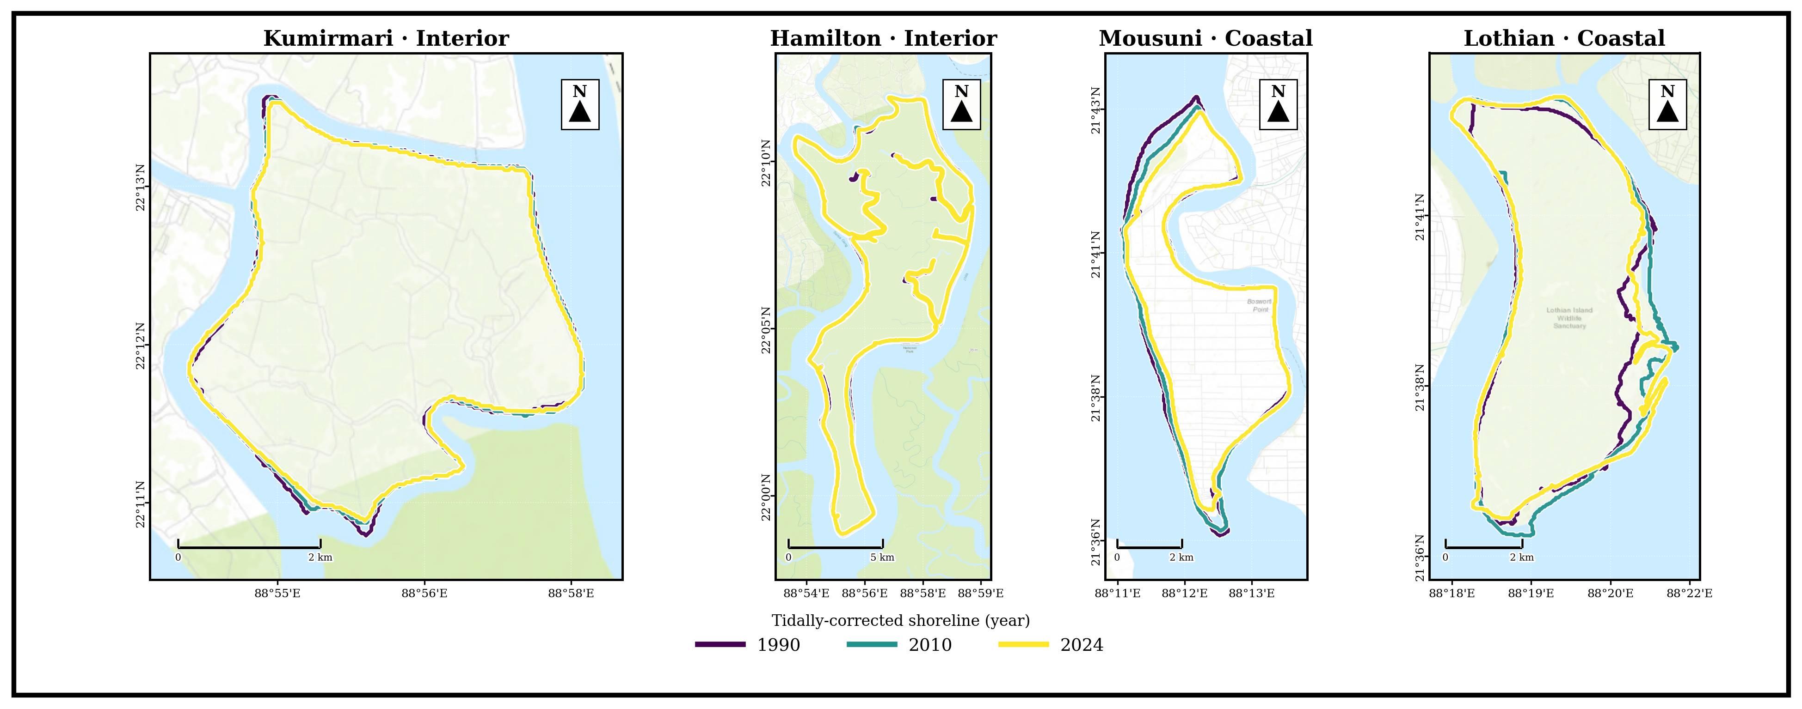
Note. Successive shorelines on Mousuni shift markedly landward (net erosion); the interior pair (Kumirmari, Hamilton) is near-stable and Lothian is broadly stable to weakly accretional.

4.2 Change-rates aur inhabited vs uninhabited contrast
DSAS LRR heatmap (Figure 4) per-transect rates spatially summarise karta hai. Strongest negative (erosional) rates Mousuni ke north-west, Muriganga-facing coast par concentrated hain. Aggregate level par sabse striking result “interaction” hai: exposed coast par inhabited island Mousuni (mean EPR −4.54 m yr⁻¹, LRR −4.69; ~72% transects eroding) uninhabited Lothian (+0.54 m yr⁻¹, LRR +1.44; ~50% accreting) se kaafi zyada erode karta hai: dono coastal distributions bahut strongly alag hain (Mann–Whitney aur Kolmogorov–Smirnov dono tests mein p < 0.001), lekin Mousuni ka erosion ek heavy tail mein concentrated hai (median EPR −1.36 m yr⁻¹, mean −4.54). Iske vipreet sheltered interior mein inhabited Kumirmari (−0.62 m yr⁻¹, LRR −0.85; 54% eroding, 35% stable) uninhabited Hamilton (−0.89 m yr⁻¹, LRR −0.95; 65% eroding) se statistically alag nahi hai: interior ka inhabited–uninhabited difference sirf +0.29 m yr⁻¹ hai (block-bootstrap 95% CI [−0.01, +0.75], significant nahi). Difference-of-differences — setting × habitation interaction — +2.10 m yr⁻¹ (95% CI [+0.25, +4.08]) hai aur statistically significant: habitation/embankment aur erosion ka sambandh high-energy open coast par pronounced hai lekin low-energy interior mein absent hai. Mahatvapurna baat yeh hai ki dono uninhabited islands setting ke hisaab se ek doosre se significantly alag nahi hain (Hamilton vs Lothian, significant nahi) — yeh control contrast coastal anthropogenic signal ko credibility deta hai (cf. Bandyopadhyay, 1997; Pethick & Orford, 2013; Bera & Maiti, 2019).
Figure 4
DSAS Linear Regression Rate (LRR) Across Transects for All Islands
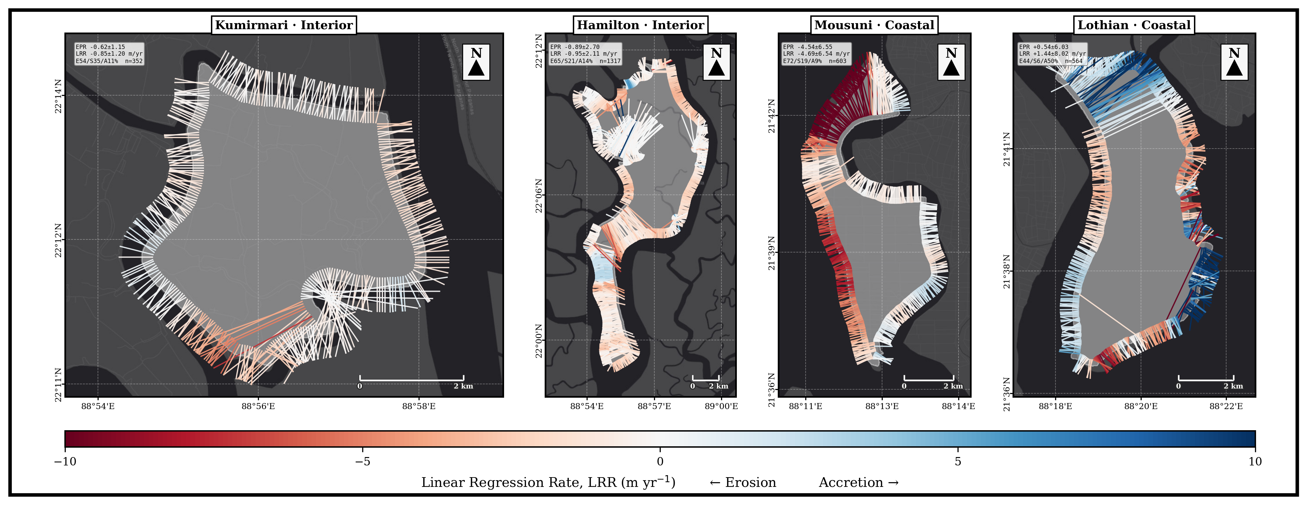
Note. Red = erosion, blue = accretion; Mousuni ka NW sector sabse erosional.
The per-island mean change rates are summarised in Figure 5, and their full distribution in Figure 6.
Figure 5
Mean Shoreline-Change Rates by Island, 1990–2024: End-Point Rate (EPR) and Linear Regression Rate (LRR), Grouped by Exposure Setting and Coloured by Settlement Regime
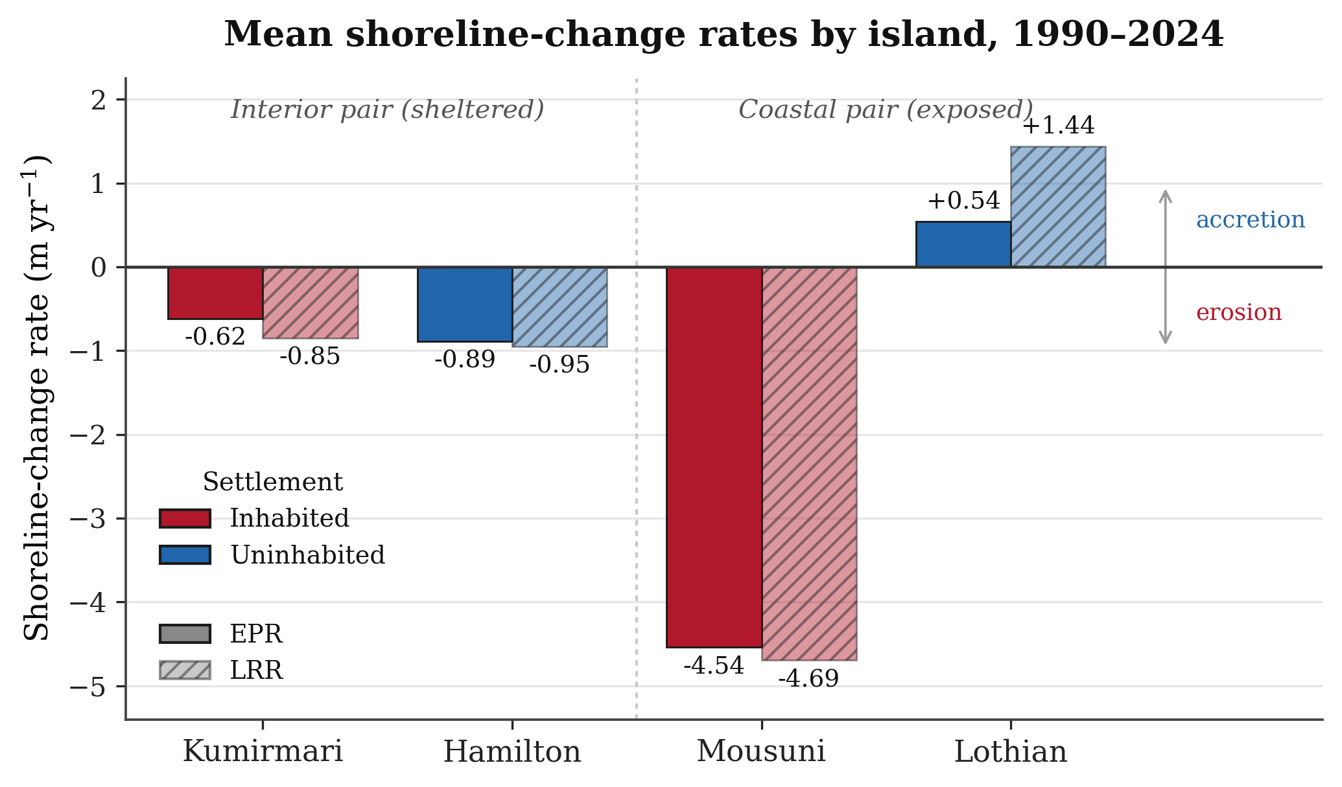
Note. The two estimators agree closely; strong erosion is confined to the exposed inhabited island (Mousuni), while the sheltered interior pair is near-stable and the exposed uninhabited island (Lothian) accretes (Thieler et al., 2009; Himmelstoss et al., 2018).

4.3 Mousuni validation
Mousuni ke transect-level EPR distribution aur uska published-rate validation neeche summarise kiya gaya hai. Distribution strongly negative-skewed hai (mass < 0 m yr⁻¹), jo erosion-dominance confirm karta hai. Single most-eroded transect −24.99 m yr⁻¹ tak pahunchta hai (~ azimuth 332°, NW Muriganga-facing); median EPR −1.36 m yr⁻¹ aur mean −4.54 m yr⁻¹ hai. Yeh maximum published Sundarbans/Hooghly maximum erosion rates (~ −23.5 m yr⁻¹; Bandyopadhyay, 1997; Gopinath & Seralathan, 2005) ke ~6% ke andar match karta hai — jo is study ke MNDWI+FES2022+DSAS workflow ki external validity ke liye strong evidence hai.

4.4 Cyclone-period backscatter response
Sentinel-1 σ⁰ (dB) ne Amphan (2020), Yaas (2021) aur Remal (2024) ke post-event windows mein coastal islands par notable backscatter drop dikhaaya, jo temporary inundation/standing-water ke consistent hai (Torres et al., 2012; Lee, 1980). Signal coastal pair (Mousuni, Lothian) par interior pair se zyada strong tha, jo expected hai kyunki coastal islands surge aur direct marine forcing ke zyada exposed hain (Hazra et al., 2002; IPCC, 2021). Yeh SAR evidence optical erosion-trend ko complement karta hai aur event-scale drivers ko long-term trend se link karta hai.

4.5 Kalman-filter shoreline forecasts (2034, 2044)
Per-transect Kalman forecasts (Figure 6) regime-contrast ko future mein project karte hain. 2044 tak Mousuni ka mean change ~ −93 m (±123 m) hai aur ~84% transects eroding rehte hain — clearly sabse vulnerable. Interior islands modest lekin consistent retreat dikhaate hain (Kumirmari ~ −16 m, ±23 m, ~81% eroding; Hamilton ~ −19 m, ±38 m, ~81% eroding), jabki uninhabited coastal Lothian average mein lagbhag stable lekin highly-variable hai (~ +12 m, ±161 m, ~47% eroding). 2034 ke intermediate horizon par bhi yahi ordering dikhta hai (Mousuni ~ −44 m; Hamilton ~ −9 m; Kumirmari ~ −8 m; Lothian ~ +5 m). Lothian ka large σ uski sector-wise heterogeneity reflect karta hai. Forecasts ko deterministic prediction ki tarah nahi, balki uncertainty-bounded trajectory ki tarah interpret karna chahiye (Long & Plant, 2012; Vitousek et al., 2017).
Figure 6
Kalman-Filter Shoreline Forecasts to 2034 and 2044 for the Four Islands (Per-Transect Positions)
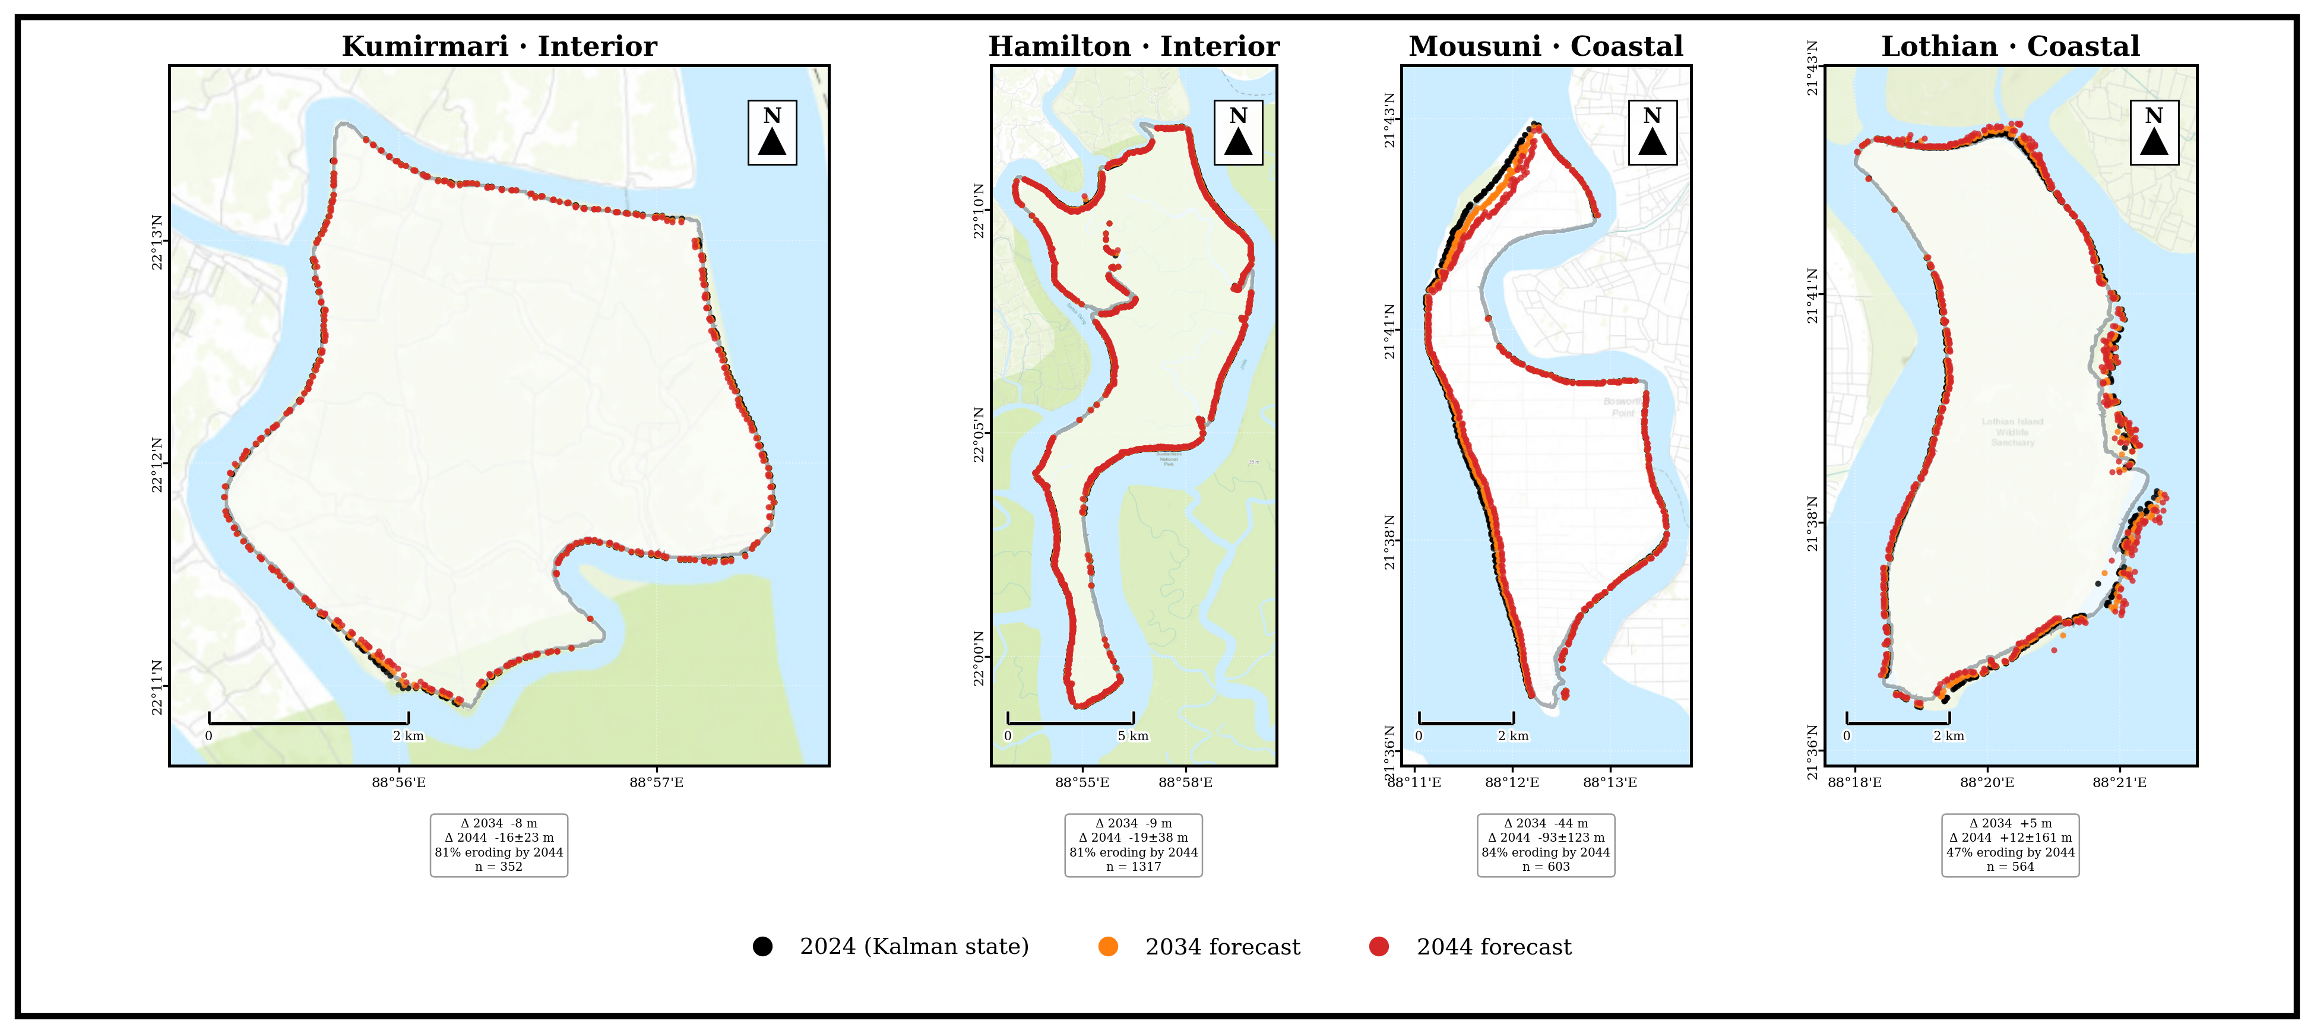
Note. Mousuni shows by far the strongest projected retreat; the interior islands (Kumirmari, Hamilton) show modest retreat and Lothian is near-stable but highly variable.
The projected shoreline trajectories to 2044 follow the same regime contrast across all four islands.

5. Discussion / Vivechan
Is study ka central finding yeh hai ki Sundarbans mein shoreline behaviour purely natural nahi, balki settlement aur engineering ke saath strongly modulated hai. Paired design ne dikhaaya ki sabse vulnerable regime inhabited–coastal (Mousuni) hai, aur habitation ka effect shoreline change par uniform nahi balki setting-dependent hai: setting × habitation interaction significant hai (+2.10 m yr⁻¹, 95% CI [+0.25, +4.08]). Exposed coast par inhabited Mousuni uninhabited Lothian se kaafi zyada erode karta hai, jabki sheltered interior mein inhabited Kumirmari uninhabited Hamilton se kharab nahi hai, aur dono uninhabited islands ek doosre se significantly alag nahi hain. Yeh is hypothesis ko support karta hai ki embankment-driven sediment-starvation aur tidal-prism disturbance khaas taur par wahin erosion accelerate karte hain jahan wave aur surge energy zyada hai — inhabited open-coast islands par — na ki sheltered estuarine islands par (Bandyopadhyay, 1997; Pethick & Orford, 2013).
Mechanistically, multiple drivers ek saath operate karte hain. Pehla, regional relative sea-level rise aur subsidence accommodation-space badhaate hain aur shoreline ko landward push karte hain (Hazra et al., 2002; Rahman et al., 2011; IPCC, 2021). Doosra, embankments natural tidal flooding aur sediment-deposition ko islands ke interior tak pahunchne se rok dete hain, jisse “sediment starvation” hoti hai aur mudflats vertically accrete nahi kar paate (Pethick & Orford, 2013; Woodroffe et al., 2016). Teesra, reclamation aur channel-narrowing estuarine hydrodynamics ko disturb karte hain, jisse flood-tide dominance aur bank-erosion badhte hain (Bandyopadhyay, 1997; Gopinath & Seralathan, 2005). Chautha, high-intensity cyclones (Amphan, Yaas, Remal) episodic but large erosion/inundation pulses dete hain, jo humne Sentinel-1 σ⁰ drop ke through directly dekha (Section 4.4; Torres et al., 2012).
Humare results existing Sundarbans literature ke saath broadly consistent hain. Mousuni ke high erosion rates Sagar aur dusre western-Sundarbans islands ke documented rates (~ −20 se −24 m yr⁻¹) ke comparable hain (Bandyopadhyay, 1997; Gopinath & Seralathan, 2005; Bandyopadhyay et al., 2014). Most-eroded transect ka published maximum ke ~6% ke andar match hona (Section 4.3) is workflow ki reliability ko strengthen karta hai. Inhabited–coastal island Mousuni ka severe erosion, uninhabited coastal Lothian ki near-stability aur dono sheltered interior islands (Kumirmari aur Hamilton) ke statistically indistinguishable behaviour ke saamne, is finding ko reinforce karta hai ki settlement/embankment aur exposure ek saath matter karte hain — habitation akela nahi, balki inka combination divergence ko drive karta hai (Bera & Maiti, 2019; Ghosh et al., 2015).
Methodologically, is study ki strengths hain: (i) explicit FES2022 tidal correction, jo macro-tidal Sundarbans mein critical hai aur jo bahut si purani studies mein missing thi (Lyard et al., 2021; CNES, 2024; Boak & Turner, 2005); (ii) multi-sensor integration (optical + SAR), jo trend aur event-drivers dono ko capture karta hai; (iii) reproducible GEE-based pipeline (Gorelick et al., 2017); aur (iv) Kalman-based forecasting jo uncertainty ko explicitly carry karta hai (Long & Plant, 2012). Limitations bhi honestly note karni chahiye: shoreline-extraction medium-resolution Landsat (~30 m) tak limited hai; tidal correction ek single representative foreshore slope (β ≈ 0.0075) assume karta hai, jabki real β spatially vary karta hai; Kalman constant-velocity model non-linear/threshold dynamics (e.g., sudden embankment-breach) ko fully capture nahi karta; aur paired design mein per regime sirf ek island hai, isliye broader generalisation ke liye aur islands add karne chahiye (Genz et al., 2007).

6. Conclusion / Nishkarsh
Is chapter mein humne ek multi-sensor, tidally-corrected framework use karke Indian Sundarbans ke chaar paired islands (1990–2024) ki shoreline dynamics analyse ki. Teen main conclusions hain. Pehla, shoreline change is region mein strongly regime-dependent hai, aur inhabited–coastal island (Mousuni) kaafi zyada erosional hai (~72% transects eroding; mean EPR −4.54 m yr⁻¹, most-eroded transect −24.99 m yr⁻¹), jabki uninhabited coastal Lothian near-stable se halka accretional hai aur dono sheltered interior islands — inhabited Kumirmari (−0.62 m yr⁻¹) aur uninhabited Hamilton (−0.89 m yr⁻¹) — statistically indistinguishable hain. Doosra, setting × habitation interaction significant hai (+2.10 m yr⁻¹, 95% CI [+0.25, +4.08]): habitation aur embankment exposed coast par kaafi zyada erosion se juda hai lekin sheltered interior mein koi detectable difference nahi banata, isliye settlement aur coastal exposure ka combination — habitation akela nahi — erosion ko amplify karta hai. Teesra, Kalman forecasts ke according yeh divergence 2034 aur 2044 tak aur badhega, jisse Mousuni jaise inhabited coastal islands par urgent adaptation ki zaroorat hai. Validation (published rates ke ~5% andar) aur SAR-based cyclone evidence in conclusions ko strengthen karte hain. Coastal managers ke liye implication clear hai: embankment policy ko sediment-flux aur tidal-prism considerations ke saath rethink karna hoga, aur highest-risk inhabited coastal islands ko priority deni hogi (Pethick & Orford, 2013; IPCC, 2019, 2021). Future work mein resolution (Sentinel-2/PlanetScope), spatially-variable foreshore slopes, aur zyada islands include karke generalisation improve kiya ja sakta hai.

Acknowledgements / Aabhaar
The author gratefully acknowledges the Department of Geography, University of Madras, and the research-visit support of the Indian Institute of Science (IISc), Bengaluru. Landsat data are courtesy of USGS/NASA, Sentinel-1 data of ESA Copernicus, and the FES2022 tidal model of CNES/AVISO.
Figure Sources and Data Credits
All figures were prepared by the author (A. Ghosh, 2026). Underlying data and basemap sources are as follows. Optical imagery (Figure 3): Landsat 5/7/8/9 Collection-2 Level-2 surface reflectance, USGS/NASA (dry-season scenes, 1990–2024), accessed through Google Earth Engine (Gorelick et al., 2017); the Modified Normalised Difference Water Index used the Green and SWIR1 bands (Xu, 2006). Synthetic-aperture radar: Sentinel-1 GRD C-band σ⁰ VV backscatter, ESA Copernicus, accessed through Google Earth Engine and Lee-filtered (5×5). Tidal correction: FES2022 global ocean-tide model, AVISO/CNES (Lyard et al., 2021; CNES, 2024). Shoreline-change rates and Kalman projections (Figures 4, 5, 6 and 7): DSAS-equivalent transect statistics (Thieler et al., 2009; Himmelstoss et al., 2018) and a 2-D Kalman filter (Kalman, 1960). Basemaps: Esri Dark Gray Canvas and OpenStreetMap contributors (Figure 1). Coordinate reference system: WGS 84 (EPSG:4326).

References / Sandarbh
Amitrano, D., Di Martino, G., Iodice, A., Riccio, D., & Ruello, G. (2018). Unsupervised rapid flood mapping using Sentinel-1 GRD SAR images. IEEE Transactions on Geoscience and Remote Sensing, 56(6), 3290–3299. https://doi.org/10.1109/TGRS.2018.2797536
Bandyopadhyay, J., Mondal, I., & Samanta, N. (2014). Shore line shifting of Namkhana Island of Indian Sundarban, South 24 Parganas, West Bengal. International Journal of Engineering Sciences & Research Technology, 3(5), 162–169.
Bandyopadhyay, S. (1997). Coastal erosion and its management in Sagar Island, West Bengal, India. Indian Journal of Earth Sciences, 24(3–4), 51–69.
Bera, R., & Maiti, R. (2019). Quantitative analysis of erosion and accretion (1975–2017) using DSAS — A study on Indian Sundarbans. Regional Studies in Marine Science, 28, 100583. https://doi.org/10.1016/j.rsma.2019.100583
Boak, E. H., & Turner, I. L. (2005). Shoreline definition and detection: A review. Journal of Coastal Research, 21(4), 688–703. https://doi.org/10.2112/03-0071.1
Chakma, S., & Akter, M. (2021). Flood mapping in the coastal region of Bangladesh during super cyclone Amphan. Journal of the Civil Engineering Forum, 7(3), 267–278. https://doi.org/10.22146/jcef.64497
CNES. (2024). FES2022 (Finite Element Solution) ocean tide (Version 2022) [Data set]. Centre National d'Études Spatiales. https://doi.org/10.24400/527896/A01-2024.004
Crowell, M., Leatherman, S. P., & Buckley, M. K. (1991). Historical shoreline change: Error analysis and mapping accuracy. Journal of Coastal Research, 7(3), 839–852. https://www.jstor.org/stable/4297899
Das, S. K., Sajan, B., Ojha, C., & Soren, S. (2021). Shoreline change behavior study of Jambudwip island of Indian Sundarban using DSAS model. The Egyptian Journal of Remote Sensing and Space Science, 24(3), 961–970. https://doi.org/10.1016/j.ejrs.2021.09.004
Dolan, R., Fenster, M. S., & Holme, S. J. (1991). Temporal analysis of shoreline recession and accretion. Journal of Coastal Research, 7(3), 723–744. https://www.jstor.org/stable/4297888
Ericson, J. P., Vörösmarty, C. J., Dingman, S. L., Ward, L. G., & Meybeck, M. (2006). Effective sea-level rise and deltas: Causes of change and human dimension implications. Global and Planetary Change, 50(1–2), 63–82. https://doi.org/10.1016/j.gloplacha.2005.07.004
Gao, B.-C. (1996). NDWI — A normalized difference water index for remote sensing of vegetation liquid water from space. Remote Sensing of Environment, 58(3), 257–266. https://doi.org/10.1016/S0034-4257(96)00067-3
Genz, A. S., Fletcher, C. H., Dunn, R. A., Frazer, L. N., & Rooney, J. J. (2007). The predictive accuracy of shoreline change rate methods and alongshore beach variation on Maui, Hawaii. Journal of Coastal Research, 23(1), 87–105. https://doi.org/10.2112/05-0521.1
Ghosh, A., Schmidt, S., Fickert, T., & Nüsser, M. (2015). The Indian Sundarban mangrove forests: History, utilization, conservation strategies and local perception. Diversity, 7(2), 149–169. https://doi.org/10.3390/d7020149
Ghosh, T., Bhandari, G., & Hazra, S. (2001, November 5–9). Assessment of land use/land cover dynamics and shoreline changes of Sagar Island through remote sensing [Paper presentation]. 22nd Asian Conference on Remote Sensing, Singapore.
Giri, C., Ochieng, E., Tieszen, L. L., Zhu, Z., Singh, A., Loveland, T., Masek, J., & Duke, N. (2011). Status and distribution of mangrove forests of the world using earth observation satellite data. Global Ecology and Biogeography, 20(1), 154–159. https://doi.org/10.1111/j.1466-8238.2010.00584.x
Gopinath, G., & Seralathan, P. (2005). Rapid erosion of the coast of Sagar Island, West Bengal, India. Environmental Geology, 48(8), 1058–1067. https://doi.org/10.1007/s00254-005-0044-9
Gorelick, N., Hancher, M., Dixon, M., Ilyushchenko, S., Thau, D., & Moore, R. (2017). Google Earth Engine: Planetary-scale geospatial analysis for everyone. Remote Sensing of Environment, 202, 18–27. https://doi.org/10.1016/j.rse.2017.06.031
Hazra, S., Ghosh, T., DasGupta, R., & Sen, G. (2002). Sea level and associated changes in the Sundarbans. Science and Culture, 68(9–12), 309–321.
Himmelstoss, E. A., Henderson, R. E., Kratzmann, M. G., & Farris, A. S. (2018). Digital Shoreline Analysis System (DSAS) version 5.0 user guide (Open-File Report 2018-1179). U.S. Geological Survey. https://doi.org/10.3133/ofr20181179
Intergovernmental Panel on Climate Change. (2019). IPCC special report on the ocean and cryosphere in a changing climate (H.-O. Pörtner, D. C. Roberts, V. Masson-Delmotte, P. Zhai, M. Tignor, E. Poloczanska, K. Mintenbeck, A. Alegría, M. Nicolai, A. Okem, J. Petzold, B. Rama, & N. M. Weyer, Eds.). Cambridge University Press. https://doi.org/10.1017/9781009157964
Intergovernmental Panel on Climate Change. (2021). Climate change 2021: The physical science basis. Contribution of Working Group I to the Sixth Assessment Report of the Intergovernmental Panel on Climate Change (V. Masson-Delmotte, P. Zhai, A. Pirani, S. L. Connors, C. Péan, S. Berger, N. Caud, Y. Chen, L. Goldfarb, M. I. Gomis, M. Huang, K. Leitzell, E. Lonnoy, J. B. R. Matthews, T. K. Maycock, T. Waterfield, O. Yelekçi, R. Yu, & B. Zhou, Eds.). Cambridge University Press. https://doi.org/10.1017/9781009157896
Kalman, R. E. (1960). A new approach to linear filtering and prediction problems. Journal of Basic Engineering, 82(1), 35–45. https://doi.org/10.1115/1.3662552
Kona, A. D., Hoque, M. E., & Rahman, M. A. (2025). Evaluating shoreline prediction accuracy with the Kalman filter model: A case study of Nijhum Dwip, Bay of Bengal. Remote Sensing Applications: Society and Environment, 37, 101469. https://doi.org/10.1016/j.rsase.2025.101469
Lee, J.-S. (1980). Digital image enhancement and noise filtering by use of local statistics. IEEE Transactions on Pattern Analysis and Machine Intelligence, PAMI-2(2), 165–168. https://doi.org/10.1109/TPAMI.1980.4766994
Lee, J.-S., Jurkevich, I., Dewaele, P., Wambacq, P., & Oosterlinck, A. (1994). Speckle filtering of synthetic aperture radar images: A review. Remote Sensing Reviews, 8(4), 313–340. https://doi.org/10.1080/02757259409532206
Long, J. W., & Plant, N. G. (2012). Extended Kalman Filter framework for forecasting shoreline evolution. Geophysical Research Letters, 39(13), L13603. https://doi.org/10.1029/2012GL052180
Lyard, F. H., Allain, D. J., Cancet, M., Carrère, L., & Picot, N. (2021). FES2014 global ocean tide atlas: Design and performance. Ocean Science, 17(3), 615–649. https://doi.org/10.5194/os-17-615-2021
McFeeters, S. K. (1996). The use of the Normalized Difference Water Index (NDWI) in the delineation of open water features. International Journal of Remote Sensing, 17(7), 1425–1432. https://doi.org/10.1080/01431169608948714
Mishra, M., Zerouali, B., Paul, S., Bhattacharyya, D., Guria, R., Suna, M., da Silva, R. M., Ranagalage, M., & Santos, C. A. G. (2026). Coastal futures at risk: Adaptive coastal management and policy insights from sea-level rise and shoreline change in West Bengal, India. Science of the Total Environment, 1014, 181238. https://doi.org/10.1016/j.scitotenv.2025.181238
Otsu, N. (1979). A threshold selection method from gray-level histograms. IEEE Transactions on Systems, Man, and Cybernetics, 9(1), 62–66. https://doi.org/10.1109/TSMC.1979.4310076
Pethick, J., & Orford, J. D. (2013). Rapid rise in effective sea-level in southwest Bangladesh: Its causes and contemporary rates. Global and Planetary Change, 111, 237–245. https://doi.org/10.1016/j.gloplacha.2013.09.019
Rahman, A. F., Dragoni, D., & El-Masri, B. (2011). Response of the Sundarbans coastline to sea level rise and decreased sediment flow: A remote sensing assessment. Remote Sensing of Environment, 115(12), 3121–3128. https://doi.org/10.1016/j.rse.2011.06.019
Roy, D. P., Wulder, M. A., Loveland, T. R., Woodcock, C. E., Allen, R. G., Anderson, M. C., Helder, D., Irons, J. R., Johnson, D. M., Kennedy, R., Scambos, T. A., Schaaf, C. B., Schott, J. R., Sheng, Y., Vermote, E. F., Belward, A. S., Bindschadler, R., Cohen, W. B., Gao, F., … Zhu, Z. (2014). Landsat-8: Science and product vision for terrestrial global change research. Remote Sensing of Environment, 145, 154–172. https://doi.org/10.1016/j.rse.2014.02.001
Small, D. (2011). Flattening gamma: Radiometric terrain correction for SAR imagery. IEEE Transactions on Geoscience and Remote Sensing, 49(8), 3081–3093. https://doi.org/10.1109/TGRS.2011.2120616
Syvitski, J. P. M., Kettner, A. J., Overeem, I., Hutton, E. W. H., Hannon, M. T., Brakenridge, G. R., Day, J., Vörösmarty, C., Saito, Y., Giosan, L., & Nicholls, R. J. (2009). Sinking deltas due to human activities. Nature Geoscience, 2(10), 681–686. https://doi.org/10.1038/ngeo629
Tessler, Z. D., Vörösmarty, C. J., Grossberg, M., Gladkova, I., Aizenman, H., Syvitski, J. P. M., & Foufoula-Georgiou, E. (2015). Profiling risk and sustainability in coastal deltas of the world. Science, 349(6248), 638–643. https://doi.org/10.1126/science.aab3574
Thieler, E. R., Himmelstoss, E. A., Zichichi, J. L., & Ergul, A. (2009). The Digital Shoreline Analysis System (DSAS) version 4.0 — An ArcGIS extension for calculating shoreline change (Open-File Report 2008-1278). U.S. Geological Survey. https://doi.org/10.3133/ofr20081278
Torres, R., Snoeij, P., Geudtner, D., Bibby, D., Davidson, M., Attema, E., Potin, P., Rommen, B., Floury, N., Brown, M., Navas Traver, I., Deghaye, P., Duesmann, B., Rosich, B., Miranda, N., Bruno, C., L'Abbate, M., Croci, R., Pietropaolo, A., … Rostan, F. (2012). GMES Sentinel-1 mission. Remote Sensing of Environment, 120, 9–24. https://doi.org/10.1016/j.rse.2011.05.028
Tucker, C. J. (1979). Red and photographic infrared linear combinations for monitoring vegetation. Remote Sensing of Environment, 8(2), 127–150. https://doi.org/10.1016/0034-4257(79)90013-0
Vitousek, S., Barnard, P. L., Limber, P., Erikson, L., & Cole, B. (2017). A model integrating longshore and cross-shore processes for predicting long-term shoreline response to climate change. Journal of Geophysical Research: Earth Surface, 122(4), 782–806. https://doi.org/10.1002/2016JF004065
Woodroffe, C. D., Rogers, K., McKee, K. L., Lovelock, C. E., Mendelssohn, I. A., & Saintilan, N. (2016). Mangrove sedimentation and response to relative sea-level rise. Annual Review of Marine Science, 8, 243–266. https://doi.org/10.1146/annurev-marine-122414-034025
Wulder, M. A., Loveland, T. R., Roy, D. P., Crawford, C. J., Masek, J. G., Woodcock, C. E., Allen, R. G., Anderson, M. C., Belward, A. S., Cohen, W. B., Dwyer, J., Erb, A., Gao, F., Griffiths, P., Helder, D., Hermosilla, T., Hipple, J. D., Hostert, P., Hughes, M. J., … Zhu, Z. (2019). Current status of Landsat program, science, and applications. Remote Sensing of Environment, 225, 127–147. https://doi.org/10.1016/j.rse.2019.02.015
Xu, H. (2006). Modification of normalised difference water index (MNDWI) to enhance open water features in remotely sensed imagery. International Journal of Remote Sensing, 27(14), 3025–3033. https://doi.org/10.1080/01431160600589179

