Differential Shoreline Dynamics of Inhabited and Uninhabited Estuarine Islands in the Indian Sundarbans (1990–2024)
Anubhav Ghosh
II-M.Tech. Geoinformatics, Department of Geography, University of Madras, Chennai 600005, India
Research Intern, Indian Institute of Science (IISc), Bengaluru 560012, India
Email: anubg2000@gmail.com
Submitted to: 100 Years of Geographical Research in India (eds. Siddiqui, Sarkar & Singh)

Abstract
The Indian Sundarbans, the world’s largest mangrove delta, faces relative sea-level rise (RSLR), strong tides, sediment-supply disturbance and frequent cyclones (Hazra et al., 2002; Pethick & Orford, 2013; IPCC, 2021). Using a paired-island design, this study tests how settlement and embankment modulate shoreline change. Four islands span a 2×2 design: Kumirmari (inhabited–interior), Hamilton (uninhabited–interior), Mousuni (inhabited–coastal) and Lothian (uninhabited–coastal). Landsat imagery (1990–2024) was processed on Google Earth Engine; shorelines were extracted by MNDWI + Otsu thresholding (Xu, 2006; Otsu, 1979; Gorelick et al., 2017), tidally corrected with FES2022 (Lyard et al., 2021; CNES, 2024), and change rates computed from DSAS-equivalent EPR/LRR transects (Thieler et al., 2009; Himmelstoss et al., 2018), with 2034/2044 positions forecast by a 2-D Kalman filter (Kalman, 1960; Long & Plant, 2012). The inhabited–coastal regime is most vulnerable: on Mousuni ~72% of transects erode and the worst (−24.99 m yr⁻¹) matches published maxima (~−23.5 m yr⁻¹; Bandyopadhyay, 1997; Mishra et al., 2026) within ~6%, with ~−93 m of retreat forecast by 2044. Severe erosion is confined to the exposed coast (Mousuni mean EPR −4.54 m yr⁻¹), while the sheltered interior islands are near-stable and statistically indistinguishable (Kumirmari −0.62, Hamilton −0.89) and uninhabited coastal Lothian is stable to weakly accretional (+0.54). A significant setting × habitation interaction (+2.10 m yr⁻¹, 95% CI [+0.25, +4.08]) shows habitation tracks erosion on the open coast but not the interior, with direct implications for embankment policy and adaptation.
Keywords: Indian Sundarbans; shoreline change; DSAS; EPR/LRR; MNDWI; FES2022 tidal correction; Sentinel-1 SAR; Kalman filter; relative sea-level rise; estuarine islands.

1. Introduction
Low-lying deltaic coasts are among the most dynamic, risk-exposed environments on Earth, and the Ganga–Brahmaputra–Meghna delta — home to the Sundarbans — exemplifies the interplay of sediment dynamics, a macro-tidal regime, mangroves and intense human pressure (Ghosh et al., 2015). The IPCC AR6 identifies relative sea-level rise as a dominant 21st-century driver for tropical deltas (IPCC, 2019, 2021), and effective rates in the Sundarbans run well above the global mean through subsidence and sediment starvation (Pethick & Orford, 2013; Hazra et al., 2002). The shoreline integrates these processes into a single geo-indicator (Boak & Turner, 2005; Crowell et al., 1991), so quantifying its movement underpins hazard assessment and adaptation.
The Indian Sundarbans have a strong tradition of such studies, especially on the Hooghly-estuary islands (Bandyopadhyay, 1997; Gopinath & Seralathan, 2005; Bandyopadhyay et al., 2014; Rahman et al., 2011), but two gaps remain: most treat single islands and cannot isolate how settlement and embankments alter shoreline behaviour, and few correct for tidal stage, though in the macro-tidal Sundarbans an uncorrected waterline can show large apparent change from the tide alone (Boak & Turner, 2005). This chapter uses a controlled 2×2 paired comparison — one island per combination of settlement (inhabited/uninhabited) and position (interior/coastal) — to isolate the interaction between habitation and exposure, integrating MNDWI + Otsu extraction, FES2022 tidal correction, DSAS-equivalent EPR/LRR statistics and Kalman forecasting. The objectives are to map the tidally-corrected shoreline evolution (1990–2024), compare rates statistically across regimes, and forecast 2034/2044 positions. We hypothesise that the inhabited–coastal regime (Mousuni) erodes most, because embankment-driven sediment starvation, tidal-prism disturbance and marine exposure act together there (Bandyopadhyay, 1997; Pethick & Orford, 2013).

2. Study Area
The Indian Sundarbans spans the South and North 24 Parganas districts of West Bengal within a UNESCO World Heritage Site and Biosphere Reserve (Ghosh et al., 2015). It is macro- to meso-tidal (spring range often > 4 m), with dense creeks, mudflats and mangrove-fringed islands, and a humid-tropical climate whose pre- and post-monsoon periods are active for cyclogenesis (IPCC, 2021; Hazra et al., 2002). The four study islands follow the 2×2 design (Table 1): Kumirmari and Mousuni are inhabited and embanked, Hamilton and Lothian effectively uninhabited and protected; Kumirmari and Hamilton are interior (estuarine, creek-dominated), Mousuni and Lothian seaward and directly exposed to the Bay of Bengal and major estuary mouths such as the Muriganga (Bandyopadhyay, 1997; Gopinath & Seralathan, 2005). Mousuni, a documented western-Sundarbans erosion hotspot, is ideal for validation.

Figure 1
Study Area and Location of the Four Study Islands in the Indian Sundarbans (South 24 Parganas, West Bengal)
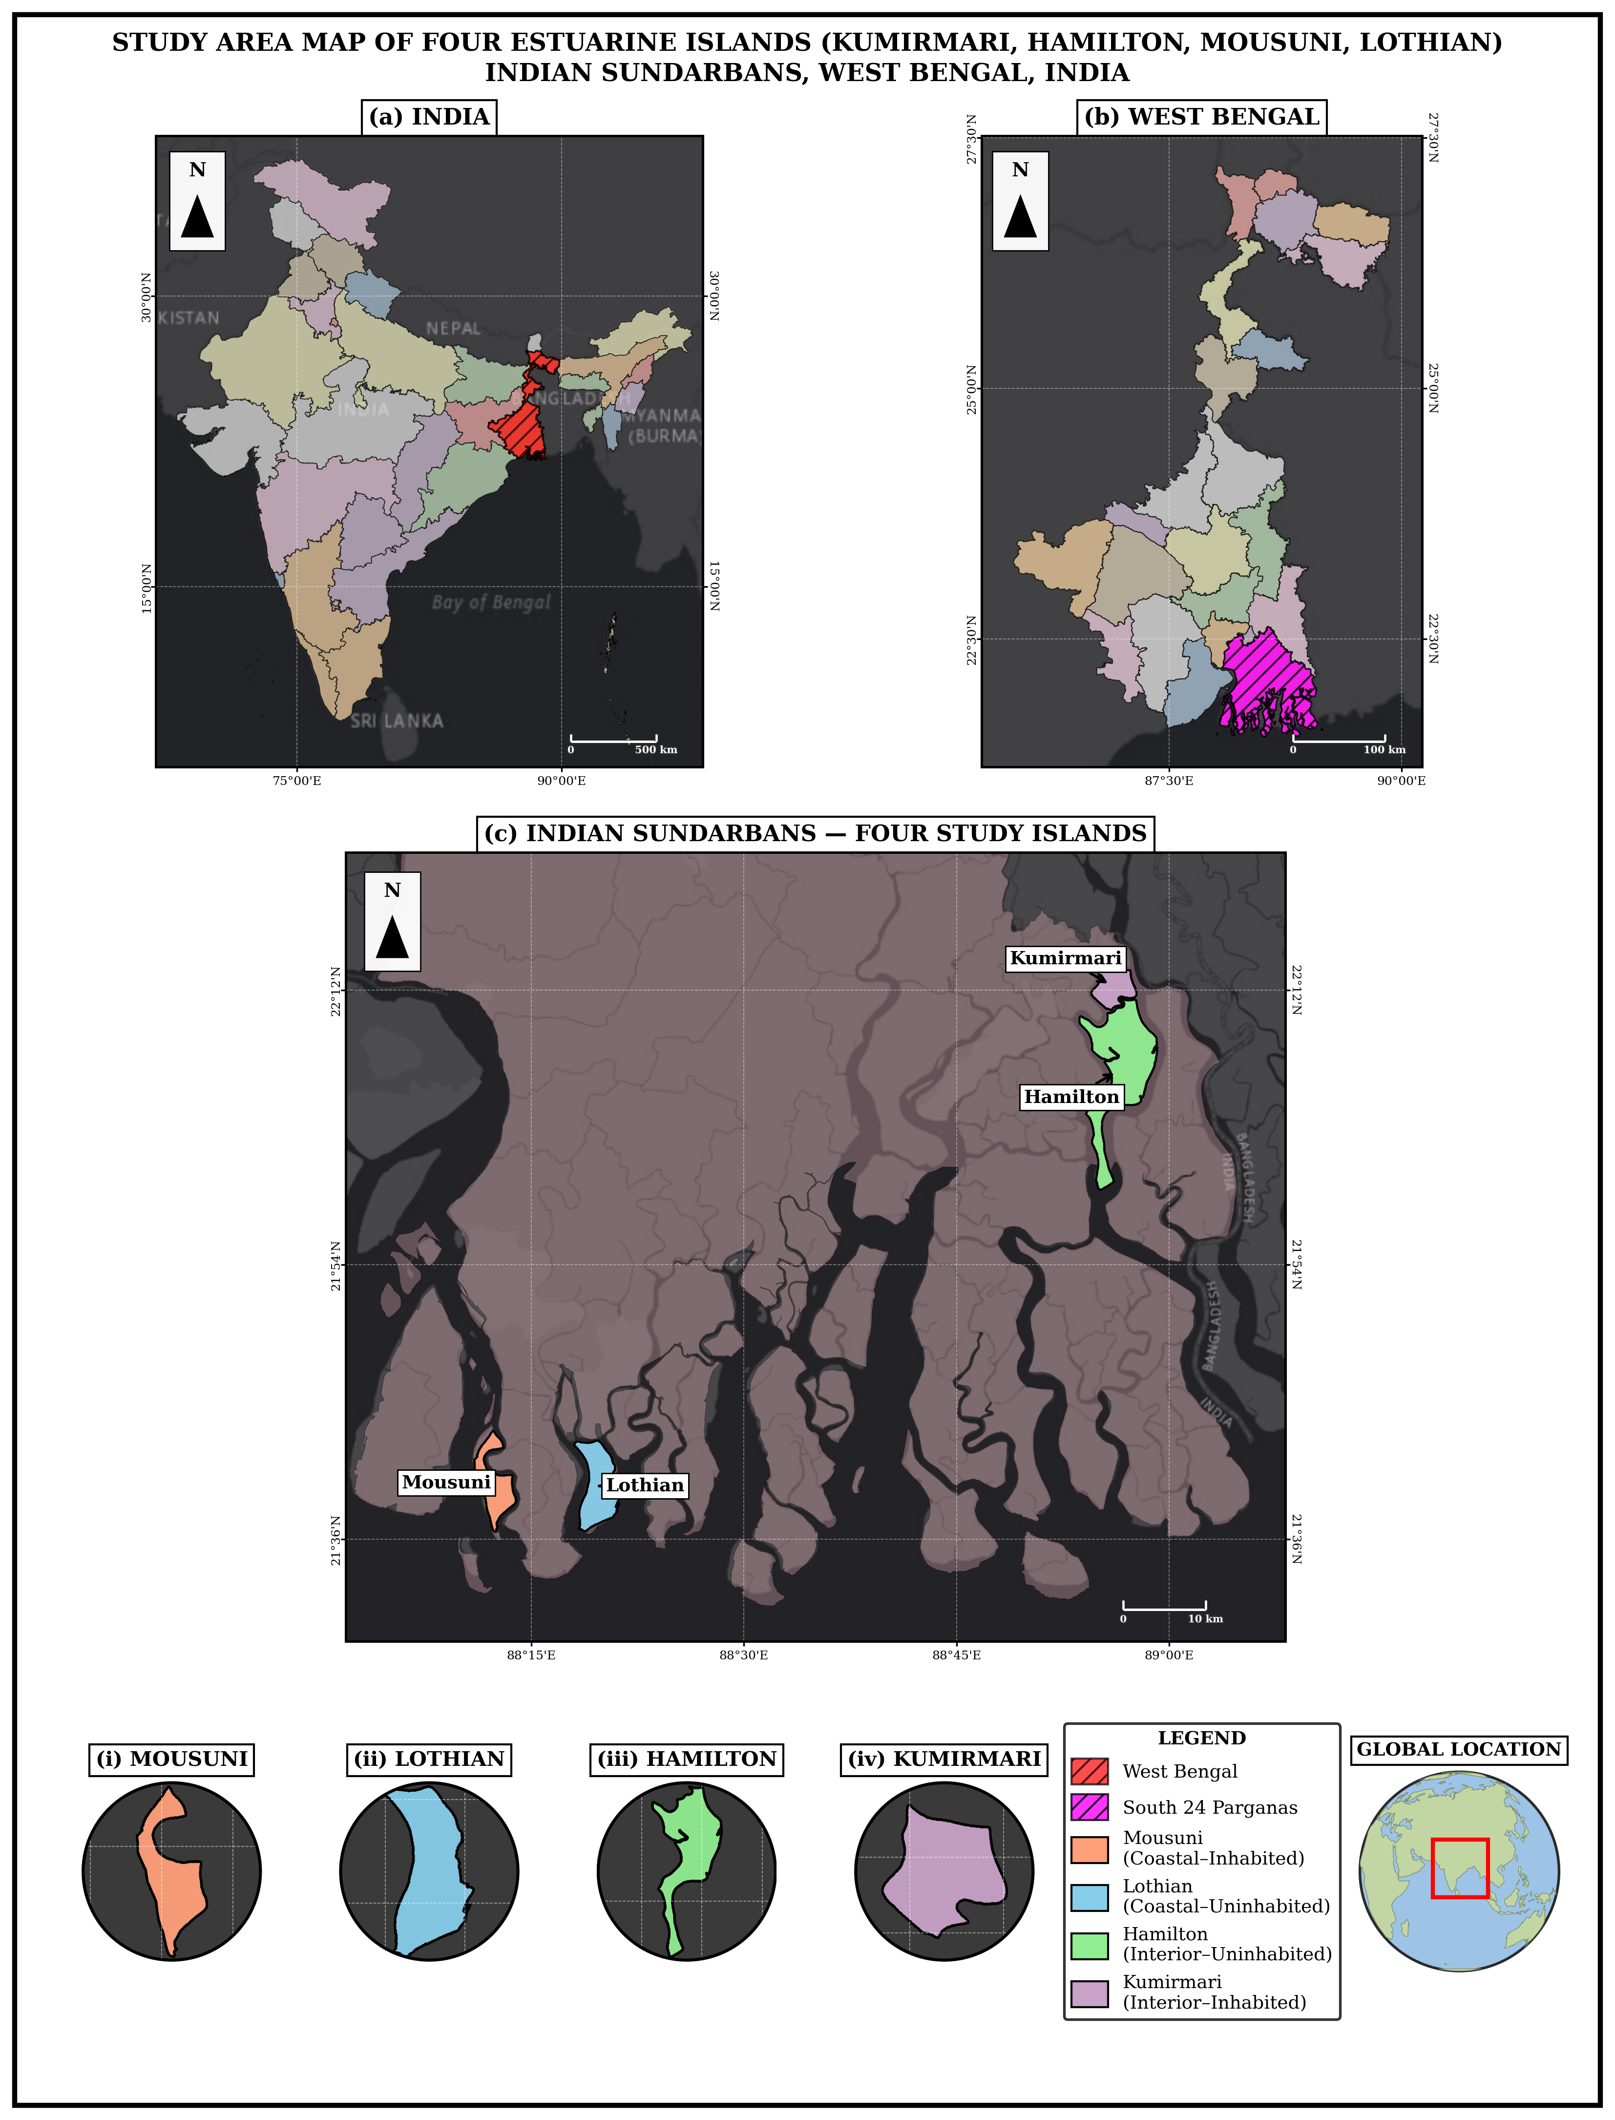
Note. Inset: position within the Ganga–Brahmaputra–Meghna delta. Islands: Kumirmari and Hamilton (interior), Mousuni and Lothian (coastal).
Table 1. Study islands and the 2×2 paired design (areas from the GEE MNDWI 2024 reference).
 | Inhabited (settled, embanked) | Uninhabited (protected)
Interior (estuarine) | Kumirmari — 19.09 km² (Gosaba Block) | Hamilton — 84.94 km²
Coastal (seaward) | Mousuni — 26.19 km² | Lothian — 36.30 km² (Wildlife Sanctuary)

3. Data and Methods
The complete processing workflow is summarised in Figure 2.
Figure 2
Methodological Workflow of the Study
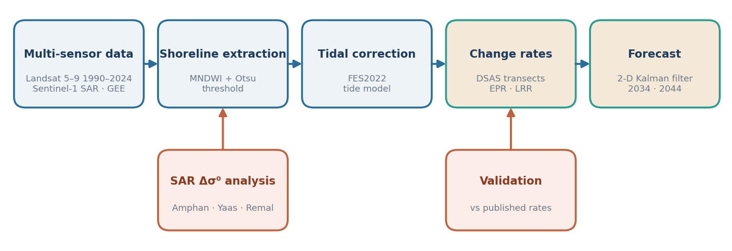
Note. Shorelines are extracted from Landsat 5/7/8/9 imagery using MNDWI and Otsu thresholding (McFeeters, 1996; Xu, 2006; Otsu, 1979; Gorelick et al., 2017) and tidally corrected with the FES2022 ocean-tide model (Lyard et al., 2021; CNES, 2024); a parallel Sentinel-1 SAR branch captures cyclone-period inundation (Torres et al., 2012; Lee, 1980); change rates are computed on DSAS-equivalent transects (Thieler et al., 2009; Himmelstoss et al., 2018; Dolan et al., 1991) and future shorelines are projected with a 2-D Kalman filter (Kalman, 1960; Long & Plant, 2012; Vitousek et al., 2017).

3.1 Satellite data and cloud processing
The optical analysis used the Landsat Collection-2 Surface Reflectance archive (Landsat 5–9) on Google Earth Engine (Gorelick et al., 2017). Twelve epochs (1990–2024) capture the long-term trend and recent cyclone years; for each, dry-season images were cloud-masked into a median composite. Sentinel-1 GRD (C-band, VV/VH) covered the cyclone windows (Torres et al., 2012). The working CRS is WGS 84 / UTM Zone 45N.

3.2 Shoreline extraction: MNDWI + Otsu
To map the land–water boundary we used the Modified Normalised Difference Water Index (MNDWI), which combines the green and shortwave-infrared (SWIR) bands and separates water from land reliably in the Sundarbans’ turbid water (Xu, 2006):
MNDWI = (Green − SWIR) / (Green + SWIR) (1)
MNDWI is high over water and low over land. Rather than thresholding by eye, Otsu’s (1979) method scans every threshold t and selects the one maximising the between-class (water vs land) variance, where ω and μ are class probabilities and mean values:
t* = argmaxₜ [ ω₀(t)·ω₁(t)·(μ₁(t) − μ₀(t))² ] (2)
We applied Otsu’s threshold to each MNDWI image and converted the water-mask boundary to a shoreline (LineString).

3.3 Tidal correction: FES2022
In the macro-tidal Sundarbans the tide level when an image is captured strongly shifts the apparent waterline, so shorelines from different dates are not comparable until placed on a common datum (Boak & Turner, 2005). For each image we took the predicted tide height h from FES2022 (Lyard et al., 2021; CNES, 2024) and shifted the shoreline horizontally to a fixed reference level; on a foreshore of slope β, a height difference moves the waterline by:
Δx = (h − h_ref) / tan β (3)
With a representative β ≈ 0.0075, a 2 m tide difference shifts the shoreline ~270 m — large enough that ignoring it would swamp the real change signal.

3.4 SAR backscatter and cyclone analysis
Because optical sensors cannot see through cyclone cloud, we used Sentinel-1 C-band SAR around Amphan (2020), Yaas (2021) and Remal (2024) (Torres et al., 2012; Chakma & Akter, 2021). Smooth water reflects radar away and looks dark, so flooding lowers backscatter (σ⁰). Scenes were speckle-filtered with the Lee filter (Lee, 1980), converted to decibels, and each cyclone’s post-storm image differenced against the pre-storm one; a clear backscatter drop marks newly flooded land. This SAR evidence supports rather than replaces the optical results, since Sentinel-1 began only in 2014 and a backscatter drop is a proxy for water.

3.5 Change-rate statistics: DSAS-equivalent transects (EPR, LRR)
To convert dated shorelines into rates we used the DSAS transect framework (Thieler et al., 2009; Himmelstoss et al., 2018; Bera & Maiti, 2019): a baseline ~200 m landward, shore-perpendicular transects at fixed spacing (352 on Kumirmari, 603 on Mousuni, 573 on Lothian, 1377 on Hamilton), and the crossing distance d of each year’s shoreline. The End-Point Rate uses the oldest and newest shoreline (Dolan et al., 1991):
EPR = (d_new − d_old) / (t_new − t_old) (4)
The Linear Regression Rate fits a least-squares line through all (t, d) points (Crowell et al., 1991):
LRR = Σ (t_i − t̄)(d_i − d̄) / Σ (t_i − t̄)² (5)
LRR is more robust to a single bad year, so we treat it as the main trend and EPR as a cross-check; each rate carries an uncertainty from the shorelines’ positional error (~35 m coastal, ~50 m interior) and counts as real change only when it exceeds that uncertainty.

3.6 Validation against published rates
To check the workflow we compared our Mousuni result with independent published rates. Western Sundarbans and Hooghly-estuary studies report maxima of roughly −20 to −24 m yr⁻¹ (Bandyopadhyay, 1997; Gopinath & Seralathan, 2005; Bandyopadhyay et al., 2014), and a recent DSAS study of Mousuni reports extremes near −23.55 m yr⁻¹ with nearly 90% of its perimeter eroding (Mishra et al., 2026). We compare the mean EPR of our worst-5% transects with this figure (Section 4.3); close agreement is evidence that the workflow is externally valid.

3.7 Future projection: 2-D Kalman filter
To project each shoreline to 2034 and 2044 we used a Kalman filter (Kalman, 1960; Long & Plant, 2012; Vitousek et al., 2017). Rather than extending the LRR line, the filter keeps a running best guess and corrects it at each measurement, yielding a smoothed rate and a forecast whose uncertainty grows with the horizon. For each transect it tracks position y and rate v as a state x = [y, v], iterating two steps over 1990–2024. The predict step advances the guess by Δt:
x⁻ = F·x, P⁻ = F·P·Fᵀ + Q, F = [[1, Δt], [0, 1]] (6)
and the update step corrects it with the observed shoreline z via the Kalman gain, trusting reliable data more:
x = x⁻ + K·(z − H·x⁻), P = (I − K·H)·P⁻ (7)
After all shorelines are assimilated, the filter forecasts forward with no new data while uncertainty σ grows:
y(t) = y_now + v·(t − t_now), σ increasing with the horizon (8)
The filter is DSAS’s built-in forecaster and has been applied in the same Bay of Bengal / Meghna system (Kona et al., 2025); it cannot anticipate sudden non-linear change, so forecasts are trend-plus-uncertainty trajectories.

4. Results

4.1 Tidally-corrected shoreline evolution (1990–2010–2024)
Figure 3 shows the tidally-corrected shoreline evolution (1990 → 2010 → 2024), and the pattern is clearly regime-dependent. Mousuni (inhabited–coastal) shifts consistently landward, confirming sustained net erosion, while Lothian (uninhabited–coastal) is mixed. Kumirmari (inhabited–interior) is essentially stable, its outlines overlapping closely across epochs, and uninhabited interior Hamilton behaves similarly, so the two interior islands are hard to tell apart — consistent with the rates in Section 4.2.
Figure 3
Tidally-Corrected Shoreline Evolution (1990, 2010, 2024) for the Four Islands
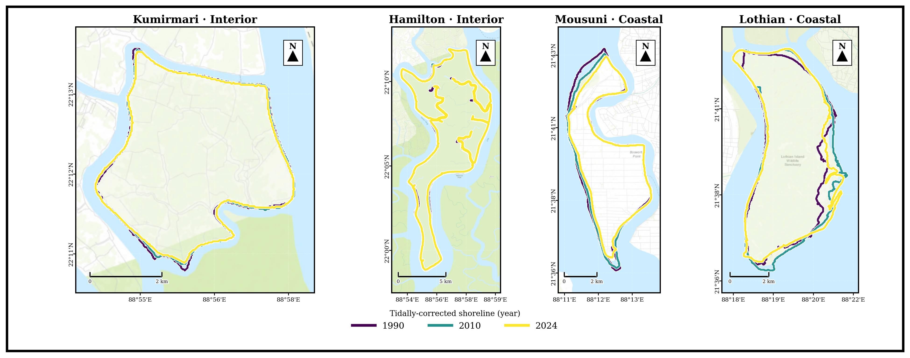
Note. Successive shorelines on Mousuni shift markedly landward (net erosion); the interior pair (Kumirmari, Hamilton) is near-stable and Lothian is broadly stable to weakly accretional.

4.2 Change rates and the inhabited vs uninhabited contrast
The DSAS LRR heatmap (Figure 4) concentrates the strongest erosional rates on the north-west, Muriganga-facing coast of Mousuni. The headline result is the interaction between setting and habitation. On the exposed coast the inhabited Mousuni (mean EPR −4.54 m yr⁻¹, LRR −4.69; ~72% eroding) erodes far more than uninhabited Lothian (+0.54, LRR +1.44; ~50% accreting), the distributions differing strongly (Mann–Whitney and Kolmogorov–Smirnov p < 0.001), though Mousuni’s erosion sits in a heavy tail (median EPR −1.36 against mean −4.54). In the sheltered interior, inhabited Kumirmari (−0.62, LRR −0.85) is statistically indistinguishable from uninhabited Hamilton (−0.89, LRR −0.95), the interior difference only +0.29 m yr⁻¹ (95% CI [−0.01, +0.75], n.s.). The difference-of-differences — the setting × habitation interaction — is +2.10 m yr⁻¹ (95% CI [+0.25, +4.08]) and significant: habitation tracks erosion on the high-energy coast but not the low-energy interior. The two uninhabited islands do not differ significantly across settings (Hamilton vs Lothian, n.s.), the control contrast that lends the coastal anthropogenic signal credibility (Bera & Maiti, 2019). Per-island means appear in Figure 5 and full distributions in Figure 6.
Figure 4
DSAS Linear Regression Rate (LRR) Across Transects for All Islands
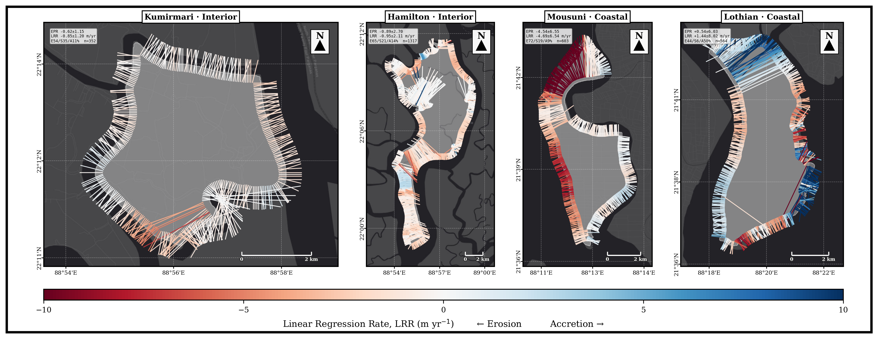
Note. Red = erosion, blue = accretion; the NW sector of Mousuni is the most erosional.
Figure 5
Mean Shoreline-Change Rates by Island, 1990–2024: End-Point Rate (EPR) and Linear Regression Rate (LRR), Grouped by Exposure Setting and Coloured by Settlement Regime
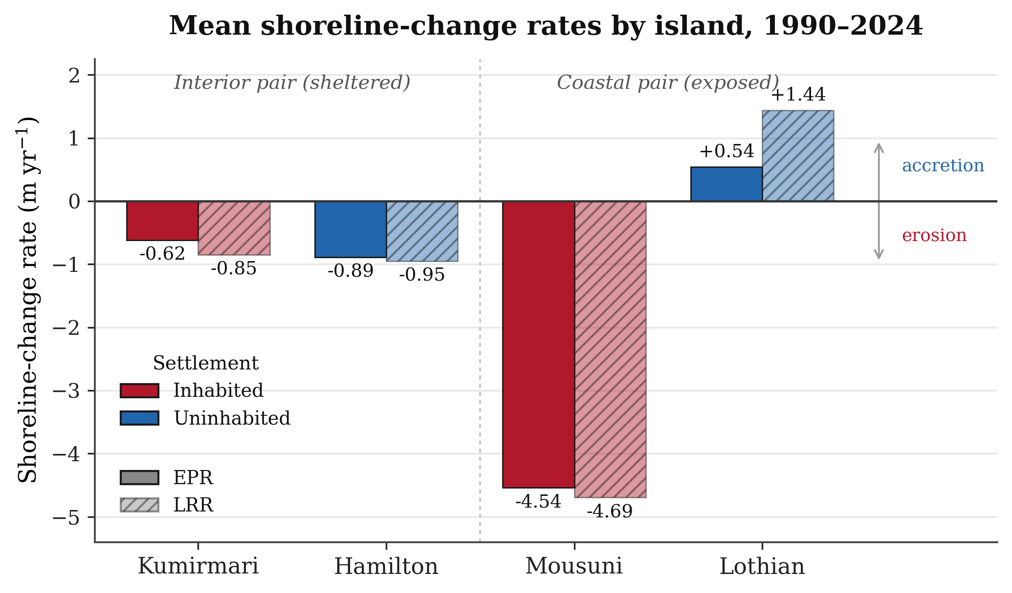
Note. The two estimators agree closely; strong erosion is confined to the exposed inhabited island (Mousuni), while the sheltered interior pair is near-stable and the exposed uninhabited island (Lothian) accretes (Thieler et al., 2009; Himmelstoss et al., 2018).

4.3 Mousuni validation
Mousuni’s transect-level EPR distribution is strongly negatively skewed (median −1.36 m yr⁻¹, mean −4.54). The single worst transect reaches −24.99 m yr⁻¹ (NW, Muriganga-facing), matching published Sundarbans/Hooghly maxima (~−23.5 m yr⁻¹; Bandyopadhyay, 1997; Gopinath & Seralathan, 2005) within ~6% — strong evidence for the external validity of the workflow.

4.4 Cyclone-period backscatter response
Sentinel-1 σ⁰ dropped markedly over the coastal islands in the post-event windows of Amphan, Yaas and Remal, consistent with temporary inundation (Torres et al., 2012). The drop was stronger over the coastal pair than the interior, as expected from greater surge exposure (Hazra et al., 2002; IPCC, 2021), linking event-scale drivers to the long-term trend.

4.5 Kalman-filter shoreline forecasts (2034, 2044)
The per-transect Kalman forecasts (Figure 6) carry the regime contrast forward. By 2044 the mean change on Mousuni is ~−93 m (±123 m) with ~84% of transects still eroding — clearly the most vulnerable. The interior islands show modest, consistent retreat (Kumirmari ~−16 m; Hamilton ~−19 m), while uninhabited coastal Lothian is near-stable but highly variable (~+12 m, ±161 m). The same ordering holds at 2034 (Mousuni ~−44 m; Hamilton ~−9 m; Kumirmari ~−8 m; Lothian ~+5 m). Forecasts are uncertainty-bounded trajectories, not deterministic predictions (Long & Plant, 2012).
Figure 6
Kalman-Filter Shoreline Forecasts to 2034 and 2044 for the Four Islands (Per-Transect Positions)
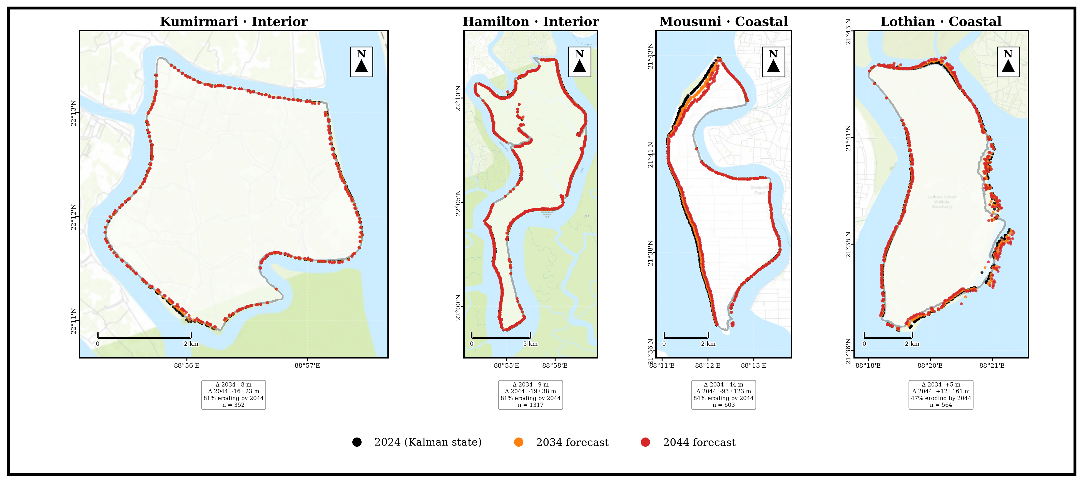
Note. Mousuni shows by far the strongest projected retreat; the interior islands (Kumirmari, Hamilton) show modest retreat and Lothian is near-stable but highly variable.

5. Discussion
The central finding is that Sundarbans shoreline behaviour is strongly modulated by settlement and engineering, and that habitation’s effect is setting-dependent: the setting × habitation interaction is significant (+2.10 m yr⁻¹, 95% CI [+0.25, +4.08]). On the exposed coast inhabited Mousuni erodes far more than uninhabited Lothian, whereas in the sheltered interior inhabited Kumirmari is no worse than uninhabited Hamilton, and the two uninhabited islands do not differ. This supports the hypothesis that embankment-driven sediment starvation and tidal-prism disturbance accelerate erosion specifically where wave and surge energy are high (Bandyopadhyay, 1997; Pethick & Orford, 2013).
Several drivers act together: regional RSLR and subsidence push the shoreline landward (Hazra et al., 2002; Rahman et al., 2011; IPCC, 2021); embankments block sediment delivery to island interiors, starving mudflats of accretion (Pethick & Orford, 2013); reclamation intensifies flood-tide dominance and bank erosion (Gopinath & Seralathan, 2005); and high-intensity cyclones deliver episodic erosion seen in the Sentinel-1 drop (Section 4.4). Mousuni’s rates match documented western-Sundarbans values, and the worst transect agrees with the published maximum within ~6%, reinforcing that settlement and exposure matter jointly — their combination, not habitation alone, drives the divergence (Bera & Maiti, 2019; Ghosh et al., 2015). The study’s strengths are explicit FES2022 tidal correction, optical–SAR integration, a reproducible GEE pipeline (Gorelick et al., 2017) and uncertainty-aware forecasting; limitations include ~30 m Landsat resolution, a single representative foreshore slope, a constant-velocity Kalman model, and one island per regime.

6. Conclusion
Across four paired Indian-Sundarbans islands (1990–2024), three conclusions stand out. First, shoreline change is strongly regime-dependent: inhabited–coastal Mousuni is by far the most erosional (~72% of transects eroding; mean EPR −4.54 m yr⁻¹; worst −24.99 m yr⁻¹), uninhabited coastal Lothian is near-stable to weakly accretional, and the sheltered interior pair — Kumirmari (−0.62) and Hamilton (−0.89) — are statistically indistinguishable. Second, the setting × habitation interaction is significant (+2.10 m yr⁻¹, 95% CI [+0.25, +4.08]): it is the combination of settlement and coastal exposure, not habitation alone, that amplifies erosion. Third, the Kalman forecasts show this divergence widening through 2034 and 2044, making adaptation urgent on inhabited coastal islands like Mousuni. For managers the implication is clear: embankment policy must account for sediment flux and tidal prism, and the highest-risk inhabited coastal islands must be prioritised (Pethick & Orford, 2013; IPCC, 2019, 2021).

Acknowledgements
The author thanks the Department of Geography, University of Madras, and the Indian Institute of Science (IISc), Bengaluru, for research-visit support. Landsat data are courtesy of USGS/NASA, Sentinel-1 of ESA Copernicus, and the FES2022 tidal model of CNES/AVISO.

Figure Sources and Data Credits
All figures were prepared by the author (A. Ghosh, 2026). Underlying data and basemap sources are as follows. Optical imagery (Figure 3): Landsat 5/7/8/9 Collection-2 Level-2 surface reflectance, USGS/NASA (dry-season scenes, 1990–2024), accessed through Google Earth Engine (Gorelick et al., 2017); the Modified Normalised Difference Water Index used the Green and SWIR1 bands (Xu, 2006). Synthetic-aperture radar: Sentinel-1 GRD C-band σ⁰ VV backscatter, ESA Copernicus, accessed through Google Earth Engine and Lee-filtered (5×5). Tidal correction: FES2022 global ocean-tide model, AVISO/CNES (Lyard et al., 2021; CNES, 2024). Shoreline-change rates and Kalman projections (Figures 4, 5, 6 and 7): DSAS-equivalent transect statistics (Thieler et al., 2009; Himmelstoss et al., 2018) and a 2-D Kalman filter (Kalman, 1960). Basemaps: Esri Dark Gray Canvas and OpenStreetMap contributors (Figure 1). Coordinate reference system: WGS 84 (EPSG:4326).

References
Bandyopadhyay, J., Mondal, I., & Samanta, N. (2014). Shore line shifting of Namkhana Island of Indian Sundarban, South 24 Parganas, West Bengal. International Journal of Engineering Sciences & Research Technology, 3(5), 162–169.
Bandyopadhyay, S. (1997). Coastal erosion and its management in Sagar Island, West Bengal, India. Indian Journal of Earth Sciences, 24(3–4), 51–69.
Bera, R., & Maiti, R. (2019). Quantitative analysis of erosion and accretion (1975–2017) using DSAS — A study on Indian Sundarbans. Regional Studies in Marine Science, 28, 100583. https://doi.org/10.1016/j.rsma.2019.100583
Boak, E. H., & Turner, I. L. (2005). Shoreline definition and detection: A review. Journal of Coastal Research, 21(4), 688–703. https://doi.org/10.2112/03-0071.1
Chakma, S., & Akter, M. (2021). Flood mapping in the coastal region of Bangladesh during super cyclone Amphan. Journal of the Civil Engineering Forum, 7(3), 267–278. https://doi.org/10.22146/jcef.64497
CNES. (2024). FES2022 (Finite Element Solution) ocean tide (Version 2022) [Data set]. Centre National d'Études Spatiales. https://doi.org/10.24400/527896/A01-2024.004
Crowell, M., Leatherman, S. P., & Buckley, M. K. (1991). Historical shoreline change: Error analysis and mapping accuracy. Journal of Coastal Research, 7(3), 839–852. https://www.jstor.org/stable/4297899
Dolan, R., Fenster, M. S., & Holme, S. J. (1991). Temporal analysis of shoreline recession and accretion. Journal of Coastal Research, 7(3), 723–744. https://www.jstor.org/stable/4297888
Ghosh, A., Schmidt, S., Fickert, T., & Nüsser, M. (2015). The Indian Sundarban mangrove forests: History, utilization, conservation strategies and local perception. Diversity, 7(2), 149–169. https://doi.org/10.3390/d7020149
Gopinath, G., & Seralathan, P. (2005). Rapid erosion of the coast of Sagar Island, West Bengal, India. Environmental Geology, 48(8), 1058–1067. https://doi.org/10.1007/s00254-005-0044-9
Gorelick, N., Hancher, M., Dixon, M., Ilyushchenko, S., Thau, D., & Moore, R. (2017). Google Earth Engine: Planetary-scale geospatial analysis for everyone. Remote Sensing of Environment, 202, 18–27. https://doi.org/10.1016/j.rse.2017.06.031
Hazra, S., Ghosh, T., DasGupta, R., & Sen, G. (2002). Sea level and associated changes in the Sundarbans. Science and Culture, 68(9–12), 309–321.
Himmelstoss, E. A., Henderson, R. E., Kratzmann, M. G., & Farris, A. S. (2018). Digital Shoreline Analysis System (DSAS) version 5.0 user guide (Open-File Report 2018-1179). U.S. Geological Survey. https://doi.org/10.3133/ofr20181179
Intergovernmental Panel on Climate Change. (2019). IPCC special report on the ocean and cryosphere in a changing climate (H.-O. Pörtner, D. C. Roberts, V. Masson-Delmotte, P. Zhai, M. Tignor, E. Poloczanska, K. Mintenbeck, A. Alegría, M. Nicolai, A. Okem, J. Petzold, B. Rama, & N. M. Weyer, Eds.). Cambridge University Press. https://doi.org/10.1017/9781009157964
Intergovernmental Panel on Climate Change. (2021). Climate change 2021: The physical science basis. Contribution of Working Group I to the Sixth Assessment Report of the Intergovernmental Panel on Climate Change (V. Masson-Delmotte, P. Zhai, A. Pirani, S. L. Connors, C. Péan, S. Berger, N. Caud, Y. Chen, L. Goldfarb, M. I. Gomis, M. Huang, K. Leitzell, E. Lonnoy, J. B. R. Matthews, T. K. Maycock, T. Waterfield, O. Yelekçi, R. Yu, & B. Zhou, Eds.). Cambridge University Press. https://doi.org/10.1017/9781009157896
Kalman, R. E. (1960). A new approach to linear filtering and prediction problems. Journal of Basic Engineering, 82(1), 35–45. https://doi.org/10.1115/1.3662552
Kona, A. D., Hoque, M. E., & Rahman, M. A. (2025). Evaluating shoreline prediction accuracy with the Kalman filter model: A case study of Nijhum Dwip, Bay of Bengal. Remote Sensing Applications: Society and Environment, 37, 101469. https://doi.org/10.1016/j.rsase.2025.101469
Lee, J.-S. (1980). Digital image enhancement and noise filtering by use of local statistics. IEEE Transactions on Pattern Analysis and Machine Intelligence, PAMI-2(2), 165–168. https://doi.org/10.1109/TPAMI.1980.4766994
Long, J. W., & Plant, N. G. (2012). Extended Kalman Filter framework for forecasting shoreline evolution. Geophysical Research Letters, 39(13), L13603. https://doi.org/10.1029/2012GL052180
Lyard, F. H., Allain, D. J., Cancet, M., Carrère, L., & Picot, N. (2021). FES2014 global ocean tide atlas: Design and performance. Ocean Science, 17(3), 615–649. https://doi.org/10.5194/os-17-615-2021
Mishra, M., Zerouali, B., Paul, S., Bhattacharyya, D., Guria, R., Suna, M., da Silva, R. M., Ranagalage, M., & Santos, C. A. G. (2026). Coastal futures at risk: Adaptive coastal management and policy insights from sea-level rise and shoreline change in West Bengal, India. Science of the Total Environment, 1014, 181238. https://doi.org/10.1016/j.scitotenv.2025.181238
Otsu, N. (1979). A threshold selection method from gray-level histograms. IEEE Transactions on Systems, Man, and Cybernetics, 9(1), 62–66. https://doi.org/10.1109/TSMC.1979.4310076
Pethick, J., & Orford, J. D. (2013). Rapid rise in effective sea-level in southwest Bangladesh: Its causes and contemporary rates. Global and Planetary Change, 111, 237–245. https://doi.org/10.1016/j.gloplacha.2013.09.019
Rahman, A. F., Dragoni, D., & El-Masri, B. (2011). Response of the Sundarbans coastline to sea level rise and decreased sediment flow: A remote sensing assessment. Remote Sensing of Environment, 115(12), 3121–3128. https://doi.org/10.1016/j.rse.2011.06.019
Thieler, E. R., Himmelstoss, E. A., Zichichi, J. L., & Ergul, A. (2009). The Digital Shoreline Analysis System (DSAS) version 4.0 — An ArcGIS extension for calculating shoreline change (Open-File Report 2008-1278). U.S. Geological Survey. https://doi.org/10.3133/ofr20081278
Torres, R., Snoeij, P., Geudtner, D., Bibby, D., Davidson, M., Attema, E., Potin, P., Rommen, B., Floury, N., Brown, M., Navas Traver, I., Deghaye, P., Duesmann, B., Rosich, B., Miranda, N., Bruno, C., L'Abbate, M., Croci, R., Pietropaolo, A., … Rostan, F. (2012). GMES Sentinel-1 mission. Remote Sensing of Environment, 120, 9–24. https://doi.org/10.1016/j.rse.2011.05.028
Vitousek, S., Barnard, P. L., Limber, P., Erikson, L., & Cole, B. (2017). A model integrating longshore and cross-shore processes for predicting long-term shoreline response to climate change. Journal of Geophysical Research: Earth Surface, 122(4), 782–806. https://doi.org/10.1002/2016JF004065
Xu, H. (2006). Modification of normalised difference water index (MNDWI) to enhance open water features in remotely sensed imagery. International Journal of Remote Sensing, 27(14), 3025–3033. https://doi.org/10.1080/01431160600589179

