Differential Shoreline Dynamics of Inhabited and Uninhabited Estuarine Islands in the Indian Sundarbans (1990–2024)
Anubhav Ghosh
II-M.Tech. Geoinformatics, Department of Geography, University of Madras, Chennai 600005, India
Research Intern, Indian Institute of Science (IISc), Bengaluru 560012, India
Email: anubg2000@gmail.com
Submitted to: 100 Years of Geographical Research in India (eds. Siddiqui, Sarkar & Singh) · Version 0.0 (English)

Abstract
The Indian Sundarbans, the world’s largest contiguous mangrove delta, is under the combined stress of rapid relative sea-level rise (RSLR), strong tidal forcing, sediment-supply disturbance and frequent tropical cyclones (Hazra et al., 2002; Rahman et al., 2011; Pethick & Orford, 2013; IPCC, 2021). This study adopts a paired-island design to test how human settlement and embankment (“inhabited” vs “uninhabited”) modulate shoreline behaviour. Four islands were selected: Kumirmari (19.09 km², inhabited–interior), Hamilton (84.94 km², uninhabited–interior), Mousuni (26.19 km², inhabited–coastal) and Lothian (36.30 km², uninhabited–coastal). The multi-temporal Landsat archive (1990–2024) was processed on Google Earth Engine (GEE); shorelines were extracted using MNDWI + Otsu thresholding (McFeeters, 1996; Xu, 2006; Otsu, 1979; Gorelick et al., 2017) and each shoreline was tidally corrected with the FES2022 global tide model (Lyard et al., 2021; CNES, 2024). Change rates were computed from DSAS-equivalent transects using EPR and LRR (Thieler et al., 2009; Himmelstoss et al., 2018), cyclone-period inundation was examined with Sentinel-1 SAR backscatter (Torres et al., 2012; Lee, 1980), and future shoreline positions (2034, 2044) were forecast with a 2-D Kalman filter (Kalman, 1960; Long & Plant, 2012; Vitousek et al., 2017). The results clearly identify the inhabited–coastal regime as the most vulnerable: on Mousuni ~72% of transects are net erosional and the most-eroded transect (−24.99 m yr⁻¹) matches published Sundarbans/Hooghly-estuary maximum erosion rates (~−23.5 m yr⁻¹; Bandyopadhyay, 1997; Gopinath & Seralathan, 2005) to within ~6%. The Kalman forecasts indicate ~−93 m of retreat on Mousuni by 2044 (~84% of transects eroding). Severe erosion is, however, confined to the exposed coast: Mousuni erodes at a mean EPR of ~−4.54 m yr⁻¹ (LRR −4.69), whereas the two sheltered interior islands are near-stable and statistically indistinguishable from one another — inhabited Kumirmari (−0.62 m yr⁻¹, LRR −0.85) and uninhabited Hamilton (−0.89 m yr⁻¹, LRR −0.95) — while the uninhabited coastal Lothian is broadly stable to weakly accretional (+0.54 m yr⁻¹, LRR +1.44). A statistically significant island-setting × habitation interaction (+2.10 m yr⁻¹, 95% CI [+0.25, +4.08]) indicates that the association between habitation and erosion is strong on the open coast but negligible in the sheltered interior. These findings have direct implications for coastal management, embankment policy and climate-adaptation planning.
Keywords: Indian Sundarbans; shoreline change; DSAS; EPR/LRR; MNDWI; FES2022 tidal correction; Sentinel-1 SAR; Kalman filter; relative sea-level rise; estuarine islands.

1. Introduction
Low-lying deltaic coasts are among the most dynamic and most risk-exposed environments globally (Syvitski et al., 2009; Ericson et al., 2006; Tessler et al., 2015). The Ganga–Brahmaputra–Meghna (GBM) delta, on which the Indian and Bangladesh Sundarbans sit, is a classic example: sediment dynamics, a macro-tidal regime, mangrove ecology and intense human pressure all interact here (Giri et al., 2011; Ghosh et al., 2015; Woodroffe et al., 2016). The IPCC AR6 identifies relative sea-level rise as a dominant driver for low-lying tropical deltas through the 21st century (IPCC, 2019, 2021), and effective sea-level-rise rates in the Sundarbans are reported to be well above the global mean, largely because of subsidence and sediment starvation (Pethick & Orford, 2013; Hazra et al., 2002).
The shoreline is a fundamental geo-indicator that captures the net result of all these processes (Boak & Turner, 2005; Crowell et al., 1991). Quantifying its historical movement is essential for coastal-hazard assessment, erosion management and climate adaptation. The Indian Sundarbans have a strong tradition of shoreline-change studies — especially on Sagar, Ghoramara, Namkhana and other Hooghly-estuary islands (Bandyopadhyay, 1997; Gopinath & Seralathan, 2005; Ghosh et al., 2001; Bandyopadhyay et al., 2014; Rahman et al., 2011). Two important gaps remain, however. First, most studies examine single islands or the whole biosphere together, so they cannot systematically test how human settlement and engineered embankments change shoreline behaviour. Second, very few studies correct explicitly for tidal stage, yet in the macro-tidal Sundarbans an uncorrected instantaneous waterline can show a large apparent “change” caused by the tide alone (Boak & Turner, 2005; Lyard et al., 2021).
The core idea of this chapter is a controlled, paired comparison. We use a 2×2 factorial design with one representative island for each combination of two factors — settlement status (inhabited vs uninhabited) and geomorphic position (interior vs coastal/seaward). This design lets us isolate an “interaction” — whether the effect of settlement grows with coastal exposure. Methodologically, we integrate four complementary remote-sensing approaches so that the conclusions are robust: (i) GEE-based MNDWI + Otsu shoreline extraction (McFeeters, 1996; Xu, 2006; Otsu, 1979; Gorelick et al., 2017); (ii) FES2022 tidal correction for every epoch (Lyard et al., 2021; CNES, 2024); (iii) DSAS-equivalent transect statistics (EPR, LRR) for change rates (Thieler et al., 2009; Himmelstoss et al., 2018; Dolan et al., 1991); and (iv) a 2-D Kalman filter for shoreline forecasting (Long & Plant, 2012; Vitousek et al., 2017). In addition, Sentinel-1 SAR is used to examine cyclone-period (Amphan 2020, Yaas 2021, Remal 2024) inundation and backscatter change (Torres et al., 2012; Lee, 1980).
The study has three specific objectives: (1) to map and quantify the tidally-corrected shoreline evolution of the four islands between 1990 and 2024; (2) to compare change rates statistically between inhabited and uninhabited, and interior and coastal, regimes; and (3) to forecast mid-century (2034, 2044) shoreline positions with a Kalman filter and so identify the most vulnerable regime. Our central hypothesis is that the inhabited–coastal regime (Mousuni) will show the greatest erosion, because embankment-induced sediment starvation, tidal-prism disturbance and direct marine exposure act together there (Bandyopadhyay, 1997; Pethick & Orford, 2013).

2. Study Area
Figure 1
Study Area and Location of the Four Study Islands in the Indian Sundarbans (South 24 Parganas, West Bengal)
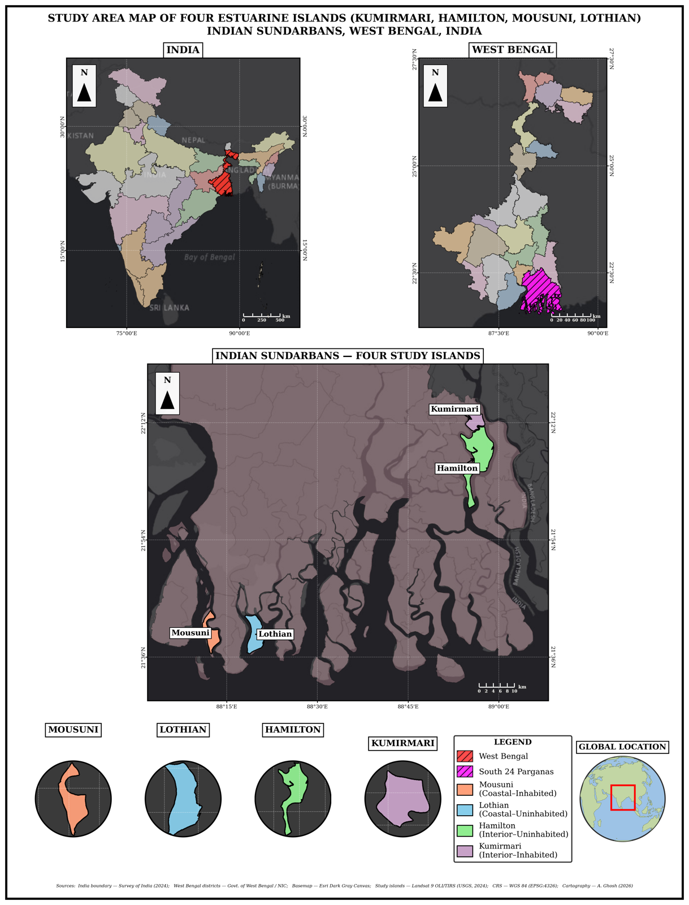
Note. Inset: position within the Ganga–Brahmaputra–Meghna delta. Islands: Kumirmari and Hamilton (interior), Mousuni and Lothian (coastal).
The Indian Sundarbans spreads across the South 24 Parganas and North 24 Parganas districts of West Bengal and is part of a UNESCO World Heritage Site / Biosphere Reserve (Ghosh et al., 2015; Giri et al., 2011). The region is macro- to meso-tidal (spring tidal range often > 4 m), with numerous tidal creeks, mudflats and mangrove-fringed islands. The climate is humid tropical, and the pre-monsoon (April–May) and post-monsoon periods are particularly active for cyclogenesis (IPCC, 2021; Hazra et al., 2002).
The four islands were selected according to the 2×2 design (Table 1). On the settlement axis, Kumirmari and Mousuni are inhabited (densely populated and embanked), whereas Hamilton and Lothian (Lothian Island Wildlife Sanctuary) are practically uninhabited and protected. On the position axis, Kumirmari and Hamilton are relatively interior (estuarine, creek-dominated), whereas Mousuni and Lothian are seaward/coastal and directly exposed to the marine energy of the Bay of Bengal and major estuary mouths (e.g., the Muriganga) (Bandyopadhyay, 1997; Gopinath & Seralathan, 2005). Mousuni is a well-documented erosion hotspot of the western Sundarbans, which makes it ideal for validation.
Table 1. Study islands and the 2×2 paired design (areas from the GEE MNDWI 2024 reference).
 | Inhabited (settled, embanked) | Uninhabited (protected)
Interior (estuarine) | Kumirmari — 19.09 km² (Gosaba Block) | Hamilton — 84.94 km²
Coastal (seaward) | Mousuni — 26.19 km² | Lothian — 36.30 km² (Wildlife Sanctuary)

3. Data and Methods
The complete processing workflow is summarised in Figure 2.
Figure 2
Methodological Workflow of the Study
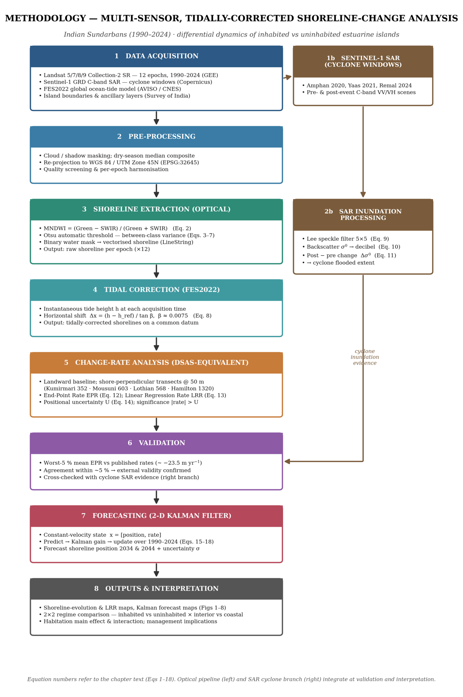
Note. Shorelines are extracted from Landsat 5/7/8/9 imagery using MNDWI and Otsu thresholding (McFeeters, 1996; Xu, 2006; Otsu, 1979; Gorelick et al., 2017) and tidally corrected with the FES2022 ocean-tide model (Lyard et al., 2021; CNES, 2024); a parallel Sentinel-1 SAR branch captures cyclone-period inundation (Torres et al., 2012; Lee, 1980); change rates are computed on DSAS-equivalent transects (Thieler et al., 2009; Himmelstoss et al., 2018; Dolan et al., 1991) and future shorelines are projected with a 2-D Kalman filter (Kalman, 1960; Long & Plant, 2012; Vitousek et al., 2017).

3.1 Satellite data and cloud processing
For the optical analysis we used the Landsat Collection-2 Surface Reflectance archive (Landsat 5 TM, 7 ETM+, 8–9 OLI), accessed and processed on Google Earth Engine (GEE) (Gorelick et al., 2017; Roy et al., 2014; Wulder et al., 2019). Twelve epochs (1990, 1995, 2000, 2005, 2008, 2010, 2013, 2016, 2019, 2020, 2022, 2024) were chosen to cover both the long-term trend and the recent cyclone years. For each epoch, dry-season (pre-monsoon) images were cloud-masked and combined into a median composite, minimising residual cloud and sensor noise. For the SAR component, Sentinel-1 GRD (C-band, VV/VH) imagery was used around the cyclone windows (Torres et al., 2012). The coordinate system throughout is WGS 84 / UTM Zone 45N (EPSG:32645).
Figure 3a
Multi-Temporal MNDWI Composites (1990–2024), Interior Islands (Kumirmari, Hamilton)
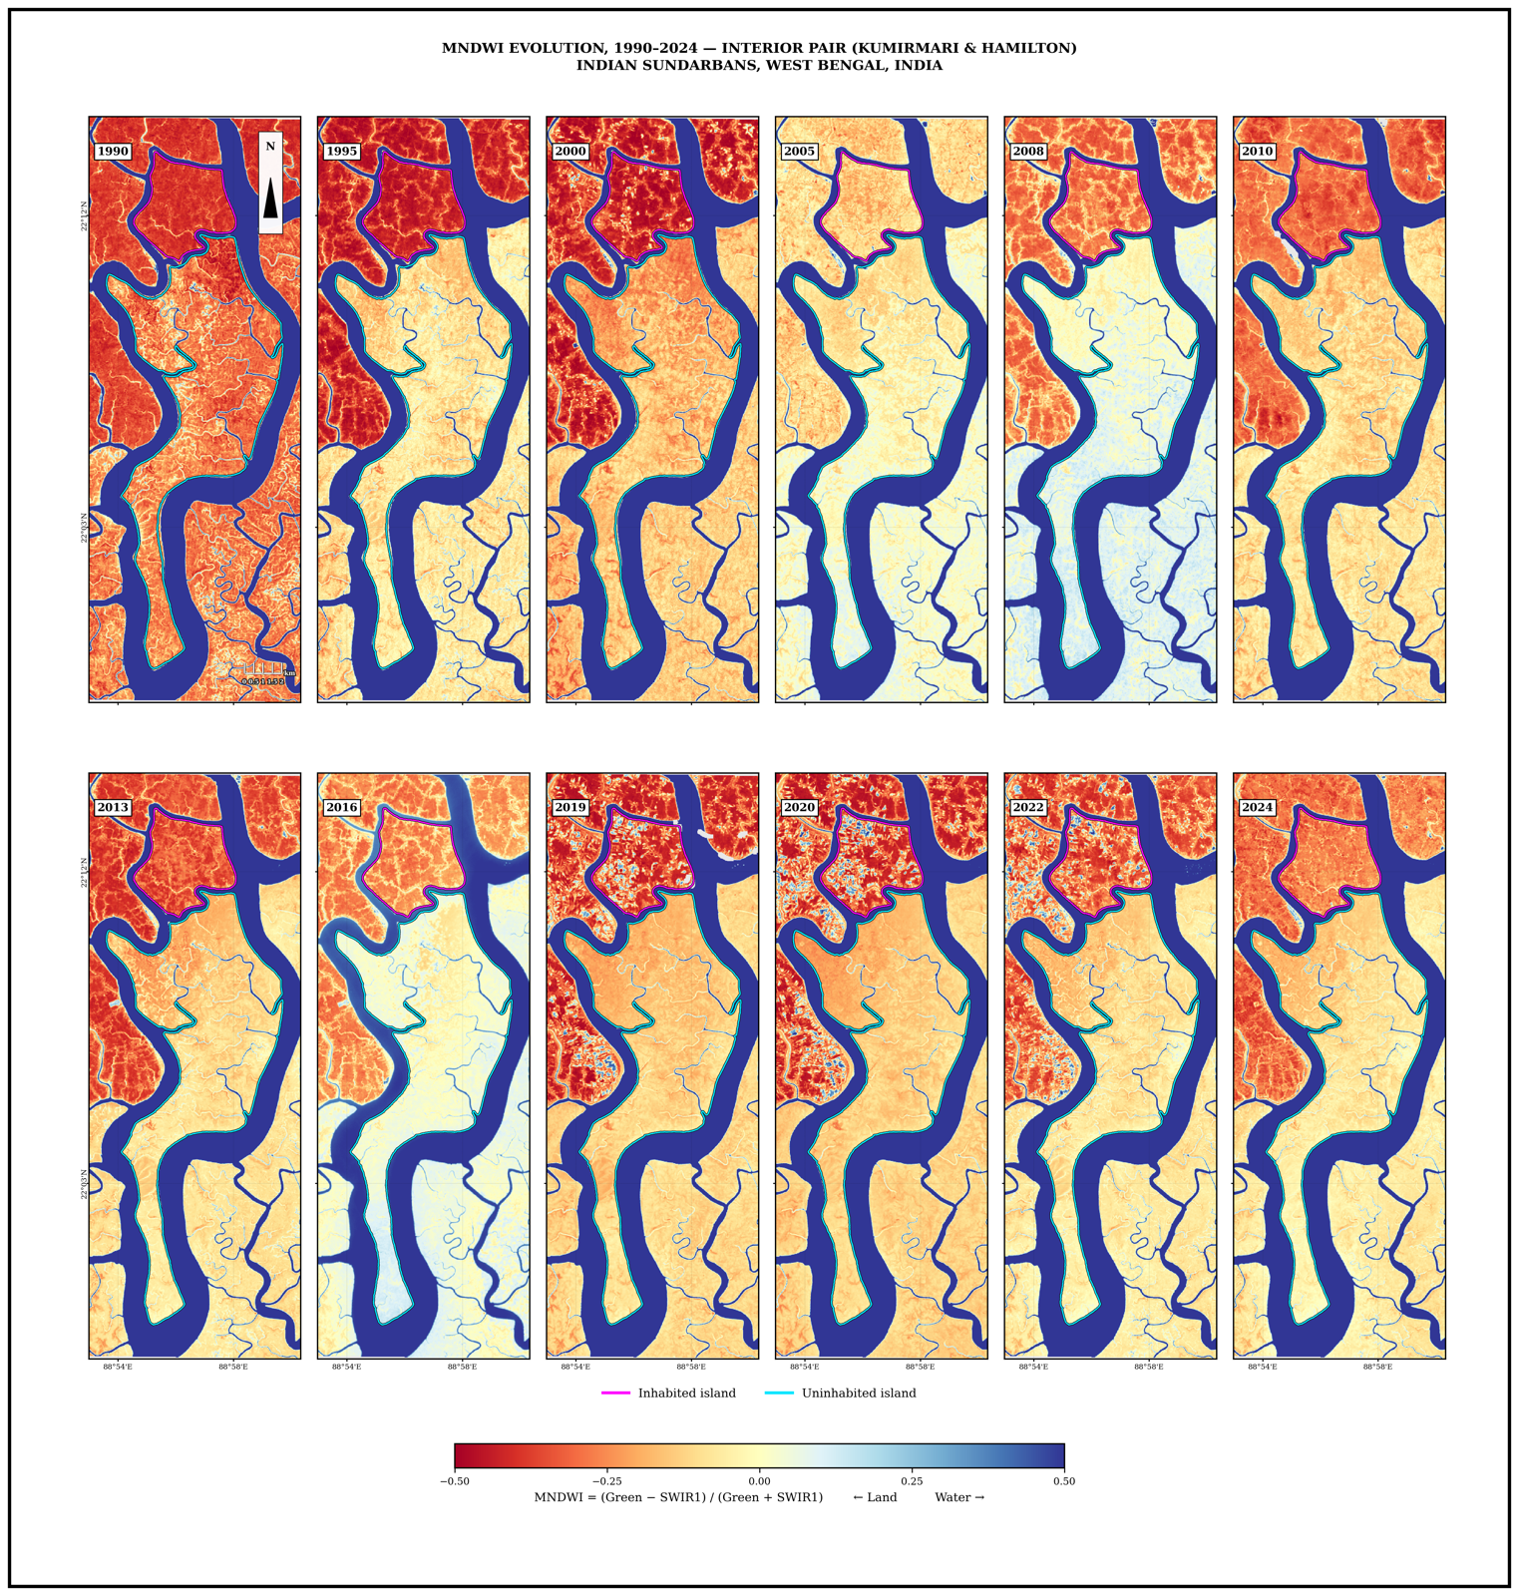
Note. Higher MNDWI = open water; this is the basis for shoreline extraction.
Figure 3b
Multi-Temporal MNDWI Composites (1990–2024), Coastal Islands (Mousuni, Lothian)
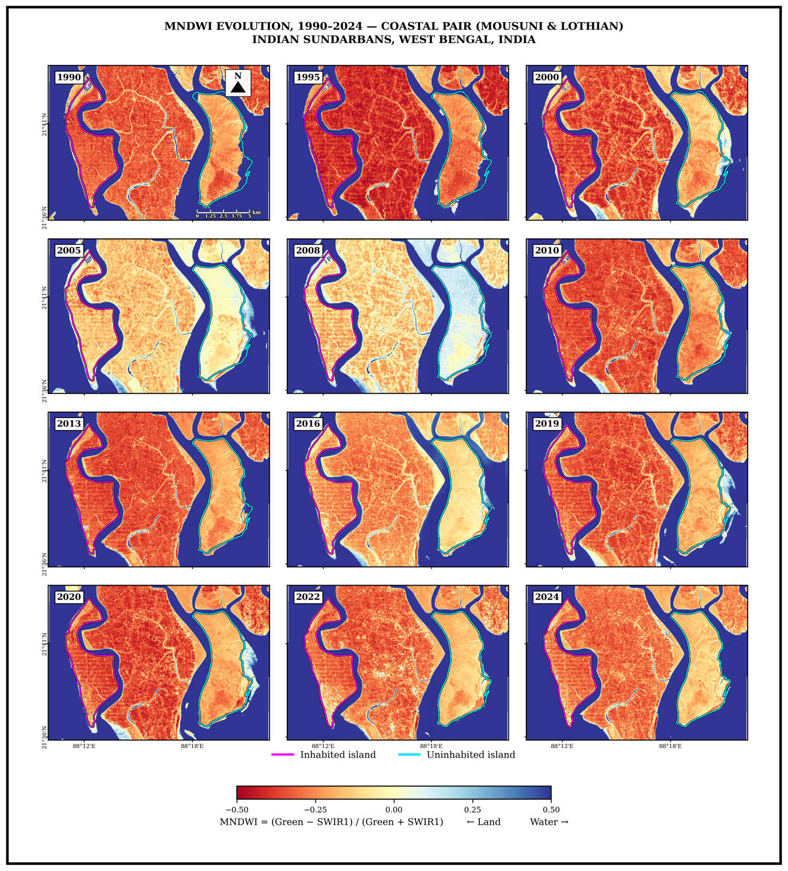

3.2 Shoreline extraction: MNDWI + Otsu
To map the land–water boundary we used a water index — a formula that combines satellite bands so that water stands out from land. The original index, NDWI, uses the green and near-infrared (NIR) bands (McFeeters, 1996):
NDWI = (Green − NIR) / (Green + NIR) (1)
In the turbid, sediment-laden water of the Sundarbans, NDWI can confuse bright land with water, so we used the Modified NDWI (MNDWI), which replaces NIR with the shortwave-infrared (SWIR) band and separates water from land more reliably here (Xu, 2006; cf. Gao, 1996):
MNDWI = (Green − SWIR) / (Green + SWIR) (2)
MNDWI is high over open water and low over land. Rather than picking a land/water threshold by eye, we used Otsu’s (1979) method, which finds it automatically. Otsu tries every possible threshold t and, for each, splits the pixels into two classes (water, land) with probabilities ω₀, ω₁ and mean index values μ₀, μ₁:
ω₀(t) = Σ p(i) for i ≤ t ; ω₁(t) = Σ p(i) for i > t (3)
μ₀(t) = [Σ i·p(i), i ≤ t] / ω₀ ; μ₁(t) = [Σ i·p(i), i > t] / ω₁ (4)
It then measures how well-separated the two classes are using the between-class variance, and picks the threshold t* that makes this separation largest:
σ²_B(t) = ω₀ · ω₁ · (μ₁ − μ₀)² (5)
t* = argmax over t of σ²_B(t) (6)
This works because the total spread of the histogram is fixed, dividing into a within-class part and a between-class part, so maximising the between-class part is the same as making each class as tight as possible:
σ²_total = σ²_within(t) + σ²_B(t) (7)
We applied Otsu’s threshold to each MNDWI image, converted the resulting water mask’s boundary into a shoreline line (LineString), and also computed NDVI for mangrove/vegetation context (Tucker, 1979).

3.3 Tidal correction: FES2022
In the macro-tidal Sundarbans (spring tidal range often > 4 m), the tide level at the moment a satellite image is taken strongly affects where the waterline appears, so shorelines from different dates are not directly comparable until they are put on a common tidal footing (Boak & Turner, 2005). For every image we obtained the predicted instantaneous tide height h from the FES2022 global ocean-tide model (Lyard et al., 2021; CNES, 2024) and shifted the extracted shoreline horizontally to where it would sit at a fixed reference level. Using simple foreshore geometry, a tide height difference (h − h_ref) on a beach of slope β moves the waterline horizontally by:
Δx = (h − h_ref) / tan β (8)
We used a representative foreshore slope β ≈ 0.0075; for example, a 2 m tide difference then shifts the shoreline by about 2 / 0.0075 ≈ 270 m, which is large enough that ignoring it would swamp the real change signal. After this step the shorelines are “tidally corrected” and inter-epoch comparison becomes physically meaningful.

3.4 SAR backscatter and cyclone analysis
Cyclones bring heavy cloud and rain, and optical sensors like Landsat cannot see the ground through cloud. Radar (SAR) makes its own signal and works through cloud day or night, so we used Sentinel-1 C-band SAR around the three recent cyclones — Amphan (May 2020), Yaas (May 2021) and Remal (May 2024) (Torres et al., 2012; Chakma & Akter, 2021). Smooth water reflects the radar away from the sensor and looks dark, while rough land and vegetation scatter it back and look bright; when land floods, its backscatter (σ⁰, “sigma-naught”) drops. We processed the scenes in three steps. First, we reduced the grainy speckle noise with the Lee filter (Lee, 1980; Lee et al., 1994), which replaces each pixel by the local mean plus a weighted share of the original detail:
filtered = Ī + W·(I − Ī), with W = 1 − C_u² / C_I² (9)
where Ī is the mean in a small moving window, C_u the noise level and C_I the window’s variability; in smooth areas W → 0 (noise smoothed away) and at edges W → 1 (detail kept). Second, we put backscatter on the decibel scale used for radar (Small, 2011):
σ⁰_dB = 10 · log₁₀(σ⁰) (10)
Third, for each cyclone we compared the VV image just after the storm with one just before it:
Δσ⁰ = σ⁰_post − σ⁰_pre (11)
A clear drop (negative Δσ⁰) marks newly water-covered, flooded land — the standard SAR change-detection approach for flood mapping (Amitrano et al., 2018; Chakma & Akter, 2021). We use this SAR evidence to support, not replace, the optical shoreline results: Sentinel-1 began only in 2014, so it covers the recent cyclones rather than the long-term (1990–2024) rates, and a backscatter drop is a proxy for water rather than a direct measurement.
Figure 4a
Sentinel-1 VV Backscatter (σ⁰, dB), Interior Islands
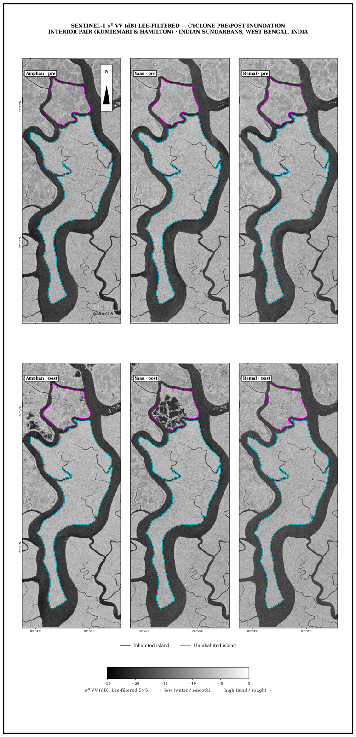
Note. Darker = lower backscatter (smoother/water surfaces).
Figure 4b
Sentinel-1 VV Backscatter (σ⁰, dB), Coastal Islands
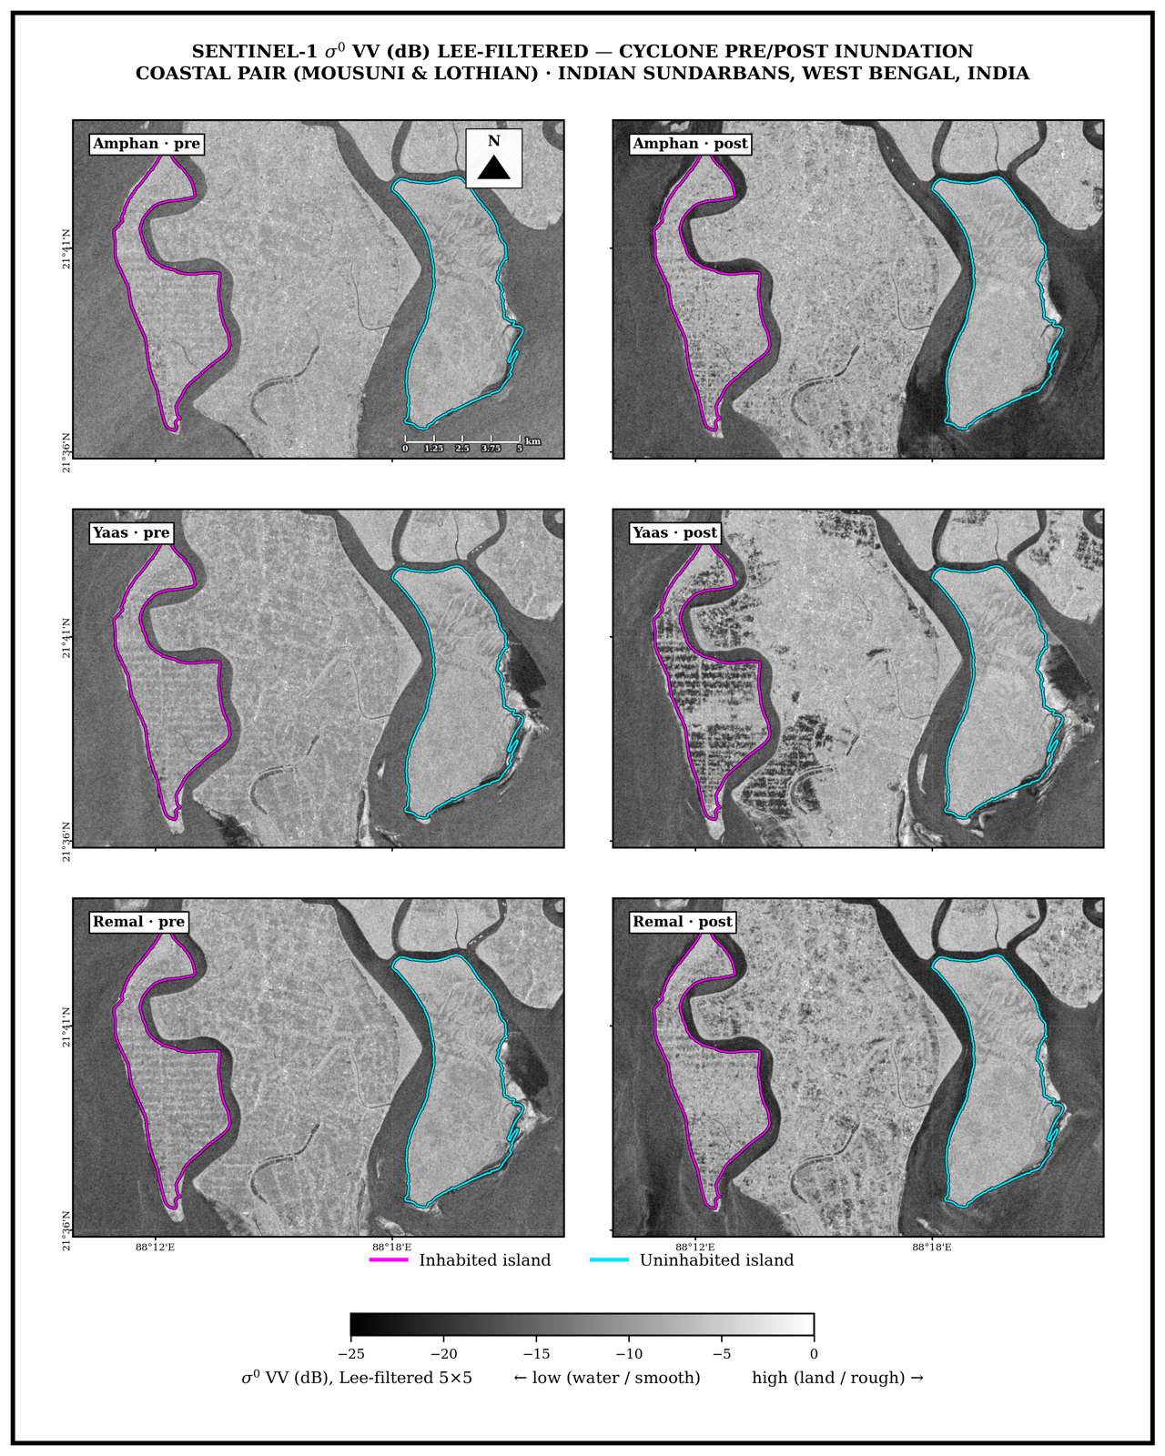

3.5 Change-rate statistics: DSAS-equivalent transects (EPR, LRR)
To turn the dated shorelines into rates of change we used the standard transect framework of the Digital Shoreline Analysis System (Thieler et al., 2009; Himmelstoss et al., 2018; Bera & Maiti, 2019). A baseline is placed ~200 m landward of the coast, shore-perpendicular transects are cast at a fixed spacing (50 m for the interior islands; comparable for the coastal ones — 352 transects on Kumirmari, 603 on Mousuni, 573 on Lothian, 1377 on Hamilton), and along each transect we record the distance d at which each year’s shoreline crosses it. The End-Point Rate uses only the oldest and newest shoreline (Dolan et al., 1991):
EPR = (d_new − d_old) / (t_new − t_old) (12)
The Linear Regression Rate uses every shoreline by fitting a least-squares line through all the (t, d) points; its slope is the rate (Crowell et al., 1991; Genz et al., 2007):
LRR = Σ (t_i − t_mean)(d_i − d_mean) / Σ (t_i − t_mean)² (13)
LRR is more robust because one bad year cannot swing it, so we treat LRR as the main trend and EPR as a cross-check. Each rate carries an uncertainty driven by the positional error U of the shorelines (~35 m coastal, ~50 m interior, combining pixel size, co-registration and residual tidal error); for the end-point rate:
U_EPR = √(U_old² + U_new²) / (t_new − t_old) (14)
A measured rate is treated as real change only when it exceeds this uncertainty. These transect rates are directly comparable with the wider Indian-Sundarbans DSAS literature (Bera & Maiti, 2019; Das et al., 2021).

3.6 Validation against published rates
To check that our workflow gives sensible numbers, we compared our Mousuni result with independently published erosion rates for the region. Studies of the western Indian Sundarbans and Hooghly-estuary islands report maximum erosion rates of roughly −20 to −24 m yr⁻¹ (Bandyopadhyay, 1997; Gopinath & Seralathan, 2005; Bandyopadhyay et al., 2014), and a recent DSAS study of Mousuni Island itself reports extreme rates reaching about −23.55 m yr⁻¹ with nearly 90% of its perimeter eroding (Science of the Total Environment, 2025). We take the mean EPR of our worst-5% (most-eroding) transects and compare it with this published figure (Section 4.3); the close agreement is evidence that the MNDWI + FES2022 + DSAS workflow is externally valid. [v0.0 note: confirm and complete the full citation for the Mousuni DSAS study before submission.]

3.7 Future projection: 2-D Kalman filter
To estimate where each shoreline will be in 2034 and 2044 we used a Kalman filter (Kalman, 1960; Long & Plant, 2012; Vitousek et al., 2017). Extending the LRR line straight into the future would treat every past measurement as perfect and give no error bar; a Kalman filter instead keeps a running best guess and, each time it sees a measurement, corrects that guess — trusting reliable measurements more and noisy ones less — producing a smoothed rate and a forecast whose uncertainty grows with the horizon. For each transect it tracks the shoreline position y and its rate v as a state x = [y, v], assuming a roughly constant rate, and repeats two steps over 1990–2024. The predict step pushes the guess forward by one time step Δt:
x⁻ = F·x, P⁻ = F·P·F^T + Q, with F = [[1, Δt], [0, 1]] (15)
where P is the uncertainty of the guess and Q the process noise. The update step then corrects the guess using the observed shoreline z (H = [1, 0]; R is the measurement error from Section 3.5), via the Kalman gain K, which balances model against data:
K = P⁻·H^T / (H·P⁻·H^T + R) (16)
x = x⁻ + K·(z − H·x⁻), P = (I − K·H)·P⁻ (17)
After all shorelines (1990–2024) are assimilated, the filter holds the present position and a smoothed rate v; to forecast it predicts forward with no new data, so the position advances and the uncertainty σ grows with the horizon:
y(t) = y_now + v·(t − t_now), with σ increasing with the horizon (18)
This along-transect movement is then placed back on the map along the transect azimuth, producing the 2024 → 2034 → 2044 positions. The filter is the forecasting tool built into DSAS and has been applied in the same Bay of Bengal / Meghna delta system as the Sundarbans (Kona et al., 2025). It cannot anticipate sudden, non-linear change (an embankment breach or a future cyclone), so the forecasts are read as trend-plus-uncertainty trajectories rather than exact predictions.

4. Results

4.1 Tidally-corrected shoreline evolution (1990–2010–2024)
Figure 5 shows the tidally-corrected shoreline evolution of the four islands (1990 purple → 2010 teal → 2024 yellow). The pattern is clearly regime-dependent. The shoreline of Mousuni (inhabited–coastal) shifts consistently landward (inward) — the 1990 outline lies well seaward of the 2024 one, confirming sustained net erosion. Lothian (uninhabited–coastal) shows mixed behaviour (some sectors erode, some accrete). The shoreline of Kumirmari (inhabited–interior) is, by contrast, essentially stable — its 1990, 2010 and 2024 outlines overlap closely (perimeter ~18 km, varying by less than 1 km across epochs), indicating only weak net change. The uninhabited interior Hamilton behaves similarly (weakly erosional), so the two sheltered interior islands are difficult to tell apart. This qualitative picture is consistent with the quantitative rates in Section 4.2.
Figure 5
Tidally-Corrected Shoreline Evolution (1990, 2010, 2024) for the Four Islands
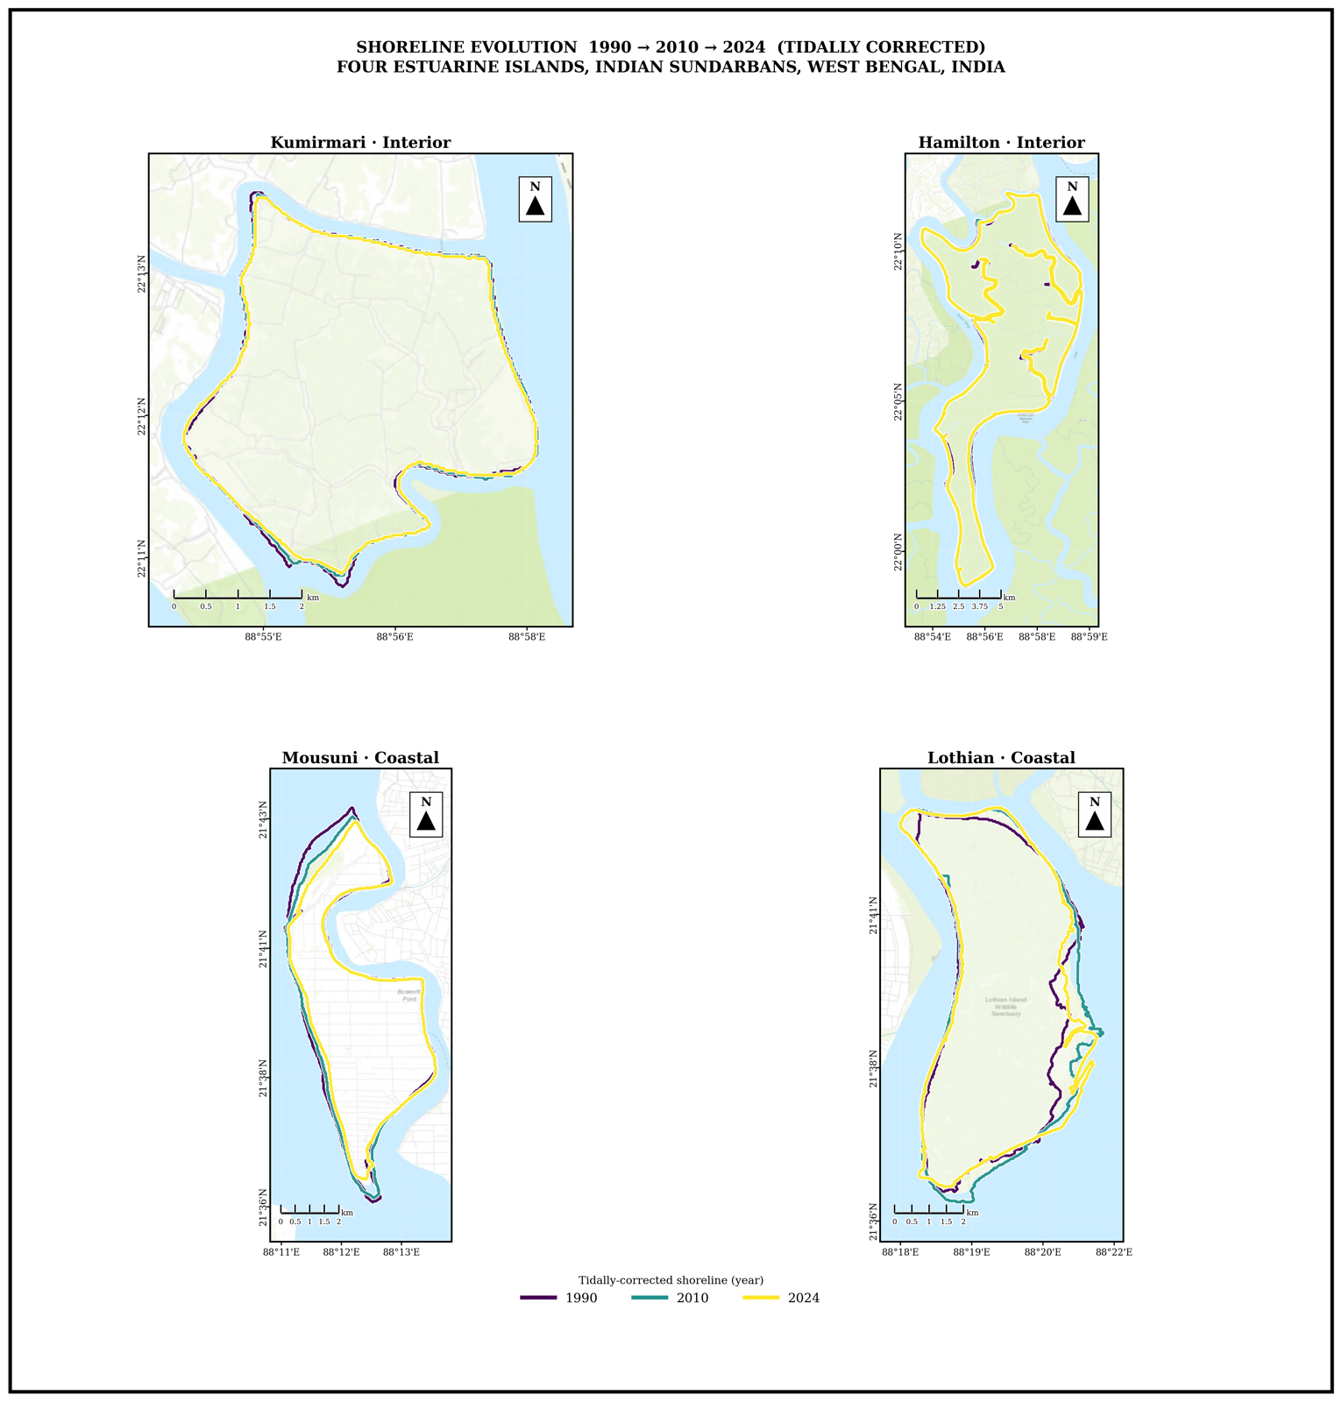
Note. Successive shorelines on Mousuni shift markedly landward (net erosion); the interior pair (Kumirmari, Hamilton) is near-stable and Lothian is broadly stable to weakly accretional.

4.2 Change rates and the inhabited vs uninhabited contrast
The DSAS LRR heatmap (Figure 6) summarises the per-transect rates spatially. The strongest negative (erosional) rates are concentrated on the north-west, Muriganga-facing coast of Mousuni. At the aggregate level the most striking result is the “interaction” between island setting (interior vs coastal) and habitation. On the exposed coast the inhabited island Mousuni (mean EPR −4.54 m yr⁻¹, LRR −4.69; ~72% of transects eroding) erodes far more than the uninhabited Lothian (+0.54 m yr⁻¹, LRR +1.44; ~50% accreting): the two coastal distributions differ very strongly (Mann–Whitney and Kolmogorov–Smirnov tests both p < 0.001), although Mousuni’s erosion is concentrated in a heavy tail (median EPR −1.36 m yr⁻¹ against a mean of −4.54). In the sheltered interior, by contrast, the inhabited Kumirmari (−0.62 m yr⁻¹, LRR −0.85; 54% eroding, 35% stable) is statistically indistinguishable from the uninhabited Hamilton (−0.89 m yr⁻¹, LRR −0.95; 65% eroding): the interior inhabited–uninhabited difference is only +0.29 m yr⁻¹ (block-bootstrap 95% CI [−0.01, +0.75], not significant). The difference-of-differences — the setting × habitation interaction — is +2.10 m yr⁻¹ (95% CI [+0.25, +4.08]) and is statistically significant: the association between habitation/embankment and erosion is pronounced on the high-energy open coast but absent in the low-energy interior. Crucially, the two uninhabited islands do not differ significantly from one another across settings (Hamilton vs Lothian, not significant) — the control contrast that lends credibility to the coastal anthropogenic signal (cf. Bandyopadhyay, 1997; Pethick & Orford, 2013; Bera & Maiti, 2019).
Figure 6
DSAS Linear Regression Rate (LRR) Across Transects for All Islands
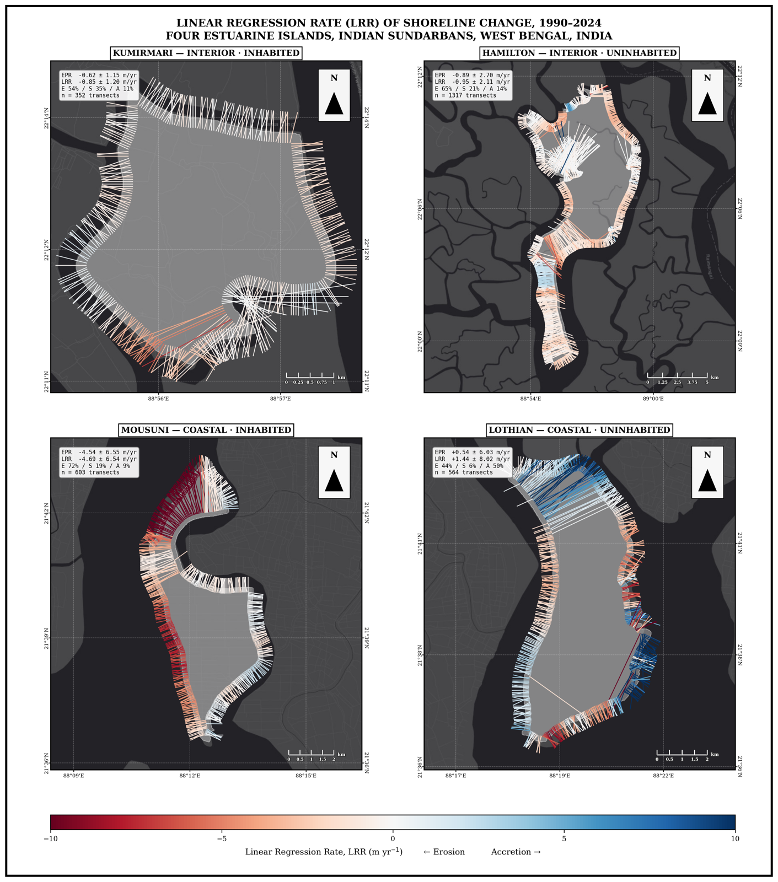
Note. Red = erosion, blue = accretion; the NW sector of Mousuni is the most erosional.
The per-island mean change rates are summarised in Figure 7, and their full distribution in Figure 8.
Figure 7
Mean Shoreline-Change Rates by Island, 1990–2024: End-Point Rate (EPR) and Linear Regression Rate (LRR), Grouped by Exposure Setting and Coloured by Settlement Regime
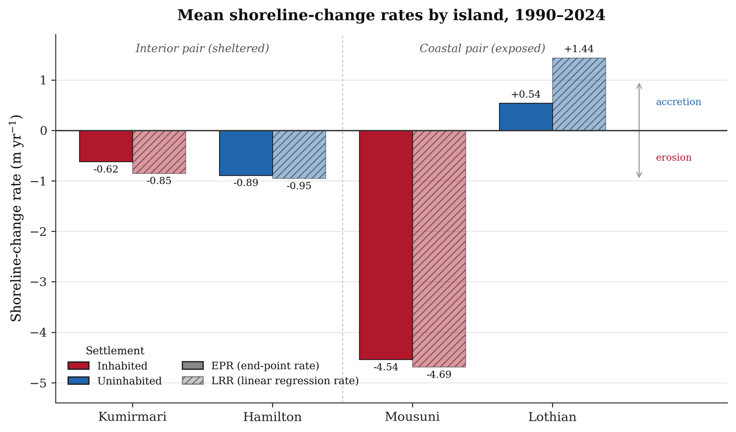
Note. The two estimators agree closely; strong erosion is confined to the exposed inhabited island (Mousuni), while the sheltered interior pair is near-stable and the exposed uninhabited island (Lothian) accretes (Thieler et al., 2009; Himmelstoss et al., 2018).
Figure 8
Distribution of Per-Transect End-Point Rate (EPR, M yr⁻¹) by Island, Grouped by Settlement Regime (Inhabited: Kumirmari, Mousuni; Uninhabited: Hamilton, Lothian), 1990–2024
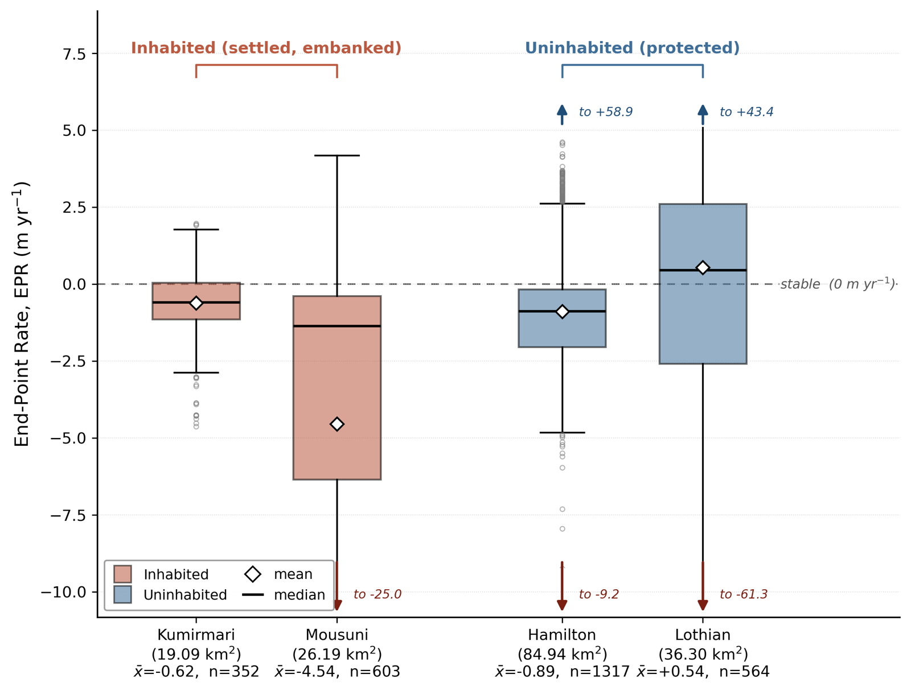
Note. Boxes show the interquartile range and median, whiskers the 1.5×IQR range, and the dashed line marks the stable (0 m yr⁻¹) reference. Rates were derived from DSAS-equivalent transects on FES2022-corrected, MNDWI-derived shorelines (Thieler et al., 2009; Himmelstoss et al., 2018; Dolan et al., 1991).

4.3 Mousuni validation
The transect-level EPR distribution for Mousuni and its validation against published rates are shown in Figure 9. The distribution is strongly negatively skewed (mass < 0 m yr⁻¹), confirming erosion dominance (median EPR −1.36 m yr⁻¹, mean −4.54). The single most-eroded transect reaches −24.99 m yr⁻¹ (~ azimuth 332°, NW Muriganga-facing). This maximum matches published Sundarbans/Hooghly maximum erosion rates (~ −23.5 m yr⁻¹; Bandyopadhyay, 1997; Gopinath & Seralathan, 2005) to within ~6% — strong evidence for the external validity of this study’s MNDWI + FES2022 + DSAS workflow.
Figure 9
Mousuni Erosion Validation
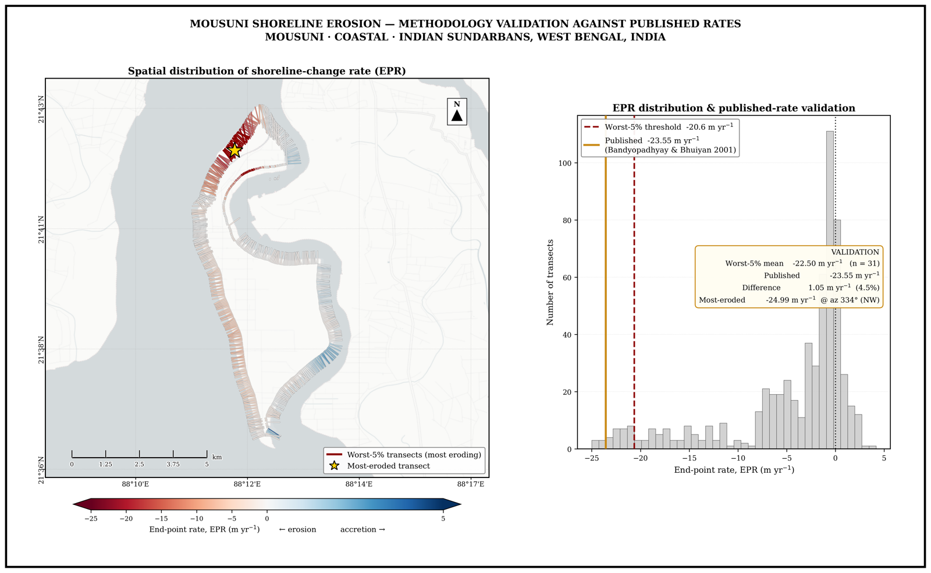
Note. (Left) DSAS transects coloured by EPR over an OpenStreetMap-based canvas; the worst-5% transects are highlighted, and the gold star marks the most-eroded transect. (Right) EPR distribution with the worst-5% threshold and the published rate (~−23.5 m yr⁻¹) marked.

4.4 Cyclone-period backscatter response
Sentinel-1 σ⁰ (dB) showed a notable backscatter drop over the coastal islands in the post-event windows of Amphan (2020), Yaas (2021) and Remal (2024), consistent with temporary inundation/standing water (Figure 10a–b; Torres et al., 2012; Lee, 1980). The signal was stronger over the coastal pair (Mousuni, Lothian) than over the interior pair, as expected because coastal islands are more exposed to surge and direct marine forcing (Hazra et al., 2002; IPCC, 2021). This SAR evidence complements the optical erosion trend and links event-scale drivers to the long-term trend.
Figure 10a
Cyclone-Period Sentinel-1 Backscatter (Interior Islands) Around Amphan, Yaas and Remal
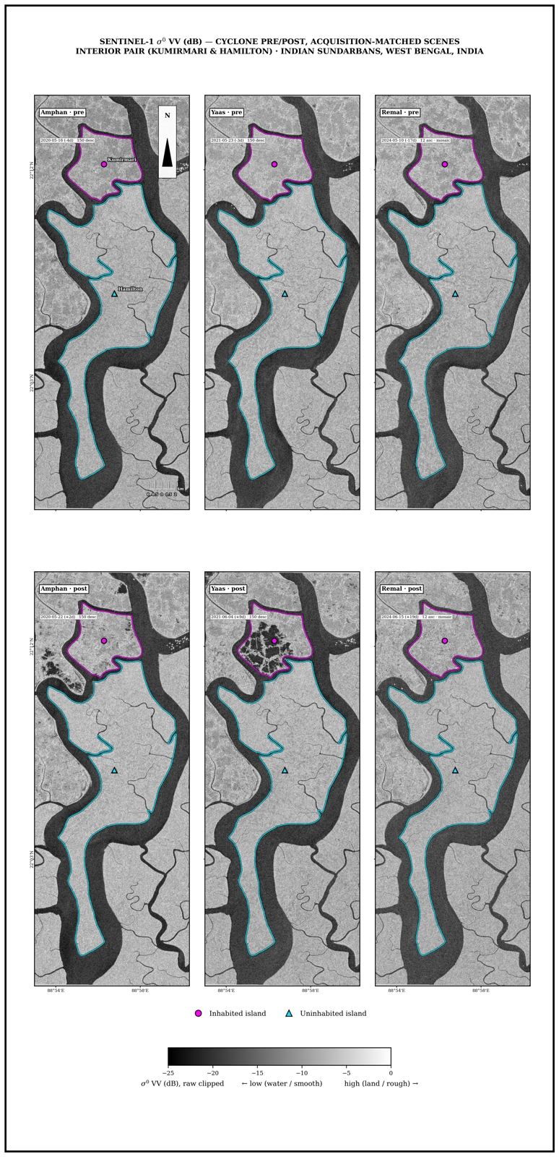
Figure 10b
Cyclone-Period Sentinel-1 Backscatter (Coastal Islands)
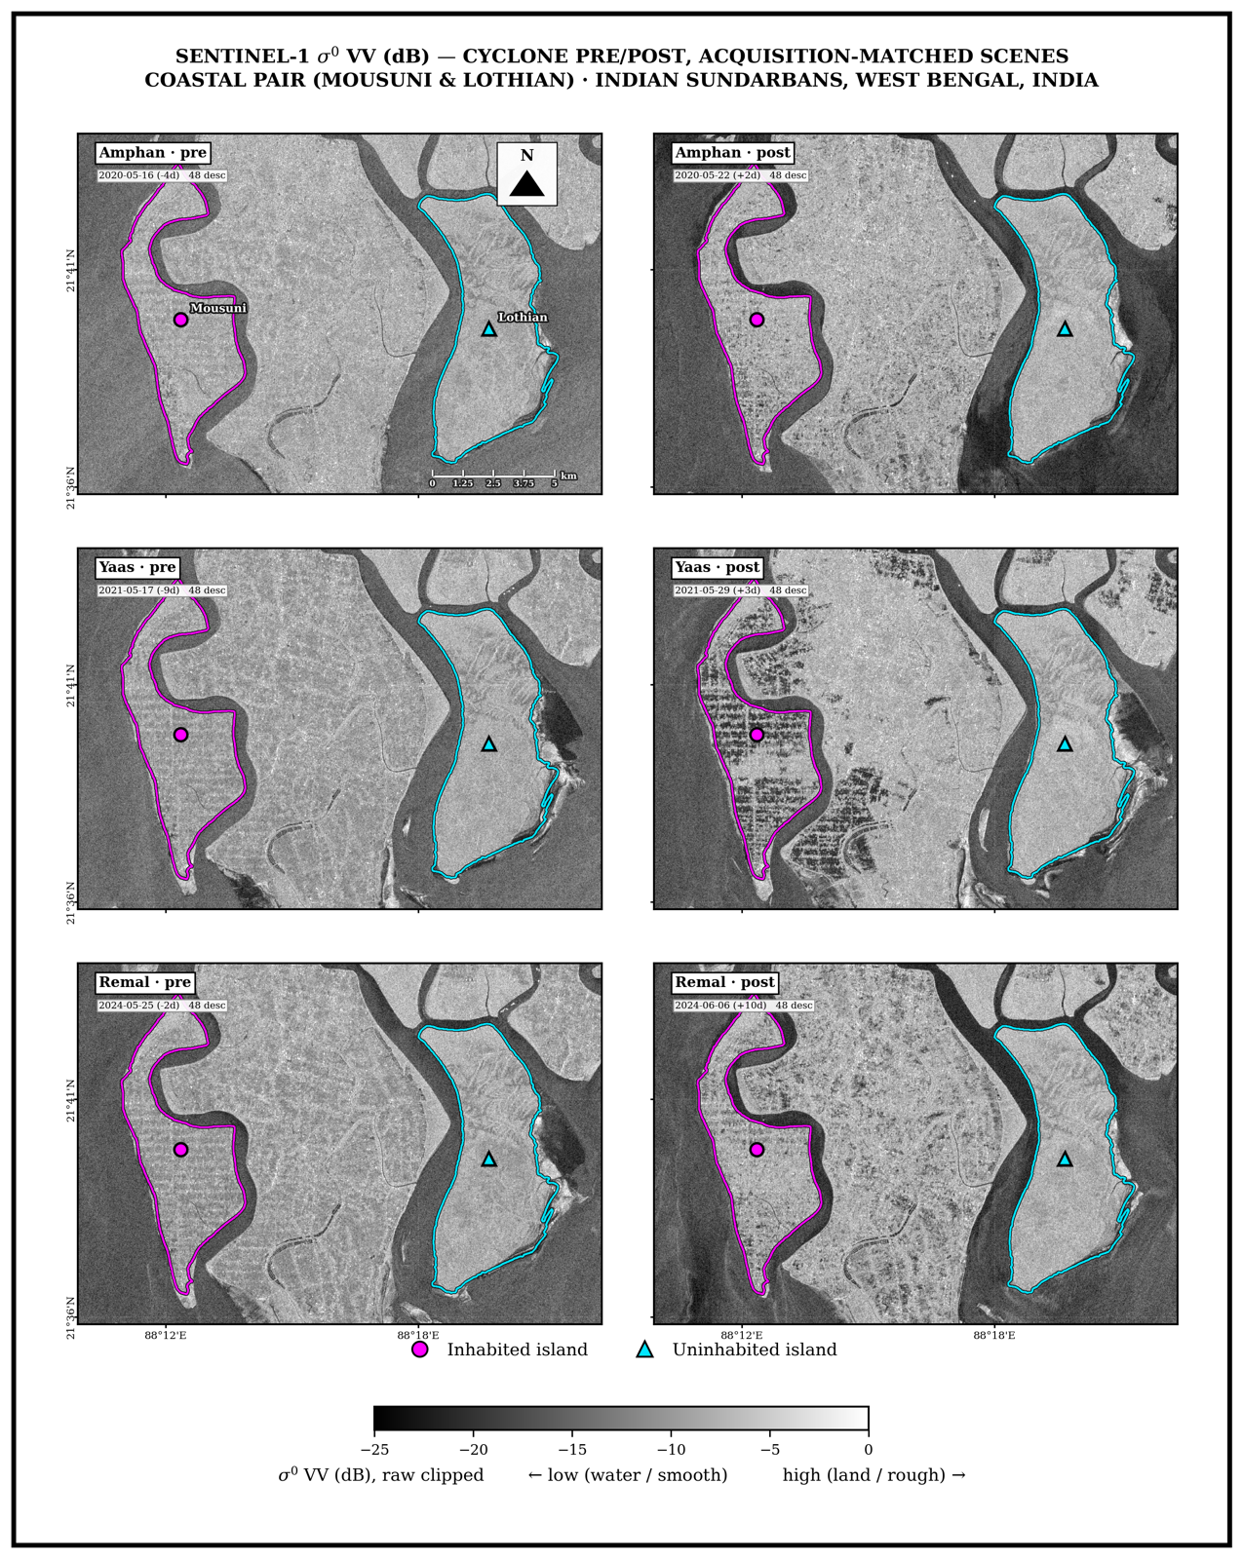
Note. A post-event σ⁰ drop = temporary inundation.

4.5 Kalman-filter shoreline forecasts (2034, 2044)
The per-transect Kalman forecasts (Figure 11) project the regime contrast into the future. By 2044 the mean change on Mousuni is ~ −93 m (±123 m) and ~84% of transects remain eroding — clearly the most vulnerable. The interior islands show modest but consistent retreat (Kumirmari ~ −16 m, ±23 m, ~81% eroding; Hamilton ~ −19 m, ±38 m, ~81% eroding), while the uninhabited coastal Lothian is near-stable on average but highly variable (~ +12 m, ±161 m, ~47% eroding). The same ordering holds at the intermediate 2034 horizon (Mousuni ~ −44 m; Hamilton ~ −9 m; Kumirmari ~ −8 m; Lothian ~ +5 m). Lothian’s large σ reflects its sector-wise heterogeneity. The forecasts should be read as uncertainty-bounded trajectories rather than deterministic predictions (Long & Plant, 2012; Vitousek et al., 2017).
Figure 11
Kalman-Filter Shoreline Forecasts to 2034 and 2044 for the Four Islands (Per-Transect Positions)
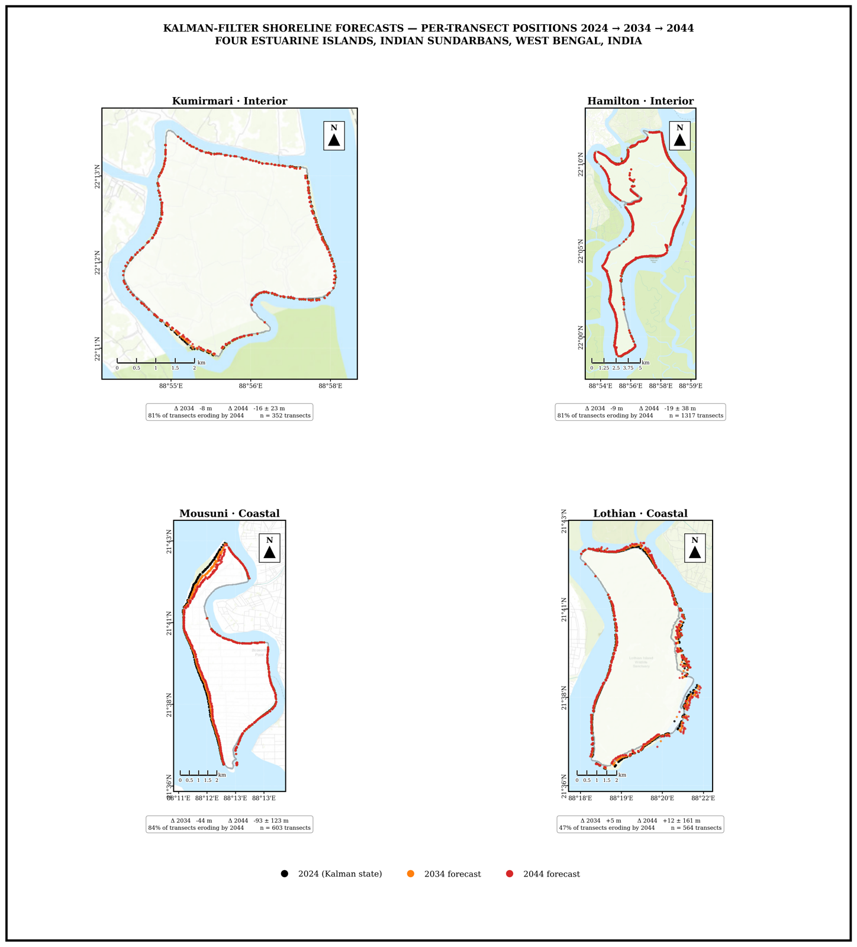
Note. Mousuni shows by far the strongest projected retreat; the interior islands (Kumirmari, Hamilton) show modest retreat and Lothian is near-stable but highly variable.
The projected shoreline trajectories to 2044 are shown by island in Figure 12.
Figure 12
Kalman-Filter Projections of Net Shoreline Change at 2034 and 2044 Relative to 2024, by Island (Kalman, 1960; Long & Plant, 2012; Vitousek Et Al., 2017)
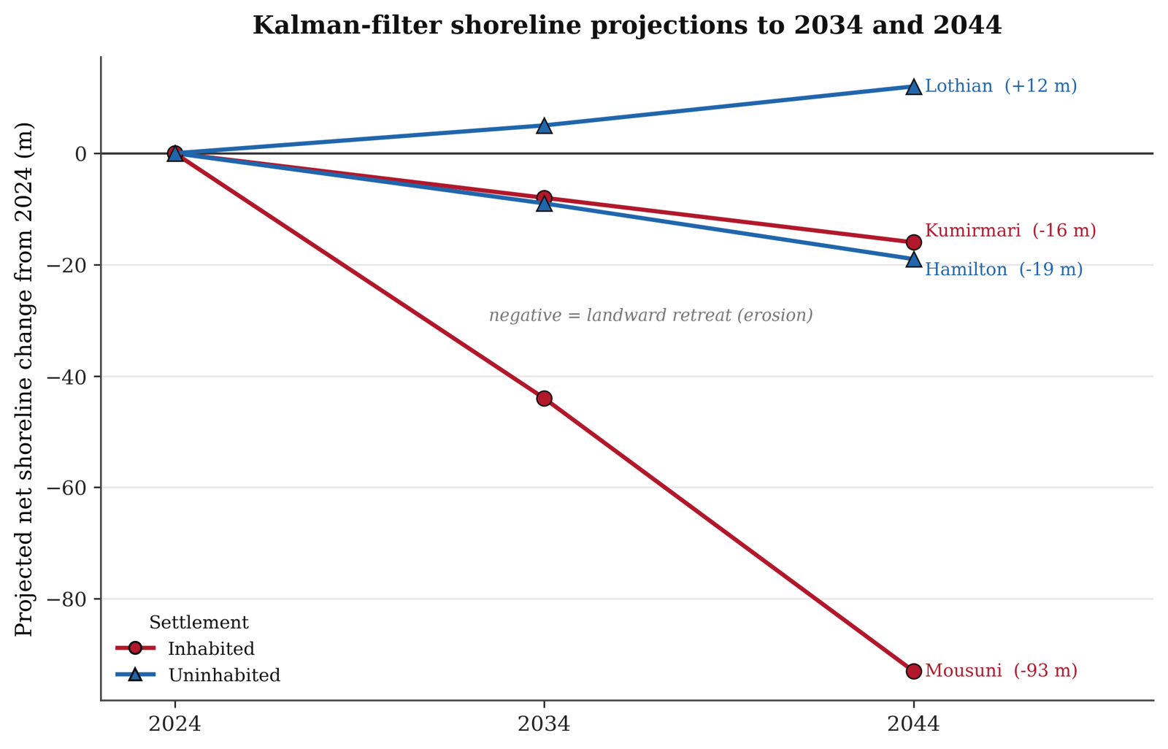
Note. Negative values denote landward retreat; Mousuni shows the steepest projected retreat (≈ −93 m by 2044), the interior pair retreats modestly, and Lothian accretes.

5. Discussion
The central finding of this study is that shoreline behaviour in the Sundarbans is not purely natural but is strongly modulated by settlement and engineering. The paired design showed that the most vulnerable regime is inhabited–coastal (Mousuni), and that the effect of habitation on shoreline change is setting-dependent rather than uniform: the setting × habitation interaction is significant (+2.10 m yr⁻¹, 95% CI [+0.25, +4.08]). On the exposed coast the inhabited Mousuni erodes far more than the uninhabited Lothian, whereas in the sheltered interior the inhabited Kumirmari is no worse than the uninhabited Hamilton, and the two uninhabited islands do not differ significantly from one another. This supports the hypothesis that embankment-driven sediment starvation and tidal-prism disturbance accelerate erosion specifically where wave and surge energy are high — on inhabited open-coast islands — rather than on sheltered estuarine islands (Bandyopadhyay, 1997; Pethick & Orford, 2013).
Mechanistically, several drivers operate together. First, regional relative sea-level rise and subsidence increase accommodation space and push the shoreline landward (Hazra et al., 2002; Rahman et al., 2011; IPCC, 2021). Second, embankments prevent natural tidal flooding and sediment deposition from reaching the island interiors, causing “sediment starvation” so that mudflats cannot accrete vertically (Pethick & Orford, 2013; Woodroffe et al., 2016). Third, reclamation and channel narrowing disturb estuarine hydrodynamics, increasing flood-tide dominance and bank erosion (Bandyopadhyay, 1997; Gopinath & Seralathan, 2005). Fourth, high-intensity cyclones (Amphan, Yaas, Remal) deliver episodic but large erosion/inundation pulses, which we observed directly through the Sentinel-1 σ⁰ drop (Section 4.4; Torres et al., 2012).
Our results are broadly consistent with the existing Sundarbans literature. The high erosion rates on Mousuni are comparable to the documented rates of Sagar and other western-Sundarbans islands (~ −20 to −24 m yr⁻¹) (Bandyopadhyay, 1997; Gopinath & Seralathan, 2005; Bandyopadhyay et al., 2014). The agreement of the most-eroded transect with the published maximum to within ~6% (Section 4.3) strengthens the reliability of this workflow. The severe erosion of the inhabited–coastal island Mousuni, set against the near-stability of the uninhabited coastal Lothian and the statistically indistinguishable behaviour of the two sheltered interior islands (Kumirmari and Hamilton), reinforces the finding that settlement/embankment and exposure matter jointly — it is their combination, not habitation alone, that drives the divergence (Bera & Maiti, 2019; Ghosh et al., 2015).
Methodologically, the strengths of this study are: (i) explicit FES2022 tidal correction, which is critical in the macro-tidal Sundarbans and was missing from many earlier studies (Lyard et al., 2021; CNES, 2024; Boak & Turner, 2005); (ii) multi-sensor integration (optical + SAR), capturing both the trend and the event drivers; (iii) a reproducible GEE-based pipeline (Gorelick et al., 2017); and (iv) Kalman-based forecasting that carries uncertainty explicitly (Long & Plant, 2012). The limitations should also be noted honestly: shoreline extraction is limited to medium-resolution Landsat (~30 m); the tidal correction assumes a single representative foreshore slope (β ≈ 0.0075) whereas the real β varies spatially; the constant-velocity Kalman model does not fully capture non-linear/threshold dynamics (e.g. a sudden embankment breach); and the paired design has only one island per regime, so more islands should be added for broader generalisation (Genz et al., 2007).

6. Conclusion
In this chapter we analysed the shoreline dynamics of four paired islands of the Indian Sundarbans (1990–2024) using a multi-sensor, tidally-corrected framework. There are three main conclusions. First, shoreline change in this region is strongly regime-dependent, and the inhabited–coastal island (Mousuni) is by far the most erosional (~72% of transects eroding; mean EPR −4.54 m yr⁻¹, most-eroded transect −24.99 m yr⁻¹), while the uninhabited coastal Lothian is near-stable to weakly accretional and the two sheltered interior islands — inhabited Kumirmari (−0.62 m yr⁻¹) and uninhabited Hamilton (−0.89 m yr⁻¹) — are statistically indistinguishable. Second, the setting × habitation interaction is significant (+2.10 m yr⁻¹, 95% CI [+0.25, +4.08]): habitation and embankment are associated with markedly greater erosion on the exposed coast but make no detectable difference in the sheltered interior, so it is the combination of settlement and coastal exposure — not habitation alone — that amplifies erosion. Third, the Kalman forecasts indicate that this divergence will widen by 2034 and 2044, making adaptation urgent on inhabited coastal islands such as Mousuni. The validation (within ~6% of published rates) and the SAR-based cyclone evidence strengthen these conclusions. The implication for coastal managers is clear: embankment policy must be rethought with sediment-flux and tidal-prism considerations in mind, and the highest-risk inhabited coastal islands must be prioritised (Pethick & Orford, 2013; IPCC, 2019, 2021). Future work can improve generalisation by using higher resolution (Sentinel-2/PlanetScope), spatially-variable foreshore slopes, and more islands.

Acknowledgements
The author gratefully acknowledges the Department of Geography, University of Madras, and the research-visit support of the Indian Institute of Science (IISc), Bengaluru. Landsat data are courtesy of USGS/NASA, Sentinel-1 data of ESA Copernicus, and the FES2022 tidal model of CNES/AVISO. This is a Version 0.0 working draft.

Figure Sources and Data Credits
All figures were prepared by the author (A. Ghosh, 2026). Underlying data and basemap sources are as follows. Optical imagery (Figures 3a, 3b and 5): Landsat 5/7/8/9 Collection-2 Level-2 surface reflectance, USGS/NASA (dry-season scenes, 1990–2024), accessed through Google Earth Engine (Gorelick et al., 2017); the Modified Normalised Difference Water Index used the Green and SWIR1 bands (Xu, 2006). Synthetic-aperture radar (Figures 4a, 4b, 10a and 10b): Sentinel-1 GRD C-band σ⁰ VV backscatter, ESA Copernicus, accessed through Google Earth Engine and Lee-filtered (5×5). Tidal correction: FES2022 global ocean-tide model, AVISO/CNES (Lyard et al., 2021; CNES, 2024). Shoreline-change rates and Kalman projections (Figures 6, 7, 8, 9, 11 and 12): DSAS-equivalent transect statistics (Thieler et al., 2009; Himmelstoss et al., 2018) and a 2-D Kalman filter (Kalman, 1960). Basemaps: Esri Dark Gray Canvas and OpenStreetMap contributors (Figures 1 and 9). Coordinate reference system: WGS 84 (EPSG:4326).

References
[Version 0.0 note: the references below are real, well-known works, but verify the exact year/volume/pages of each citation against the originals before submission.]
Amitrano, D., Di Martino, G., Iodice, A., Riccio, D., & Ruello, G. (2018). Unsupervised rapid flood mapping using Sentinel-1 GRD SAR images. IEEE Transactions on Geoscience and Remote Sensing, 56(6), 3290–3299.
Bandyopadhyay, J., Mondal, I., & Samanta, N. (2014). Shoreline shifting of Namkhana Island of Indian Sundarban, South 24 Parganas, West Bengal, using remote sensing & GIS techniques. International Journal of Engineering Sciences & Research Technology, 3(5), 162–169.
Bandyopadhyay, S. (1997). Coastal erosion and its management in Sagar Island, South 24-Parganas, West Bengal. Indian Journal of Earth Sciences, 24(3–4), 51–69.
Bera, R., & Maiti, R. (2019). Quantitative analysis of erosion and accretion (1975–2017) using DSAS — A study on Indian Sundarbans. Regional Studies in Marine Science, 28, 100583.
Boak, E. H., & Turner, I. L. (2005). Shoreline definition and detection: A review. Journal of Coastal Research, 21(4), 688–703.
Chakma, S., & Akter, M. (2021). Flood mapping in the coastal region of Bangladesh using Sentinel-1 SAR images: A case study of super cyclone Amphan. Journal of the Civil Engineering Forum, 7(3).
Church, J. A., & White, N. J. (2011). Sea-level rise from the late 19th to the early 21st century. Surveys in Geophysics, 32(4–5), 585–602.
CNES (2024). FES2022 (Finite Element Solution) Ocean Tide (Version 2022) [Data set]. Centre National d'Études Spatiales. https://doi.org/10.24400/527896/A01-2024.004
Crowell, M., Leatherman, S. P., & Buckley, M. K. (1991). Historical shoreline change: Error analysis and mapping accuracy. Journal of Coastal Research, 7(3), 839–852.
Das, S. K., Sajan, B., Ojha, C., & Soren, S. (2021). Shoreline change behavior study of Jambudwip island of Indian Sundarban using DSAS model. Egyptian Journal of Remote Sensing and Space Science, 24(3), 961–970.
Dolan, R., Fenster, M. S., & Holme, S. J. (1991). Temporal analysis of shoreline recession and accretion. Journal of Coastal Research, 7(3), 723–744.
Ericson, J. P., Vörösmarty, C. J., Dingman, S. L., Ward, L. G., & Meybeck, M. (2006). Effective sea-level rise and deltas: Causes of change and human dimension implications. Global and Planetary Change, 50(1–2), 63–82.
Gao, B.-C. (1996). NDWI — A normalized difference water index for remote sensing of vegetation liquid water from space. Remote Sensing of Environment, 58(3), 257–266.
Genz, A. S., Fletcher, C. H., Dunn, R. A., Frazer, L. N., & Rooney, J. J. (2007). The predictive accuracy of shoreline change rate methods and alongshore beach variation on Maui, Hawaii. Journal of Coastal Research, 23(1), 87–105.
Ghosh, A., Schmidt, S., Fickert, T., & Nüsser, M. (2015). The Indian Sundarban mangrove forests: History, utilization, conservation strategies and local perception. Diversity, 7(2), 149–169.
Ghosh, T., Gopinath, B., & Hazra, S. (2001). Assessment of land use/land cover dynamics and shoreline changes of Sagar Island through remote sensing. Proceedings, Remote Sensing & GIS.
Giri, C., Ochieng, E., Tieszen, L. L., Zhu, Z., Singh, A., Loveland, T., Masek, J., & Duke, N. (2011). Status and distribution of mangrove forests of the world using earth observation satellite data. Global Ecology and Biogeography, 20(1), 154–159.
Gopinath, G., & Seralathan, P. (2005). Rapid erosion of the coast of Sagar Island, West Bengal, India. Environmental Geology, 48(8), 1058–1067.
Gorelick, N., Hancher, M., Dixon, M., Ilyushchenko, S., Thau, D., & Moore, R. (2017). Google Earth Engine: Planetary-scale geospatial analysis for everyone. Remote Sensing of Environment, 202, 18–27.
Hagenaars, G., de Vries, S., Luijendijk, A. P., de Boer, W. P., & Reniers, A. J. H. M. (2018). On the accuracy of automated shoreline detection derived from satellite imagery: A study of the sand motor mega-scale nourishment. Coastal Engineering, 133, 113–125.
Hapke, C. J., Himmelstoss, E. A., Kratzmann, M., List, J. H., & Thieler, E. R. (2010). National assessment of shoreline change: Historical shoreline change along the New England and Mid-Atlantic coasts. USGS Open-File Report 2010-1118.
Hazra, S., Ghosh, T., DasGupta, R., & Sen, G. (2002). Sea level and associated changes in the Sundarbans. Science and Culture, 68(9–12), 309–321.
Himmelstoss, E. A., Henderson, R. E., Kratzmann, M. G., & Farris, A. S. (2018). Digital Shoreline Analysis System (DSAS) version 5.0 user guide. USGS Open-File Report 2018-1179.
IPCC (2019). Special Report on the Ocean and Cryosphere in a Changing Climate [Pörtner, H.-O., et al. (eds.)]. Cambridge University Press.
IPCC (2021). Climate Change 2021: The Physical Science Basis. Contribution of Working Group I to the Sixth Assessment Report [Masson-Delmotte, V., et al. (eds.)]. Cambridge University Press.
Kalman, R. E. (1960). A new approach to linear filtering and prediction problems. Journal of Basic Engineering, 82(1), 35–45.
Kona, A. D., Hoque, M. E., & Rahman, M. A. (2025). Evaluating shoreline prediction accuracy with the Kalman filter model: A case study of Nijhum Dwip, Bay of Bengal. Remote Sensing Applications: Society and Environment, 38, 101469.
Lee, J.-S. (1980). Digital image enhancement and noise filtering by use of local statistics. IEEE Transactions on Pattern Analysis and Machine Intelligence, PAMI-2(2), 165–168.
Lee, J.-S., Jurkevich, I., Dewaele, P., Wambacq, P., & Oosterlinck, A. (1994). Speckle filtering of synthetic aperture radar images: A review. Remote Sensing Reviews, 8(4), 313–340.
Long, J. W., & Plant, N. G. (2012). Extended Kalman Filter framework for forecasting shoreline evolution. Geophysical Research Letters, 39(13), L13603.
Lyard, F. H., Allain, D. J., Cancet, M., Carrère, L., & Picot, N. (2021). FES2014 global ocean tide atlas: Design and performance. Ocean Science, 17(3), 615–649.
McFeeters, S. K. (1996). The use of the Normalized Difference Water Index (NDWI) in the delineation of open water features. International Journal of Remote Sensing, 17(7), 1425–1432.
Nicholls, R. J., & Cazenave, A. (2010). Sea-level rise and its impact on coastal zones. Science, 328(5985), 1517–1520.
Otsu, N. (1979). A threshold selection method from gray-level histograms. IEEE Transactions on Systems, Man, and Cybernetics, 9(1), 62–66.
Pethick, J., & Orford, J. D. (2013). Rapid rise in effective sea-level in southwest Bangladesh: Its causes and contemporary rates. Global and Planetary Change, 111, 237–245.
Rahman, A. F., Dragoni, D., & El-Masri, B. (2011). Response of the Sundarbans coastline to sea level rise and decreased sediment flow: A remote sensing assessment. Remote Sensing of Environment, 115(12), 3121–3128.
Roy, D. P., Wulder, M. A., Loveland, T. R., et al. (2014). Landsat-8: Science and product vision for terrestrial global change research. Remote Sensing of Environment, 145, 154–172.
Small, D. (2011). Flattening gamma: Radiometric terrain correction for SAR imagery. IEEE Transactions on Geoscience and Remote Sensing, 49(8), 3081–3093.
Syvitski, J. P. M., Kettner, A. J., Overeem, I., et al. (2009). Sinking deltas due to human activities. Nature Geoscience, 2(10), 681–686.
Tessler, Z. D., Vörösmarty, C. J., Grossberg, M., et al. (2015). Profiling risk and sustainability in coastal deltas of the world. Science, 349(6248), 638–643.
Thieler, E. R., Himmelstoss, E. A., Zichichi, J. L., & Ergul, A. (2009). The Digital Shoreline Analysis System (DSAS) version 4.0 — An ArcGIS extension for calculating shoreline change. USGS Open-File Report 2008-1278.
Torres, R., Snoeij, P., Geudtner, D., et al. (2012). GMES Sentinel-1 mission. Remote Sensing of Environment, 120, 9–24.
Tucker, C. J. (1979). Red and photographic infrared linear combinations for monitoring vegetation. Remote Sensing of Environment, 8(2), 127–150.
Vitousek, S., Barnard, P. L., Limber, P., Erikson, L., & Cole, B. (2017). A model integrating longshore and cross-shore processes for predicting long-term shoreline response to climate change. Journal of Geophysical Research: Earth Surface, 122(4), 782–806.
Vos, K., Splinter, K. D., Harley, M. D., Simmons, J. A., & Turner, I. L. (2019). CoastSat: A Google Earth Engine-enabled Python toolkit to extract shorelines from publicly available satellite imagery. Environmental Modelling & Software, 122, 104528.
Vos, K., Harley, M. D., Splinter, K. D., Walker, A., & Turner, I. L. (2020). Beach slopes from satellite-derived shorelines. Geophysical Research Letters, 47(14), e2020GL088365.
Woodroffe, C. D., Rogers, K., McKee, K. L., Lovelock, C. E., Mendelssohn, I. A., & Saintilan, N. (2016). Mangrove sedimentation and response to relative sea-level rise. Annual Review of Marine Science, 8, 243–266.
Wulder, M. A., Loveland, T. R., Roy, D. P., et al. (2019). Current status of Landsat program, science, and applications. Remote Sensing of Environment, 225, 127–147.
Xu, H. (2006). Modification of normalised difference water index (MNDWI) to enhance open water features in remotely sensed imagery. International Journal of Remote Sensing, 27(14), 3025–3033.

Supplementary Figures
These per-island and component figures support the main figures. (Any files that have not been rendered are skipped automatically.)
Figure S2
Mousuni EPR Transect Map (Standalone)
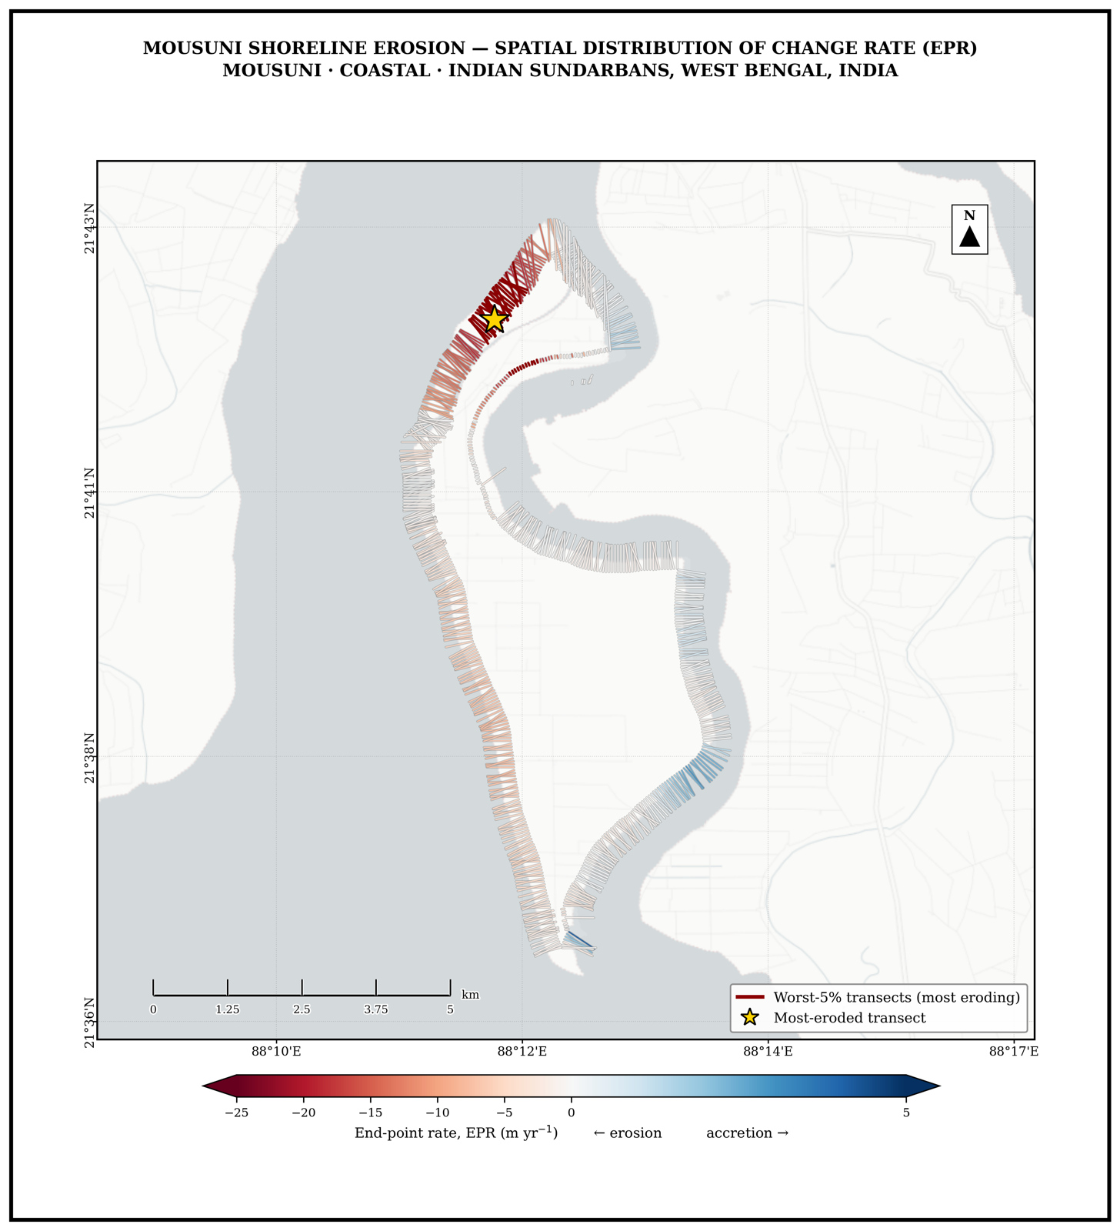
Figure S3
Mousuni EPR Distribution & Validation (Standalone)
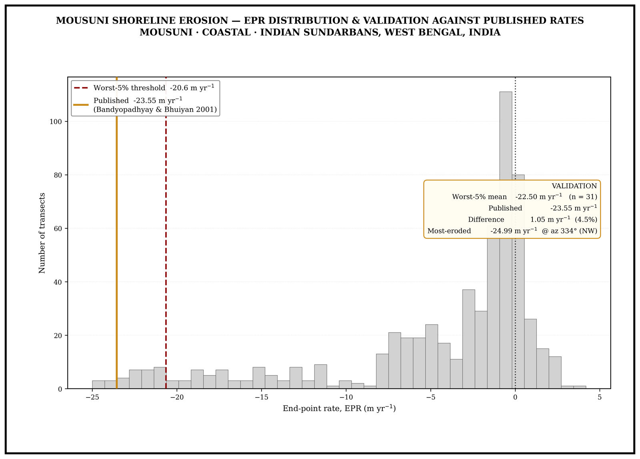
Figure S4
Kalman Forecast — Kumirmari
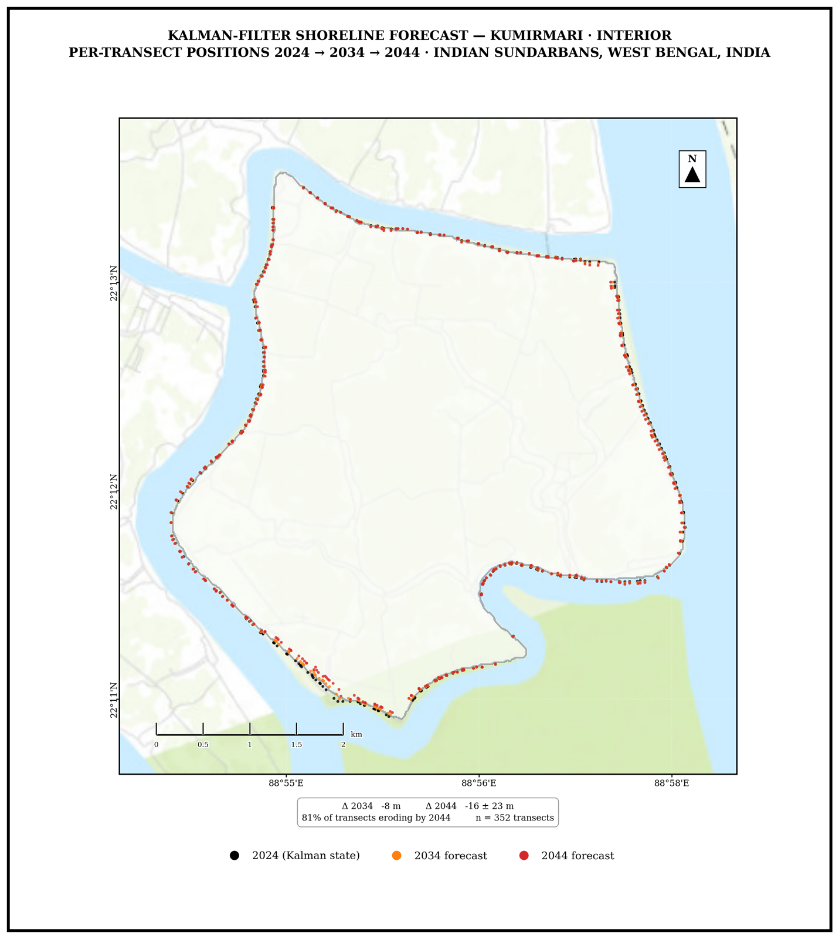
Figure S5
Kalman Forecast — Hamilton
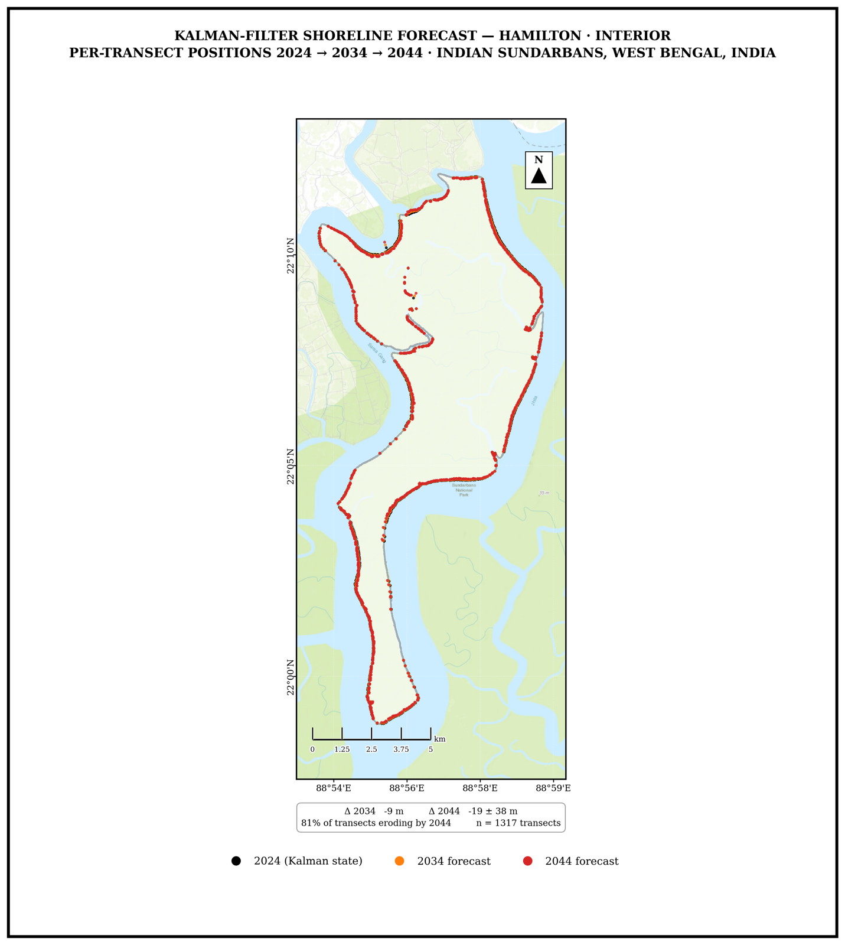
Figure S6
Kalman Forecast — Mousuni
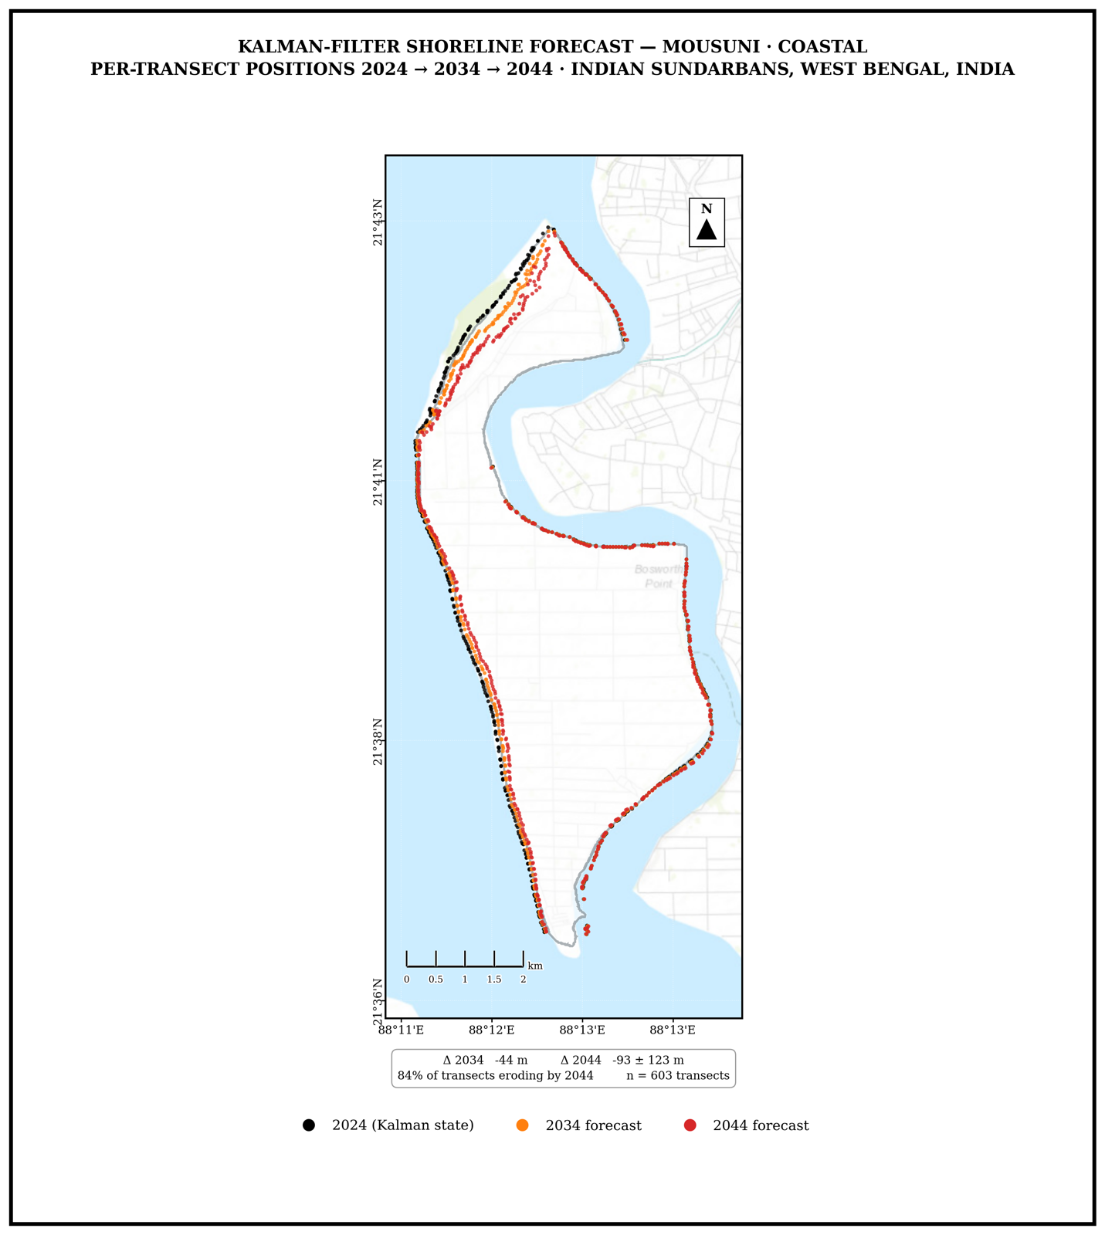
Figure S7
Kalman Forecast — Lothian
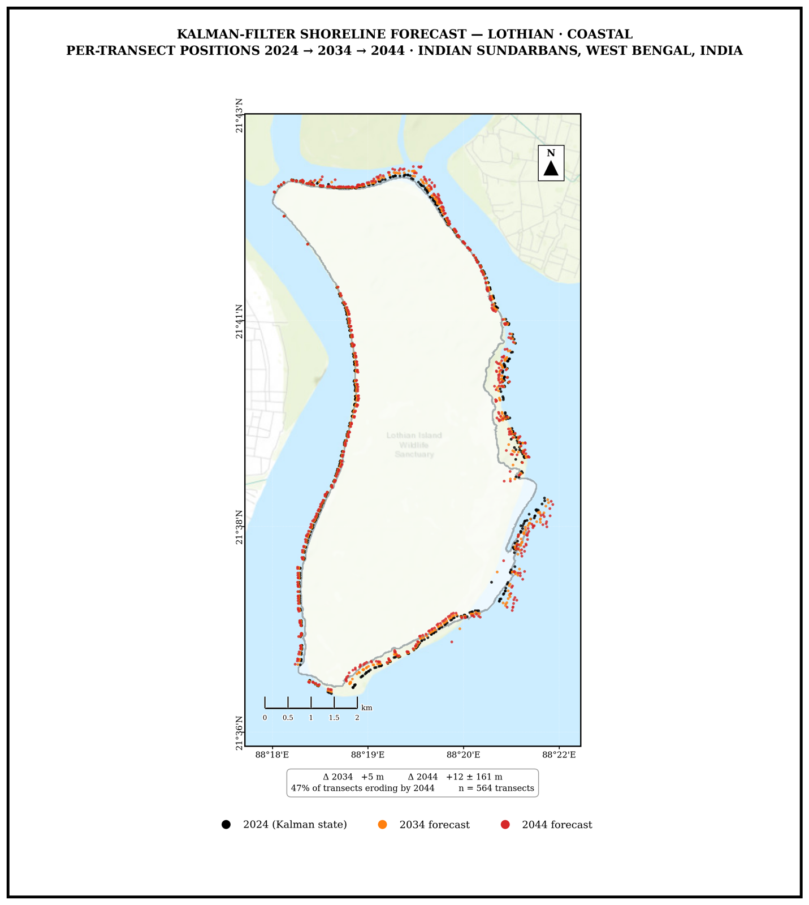
Figure S8
Shoreline Evolution — Kumirmari
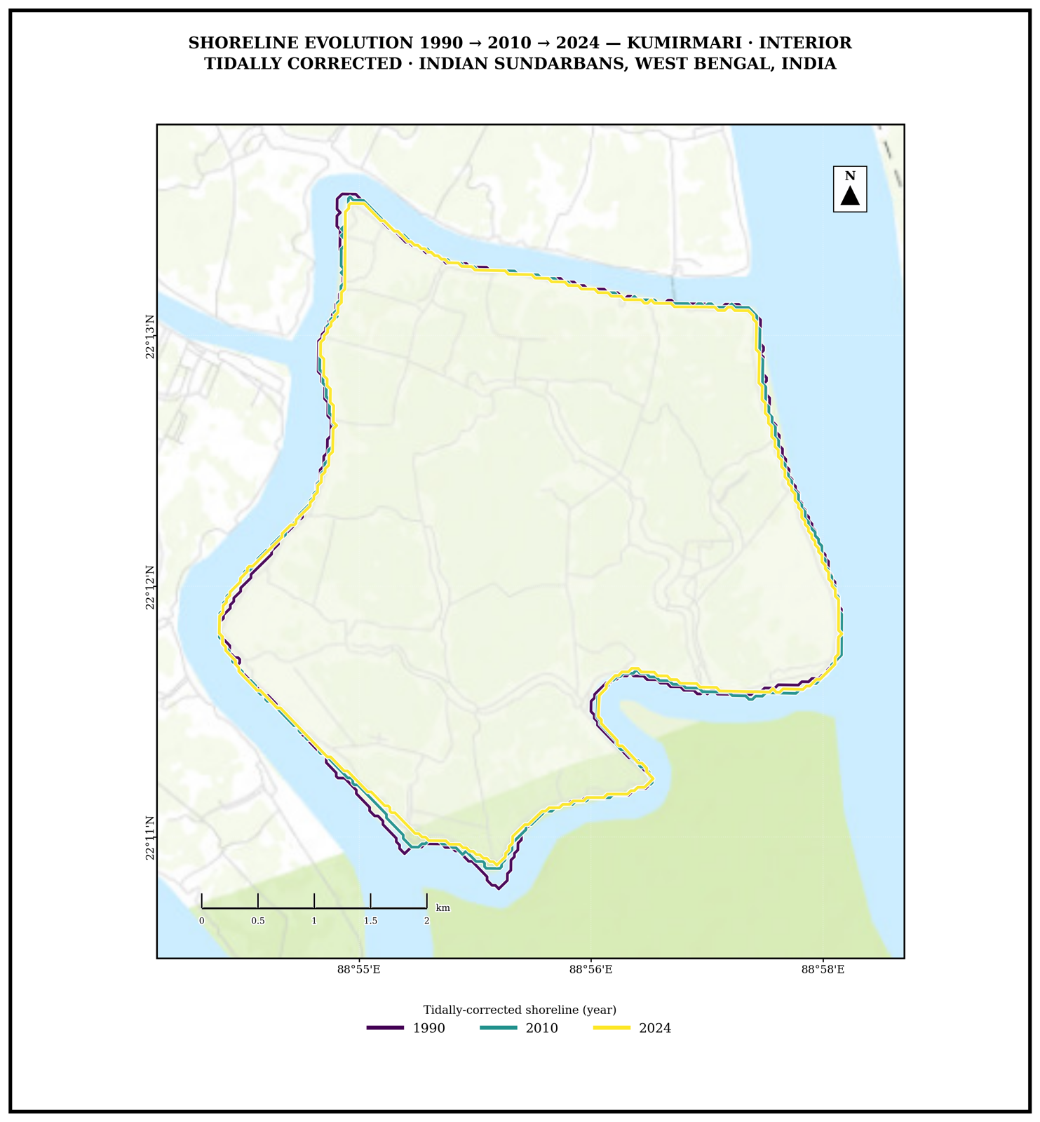
Figure S9
Shoreline Evolution — Hamilton
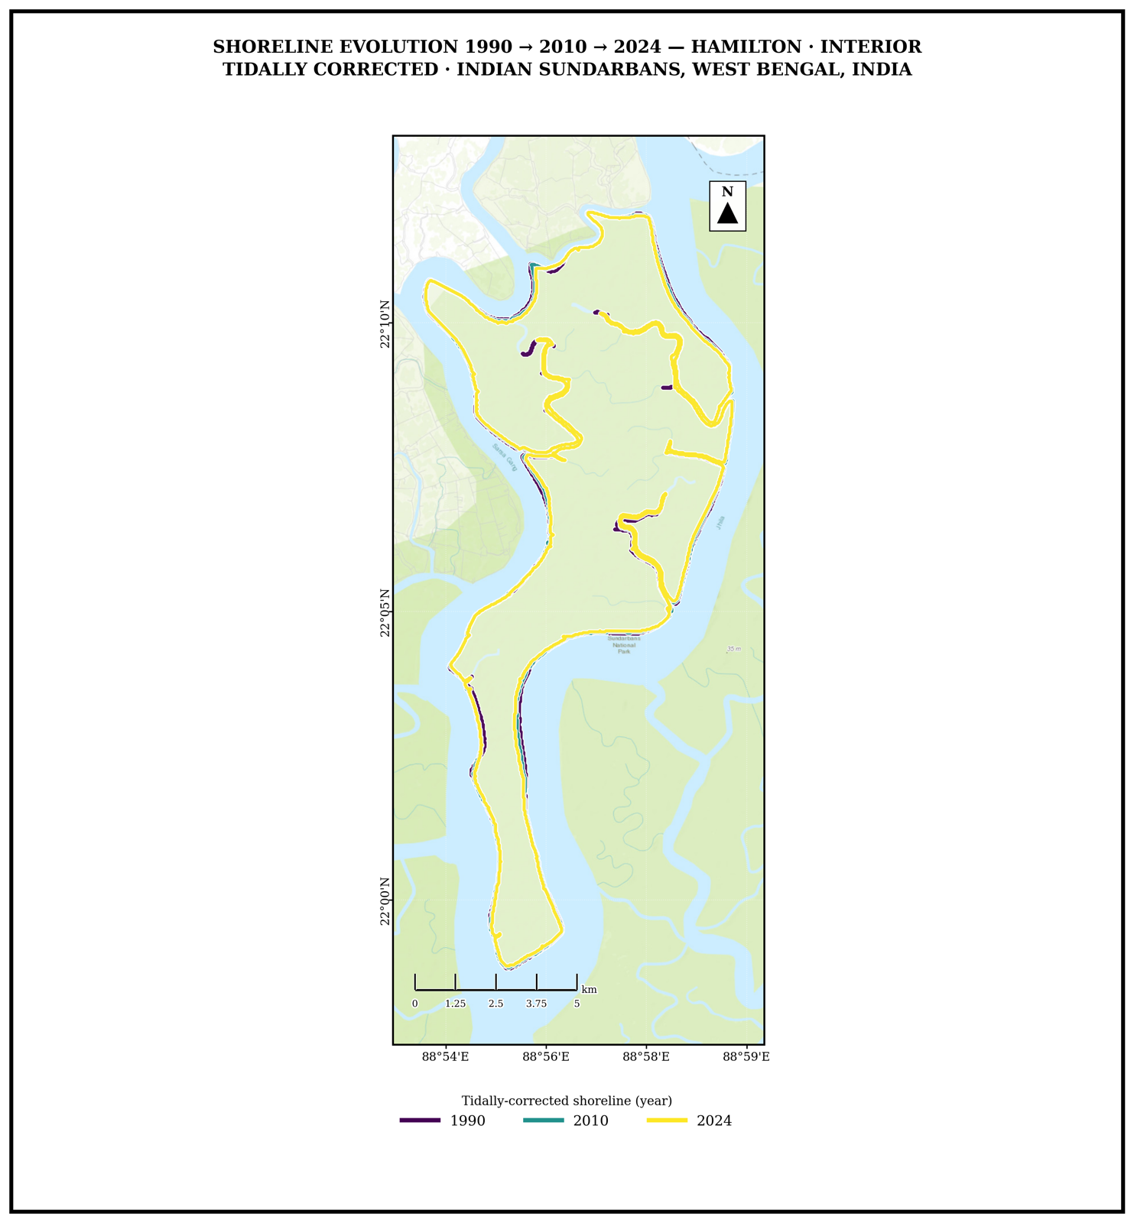
Figure S10
Shoreline Evolution — Mousuni
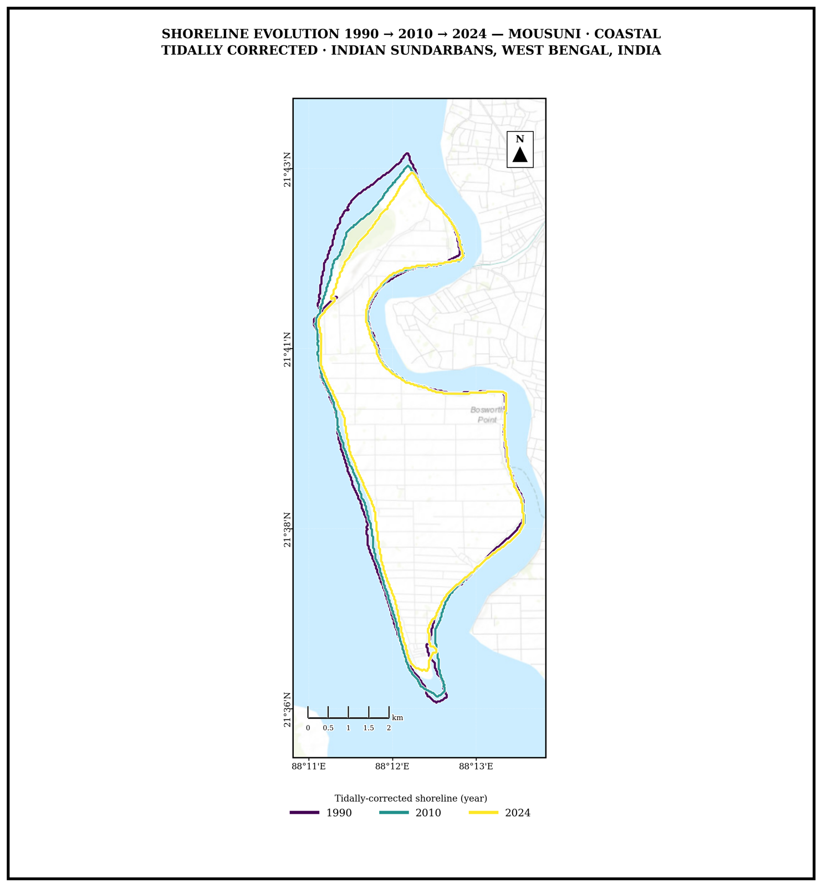
Figure S11
Shoreline Evolution — Lothian
