Sample1:

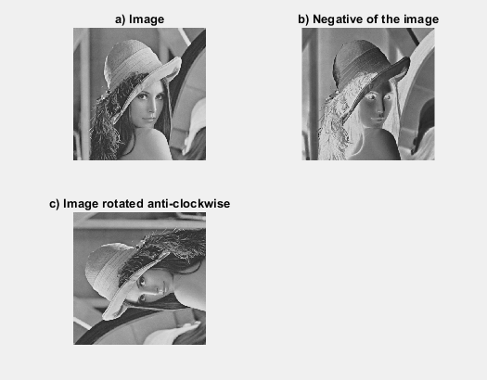

Sample2: clc;

close all;

clear all;

% a)

a = imread('lena_gray.bmp','bmp');

subplot(221),imshow(a), title('a) Image');

% b)

subplot(222), imhist(a,255), title('b) Negative of the image');

% c)

J= histeq(a);

subplot(223),imshow(J), title('a) Image');

% d)

subplot(224), imhist(J,255), title('b) Negative of the image');

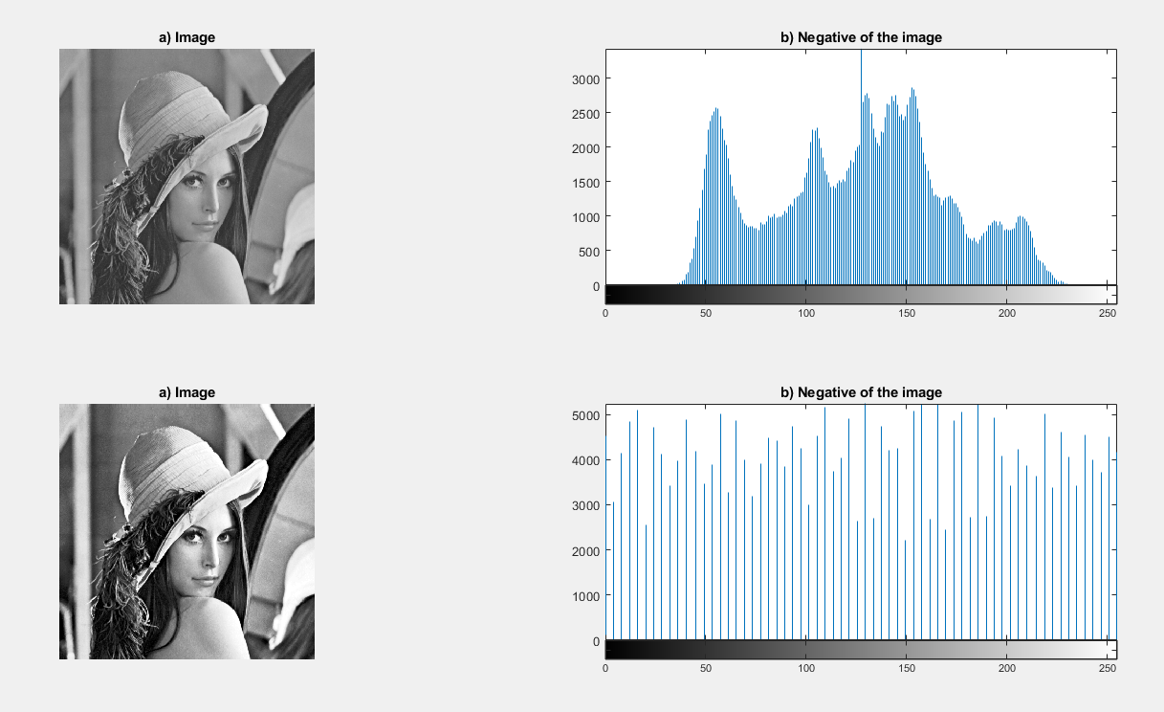

Sample3:

a = [[1,2,3],[0,8,6],[5,3,1]];

b = [[0,1],[1,0],[3,5]];

c = conv2(a,b,1);

c



Sample4:

clc;

close all;

clear all;

% a)

a = imread('barbara_gray.bmp','bmp');

subplot(211),imshow(a), title('a) Image');

% b)

b = fft2(a);

subplot(212), imagesc(abs(fftshift(b))), title('b) dft of image');

