HPC Quest
Organised by A*STAR’s Institute of High Performance Computing (IHPC)



Team Members:
Anubhav Ashok,
Nguyen Duc Bao,
Christopher Teo,
Lee Jong Hyun

Class of 10S30
Pioneer Junior College


Abstract Summary

Our group has picked Problem 1 - The Scalable Categorization Algorithm (CA) for Drug Discovery. We have chosen this problem because the medicinal industry shows high potential in which high performance computing can be used. Basically, we are required to develop a scalable program that enables us to analyze the data given, the biological data to automatically categorize the cells. Since the current categorization algorithm is relatively slow, we are to develop on shortening the timing for the process. First of all, we are using Visual C++ instead of other languages as we realized that C++ is adequate to develop this program.

Introduction

In Problem 1, there are 3 main challenges to overcome. Challenge 1 is the auto-categorization of cells. Basically, our program is able to analyze the given data accurately and give the same results as the one provided. Challenge 2 is about scalable auto-categorization, so we have to make the process faster. We were able to identify the parts which take up most time and parallelize it. Challenge 3 is the visualization of categorized cells. This meant that we have to present cluster contents visually so the researchers are able to interpret the data accurately.
Although there were some technical problems, our group managed to complete challenge 2 successfully. Unfortunately for the last challenge, we were unable to complete it due to the shortage of the time and the lack of information about visualization.

Proposed Solution(s)

This problem is computationally intensive as it requires a large data set of cells to be clustered. If a serial solution or an inefficient solution is implemented, it could take up significant computational resources such as memory and CPU time. To mitigate this problem, we have to make use of HPC so that the workload can be split among various nodes and the data can be processed in parallel.

To test the clustering algorithm, a serial version of the solution was implemented; for this test, our group decided to strictly adhere to the algorithm provided which involved a number of memory altering operations such as deleting rows in the Euclidean Distance Matrix.

Algorithm Explanation

Input: X (an NxK matrix)

The cell dataset that was given is cast as a matrix of the above dimensions. N refers to the number of cells, while K denotes the number of dimensions, or attributes in this case, for each cell. Each cell can be thought of as describing a point in a K-dimensional space, and is treated as such in the analyses that follow.

Procedure
This section elaborates the algorithm for clustering the cells.

1. Compute D, which is an NxN Euclidean Distance Matrix (EDM) of X

The EDM matrix D is the matrix containing the distance of a point relative to all other points. The matrix is symmetric, and as such in Figure 1, the top half of the matrix is left blank for simplification. Once the values are stored in the EDM, they do not need to be calculated again.
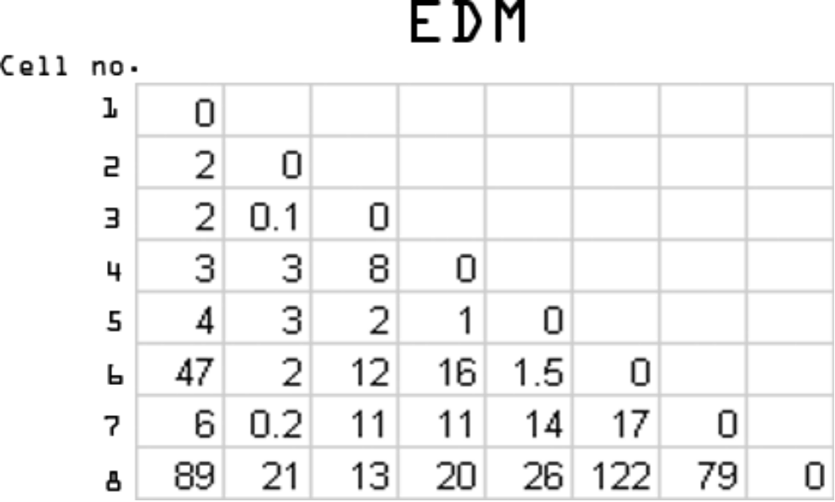
Figure 1: This image shows a sample EDM with random values.

To calculate this matrix, we used the formula where p is the attribute number and i and j are the two cells corresponding to the location in the EDM.

D(i, j) = |x_{i1} - x_{j1} |²+ | x_{i2} - x_{j2}|² + … + | x_{ip} - x_{jp}|²

2. Set count = N

N is the number of cells. The significance of this step is to initialize the control variable for the iteration such that the loop is executed n-1 times such that there is only 1 cluster at the end.

REPEAT UNTIL count=1 steps 3 and 4
3. Find i,j such that d_{i,j} is the minimum of D
To find the minimum, we only need to check the bottom triangular half of the matrix. To ensure this occurs, we initialized the column index of the matrix to the first element, and the row index to the second element. During each iteration, only the row index i would increase such that all the elements in the column would be checked. After every iteration, the column index j was incremented by 1, while the row index was assigned the value of j+1. This would avoid choosing the diagonal elements of 0s as a minimum (since the self-distance will always be zero) as well as achieve our goal of only checking the bottom half of the EDM.

4. Merge i,j into k; update count = count-1
*5 Update d_{kl}, where l is element of (1,...,N) and l is not i or j

This step is to update the distance of the new cluster to every other point in the matrix. To do this, the program would have to make use of the distances of the two merged clusters/cells and compare them to do the update. There were 3 suggested comparing methods: maximum, minimum and mean. We decided to use the minimum distance condition. This meant we would compare the distance between each point in the new cluster and the other points in the dataset and store the minimum as the representative distance of the cluster. We realized this was a potential point for parallelization as the updating of the minimum distances could be done in parallel.

Output
This section describes the output.

1. Sequence of merging, e.g. {(i,j), ((i,j),m), (n,a), ...}
2. Distance corresponding to the sequence of merging, e.g. {d_{ij}, d_{(i,j),m}, d_{na}, ...}

In the next version of our program, we improved the serial performance by using a ‘Boolean Checker’ to “activate” or “deactivate” the rows and columns of the Euclidean Distance Matrix instead of deleting them as was done under the old algorithm. We did this by creating a Boolean array which corresponded to the indexes of the cells and changing them after the clusters merged. We saw a significant improvement in the performance using this method.

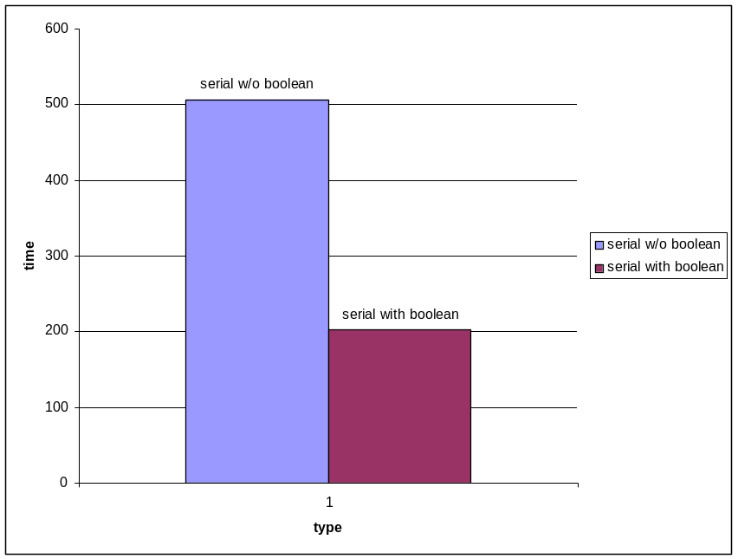
Figure 2: Time taken for execution of the program

Figure 2 illustrates the time taken by each execution of the program. While all produced identical results, they did not take the same amount of time.

The updated algorithm is depicted in figure 2-6.

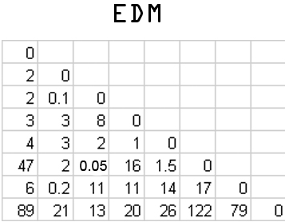
Figure 3
The Euclidean Distance Matrix is calculated from the points and stored in a 2-dimensional array shown in figure 3. This process is identical for both versions of the program

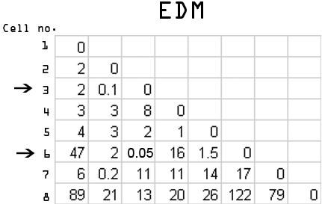
Figure 4
Next, the minimum distance is found. In this case it is the distance between cell number 3 and 6. This step is also identical for both of our versions.
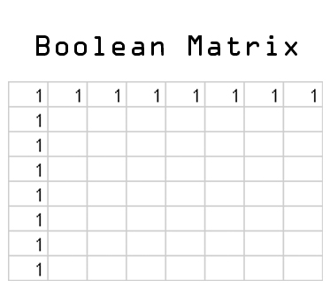
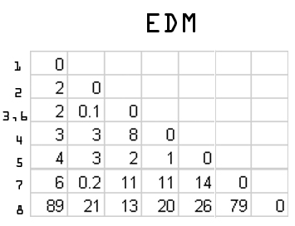

Figure 5.1 Figure 5.2
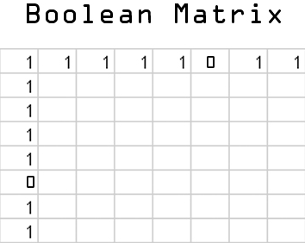

Figure 6

This step is where our first version differs from the second one. In the first version, the program would update the values into the third row then shift all the rows after row 6 up such that row 6 is deleted (figure 5.1). However, our second version would just update both the row and the column of the Boolean matrix that corresponds to the row which needs to be “deleted” and makes the row inactive instead of deleting it shown in figure 6. This yields the same results and is faster. One downside however, is that additional memory has to be allocated to store the Boolean matrix.

Parallelization
The next step was to make use of OpenMP Programming to make the program run in parallel threads. Our first task was to identify the portions of code that take up the most time to execute. Then the second step was to design parallelization for these portions. We ran several tests to determine which section of the serial program took up the most time. Our experiments indicated that the step at which we were searching the Euclidean Distance Matrix for the minimum value took up the most time. It was parallelizable as the search could be split into several independent blocks. To achieve optimum parallelization, we parallelized various other parts of the program such as the updating of values and the calculation of the EDM. These however, did not affect the timing substantially. We used OpenMP to code our parallel solution. A code snippet of how OpenMP is implemented in our code is shown below:

#pragma omp parallel shared(m,check,minimum_section,mini_section,minj_section,j,temp_section) private (tid,first,i)

We used shared and private variables appropriately to ensure there was no unnecessary updating of variables and there was updating/reading of common variables when needed.

tid=omp_get_thread_num();
We used the omp_get_thread_num() function to identify each thread by giving it a unique id.

#pragma omp for schedule(dynamic)

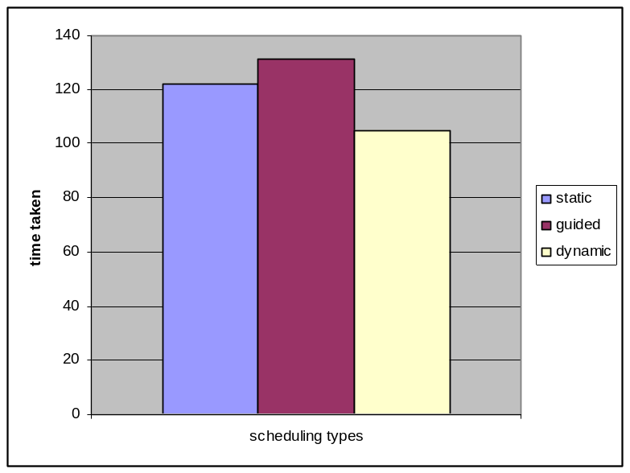
Figure 7: Disparity between the various scheduling types

Figure 7 shows the timings taken with the boolean implemented version of our program.
These timings were taken in our personal computers.

for (j=0;j<COUNT-1;j++)
{
The main use of OpenMP in our program was to parallelize the for loops. We tried various types of scheduling (guided, static, runtime)¹ and dynamic worked the best.
#pragma omp barrier
We used barriers in order to make sure all the threads have completed their assigned work before moving to the next stage of the procedure.

When testing, we also realised we needed to include the statement
#pragma omp critical
In order to ensure the output to screen is done one thread by one thread and is thus legible.

Results

Scalability

We feel that the program could be more scalable by running the program on segmented sections of the input data. Our current solution has a memory limitation as it cannot store excessively large arrays in memory due to the environment we coded it in (Visual Studio 2005). This could be a possible problem when working with larger data sets, but will not be a problem for smaller data sets.

When searching for the minimum, we decided to only check one half of the EDM due to its symmetrical property. This would save 2 times the amount of processing time taken to find the minimum.

Load balancing

When we implemented this approach, we realized that parallelization was not as easy as equally splitting the iteration numbers to each thread. If we did so, the first thread will end up having to wait for the other threads to finish. This occurs as the number of elements to process would be unevenly spread if only the row indexes were split evenly. Thus, we derived a formula to use to equally divide the iteration indexes such that the area processed by each thread is the same.

Y is the iteration number range, x is the size of the base of the previous segment, Count is the total number of cells (i.e. EDM size) and num_threads is the number of threads that the load is split among.
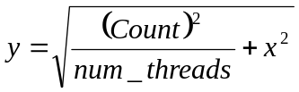

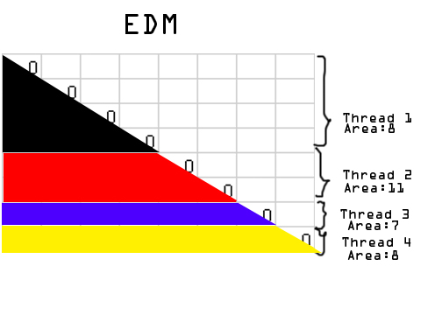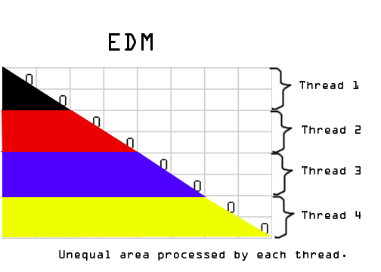
Figure 8 Figure 9
Figure 8 shows the normal method of distributing the workload to the threads the area is largely unequal and this causes the threads that finish first to wait for the other threads that will take a longer time.

Figure 9 shows the proposed method of distributing the workload. This approach is better as the workload of each thread is more equal than the previous way. This means the threads will have to wait a lesser time for one another to finish processing the data.

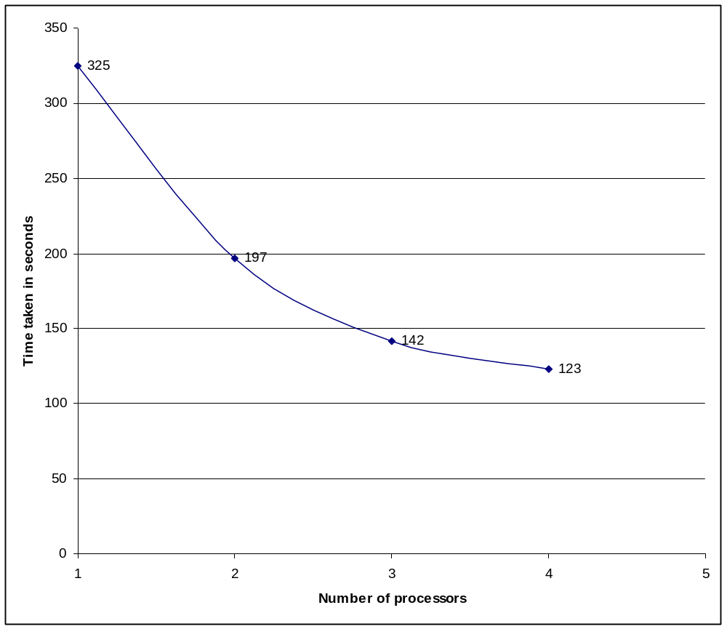
Figure 10
Figure shows the time our program took when run on 1, 2, 3 and 4 threads. We experienced a large improvement when we increased the number of processors from 1 to 2. However, we did not experience such a large decrease when we increased it from 3 to 4. This is due to certain parts of our program which cannot be parallelized such as the input and output. For any number of processors greater than 4, the time did not improve as there are only 4 processors available in the IHPC servers.

Discussion
Instead of hard coding an input filename or prompting the user for a filename, we implemented a command line input to read the cell dataset. This allows for more flexibility in terms of filename and type. A user would just need to compile the program and include the input filename followed by the output filename before running the program. This also meant once run, there would not be any stoppages due to the program awaiting user input. We also made to program such that the input file could be read by the program regardless of the type of delimiter used. Therefore, the excel spreadsheet in comma-separated values format can be directly read by our program.

About parallelization
With OpenMP, a limitation we faced was the use of shared memory instead of distributed memory. This meant we had a limited amount of memory to store data in and the number of processors available for computations was dependent on the node being used. Shared memory would, on the other hand, eliminate delays in passing and receiving packets of data from one processor to another. A possible way to get the best of both worlds could be to use a hybrid method of both MPI and OpenMP. The finer parallelization could be done using OpenMP while the coarser part could be done by means of MPI.
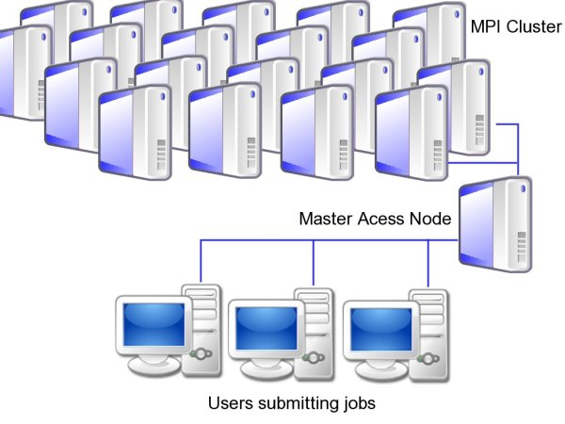
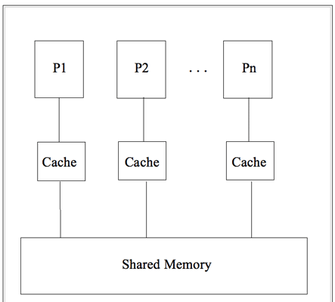
Figure 11: Shared-Memory OpenMP Figure 12: MPI cluster
Figure 11 illustrates the way OpenMP works (i.e. on a shared-memory system) while figure 12 shows how MPI distributes the workload across a cluster of nodes.

Conclusion

Our results for challenge 1 were pleasing as they matched those of which were provided. Challenge 2 was a success as we managed to significantly reduce the time taken for the categorization of cells. Although much effort was put into finding out how to present the results visually, we were still unable to do so. This led us to improve our algorithm by concentrating on the challenges to give us better accuracy in categorizing and the speed of which it was done.

We are thankful to be able to participate in this project and be able to see what the Institute of High Performance Computing is doing in contributing to the medicinal industry. We have definitely gained valuable experiences which would stay with us even in the long run.

A short description of these scheduling types can be found in the appendix.

