Weather Dataset Analysis and Rain Prediction
Dataset: weather.csv (366 daily records, 22 columns). Tools: Python, pandas, matplotlib, scikit-learn.
The program loads and cleans the data, calculates summary statistics, draws charts, then trains two models (Logistic Regression and Random Forest) to predict whether it will rain tomorrow.

1. Program (Screenshots)
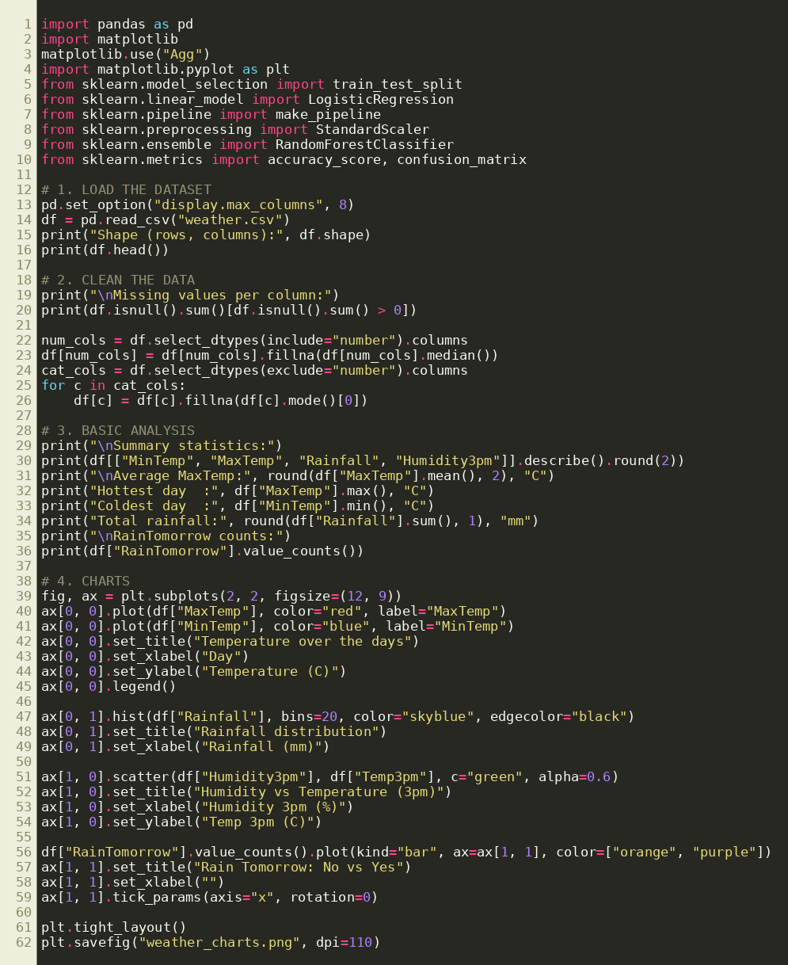
Figure 1: Program code, part 1 (load, clean, analyse, charts)
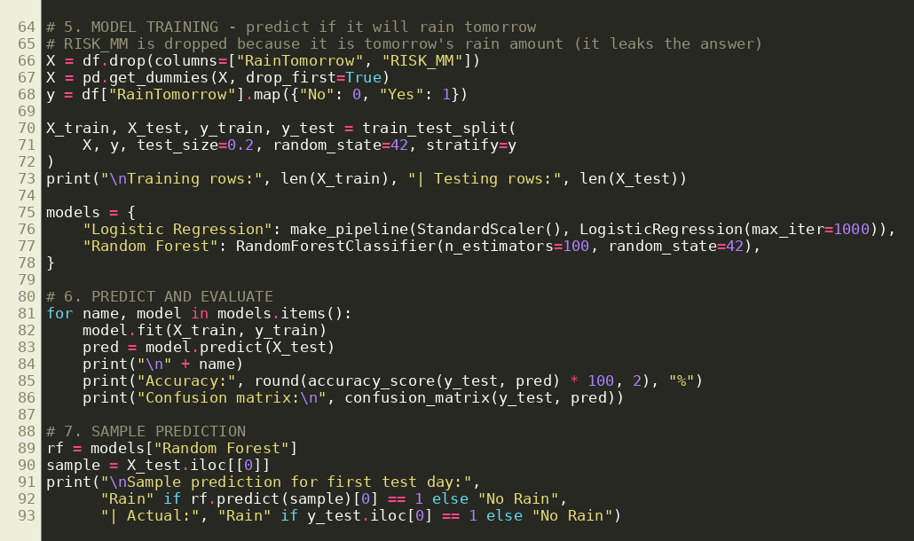
Figure 2: Program code, part 2 (model training and prediction)

2. Output (Screenshots)
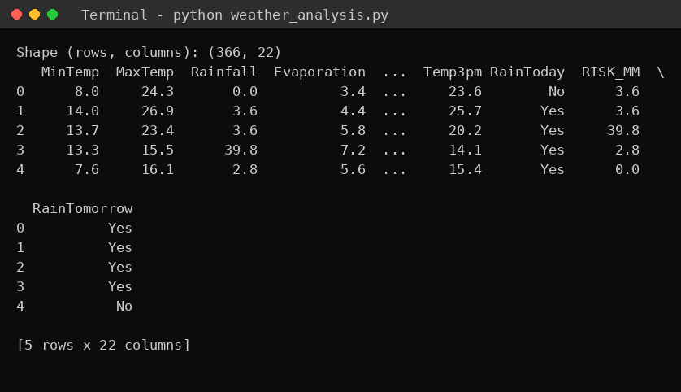
Figure 3: Output, dataset shape and first rows
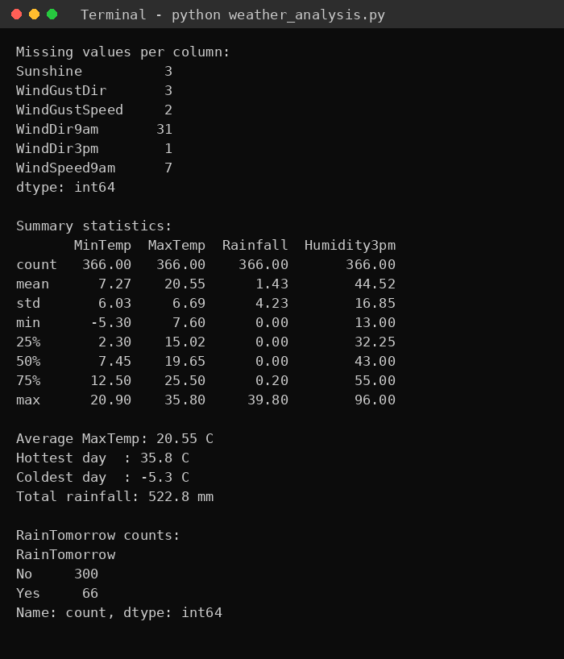
Figure 4: Output, missing values, statistics and class counts
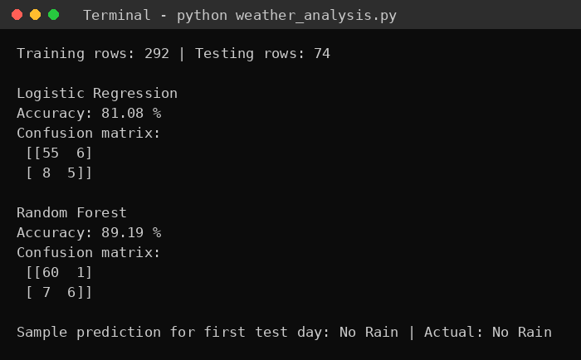
Figure 5: Output, model accuracy and sample prediction
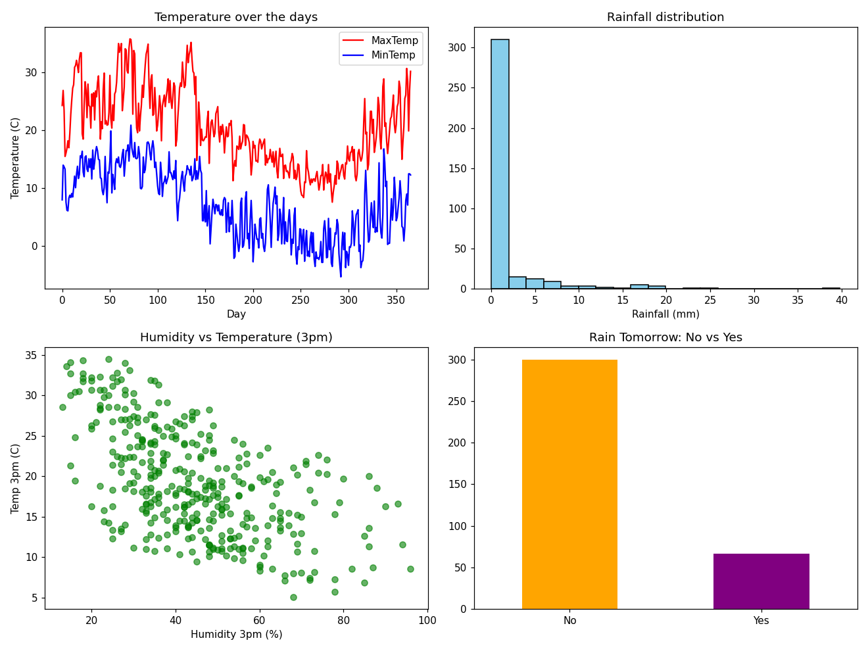
Figure 6: Charts generated by the program (weather_charts.png)

3. Result Summary
Average maximum temperature was 20.55 C, the hottest day reached 35.8 C and the coldest minimum was -5.3 C. Total rainfall for the year was 522.8 mm. Rain was expected the next day on 66 of 366 days.
Random Forest reached 89.19% accuracy on the test set and Logistic Regression reached 81.08%, so Random Forest performed better on this dataset. The RISK_MM column was removed before training because it holds the next day's rainfall and would leak the answer.

