[Appendix 1]
DIGITAL FORENSIC INVESTIGATION

SUMMER INTERNSHIP
REPORT
Submitted by
EZHUTHASSAN ANUBHAV MOHANDAS
[23162172013]

Guided by
PROF. ANIKET PATEL
Assistant Professor

In partial fulfillment for the award of the degree of
BACHELOR OF TECHNOLOGY
In
Computer Science Engineering Department
Institute of Computer Technology

[Appendix 2]


CERTIFICATE

This is to certify that the Summer Internship report submitted along with the project entitled Digital Forensic Investigation has been carried out by Ezhuthassan Anubhav Mohandas at Cyber Forensic Security Solutions in partial fulfillment for the degree of Bachelor of Technology in Computer Science and Engineering with specialization of Cyber Security, 5th semester, Semester of Institute of Computer Technology, Ganpat University during the academic year 2024-25. These results/findings contained in this report have not been submitted in part or full to any other University/Institute for award of any other Degree/Diploma.

Name & Sign of Internal Guide Name & Sign of Head of Department
Prof. Aniket Patel Prof. Dharmesh Darji

[Appendix 3]

INDUSTRY CERTIFICATE

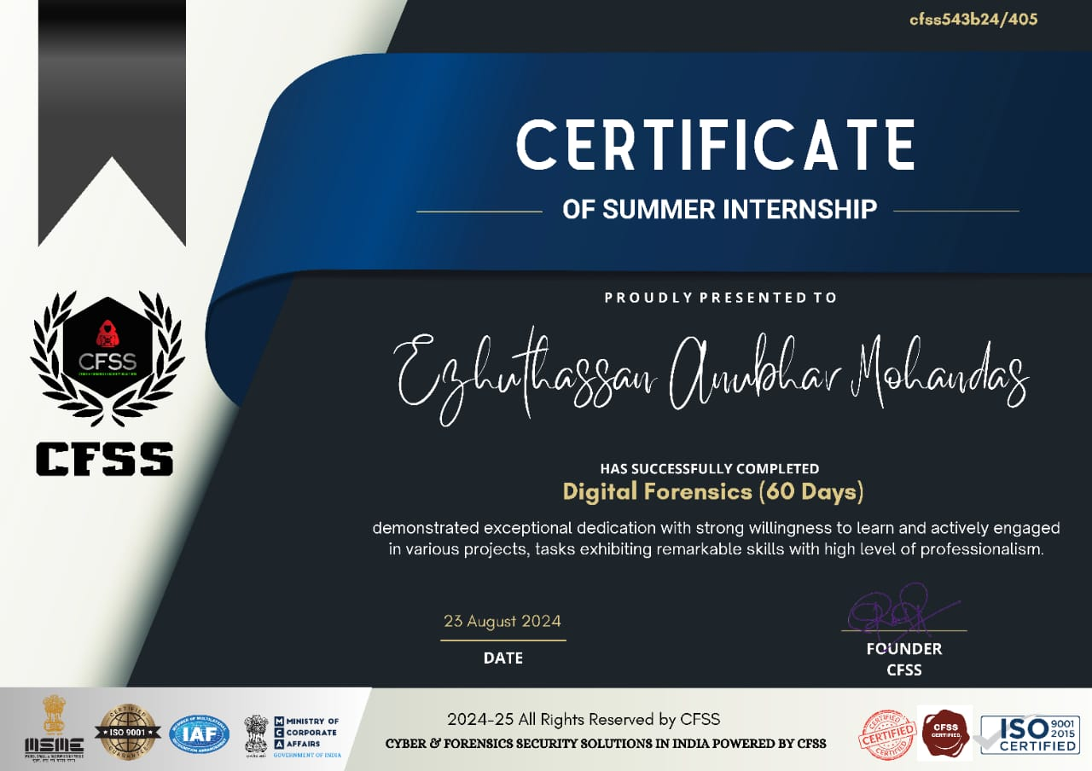

[Appendix 4]

DECLARATION
I hereby declare that the Summer Internship report submitted along with the Project entitled Digital Forensic Investigation in partial fulfillment for the degree of Bachelor of Technology in Computer Science and Engineering with specialization of Cyber Security to Institute of Computer Technology, Ganpat University. It is a bonafide record of original project work carried out by me at Cyber Forensic Security Solutions under the supervision of Prof. Aniket Patel and that no part of this report has been directly copied from any students’ reports or taken from any other source, without providing due reference.

Ezhuthassan Anubhav Mohandas

[Appendix 5]

ACKNOWLEDGEMENT

I would like to express my sincere gratitude to Cyber Forensic Security Solutions for providing me the invaluable opportunity to work with them as an intern. This experience has been a significant learning milestone, and I am thankful for their continued support throughout the internship.
I extend my heartfelt thanks to my fellow team members and my supervisor, whose guidance and expertise in digital forensics have been instrumental to my growth and learning. Their encouragement and insights have greatly enhanced my understanding of forensic investigations.
I would also like to thank Prof. Aniket Patel and Prof. Dharmesh Darji from the Institute of Information and Communication Technology (ICT) for granting me the opportunity to undertake this internship as a part of my summer project. Their support and guidance have been critical in shaping my academic journey.
A special thanks goes to all those who helped me complete this project, particularly my supervisor at CFSS and Prof. Aniket Patel, ICT, for their guidance despite their busy schedules.
Lastly, I am deeply grateful to my family and friends for their unwavering encouragement and support, which has been a constant source of motivation throughout this journey.

Ezhuthassan Anubhav Mohandas
23162172013

[Appendix 6]

ABSTRACT

This report represents a detailed account of a digital forensic investigation conducted as part of my internship at Cyber Forensic Security Solutions. This investigation was initiated when an unauthorized message was discovered on a compromised system, raising concerns of a security breach. My task was to investigate the security breach using tools and techniques which is most appropriate like Autopsy and FTK (Forensic Toolkit) and do the analysis accordingly.
This report outlines the step-by-step procedures or methodology used, the challenges encountered during the investigation, and the results obtained through digital forensic analysis. The findings underscore the importance of thorough forensic procedures and the applications of specialized tools in investigating the breach.

[Appendix 7]
No table of figures entries found.

[Appendix 8]
No table of figures entries found.

[Appendix 9]
ABBREVATIONS

CFSS – Cyber Forensic Security Solution
FTK – Forensic Toolkit

[Appendix 10]
Table of Contents
CERTIFICATE II
INDUSTRY CERTIFICATE III
DECLARATION IV
ACKNOWLEDGEMENT V
ABSTRACT VI
Introduction 1

Introduction

