Phani Srikar Edupuganti – 5508163

1.a)

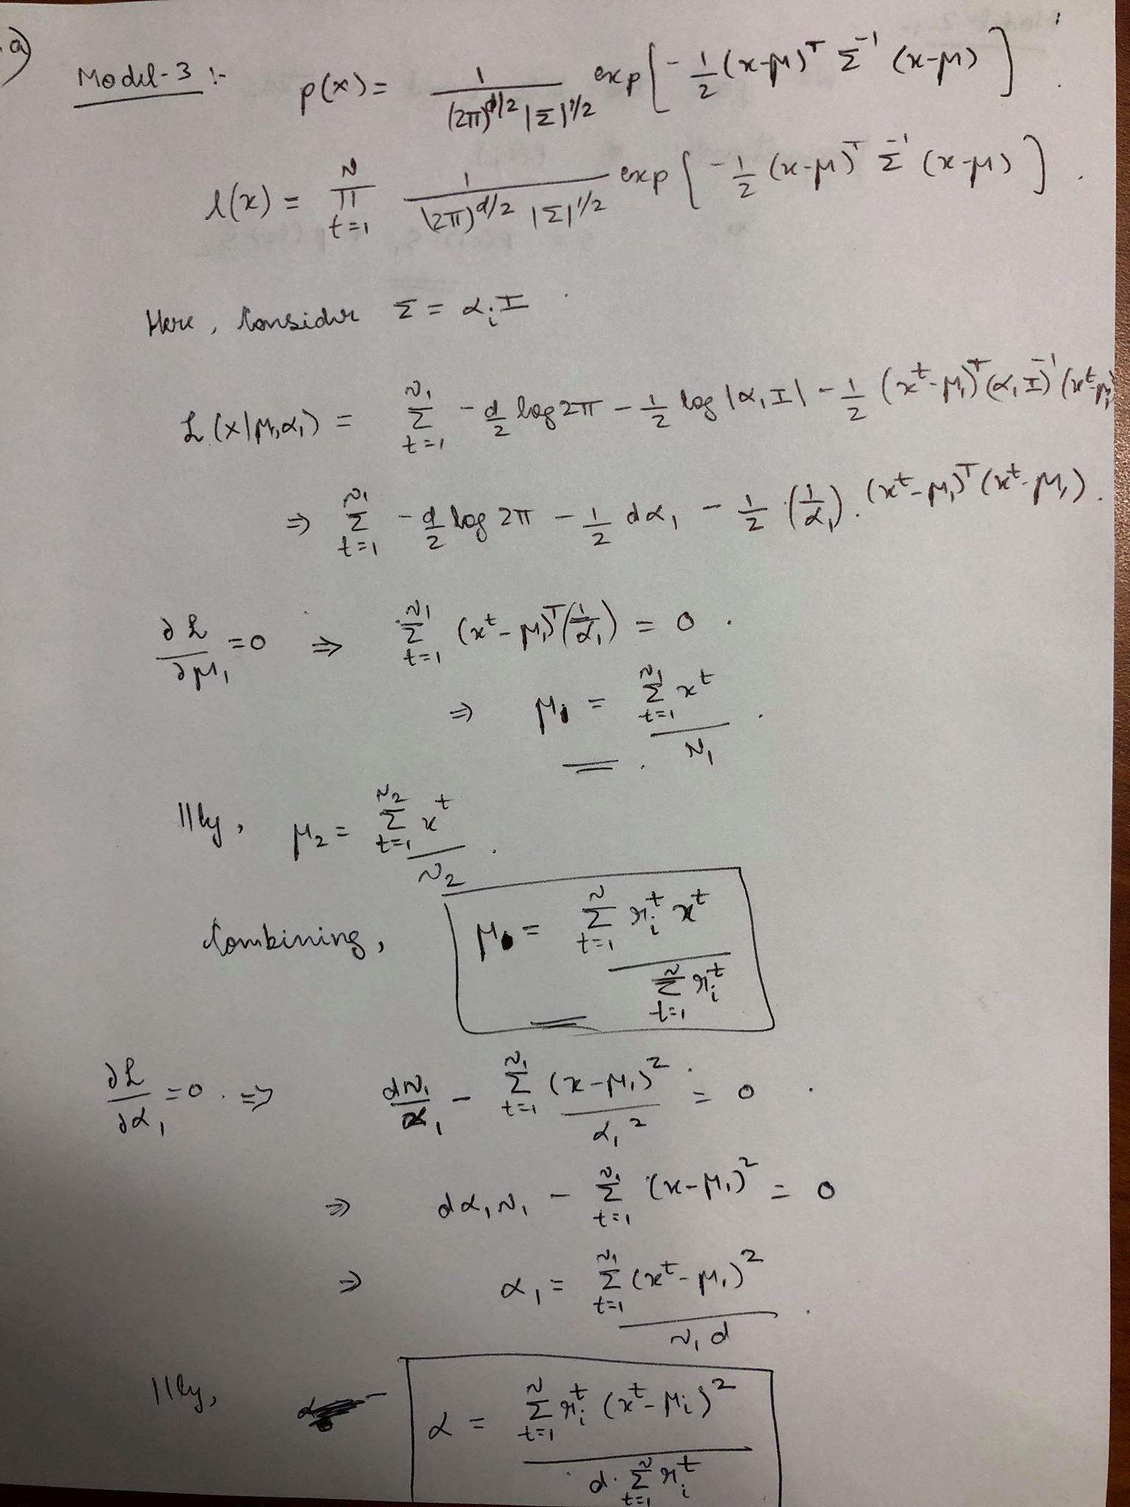

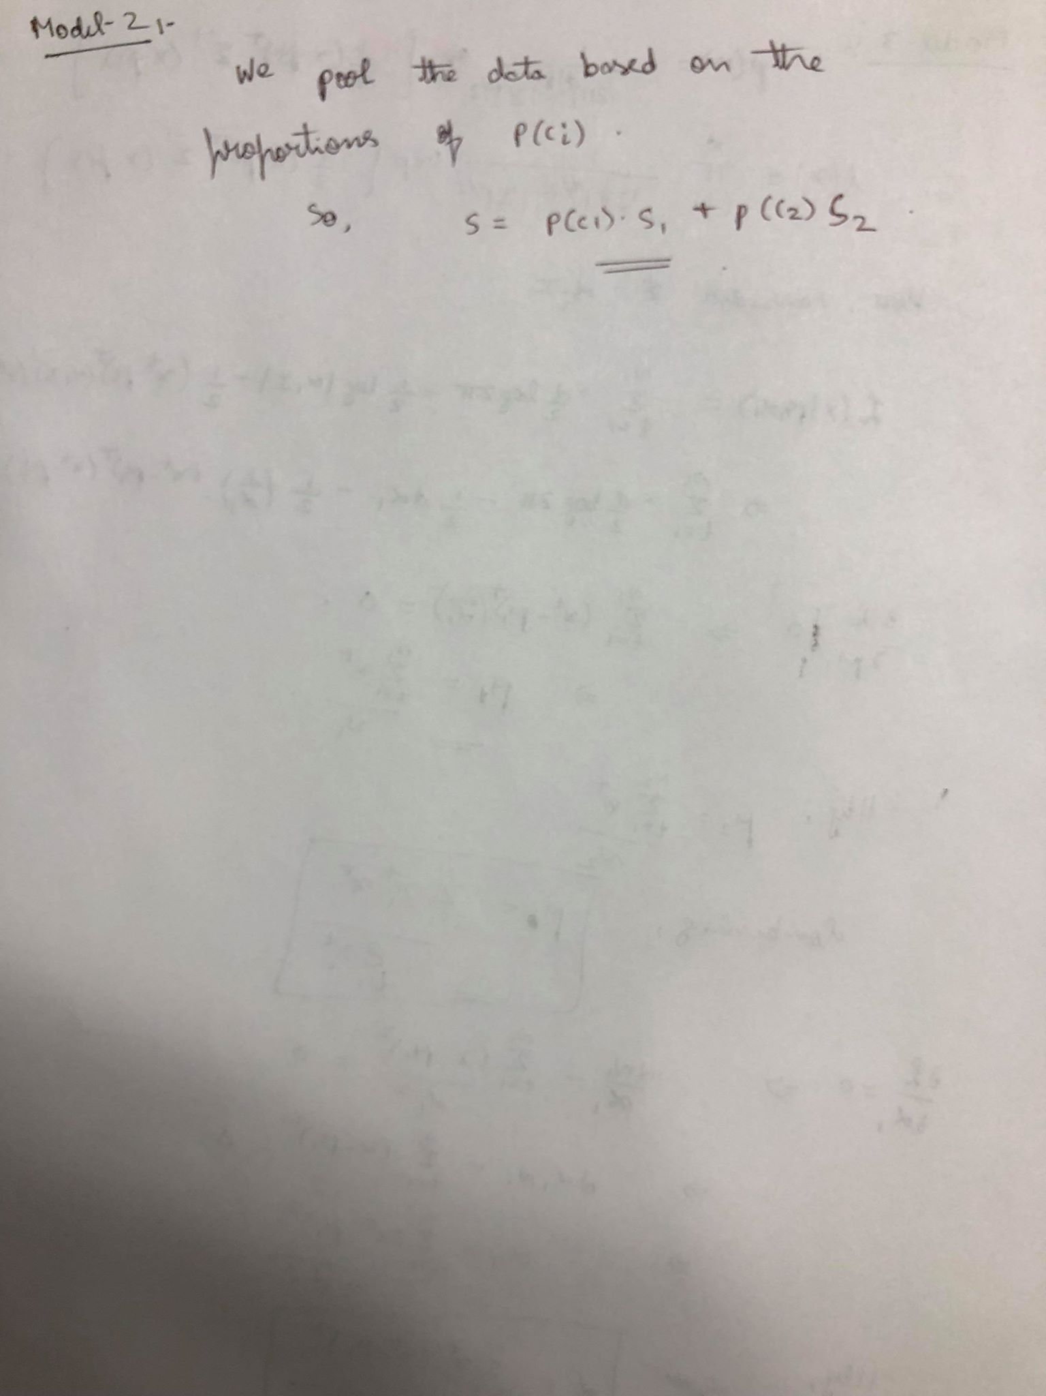

1.b) and 1.c)

The error rate for Model 1 = 0.14; for Model 2 = 0.12 and for Model 3 = 0.3. From Model 1 to Model 2 to Model 3, we are decreasing the complexity of the model by decreasing the number of parameters to be computed for the model. We observe that as we simplify the models, the error first decreases and then increases. This would imply that Model 2 matches the actual problem complexity better than Model 1 and Model 3.

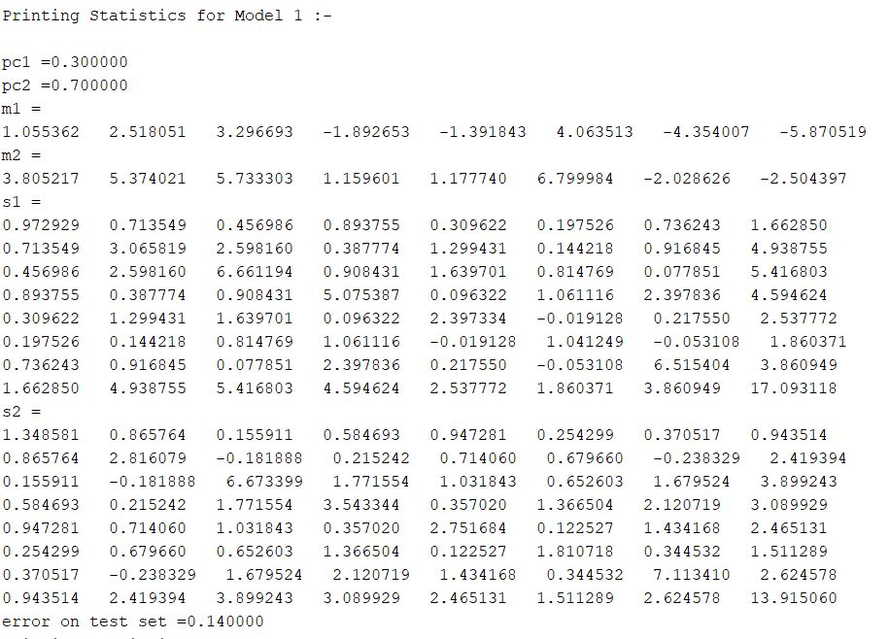

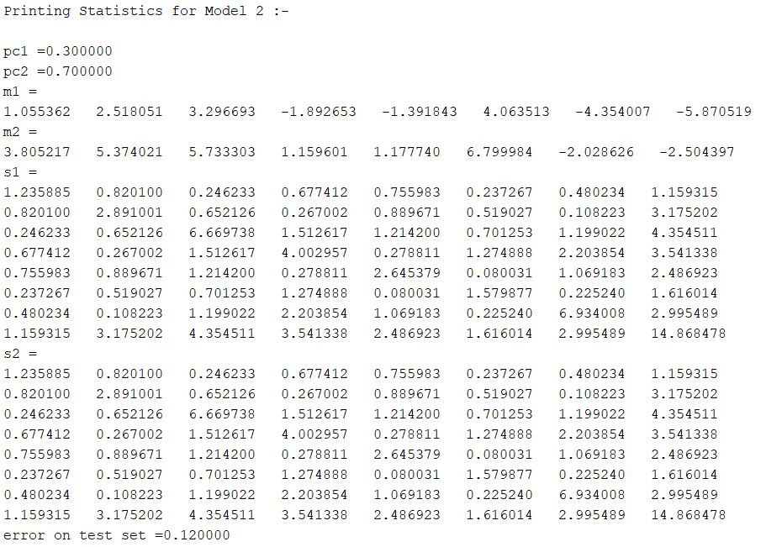

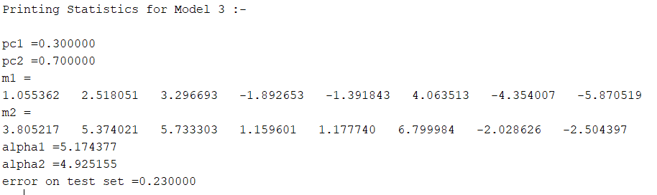

2.a)

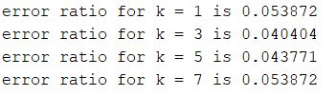

2.b)

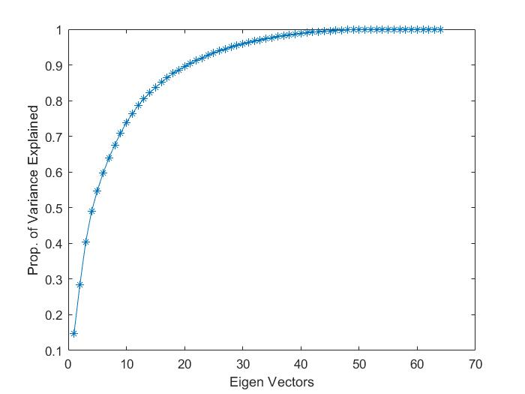

**K = 21**

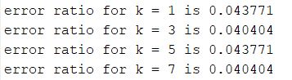

2.c)

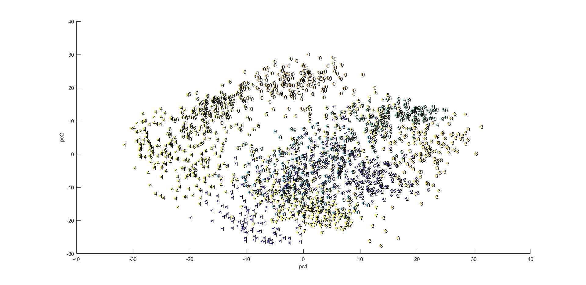

2.d)

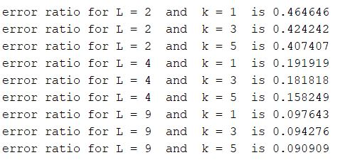

2.e)

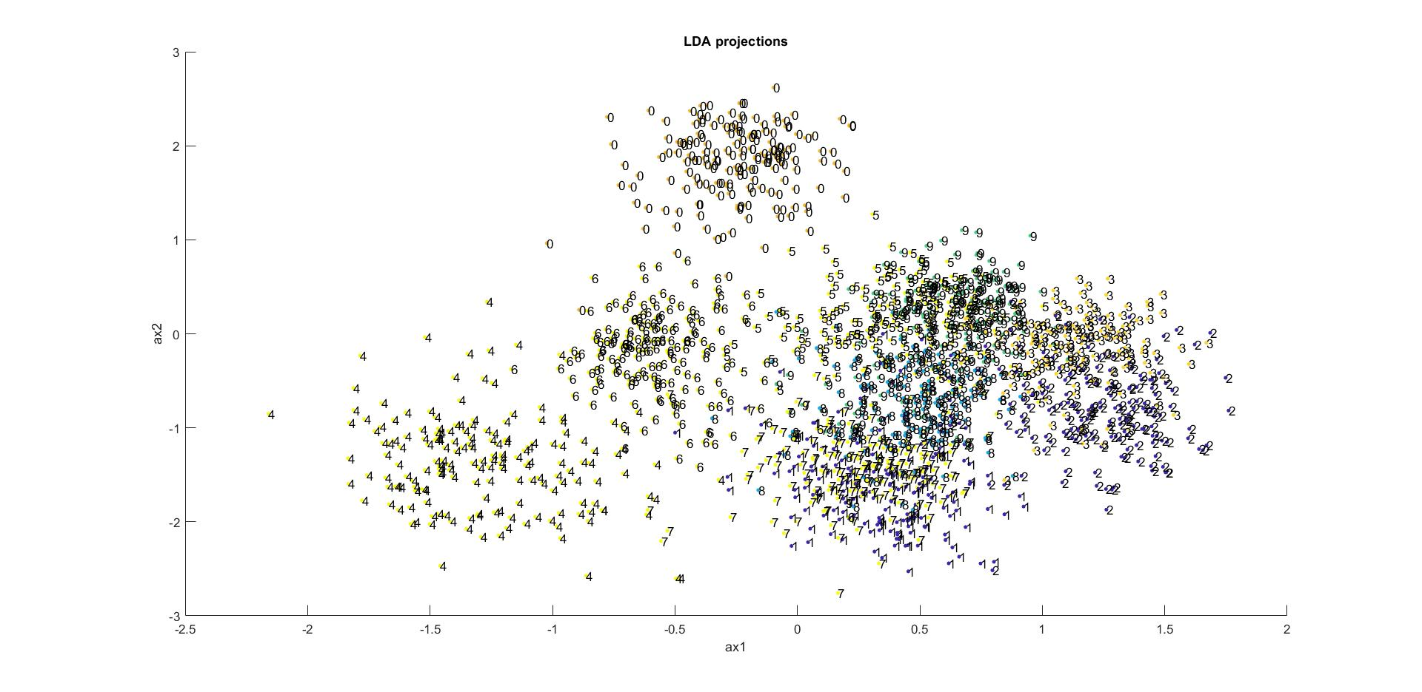

3.a)

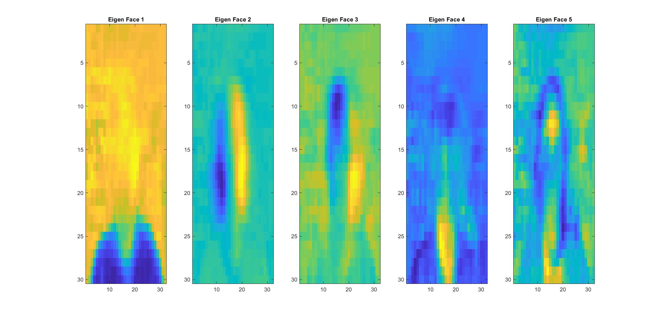

3.b)

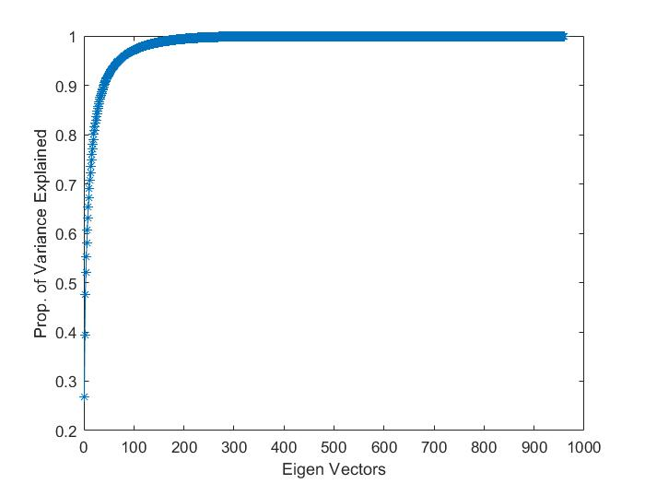

**K = 41**

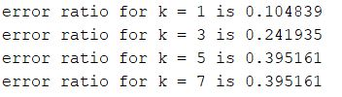

3.c)

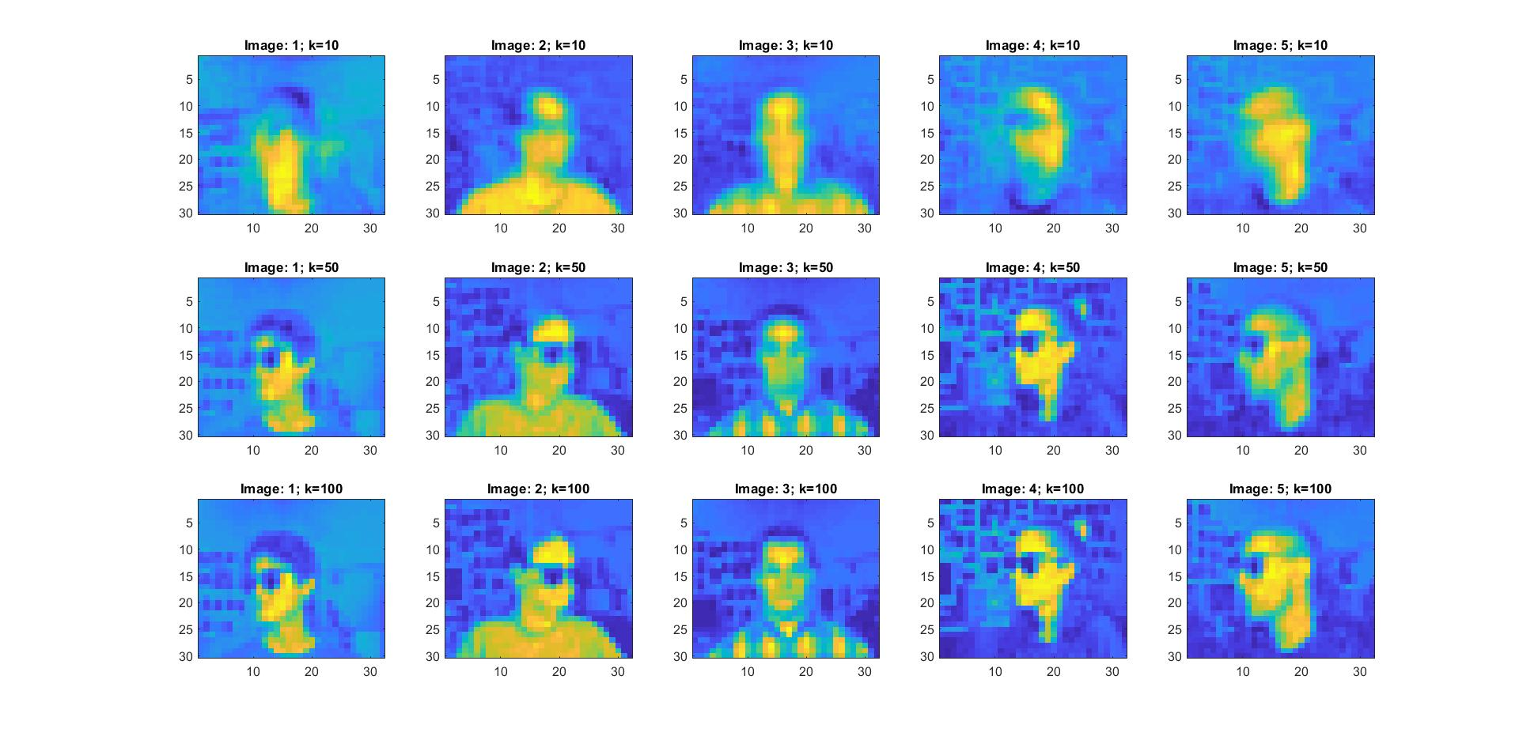

The images match the original image very closely as we increase the value of k. So the reconstruction error reduces as we increase the number of components. This is because more variance inherent in the data is explained if we increase the value of k.