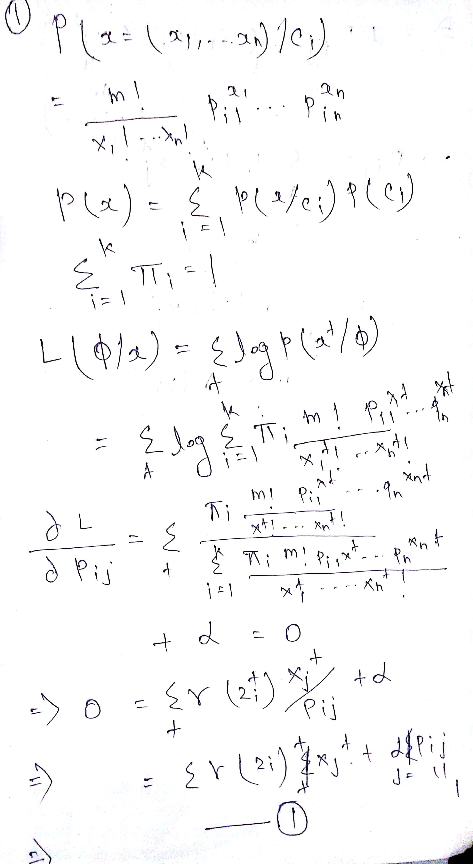

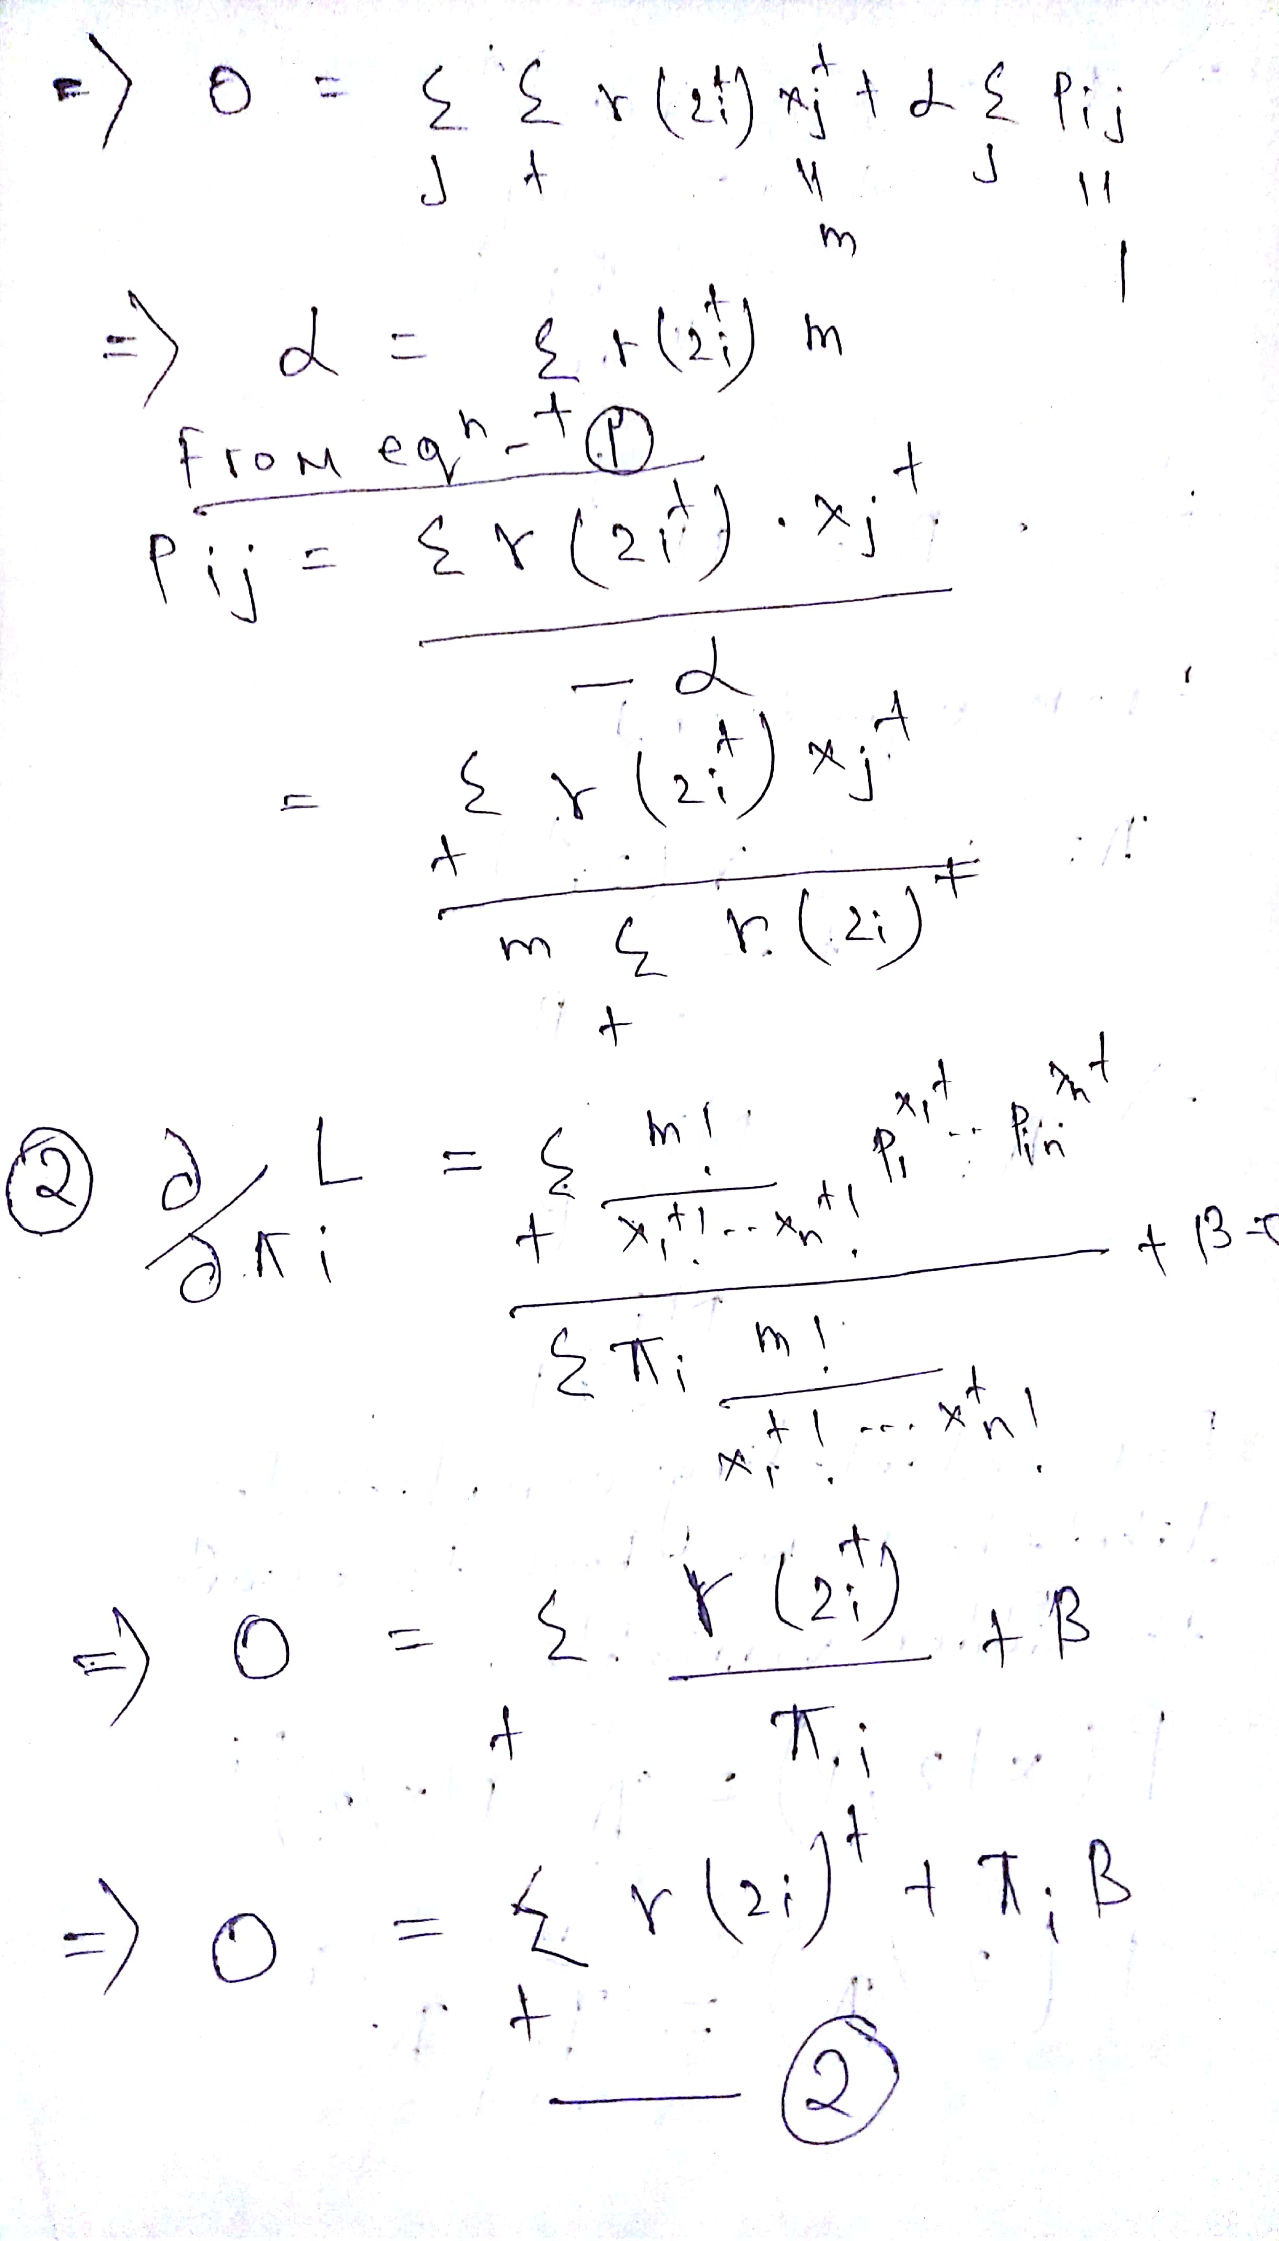

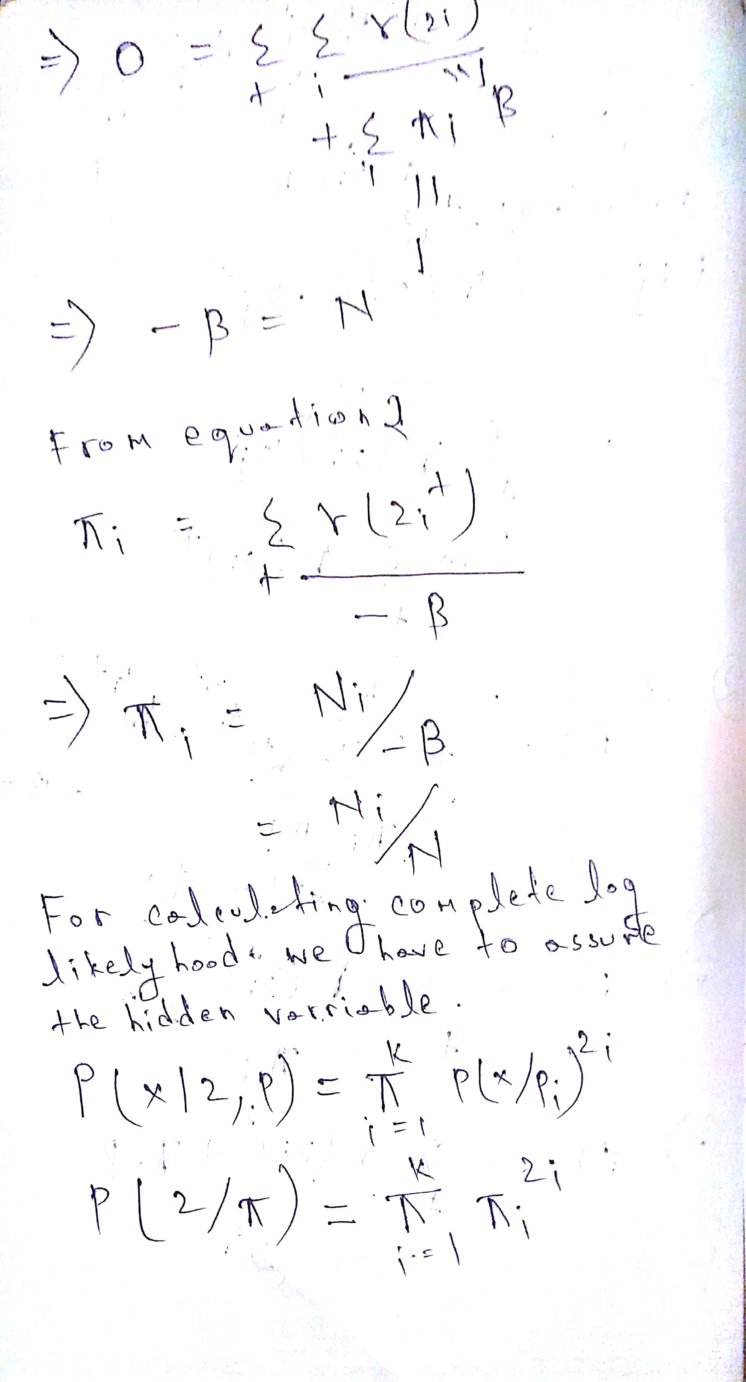

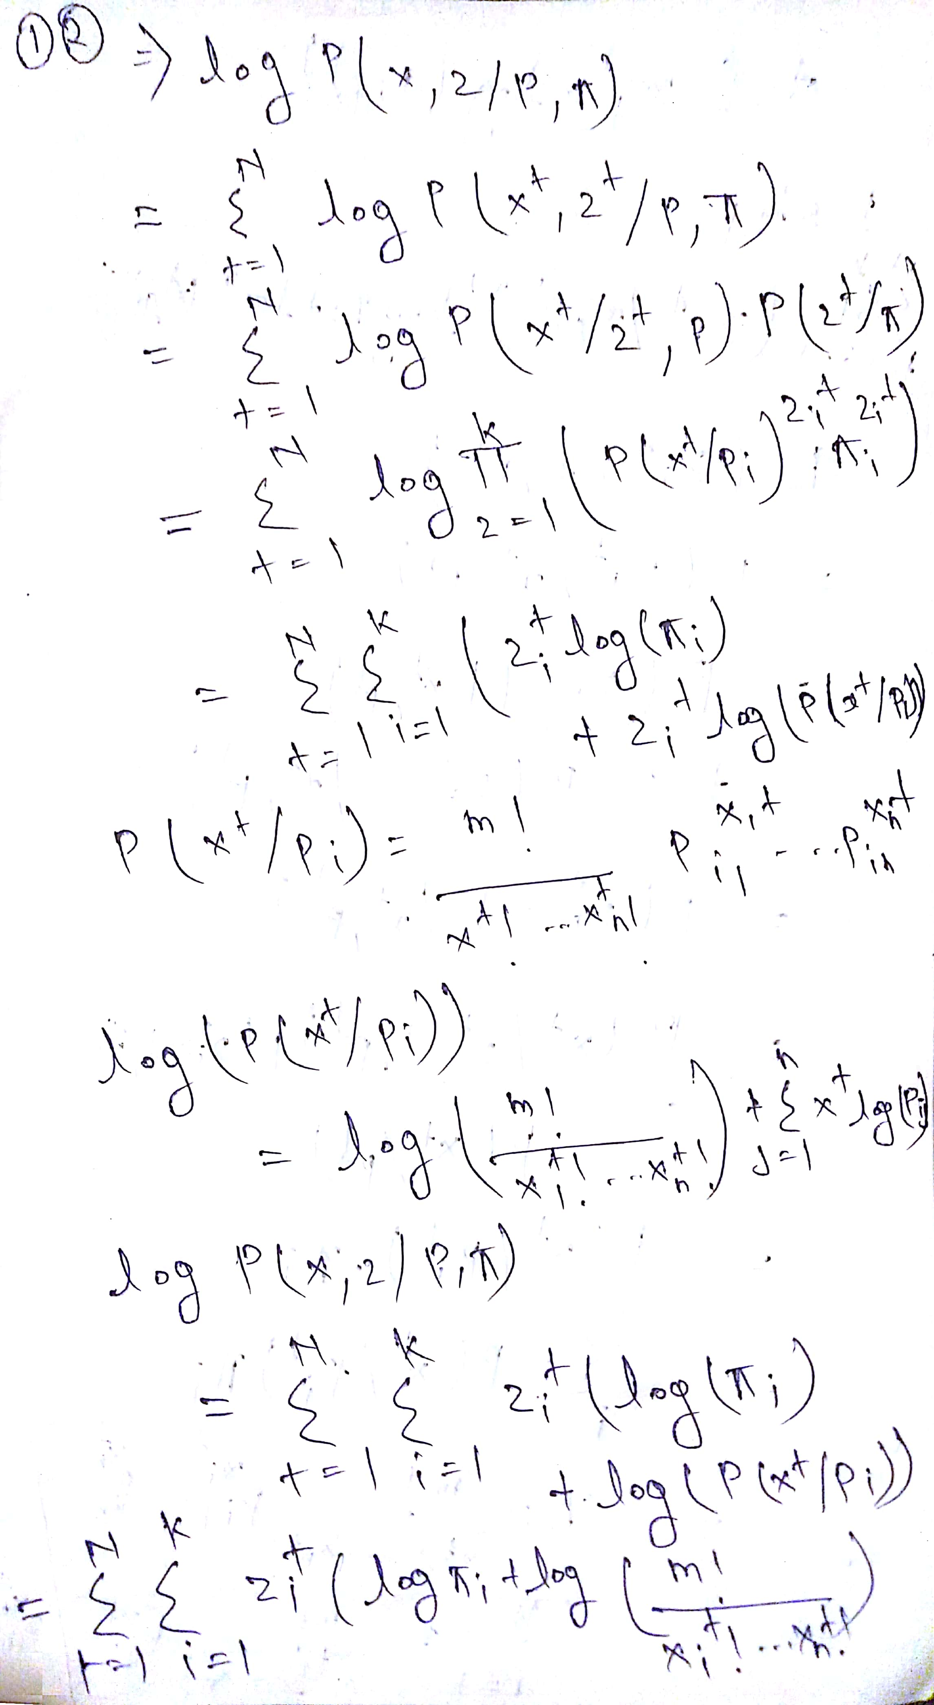

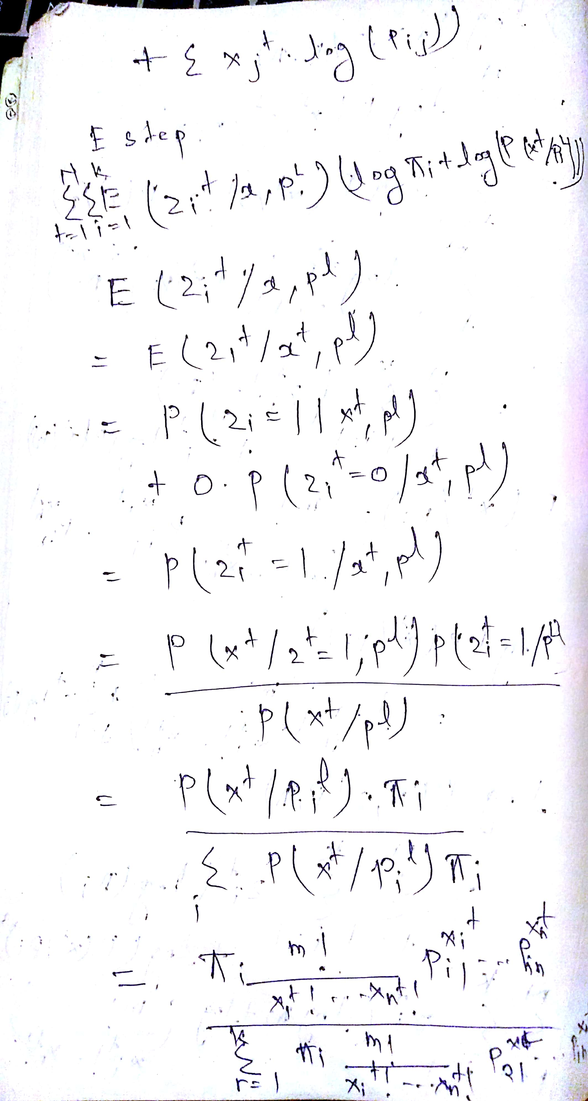

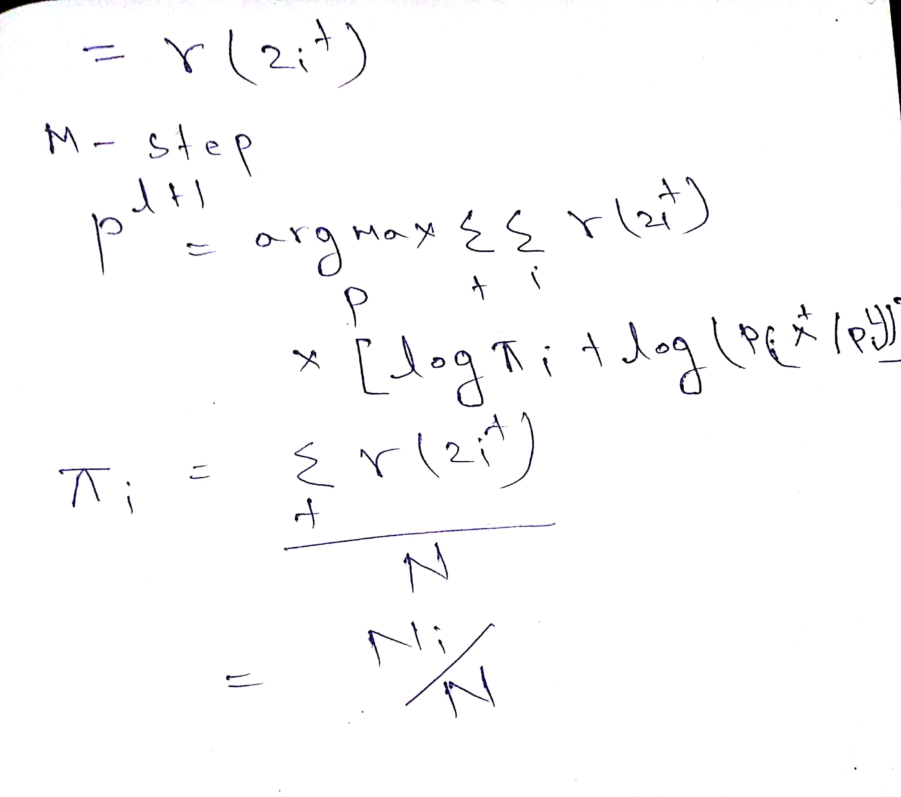

Question 2

K=4

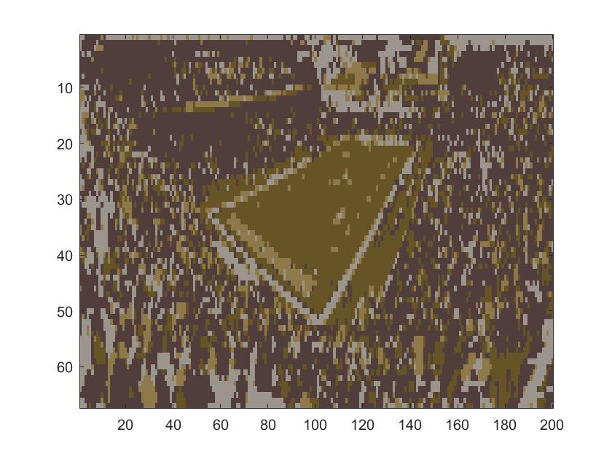

K=8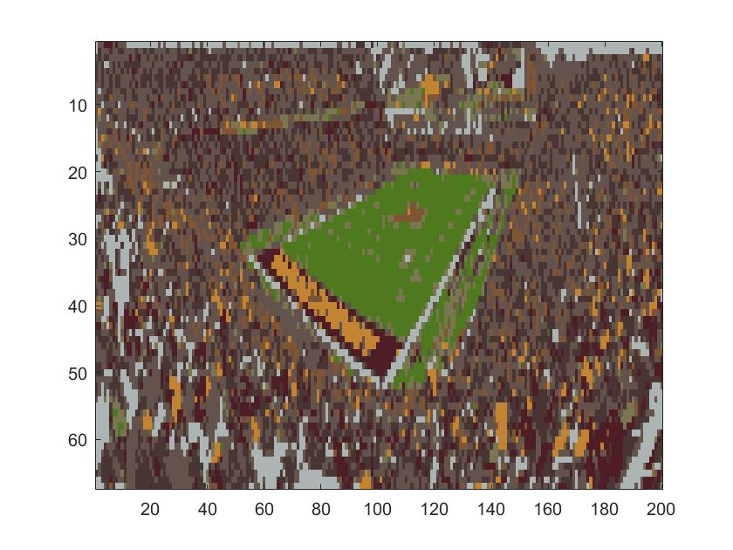

K=12

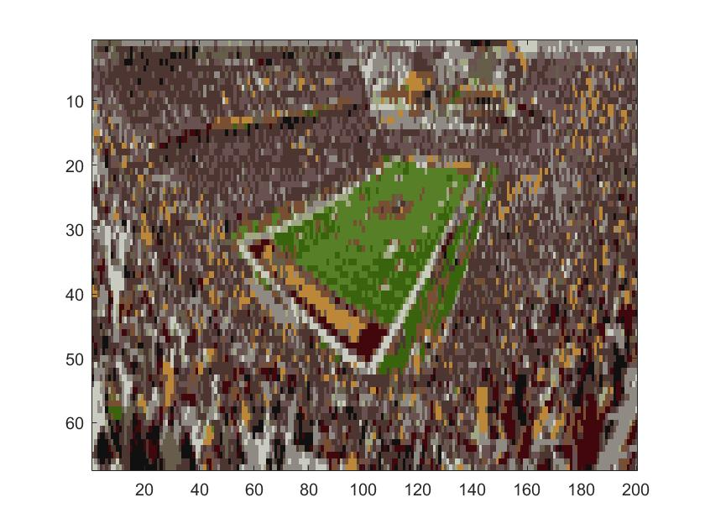

Question 2b

Red=After expectation

Green=After maximization Xaxis=iterations Yaxis=loglikelihood value

K=4

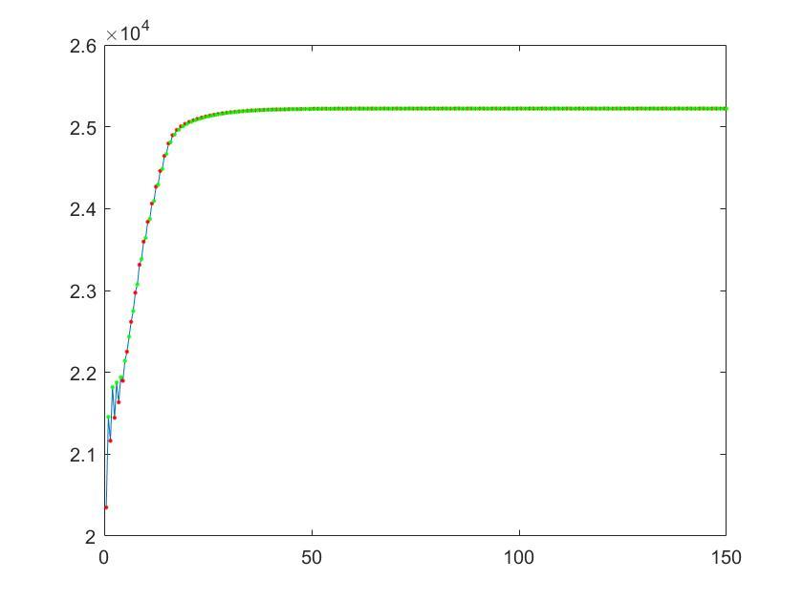

K=8

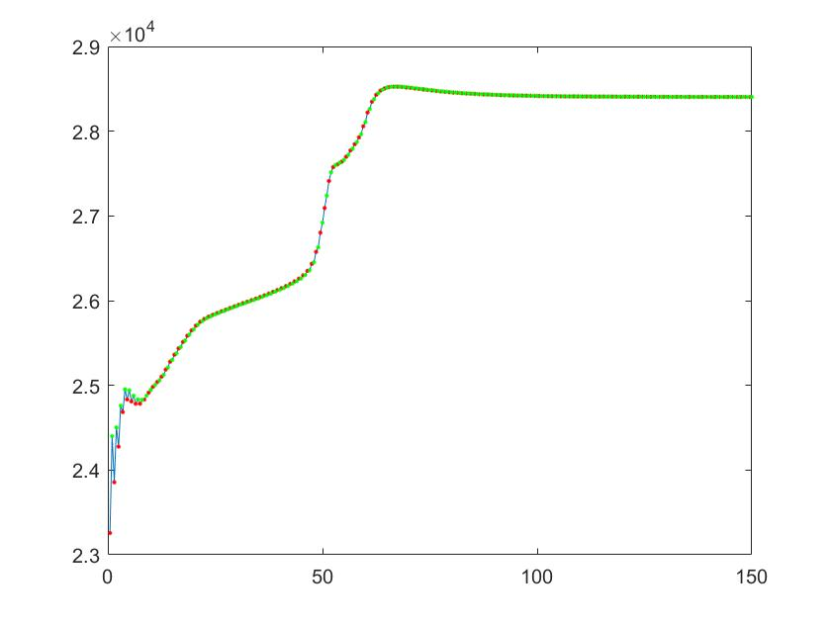

K=12

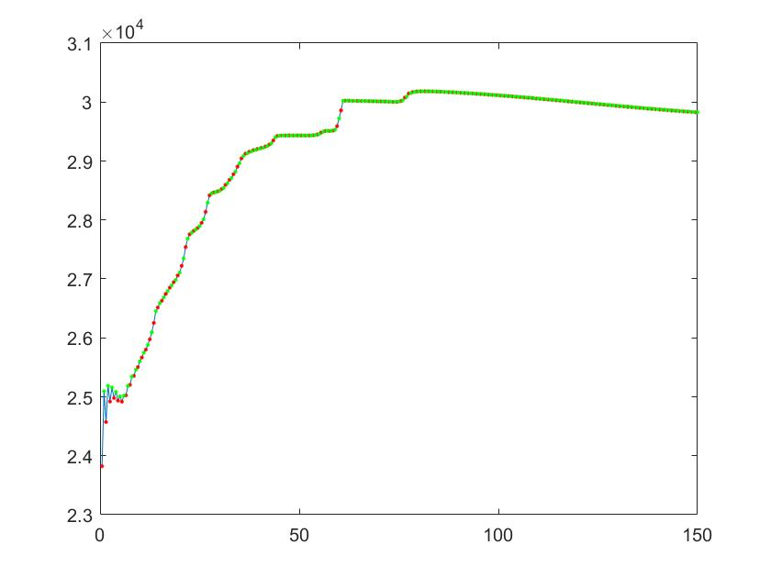

If we increase the value of K the value of complete log-likelihood increases.

2c

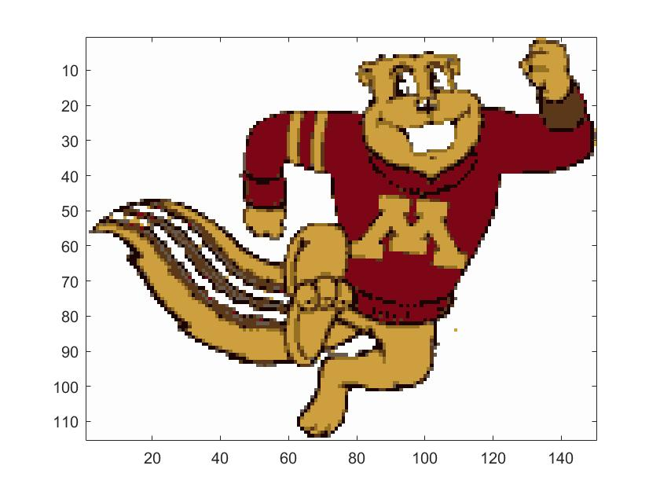

Here the kmeans (it does not required to calculate the covariance matrix and it uses Euclidian Distance )algorithm ran successfully but the Em implementation failed .

since the Em using gaussians distributions uses covariance matrix and sigma matrix(covariance matrix) in this case is not positive definite so calculation of the square root of sigma matrix is impossible .thats why it was failed.

Sometimes the em using gaussian distribution fails because the sigma matrix(covariance matrix) is singular so calculation of inv(sigma )is not possible.

Formula to check a matrix is positive definite or not : all(eig(S(:,:,4)) > eps)

2 d

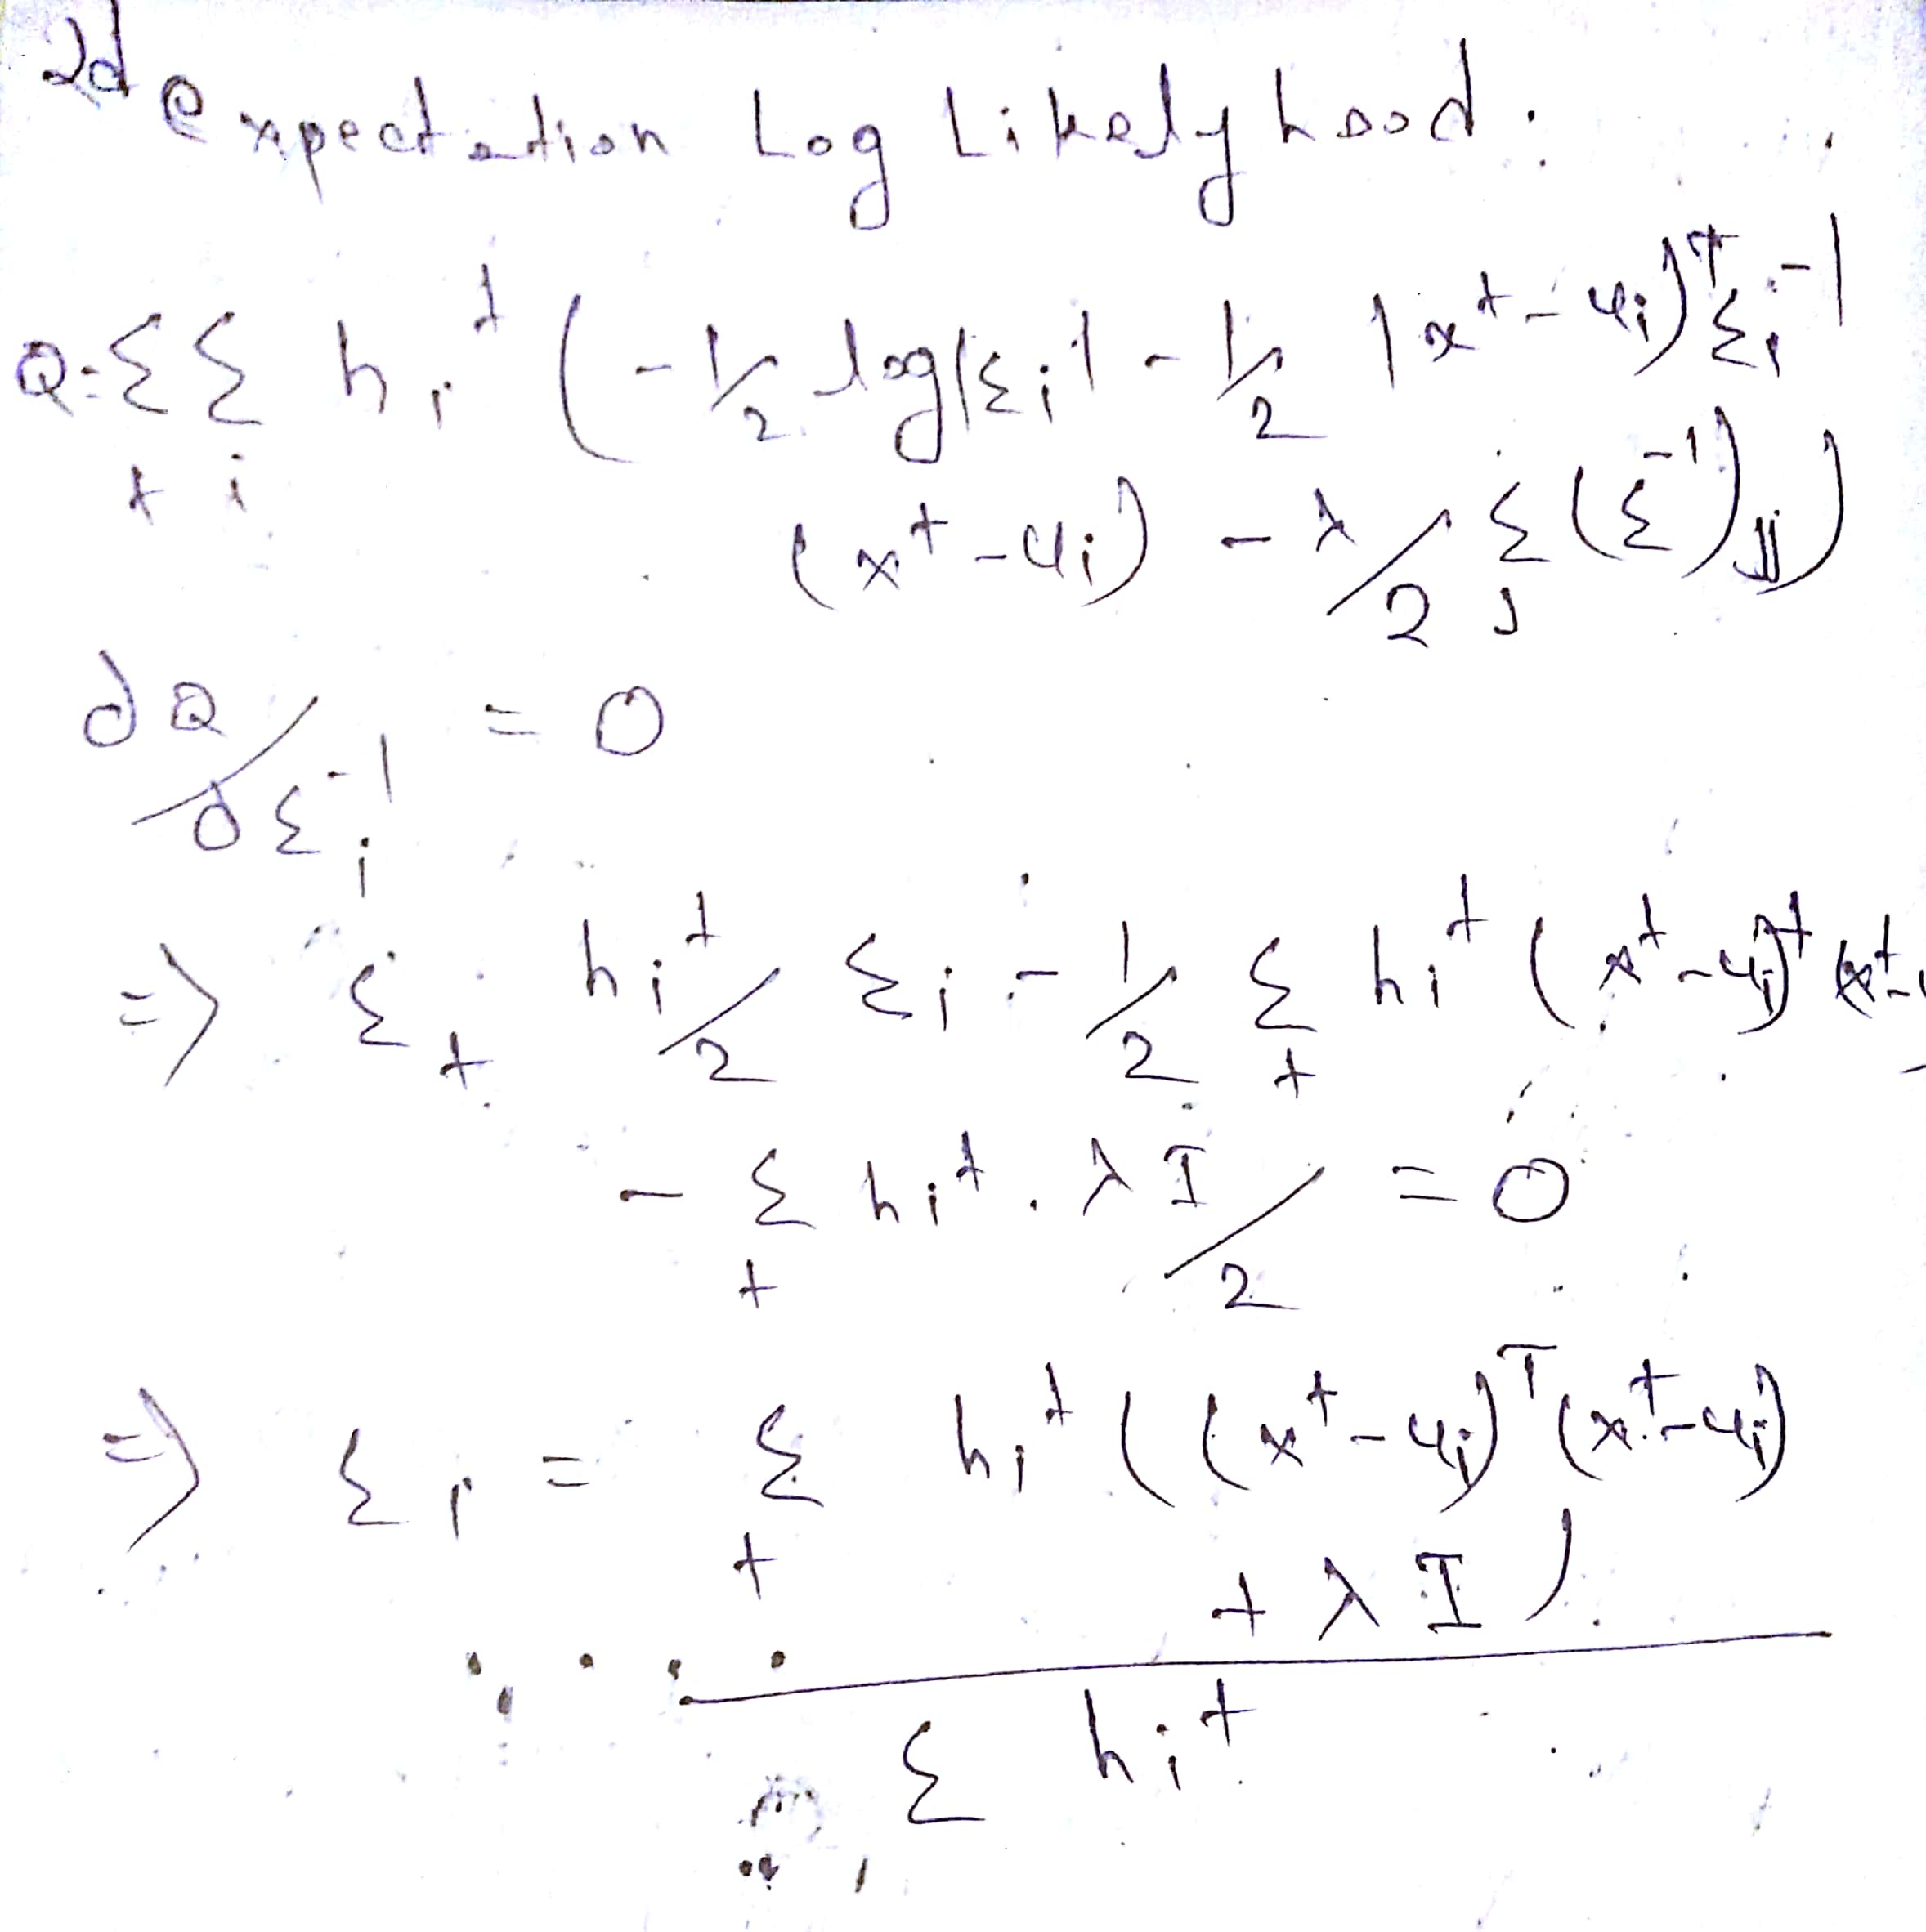

Sigma is only modified and all the others calculation will be same.Now the covariance matrix calculation is modified in the em algorithm (flag=1) by adding a factor lambda\*eye();

E

So after adding the lambda\*I parameter we have removed the probability of the covariance matrix being singular and decreased the probability of matrix not being positive definite so in this case the EM worked successfully in goldy image.

Em goldy.bmp

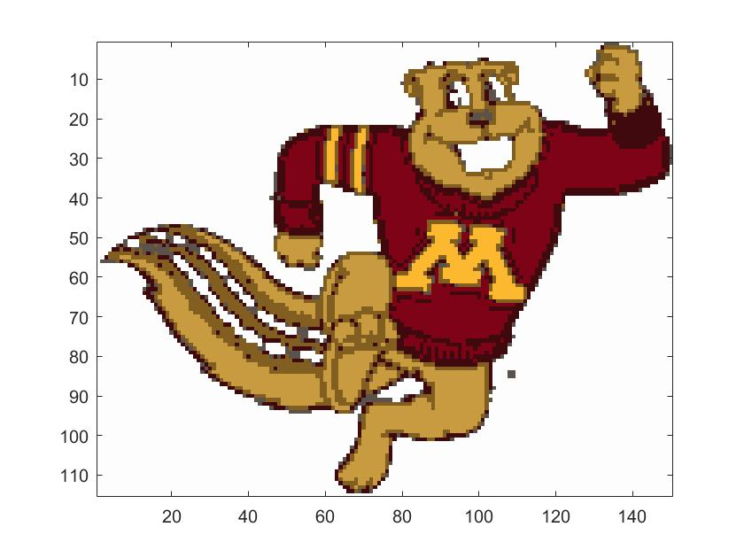

Kmeans goldy

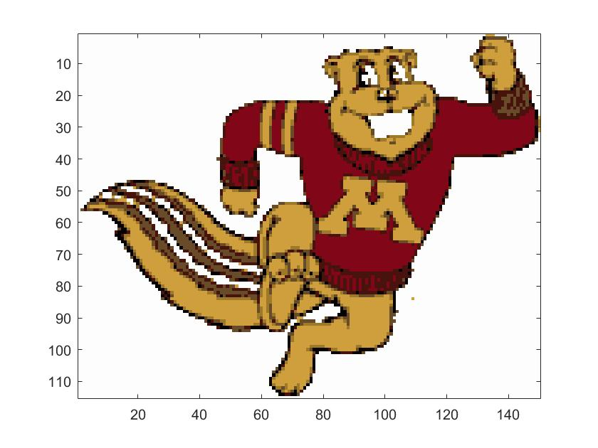

Log likely hood em

