1.1 Computer: It is an electronic machine which performs following major operations or functions
- Accepts data or instructions as input,
- Stores data and instruction
- Processes data as per the instructions,
- Controls all operations inside a computer, and
- Gives results in the form of output.
Therefore it consists of mainly four basic units; namely input unit, storage unit, central processing unit and output unit. Central Processing unit further includes Arithmetic logic unit and control unit, as shown in the figure.
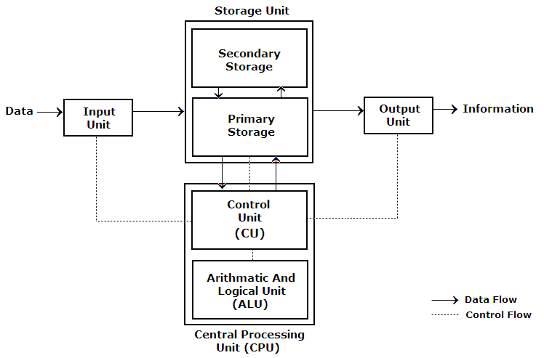
Functional Units:
- Input Unit: This unit is used for entering data and programs into the computer system by the user for processing e.g. Keyboard, Mouse etc.
- Storage Unit: The storage unit is used for storing data and instructions before and after processing. e.g. RAM, Hard Disk etc.
- Output Unit: The output unit is used for storing the result as output produced by the computer after processing e.g. Monitor, Printer etc.
- Processing: The task of performing operations like arithmetic and logical operations is called processing. The Central Processing Unit (CPU) takes data and instructions from the storage unit and makes all sorts of calculations based on the instructions given and the type of data provided. It is then sent back to the storage unit. CPU includes Arithmetic logic unit (ALU) and control unit (CU)
  - Arithmetic Logic Unit: All calculations and comparisons, based on the instructions provided, are carried out within the ALU. It performs arithmetic functions like addition, subtraction, multiplication, division and also logical operations like greater than, less than and equal to etc.
  - Control Unit: Controlling of all operations like input, processing and output are performed by control unit. It takes care of step by step processing of all operations inside the computer.
  - Registers: It is small amount of storage as a part of CPU and is used to hold information on a temporary basis. In this data is accessed from larger memory for calculation and manipulation. Manipulated data is often stored back into the main memory. There are different types of registers available.
e.g. Address Register: To hold the address of the active memory location.
Instruction register: It holds the current instruction being executed.
Accumulator Register: It holds data to be operated upon, intermediate
result and the result of processing.

1.2 Memory: Computer’s memory can be classified into two types; primary memory and secondary memory
a. Primary Memory can be further classified as RAM and ROM.
- RAM or Random Access Memory is the unit in a computer system. It is the place in a computer where the operating system, application programs and the data in current use are kept temporarily so that they can be accessed by the computer’s processor. It is said to be ‘volatile’ since its contents are accessible only as long as the computer is on. The contents of RAM are no more available once the computer is turned off.

- ROM or Read Only Memory is a special type of memory which can only be read and contents of which are not lost even when the computer is switched off. It typically contains manufacturer’s instructions. For example BIOS chip that stores an initial program called the ‘bootstrap loader’ whose function is to start the operation of computer system once the power is turned on.

- Cache Memory (pronounced “cash memory”): It is an extremely fast and small memory between CPU and main memory. Its access time is closer to the processing speed of CPU. It acts as a high speed buffer between CPU and main memory. It is used to store active data and instructions temporarily during processing. If searched data is available in CACHE then this event is known as CACHE Hit otherwise CACHE Miss.
CPU
CACHE MEMORY
Main Memory

b. Secondary Memory
RAM is volatile memory having a limited storage capacity. Secondary/auxiliary memory is storage other than the RAM. These include devices that are peripheral and are connected and controlled by the computer to enable permanent storage of programs and data.
Secondary storage devices like hard disks, CDs, DVD, Pen Drives etc.

Hard Disk
Hard disks are made up of rigid material and are usually a stack of metal disks sealed in a box. The hard disk and the hard disk drive exist together as a unit and is a permanent part of the computer where data and programs are saved. These disks have storage capacities ranging from GB to TB and more. Hard disks are rewritable.

Compact Disk
Compact Disk (CD) is portable disk having data storage capacity between 650-700 MB. It can hold large amount of information such as music, full-motion videos, and text etc. CDs can be either read only or read write type.

Digital Video Disk or Digital Versatile Disk
Digital Video Disk (DVD) is similar to a CD but has larger storage capacity and enormous clarity. Depending upon the disk type it can store several Gigabytes of data. DVDs are primarily used to store music or movies and can be played back on your television or the computer too.

1.3 Input / Output Devices: These devices are used to enter information and instructions into a computer for storage or processing and to deliver the processed data to a user. Input/Output devices are required for users to communicate with the computer. In simple terms, input devices bring information into the computer and output devices bring information out of a computer system. These input/output devices are also known as peripherals since they surround the CPU and memory of a computer system.

Input Devices
An input device is any device that provides input to a computer. There are many input devices, but the two most common ones are a keyboard and mouse. Every key you press on the keyboard and every movement or click you make with the mouse sends a specific input signal to the computer.
- Keyboard: The keyboard is very much like a standard typewriter keyboard with a few additional keys. The basic QWERTY layout of characters is maintained to make it easy to use the system. The additional keys are included to perform certain special functions. These are known as function keys that vary in number from keyboard to keyboard.
- Mouse: A device that controls the movement of the cursor or pointer on a display screen. A mouse is a small object you can roll along a hard and flat surface. Its name is derived from its shape, which looks a bit like a mouse. As you move the mouse, the pointer on the display screen moves in the same direction.
- Trackball: A trackball is an input device used to enter motion data into computers or other electronic devices. It serves the same purpose as a mouse, but is designed with a moveable ball on the top, which can be rolled in any direction.
- Touchpad: A touch pad is a device for pointing (controlling input positioning) on a computer display screen. It is an alternative to the mouse. Originally incorporated in laptop computers, touch pads are also being made for use with desktop computers. A touch pad works by sensing the user’s finger movement and downward pressure. • Touch Screen: It allows the user to operate/make selections by simply touching the display screen. A display screen that is sensitive to the touch of a finger or stylus. Widely used on ATM machines, retail point-of-sale terminals, car navigation systems, medical monitors and industrial control panels.
- Light Pen: Light pen is an input device that utilizes a light-sensitive detector to select objects on a display screen.
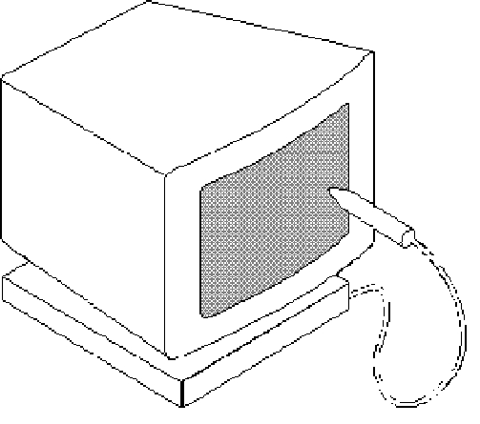
- Magnetic ink character recognition (MICR): MICR can identify character printed with a special ink that contains particles of magnetic material. This device particularly finds applications in banking industry.
- Optical mark recognition (OMR): Optical mark recognition, also called mark sense reader is a technology where an OMR device senses the presence or absence of a mark, such as pencil mark. OMR is widely used in tests such as aptitude test.
- Bar code reader: Bar-code readers are photoelectric scanners that read the bar codes or vertical zebra strips marks, printed on product containers. These devices are generally used in super markets, bookshops etc.

- Scanner: Scanner is an input device that can read text or illustration printed on paper and translates the information into a form that the computer can use.
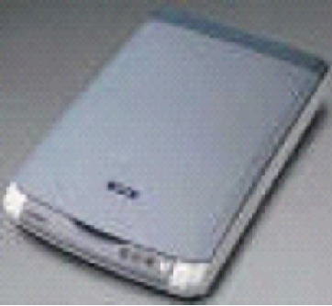

Output Devices: Output device receives information from the CPU and presents it to the user in the desired from. The processed data, stored in the memory of the computer is sent to the output unit, which then converts it into a form that can be understood by the user. The output is usually produced in one of the two ways – on the display device, or on paper (hard copy).
- Monitor: is often used synonymously with “computer screen” or “display.” Monitor is an output device that resembles the television screen (fig. 1.8). It may use a Cathode Ray Tube (CRT) to display information. The monitor is associated with a keyboard for manual input of characters and displays the information as it is keyed in. It also displays the program or application output. Like the television, monitors are also available in different sizes.
- Printer: Printers are used to produce paper (commonly known as hard copy) output. Based on the technology used, they can be classified as Impact or Non-impact printers.
Impact printers use the typewriting printing mechanism wherein a hammer strikes the paper through a ribbon in order to produce output. Dot-matrix and Character printers fall under this category.
Non-impact printers do not touch the paper while printing. They use chemical, heat or electrical signals to etch the symbols on paper. Inkjet, Deskjet, Laser, Thermal printers fall under this category of printers.

- Plotter: Plotters are used to print graphical output on paper. It interprets computer commands and makes line drawings on paper using multi colored automated pens. It is capable of producing graphs, drawings, charts, maps etc.
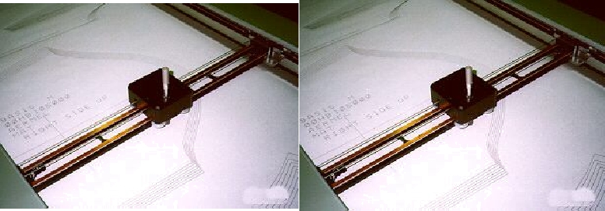
- Facsimile (FAX): Facsimile machine, a device that can send or receive pictures and text over a telephone line. Fax machines work by digitizing an image.
- Sound cards and Speaker(s): An expansion board that enables a computer to manipulate and output sounds. Sound cards are necessary for nearly all CD-ROMs and have become commonplace on modern personal computers. Sound cards enable the computer to output sound through speakers connected to the board, to record sound input from a microphone connected to the computer, and manipulate sound stored on a disk.

1.4 Computer Characteristics:
- Speed: Computer work at an incredible speed. A powerful computer is capable performing about 3-4 million instructions per second.
- Accuracy: The degree of accuracy of computer is very high and every calculation is performed with the same accuracy. The errors in computer are due to human and inaccurate data.
- Diligent: A computer is free from tiredness, lack of concentration, fatigue, etc. It can work for hours without creating any error. If millions of calculations are to be performed, a computer will perform every calculation with the same accuracy. Due to this capability it overpowers human being in routine type of work.
- Versatility: It means the capacity to perform completely different type of work. You may use your computer to prepare payroll slips. Next moment you may use it for inventory management or to prepare electric bills.
- Storage capacity: The Computer has an in-built memory where it can store a large amount of data. You can also store data in secondary storage devices such as floppies, which can be kept outside your computer and can be carried to other computers.
- No feeling : It does not have feelings or emotion, taste, knowledge and experience. Thus it does not get tired even after long hours of work. It does not distinguish between users.
- No IQ: Computer is a dumb machine and it cannot do any work without instruction from the user. It performs the instructions at tremendous speed and with accuracy. It is you to decide what you want to do and in what sequence. So a computer cannot take its own decision as you can.

1.5 History of Computer:

Generation  (Period) | Key Hardware | Key Software | Key characteristics | Example
First  (1942-1955) | Vacuum Tubes, Punched cards etc. | Machine & assembly languages | Bulky in size, Unreliable, Difficult to use, limited commercial use | ENIAC, EDVAC, UNIVAC etc.
Second  (1955-1964) | Transistors, Magnetic Tapes and disk as secondary storage | High level programming languages, scientific and commercial applications | Faster, smaller, more reliable and easier to program | Honeywell 400,IBM 7030 etc.
Third  (1964- 1975) | Integrated circuits(IC) with small scale integration(SSI) and medium scale integration technology, larger capacity disks and magnetic tapes | Time sharing operating system, standardization of high level programming languages | Faster, smaller more reliable and easier and cheaper to use | IBM 360/370,  PDP -8, PDP -11 etc.
Fourth  (1975-1989) | IC^{s} with VLSI technology, Microprocessor, semiconductor memory, larger capacity hard disk etc. | Operating system for personal computers like UNIX, Windows | Small, affordable ,reliable ,easy to use, totally general purpose machine | IBM PC, Apple II,CRAY 1 etc.
Fifth  (1989-Present) | IC^{s} with ultra large scale integration technology,  Larger capacity main memory and hard disk | World Wide Web, Multimedia Applications | Portable ,more powerful ,cheaper, reliable and easier to use. | IBM note books, Pentium,Core2Duo, PARAM etc.

1.6 Classification of computer:
1.6.1 Based on the configuration computer can be classified as follows:

Types | Super Computer | Mainframe Computer | Mini Computer | Micro Computer
Size | May be room or building | May be room | May have size of Washing machine | May be on a desk
Speed | In PFLOPs  Peta floating point operations per sec. | In FLOPS | MIPS | KIPS
Memory capacity | In Peta Bytes | In TB | In TB | In TB
Cost | Very Expensive  Around 1000 million dollar | Less than super  Around 75000 dollar | Less than mainframe  May be in lacks | Less than mini  May be in thousands
Purpose | Weather forecasting,  Research & Exploration | To run business operations  In Bank and Insurance company | In small business and firms | For personal use
Example | CRAY YMP, CRAY2, NEC SX-3, CRAY XMP and PARAM | DEC, ICL and IBM 3000 series. | Hitachi 2800 | IBM PC, PC-AT

1.6.2 Classification based on operation can be done as follows:
Analog Computer, Digital Computer and Hybrid computer

Analog computers: These are used to process analog data. Analog data is of continuous nature and which is not discrete or separate. Such type of data includes temperature, pressure, speed weight, voltage, depth etc. It measures continuous changes in some physical quantity e.g. The Speedometer of a car measures speed, the change of temperature is measured by a Thermometer, the weight is measured by Weights machine. Analog computers are the first computers being developed and provided the basis for the development of the modern digital computers. Analog computers are widely used for certain specialized engineering and scientific applications, for calculation and measurement of analog quantities. They are frequently used to control process such as those found in oil refinery where flow and temperature measurements are important. They are used for example in paper making and in chemical industry. Analog computers do not require any storage capability because they measure and compare quantities in a single operation. Output from an analog computer is generally in the form of readings on a series of dial (Speedometer of a car) or a graph on strip chart. e.g. TDC Mark III (Torpedo Data Computer)

Digital Computer: A Digital Computer, as its name implies, works with digits to represent numerals, letters or other special symbols. Digital Computers operate on inputs which are ON-OFF type and its output is also in the form of ON-OFF signal. Normally, an ON is represented by a 1 and an OFF is represented by a 0. So we can say that digital computers process information which is based on the presence or the absence of an electrical charge or we prefer to say a binary 1 or 0.
A digital computer can be used to process numeric as well as non-numeric data. It can perform arithmetic operations like addition, subtraction, multiplication and division and also logical operations. Most of the computers available today are digital computers. The most common examples of digital computers are accounting machines and calculators. The results of digital computers are more accurate than the results of analog computers. Analog computers are faster than digital. Analog computers lack memory whereas digital computers store information. We can say that digital computers count and analog computers measures.
e.g. HP 530

Hybrid computer:
A hybrid is a combination of digital and analog computers. It combines the best features of both types of computers, i-e. It has the speed of analog computer and the memory and accuracy of digital computer. They help the user, to process both continuous and discrete data. For example a petrol pump contains a processor that converts fuel flow measurements into quantity and price values. In hospital Intensive Care Unit (ICU), an analog device is used which measures patient's blood pressure and temperature etc, which are then converted and displayed in the form of digits. Hybrid computers for example are used for scientific calculations, in defense and radar systems.
e.g. Dell XPS 12

1.7 Memory Hierarchy in a computer: Following figure represents hierarchy of memory in terms of Access time and storing capacity.

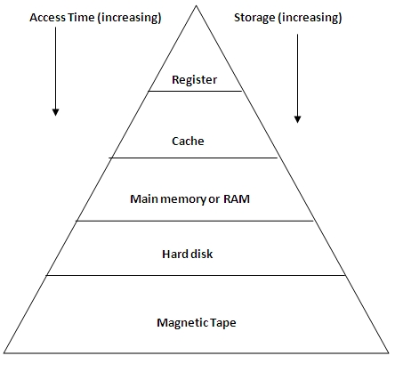
1.8 Unit of memory:
1 Byte = 8 bits

1 KB (Kilo Bytes) = 1024 bytes

1 MB (Mega Bytes) = 1024 KB

1 GB (Giga Bytes) = 1024 MB

1 TB (Tera Bytes) = 1024 GB

1 PB ( Peta Bytes) = 1024 TB

1.9 Operating System: It is the set of programs that controls a computer and works as an interface between user and hardware. e.g.

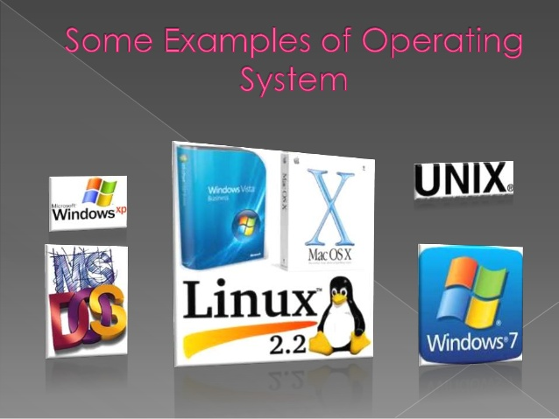

Functions of an Operating System:
- Process Management: It controls all processes from start to shutdown. It also control creation and deletion of user and system processes.
- Memory Management: It controls allocation and deallocation of memory space as per need. It controls loading of processes when space is available.
- File Management: It controls creation, deletion, renaming, copying and moving of file and directories.
- Security Management: It performs many tasks like Alert message, password and firewall protection.
- Command interpreter: It works as an interface between user and system. Two types of interface like Command line and Graphical User Interface (GUI).In command line user interact with the system by command to perform specific task while in GUI user interact with the help of mouse to access windows icons and menus.

Types of Operating System:
- Single User: One user can access one computer at a time e.g. DOS
- Multi User: Many users can access the same computer at the same time and different time e.g. Windows NT, UNIX
- Multiprocessing: more than one processor is there e.g. UNIX, LINUX, and WINDOWS XP
- Multitasking: It allows many software processes to run at the same time e.g. UNIX, LINUX, and WINDOWS 7.
- Multithreading: It allows different parts of a software program to run concurrently e.g. LINUX, UNIX and WINDOWS XP.

Android: Android is a mobile operating system (OS) based on the Linux kernel and currently developed by Google. It’s source code is released by Google under open source licenses. It uses touch inputs that loosely correspond to real-world actions, like swiping, pinching, and reverse pinching to manipulate on-screen objects. It is the most widely used mobile OS and, as of 2013. Google Play store has over 1 million Android apps published, and over 50 billion apps downloaded.

DOS (Disk Operating System): DOS was the first operating system used by IBM-compatible computers. It was originally available in two versions that were essentially the same, but marketed under two different names. "PC-DOS" was the version developed by IBM and sold to the first IBM-compatible manufacturers. "MS-DOS" was the version that Microsoft bought the rights to, and was bundled with the first versions of Windows.
DOS uses a command line, or text-based interface, that allows the user to type commands. This made the operating system difficult for novices to use, which is why Microsoft later bundled the graphic-based Windows operating system with DOS. The first versions of Windows (through Windows 95) actually ran on top of the DOS operating system. Windows operating system was rewritten for Windows NT (New Technology), which enabled Windows to run on its own, without using DOS. Later versions of Windows, such as Windows 2000, XP, and Vista, also do not require DOS.

Windows Operating System: It is a graphical user interface based operating systems developed, marketed, and sold by Microsoft. It was developed by Microsoft to overcome the limitations of DOS OS. First successful version of this was windows 3.0 released in 1990. It is basically an environment where different programs can run at the same time. It consists of several families like Windows NT, Windows Embedded and Windows Phone. Microsoft Windows came to dominate the world's personal computer market with over 90% market share, overtaking Mac OS, which had been introduced in 1984.

Linux: Open source operating system which is enhanced and backed by thousands of programmers worldwide. Its name is derived from its originator Linus Torvalds who was a student at the University of Helsinki, Finland in early 1990. It is a multi tasking and multiprocessing operating system (OS). It has two interfaces known as the shell or command-line interface (CLI) and a graphical user interface (GUI. For desktop systems, the default mode is usually a graphical user interface.

1.10 A number system: It defines how a number can be represented using distinct symbols. A number can be represented differently in different systems. For example, the two numbers (2A)₁₆ and (52)₈ both refer to the same quantity, (42)₁₀, but their representations are different.
In a positional number system, the position a symbol occupies in the number determines the value it represents. In this system, a number represented as:
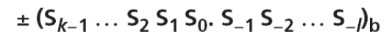
has the value of:
Where S is the set of symbols, b is the base (or radix).

The decimal system (base 10)
The word decimal is derived from the Latin root decem (ten). In this system the base b = 10 and we use ten symbols
S = {0, 1, 2, 3, 4, 5, 6, 7, 8, 9}
The symbols in this system are often referred to as decimal digits or just digits.
The following shows the place values for the integer +224 in the decimal system.
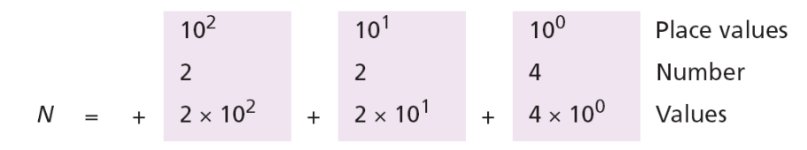
Note that the digit 2 in position 1 has the value 20, but the same digit in position 2 has the value 200. Also note that we normally drop the plus sign, but it is implicit.
The following shows the place values for the real number +24.13.
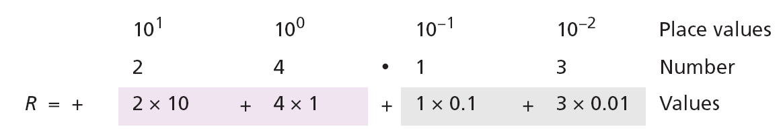

Binary Number: The word binary is derived from the Latin root bini (or two by two). In this system the base b = 2 and we use only two symbols,
S = {0, 1}
The symbols in this system are often referred to as binary digits or bits (binary digit). The following shows that the number (11001)₂ in binary is the same as 25 in decimal. The subscript 2 shows that the base is 2.
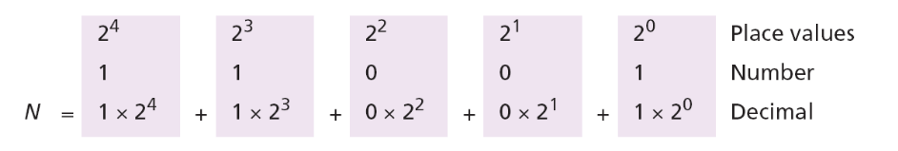
The equivalent decimal number is N = 16 + 8 + 0 + 0 + 1 = 25.

The following shows that the number (101.11)₂ in binary is equal to the number 5.75 in decimal.
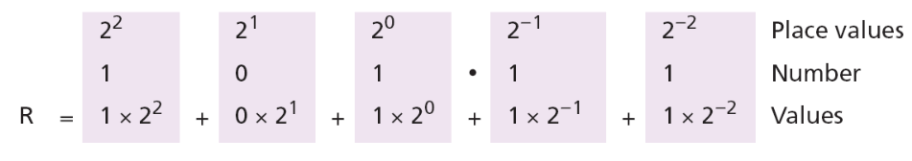
The hexadecimal system (base 16):
The word hexadecimal is derived from the Greek root hex (six) and the Latin root decem (ten). In this system the base b = 16 and we use sixteen symbols to represent a number. The set of symbols is
S = {0, 1, 2, 3, 4, 5, 6, 7, 8, 9, A, B, C, D, E, F}
Note that the symbols A, B, C, D, E, F are equivalent to 10, 11, 12, 13, 14, and 15 respectively. The symbols in this system are often referred to as hexadecimal digits. The following shows that the number (2AE)16 in hexadecimal is equivalent to 686 in decimal.
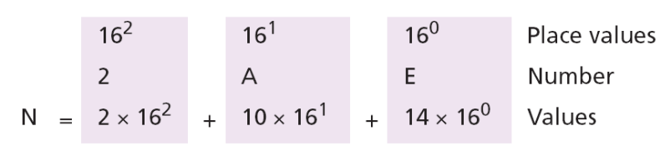
The equivalent decimal number is N = 512 + 160 + 14 = 686.

The octal system (base 8):
The word octal is derived from the Latin root octo (eight). In this system the base b = 8 and we use eight symbols to represent a number. The set of symbols is
S = {0, 1, 2, 3, 4, 5, 6, 7}
The following shows that the number (1256)₈ in octal is the same as 686 in decimal.
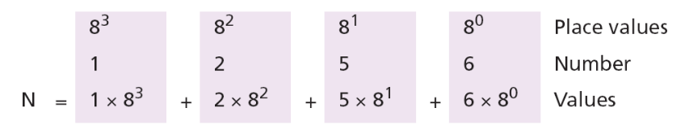
Note that the decimal number is N = 512 + 128 + 40 + 6 = 686.
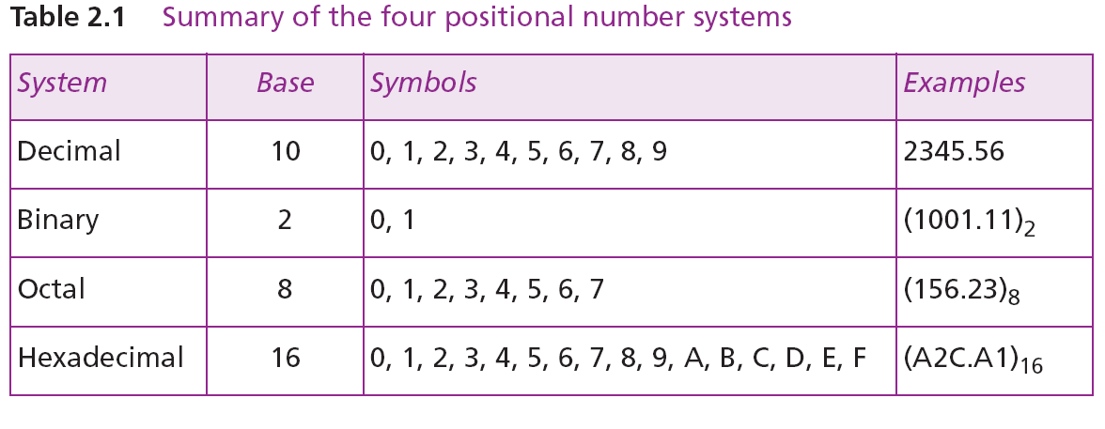

1.11 Numbers base Conversion: We need to know how to convert a number in one system to the equivalent number in another system. Since the decimal system is more familiar than the other systems, we first show how to covert from any base to decimal. Then we show how to convert from decimal to any base. Finally, we show how we can easily convert from binary to hexadecimal or octal and vice versa.

Any base to decimal conversion
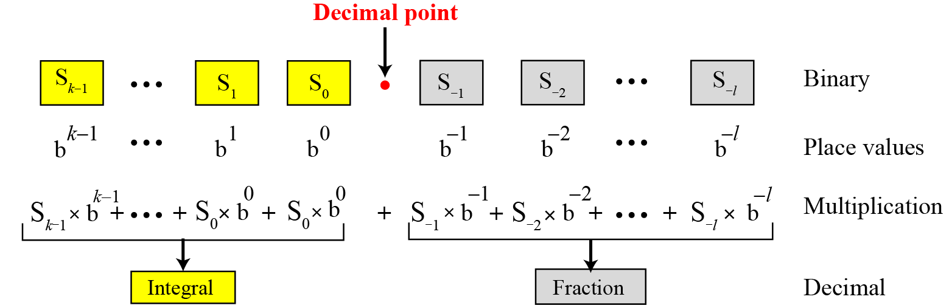

The following shows how to convert the binary number (110.11)₂ to decimal: (110.11)₂ = 6.75.
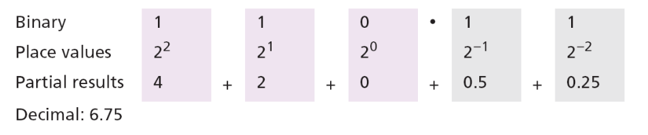
The following shows how to convert the hexadecimal number (1A.23)₁₆ to decimal.
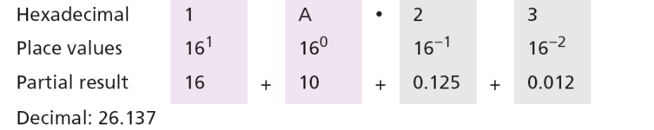
Note that the result in the decimal notation is not exact, because
3 × 16⁻² = 0.01171875. We have rounded this value to three digits (0.012). The following shows how to convert (23.17)₈ to decimal
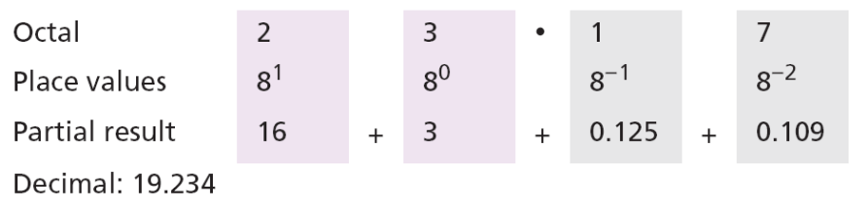

This means that (23.17)8 ≈ 19.234 in decimal. Again, we have rounded up 7 × 8⁻² = 0.109375.

Decimal to any base
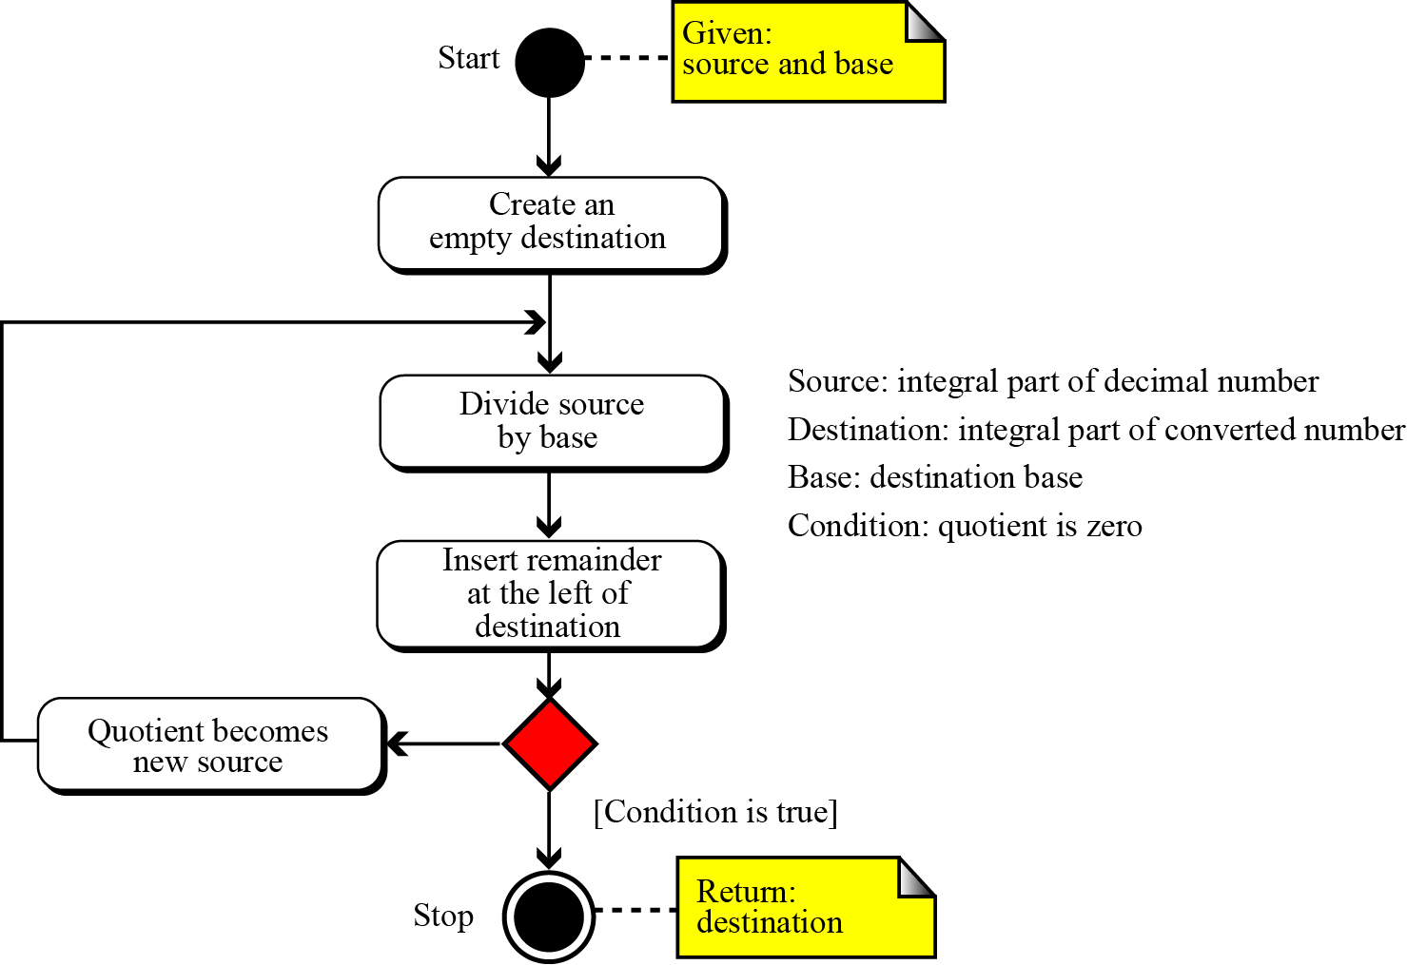
The following shows how to convert 35 in decimal to binary. We start with the number in decimal, we move to the left while continuously finding the quotients and the remainder of division by 2. The result is 35 = (100011)₂.
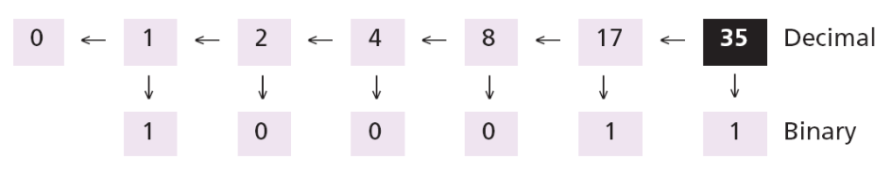
The following shows how to convert 126 in decimal to its equivalent in the octal system. We move to the right while continuously finding the quotients and the remainder of division by 8. The result is 126 = (176)₈.
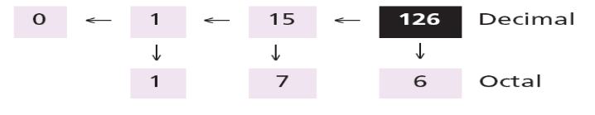
The following shows how we convert 126 in decimal to its equivalent in the hexadecimal system. We move to the right while continuously finding the quotients and the remainder of division by 16. The result is 126 = (7E)₁₆
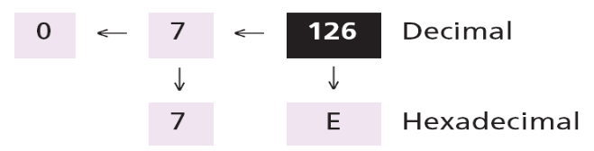

Converting the fractional part of a number in decimal to other bases:
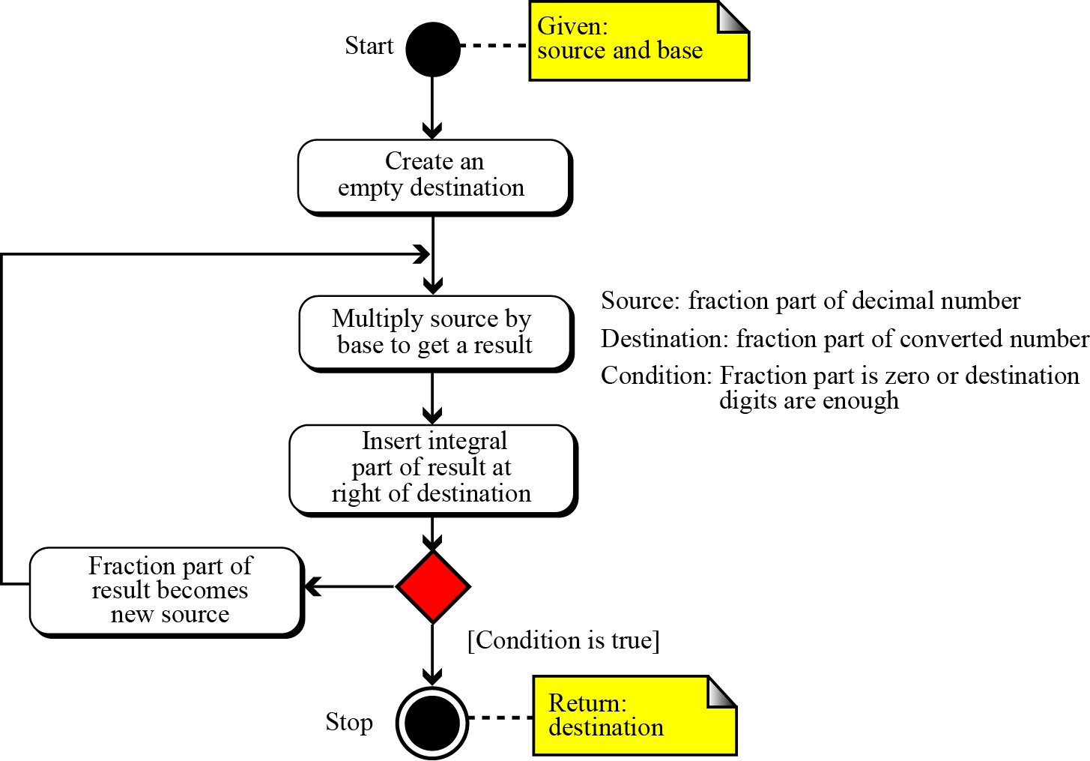
Convert the decimal number 0.625 to binary.
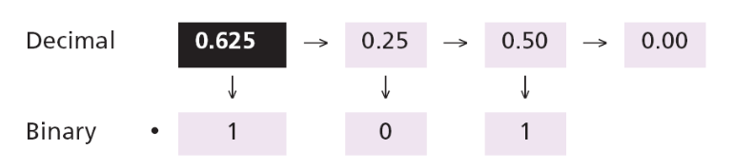
Since the number 0.625 = (0.101)₂ has no integral part, the example shows how the fractional part is calculated.
The following shows how to convert 0.634 to octal using a maximum of four digits. The result is 0.634 = (0.5044)₈. Note that we multiple by 8 (base octal).
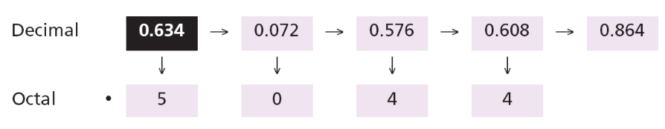
The following shows how to convert 178.6 in decimal to hexadecimal using only one digit to the right of the decimal point. The result is 178.6 = (B2.9)₁₆ Note that we divide or multiple by 16 (base hexadecimal).
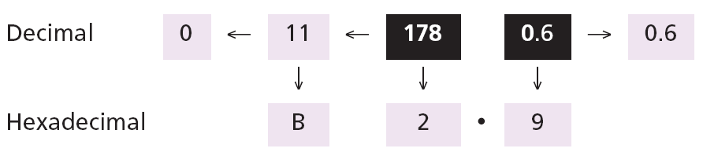

Binary-hexadecimal conversion:
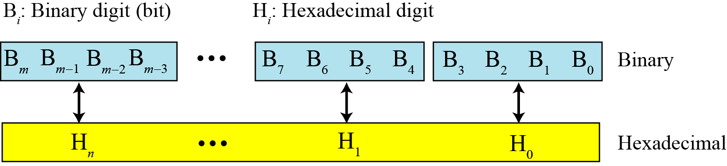

Show the hexadecimal equivalent of the binary number (110011100010)₂.
Solution
We first arrange the binary number in 4-bit patterns:
100 1110 0010
Note that the leftmost pattern can have one to four bits. We then use the equivalent of each pattern shown in Table 2.2 on page 25 to change the number to hexadecimal: (4E2)16.
What is the binary equivalent of (24C)₁₆?
Solution
Each hexadecimal digit is converted to 4-bit patterns:
2 → 0010, 4 → 0100, and C → 1100
The result is (001001001100)₂.
Binary-octal conversion:
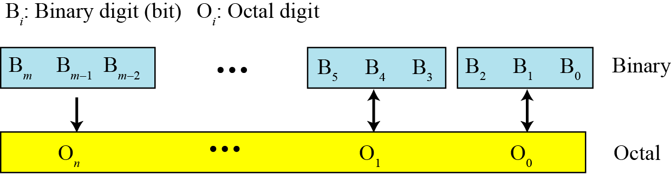

Show the octal equivalent of the binary number (101110010)₂.
Solution
Each group of three bits is translated into one octal digit. The equivalent of each 3-bit group is shown in Table 2.2 on page 25.
101 110 010
The result is (562)₈.
What is the binary equivalent of for (24)₈?
Solution
Write each octal digit as its equivalent bit pattern to get
2 → 010 and 4 → 100
The result is (010100)₂.

Octal-hexadecimal conversion:
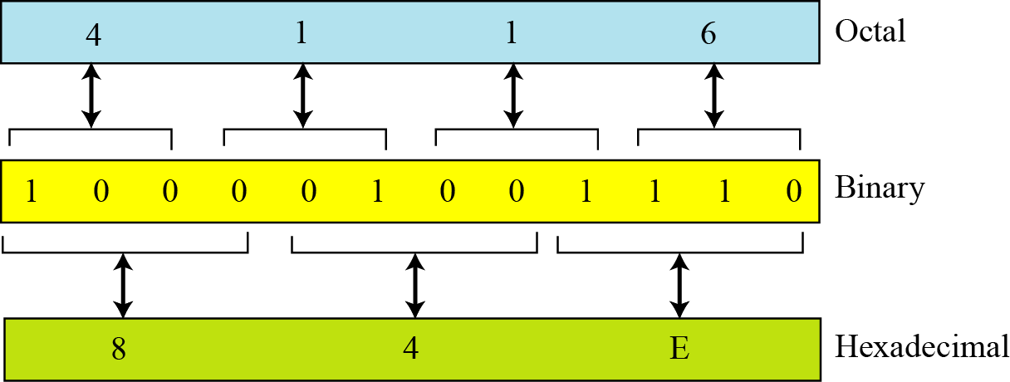

1.12 Binary Arithmatic:
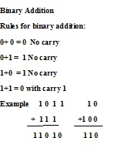
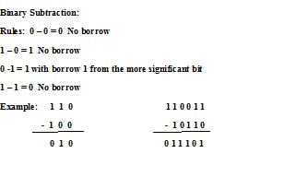
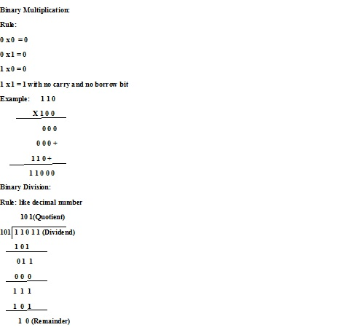

1.13 Computer languages: we use a computer language to write a program in computer. A computer language is a set of predefined words and predefined rules (syntax). Over the years, computer languages have evolved from machine language to high-level languages.

Machine Languages (First Generation Language):
In the earliest days of computers, the only programming languages available were machine languages. Each computer had its own machine language, which was made of streams of 0s and 1s. It is the language understood by a computer. In this data and operation is represented in terms of binary number. We use Opcode as shown in the table.
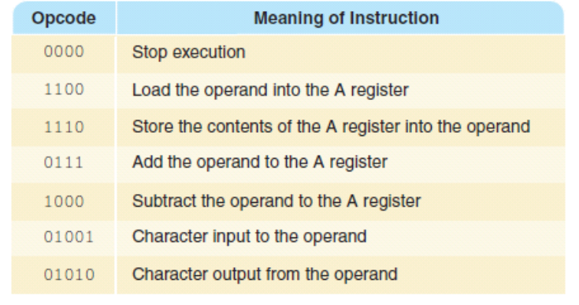

Assembly Language (2nd Generation language):
The next evolution in programming came with the idea of replacing binary code for instruction and addresses with symbols or mnemonics. Because they used symbols, these languages were first known as symbolic languages. The set of these mnemonic languages were later referred to as assembly languages.
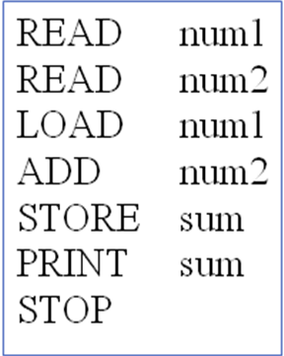

High Level Language (3rd Generation Language):
Although assembly languages greatly improved programming efficiency, they still required programmers to concentrate on the hardware they were using. Working with symbolic languages was also very tedious, because each machine instruction had to be individually coded. The desire to improve programmer efficiency and to change the focus from the computer to the problem being solved led to the development of high-level languages.
Over the years, various languages, most notably BASIC, COBOL, Pascal, Ada, C, C++ and Java, were developed. Program for adding two integers in C is shown below.
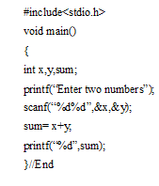
Non-Procedural Languages (4th Generation Language):
These are easy to understand and use like Query Language SQL. Such languages enable a person to specify exactly what information they require from the database and usually embedded within database management.
Writing query:
Select name, class, address from student where rollno=10;

Natural Languages (5th Generation Language):
Natural-Language: Languages that use ordinary conversation in one’s own language. Research and experimentation toward this goal is being done. Intelligent compilers are now being developed to translate natural language (spoken) programs into structured machine-coded instructions that can be executed by computers. Effortless, error-free natural language programs are still some distance into the future.
Typical examples of a 5GL include Prolog and Mercury.

1.14 Difference among hardware, software and firmware:
Hardware | Software | Firmware
The physical components of computers are called hardware such as input devices, output devices, processing devices, memory devices etc.  Example: Registers, CPU, Hard Disk, Floppy Disk, Printers, and Mouse etc which are touchable, visible and replaceable. | The collection of program and other associated documents that helps to control, manage and integrate the components of computer system to accomplish a specific task. It is a non-touchable, non viable set of instructions coded in computer languages. It is a vital part of computer, without it computer is nothing.  Example: Operating system, compiler and interpreter, application software etc. | Pre written program that is stored in ROM. It configures the computer and not easily modified by users.  Example: Instructions coded in BIOS (Basic Input Output Service) are example of Firmware. Firmware ROM contains loader program to load a program into memory.

1.15 Software Classification: Software can be classified as follows

System Software
Like Operating System (Windows, DOS, Linux etc.) Utility software
e.g. compiler, Interpreter

Application Software

General purpose Specific Purpose
e.g. MS Office e.g. Library Information system

Compiler: It is a software which converts (or translates) source program written using high level language into object code.
Compiler
Program in HLL Object code

It checks whole program lexically, syntactically and if error then give message to the programmer and does not convert into object code.
Example: Turbo C++, gcc etc.

Interpreter: It translate program into machine code.
Interpreter

Program machine code

Get next instruction

It checks program statement by statement and convert into machine if there is no error. Therefore it is slower than compiler.
Example: Thin Basic for Windows, Java Script engine for Java Script.

Assembler: It converts program written in assembly language or symbolic language into machine code.
Assembler
Program Executable code

Example: MASSAM (Microsoft Assembler), FASM (Flat Assembler)

Linker: In high level languages, some built in header files or libraries are stored. These libraries are predefined and these contain basic functions which are essential for executing the program. These functions are linked to the libraries by a program called Linker. If linker does not find a library of a function then it informs to compiler and then compiler generates an error. The compiler automatically invokes the linker as the last step in compiling a program.

Loader: It is a part of the OS that brings an executable file residing on disk into memory and starts it running. Loading a program involves reading the contents of executable file into memory.

1.16 Algorithm: It is a well-ordered collection of steps in order to achieve a solution of a problem. It is for user understanding.

Characteristics of an Algorithm:

Easy to understand: steps should be clear and easy to understand.

Definiteness: The definiteness property assures that the agent executing the instructions will always know what command to perform next.

Effectiveness: Effectiveness assures the computer can accomplish the command.

Finiteness: An algorithm must eventually end / terminate with either the “right” output or an indication that no solution is possible.

Efficient: It should be efficient time wise and memory wise.

Algorithm to find average of two numbers

Step1: Start
Step 2: Input two numbers
Step3: Calculate average
Step 4: Print average
Step 5: Stop
There are generally three various ways to represent an algorithm.
- Pseudocode
- Flow Chart
- Program

1.17 Pseudocode (or Program Design Language): It is representation of an algorithm in code like format. It will be closer to any high level language like C, Pascal, Fortran etc. It is for programmer understanding.
Read A ,B
Sum =A+B
Avg = Sum/2
Print Avg

1.18 Flow Chart: It is used to visualize an algorithm. It means it is pictorial representation of the algorithm which shows the flow of steps in an algorithm.
Symbol used in flow chart:
?
Start/Stop

Input/ Output False
Decision Box

Process
True

Flow of steps

Connector

Algorithm to calculate age:
  - Start
  - Get year born
  - Calculate age
  - Print age
  - If age > 50 print OLD
  - End

Flow chart:
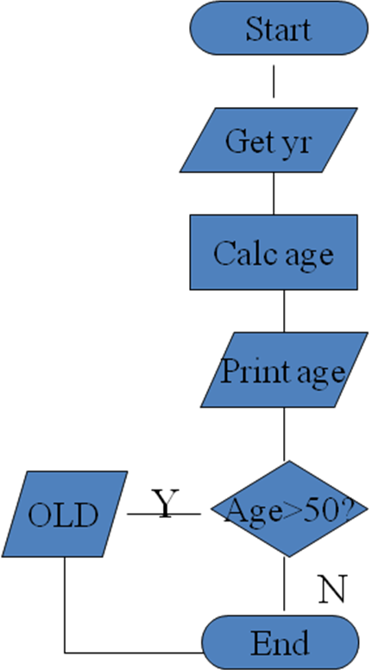

To find the biggest between two numbers

Algorithm:
Step 1 Start
Step 2. Input A, B
Step 3. Comprare A and B
Step 4. Print Biggest one
Step 5. Stop

Pdeudo code
Read A,B
If A>B
Print A
Else
Print B

Flow Chart:
Start
Print A
A >B?
Print B
Read A, B
Stop

False

True

Questions
From 2011-2012

Q.1. What is an Algorithm? What are different types of algorithm? Write its properties. Find
largest of 3 numbers.

Q.2. Draw neat and clean diagram of digital computer.

Q.3. What is Operating system? Write about multiprogramming and multithreading.

Q.4 Perform the following:
(786)₁₀ = ( )₂
(10101.1101)₂ = ( )₈
(161)₈ = ( )₁₀
(11101001)₂ = ( )₁₆

Q.5. What are Symbols used in flowchart? Draw flowchart of factorial of a number. Write about
Generation of computers along with advantages and disadvantages?

Q.6.What is goals of operating system?

Q7. What do you mean by System software and application software?

Q.8. Write difference between compiler and interpreter.

Q.9.Differentiate between:
a. High and low level language.
b. Compiler and interpreter.
c. Logical and runtime error.
d. Algorithm and flowchart.

Q.10. Define Operating system. Name of 4 OS. Write its features.

Q.11. For a digital computer explain the following:
a. Cache memory.
b. Control unit.
c. ALU.

Q.12. Convert:
a. (999)₁₀ = (? )₁₆
b. (11011101999)₂ = (? )₈
c. (786)₁₀ = ( ?)_{BCD}
d. Two’s complement of 1100100. And write the value in decimal.

From 2012-2013

Q.1. Define CPU. Explain its major components.

Q.2. What do you mean by application software? Give any two examples.

Q.3. What is an operating system? List the various types of OS.

Q.4. What do you mean by algorithm? Discuss characteristics of algorithm.

Q.5. What is secondary memory? Give any two examples.

Q.6. How plotter is different from printer.

Q.7. Convert the following:
a) (1110101.101)₂ = (? )₈
b) (5454.11)₆ = ( ?)₁₀
c) (CD1B)₁₆ = (? )₈
d) (254.5)₁₀ = (? )₂
Q.8. Write about various types of programming languages and their characteristics.

Q.9. Convert the following:
(D123.AB)₁₆ = ( ?)₁₀
(-76)₈ = (? )₁₀
(AB15)₁₆ + (EF5)₁₆ = (? )₁₀
(642)₈ = (? )₁₀

Q.10. Draw neat diagram of digital computer.

From 2013-14

Q.1. Write in brief about the components of central processing unit of a computer.

Q.2. Make the hierarchy of different memories available in a computer.

Q.3. Write difference between compiler and interpreter.

Q.4. Define operating system with its different functions.

Q.5. Convert the following:
a) (FA1.2C)₁₆=(?)₈
b) (756)₁₀=(?)₄
c) (11011.011)₂=(?)₁₆
d) (574.32)₈=(?)₂

Q.6. Define algorithm. Make flowchart to find prime numbers between 101 and 999.

From 2014 -15
Q.1. What are the classification of computer? Explain any two in detail.
Q.2. Describe the functionalities of an operating system.
Q.3. Convert the hexa decimal number (A9C5.DB4)₁₆ to octal number.
Q.4. Draw a flowchart to find the sum and reverse of a given number.
Q.5. Discuss various functionalities of compiler, linker and loader.
Q.6. Describe about the basic components of computer with a neat block diagram.
Q.7. Draw the memory hierarchical structure of a computer system. Explain each memory unit in brief.
Q.8. What is an operating system? Describe the functionalities of operating system.
Q.9. Describe compiler, interpreter, assembler? Write the names of compiler that are used in C programming.
Q.10. What do you mean by algorithm? Explain the properties of algorithm?
Q.11. Differentiate between high level and machine level language?
Q.12. What is pseudo code? Differentiate between flowchart and algorithm with example.
Q.13. Convert the following numbers into:
a) (11010.0110)₂ = (…)₁₀
b) (110101011.0110110)₂ = (…)₈
c) (2B6D)₁₆ = (…)₂
d) (AB4F.C1)₁₆ = (…)₁₀
e) (54)₆ = (…)₄

From 2015 -16 (Even Sem.)(2 Marks each)
- What do you mean by Algorithm?
- What are various components of Operating System?
- Convert the octal number 2354 to hexadecimal number.
- Write short note on Android O.S.
- Give the architecture of UNIX.
- Differentiate between RAM and ROM
- What do you mean by Software?

From 2015 -16 (Odd Sem.)(2 Marks each)
- List five internal and external commands used in DOS Operating System.
- Give difference between android and windows O.S.
- Justify that operating system is a resource manager
- What is algorithm and its characteristics?
- Difference between Algorithm and flowchart
- Difference between Logical error and run time error.
- Difference between High level language and low level language.

