Name – Anubhav Srivastava
Superset id - 7995228
Design principles & Patterns

Exercise 1: Implementing the Singleton Pattern
Scenario:
You need to ensure that a logging utility class in your application has only one instance throughout the application lifecycle to ensure consistent logging.
Steps:
- Create a New Java Project:
  - Create a new Java project named SingletonPatternExample.
- Define a Singleton Class:
  - Create a class named Logger that has a private static instance of itself.
  - Ensure the constructor of Logger is private.
  - Provide a public static method to get the instance of the Logger class.
- Implement the Singleton Pattern:
  - Write code to ensure that the Logger class follows the Singleton design pattern.
- Test the Singleton Implementation:
  - Create a test class to verify that only one instance of Logger is created and used across the application.

Ans
Logger.java
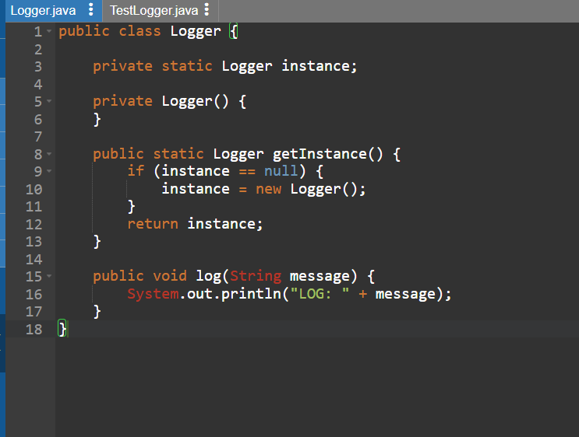

TestLogger.java
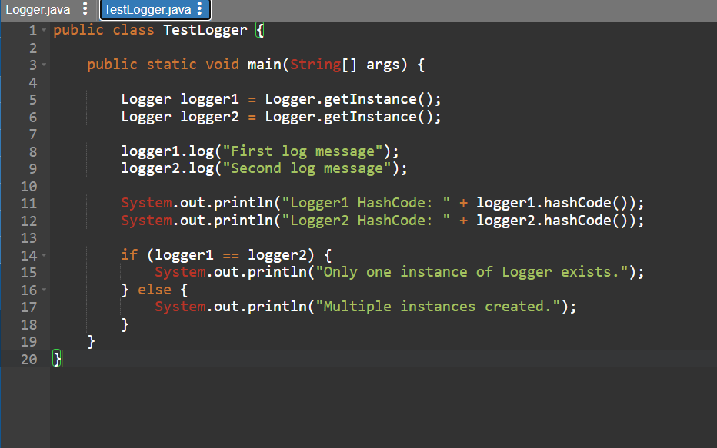

Output
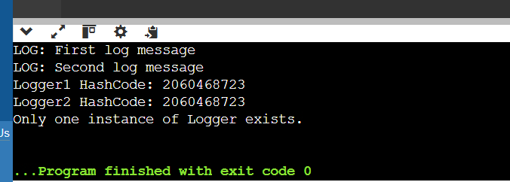

Exercise 2: Implementing the Factory Method Pattern
Scenario:
You are developing a document management system that needs to create different types of documents (e.g., Word, PDF, Excel). Use the Factory Method Pattern to achieve this.
Steps:
- Create a New Java Project:
  - Create a new Java project named FactoryMethodPatternExample.
- Define Document Classes:
  - Create interfaces or abstract classes for different document types such as WordDocument, PdfDocument, and ExcelDocument.
- Create Concrete Document Classes:
  - Implement concrete classes for each document type that implements or extends the above interfaces or abstract classes.
- Implement the Factory Method:
  - Create an abstract class DocumentFactory with a method createDocument().
  - Create concrete factory classes for each document type that extends DocumentFactory and implements the createDocument() method.
- Test the Factory Method Implementation:
  - Create a test class to demonstrate the creation of different document types using the factory method.
ANS
DocumentFactoryDemo.java
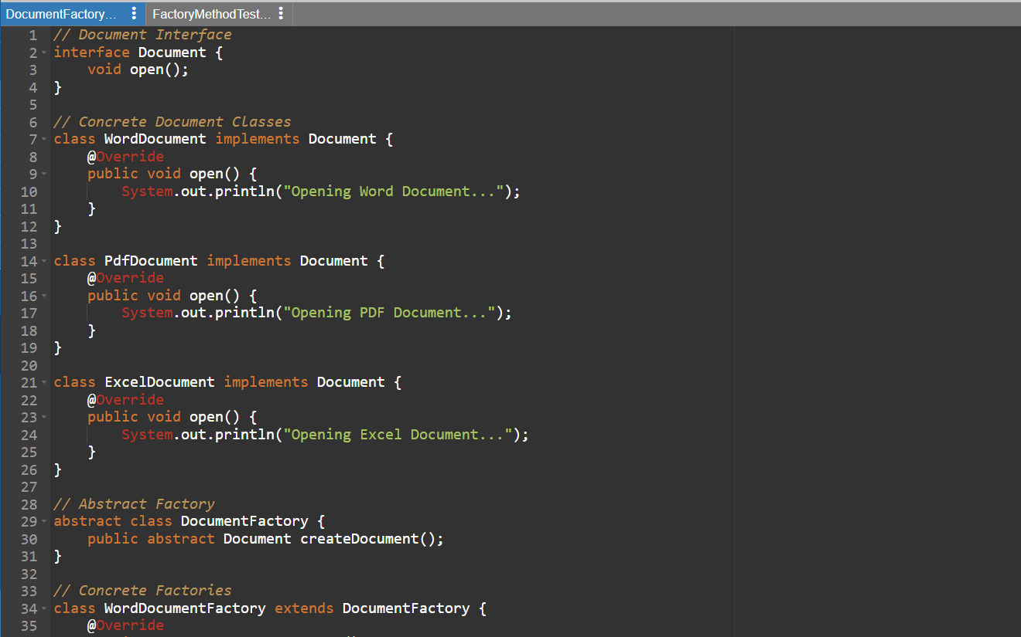
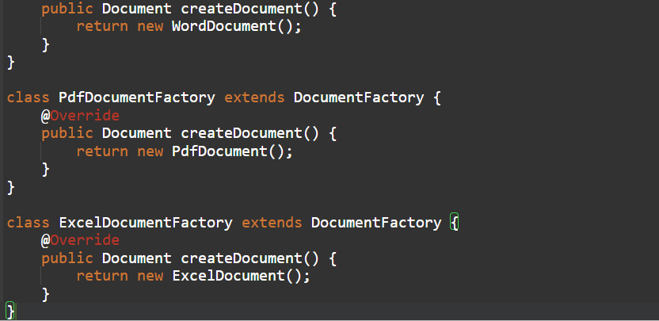

FactoryMethodTest.java

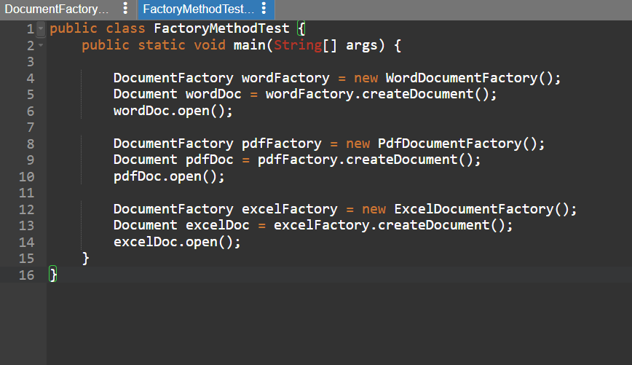

Output
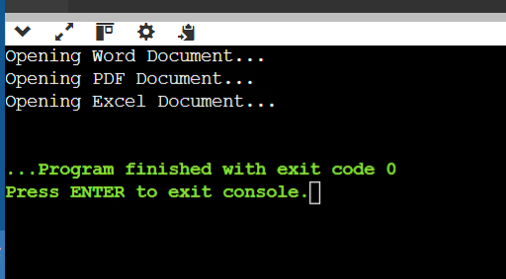

Data structures and Algorithms

Exercise 2: E-commerce Platform Search Function
Scenario:
You are working on the search functionality of an e-commerce platform. The search needs to be optimized for fast performance.
Steps:
- Understand Asymptotic Notation:
  - Explain Big O notation and how it helps in analyzing algorithms.
  - Describe the best, average, and worst-case scenarios for search operations.
- Setup:
  - Create a class Product with attributes for searching, such as productId, productName, and category.
- Implementation:
  - Implement linear search and binary search algorithms.
  - Store products in an array for linear search and a sorted array for binary search.
- Analysis:
  - Compare the time complexity of linear and binary search algorithms.
  - Discuss which algorithm is more suitable for your platform and why.

ANS

1. Big O Notation
Big O notation measures how the running time of an algorithm grows as the input size (n) increases.
Examples:
- O(1) → Constant time
- O(log n) → Logarithmic time
- O(n) → Linear time
- O(n²) → Quadratic time
It helps compare algorithms and choose the most efficient one for large datasets.
Search Operation Cases
Case | Linear Search | Binary Search
Best Case | O(1) | O(1)
Average Case | O(n) | O(log n)
Worst Case | O(n) | O(log n)
Best Case: Element found at the beginning.
- Average Case: Element found somewhere in the middle.
- Worst Case: Element at the end or not present.

2. ECommerceSearch.java
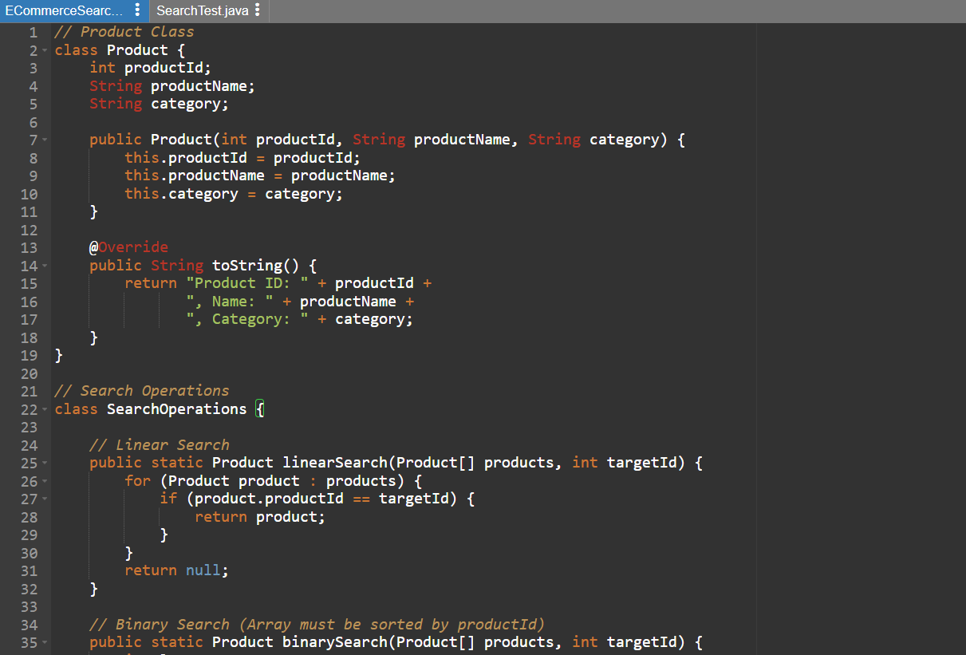
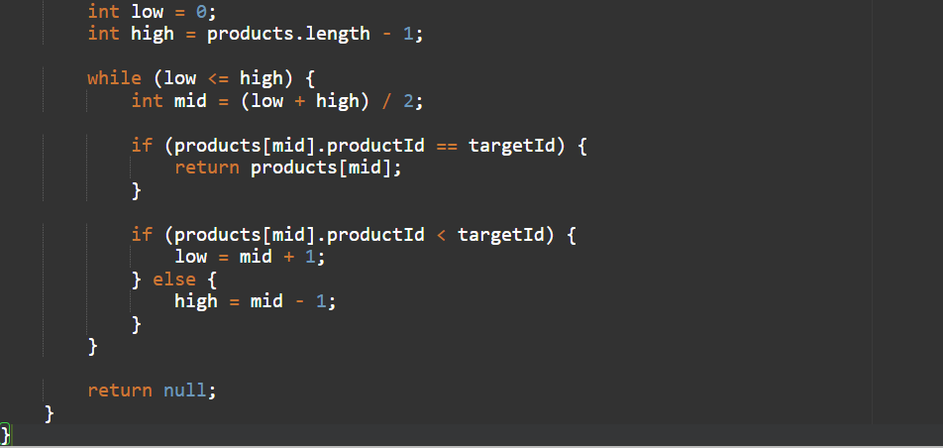

SearchTest.java
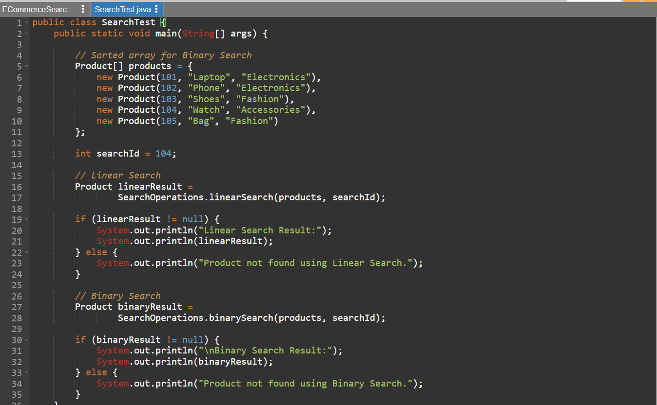

Output

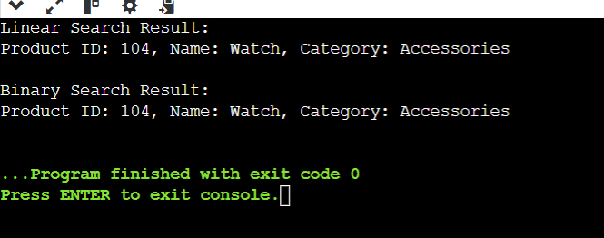

3. Analysis

Linear Search
- Checks each element one by one.
- Time Complexity:
  - Best Case: O(1)
  - Average Case: O(n)
  - Worst Case: O(n)
Binary Search
- Repeatedly divides the search space in half.
- Requires a sorted array.
- Time Complexity:
  - Best Case: O(1)
  - Average Case: O(log n)
  - Worst Case: O(log n)

For an e-commerce platform with thousands or millions of products, Binary Search is more suitable because:
- It is much faster for large datasets.
- It reduces the number of comparisons significantly.
- Search performance remains efficient as the product catalog grows

Exercise 7: Financial Forecasting
Scenario:
You are developing a financial forecasting tool that predicts future values based on past data.
Steps:
- Understand Recursive Algorithms:
  - Explain the concept of recursion and how it can simplify certain problems.
- Setup:
  - Create a method to calculate the future value using a recursive approach.
- Implementation:
  - Implement a recursive algorithm to predict future values based on past growth rates.
- Analysis:
  - Discuss the time complexity of your recursive algorithm.
  - Explain how to optimize the recursive solution to avoid excessive computation.

ANS
1.
Recursion is a programming technique where a method calls itself to solve a smaller version of the same problem until a base condition is reached.
A recursive solution consists of:
- Base Case – stops the recursion.
- Recursive Case – calls itself with a smaller input.

- Makes code shorter and easier to understand for repetitive calculations.
- Useful for problems that can be broken into smaller subproblems.
For financial forecasting, each year's value can be calculated from the previous year's value using the growth rate.

2.
Assume:
- Present Value = ₹10,000
- Annual Growth Rate = 10% (0.10)
- Number of Years = 5
Formula:
$$FutureValue=PresentValue×(1+GrowthRate)^{n}$$
Using recursion:
$$FV(n)=FV(n-1)×(1+GrowthRate)$$
Base Case:
$$FV(0)=PresentValue$$

3.
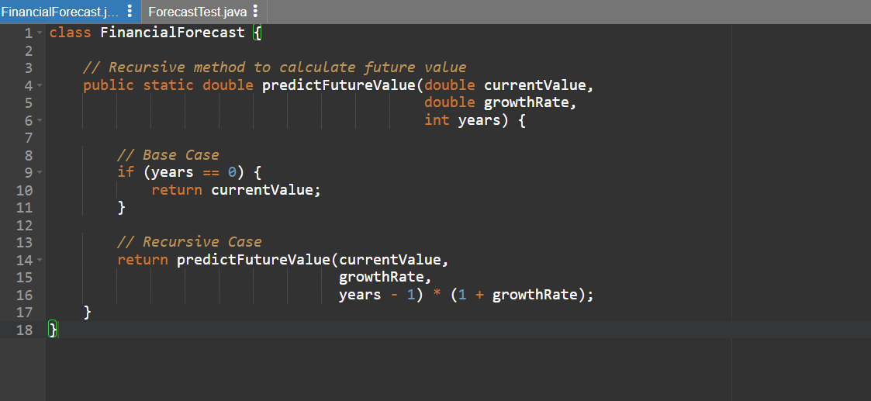

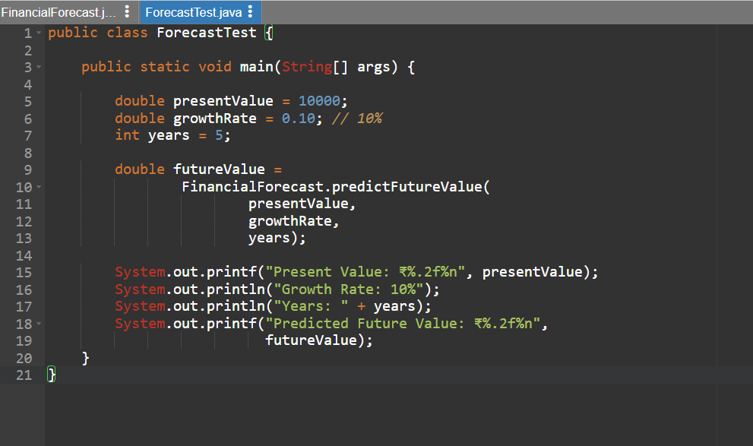

Output
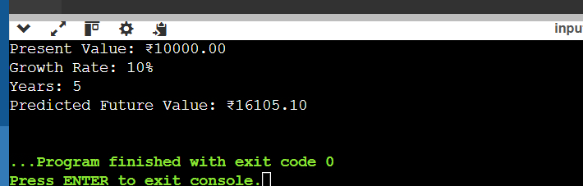

4.

ime Complexity
For the recursive method:
predictFutureValue(value, rate, years)
The function makes one recursive call for each year.
Therefore:
- Number of recursive calls = n
- Time Complexity = O(n)
- Space Complexity = O(n) (due to the recursion stack)

1. Iterative Approach
Instead of recursion, use a loop:
double futureValue = currentValue;
for(int i = 0; i < years; i++) {
futureValue *= (1 + growthRate);
}
- Time Complexity: O(n)
- Space Complexity: O(1)
2. Using Mathematical Formula
double futureValue =
currentValue * Math.pow(1 + growthRate, years);
- Time Complexity: approximately O(log n)
- Space Complexity: O(1)
This is the most efficient approach for financial forecasting.

