AP Calculus BC — Mock Exam 05

Topic Focus: Power series: radius and interval of convergence | Vector-valued functions: position, velocity, acceleration, speed | Higher-order derivatives | Lagrange error bound for Taylor polynomials | Implicit differentiation Total Time: 195 minutes | Total Questions: 45 MCQs + 6 FRQs

SECTION I — MULTIPLE CHOICE

Part A — Questions 1–30 | 60 minutes | NO CALCULATOR
Question 1 | Topic: Unit 2: Differentiation | Difficulty: ★☆☆ If $f(x)=sin(x^{2})$, then $f^{'}(x)=$
(A) $cos(x^{2})$
(B) $2xcos(x^{2})$
(C) $\cos\left(2x\right)$
(D) $-2xcos(x^{2})$
Question 2 | Topic: Unit 3: Higher-Order Derivatives | Difficulty: ★★★☆ If $y=xe^{x}$, then $\frac{d^{2}y}{dx^{2}}=$
(A) $e^{x}(x+2)$ (B) $e^{x}(x+1)$ (C) $x^{2}e^{x}$ (D) $2e^{x}$
Question 3 | Topic: Unit 6: Integration | Difficulty: ★☆☆☆ $\int_{0}^{π/4}{\sec^{2}}x dx=$
(A) -1 (B) 0 (C) 1 (D) 2
Question 4 | Topic: Unit 1: L’Hôpital’s Rule | Difficulty: ★★☆☆ $\lim_{x→0}\frac{sinx}{x}=$ (A) 0 (B) 1 (C) 2 (D) $∞$
Question 5 | Topic: Unit 3: Implicit Differentiation | Difficulty: ★★☆ If $x^{2}+xy+y^{2}=7$, then the value of $\frac{dy}{dx}$ at the point (1,2) is
(A) $-4/5$ (B) $-3/4$ (C) $3/4$ (D) $4/5$
Question 6 | Topic: Unit 6: Integration by Substitution | Difficulty: ★★☆☆ $∫x\sqrt{x^{2}+1} dx=$ (A) $\frac{1}{3}(x^{2}+1)^{3/2}+C$ (B) $\frac{2}{3}(x^{2}+1)^{3/2}+C$ (C) $x^{2}(x^{2}+1)^{3/2}+C$ (D) $\frac{1}{2}(x^{2}+1)^{3/2}+C$
Question 7 | Topic: Unit 5: Analytical Applications | Difficulty: ★☆☆ The function $f$ is given by $f(x)=x^{3}-6x^{2}$. The graph of $f$ is concave down for which values of $x$?
(A) $x<2$ (B) $x>2$ (C) $x<0$ or $x>4$ (D) $0<x<4$
Question 8 | Topic: Unit 7: Differential Equations | Difficulty: ★★☆ Which of the following is a solution to the differential equation $\frac{dy}{dx}=2y$?
(A) $y=2x$ (B) $y=e^{2x}$ (C) $y=x^{2}$ (D) $y=e^{2x}+2x$
Question 9 | Topic: Unit 1: Limits at Infinity | Difficulty: ★☆☆☆ $\lim_{x→∞}\frac{3x^{2}+1}{x^{2}-5}=$
(A) 0 (B) 1 (C) 3 (D) $∞$
Question 10 | Topic: Unit 9: Parametric Derivatives | Difficulty: ★★☆ A particle moves in the $xy$-plane such that its position is given by $x(t)=t^{3}-3t$ and $y(t)=t^{2}-2t$. At what value of $t$ is the particle at rest?
(A) $t=0$ (B) $t=1$ (C) $t=2$ (D) There is no such $t$.
Question 11 | Topic: Unit 11: Geometric Series | Difficulty: ★★☆ Which of the following series converges?
(A) $\sum_{n=1}^{∞}{\frac{1}{n}}$ (B) $\sum_{n=1}^{∞}{\frac{n}{n^{2}+1}}$ (C) $\sum_{n=1}^{∞}{(}\frac{3}{2})^{n}$ (D) $\sum_{n=1}^{∞}{(}\frac{2}{3})^{n}$
Question 12 | Topic: Unit 6: Fundamental Theorem of Calculus | Difficulty: ★★☆ If $F(x)=\int_{0}^{x^{2}}{sin}(t^{3}) dt$, then $F^{'}(x)=$
(A) $sin(x^{6})$ (B) $2xsin(x^{6})$ (C) $sin(x^{3})$ (D) $2xsin(x^{3})$
Question 13 | Topic: Unit 4: Related Rates | Difficulty: ★★☆ A spherical balloon is inflated such that its volume is increasing at a constant rate of 20 cm³/sec. How fast is the radius of the balloon increasing when the radius is 5 cm? (Volume of a sphere: $V=\frac{4}{3}πr^{3}$)
(A) $\frac{1}{20π}$ cm/sec (B) $\frac{1}{5π}$ cm/sec (C) $\frac{1}{4π}$ cm/sec (D) $5π$ cm/sec
Question 14 | Topic: Unit 5: Optimization | Difficulty: ★★☆ A rectangle has its base on the x-axis and its upper two vertices on the parabola $y=12-x^{2}$. What is the maximum possible area of the rectangle?
(A) 8 (B) 16 (C) 32 (D) 48
Question 15 | Topic: Unit 10: Polar Coordinates | Difficulty: ★★☆ For a curve given in polar coordinates by $r=3cosθ$, which of the following expressions gives $\frac{dy}{dx}$?
(A) $-cotθ$ (B) $\frac{3\cos^{2}θ-3\sin^{2}θ}{-6sinθcosθ}$ (C) $tanθ$ (D) $\frac{3cosθ}{-3sinθ}$
Question 16 | Topic: Unit 11: Power Series | Difficulty: ★★☆ The Taylor series for $\frac{1}{1-x}$ is $\sum_{n=0}^{∞}{x^{n}}$. Which of the following is the Taylor series for $\frac{1}{1+x^{2}}$ centered at $x=0$?
(A) $\sum_{n=0}^{∞}{x^{2n}}$ (B) $\sum_{n=0}^{∞}{(}-1)^{n}x^{2n}$ (C) $\sum_{n=0}^{∞}{(}-1)^{n+1}x^{2n}$ (D) $\sum_{n=0}^{∞}{x^{n+2}}$
Question 17 | Topic: Unit 6: Integration by Parts | Difficulty: ★★★ $∫xe^{x} dx=$
(A) $xe^{x}-e^{x}+C$ (B) $xe^{x}+e^{x}+C$ (C) $\frac{x^{2}}{2}e^{x}+C$ (D) $e^{x}-xe^{x}+C$
Question 18 | Topic: Unit 11: Radius of Convergence | Difficulty: ★★★ The radius of convergence for the series $\sum_{n=1}^{∞}{\frac{(x-3)^{n}}{n⋅2^{n}}}$ is
(A) 1 (B) 2 (C) 3 (D) 4
Question 19 | Topic: Unit 5: MVT | Difficulty: ★★☆ Let $f$ be a differentiable function such that $f(1)=4$ and $f(4)=10$. Which of the following statements must be true?
(A) $f^{'}(c)=2$ for some $c$ in (1,4). (B) $f^{'}(c)=0$ for some $c$ in (1,4). (C) $f(x)=6x-2$ for all $x$. (D) $f(c)=7$ for some $c$ in (1,4).
Question 20 | Topic: Unit 9: Vector Velocity/Acceleration | Difficulty: ★★☆ A particle moves in the $xy$-plane with position $(x(t),y(t))$ such that $x(t)=e^{2t}$ and $y(t)=cos(3t)$. What is the acceleration vector of the particle at $t=0$?
(A) $⟨2,-3⟩$ (B) $⟨4,0⟩$ (C) $⟨4,-9⟩$ (D) $⟨1,1⟩$
Question 21 | Topic: Unit 8: Area between curves | Difficulty: ★★☆ The area of the region bounded by $y=x^{2}$ and $y=x$ is
(A) $1/6$ (B) $1/3$ (C) $1/2$ (D) 1
Question 22 | Topic: Unit 3: Higher-Order Derivatives | Difficulty: ★★☆ If $f(x)=ln(3x)$, find $f^{″}(x)$.
(A) $1/x$ (B) $-1/x^{2}$ (C) $1/(3x)$ (D) $1/x^{2}$
Question 23 | Topic: Unit 11: Taylor Series | Difficulty: ★★☆ What is the coefficient of $(x-π)^{2}$ in the Taylor series for $f(x)=cosx$ centered at $x=π$?
(A) -1 (B) $-1/2$ (C) 0 (D) $1/2$
Question 24 | Topic: Unit 6: Improper Integrals | Difficulty: ★★★☆ $\int_{1}^{∞}{\frac{1}{x^{2}}} dx=$
(A) 0 (B) 1 (C) 2 (D) Diverges
Question 25 | Topic: Unit 7: Differential Equations | Difficulty: ★★★☆ Which of the following differential equations is represented by the slope field shown in the figure below?
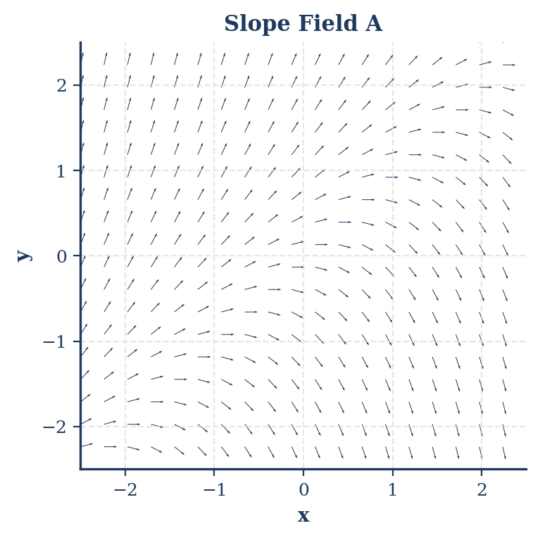
- (A) $\frac{dy}{dx}=x-y$
- (B) $\frac{dy}{dx}=y-x$
- (C) $\frac{dy}{dx}=x+y$
- (D) $\frac{dy}{dx}=-x-y$
Question 26 | Topic: Unit 11: Ratio Test | Difficulty: ★★★ For which of the following series does the Ratio Test provide no conclusive information?
(A) $\sum_{n=1}^{∞}{\frac{1}{n^{2}}}$ (B) $\sum_{n=1}^{∞}{\frac{n}{2^{n}}}$ (C) $\sum_{n=1}^{∞}{\frac{(-1)^{n}}{n!}}$ (D) $\sum_{n=1}^{∞}{\frac{2^{n}}{n!}}$
Question 27 | Topic: Unit 2: Limit Definition of Derivative | Difficulty: ★★☆ Let $f$ be a function such that $\lim_{h→0}\frac{f(2+h)-f(2)}{h}=5$. Which of the following statements must be true? (A) $f(2)=5$.
(B) $f^{'}(2)=5$.
(C) $f(x)$ is continuous at $x=5$.
(D) $f(x)$ is differentiable at $x=5$.
Question 28 | Topic: Unit 9: Arc Length | Difficulty: ★★★ The length of the curve defined by $x(t)=cost$ and $y(t)=sint$ for $0≤t≤π$ is
(A) 1
(B) 2
(C) $π$
(D) $2π$
Question 29 | Topic: Unit 11: Power Series Manipulation | Difficulty: ★★★ Given that the Taylor series for $e^{x}$ is $\sum_{n=0}^{∞}{\frac{x^{n}}{n!}}$ for all real numbers $x$. Which of the following is the Taylor series for $xe^{2x}$?
(A) $\sum_{n=0}^{∞}{\frac{x^{n+1}}{n!}}$
(B) $\sum_{n=0}^{∞}{\frac{2x^{n+1}}{n!}}$
(C) $\sum_{n=0}^{∞}{\frac{2^{n}x^{n+1}}{n!}}$
(D) $\sum_{n=0}^{∞}{\frac{2^{n}x^{n}}{n!}}$
Question 30 | Topic: Unit 8: Volume by Cross Sections | Difficulty: ★★★ The base of a solid is the region in the $xy$-plane bounded by the graphs of $y=x^{2}$ and $y=4$. For this solid, each cross section perpendicular to the $y$-axis is a square. What is the volume of the solid
(A) $\int_{0}^{4}{(}4-y)^{2} dy$
(B) $\int_{0}^{4}{y} dy$
(C) $\int_{0}^{4}{4}y dy$
(D) $\int_{0}^{4}{(}4-x^{2})^{2} dy$

Question 31
A particle moves along the x-axis. The velocity of the particle at time $t$ is given by $v(t)=3cos(2t)$ for $0≤t≤π$. What is the total distance traveled by the particle during the time interval $0≤t≤π$?
- (A) 0
- (B) 3
- $3π$
- (D) 6

Question 32
What is the average value of $f(x)=sin(x)$ on the interval $[0,π]$?
- (A) 0
- $1/π$
- $2/π$
- (D) 2

Question 33
A particle moves in the $xy$-plane such that its velocity vector is given by $v(t)=⟨t+1,sin(t^{2})⟩$. If the particle’s position at $t=0$ is $(1,-2)$, what is the x-coordinate of the particle’s position at $t=3$?
- (A) 3.5
- (B) 4.5
- (C) 8.5
- (D) 9.5

Question 34
Let $P_{3}(x)$ be the third-degree Taylor polynomial for a function $f$ about $x=0$. If $f(0)=-1$, $f^{'}(0)=-2$, $f^{″}(0)=0$, and $f^{‴}(0)=12$, then $P_{3}(1)=$
- (A) -9
- (B) -1
- (C) 0
- (D) 3

Question 35
The area of the region enclosed by the polar curve $r=4sin(θ)$ for $0≤θ≤π$ is
- (A) $2π$
- (B) $4π$
- (C) $8π$
- (D) $16π$

Question 36
The rate at which a chemical leaks from a tank is given by $R(t)=50e^{-0.1t}$ liters per hour. How many liters of chemical will leak from the tank over an infinite amount of time?
- (A) 500 liters
- (B) 50 liters
- (C) 5 liters
- (D) 0.5 liters

Question 37
A particle moves in the $xy$-plane with position given by $x(t)=cos(t^{2})$ and $y(t)=sin(t^{2})$. What is the speed of the particle at $t=1$?
- (A) 1.000
- (B) 1.414
- (C) 2.000
- (D) 4.000

Question 38
Using the line tangent to $f(x)=\sqrt{x}$ at $x=4$, approximate $\sqrt{3.9}$.
- (A) 1.975
- (B) 1.977
- (C) 2.025
- (D) 2.050

Question 39
Consider the differential equation $\frac{dy}{dx}=2x+y$. Let $y=f(x)$ be the particular solution with the initial condition $f(1)=2$. Use Euler’s method with two steps of equal size to approximate $f(1.4)$.
- (A) 3.40
- (B) 3.84
- (C) 4.20
- (D) 4.80

Question 40
For the power series $\sum_{n=1}^{∞}{\frac{(x-2)^{n}}{n^{2}}}$, the interval of convergence is
- (A) $(1,3)$
- (B) $(1,3]$
- (C) $[1,3)$
- (D) $[1,3]$

Question 41
The area of the region bounded by the curve $x=\sqrt{t}$, $y=t^{2}$ and the lines $x=0,x=2$ is given by
- (A) $\int_{0}^{2}{t^{2}} dt$
- (B) $\int_{0}^{4}{\sqrt{t}} dt$
- (C) $\int_{0}^{4}{t^{2}}\left(\frac{1}{2\sqrt{t}}\right) dt$
- (D) $\int_{0}^{2}{\frac{t^{2}}{2\sqrt{t}}} dt$

Question 42
Find the limit as $x$ approaches 0 of $\frac{e^{2x}-1}{x}$:
- (A) 0
- (B) 1
- (C) $e$
- (D) 2

Question 43
Let $P_{2}(x)$ be the second-degree Taylor polynomial for $f(x)=e^{x}$ about $x=0$. Which of the following is an upper bound for the error $|f(x)-P_{2}(x)|$ for $0≤x≤0.5$?
- (A) $\frac{1}{6}(0.5)^{3}$
- (B) $\frac{e^{0.5}}{6}(0.5)^{3}$
- (C) $\frac{e^{-0.5}}{6}(0.5)^{3}$
- (D) $\frac{1}{2}(0.5)^{2}$

Question 44
A car’s velocity, in miles per hour, is given by $v(t)=50+10sin(πt/5)$, where $t$ is in hours. What is the average velocity of the car over the interval $0≤t≤10$ hours?
- (A) 50 mph
- (B) 55 mph
- (C) 60 mph
- (D) 65 mph

Question 45
Let $f$ be a continuous function defined on the closed interval $[0,3]$ with $f(0)=2$ and $f(3)=5$. Which of the following statements must be true?
$A. f(x)=3$ for some $x$ in $[0,3]$.
$B. f^{'}(x)=1$ for some $x$ in $(0,3)$.
$C. f(x)$ has a maximum value of 5 on $[0,3]$.
$D. f(x)$ is increasing on $[0,3]$.

SECTION II — FREE RESPONSE

Part A — FRQs 1–2 | 30 minutes | CALCULATOR ACTIVE
FRQ 1 A particle moves along a curve in the $xy$-plane. The position of the particle at time $t≥0$ is given by the vector-valued function $⟨x(t),y(t)⟩$, where $x^{'}(t)=3-2sin(t^{2})$ and $y^{'}(t)=e^{-t^{2}/2}$. At time $t=1$, the particle is at the point $(4,5)$.
- Find the acceleration vector of the particle at $t=1$.
- Find the equation of the tangent line to the path of the particle at $t=1$.
- Find the speed of the particle at $t=1$.
- Find the total distance traveled by the particle from $t=0$ to $t=2$.
Part | Points | Skill
(a) | 2 | 3.4.B (Differentiating a vector-valued function)
(b) | 3 | 3.4.D (Finding tangent lines for parametric/vector functions)
(c) | 1 | 3.4.C (Calculating speed)
(d) | 3 | 3.4.C (Calculating total distance for vector functions)
FRQ 2 A certain function $f$ has derivatives of all orders for all real numbers. The Taylor series for $f(x)$ centered at $x=0$ is given by $T(x)=3+4x-\frac{5}{2!}x^{2}+\frac{6}{3!}x^{3}-\frac{7}{4!}x^{4}+⋯+(-1)^{n}\frac{n+3}{(n+1)!}x^{n}+⋯$.
- Find $f(0)$, $f^{'}(0)$, $f^{″}(0)$, and $f^{‴}(0)$.
- Write the first four nonzero terms and the general term for the Taylor series for $g(x)=f(x^{2})$ centered at $x=0$.
- Use the fourth-degree Taylor polynomial for $f$ about $x=0$ to approximate $f(0.1)$.
- The fifth derivative of $f$ satisfies $|f^{(5)}(x)|≤10$ for all $x$ in the interval $[0,0.1]$. Use the Lagrange error bound to find an upper bound for the error in the approximation found in part (c).
Part | Points | Skill
(a) | 2 | 11.2.C (Identifying Taylor coefficients)
(b) | 3 | 11.2.D (Manipulating Taylor series)
(c) | 2 | 11.2.B (Approximating function values with Taylor polynomials)
(d) | 2 | 11.2.E (Applying Lagrange error bound)

Part B — FRQs 3–6 | 60 minutes | NO CALCULATOR
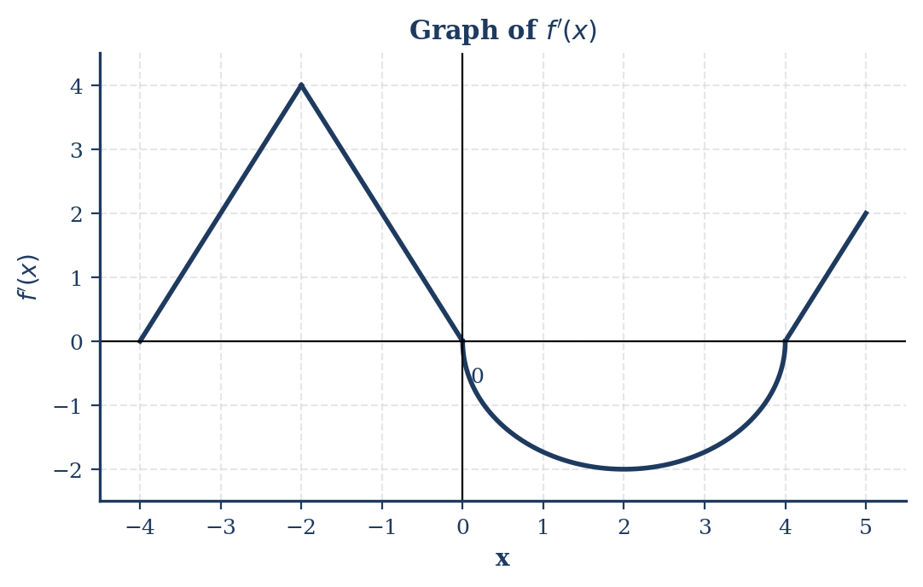
Graph of f’(x)
- Find the values of $f(-4)$ and $f(2)$.
- On what open intervals is $f$ increasing? Justify your answer.
- Find the $x$-coordinate of each point of inflection of the graph of $f$. Justify your answer.
- Find the absolute minimum value of $f$ on the interval $[-4,5]$. Justify your answer.
Part | Points | Skill
(a) | 2 | 6.2.B (Accumulation function from graph)
(b) | 2 | 5.3.A (Determining intervals of increase/decrease)
(c) | 2 | 5.3.C (Determining points of inflection)
(d) | 3 | 5.3.B (Finding absolute extrema)
FRQ 4 Consider the differential equation $\frac{dy}{dx}=\frac{x^{2}}{y}$.
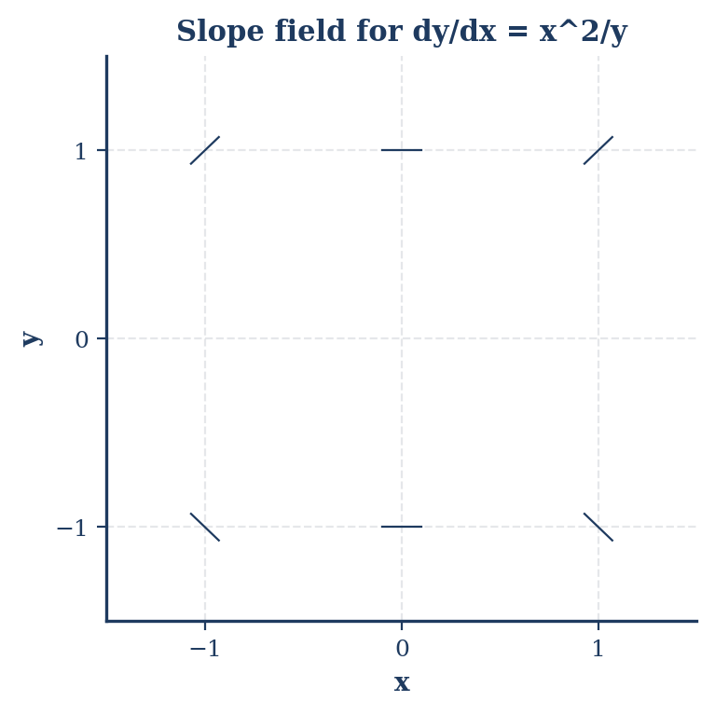
Slope field for dy/dx = x^2/y
- Find the particular solution $y=f(x)$ to the differential equation with the initial condition $f(0)=2$.
- Use your solution from part (b) to find the value of $f(3)$.
Part | Points | Skill
(a) | 2 | 7.1.B (Sketching slope fields)
(b) | 5 | 7.1.C (Solving separable differential equations)
(c) | 2 | 7.1.C (Evaluating a particular solution)
FRQ 5 Consider the function $f(x)$ defined by the power series $\sum_{n=0}^{∞}{\frac{(-1)^{n}(x-1)^{n}}{3^{n}(n+1)}}$.
- Find the radius of convergence for the power series. Show your work.
- Find the interval of convergence for the power series. Show your work.
- Write the first four nonzero terms and the general term for the series for $f^{'}(x)$.
- Evaluate $f(1)$.
Part | Points | Skill
(a) | 3 | 11.2.A (Finding radius of convergence)
(b) | 3 | 11.2.A (Finding interval of convergence)
(c) | 2 | 11.2.D (Differentiating a power series)
(d) | 1 | 11.2.B (Evaluating a series)
FRQ 6 A particle moves in the $xy$-plane for $t≥0$ with position vector $r(t)=⟨x(t),y(t)⟩$. The velocity vector is given by $v(t)=⟨t^{2}-1,e^{-t}⟩$. At time $t=0$, the particle is at the point $(1,2)$.
- Find the position vector $r(t)$ for all $t≥0$.
- Find the time $t$ when the particle is moving horizontally.
- Find the rate of change of the slope of the path of the particle with respect to $t$ at $t=1$.
- Find the $y$-coordinate of the point where the tangent line to the path of the particle at $t=0$ intersects the $x$-axis.
Part | Points | Skill
(a) | 3 | 9.4.A (Finding position from velocity)
(b) | 1 | 9.4.B (Interpreting velocity components)
(c) | 3 | 9.4.C (Higher-order derivatives for parametric functions)
(d) | 2 | 9.4.D (Finding tangent lines for parametric functions)

ANSWER KEY & SCORING GUIDELINES

SECTION I — MCQ ANSWER KEY

Section I: Multiple Choice Solutions
Question 1 * Step 1: Apply the Chain Rule: $\frac{d}{du}[sin(u)]=cos(u)$ and $u=x^{2}$. * Step 2: $f^{'}(x)=cos(x^{2})⋅\frac{d}{dx}[x^{2}]=cos(x^{2})⋅2x$. * Solution: $2xcos(x^{2})$ (Option B).
Question 2 * Step 1: Find the first derivative using the Product Rule: $y^{'}=(1)(e^{x})+(x)(e^{x})=e^{x}(1+x)$. * Step 2: Find the second derivative: $y^{″}=\frac{d}{dx}[e^{x}]⋅(1+x)+e^{x}⋅\frac{d}{dx}[1+x]=e^{x}(1+x)+e^{x}(1)$. * Step 3: Simplify: $y^{″}=e^{x}(1+x+1)=e^{x}(x+2)$. * Solution: $e^{x}(x+2)$ (Option A).
Question 3 * Step 1: The antiderivative of $\sec^{2}x$ is $tanx$. * Step 2: Evaluate $[tanx]_{0}^{π/4}=tan(π/4)-tan(0)$. * Step 3: $1-0=1$. * Solution: 1 (Option C).
Question 4 * Step 1: This is a special trigonometric limit. As $x→0$, $\frac{sinx}{x}$ approaches 1. * Step 2: Alternatively, use L’Hôpital’s Rule: $\lim_{x→0}\frac{cosx}{1}=cos(0)=1$. * Solution: 1 (Option B).
Question 5 * Step 1: Differentiate implicitly: $2x+(x\frac{dy}{dx}+y)+2y\frac{dy}{dx}=0$. * Step 2: Plug in $(1,2)$: $2(1)+(1⋅\frac{dy}{dx}+2)+2(2)\frac{dy}{dx}=0$. * Step 3: $4+5\frac{dy}{dx}=0⟹\frac{dy}{dx}=-4/5$. * Solution: $-4/5$ (Option A).
Question 6 * Step 1: Let $u=x^{2}+1$, then $du=2x dx$, or $\frac{1}{2}du=x dx$. * Step 2: Substitute: $∫\sqrt{u}⋅\frac{1}{2}du=\frac{1}{2}⋅\frac{2}{3}u^{3/2}+C$. * Step 3: $\frac{1}{3}(x^{2}+1)^{3/2}+C$. * Solution: $\frac{1}{3}(x^{2}+1)^{3/2}+C$ (Option A).
Question 7 * Step 1: Find $f^{″}(x)$. $f^{'}(x)=3x^{2}-12x$; $f^{″}(x)=6x-12$. * Step 2: Concave down when $f^{″}(x)<0$. * Step 3: $6x-12<0⟹6x<12⟹x<2$. * Solution: $x<2$ (Option A).
Question 8 * Step 1: This is a separable differential equation $\frac{dy}{y}=2 dx$. * Step 2: Integrate: $ln|y|=2x+C⟹y=Ce^{2x}$. * Step 3: For $C=1$, $y=e^{2x}$. * Solution: $y=e^{2x}$ (Option B).
Question 9 * Step 1: For limits at infinity of rational functions, compare the highest degrees. * Step 2: Both numerator and denominator are degree 2. The limit is the ratio of leading coefficients: $3/1=3$. * Solution: 3 (Option C).
Question 10 * Step 1: Particle is at rest when $x^{'}(t)=0$ AND $y^{'}(t)=0$. * Step 2: $x^{'}(t)=3t^{2}-3=0⟹t^{2}=1⟹t=±1$. * Step 3: $y^{'}(t)=2t-2=0⟹t=1$. Both are zero at $t=1$. * Solution: $t=1$ (Option B).
Question 11 * Step 1: Check types of series. (A), (B), and (D) are p-series or comparison variants where $p≤1$, so they diverge. * Step 2: (C) and (D) are geometric series. $|r|<1$ for convergence. * Step 3: In (D), $r=2/3$, which is less than 1. * Solution: $∑(2/3)^{n}$ (Option D).
Question 12 * Step 1: Use the Fundamental Theorem of Calculus (Part 2) with the Chain Rule. * Step 2: $F^{'}(x)=sin((x^{2})^{3})⋅\frac{d}{dx}[x^{2}]$. * Step 3: $F^{'}(x)=sin(x^{6})⋅2x$. * Solution: $2xsin(x^{6})$ (Option B).
Question 13 * Step 1: $\frac{dV}{dt}=4πr^{2}\frac{dr}{dt}$. Given $\frac{dV}{dt}=20$ and $r=5$. * Step 2: $20=4π(5^{2})\frac{dr}{dt}⟹20=100π\frac{dr}{dt}$. * Step 3: $\frac{dr}{dt}=\frac{20}{100π}=\frac{1}{5π}$. * Solution: $1/5π$ (Option B).
Question 14 * Step 1: Area $A=(2x)(y)=2x(12-x^{2})=24x-2x^{3}$. * Step 2: $A^{'}=24-6x^{2}=0⟹x^{2}=4⟹x=2$. * Step 3: $A(2)=2(2)(12-4)=4(8)=32$. * Solution: 32 (Option C).
Question 15 * Step 1: $x=rcosθ=3\cos^{2}θ$; $y=rsinθ=3cosθsinθ$. * Step 2: $\frac{dx}{dθ}=-6cosθsinθ$; $\frac{dy}{dθ}=3(\cos^{2}θ-\sin^{2}θ)$. * Step 3: $\frac{dy}{dx}=\frac{3(\cos^{2}θ-\sin^{2}θ)}{-6cosθsinθ}$. This is the expanded product rule form. * Solution: $\frac{3\cos^{2}θ-3\sin^{2}θ}{-6sinθcosθ}$ (Option B).
Question 16 * Step 1: Substitute $-x^{2}$ for $x$ in the series $∑x^{n}$. * Step 2: $∑(-x^{2})^{n}=∑(-1)^{n}x^{2n}$. * Solution: $∑(-1)^{n}x^{2n}$ (Option B).
Question 17 * Step 1: Use Integration by Parts: $u=x,dv=e^{x}dx⟹du=dx,v=e^{x}$. * Step 2: $∫u dv=uv-∫v du=xe^{x}-∫e^{x} dx$. * Step 3: $xe^{x}-e^{x}+C$. * Solution: $xe^{x}-e^{x}+C$ (Option A).
Question 18 * Step 1: Use Ratio Test: $\lim_{n→∞}|\frac{(x-3)^{n+1}}{(n+1)2^{n+1}}⋅\frac{n2^{n}}{(x-3)^{n}}|=\frac{|x-3|}{2}$. * Step 2: Convergence if $\frac{|x-3|}{2}<1⟹|x-3|<2$. * Step 3: The radius $R=2$. * Solution: 2 (Option B).
Question 19 * Step 1: Mean Value Theorem: $f^{'}(c)=\frac{f(4)-f(1)}{4-1}=\frac{10-4}{3}=\frac{6}{3}=2$. * Solution: $f^{'}(c)=2$ (Option A).
Question 20 * Step 1: Find velocity $v(t)=⟨2e^{2t},-3sin(3t)⟩$. * Step 2: Find acceleration $a(t)=⟨4e^{2t},-9cos(3t)⟩$. * Step 3: $a(0)=⟨4e^{0},-9cos(0)⟩=⟨4,-9⟩$. * Solution: $⟨4,-9⟩$ (Option C).
Question 21 * Step 1: Points of intersection: $x^{2}=x⟹x=0,1$. * Step 2: Area = $\int_{0}^{1}{(}x-x^{2}) dx=[\frac{1}{2}x^{2}-\frac{1}{3}x^{3}]_{0}^{1}$. * Step 3: $1/2-1/3=1/6$. * Solution: 1/6 (Option A).
Question 22 * Step 1: $f^{'}(x)=\frac{1}{3x}⋅3=\frac{1}{x}=x^{-1}$. * Step 2: $f^{″}(x)=-1x^{-2}=-1/x^{2}$. * Solution: $-1/x^{2}$ (Option B).
Question 23 * Step 1: The coefficient of $(x-a)^{n}$ is $\frac{f^{(n)}(a)}{n!}$. Here $a=π,n=2$. * Step 2: $f(π)=cos(π)=-1$; $f^{'}(π)=-sin(π)=0$; $f^{″}(π)=-cos(π)=1$. * Step 3: Coefficient = $\frac{f^{″}(π)}{2!}=\frac{1}{2}$. * Solution: 1/2 (Option D).
Question 24 * Step 1: $\lim_{b→∞}\int_{1}^{b}{x^{-2}} dx=\lim_{b→∞}[-x^{-1}]_{1}^{b}$. * Step 2: $\lim_{b→∞}(-1/b-(-1/1))=0+1=1$. * Solution: 1 (Option B).
Question 25 * Step 1: Analyze the slope field for $dy/dx=0$. * Step 2: If slopes are horizontal along the line $y=x$, then $dy/dx=x-y$ or $y-x$. * Step 3: Observing the pattern, if $x>y$, the slope is positive, fitting $x-y$. * Solution: $dy/dx=x-y$ (Option A).
Question 26 * Step 1: Ratio Test is inconclusive if $\lim_{n→∞}|\frac{a_{n+1}}{a_{n}}|=1$. * Step 2: For p-series like $∑1/n^{2}$, the ratio limit is 1. * Solution: $∑1/n^{2}$ (Option A).
Question 27 * Step 1: The limit expression is the definition of the derivative $f^{'}(a)$. * Step 2: Here $a=2$, so the statement means $f^{'}(2)=5$. * Solution: $f^{'}(2)=5$ (Option B).
Question 28 * Step 1: $L=\int_{0}^{π}{\sqrt{(x^{'})^{2}+(y^{'})^{2}}} dt$. * Step 2: $x^{'}=-sint,y^{'}=cost⟹\sqrt{\sin^{2}t+\cos^{2}t}=1$. * Step 3: $\int_{0}^{π}{1} dt=π$. * Solution: $π$ (Option C).
Question 29 * Step 1: $e^{2x}=∑\frac{(2x)^{n}}{n!}=∑\frac{2^{n}x^{n}}{n!}$. * Step 2: $xe^{2x}=x∑\frac{2^{n}x^{n}}{n!}=∑\frac{2^{n}x^{n+1}}{n!}$. * Solution: $∑\frac{2^{n}x^{n+1}}{n!}$ (Option C).
Question 30 * Step 1: Side length $s$ of square is $x_{right}-x_{left}=\sqrt{y}-(-\sqrt{y})=2\sqrt{y}$. * Step 2: Area $A(y)=s^{2}=(2\sqrt{y})^{2}=4y$. * Step 3: $V=\int_{0}^{4}{A}(y) dy=\int_{0}^{4}{4}y dy$. * Solution: $\int_{0}^{4}{4}y dy$ (Option C).

Question 31
Solution: To find the total distance traveled, we must integrate the absolute value of the velocity function over the given interval.
TI-Nspire CAS Steps: 1. Open a Calculator page. 2. Define the velocity function: v(t):=3*cos(2*t) 3. Enter the definite integral of the absolute value: integral(abs(v(t)),t,0,pi) 4. The calculator returns 6.
Answer: 6

Question 32
Solution: The average value of a function $f(x)$ on $[a,b]$ is given by $\frac{1}{b-a}\int_{a}^{b}{f}(x)dx$.
TI-Nspire CAS Steps: 1. Enter the expression: (1/(pi-0))*integral(sin(x),x,0,pi) 2. The calculator returns 2/pi.
Answer: 2/π

Question 33
Solution: The x-coordinate of the position is the initial x-position plus the integral of the x-component of velocity: $x(3)=x(0)+\int_{0}^{3}{v_{x}}(t)dt$.
TI-Nspire CAS Steps: 1. Define the x-velocity: vx(t):=t+1 2. Calculate the position: 1 + integral(vx(t),t,0,3) 3. The result is 8.5.
Answer: 8.5

Question 34
Solution: The third-degree Taylor polynomial $P_{3}(x)$ about $x=0$ is: $P_{3}(x)=f(0)+f^{'}(0)x+\frac{f^{″}(0)}{2!}x^{2}+\frac{f^{‴}(0)}{3!}x^{3}$
Manual Calculation: $P_{3}(x)=-1-2x+\frac{0}{2}x^{2}+\frac{12}{6}x^{3}$ $P_{3}(x)=-1-2x+2x^{3}$ Evaluate at $x=1$: $P_{3}(1)=-1-2(1)+2(1)^{3}=-1-2+2=-1$
Answer: -1

Question 35
Solution: The area in polar coordinates is given by $\frac{1}{2}\int_{α}^{β}{[}r(θ)]^{2}dθ$.
TI-Nspire CAS Steps: 1. Enter the integral: 1/2 * integral((4*sin(theta))^2, theta, 0, pi) 2. The calculator returns **4*pi**.
Answer: 4π

Question 36
Solution: The total amount leaked over an infinite time is the improper integral $\int_{0}^{∞}{R}(t)dt$.
TI-Nspire CAS Steps: 1. Enter the integral: integral(50*e^(-0.1*t), t, 0, infinity) 2. The calculator returns 500.
Answer: 500 liters

Question 37
Solution: Speed is the magnitude of the velocity vector: $\sqrt{(\frac{dx}{dt})^{2}+(\frac{dy}{dt})^{2}}$.
TI-Nspire CAS Steps: 1. Define $x(t)=cos(t^{2})$ and $y(t)=sin(t^{2})$. 2. Calculate the derivatives: $\frac{dx}{dt}=-2tsin(t^{2})$ $\frac{dy}{dt}=2tcos(t^{2})$ 3. Evaluate speed at $t=1$: $\sqrt{(-2sin(1))^{2}+(2cos(1))^{2}}=\sqrt{4(\sin^{2}(1)+\cos^{2}(1))}=\sqrt{4}=2$.
Answer: 2.000

Question 38
Solution: Find the tangent line to $f(x)=\sqrt{x}$ at $x=4$. $f(4)=2$ $f^{'}(x)=\frac{1}{2\sqrt{x}}⟹f^{'}(4)=\frac{1}{4}=0.25$ Tangent line: $y-2=0.25(x-4)⟹y=2+0.25(x-4)$
Approximate 3.9: $y=2+0.25(3.9-4)=2+0.25(-0.1)=2-0.025=1.975$
Answer: 1.975

Question 39
Solution: Euler’s Method with $h=\frac{1.4-1}{2}=0.2$. 1. $(x_{0},y_{0})=(1,2)$. Slope $k_{1}=2(1)+2=4$. $y_{1}=2+4(0.2)=2.8$. 2. $(x_{1},y_{1})=(1.2,2.8)$. Slope $k_{2}=2(1.2)+2.8=2.4+2.8=5.2$. $y_{2}=2.8+5.2(0.2)=2.8+1.04=3.84$.
Answer: 3.84

Question 40
Solution: Use the Ratio Test: $\lim_{n→∞}|\frac{(x-2)^{n+1}}{(n+1)^{2}}⋅\frac{n^{2}}{(x-2)^{n}}|=|x-2|$. Convergence requires $|x-2|<1$, so $1<x<3$. Check endpoints: - $x=1$: $∑\frac{(-1)^{n}}{n^{2}}$ converges (Alternating Series Test). - $x=3$: $∑\frac{1}{n^{2}}$ converges (p-series, $p=2>1$). Both endpoints are included.
Answer: [1,3]

Question 41 option C
Solution: Given the parametric equations $x=t$ and $y=t^{2}$. Since $x=\sqrt{t}$, , then
$dx=\left(\frac{1}{2\sqrt{t}}\right) dt$. The limits for $x$ (0 to 2) correspond to limits for $t$ (0 to 4). The area is $∫ydx=\int_{0}^{4}{t^{2}\left(\frac{1}{2\sqrt{t}}\right) }dt$.
Answer: $\int_{0}^{4}{t^{2}\left(\frac{1}{2\sqrt{t}}\right) }dt$

Question 42
Solution: Evaluate $\lim_{x→0}\frac{e^{2x}-1}{x}$. This is a $0/0$ form. Apply L’Hôpital’s Rule: $\lim_{x→0}\frac{2e^{2x}}{1}=2e^{0}=2$.
TI-Nspire CAS Steps: 1. limit((e^(2*x)-1)/x, x, 0) 2. The calculator returns 2.
Answer: 2

Question 43
Solution: The Taylor Remainder Theorem (Lagrange Error Bound) states $|R_{n}(x)|=|\frac{f^{(n+1)}(c)}{(n+1)!}x^{n+1}|$. For $n=2$ and $f(x)=e^{x}$, $f^{(3)}(c)=e^{c}$. On $[0,0.5]$, Since f(x) = e⁻ˣ, |f'''(x)| = e⁻ˣ is decreasing on [0, 0.5], so the maximum is at x = 0, giving M = 1. Error $e^{c}$ is $e^{0.5}$. Error $≤\frac{1}{3!}(0.5)^{3}=\frac{1}{6}(0.5)^{3}$.
Answer: $\frac{1}{6}(0.5)^{3}$

Question 44
Solution: Average velocity $=\frac{1}{10-0}\int_{0}^{10}{(}50+10sin(\frac{πt}{5}))dt$.
TI-Nspire CAS Steps: 1. (1/10) * integral(50 + 10*sin(pi*t/5), t, 0, 10) 2. The integral of the sine term over two full periods (10 hours) is 0. 3. The result is 50.
Answer: 50 mph

Question 45
Solution: By the Intermediate Value Theorem (IVT), since $f$ is continuous on $[0,3]$ and $f(0)=2$ and $f(3)=5$, the function must take on every value between 2 and 5. Since $2<3<5$, there must be some $x$ in $[0,3]$ such that $f(x)=3$.
Note: Options B, C, and D require $f$ to be differentiable or monotonic, which is not guaranteed.
Answer: f(x)=3 for some x in [0,3].

FRQ 1: Particle Motion in the xy-Plane

Problem
A particle moves along a curve in the $xy$-plane. The position of the particle at time $t≥0$ is given by the vector-valued function $⟨x(t),y(t)⟩$, where $x^{'}(t)=3-2sin(t^{2})$ and $y^{'}(t)=e^{-t^{2}/2}$. At time $t=1$, the particle is at the point $(4,5)$.
- Find the acceleration vector of the particle at $t=1$.
- Find the equation of the tangent line to the path of the particle at $t=1$.
- Find the speed of the particle at $t=1$.
- Find the total distance traveled by the particle from $t=0$ to $t=2$.

Model Solution
(a) Find the acceleration vector at $t=1$. The acceleration vector is $a(t)=⟨x^{″}(t),y^{″}(t)⟩$. Using the TI-Nspire CAS: * Syntax: derivative(3 - 2*sin(t^2), t) | t = 1 $→-4cos(1)≈-2.161$ * Syntax: derivative(exp(-t^2/2), t) | t = 1 $→-e^{-1/2}≈-0.607$ $a(1)=⟨-2.161,-0.607⟩$.
(b) Find the equation of the tangent line at $t=1$. Slope $m=\frac{dy}{dx}=\frac{y^{'}(1)}{x^{'}(1)}$. * TI-Nspire: exp(-1/2) / (3 - 2*sin(1)) $≈0.461$ Using point-slope form with $(x(1),y(1))=(4,5)$: $y-5=0.461(x-4)$
(c) Find the speed of the particle at $t=1$. $\text{Speed}=\sqrt{(x^{'}(1))^{2}+(y^{'}(1))^{2}}$ * TI-Nspire: norm([3 - 2*sin(1), exp(-1/2)]) $≈1.450$
(d) Find the total distance traveled from $t=0$ to $t=2$. $\text{Distance}=\int_{0}^{2}{\sqrt{(x^{'}(t))^{2}+(y^{'}(t))^{2}}} dt$ * TI-Nspire: nInt(sqrt((3 - 2*sin(t^2))^2 + (exp(-t^2/2))^2), t, 0, 2) $≈5.760$

Scoring Guidelines & Rubric
Part | Criteria | Points
(a) | x’‘(1) and y’’(1) | 2
(b) | Slope and tangent line equation | 3
(c) | Correct speed | 1
(d) | Integral setup and correct answer | 3
Total |  | 9

FRQ 2: Taylor Series and Error Bounds

Problem
The Taylor series for $f(x)$ centered at $x=0$ is $T(x)=3+4x-\frac{5}{2!}x^{2}+\frac{6}{3!}x^{3}-\frac{7}{4!}x^{4}+…+(-1)^{n}\frac{n+3}{(n+1)!}x^{n}+…$
- Find $f(0),f^{'}(0),f^{″}(0)$, and $f^{‴}(0)$.
- Write the first four nonzero terms and the general term for $g(x)=f(x^{2})$ centered at $x=0$.
- Use the fourth-degree Taylor polynomial for $f$ to approximate $f(0.1)$.
- Given $|f^{(5)}(x)|≤10$ for $[0,0.1]$, use Lagrange error bound to find the upper bound for error in part (c).

Model Solution
(a) Derivatives at zero. The coefficient of $x^{n}$ is $\frac{f^{(n)}(0)}{n!}$. * $f(0)=3$ * $f^{'}(0)=4$ * $\frac{f^{″}(0)}{2!}=-\frac{5}{2!}→f^{″}(0)=-5$ * $\frac{f^{‴}(0)}{3!}=\frac{6}{3!}→f^{‴}(0)=6$
(b) Series for $g(x)=f(x^{2})$. Substitute $x^{2}$ for $x$: $g(x)=3+4(x^{2})-\frac{5}{2!}(x^{2})^{2}+\frac{6}{3!}(x^{2})^{3}=3+4x^{2}-\frac{5}{2}x^{4}+x^{6}$ General term: $(-1)^{n}\frac{n+3}{(n+1)!}x^{2n}$
(c) Approximation. $P_{4}(0.1)=3+4(0.1)-\frac{5}{2}(0.1)^{2}+\frac{6}{6}(0.1)^{3}-\frac{7}{24}(0.1)^{4}$ * TI-Nspire: 3 + 0.4 - 0.025 + 0.001 - (7/24)*0.0001 $≈3.376$
(d) Lagrange Error Bound. $|R_{4}(0.1)|≤\frac{max|f^{(5)}(z)|}{5!}(0.1-0)^{5}$ $|R_{4}(0.1)|≤\frac{10}{120}(0.1)^{5}=\frac{1}{12}({10}^{-5})≈0.000000833$

Scoring Guidelines & Rubric
Part | Criteria | Points
(a) | $f(0),f^{'}(0)$ and $f^{″}(0),f^{‴}(0)$ | 2
(b) | First 4 terms and General term | 3
(c) | $P_{4}(x)$ and evaluation | 2
(d) | Form of error bound and answer | 2
Total |  | 9

FRQ 3: Analysis of f’ Graph

Problem
[Graph of f’ provided on [-4, 5]] (a) Find $f(-4)$ and $f(2)$ if $f(0)=3$. (b) Intervals where $f$ is increasing. Justify. (c) x-coordinates of points of inflection. Justify. (d) Absolute minimum on [-4, 5]. Justify.

Model Solution
(a) Function values via accumulation. $f(-4)=f(0)+\int_{0}^{-4}{f^{'}}(t)dt=3-\int_{-4}^{0}{f^{'}}(t)dt=3-(\frac{1}{2}⋅4⋅4)=3-8=-5$. $f(2)=f(0)+\int_{0}^{2}{f^{'}}(t)dt=3-(\frac{1}{4}π⋅2^{2})=3-π$.
(b) Increasing intervals. $f$ increases when $f^{'}(x)>0$. From the graph, this occurs on $(-4,0)∪(4,5)$.
(c) Points of Inflection. POI occur when $f^{'}$ changes from increasing to decreasing or vice versa. This occurs at $x=-2$ (local max of $f^{'}$) and $x=2$ (local min of $f^{'}$).
(d) Absolute Minimum. Candidates: $x=-4,0,4,5$. * $f(-4)=-5$ * $f(0)=3$ * $f(4)=3-2π≈-3.28$ * $f(5)=f(4)+\frac{1}{2}(1)(2)=4-2π≈-2.28$ The absolute minimum value is $-5$ at $x=-4$.

Scoring Guidelines & Rubric
Part | Criteria | Points
(a) | Integral setup and evaluations | 2
(b) | Intervals and justification ($f^{'}>0$) | 2
(c) | $x=-2,2$ and justification | 2
(d) | Identification of candidates and answer | 3
Total |  | 9

FRQ 4: Separable Differential Equations

Problem
Consider $\frac{dy}{dx}=\frac{x^{2}}{y}$.
- Find the particular solution $y=f(x)$ with $f(0)=2$.
- Evaluate $f(3)$.

Model Solution
(a) Separate and Integrate. $y dy=x^{2} dx$ $∫y dy=∫x^{2} dx$ $\frac{1}{2}y^{2}=\frac{1}{3}x^{3}+C$ Use $(0,2)$: $\frac{1}{2}(2)^{2}=\frac{1}{3}(0)^{3}+C→2=C$. $\frac{1}{2}y^{2}=\frac{1}{3}x^{3}+2$ $y^{2}=\frac{2}{3}x^{3}+4$ $y=\sqrt{\frac{2}{3}x^{3}+4}$ (positive root since $y(0)=2$).
(b) Evaluate at $x=3$. $f(3)=\sqrt{\frac{2}{3}(27)+4}=\sqrt{18+4}=\sqrt{22}$.

Scoring Guidelines & Rubric
Part | Criteria | Points
(a) | Separation of variables | 1
 | Antiderivatives | 2
 | Constant of integration and IC | 1
 | Solves for $y$ | 1
(b) | Correct evaluation | 2
 | (Bonus: Sketching slope field - if required) | 2
Total |  | 9

FRQ 5: Power Series Convergence

Problem
$$f(x)=\sum_{n=0}^{∞}{\frac{(-1)^{n}(x-1)^{n}}{3^{n}(n+1)}}$$
- Radius of convergence.
- Interval of convergence.
- First four terms and general term of $f^{'}(x)$.
- $f(1)$.

Model Solution
(a) Ratio Test. $\lim_{n→∞}|\frac{(x-1)^{n+1}}{3^{n+1}(n+2)}⋅\frac{3^{n}(n+1)}{(x-1)^{n}}|=\frac{|x-1|}{3}\lim_{n→∞}\frac{n+1}{n+2}=\frac{|x-1|}{3}$. $\frac{|x-1|}{3}<1→|x-1|<3$. Radius $R=3$.
(b) Endpoints. Interval is $(-2,4)$. * $x=-2$: $∑\frac{(-1)^{n}(-3)^{n}}{3^{n}(n+1)}=∑\frac{3^{n}}{3^{n}(n+1)}=∑\frac{1}{n+1}$ (Divergent Harmonic). * $x=4$: $∑\frac{(-1)^{n}(3)^{n}}{3^{n}(n+1)}=∑\frac{(-1)^{n}}{n+1}$ (Convergent Alternating Harmonic). Interval: $(-2,4]$.
(c) Derivative $f^{'}(x)$. $f(x)=1-\frac{1}{6}(x-1)+…$ $f^{'}(x)=\sum_{n=1}^{∞}{\frac{(-1)^{n}n(x-1)^{n-1}}{3^{n}(n+1)}}$ First four terms: $-\frac{1}{6}+\frac{2}{27}(x-1)-\frac{3}{108}(x-1)^{2}+…$
(d) Evaluate. $f(1)=\frac{(-1)^{0}(0)^{0}}{3^{0}(1)}+0+…=1$.

Scoring Guidelines & Rubric
Part | Criteria | Points
(a) | Ratio test setup and $R=3$ | 3
(b) | Endpoint analysis and interval | 3
(c) | Term-by-term differentiation | 2
(d) | Correct value | 1
Total |  | 9

FRQ 6: Parametric Motion (No Calculator)

Problem
$v(t)=⟨t^{2}-1,e^{-t}⟩$, $r(0)=(1,2)$.
- Position vector $r(t)$.
- Time $t$ when moving horizontally.
- Rate of change of slope at $t=1$.
- Intersection of tangent line ($t=0$) with x-axis.

Model Solution
(a) Integrate velocity. $x(t)=∫(t^{2}-1)dt=\frac{1}{3}t^{3}-t+C_{1}$. $x(0)=1→C_{1}=1$. $y(t)=∫e^{-t}dt=-e^{-t}+C_{2}$. $y(0)=2→-1+C_{2}=2→C_{2}=3$. $r(t)=⟨\frac{1}{3}t^{3}-t+1,-e^{-t}+3⟩$.
(b) Horizontal motion. $\frac{dy}{dt}=0→e^{-t}=0$. No solution for $t$. (Note: Horizontal motion requires $y^{'}(t)=0$ and $x^{'}(t)≠0$. $e^{-t}$ is never zero).
(c) Rate of change of slope. Slope $S=\frac{dy/dt}{dx/dt}=\frac{e^{-t}}{t^{2}-1}$. $\frac{dS}{dt}=\frac{(t^{2}-1)(-e^{-t})-(e^{-t})(2t)}{(t^{2}-1)^{2}}$. At $t=1$, the denominator is $0$. The slope is undefined (vertical tangent).
(d) Tangent line at $t=0$. $v(0)=⟨-1,1⟩→m=-1$. Point $(1,2)$. $y-2=-1(x-1)→y=-x+3$. x-axis intersection ($y=0$): $0=-x+3→x=3$. Point: $(3,0)$.

Scoring Guidelines & Rubric
Part | Criteria | Points
(a) | Antiderivatives and constants | 3
(b) | Analysis of $y^{'}(t)$ | 1
(c) | Derivative of slope and evaluation | 3
(d) | Tangent equation and intersection | 2
Total |  | 9

