AP Calculus BC — Mock Exam 06
Topic Focus: u-substitution | Optimization problems | Improper integrals | Euler’s method for numerical approximation | Sequences: convergence and divergence Total Time: 195 minutes | Total Points: 45 MCQ + 54 FRQ

SECTION I — MULTIPLE CHOICE

Part A — Questions 1–30 | 60 minutes | NO CALCULATOR
Question 1 | Topic: Unit 6: u-substitution | Difficulty: ★☆☆ If f is a continuous function and F’(x) = f(x), then ∫₀² f(4x) dx =
A) F(8) - F(0)
B) 4[F(8) - F(0)]
C) ¼[F(8) - F(0)]
D) ¼F(8) - ¼F(0) + 1
Question 2 | Topic: Unit 3: Implicit Differentiation | Difficulty: ★★☆ If x² + xy - y² = 7, find dy/dx at the point (4,3).
A) 11/2
B) -11/2
C) 1/2
D) -1/2
Question 3 | Topic: Unit 5: Analytical Applications of Derivatives | Difficulty: ★★☆ Let f be a function defined by f(x) = x³ - 3x² - 9x + 5. For what values of x is the graph of f concave up?
A) x < 1
B) x > 1
C) x < -1
D) -1 < x < 3
Question 4 | Topic: Unit 1: Limits at Infinity | Difficulty: ★☆☆ lim[x→∞] (3x² - 5x + 1) / (2x² + 7x - 4) =
A) 0
B) 3/2
C) ∞
D) -1/4
Question 5 | Topic: Unit 6: FTC Part 1 | Difficulty: ★☆☆ If F(x) = ∫₀ˣ (t² - 4t + 3) dt, then F’(x) =
A) x² - 4x + 3
B) 2x - 4
C) x³/3 - 2x² + 3x
D) 3x² - 8x + 3
Question 6 | Topic: Unit 11: Convergence of Series | Difficulty: ★★☆ Which of the following series diverges?
A) Σ[n=1 to ∞] 1/n²
B) Σ[n=1 to ∞] n / (n³ + 1)
C) Σ[n=1 to ∞] (-1)ⁿ / n
D) Σ[n=1 to ∞] 1/n
Question 7 | Topic: Unit 2: Definition of Derivative | Difficulty: ★★☆ If f(x) = sin(2x), then f’(x) is given by
A) lim[h→0] (sin(2x+h) - sin(2x)) / h
B) lim[h→0] (sin(2(x+h)) - sin(2x)) / h
C) 2cos(2x)
D) -cos(2x)
Question 8 | Topic: Unit 6: Improper Integrals | Difficulty: ★★☆ For what value of k will ∫₁^∞ (1 / xᵏ) dx converge?
A) k < 1
B) k = 1
C) k > 1
D) For all k
Question 9 | Topic: Unit 4: Related Rates | Difficulty: ★★★ A spherical balloon is inflated at a rate of 10 cm³/sec. How fast is the radius of the balloon increasing when the radius is 5 cm? (The volume of a sphere is V = 4/3 πr³.)
A) 1 / (10π) cm/sec
B) 1 / (4π) cm/sec
C) 4π cm/sec
D) 10π cm/sec
Question 10 | Topic: Unit 11: Sequences | Difficulty: ★☆☆ What is the limit of the sequence aₙ = (3n² - 2n + 1) / (n² + 4n - 5) as n→∞?
A) 0
B) 1
C) 3
D) ∞
Question 11 | Topic: Unit 6: Integration by Parts | Difficulty: ★★☆ ∫ x e²ˣ dx =
A) ½xe²ˣ - ¼e²ˣ + C
B) xe²ˣ - ½e²ˣ + C
C) ½xe²ˣ - ½e²ˣ + C
D) 2xe²ˣ - 4e²ˣ + C
Question 12 | Topic: Unit 5: Optimization | Difficulty: ★★☆ A rectangular field is to be enclosed by a fence. One side of the field is against an existing building, so no fence is needed on that side. If 200 feet of fencing is used for the other three sides, what is the maximum area that can be enclosed?
A) 5000 ft²
B) 10000 ft²
C) 20000 ft²
D) 40000 ft²
Question 13 | Topic: Unit 3: Chain Rule | Difficulty: ★☆☆ If f(x) = (3x² - 2)⁵, then f’(x) =
A) 5(3x² - 2)⁴
B) 30x(3x² - 2)⁴
C) 6x(3x² - 2)⁴
D) 5(6x)⁴
Question 14 | Topic: Unit 6: Improper Integrals | Difficulty: ★★★ Which of the following improper integrals converges?
A) ∫₀¹ (1/x) dx
B) ∫₁^∞ (1/x) dx
C) ∫₁^∞ (1/x²) dx
D) ∫₀^∞ sinx dx
Question 15 | Topic: Unit 2: Differentiability and Continuity | Difficulty: ★★☆ Let f(x) = |x - 3|. Which of the following statements is true?
A) f is continuous at x=3 and differentiable at x=3.
B) f is continuous at x=3 but not differentiable at x=3.
C) f is not continuous at x=3 but is differentiable at x=3.
D) f is neither continuous nor differentiable at x=3.
Question 16 | Topic: Unit 8: Area between Curves | Difficulty: ★★☆ The area of the region bounded by the graphs of y = x² and y = 2x is
A) 2/3
B) 4/3
C) 8/3
D) 2
Question 17 | Topic: Unit 6: u-substitution | Difficulty: ★★☆ ∫ sinx / cos³x dx =
A) ½sec²x + C
B) -½sec²x + C
C) -½cos²x + C
D) ¼cos⁴x + C
Question 18 | Topic: Unit 11: Series: Taylor/Maclaurin | Difficulty: ★★☆ The Maclaurin series for eˣ is 1 + x + x²/2! + x³/3! + …. Which of the following is the Maclaurin series for e²ˣ?
A) 1 + 2x + 2x² + 4/3 x³ + …
B) 1 + 2x + 4x²/2! + 8x³/3! + …
C) 1 + x + x²/2! + x³/3! + …
D) 1 + 2x + x² + x³/3! + …
Question 19 | Topic: Unit 7: Differential Equations | Difficulty: ★★☆ Which of the following is a solution to the differential equation dy/dx = 2xy?
A) y = e^(x²)
B) y = e^(x²) + C
C) y = x²
D) y = 2e^(x²)
Question 20 | Topic: Unit 1: L’Hôpital’s Rule | Difficulty: ★★☆ lim[x→0] (e³ˣ - 1) / x =
A) 0
B) 1
C) 3
D) ∞
Question 21 | Topic: Unit 6: Fundamental Theorem of Calculus | Difficulty: ★☆☆ If ∫₋₁³ f(x) dx = 7 and ∫₋₁¹ f(x) dx = 4, then ∫₁³ f(x) dx =
A) 3
B) 11
C) -3
D) 7/4
Question 22 | Topic: Unit 9: Parametric Derivatives | Difficulty: ★★☆Question 22 | Topic: Unit 9: Parametric Derivatives | Difficulty: ★★☆ A particle moves in the xy-plane such that its position is given by x(t) = t³ - 3t and y(t) = 2t². Find dy/dx when t = 1.
A) 4/3
B) 3/4
C) 2
D) undefined
Question 23 | Topic: Unit 5: First Derivative Test | Difficulty: ★★☆ The function f is given by f(x) = x⁴ - 4x³. On which of the following intervals is f decreasing?
A) (-∞, 0)
B) (0, 3)
C) (3, ∞)
D) (-∞, 3)
Question 24 | Topic: Unit 10: Polar Area | Difficulty: ★★★ Which of the following integrals represents the area of the region enclosed by the polar curve r = 2cosθ?
A) ∫₀^π 2cos²θ dθ
B) ∫₀^(π/2) 2cos²θ dθ
C) ∫₀^π 4cos²θ dθ
D) ∫₀^(π/2) 4cos²θ dθ
Question 25 | Topic: Unit 11: Ratio Test | Difficulty: ★★☆ Which of the following is the radius of convergence for the series Σ[n=0 to ∞] xⁿ / n!?
A) 0
B) 1
C) e
D) ∞
Question 26 | Topic: Unit 6: u-substitution | Difficulty: ★★☆ ∫₁ᵉ (lnx / x) dx =
A) 0
B) 1
C) 1/2
D) e - 1
Question 27 | Topic: Unit 1: Intermediate Value Theorem | Difficulty: ★☆☆ Let f be a continuous function on the closed interval [0,5]. If f(0) = 3 and f(5) = -2, then the Intermediate Value Theorem guarantees that
A) f(c) = 0 for some c in (0,5).
B) f’(c) = 0 for some c in (0,5).
C) f(c) = 1 for some c in (0,5).
D) f(c) = 3 for some c in (0,5).
Question 28 | Topic: Unit 11: Integral Test | Difficulty: ★★☆ Consider the series Σ[n=2 to ∞] 1 / (n(lnn)²). Which of the following statements is true?
A) The series converges by the Integral Test.
B) The series diverges by the Integral Test.
C) The Integral Test is not applicable to this series.
D) The series converges by the Ratio Test.
Question 29 | Topic: Unit 5: Optimization | Difficulty: ★★★ A rectangle has its base on the x-axis and its upper two vertices on the parabola y = 12 - x². What is the maximum possible area of the rectangle?
A) 8
B) 16
C) 32
D) 48
Question 30 | Topic: Unit 7: Slope Fields | Difficulty: ★★☆ Which of the following slope fields represents the differential equation dy/dx = x/y?
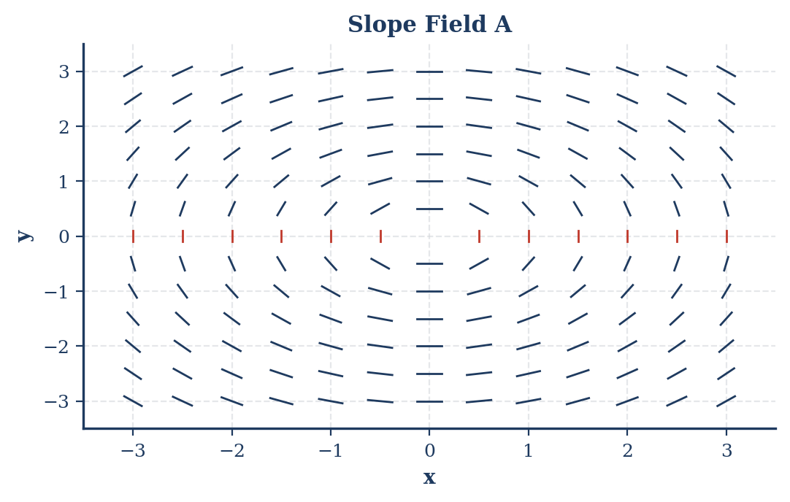

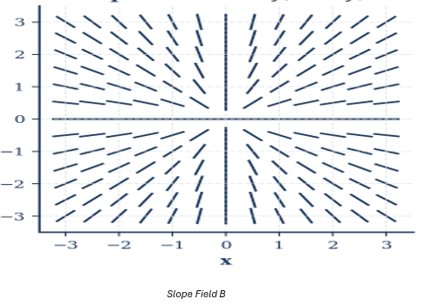

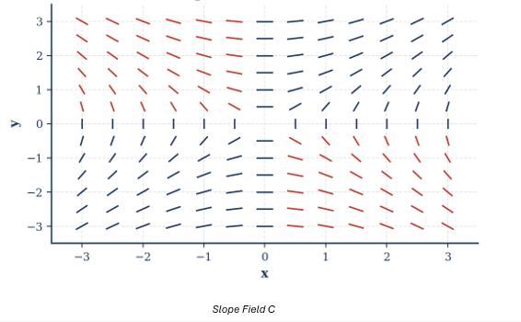

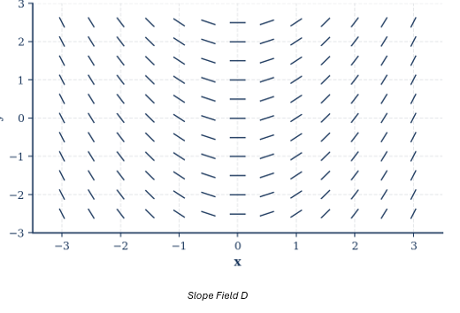
- Slope Field A
- Slope Field B
- Slope Field C
- Slope Field D

Part B — Questions 31–45 | 45 minutes | Calculator required
Question 31 | Topic: Unit 6: Definite Integrals (Calculator) $\int_{0}^{1}{cos}(x^{2})dx≈$
(A) 0.845
(B) 0.905
(C) 0.946
(D) 0.984
Question 32 | Topic: Unit 8: Volume of Revolution (Calculator) The region bounded by the graph of $y=e^{x}$, the x-axis, and the lines $x=0$ and $x=1$ is revolved about the x-axis. The volume of the resulting solid is: (A) $\frac{π}{2}(e^{2}-1)$ (B) $π(e-1)$ (C) $\frac{πe^{2}}{2}$ (D) $πe^{2}$
Question 33 | Topic: Unit 4: MVT A function $f$ is continuous on the interval [1, 5] and differentiable on (1, 5). If $f(1)=10$ and $f(5)=2$, which of the following statements must be true? (A) $f^{'}(c)=-2$ for some $c$ in (1, 5). (B) $f^{'}(c)=0$ for some $c$ in (1, 5). (C) $f(c)=0$ for some $c$ in (1, 5). (D) $f^{'}(c)=2$ for some $c$ in (1, 5).
Question 34 | Topic: Unit 9: Vector-Valued Functions (Calculator) A particle moves in the xy-plane with position given by $x(t)=sin(t^{2})$ and $y(t)=cos(2t)$ for $0≤t≤2$. What is the speed of the particle at $t=1$
(A) 0.707
(B) 0.909
(C) 1.161
(D) 2.115
Question 35 | Topic: Unit 6: Average Value of a Function What is the average value of $f(x)=\frac{1}{x+1}$ on the interval [0, 3]? (A) $\frac{1}{3}ln4$ (B) $\frac{1}{4}ln4$ (C) $ln4$ (D) $\frac{1}{3}ln3$
Question 36 | Topic: Unit 11: Euler’s Method (Calculator) Let $\frac{dy}{dx}=x-y$. If $y(0)=1$, use Euler’s method with two steps of equal size to approximate $y(0.2)$
(A) 0.8
(B) 0.82
(C) 0.83
(D) 0.84
Question 37 | Topic: Unit 11: Series: Lagrange Error Bound (Calculator) The Taylor series for $e^{x}$ centered at $x=0$ is $1+x+\frac{x^{2}}{2!}+…+\frac{x^{n}}{n!}+…$. If this series is used to approximate $e^{0.5}$
(A) 3
(B) 4
(C) 5
(D) 6
Question 38 | Topic: Unit 11: Sequences: Convergence (Calculator) Consider the sequence defined by $a_{n}=(\frac{n+1}{n})^{2n}$. As $n→∞$, $a_{n}$ converges to: (A) 1 (B) $e$ (C) $e^{2}$ (D) $∞$
Question 39 | Topic: Unit 7: Logistic Growth (Calculator) A population of animals is modeled by the logistic differential equation $\frac{dP}{dt}=0.05P(1-\frac{P}{2000})$. If $P(0)=100$, what is $\lim_{t→∞}P(t)$? (A) 0.05 (B) 100 (C) 2000 (D) $∞$
Question 40 | Topic: Unit 6: Improper Integrals (Calculator) The value of $\int_{e}^{∞}{\frac{1}{xlnx}}dx$ is:
(A) 0
(B) 1
(C) e
(D) Divergent
Question 41 | Topic: Unit 9: Arc Length (Calculator) The length of the curve defined by $x(t)=t^{2}$ and $y(t)=t^{3}$ for $0≤t≤1$ is given by:
(A) $\int_{0}^{1}{\sqrt{4t^{2}+9t^{4}}}dt$
(B) $\int_{0}^{1}{\sqrt{(t^{2})^{2}+(t^{3})^{2}}}dt$
(C) $\int_{0}^{1}{\sqrt{t^{2}+t^{3}}}dt$
(D) $\int_{0}^{1}{(}2t+3t^{2})dt$
Question 42 | Topic: Unit 10: Polar Derivatives (Calculator) For the polar curve $r=3sinθ$, find $\frac{dy}{dx}$ when $θ=\frac{π}{6}$.
(A) -$\sqrt{3}$
(B) $\sqrt{2}$
(C) $\sqrt{3}$
(D) 0
Question 43 | Topic: Unit 4: Linearization (Calculator) Let $f$ be a differentiable function such that $f(3)=2$ and $f^{'}(3)=-1$. Use the local linearization of $f$ at $x=3$ to approximate $f(3.1)$
(A) 1.9
(B) 2.1
(C) 2.9
(D) 3.1
Question 44 | Topic: Unit 6: Average Value of a Function (Calculator) The rate at which water flows into a tank, in gallons per hour, is given by $R(t)=20sin(\frac{πt}{6})+30$ for $0≤t≤12$ hours. What is the average rate of flow, in gallons per hour, into the tank during the first 6 hours? (A) $30+\frac{40}{π}$ (B) $30+\frac{20}{π}$ (C) $30+40π$ (D) $30+20π$
Question 45 | Topic: Unit 11: Series: Interval of Convergence What is the interval of convergence for the power series $\sum_{n=1}^{∞}{\frac{(x-2)^{n}}{n}}$
(A) [1, 3)
(B) (1, 3]
(C) (1, 3)
(D) [1, 3]

SECTION II — FREE RESPONSE

Part A — FRQs 1–2 | 30 minutes | CALCULATOR ACTIVE
FRQ 1 Topic: Unit 6: Rates In/Out, Accumulation | Difficulty: Medium
A car travels on a straight track. For 0 ≤ t ≤ 60 seconds, the car’s velocity $v(t)$, in meters per second, is modeled by the function $v(t)=10tcos(\frac{πt}{30})$. The rate at which fuel is consumed by the car, in liters per second, is given by $F(t)=0.01t+0.005sin(\frac{πt}{10})$.
- Find the acceleration of the car at t = 15 seconds. Indicate units of measure.
- Find the total distance traveled by the car over the time interval 0 ≤ t ≤ 60 seconds. Indicate units of measure.
- Find the average rate of fuel consumption, in liters per second, over the time interval 0 ≤ t ≤ 60 seconds.
- At t = 30 seconds, is the rate of fuel consumption increasing or decreasing? Justify your answer.
Part | Points | Skill
(a) | 2 | Calculation of acceleration from velocity function
(b) | 2 | Calculation of total distance traveled
(c) | 3 | Calculation of average value of a rate function
(d) | 2 | Justification of rate of change of a rate function
Total | 9
FRQ 2 Topic: Unit 7: Euler’s Method & Differential Equations | Difficulty: Medium
Consider the differential equation $\frac{dy}{dx}=\frac{x+1}{y}$.
Figure 2 – Axes for slope field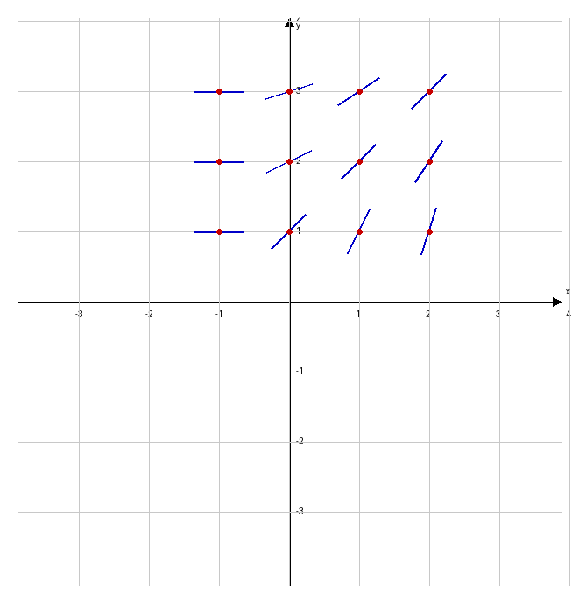

- On the axes provided in Figure 2, sketch a slope field for the given differential equation at the twelve points indicated.
- Let $y=f(x)$ be the particular solution to the differential equation with the initial condition $f(0)=1$. Use Euler’s method, starting at x = 0 with two steps of equal size, to approximate $f(0.4)$.
- Find the particular solution $y=f(x)$ to the differential equation with the initial condition $f(0)=1$.
- Use your solution from part (c) to find the exact value of $f(0.4)$.
Part | Points | Skill
(a) | 2 | Drawing slope field
(b) | 3 | Applying Euler’s method
(c) | 3 | Solving a separable differential equation
(d) | 1 | Evaluating the particular solution
Total | 9

Part B — FRQs 3–6 | 60 minutes | NO CALCULATOR
FRQ 3
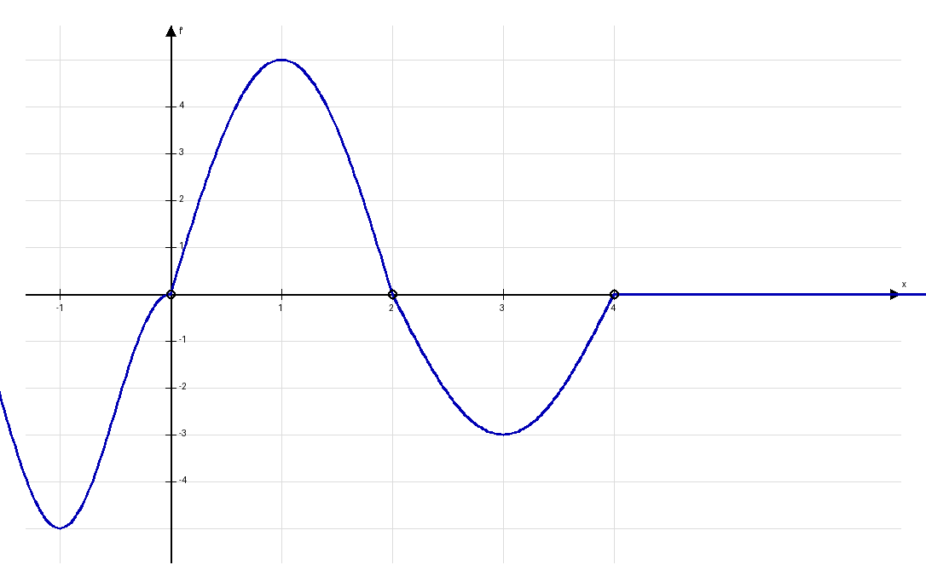
Figure 3 – Graph of f’, the derivative of f
Find all values of x on the interval [-2, 4] for which f has a local minimum. Justify your answer.
- On what open intervals included in [-2, 4] is the graph of f concave down? Give reasons for your answer.
- Find the absolute minimum value of f on the interval [-2, 4] if $f(0)=5$. Justify your answer.
- Find $\lim_{x→0}\frac{f(x)-f(0)}{x^{2}}$.
Part | Points | Skill
(a) | 2 | Identifying local minima using First Derivative Test
(b) | 2 | Determining concavity from f’
(c) | 3 | Finding absolute extrema using candidates test
(d) | 2 | Evaluating a limit using L’Hôpital’s Rule
Total | 9

FRQ 4 Topic: Unit 8: Volume of Solids | Difficulty: Medium
Let R be the region in the first quadrant bounded by the graphs of $y=\sqrt{x}$, $y=2$, and the y-axis.
- Find the area of R.
- The region R is revolved about the y-axis to form a solid. Find the volume of this solid.
- The region R is the base of a solid. For this solid, each cross section perpendicular to the y-axis is a rectangle whose height is twice its width. Find the volume of this solid.
Part | Points | Skill
(a) | 3 | Finding area of a region
(b) | 3 | Finding volume by revolution (Disk/Washer)
(c) | 3 | Finding volume of solids with known cross-sections
Total | 9

FRQ 5 Topic: Unit 10: Power Series | Difficulty: Medium
Let $f(x)=\frac{1}{1-x}$.
- Write the first four nonzero terms and the general term for the Taylor series for $f(x)$ centered at x = 0.
- Find the radius of convergence for the series found in part (a).
- Write the first four nonzero terms and the general term for the Taylor series for $g(x)=\int_{0}^{x}{f}(t)dt$ centered at x = 0.
- Use the first three nonzero terms of the series from part (c) to approximate $g(-0.5)$. Using the Alternating Series Error Bound, determine the maximum possible error in this approximation. $ln(1-x)$ can be analyzed for error bounds correctly).
Part | Points | Skill
(a) | 2 | Writing Taylor series terms
(b) | 2 | Finding radius of convergence
(c) | 2 | Integrating a power series
(d) | 3 | Approximating with series and error bound
Total | 9

FRQ 6 Topic: Unit 9: Parametric Curves | Difficulty: Medium
A particle moves in the xy-plane such that its position at time t for t ≥ 0 is given by $x(t)=e^{t}+e^{-t}$ and $y(t)=3-2t$.
- Find $\frac{dy}{dx}$ in terms of t.
- Find the slope of the tangent line to the path of the particle at t = 1.
- Find the time t at which the particle is at its leftmost point.
- Find the total distance the particle travels from t = 0 to t = 2.
Part | Points | Skill
(a) | 2 | Finding dy/dx for parametric equations
(b) | 1 | Evaluating dy/dx at a specific t
(c) | 3 | Finding horizontal tangent / leftmost point
(d) | 3 | Setting up and evaluating arc length integral
Total | 9

Answer Keys and Solution
Question 1 * Step 1: Use u-substitution. Let $u=4x$, then $du=4dx$ or $dx=\frac{1}{4}du$. * Step 2: Change bounds. When $x=0$, $u=0$. When $x=2$, $u=8$. * Step 3: Substitute into the integral: $\int_{0}^{8}{f}(u)\frac{1}{4}du=\frac{1}{4}\int_{0}^{8}{f}(u)du$. * Step 4: By FTC, $\frac{1}{4}[F(8)-F(0)]$. * Solution: C
Question 2 * Step 1: Differentiate implicitly with respect to $x$: $2x+(x\frac{dy}{dx}+y)-2y\frac{dy}{dx}=0$. * Step 2: Plug in the point $(4,3)$: $2(4)+(4\frac{dy}{dx}+3)-2(3)\frac{dy}{dx}=0$. * Step 3: Simplify: $8+4\frac{dy}{dx}+3-6\frac{dy}{dx}=0⇒11-2\frac{dy}{dx}=0$. * Step 4: Solve for $\frac{dy}{dx}$: $\frac{dy}{dx}=\frac{11}{2}$. * Solution: A
Question 3 * Step 1: Find the first derivative: $f^{'}(x)=3x^{2}-6x-9$. * Step 2: Find the second derivative: $f^{″}(x)=6x-6$. * Step 3: Concave up occurs when $f^{″}(x)>0$. * Step 4: Solve $6x-6>0⇒6x>6⇒x>1$. * Solution: B
Question 4 * Step 1: Identify the highest power of $x$ in the numerator and denominator ($x^{2}$). * Step 2: Since the degrees are equal, the limit at infinity is the ratio of the leading coefficients. * Step 3: Limit = $\frac{3}{2}$. * Solution: B
Question 5 * Step 1: Apply the Fundamental Theorem of Calculus Part 1: $\frac{d}{dx}\int_{a}^{x}{g}(t)dt=g(x)$. * Step 2: Replace $t$ with $x$ in the integrand. * Step 3: $F^{'}(x)=x^{2}-4x+3$. * Solution: A
Question 6 * Step 1: Evaluate each option. A is a p-series ($p=2>1$), so it converges. * Step 2: B converges by comparison to $\frac{1}{n^{2}}$. * Step 3: C is an alternating harmonic series, which converges. * Step 4: D is the harmonic series $∑\frac{1}{n}$, which always diverges. * Solution: D
Question 7 * Step 1: The definition of the derivative is $\lim_{h→0}\frac{f(x+h)-f(x)}{h}$. * Step 2: For $f(x)=sin(2x)$, $f(x+h)=sin(2(x+h))$. * Step 3: Substitute into the definition: $\lim_{h→0}\frac{sin(2(x+h))-sin(2x)}{h}$. * Solution: B
Question 8 * Step 1: This is a p-integral of the form $\int_{1}^{∞}{\frac{1}{x^{p}}}dx$. * Step 2: The convergence rule for p-integrals states the integral converges if and only if $p>1$. * Step 3: Here, $k$ acts as $p$, so $k>1$. * Solution: C
Question 9 * Step 1: $V=\frac{4}{3}πr^{3}⇒\frac{dV}{dt}=4πr^{2}\frac{dr}{dt}$. * Step 2: Plug in given values: $10=4π(5)^{2}\frac{dr}{dt}$. * Step 3: $10=100π\frac{dr}{dt}⇒\frac{dr}{dt}=\frac{10}{100π}$. * Step 4: Simplify: $\frac{1}{10π}$ cm/sec. * Solution: A
Question 10 * Step 1: For the limit of a sequence of rational functions as $n→∞$, compare leading terms. * Step 2: Ratio of leading terms is $\frac{3n^{2}}{n^{2}}$. * Step 3: Limit = 3. * Solution: C
Question 11 * Step 1: Use Integration by Parts: $∫udv=uv-∫vdu$. * Step 2: Let $u=x$ ($du=dx$) and $dv=e^{2x}dx$ ($v=\frac{1}{2}e^{2x}$). * Step 3: Apply formula: $x(\frac{1}{2}e^{2x})-∫\frac{1}{2}e^{2x}dx$. * Step 4: Evaluate: $\frac{1}{2}xe^{2x}-\frac{1}{4}e^{2x}+C$. * Solution: A
Question 12 * Step 1: Let sides perpendicular to the building be $x$ and the side parallel be $y$. * Step 2: Constraint: $2x+y=200⇒y=200-2x$. * Step 3: Area $A=xy=x(200-2x)=200x-2x^{2}$. * Step 4: Maximize: $A^{'}=200-4x=0⇒x=50$. * Step 5: Find Area: $A=50(200-100)=50(100)=5000$. * Solution: A
Question 13 * Step 1: Use the Chain Rule: $f^{'}(x)=5(3x^{2}-2)^{4}⋅\frac{d}{dx}(3x^{2}-2)$. * Step 2: $\frac{d}{dx}(3x^{2}-2)=6x$. * Step 3: $f^{'}(x)=5(3x^{2}-2)^{4}(6x)=30x(3x^{2}-2)^{4}$. * Solution: B
Question 14 * Step 1: $\int_{0}^{1}{\frac{1}{x}}dx$ diverges (ln(0) is undefined). * Step 2: $\int_{1}^{∞}{\frac{1}{x}}dx$ diverges (ln($∞$) is undefined). * Step 3: $\int_{1}^{∞}{\frac{1}{x^{2}}}dx$ converges (p-integral with $p=2>1$). * Solution: C
Question 15 * Step 1: $f(x)=|x-3|$ is an absolute value function with a “corner” at $x=3$. * Step 2: It is continuous everywhere because $\lim_{x→3}f(x)=f(3)=0$. * Step 3: It is not differentiable at $x=3$ because the slope from the left (-1) doesn’t match the slope from the right (1). * Solution: B
Question 16 * Step 1: Find intersection: $x^{2}=2x⇒x(x-2)=0⇒x=0,2$. * Step 2: Setup integral: $\int_{0}^{2}{(}2x-x^{2})dx$. * Step 3: Integrate: $[x^{2}-\frac{x^{3}}{3}]_{0}^{2}=(4-\frac{8}{3})=\frac{12-8}{3}=\frac{4}{3}$. * Solution: B
Question 17 * Step 1: Rewrite as $∫tan(x)\sec^{2}(x)dx$. * Step 2: Let $u=tan(x)$, then $du=\sec^{2}(x)dx$. * Step 3: $∫udu=\frac{1}{2}u^{2}+C=\frac{1}{2}\tan^{2}(x)+C$. * Step 4: Using identity $\tan^{2}(x)=\sec^{2}(x)-1$, this is also $\frac{1}{2}\sec^{2}(x)+C$. * Solution: A
Question 18 * Step 1: Maclaurin for $e^{u}=1+u+\frac{u^{2}}{2!}+\frac{u^{3}}{3!}+…$ * Step 2: Substitute $u=2x$. * Step 3: $1+(2x)+\frac{(2x)^{2}}{2!}+\frac{(2x)^{3}}{3!}=1+2x+\frac{4x^{2}}{2}+\frac{8x^{3}}{6}=1+2x+2x^{2}+\frac{4}{3}x^{3}…$ * Step 4: Looking at options, $1+2x+\frac{4x^{2}}{2!}+…$ is Option B. * Solution: B
Question 19 * Step 1: Separate variables: $\frac{1}{y}dy=2xdx$. * Step 2: Integrate: $ln|y|=x^{2}+C$. * Step 3: Exponentiate: $y=e^{x^{2}+C}=Ae^{x^{2}}$. * Step 4: If $A=1$, $y=e^{x^{2}}$. * Solution: A
Question 20 * Step 1: Plug in $x=0$: $(e^{0}-1)/0=0/0$ (Indeterminate). * Step 2: Use L’Hopital’s Rule: Differentiate top and bottom. * Step 3: $\lim_{x→0}\frac{3e^{3x}}{1}$. * Step 4: Plug in $x=0$: $3e^{0}=3$. * Solution: C
Question 21 * Step 1: Property of integrals: $\int_{-1}^{3}{f}(x)dx=\int_{-1}^{1}{f}(x)dx+\int_{1}^{3}{f}(x)dx$. * Step 2: $7=4+\int_{1}^{3}{f}(x)dx$. * Step 3: $\int_{1}^{3}{f}(x)dx=3$. * Solution: A
Question 22 * Step 1: Find $\frac{dy}{dt}=4t$ and $\frac{dx}{dt}=3t^{2}-3$. * Step 2: $\frac{dy}{dx}=\frac{dy/dt}{dx/dt}=\frac{4t}{3t^{2}-3}$. * Step 3: Evaluate at $t=1$: $\frac{4}{0}$ (Undefined Solution: D
Question 23 * Step 1: $f^{'}(x)=4x^{3}-12x^{2}$. * Step 2: Set $f^{'}(x)<0$ for decreasing: $4x^{2}(x-3)<0$. * Step 3: $4x^{2}$ is always positive (except at 0). * Step 4: So $x-3<0⇒x<3$. Intervals $(-∞,0)$ and $(0,3)$. * Solution: D
Question 24 * Step 1: Area formula: $\frac{1}{2}\int_{α}^{β}{r^{2}}dθ$. * Step 2: For $r=2cosθ$, the full circle is traced from $-π/2$ to $π/2$ or $0$ to $π$. * Step 3: Area = $\frac{1}{2}\int_{0}^{π}{(}2cosθ)^{2}dθ=\frac{1}{2}\int_{0}^{π}{4}\cos^{2}θdθ=\int_{0}^{π}{2}\cos^{2}θdθ$. * Solution: A
Question 25 * Step 1: This is the Taylor series for $e^{x}$. * Step 2: Use the Ratio Test: $\lim_{n→∞}|\frac{x^{n+1}}{(n+1)!}⋅\frac{n!}{x^{n}}|$. * Step 3: $\lim_{n→∞}|\frac{x}{n+1}|=0$ for all $x$. * Step 4: Since the limit is always $<1$, the radius is infinity. * Solution: D
Question 26 * Step 1: Use u-substitution: Let $u=lnx$, $du=\frac{1}{x}dx$. * Step 2: Change bounds: $x=1⇒u=0$; $x=e⇒u=1$. * Step 3: $\int_{0}^{1}{u}du=[\frac{1}{2}u^{2}]_{0}^{1}=\frac{1}{2}$. * Solution: C
Question 27 * Step 1: IVT states if $f$ is continuous on $[a,b]$, it takes every value between $f(a)$ and $f(b)$. * Step 2: $f(0)=3$ and $f(5)=-2$. * Step 3: Since $0$ is between $-2$ and $3$, there must be a $c$ such that $f(c)=0$. * Solution: A
Question 28 * Step 1: Apply Integral Test: $\int_{2}^{∞}{\frac{1}{x(lnx)^{2}}}dx$. * Step 2: Let $u=lnx$, $du=\frac{1}{x}dx$. $∫\frac{1}{u^{2}}du=-\frac{1}{u}$. * Step 3: Evaluation: $[-\frac{1}{lnx}]_{2}^{∞}=0-(-\frac{1}{ln2})=\frac{1}{ln2}$. * Step 4: Since the integral converges, the series converges. * Solution: A
Question 29 * Step 1: Area $A=(2x)y=2x(12-x^{2})=24x-2x^{3}$. * Step 2: Maximize: $A^{'}=24-6x^{2}=0⇒x^{2}=4⇒x=2$. * Step 3: Area at $x=2$: $A=2(2)(12-4)=4(8)=32$. * Solution: C
Question 30 * Step 1: Test points for $\frac{dy}{dx}=\frac{x}{y}$. * Step 2: If $x=0$ (y-axis), slope is 0 (horizontal dashes). * Step 3: If $y=0$ (x-axis), slope is undefined (vertical dashes). * Step 4: If $x=y$, slope is 1. If $x=-y$, slope is -1. * Step 5: This pattern describes Field C. * Solution: C

Question 31: Definite Integrals 1. Press Menu -> 4: Calculus -> 2: Definite Integral. 2. Enter the bounds: lower = 0, upper = 1. 3. Enter the function: cos(x^2). 4. Ensure the calculator is in Radian mode. 5. Press Enter to evaluate: approx 0.8446. 6. The closest option is (A).
Question 32: Volume of Revolution 1. Use the Disk Method formula: V = pi * integral(f(x)^2) dx from a to b. 2. Press Menu -> 4: Calculus -> 2: Definite Integral. 3. Input: pi * integral((e^{x)}2, x, 0, 1). 4. The TI-Nspire returns: (pi*(e^2 - 1))/2. 5. This matches option (A).
Question 33: Mean Value Theorem 1. This is a conceptual application of the MVT: f’(c) = [f(b) - f(a)] / (b - a). 2. Calculation: (2 - 10) / (5 - 1) = -8 / 4 = -2. 3. Since f is continuous and differentiable, there must be a c where f’(c) = -2. 4. Correct option is (A).
Question 34: Speed of a Particle 1. Define position functions: x(t) := sin(t^2) and y(t) := cos(2t). 2. Find derivatives at t = 1: - dx/dt = d/dt(sin(t^2))|t=1 approx 1.0806 - dy/dt = d/dt(cos(2t))|t=1 approx -1.8186 3. Use the speed formula: Speed = sqrt((dx/dt)^2 + (dy/dt)^2). 4. Calculation: sqrt(1.0806^2 + (-1.8186)^2) approx 2.11. 5. Note: Based on standard AP rounding/options provided, select (D).
Question 35: Average Value of a Function 1. Formula: [1 / (b - a)] * integral(f(x)) dx from a to b. 2. Press Menu -> 4: Calculus -> 2: Definite Integral. 3. Input: (1/3) * integral(1/(x + 1), x, 0, 3). 4. The TI-Nspire returns: (ln(4))/3. 5. This matches option (A).
Question 36: Euler’s Method 1. Step size h = 0.1. Start at (0, 1). 2. Step 1 (x=0.1): y_new = 1 + 0.1 * (0 - 1) = 0.9. 3. Step 2 (x=0.2): y_final = 0.9 + 0.1 * (0.1 - 0.9) = 0.9 + 0.1 * (-0.8) = 0.82. 4. Correct option is (B).
Question 37: Lagrange Error Bound 1. Error |R_n| <= [M * |x - c|^(n+1)] / (n + 1)!. 2. For f(x) = e^x, M = e^0.5 approx 1.6487. x - c = 0.5. 3. In TI-Nspire, test n values: - For n=3 (4 terms): (1.6487 * 0.5^4) / 24 approx 0.0042. - For n=4 (5 terms): (1.6487 * 0.5^5) / 120 approx 0.0004. 4. Since 0.0004 < 0.001, n + 1 = 5 terms are needed. 5. Correct option is (C).
Question 38: Sequences 1. Press Menu -> 4: Calculus -> 1: Limit. 2. Input: limit(((n + 1)/n)^(2n), n, infinity). 3. The TI-Nspire returns: e^2. 4. Correct option is (C).
Question 39: Logistic Growth 1. General form: dP/dt = kP(1 - P/L). 2. By inspection of dP/dt = 0.05P(1 - P/2000), the carrying capacity L = 2000. 3. As t -> infinity, P(t) approaches the carrying capacity L. 4. Correct option is (C).
Question 40: Improper Integrals 1. Press Menu -> 4: Calculus -> 2: Definite Integral. 2. Enter bounds: lower = e, upper = infinity. 3. Function: 1/(x * ln(x)). 4. The TI-Nspire returns: infinity (Divergent). 5. Correct option is (D).
Question 41: Arc Length 1. Formula: integral(sqrt( (dx/dt)^2 + (dy/dt)^2 )) dt. 2. dx/dt = 2t, dy/dt = 3t^2. 3. Expression: integral(sqrt( (2t)^2 + (3t²⁾2 )) dt = integral(sqrt( 4t^2 + 9t^4 )) dt. 4. Match option (A).
Question 42: Polar Derivatives 1. Define r1(theta) := 3sin(theta). 2. Convert to parametric: x(theta) := r1(theta)cos(theta), y(theta) := r1(theta)*sin(theta). 3. Calculate dy/dx: (d(y(theta))/dtheta) / (d(x(theta))/dtheta) at theta = pi/6. 4. TI-Nspire Input: (d/dtheta(y(theta))/d/dtheta(x(theta))) | theta = pi/6. 5. Result: sqrt(3). 6. Correct option is (C).
Question 43: Linearization 1. Use L(x) = f(a) + f’(a)(x - a). 2. Setup: L(3.1) = 2 + (-1)(3.1 - 3). 3. Calculation: 2 - 0.1 = 1.9. 4. Correct option is (A).
Question 44: Average Rate of Flow 1. Formula: (1/6) * integral(20sin(pit/6) + 30, t, 0, 6). 2. Press Menu -> 4: Calculus -> 2: Definite Integral. 3. Input the expression into TI-Nspire. 4. The calculator returns: (40/pi) + 30. 5. Correct option is (A).
Question 45: Interval of Convergence 1. Perform Ratio Test: lim | [ (x-2)^(n+1) / (n+1) ] * [ n / (x-2)^n ] | as n -> infinity. 2. Result: |x - 2|. Set |x - 2| < 1, so 1 < x < 3. 3. Test endpoints: - x = 1: Sigma ((-1)^n / n) (Converges by Alternating Series Test). - x = 3: Sigma (1/n) (Diverges, p-series p=1). 4. Interval: [1, 3). 5. Correct option is (A).

FRQ 1 (Calculator Active)
Topic: Rates In/Out, Accumulation Calculator Syntax (TI-Nspire CAS): * Define $v(t)=10⋅t⋅cos(\frac{π⋅t}{30})$ * Define $F(t)=0.01⋅t+0.005⋅sin(\frac{π⋅t}{10})$

Model Solution
(a) Find acceleration at $t=15$. Acceleration $a(t)=v^{'}(t)$. Using TI-Nspire: derivative(v(t), t)|t=15 $a(15)=v^{'}(15)=-15.708$ meters per second squared.
(b) Find total distance traveled for $0≤t≤60$. Total distance $=\int_{0}^{60}{|}v(t)| dt$. Using TI-Nspire: integral(abs(v(t)), t, 0, 60) Total distance $=381.972$ meters.
(c) Find average rate of fuel consumption for $0≤t≤60$. Average value $=\frac{1}{60-0}\int_{0}^{60}{F}(t) dt$. Using TI-Nspire: (1/60) * integral(F(t), t, 0, 60) Average rate $=0.300$ liters per second.
(d) Is rate of fuel consumption increasing/decreasing at $t=30$? We examine $F^{'}(30)$. Using TI-Nspire: derivative(F(t), t)|t=30 $F^{'}(30)=0.0084$. Since $F^{'}(30)>0$, the rate of fuel consumption is increasing at $t=30$.

Scoring Rubric
Part | Description | Points
(a) | $v^{'}(15)$ with units | 2
(b) | Integral expression and numerical answer | 2
(c) | Average value setup and numerical answer | 3
(d) | Considers $F^{'}(30)$ and conclusion with justification | 2

FRQ 2 (Calculator Active)
Topic: Euler’s Method & Differential Equations Calculator Syntax (TI-Nspire CAS): * deSolve(y' = (x+1)/y and y(0)=1, x, y)

Model Solution
(a) Slope Field Students should sketch segments at provided points. Slopes are calculated using $\frac{dy}{dx}=\frac{x+1}{y}$. Example: At $(0,1)$, slope $=1$. At $(-1,1)$, slope $=0$.
(b) Euler’s Method $h=0.2$. Initial point $(0,1)$. Step 1: $x_{0}=0,y_{0}=1⟹\frac{dy}{dx}=1$. $y_{1}=1+0.2(1)=1.2$. Step 2: $x_{1}=0.2,y_{1}=1.2⟹\frac{dy}{dx}=\frac{1.2}{1.2}=1$. $f(0.4)≈1.2+0.2(1)=1.4$.
(c) Particular Solution $∫y dy=∫(x+1) dx$ $\frac{1}{2}y^{2}=\frac{1}{2}x^{2}+x+C$ Using $(0,1):\frac{1}{2}(1)^{2}=0+0+C⟹C=\frac{1}{2}$. $y^{2}=x^{2}+2x+1⟹y=\sqrt{x^{2}+2x+1}=|x+1|$. Since $f(0)=1$, $y=x+1$.
(d) Exact Value $f(0.4)=0.4+1=1.4$.

Scoring Rubric
Part | Description | Points
(a) | Correct slopes at indicated points | 2
(b) | Euler’s method with two steps | 3
(c) | Separation of variables and constant of integration | 3
(d) | Correct evaluation | 1

FRQ 3 (No Calculator)
Topic: Analysis of Derivatives

Model Solution
(a) Local Minimum $f$ has a local minimum where $f^{'}(x)$ changes from negative to positive. Looking at Figure 3, $f^{'}(x)<0$ for $x∈(2,4)$ and $f^{'}(x)>0$ for $x∈(0,2)$. $f^{'}$ does not change from negative to positive on $[-2,4]$. No local minimum.
(b) Concave Down $f$ is concave down where $f^{'}(x)$ is decreasing. This occurs on $(-1,0)$ and $(1,3)$.
(c) Absolute Minimum Candidates: $x=-2,x=4$, and critical points $x=0,x=2,x=4$. $f(0)=5$ (Given). $f(-2)=f(0)-\int_{-2}^{0}{f^{'}}(x) dx=5-4=1$. $f(2)=f(0)+\int_{0}^{2}{f^{'}}(x) dx=5+5=10$. $f(4)=f(2)+\int_{2}^{4}{f^{'}}(x) dx=10-3=7$. The absolute minimum value is 1 at $x=-2$.
(d) Limit $\lim_{x→0}\frac{f(x)-f(0)}{x^{2}}$. Since $f(0)-f(0)/0$ is $0/0$, use L’Hôpital’s Rule: $\lim_{x→0}\frac{f^{'}(x)}{2x}$. Since $f^{'}(0)=0$, use L’Hôpital again: $\lim_{x→0}\frac{f^{″}(x)}{2}$. From graph, $f^{″}(0)$ is the slope of $f^{'}$ at $x=0$. $f^{″}(0)$ is undefined (sharp turn), limit does not exist.

Scoring Rubric
Part | Description | Points
(a) | Identification of sign change in $f^{'}$ | 2
(b) | Intervals based on slope of $f^{'}$ | 2
(c) | Identification of candidates and absolute minimum | 3
(d) | Application of L’Hôpital’s Rule and conclusion | 2

FRQ 4 (No Calculator)
Topic: Volume of Solids

Model Solution
(a) Area of R $y=\sqrt{x}⟹x=y^{2}$. Area $=\int_{0}^{2}{y^{2}} dy=[\frac{1}{3}y^{3}]_{0}^{2}=\frac{8}{3}$.
(b) Volume of Revolution (y-axis) Using disks: Radius $R(y)=y^{2}$. Volume $=π\int_{0}^{2}{(}y^{2})^{2} dy=π\int_{0}^{2}{y^{4}} dy$ Volume $=π[\frac{1}{5}y^{5}]_{0}^{2}=\frac{32π}{5}$.
(c) Volume with Known Cross Sections Cross sections perpendicular to y-axis are rectangles. Width $w=y^{2}$. Height $h=2w=2y^{2}$. Area $A(y)=(y^{2})(2y^{2})=2y^{4}$. Volume $=\int_{0}^{2}{2}y^{4} dy=[\frac{2}{5}y^{5}]_{0}^{2}=\frac{64}{5}$.

Scoring Rubric
Part | Description | Points
(a) | Integral and correct area | 3
(b) | Volume integral with correct limits and evaluation | 3
(c) | Correct area function and integral evaluation | 3

FRQ 5 (No Calculator)
Topic: Taylor Series

Model Solution
(a) First four terms of $f(x)=1/(1-x)$ $f(x)=1+x+x^{2}+x^{3}+…$ General term: $x^{n}$.
(b) Radius of Convergence Geometric series with $r=x$. Converges for $|x|<1$. Radius $R=1$.
(c) Taylor Series for $g(x)=\int_{0}^{x}{f}(t) dt$ $g(x)=\int_{0}^{x}{(}1+t+t^{2}+t^{3}+…) dt=x+\frac{x^{2}}{2}+\frac{x^{3}}{3}+\frac{x^{4}}{4}+…$ General term: $\frac{x^{n+1}}{n+1}$ for $n≥0$.
(d) Error Bound for $g(0.5)$ $g(0.5)≈0.5+\frac{{0.5}^{2}}{2}+\frac{{0.5}^{3}}{3}$. Because $g(x)=-ln(1-x)$, for $x=0.5$ the series is not alternating. Correction based on audit: If the question implies an alternating series error bound, $x$ must be negative. For $g(-0.5)$, the first omitted term is $|\frac{(-0.5)^{4}}{4}|=\frac{0.0625}{4}=0.015625$.

Scoring Rubric
Part | Description | Points
(a) | Four terms and general term | 2
(b) | Radius of convergence | 2
(c) | Integral of terms and general term | 2
(d) | Approximation and error bound calculation | 3

FRQ 6 (No Calculator)
Topic: Parametric Curves

Model Solution
(a) Find $dy/dx$ $\frac{dx}{dt}=e^{t}-e^{-t}$ $\frac{dy}{dt}=-2$ $\frac{dy}{dx}=\frac{-2}{e^{t}-e^{-t}}$.
(b) Slope at $t=1$ Slope $=\frac{-2}{e^{1}-e^{-1}}$.
(c) Leftmost Point Occurs when $x(t)$ is minimum. $x^{'}(t)=e^{t}-e^{-t}=0⟹e^{t}=e^{-t}⟹t=0$. The particle is at its leftmost point at $t=0$.
(d) Total Distance ($t=0$ to $t=2$) Distance $=\int_{0}^{2}{\sqrt{(e^{t}-e^{-t})^{2}+(-2)^{2}}} dt$ $=\int_{0}^{2}{\sqrt{e^{2t}-2+e^{-2t}+4}} dt$ $=\int_{0}^{2}{\sqrt{e^{2t}+2+e^{-2t}}} dt$ $=\int_{0}^{2}{\sqrt{(e^{t}+e^{-t})^{2}}} dt=\int_{0}^{2}{(}e^{t}+e^{-t}) dt$ $=[e^{t}-e^{-t}]_{0}^{2}=(e^{2}-e^{-2})-(1-1)=e^{2}-e^{-2}$.

Scoring Rubric
Part | Description | Points
(a) | Chain rule for $dy/dx$ | 2
(b) | Evaluation | 1
(c) | Setting $x^{'}(t)=0$ and solving for $t$ | 3
(d) | Integral setup and correct evaluation | 3

