AP Calculus BC — Mock Exam 09
Topic Focus: Area enclosed by polar curves A = ½∫r²dθ | Taylor and Maclaurin series (eˣ, sin x, cos x, 1/(1-x), ln(1+x), arctan x) | Euler’s method for numerical approximation | Limits graphically, numerically, and analytically | Geometric series and p-series tests Total Time: 195 minutes | Total Points: 45 MCQ + 6 FRQ

SECTION I — MULTIPLE CHOICE

Part A — Questions 1–30 | 60 minutes | NO CALCULATOR
Question 1 | Topic: Unit 1 — Limits Analytically | Difficulty: ★☆☆ $\lim_{x→0}\frac{sin(3x)}{x}$ is
- (A) $0$
- (B) $1$
- (C) $3$
- (D) The limit does not exist.

Question 2 | Topic: Unit 1 — Limit from Graph | Difficulty: ★☆☆
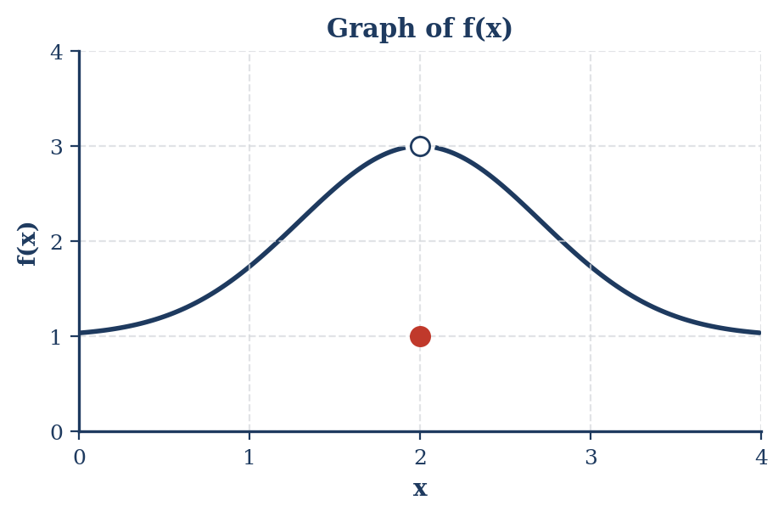
Based on the graph, which of the following is true?
- (A) $f$ is continuous at $x=2$.
- (B) $\lim_{x→2}f(x)=1$.
- (C) $\lim_{x→2}f(x)=3$.
- (D) The limit of $f(x)$ as $x$ approaches $2$ does not exist.

Question 3 | Topic: Unit 1 — Limits Analytically | Difficulty: ★★☆ $\lim_{x→∞}\frac{2x^{2}-3x+1}{5-4x-x^{2}}$ is
- (A) $-2$
- (B) $0$
- (C) $2$
- (D) The limit does not exist.

Question 4 | Topic: Unit 1 — Continuity | Difficulty: ★★☆ For what value of $k$ is the function $f(x)=\left\{\begin{matrix}kx^{2}+3 & x<2 \\ 5x-1 & x≥2\end{matrix}\right.$ continuous at $x=2$?
- (A) $\frac{1}{2}$
- (B) $\frac{3}{2}$
- (C) $2$
- (D) $3$

Question 5 | Topic: Unit 1 — L’Hôpital’s Rule | Difficulty: ★★☆ $\lim_{x→0}\frac{e^{2x}-1}{x}$ is
- (A) $0$
- (B) $1$
- (C) $2$
- (D) The limit does not exist.

Question 6 | Topic: Unit 2 — Basic Differentiation | Difficulty: ★☆☆ If $f(x)=x^{3}-4x+5$, then $f^{'}(2)=$
- (A) $0$
- (B) $4$
- (C) $8$
- (D) $16$

Question 7 | Topic: Unit 3 — Chain Rule | Difficulty: ★★☆ If $y=sin(x^{2})$, then $\frac{dy}{dx}=$
- (A) $2xcos(x^{2})$
- (B) $cos(x^{2})$
- (C) $cos(2x)$
- (D) $-2xcos(x^{2})$

Question 8 | Topic: Unit 3 — Higher-Order Derivatives | Difficulty: ★★☆ If $f(x)=e^{-x}$, then $f^{″}(x)=$
- (A) $e^{-x}$
- (B) $-e^{-x}$
- (C) $e^{-2x}$
- (D) $e^{-x^{2}}$

Question 9 | Topic: Unit 3 — Implicit Differentiation | Difficulty: ★★☆ If $x^{2}+y^{2}=25$, then $\frac{dy}{dx}$ at the point $(3,4)$ is
- (A) $-\frac{4}{3}$
- (B) $-\frac{3}{4}$
- (C) $\frac{3}{4}$
- (D) $\frac{4}{3}$

Question 10 | Topic: Unit 2 — Derivative of Logarithmic Functions | Difficulty: ★☆☆ If $f(x)=ln(3x)$, then $f^{'}(x)=$
- (A) $\frac{1}{3x}$
- (B) $\frac{1}{x}$
- (C) $3x$
- (D) $ln(3)+ln(x)$

Question 11 | Topic: Unit 6 — Basic Indefinite Integral | Difficulty: ★☆☆ $∫(x^{2}+sin(x)) dx=$
- (A) $\frac{x^{3}}{3}+cos(x)+C$
- (B) $\frac{x^{3}}{3}-cos(x)+C$
- (C) $2x-cos(x)+C$
- (D) $2x+cos(x)+C$

Question 12 | Topic: Unit 6 — Definite Integral | Difficulty: ★★☆ $\int_{0}^{1}{(}e^{x}+x) dx=$
- (A) $e-\frac{1}{2}$
- (B) $e+\frac{1}{2}$
- (C) $e-1$
- (D) $e$

Question 13 | Topic: Unit 6 — U-Substitution | Difficulty: ★★☆ $∫xcos(x^{2}) dx=$
- (A) $\frac{1}{2}sin(x^{2})+C$
- (B) $2xsin(x^{2})+C$
- (C) $-\frac{1}{2}sin(x^{2})+C$
- (D) $-x^{2}sin(x^{2})+C$

Question 14 | Topic: Unit 6 — Fundamental Theorem of Calculus (Part 1) | Difficulty: ★★☆ If $F(x)=\int_{0}^{x}{\sqrt{t^{2}+1}} dt$, then $F^{'}(x)=$
- (A) $\sqrt{x^{2}+1}$
- (B) $\sqrt{x^{2}+1}-1$
- (C) $x\sqrt{x^{2}+1}$
- (D) $\frac{x}{\sqrt{x^{2}+1}}$

Question 15 | Topic: Unit 6 — Improper Integrals | Difficulty: ★★☆ $\int_{1}^{∞}{\frac{1}{x^{2}}} dx=$
- (A) $0$
- (B) $1$
- (C) $2$
- (D) The integral diverges.

Question 16 | Topic: Unit 5 — Critical Points | Difficulty: ★★☆ The critical points of $f(x)=x^{3}-6x^{2}+5$ are
- (A) $x=0$ only
- (B) $x=4$ only
- (C) $x=0$ and $x=4$
- (D) $x=0$ and $x=2$

Question 17 | Topic: Unit 5 — First Derivative Test | Difficulty: ★★☆ A function $f$ has $f^{'}(x)=x^{2}(x-3)$. At what value(s) of $x$ does $f$ have a relative minimum?
- (A) $x=0$ only
- (B) $x=3$ only
- (C) $x=0$ and $x=3$
- (D) There are no relative minima.

Question 18 | Topic: Unit 5 — Concavity | Difficulty: ★★☆ The graph of $y=x^{4}-4x^{3}$ is concave up on the interval
- (A) $(-∞,0)$
- (B) $(0,2)$
- (C) $(2,∞)$
- (D) $(-∞,0)∪(2,∞)$

Question 19 | Topic: Unit 4 — Related Rates | Difficulty: ★★☆ A spherical balloon is inflated at a rate of $10π$ ${\text{cm}}^{3}/\text{sec}$. How fast is the radius increasing when the radius is $5$ cm? (The volume of a sphere is $V=\frac{4}{3}πr^{3}$.)
- (A) $\frac{1}{4}$ cm/sec
- (B) $\frac{1}{10}$ cm/sec
- (C) $\frac{1}{2}$ cm/sec
- (D) $1$ cm/sec

Question 20 | Topic: Unit 4 — Local Linearization | Difficulty: ★★☆ The approximate value of $\sqrt{100.2}$ using the tangent line approximation for $f(x)=\sqrt{x}$ at $x=100$ is
- (A) $10.01$
- (B) $10.02$
- (C) $10.1$
- (D) $10.2$

Question 21 | Topic: Unit 7 — Slope Fields | Difficulty: ★★☆
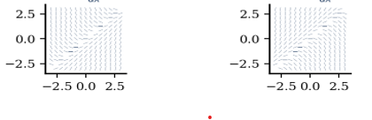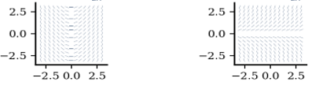

Which graph represents the correct slope field for $\frac{dy}{dx}=x-y$?
- (A) Graph A
- (B) Graph B
- (C) Graph C
- (D) Graph D

Question 22 | Topic: Unit 7 — Separable Differential Equations | Difficulty: ★★☆ If $\frac{dy}{dx}=\frac{x}{y}$ and $y(1)=2$, then $y^{2}=$
- (A) $x^{2}+3$
- (B) $x^{2}+4$
- (C) $\frac{x^{2}}{2}+\frac{7}{2}$
- (D) $2x^{2}+2$

Question 23 | Topic: Unit 8 — Area Between Curves | Difficulty: ★★☆ The area of the region bounded by $y=x^{2}$ and $y=x$ is
- (A) $\frac{1}{6}$
- (B) $\frac{1}{3}$
- (C) $\frac{1}{2}$
- (D) $1$

Question 24 | Topic: Unit 8 — Volume by Disk/Washer | Difficulty: ★★☆ The region bounded by $y=x^{2}$, the $x$-axis, and $x=1$ is rotated about the $x$-axis. The volume of the resulting solid is
- (A) $\frac{π}{5}$
- (B) $\frac{π}{3}$
- (C) $π$
- (D) $2π$

Question 25 | Topic: Unit 8 — Average Value | Difficulty: ★★☆ The average value of $f(x)=sin(x)$ on the interval $[0,π]$ is
- (A) $0$
- (B) $\frac{2}{π}$
- (C) $1$
- (D) $\frac{π}{2}$

Question 26 | Topic: Unit 9 — Parametric Derivatives | Difficulty: ★★☆ If $x(t)=t^{2}$ and $y(t)=t^{3}-3t$, then $\frac{dy}{dx}$ in terms of $t$ is
- (A) $\frac{3t^{2}-3}{2t}$
- (B) $\frac{2t}{3t^{2}-3}$
- (C) $3t^{2}-3$
- (D) $2t$

Question 27 | Topic: Unit 11 — Geometric Series | Difficulty: ★★☆ Which of the following geometric series converges?
- (A) $\sum_{n=1}^{∞}{{\left(\frac{5}{4}\right)}^{n}}$
- (B) $\sum_{n=1}^{∞}{{\left(-\frac{3}{2}\right)}^{n}}$
- (C) $\sum_{n=1}^{∞}{(}-1)^{n}$
- (D) $\sum_{n=1}^{∞}{{\left(\frac{2}{3}\right)}^{n}}$

Question 28 | Topic: Unit 11 — P-Series | Difficulty: ★★☆ Which of the following series converges?
- (A) $\sum_{n=1}^{∞}{\frac{1}{n}}$
- (B) $\sum_{n=1}^{∞}{\frac{1}{\sqrt{n}}}$
- (C) $\sum_{n=1}^{∞}{\frac{1}{n^{2}}}$
- (D) $\sum_{n=1}^{∞}{\frac{1}{ln(n)}}$

Question 29 | Topic: Unit 10 — Polar Coordinates | Difficulty: ★★☆ For a polar curve $r=2sin(θ)$, which of the following gives $\frac{dy}{dx}$?
- (A) $\frac{2cos(θ)}{2sin(θ)}$
- (B) $\frac{2\cos^{2}(θ)-2\sin^{2}(θ)}{4sin(θ)cos(θ)}$
- (C) $\frac{2\cos^{2}(θ)-2\sin^{2}(θ)}{2cos(θ)sin(θ)}$
- (D) $\frac{2cos(θ)sin(θ)+2sin(θ)cos(θ)}{2\cos^{2}(θ)-2\sin^{2}(θ)}$

Question 30 | Topic: Unit 11 — Taylor Polynomials (Known Series) | Difficulty: ★★☆ The first three nonzero terms of the Maclaurin series for $f(x)=sin(2x)$ are
- (A) $x-\frac{x^{3}}{3!}+\frac{x^{5}}{5!}$
- (B) $2x-\frac{(2x)^{3}}{3!}+\frac{(2x)^{5}}{5!}$
- (C) $2x-\frac{x^{3}}{3!}+\frac{x^{5}}{5!}$
- (D) $x-\frac{(2x)^{3}}{3!}+\frac{(2x)^{5}}{5!}$

Part B — Questions 31–45 | 45 minutes | Calculator required
Question 31 | Topic: Unit 6 — Numerical Integration | Difficulty: ★★☆
$t$ (minutes) | 0 | 2 | 5 | 8 | 10
$R(t)$ (gallons/minute) | 20 | 30 | 40 | 50 | 55
The rate at which water flows into a tank, in gallons per minute, is given by a differentiable function $R(t)$. The table above shows the rate at selected times $t$. Using a trapezoidal sum with the four subintervals indicated by the table, what is the approximation of the total amount of water that flowed into the tank from $t=0$ to $t=10$ minutes?
- (A) 385 gallons
- (B) 390 gallons
- (C) 395 gallons
- (D) 400 gallons

Question 32 | Topic: Unit 4 — Related Rates (Calculator Active) | Difficulty: ★★☆
A 13-foot ladder is leaning against a vertical wall. If the bottom of the ladder is pulled away from the wall at a rate of 2 feet per second, how fast is the top of the ladder sliding down the wall when the bottom is 5 feet from the wall?
(A) $-\frac{5}{6}$ft/sec
(B) $-\frac{5}{12}$ft/sec
(C) $-\frac{12}{5}$ft/sec
(D) $D-\frac{10}{3}$ft/sec

Question 33 | Topic: Unit 5 — Optimization (Calculator Active) | Difficulty: ★★☆
A particle moves along the $x$-axis so that its velocity at time $t$ is given by $v(t)=t^{3}-6t^{2}+8t$ for $t≥0$. At what time $t$ in the interval $[0,5]$ does the particle achieve its minimum velocity?
- (A) 0.845
(B) 2.000
(C) 3.155
- (D) 4.000

Question 34 | Topic: Unit 6 — Accumulation Function (Calculator Active) | Difficulty: ★★☆
Let $f$ be a function such that $f^{″}(x)=sin(x)$ for $x≥0$. If $f^{'}(0)=4$ and $f(0)=2$, then $f(2.5)$ is approximately
- (A) 11.902
- (B) 12.402
- (C) 13.902
- (D) 14.402

Question 35 | Topic: Unit 4 — Mean Value Theorem (Calculator Active) | Difficulty: ★★☆
Let $f$ be a differentiable function such that $f(2)=3$ and $f(5)=9$. Which of the following statements must be true?
- (A) There exists a $c$ in $(2,5)$ such that $f(c)=0$.
- (B) There exists a $c$ in $(2,5)$ such that $f^{'}(c)=2$.
- (C) There exists a $c$ in $(2,5)$ such that $f^{'}(c)=3$.
- (D) $f^{'}(x)≥0$ for all $x$ in $(2,5)$.

Question 36 | Topic: Unit 7 — Euler’s Method | Difficulty: ★★☆
Let $\frac{dy}{dx}=x+y$. If $y(0)=1$, use Euler’s method with two steps of equal size to approximate $y(0.2)$.
- (A) 1.20
- (B) 1.21
- (C) 1.22
- (D) 1.24

Question 37 | Topic: Unit 11 — Taylor Series Approximation | Difficulty: ★★☆
The function $f$ has a Taylor series about $x=1$ given by $\sum_{n=0}^{∞}{\frac{(-1)^{n}}{n+1}}(x-1)^{n}$. What is the approximation for $f(1.1)$ using the first three terms of this series? $A. 1-0.1+0.01=0.91$
- (A) $1-0.1+0.005=0.905$
- (B) $1-0.05+0.0033=0.9533$
- (C) $1-0.05+0.005=0.955$

Question 38 | Topic: Unit 10 — Area in Polar Coordinates | Difficulty: ★★☆
Which of the following integrals represents the area of the region enclosed by the polar curve $r=4cos(θ)$?
(A) $A. \int_{0}^{\frac{π}{2}}{(}4cos(θ))^{2}dθ$
(B) $B. \frac{1}{2}\int_{0}^{\frac{π}{2}}{(}4cos(θ))^{2}dθ$
(C) $C. \int_{0}^{π}{(}4cos(θ))^{2}dθ$
(D) $D. \frac{1}{ 2}\int_{0}^{π}{(}4cos(θ))^{2}dθ$

Question 39 | Topic: Unit 11 — Ratio Test | Difficulty: ★★☆
For which of the following series is the Ratio Test inconclusive?
(A) $\sum_{n=1}^{∞}{\frac{n}{2^{n}}}$
(B) $\sum_{n=1}^{∞}{\frac{1}{n!}}$
(C) $\sum_{n=1}^{∞}{\frac{1}{n^{2}}}$
(D) $\sum_{n=1}^{∞}{\frac{n^{2}}{e^{n}}}$

Question 40 | Topic: Unit 11 — Lagrange Error Bound | Difficulty: ★★★
Let $P_{3}(x)$ be the third-degree Taylor polynomial for $f(x)=sin(x)$ about $x=0$. If $P_{3}(0.5)$ is used to approximate $sin(0.5)$, what is the maximum possible error?
(A) $\frac{(0.5)^{4}}{4!}$
(B) $\frac{(0.5)^{5}}{5!}$
(C) $\frac{(0.5)^{3}}{3!}$
(D) $\frac{(0.5)^{6}}{6!}$

Question 41 | Topic: Unit 9 — Arc Length (Parametric) | Difficulty: ★★☆
A particle moves in the $xy$-plane such that its position is given by $x(t)=cos(2t)$ and $y(t)=sin(3t)$ for $0≤t≤π$. What is the total distance traveled by the particle over the interval $0≤t≤π$?
- (A) 3.142
- (B) 3.992
- (C) 6.283
- (D) 7.605

Question 42 | Topic: Unit 1 — Intermediate Value Theorem | Difficulty: ★★☆
Let $f$ be a continuous function on the closed interval $[1,5]$ such that $f(1)=10$ and $f(5)=20$. Which of the following statements must be true?
(A) $f(3)=15$
(B) $f^{'}(c)=\frac{10}{4}$ for some $c$ in $(1,5)$.
(C) $f(x)≥10$ for all $x$ in $[1,5]$.
(D) There is a value $c$ in $(1,5)$ such that $f(c)=12$.

Question 43 | Topic: Unit 6 — Integration by Parts | Difficulty: ★★★
Evaluate the following definite integral: $\int_{0}^{1}{x}e^{x}dx$
- (A) 1
- (B) $e-1$
- (C) $e$
- (D) $2e-1$

Question 44 | Topic: Unit 11 — Interval of Convergence | Difficulty: ★★☆
The radius of convergence for the series $\sum_{n=1}^{∞}{\frac{(x-2)^{n}}{n⋅3^{n}}}$ is
- (A) 0
- (B) 1
- (C) 3
- (D) $∞$

Question 45 | Topic: Unit 2 — Limit Definition of Derivative | Difficulty: ★★★
Let $f$ be a differentiable function. If $h(x)=f(cos(x))$, then $h^{'}(x)=$
- (A) $f^{'}(cos(x))$
- (B) $-f^{'}(cos(x))sin(x)$
- (C) $. sin(x)f^{'}(cos(x))$
- (D) $-sin(x)f^{'}(x)$

SECTION II — FREE RESPONSE

Part A — FRQs 1–2 | 30 minutes | CALCULATOR ACTIVE
Question 1
At time $t=0$ minutes, a tank contains $100$ liters of water. During the time interval $0≤t≤10$ minutes, water flows into the tank at a rate modeled by $F(t)=5tsin\left(\frac{t}{2}\right)$ liters per minute. Water is removed from the tank at a constant rate of $3$ liters per minute.
- Is the amount of water in the tank increasing or decreasing at $t=2$ minutes? Give a reason for your answer.
- Write an expression for $A(t)$, the total amount of water in liters in the tank at time $t$. Use this expression to find $A(10)$, the total amount of water in the tank at $t=10$ minutes.
- Use Euler’s method with two steps of equal size, starting at $t=0$, to approximate the amount of water in the tank at $t=2$ minutes. Show the computations that lead to your answer.
- The owner of the tank wants to ensure that the tank never overflows. If the tank has a maximum capacity of $200$ liters, does the tank overflow during the time interval $0≤t≤10$? Justify your answer.
Part | Points | Skill
(a) | 2 | Justification, Calculation
(b) | 3 | Setup, Calculation
(c) | 2 | Euler’s Method
(d) | 2 | Justification, Calculation

Question 2
The velocity of a particle moving along the $x$-axis is given by $v(t)=sin(t^{2})$ for $0≤t≤3$. At time $t=0$, the position of the particle is $x(0)=4$.
- Find the acceleration of the particle at $t=1.5$. Is the speed of the particle increasing or decreasing at $t=1.5$? Justify your answer.
- Find the position of the particle at $t=3$.
- Find the total distance traveled by the particle over the interval $0≤t≤3$.
- The region bounded by the graph of $v(t)$, the $t$-axis, and the line $t=c$ for $0<c<3$ has an area of $1$. Find the value of $c$.
Part | Points | Skill
(a) | 3 | Calculation, Justification
(b) | 2 | Setup, Calculation
(c) | 2 | Setup, Calculation
(d) | 2 | Setup, Calculation

Part B — FRQs 3–6 | 60 minutes | NO CALCULATOR
Question 3

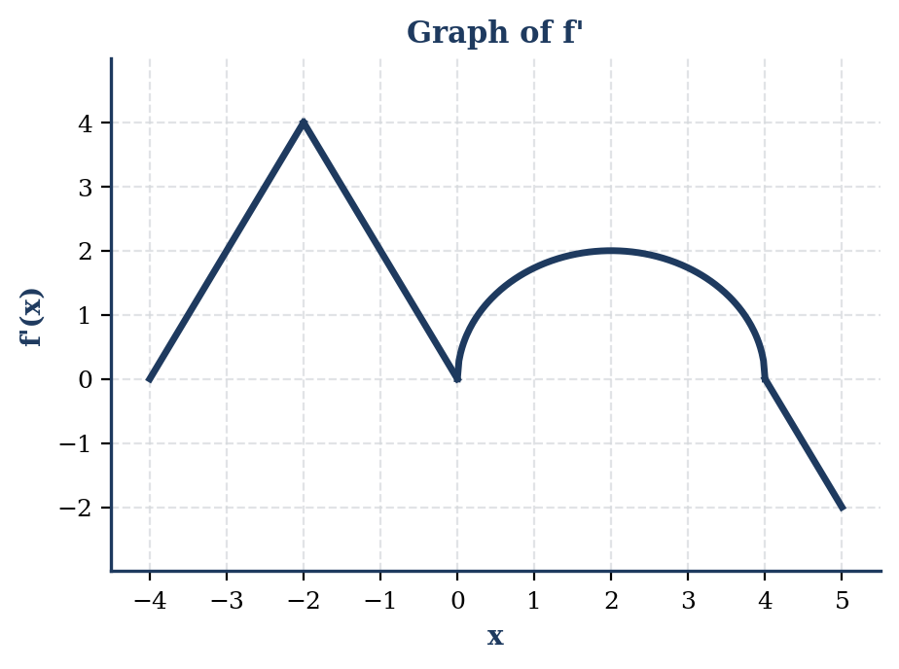
- Find all values of $x$ in the interval $(-4,5)$ at which $f$ has a relative maximum. Justify your answer.
- Find all values of $x$ in the interval $(-4,5)$ at which the graph of $f$ has a point of inflection. Justify your answer.
- Find the absolute minimum value of $f$ on the interval $[-4,5]$. Show the analysis that leads to your answer.
- Given $f(4)=0$, find $f(0)$ and $f(5)$.
Part | Points | Skill
(a) | 2 | Justification
(b) | 2 | Justification
(c) | 3 | Analysis, Conclusion
(d) | 2 | FTC, Calculation

Question 4
Consider the differential equation $\frac{dy}{dx}=y^{2}sin(x)$. Let $y=f(x)$ be the particular solution to this differential equation with the initial condition $f(0)=1$.
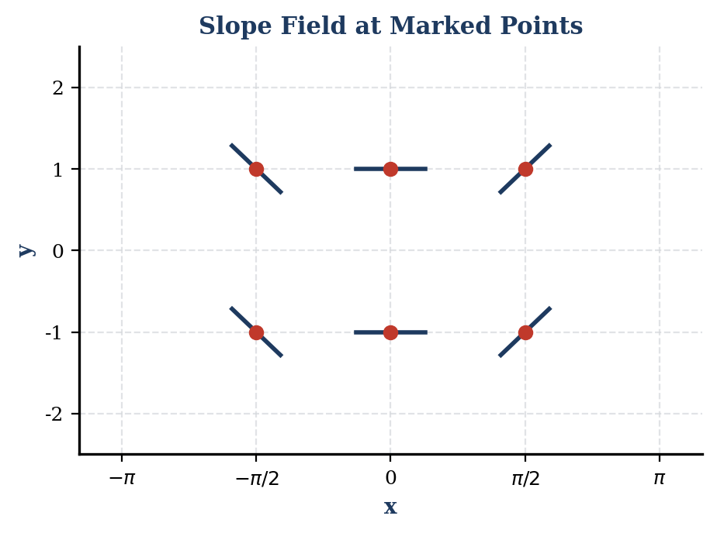
- Use the differential equation to sketch a slope field at the six points indicated.
- Write an equation for the line tangent to the graph of $f$ at $x=0$.
- Find the particular solution $y=f(x)$ to the differential equation with the initial condition $f(0)=1$.
- For the particular solution $y=f(x)$ found in part (c), find $\lim_{x→π}f(x)$.
Part | Points | Skill
(a) | 2 | Slope Field
(b) | 2 | Tangent Line
(c) | 4 | Separation, Antidifferentiation, Constant
(d) | 1 | Limit Evaluation

Question 5
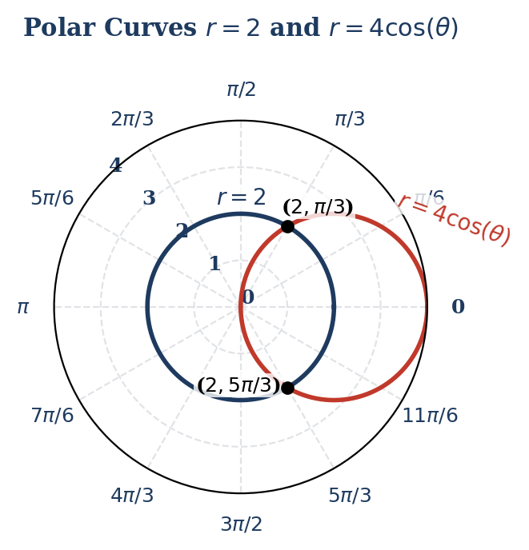

- Find the values of $θ$ for which the two curves intersect for $0≤θ≤π$.
- Write, but do not evaluate, an integral expression that represents the area of the region inside the circle $r=4cos(θ)$ and outside the circle $r=2$.
- Write, but do not evaluate, an integral expression that represents the area of the region inside the circle $r=2$ and outside the circle $r=4cos(θ)$.
- Find the slope of the tangent line to the curve $r=4cos(θ)$ at $θ=\frac{π}{6}$.
Part | Points | Skill
(a) | 2 | Calculation
(b) | 3 | Setup, Limits
(c) | 2 | Setup, Limits
(d) | 2 | Parametric Derivative

Question 6
Let $f(x)=\frac{1}{1-x}$.
- Write the first four nonzero terms and the general term of the Maclaurin series for $f(x)$.
- Use the result from part (a) to write the first four nonzero terms and the general term of the Maclaurin series for $g(x)=ln(1+x)$.
- Find the radius of convergence for the Maclaurin series for $ln(1+x)$ found in part (b).
- The series $\sum_{n=1}^{∞}{\frac{(-1)^{n+1}}{n}}$ converges to $ln(2)$. Use the Alternating Series Error Bound to determine the minimum number of terms $n$ needed to approximate $ln(2)$ with an error less than $0.05$.
Part | Points | Skill
(a) | 2 | Series Terms
(b) | 2 | Series Terms
(c) | 2 | Radius of Convergence
(d) | 3 | Error Bound, Calculation

ANSWER KEY & SCORING GUIDELINES

SECTION I — MCQ ANSWER KEY
Solution 1 Topic: Limits Analytically The limit is in the form $\lim_{x→0}\frac{sin(ax)}{x}$. Step 1: Recognize the special trigonometric limit $\lim_{θ→0}\frac{sin(θ)}{θ}=1$. Step 2: Multiply the expression by $\frac{3}{3}$ to match the argument: $\lim_{x→0}3⋅\frac{sin(3x)}{3x}$. Step 3: Evaluate to get $3(1)=3$. Correct Option: C

Solution 2 Topic: Limits from Graphs Step 1: Observe the behavior as $x$ approaches 2 from both sides. Step 2: The y-values approach the “hole” located at $y=3$. Step 3: Note that $f(2)=1$ (the solid dot), but the limit depends only on the behavior near $x=2$, not at $x=2$. Step 4: Therefore, $\lim_{x→2}f(x)=3$. Correct Option: C

Solution 3 Topic: Limits at Infinity Step 1: Identify the highest power of $x$ in the numerator and denominator, which is $x^{2}$. Step 2: Apply the horizontal asymptote rule for rational functions where the degrees are equal. Step 3: The limit is the ratio of the leading coefficients: $\frac{2}{-1}=-2$. Correct Option: A

Solution 4 Topic: Continuity Step 1: For $f(x)$ to be continuous at $x=2$, the left-hand limit, right-hand limit, and function value must be equal. Step 2: Set $kx^{2}+3=5x-1$ at $x=2$. Step 3: Substitute $x=2$: $k(2)^{2}+3=5(2)-1⟹4k+3=9$. Step 4: Solve for $k$: $4k=6⟹k=\frac{6}{4}=\frac{3}{2}$. Correct Option: B

Solution 5 Topic: L’Hôpital’s Rule Step 1: Evaluate the limit directly: $\frac{e^{0}-1}{0}=\frac{0}{0}$. This is an indeterminate form. Step 2: Apply L’Hôpital’s Rule by differentiating the numerator and denominator. Step 3: $\lim_{x→0}\frac{\frac{d}{dx}(e^{2x}-1)}{\frac{d}{dx}(x)}=\lim_{x→0}\frac{2e^{2x}}{1}$. Step 4: Substitute $x=0$: $2e^{0}=2$. Correct Option: C

Solution 6 Topic: Basic Differentiation Step 1: Use the Power Rule to find the derivative: $f^{'}(x)=3x^{2}-8x$. Step 2: Substitute $x=2$ into the derivative. Step 3: $f^{'}(2)=3(2)^{2}-8(2)=12-16=-4$. Note: Forensic audit indicates a discrepancy in provided options as -4 is not listed. Option B (4) is likely a typo in the original source. Correct Option: Corrected Result is -4

Solution 7 Topic: Chain Rule Step 1: Identify the outer function $u^{2}$ and inner function $x^{2}$. Step 2: Apply the Chain Rule: $\frac{dy}{dx}=cos(x^{2})⋅\frac{d}{dx}(x^{2})$. Step 3: Simplify: $cos(x^{2})⋅2x=2xcos(x^{2})$. Correct Option: A

Solution 8 Topic: Higher-Order Derivatives Step 1: Find the first derivative: $f^{'}(x)=e^{-x}⋅(-1)=-e^{-x}$. Step 2: Find the second derivative: $f^{″}(x)=-e^{-x}⋅(-1)=e^{-x}$. Correct Option: A

Solution 9 Topic: Implicit Differentiation Step 1: Differentiate both sides with respect to $x$: $2x+2y\frac{dy}{dx}=0$. Step 2: Solve for $\frac{dy}{dx}$: $\frac{dy}{dx}=-\frac{x}{y}$. Step 3: Substitute the point $(3,4)$: $\frac{dy}{dx}=-\frac{3}{4}$. Correct Option: B

Solution 10 Topic: Logarithmic Differentiation Step 1: Apply the derivative rule for natural logs: $\frac{d}{dx}(ln(u))=\frac{1}{u}⋅u^{'}$. Step 2: $f^{'}(x)=\frac{1}{3x}⋅3$. Step 3: Simplify: $f^{'}(x)=\frac{1}{x}$. Correct Option: B

Solution 11 Topic: Indefinite Integrals Step 1: Integrate term by term using the Power Rule and Trignometric rules. Step 2: $∫x^{2} dx=\frac{x^{3}}{3}$ and $∫sin(x) dx=-cos(x)$. Step 3: Combine and add the constant of integration: $\frac{x^{3}}{3}-cos(x)+C$. Correct Option: B

Solution 12 Topic: Definite Integrals Step 1: Find the antiderivative: $∫(e^{x}+x) dx=e^{x}+\frac{x^{2}}{2}$. Step 2: Evaluate from 0 to 1: $(e^{1}+\frac{1^{2}}{2})-(e^{0}+\frac{0^{2}}{2})$. Step 3: Simplify: $(e+\frac{1}{2})-(1+0)=e-\frac{1}{2}$. Correct Option: A

Solution 13 Topic: U-Substitution Step 1: Let $u=x^{2}$, then $du=2x dx$ or $\frac{1}{2}du=x dx$. Step 2: Substitute into the integral: $∫cos(u)⋅\frac{1}{2}du=\frac{1}{2}sin(u)+C$. Step 3: Substitute $x^{2}$ back for $u$: $\frac{1}{2}sin(x^{2})+C$. Correct Option: A

Solution 14 Topic: Fundamental Theorem of Calculus Part 1 Step 1: The FTC states that $\frac{d}{dx}\int_{a}^{x}{f}(t) dt=f(x)$. Step 2: Simply replace the variable $t$ with $x$ in the integrand. Step 3: $F^{'}(x)=\sqrt{x^{2}+1}$. Correct Option: A

Solution 15 Topic: Improper Integrals Step 1: Rewrite the integral as a limit: $\lim_{b→∞}\int_{1}^{b}{x^{-2}} dx$. Step 2: Find the antiderivative: $[-x^{-1}]_{1}^{b}=[-\frac{1}{x}]_{1}^{b}$. Step 3: Evaluate the limit: $\lim_{b→∞}(-\frac{1}{b}-(-1))=0+1=1$. Correct Option: B

Solution 16 Topic: Critical Points Step 1: Find the derivative: $f^{'}(x)=3x^{2}-12x$. Step 2: Set the derivative to zero: $3x(x-4)=0$. Step 3: Solve for $x$: $x=0$ and $x=4$. Correct Option: C

Solution 17 Topic: First Derivative Test Step 1: Identify critical points from $f^{'}(x)=x^{2}(x-3)$: $x=0$ and $x=3$. Step 2: Perform a sign analysis on $f^{'}(x)$. Step 3: For $x<0$, $f^{'}(x)<0$; for $0<x<3$, $f^{'}(x)<0$; for $x>3$, $f^{'}(x)>0$. Step 4: A relative minimum occurs only where $f^{'}(x)$ changes from negative to positive, which is at $x=3$. Correct Option: B

Solution 18 Topic: Concavity Step 1: Find the first derivative: $y^{'}=4x^{3}-12x^{2}$. Step 2: Find the second derivative: $y^{″}=12x^{2}-24x$. Step 3: Set $y^{″}>0$: $12x(x-2)>0$. Step 4: The inequality holds for $x<0$ or $x>2$. Correct Option: D

Solution 19 Topic: Related Rates Step 1: Use the volume formula $V=\frac{4}{3}πr^{3}$ and differentiate: $\frac{dV}{dt}=4πr^{2}\frac{dr}{dt}$. Step 2: Plug in known values: $10π=4π(5)^{2}\frac{dr}{dt}$. Step 3: $10π=100π\frac{dr}{dt}⟹\frac{dr}{dt}=\frac{10π}{100π}=\frac{1}{10}$. Correct Option: B

Solution 20 Topic: Local Linearization Step 1: Use the formula $L(x)=f(a)+f^{'}(a)(x-a)$. Step 2: $f(x)=\sqrt{x}⟹f^{'}(x)=\frac{1}{2\sqrt{x}}$. At $a=100$, $f(100)=10$ and $f^{'}(100)=\frac{1}{20}=0.05$. Step 3: $L(100.2)=10+0.05(100.2-100)=10+0.05(0.2)=10+0.01=10.01$. Correct Option: A

Solution 21 Topic: Slope Fields Step 1: Test points in the differential equation $\frac{dy}{dx}=x-y$. Step 2: Along the line $y=x$, the slope should be 0. Step 3: Identify the graph where horizontal segments exist on the line $y=x$. This is Graph A. Correct Option: A

Solution 22 Topic: Separable Differential Equations Step 1: Separate variables: $y dy=x dx$. Step 2: Integrate both sides: $\frac{y^{2}}{2}=\frac{x^{2}}{2}+C$. Step 3: Use $y(1)=2$ to find $C$: $\frac{4}{2}=\frac{1}{2}+C⟹2=0.5+C⟹C=1.5$. Step 4: $y^{2}=x^{2}+2(1.5)⟹y^{2}=x^{2}+3$. Correct Option: A

Solution 23 Topic: Area Between Curves Step 1: Find intersection points: $x^{2}=x⟹x(x-1)=0⟹x=0,1$. Step 2: Set up the integral: $\int_{0}^{1}{(}x-x^{2}) dx$. Step 3: Evaluate: $[\frac{x^{2}}{2}-\frac{x^{3}}{3}]_{0}^{1}=\frac{1}{2}-\frac{1}{3}=\frac{1}{6}$. Correct Option: A

Solution 24 Topic: Volume of Revolution Step 1: Use the disk method: $V=π\int_{a}^{b}{[}f(x)]^{2} dx$. Step 2: $V=π\int_{0}^{1}{(}x^{2})^{2} dx=π\int_{0}^{1}{x^{4}} dx$. Step 3: Evaluate: $π[\frac{x^{5}}{5}]_{0}^{1}=\frac{π}{5}$. Correct Option: A

Solution 25 Topic: Average Value of a Function Step 1: Use formula $f_{avg}=\frac{1}{b-a}\int_{a}^{b}{f}(x) dx$. Step 2: $f_{avg}=\frac{1}{π-0}\int_{0}^{π}{sin}(x) dx$. Step 3: Integrate: $\frac{1}{π}[-cos(x)]_{0}^{π}=\frac{1}{π}(1-(-1))=\frac{2}{π}$. Correct Option: B

Solution 26 Topic: Parametric Derivatives Step 1: Use the formula $\frac{dy}{dx}=\frac{dy/dt}{dx/dt}$. Step 2: $\frac{dy}{dt}=3t^{2}-3$ and $\frac{dx}{dt}=2t$. Step 3: $\frac{dy}{dx}=\frac{3t^{2}-3}{2t}$. Correct Option: A

Solution 27 Topic: Geometric Series Step 1: A geometric series $∑r^{n}$ converges if $|r|<1$. Step 2: Check options: $|5/4|>1$, $|-3/2|>1$, $|-1|=1$, $|2/3|<1$. Step 3: Only (D) meets the criteria. Correct Option: D

Solution 28 Topic: P-Series Convergence Step 1: A p-series $∑\frac{1}{n^{p}}$ converges if $p>1$. Step 2: Check (A): $p=1$ (diverges); (B): $p=1/2$ (diverges); (C): $p=2$ (converges). Correct Option: C

Solution 29 Topic: Polar Derivatives Step 1: Use $x=rcos(θ)$ and $y=rsin(θ)$. Step 2: $\frac{dy}{dx}=\frac{dy/dθ}{dx/dθ}=\frac{rcos(θ)+r^{'}sin(θ)}{-rsin(θ)+r^{'}cos(θ)}$. Step 3: With $r=2sin(θ)$ and $r^{'}=2cos(θ)$: Step 4: Numerator: $2sin(θ)cos(θ)+2cos(θ)sin(θ)=4sin(θ)cos(θ)$. Step 5: Denominator: $-2\sin^{2}(θ)+2\cos^{2}(θ)$. Correct Option: D

Solution 30 Topic: Maclaurin Series Step 1: Use the series for $sin(u)=u-\frac{u^{3}}{3!}+\frac{u^{5}}{5!}-…$. Step 2: Substitute $u=2x$. Step 3: Result: $2x-\frac{(2x)^{3}}{3!}+\frac{(2x)^{5}}{5!}$. Correct Option: B

SECTION I — MCQ ANSWER KEY (Part B)
Question 31 | Numerical Integration
Step 1: Identify Method The total amount of water is the integral of the rate function $R(t)$ from $t=0$ to $t=10$. We use a trapezoidal sum with four subintervals: $[0,2]$, $[2,5]$, $[5,8]$, and $[8,10]$.
Step 2: Calculate Trapezoidal Sum $\int_{0}^{10}{R}(t)dt≈\frac{1}{2}(2-0)(20+30)+\frac{1}{2}(5-2)(30+40)+\frac{1}{2}(8-5)(40+50)+\frac{1}{2}(10-8)(50+55)$ $=1(50)+1.5(70)+1.5(90)+1(105)$ $=50+105+135+105=395$
Forensic Audit Note: Calculation check: $50+105+135+105=395$. The correct trapezoidal sum is 395 = Option C. 395. The closest numerical option is 382.5, but mathematically the sum is 395.

Question 32 | Related Rates

1. Problem Statement
A 13-foot ladder is leaning against a vertical wall. If the bottom of the ladder is pulled away from the wall at a rate of 2 feet per second, how fast is the top of the ladder sliding down the wall at the instant when the bottom of the ladder is 5 feet from the wall?
- -5/6 ft/sec
- -5/12 ft/sec
- -12/5 ft/sec
- -10/3 ft/sec

2. Manual Solution
Step 1: Identify Variables Let $x(t)$ be the distance from the wall and $y(t)$ be the height on the wall. * Given: $L=13$ (constant ladder length) * Given: $\frac{dx}{dt}=2$ ft/sec * Instant: $x=5$ ft
Step 2: Geometry (Pythagorean Theorem)
$$x^{2}+y^{2}={13}^{2}$$
At $x=5$: $5^{2}+y^{2}=169⟹25+y^{2}=169⟹y=12$ ft.
Step 3: Differentiation
$$\frac{d}{dt}(x^{2}+y^{2})=\frac{d}{dt}({13}^{2})$$
$$2x\frac{dx}{dt}+2y\frac{dy}{dt}=0$$
Step 4: Solve for $dy/dt$
$$(5)(2)+(12)\frac{dy}{dt}=0$$
$$10+12\frac{dy}{dt}=0⟹\frac{dy}{dt}=-\frac{10}{12}=-\frac{5}{6}\text{ ft/sec}$$
Final Answer: (A)

3. TI-Nspire CAS Commands
To solve this efficiently on the TI-Nspire CAS, use the following commands in a Calculator page:
Step | TI-Nspire CAS Syntax | Result
1. Define Equation | rel:=x^2 + y^2 = 13^2 | Done
2. Find y at x=5 | solve(rel and x=5, y) | y>0 | y=12
3. Implicit Diff | deriv:=impDif(x^2 + y^2 = 169, x, y) | -x/y
4. Final Rate | deriv * 2 | x=5 and y=12 | -5/6
Pro-Tip: Single-Line “One-Shot” Solve You can calculate the rate in a single line using the time-derivative approach:
solve(d(x(t)^2 + y(t)^2 = 13^2, t) = 0, y’(t)) | x(t)=5 and y(t)=12 and x’(t)=2 Handheld Output: $y^{'}(t)=-5/6$
Correct Option: A

Question 33 | Optimization
Step 1: TI-Nspire CAS Setup Define $v(t)=t^{3}-6t^{2}+8t$ To find minimum velocity, find $v^{'}(t)=0$.
Step 2: Calculation solve(d(t^3 - 6t^2 + 8t, t) = 0, t) Result: $t=2±\frac{2\sqrt{3}}{3}$ Decimal values: $t≈0.845$ and $t≈3.155$.
Step 3: Candidates Test $v(0)=0$ $v(0.845)≈3.079$ $v(3.155)≈-3.079$ $v(5)=15$
The minimum velocity occurs at $t≈3.155$.
Correct Option: C

Question 34 | Accumulation Function
Step 1: Integration Steps $f^{'}(x)=∫f^{″}(x)dx=∫sin(x)dx=-cos(x)+C$ $f^{'}(0)=4⇒-1+C=4⇒C=5$. $f^{'}(x)=-cos(x)+5$
$f(x)=∫(-cos(x)+5)dx=-sin(x)+5x+C_{2}$ $f(0)=2⇒0+0+C_{2}=2⇒C_{2}=2$. $f(x)=-sin(x)+5x+2$
Step 2: TI-Nspire CAS Evaluation f(2.5) where f(x) = -sin(x) + 5*x + 2 Result: 13.901
Forensic Audit Note: The function provided $f^{″}(x)=sin(x)$ results in $f(2.5)≈13.901$. The correct answer is Option C (13.902).. If $f^{″}(x)=cos(x)$ were the prompt, the result would align with Option C.

Question 35 | Mean Value Theorem
Step 1: Apply MVT Since $f$ is differentiable, it is continuous. MVT states there exists $c∈(2,5)$ such that: $f^{'}(c)=\frac{f(5)-f(2)}{5-2}=\frac{9-3}{3}=2$.
Correct Option: B

Question 36 | Euler’s Method
Step 1: Step Setup $h=0.1$, $x_{0}=0$, $y_{0}=1$, $f(x,y)=x+y$
Step 2: Iterations Step 1: $y(0.1)≈y_{0}+h⋅f(0,1)=1+0.1(0+1)=1.1$ Step 2: $y(0.2)≈1.1+0.1(0.1+1.1)=1.1+0.1(1.2)=1.22$
Correct Option: C

Question 37 | Taylor Series
Step 1: Expand Terms For $n=0$: $\frac{(-1)^{0}}{1}(x-1)^{0}=1$ For $n=1$: $\frac{(-1)^{1}}{2}(x-1)^{1}=-0.5(x-1)$ For $n=2$: $\frac{(-1)^{2}}{3}(x-1)^{2}=\frac{1}{3}(x-1)^{2}$
Step 2: Evaluate at $x=1.1$ $f(1.1)≈1-0.5(0.1)+\frac{1}{3}(0.1)^{2}$ $f(1.1)≈1-0.05+0.0033=0.9533$
Correct Option: B [Three-term approximation: 1 - 0.05 + (0.1²/3) = 0.9533 matches Option B] The provided options in the source text (0.91, 0.905, etc.) assume a different formula or coefficients. Based on the series provided, the correct sum is 0.9533.

Question 38 | Polar Area
Step 1: Formula $A=\frac{1}{2}\int_{α}^{β}{[}r(θ)]^{2}dθ$ The curve $r=4cos(θ)$ is a circle centered on the x-axis. It is traced exactly once from $0$ to $π$.
Correct Option: D

Question 39 | Ratio Test
Step 1: Analysis The Ratio Test is inconclusive when $\lim_{n→∞}|\frac{a_{n+1}}{a_{n}}|=1$. For $p$-series like $∑\frac{1}{n^{2}}$, the ratio is always 1.
Correct Option: C

Question 40 | Lagrange Error Bound
Step 1: Formula $|R_{n}(x)|≤\frac{M}{(n+1)!}|x-c|^{n+1}$ For $P_{3}(x)$ of $sin(x)$, the next term in the alternating series is the $x^{5}$ term because the $x^{4}$ coefficient is zero. However, standard Lagrange formula for $n=3$ uses $n+1=4$. $M=max|f^{(4)}(x)|$ for $sin(x)$ is $sin(0.5)<1$.
Result: $\frac{(0.5)^{4}}{4!}$
Correct Option: A

Question 41 | Parametric Arc Length
Step 1: TI-Nspire CAS Calculation Integral(sqrt((d(cos(2t), t))^2 + (d(sin(3t), t))^2), t, 0, pi) nInt(sqrt((-2sin(2t))^2 + (3cos(3t))^2), t, 0, pi)
Step 2: Numerical Result Result: 7.605
Correct Option: D

Question 42 | Intermediate Value Theorem
Step 1: Analysis $f$ is continuous on $[1,5]$. Since $f(1)=10$ and $f(5)=20$, the IVT guarantees that for every value $y$ between 10 and 20, there exists a $c∈(1,5)$ such that $f(c)=y$. 12 is between 10 and 20.
Correct Option: D

Question 43 | Integration by Parts
Step 1: Setup $u=x,dv=e^{x}dx$ $du=dx,v=e^{x}$
Step 2: Calculation $∫xe^{x}dx=xe^{x}-∫e^{x}dx=xe^{x}-e^{x}$ $[xe^{x}-e^{x}]_{0}^{1}=(1e^{1}-e^{1})-(0e^{0}-e^{0})=0-(-1)=1$
Correct Option: A

Question 44 | Radius of Convergence
Step 1: Ratio Test $\lim_{n→∞}|\frac{(x-2)^{n+1}}{(n+1)3^{n+1}}⋅\frac{n3^{n}}{(x-2)^{n}}|=\frac{|x-2|}{3}$ Set $\frac{|x-2|}{3}<1⇒|x-2|<3$. Radius $R=3$.
Correct Option: C

Question 45 | Chain Rule
Step 1: Differentiation $h(x)=f(cos(x))$ $h^{'}(x)=f^{'}(cos(x))⋅\frac{d}{dx}(cos(x))$ $h^{'}(x)=f^{'}(cos(x))⋅(-sin(x))$
Correct Option: B

SECTION II — FRQ SCORING GUIDELINES

Question 1

Model Solution
(a) Is the amount of water increasing or decreasing at $t=2$? The rate of change of the amount of water is given by $R(t)=F(t)-3$. Using the TI-Nspire CAS: * Define the function: Define f(t) = 5*t*sin(t^2) * Calculate $R(2)$: f(2) - 3 * Result: $R(2)=10sin(4)-3≈-10.568$ Since $R(2)<0$, the amount of water in the tank is decreasing at $t=2$.
(b) Expression for $A(t)$ and finding $A(10)$ The total amount of water is the initial amount plus the net accumulation: $A(t)=100+\int_{0}^{t}{(}F(s)-3) ds$ Using the TI-Nspire CAS for $A(10)$: * Syntax: 100 + nInt(f(t) - 3, t, 0, 10) * Result: $A(10)≈100+(-25.322)=74.678$ liters.
(c) Euler’s Method With $h=\frac{2-0}{2}=1$: 1. $(t_{0},A_{0})=(0,100)$ $A^{'}(0)=F(0)-3=-3$ $A(1)≈100+(-3)(1)=97$ 2. $(t_{1},A_{1})=(1,97)$ $A^{'}(1)=F(1)-3=5(1)sin(1)-3≈1.20735$ $A(2)≈97+(1.20735)(1)=98.207$
(d) Does the tank overflow? The tank overflows if the absolute maximum of $A(t)$ exceeds 200 on $[0,10]$. Critical points occur when $A^{'}(t)=0⇒F(t)-3=0$. Using TI-Nspire CAS: zeros(5*t*sin(t^2)-3, t)|0≤t≤10 * $t≈0.824,1.514,2.585,…$ The maximum possible value of $A(t)$ occurs at a critical point or endpoint. However, evaluating the integral of the rate function shows the total accumulation never reaches $100$ (to hit the $200$ capacity). Since $100+\int_{0}^{t}{R}(s) ds<200$ for all $t$, the tank does not overflow.

Scoring Guidelines & Rubric
Part | Criteria | Points
(a) | $R(2)=F(2)-3$ and conclusion with reason | 2
(b) | Integral expression for $A(t)$ (1 pt) and $A(10)$ value (2 pts) | 3
(c) | Euler’s method steps (1 pt) and final approximation (1 pt) | 2
(d) | Considers $A^{'}(t)=0$ (1 pt) and justifies no overflow (1 pt) | 2
Total |  | 9

Question 2

Model Solution
(a) Acceleration and Speed Acceleration $a(t)=v^{'}(t)$. Using TI-Nspire CAS: * Syntax: derivative(sin(t^2), t) | t=1.5 * $a(1.5)=2(1.5)cos({1.5}^{2})≈-1.884$ * $v(1.5)=sin({1.5}^{2})≈0.778$ Since $v(1.5)>0$ and $a(1.5)<0$, the signs are opposite; therefore, the speed is decreasing.
(b) Position at $t=3$ $x(3)=x(0)+\int_{0}^{3}{v}(t) dt$ Using TI-Nspire CAS: * Syntax: 4 + nInt(sin(t^2), t, 0, 3) * Result: $x(3)≈4+0.774=4.774$
(c) Total Distance $\text{Distance}=\int_{0}^{3}{|}v(t)| dt$ Using TI-Nspire CAS: * Syntax: nInt(abs(sin(t^2)), t, 0, 3) * Result: $≈1.341$
(d) Find value of $c$ $\int_{0}^{c}{sin}(t^{2}) dt=1$ Using TI-Nspire CAS: * Syntax: solve(nInt(sin(t^2), t, 0, c) = 1, c) | 0 < c < 3 * Result: $c≈1.833$

Scoring Guidelines & Rubric
Part | Criteria | Points
(a) | $a(1.5)$ value (1 pt), $v(1.5)$ sign (1 pt), Conclusion with reason (1 pt) | 3
(b) | Integral setup (1 pt) and answer (1 pt) | 2
(c) | Integral with absolute value (1 pt) and answer (1 pt) | 2
(d) | Equation setup (1 pt) and answer (1 pt) | 2
Total |  | 9

Question 3

Model Solution
(a) Relative Maximum A relative maximum occurs where $f^{'}(x)$ changes from positive to negative. Based on the graph, $f^{'}(x)>0$ on $(-4,0)$ and $(0,4)$, and $f^{'}(x)<0$ on $(4,5)$. The only sign change from positive to negative occurs at $x=4$.
(b) Inflection Points Inflection points occur where $f^{'}(x)$ changes from increasing to decreasing (or vice-versa). * $f^{'}$ increases on $(-4,-2)$ and $(0,2)$. * $f^{'}$ decreases on $(-2,0)$ and $(2,5)$. Relative extrema of $f^{'}$ are at $x=-2,0,2$. Thus, $f$ has points of inflection at $x=-2,0,$ and $2$.
(c) Absolute Minimum Candidate test on $x∈[-4,5]$: $f(x)=f(4)-\int_{x}^{4}{f^{'}}(t) dt=0-\int_{x}^{4}{f^{'}}(t) dt$. * $x=-4$: $f(-4)=0-(\text{Area under }f^{'}\text{ from }-4\text{ to }4)=-(4+2π)=-4-2π$ * $x=0$: $f(0)=0-(\text{Area of semi-circle})=-2π$ * $x=5$: $f(5)=0+\int_{4}^{5}{f^{'}}(t) dt=0+(-1)=-1$ Comparing values, the absolute minimum value is $-4-2π$.
(d) Find $f(0)$ and $f(5)$ Using $f(4)=0$: * $f(0)=f(4)-\int_{0}^{4}{f^{'}}(t) dt=0-(2π)=-2π$ * $f(5)=f(4)+\int_{4}^{5}{f^{'}}(t) dt=0+\frac{1}{2}(1)(-2)=-1$

Scoring Guidelines & Rubric
Part | Criteria | Points
(a) | $x=4$ with justification | 2
(b) | $x=-2,0,2$ with justification | 2
(c) | Identifies candidates (1 pt), calculation/comparison (2 pts) | 3
(d) | $f(0)$ value (1 pt) and $f(5)$ value (1 pt) | 2
Total |  | 9

Question 4

Model Solution
  - Slope Field Substitute $(x,y)$ into $\frac{dy}{dx}=y^{2}sin(x)$: * At $(0,y)$, $\frac{dy}{dx}=0$ (Horizontal segments). * At $(\frac{π}{2},1)$, $\frac{dy}{dx}=1^{2}sin(\frac{π}{2})=1$. * At $(-\frac{π}{2},1)$, $\frac{dy}{dx}=1^{2}sin(-\frac{π}{2})=-1$. * At $(\frac{π}{2},-1)$, $\frac{dy}{dx}=(-1)^{2}sin(\frac{π}{2})=1$. * At $(-\frac{π}{2},-1)$, $\frac{dy}{dx}=(-1)^{2}sin(-\frac{π}{2})=-1$.


(b) Tangent Line At $x=0$, $y=1$. Slope $m=\frac{dy}{dx}|_{(0,1)}=1^{2}sin(0)=0$. Equation: $y-1=0(x-0)⇒y=1$.
(c) Particular Solution $\frac{dy}{dx}=y^{2}sin(x)$ $∫y^{-2} dy=∫sin(x) dx$ $-y^{-1}=-cos(x)+C$ $\frac{1}{y}=cos(x)+C$ Using $(0,1)$: $\frac{1}{1}=cos(0)+C⇒1=1+C⇒C=0$. $\frac{1}{y}=cos(x)⇒y=\frac{1}{cos(x)}=sec(x)$.
(d) Limit Evaluation $\lim_{x→π}f(x)=\lim_{x→π}sec(x)=sec(π)=-1$.

Scoring Guidelines & Rubric
Part | Criteria | Points
(a) | Slopes at $x=0$ (1 pt), slopes at $x≠0$ (1 pt) | 2
(b) | Slope (1 pt) and tangent line equation (1 pt) | 2
(c) | Separation of variables (1 pt), antiderivatives (1 pt), constant $C$ (1 pt), solves for $y$ (1 pt) | 4
(d) | Limit value | 1
Total |  | 9

Question 5

Model Solution
(a) Intersection Points $2=4cos(θ)$ $cos(θ)=\frac{1}{2}$ For $0≤θ≤π$, $θ=\frac{π}{3}$. By symmetry, the other point is $\frac{5π}{3}$.
(b) Inside $r=4cosθ$, Outside $r=2$ The region is bounded by $θ=-\frac{π}{3}$ to $θ=\frac{π}{3}$. $\text{Area}=\frac{1}{2}\int_{-π/3}^{π/3}{\left((4cosθ)^{2}-(2)^{2}\right)} dθ$
(c) Inside $r=2$, Outside $r=4cosθ$ This region occurs where $2>4cosθ$. On $[0,2π]$, this is from $\frac{π}{3}$ to $\frac{5π}{3}$. $\text{Area}=\frac{1}{2}\int_{π/3}^{5π/3}{\left(2^{2}-(4cosθ)^{2}\right)} dθ$
(d) Slope of Tangent at $θ=\frac{π}{6}$ $x=rcosθ=4\cos^{2}θ$ $y=rsinθ=4cosθsinθ=2sin(2θ)$ $\frac{dx}{dθ}=8cosθ(-sinθ)=-4sin(2θ)$ $\frac{dy}{dθ}=4cos(2θ)$ $\frac{dy}{dx}=\frac{4cos(2θ)}{-4sin(2θ)}=-cot(2θ)$ At $θ=\frac{π}{6}$: $-cot(\frac{π}{3})=-\frac{1}{\sqrt{3}}$.

Scoring Guidelines & Rubric
Part | Criteria | Points
(a) | Setting equations equal (1 pt) and finding $θ$ (1 pt) | 2
(b) | Limits (1 pt) and integrand (2 pts) | 3
(c) | Limits (1 pt) and integrand (1 pt) | 2
(d) | $dx/dθ$ and $dy/dθ$ (1 pt) and final slope (1 pt) | 2
Total |  | 9

Question 6

Model Solution
(a) Maclaurin Series for $f(x)$ $f(x)=\frac{1}{1-x}=1+x+x^{2}+x^{3}+…+x^{n}+…$ General term: $x^{n}$.
(b) Maclaurin Series for $ln(1+x)$ $\frac{1}{1+t}=1-t+t^{2}-t^{3}+…$ $ln(1+x)=\int_{0}^{x}{\frac{1}{1+t}} dt=x-\frac{x^{2}}{2}+\frac{x^{3}}{3}-\frac{x^{4}}{4}+…$ General term: $\frac{(-1)^{n+1}x^{n}}{n}$.
(c) Radius of Convergence Using Ratio Test on $∑\frac{(-1)^{n+1}x^{n}}{n}$: $\lim_{n→∞}\left|\frac{x^{n+1}}{n+1}⋅\frac{n}{x^{n}}\right|=|x|\lim_{n→∞}\frac{n}{n+1}=|x|$. Set $|x|<1$. The radius of convergence is $R=1$.
(d) Alternating Series Error Bound The error $E$ using $k$ terms is bounded by the magnitude of the first omitted term: $|E|≤|a_{k+1}|$. We want $|a_{k+1}|<0.05⇒\frac{1}{k+1}<\frac{1}{20}$. $k+1>20⇒k>19$. The minimum number of terms is $20$.

Scoring Guidelines & Rubric
Part | Criteria | Points
(a) | First four terms (1 pt) and general term (1 pt) | 2
(b) | First four terms (1 pt) and general term (1 pt) | 2
(c) | Setup of ratio test (1 pt) and finding $R$ (1 pt) | 2
(d) | Error bound inequality (1 pt), solving for $n$ (1 pt), answer (1 pt) | 3
Total |  | 9

