SJF – Non-Preemptive
#include<stdio.h>

int main()
{
int n,i,j,temp;
int bt[20],wt[20],tat[20],p[20];

float avg_wt=0,avg_tat=0;

printf("Enter number of processes: ");
scanf("%d",&n);

for(i=0;i<n;i++)
{
printf("Enter Burst Time for P%d: ",i+1);
scanf("%d",&bt[i]);
p[i]=i+1;
}

// Sorting according to burst time
for(i=0;i<n;i++)
{
for(j=i+1;j<n;j++)
{
if(bt[i]>bt[j])
{
temp=bt[i];
bt[i]=bt[j];
bt[j]=temp;

temp=p[i];
p[i]=p[j];
p[j]=temp;
}
}
}

wt[0]=0;

for(i=1;i<n;i++)
wt[i]=wt[i-1]+bt[i-1];

for(i=0;i<n;i++)
{
tat[i]=bt[i]+wt[i];
avg_wt+=wt[i];
avg_tat+=tat[i];
}

printf("\nP\tBT\tWT\tTAT\n");

for(i=0;i<n;i++)
printf("P%d\t%d\t%d\t%d\n",p[i],bt[i],wt[i],tat[i]);

printf("\nAverage Waiting Time = %.2f",avg_wt/n);
printf("\nAverage Turnaround Time = %.2f",avg_tat/n);

return 0;
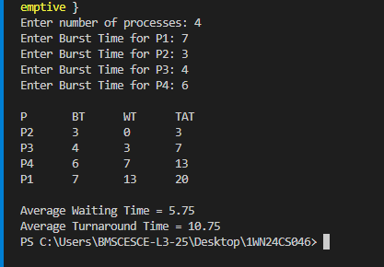
SJF – Preemptive
#include<stdio.h>
#include<limits.h>

int main()
{
int n,i,time=0,remain,smallest;
int bt[20],rt[20],wt[20],tat[20];

float avg_wt=0,avg_tat=0;

printf("Enter number of processes: ");
scanf("%d",&n);

for(i=0;i<n;i++)
{
printf("Enter Burst Time for P%d: ",i+1);
scanf("%d",&bt[i]);
rt[i]=bt[i];
}

rt[19]=9999;
remain=n;

while(remain!=0)
{
smallest=19;

for(i=0;i<n;i++)
{
if(rt[i]>0 && rt[i]<rt[smallest])
smallest=i;
}

rt[smallest]--;
time++;

if(rt[smallest]==0)
{
remain--;
tat[smallest]=time;
wt[smallest]=tat[smallest]-bt[smallest];
}
}

printf("\nP\tBT\tWT\tTAT\n");

for(i=0;i<n;i++)
{
printf("P%d\t%d\t%d\t%d\n",i+1,bt[i],wt[i],tat[i]);
avg_wt+=wt[i];
avg_tat+=tat[i];
}

printf("\nAverage WT = %.2f",avg_wt/n);
printf("\nAverage TAT = %.2f",avg_tat/n);

return 0;
}
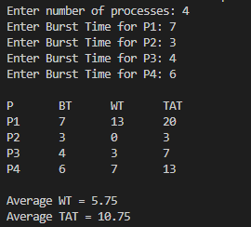 Priority Scheduling – Non-Preemptive
#include<stdio.h>

int main()
{
int n,i,j,temp;
int bt[20],pr[20],wt[20],tat[20],p[20];
float avg_wt=0,avg_tat=0;

printf("Enter number of processes: ");
scanf("%d",&n);

for(i=0;i<n;i++)
{
printf("Enter Burst Time and Priority for P%d: ",i+1);
scanf("%d%d",&bt[i],&pr[i]);
p[i]=i+1;
}

// Sorting by priority
for(i=0;i<n;i++)
{
for(j=i+1;j<n;j++)
{
if(pr[i]>pr[j])
{
temp=pr[i];
pr[i]=pr[j];
pr[j]=temp;

temp=bt[i];
bt[i]=bt[j];
bt[j]=temp;

temp=p[i];
p[i]=p[j];
p[j]=temp;
}
}
}

wt[0]=0;

for(i=1;i<n;i++)
wt[i]=wt[i-1]+bt[i-1];

for(i=0;i<n;i++)
{
tat[i]=bt[i]+wt[i];
avg_wt+=wt[i];
avg_tat+=tat[i];
}

printf("\nP\tBT\tPR\tWT\tTAT\n");

for(i=0;i<n;i++)
printf("P%d\t%d\t%d\t%d\t%d\n",p[i],bt[i],pr[i],wt[i],tat[i]);

printf("\nAverage WT = %.2f",avg_wt/n);
printf("\nAverage TAT = %.2f",avg_tat/n);

return 0;
}
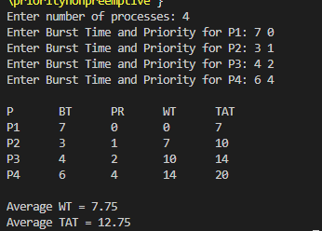

Priority Scheduling – Preemptive
#include<stdio.h>
#include<limits.h>

int main()
{
int n,i,time=0,remain,highest;
int bt[20],pr[20],rt[20],wt[20],tat[20];

float avg_wt=0,avg_tat=0;

printf("Enter number of processes: ");
scanf("%d",&n);

for(i=0;i<n;i++)
{
printf("Enter Burst Time and Priority for P%d: ",i+1);
scanf("%d%d",&bt[i],&pr[i]);
rt[i]=bt[i];
}

pr[19]=INT_MAX;
remain=n;

while(remain!=0)
{
highest=19;

for(i=0;i<n;i++)
{
if(rt[i]>0 && pr[i]<pr[highest])
highest=i;
}

rt[highest]--;
time++;

if(rt[highest]==0)
{
remain--;
tat[highest]=time;
wt[highest]=tat[highest]-bt[highest];
}
}

printf("\nP\tBT\tPR\tWT\tTAT\n");

for(i=0;i<n;i++)
{
printf("P%d\t%d\t%d\t%d\t%d\n",i+1,bt[i],pr[i],wt[i],tat[i]);
avg_wt+=wt[i];
avg_tat+=tat[i];
}

printf("\nAverage WT = %.2f",avg_wt/n);
printf("\nAverage TAT = %.2f",avg_tat/n);

return 0;
}

