**Course Recommendation Framework Using Semantic AI and Generative AI Principles with Differential Control Metadata Scheme**

Anubrat Bora1 and Gerard Deepak2

1Department of Computer Science and Engineering, Manipal Institute of Technology Bangalore, Manipal Academy of Higher Education, Manipal, Karnataka, India

2Department of Computer Science and Engineering, BMS Institute of Technology, Yelahanka, Karnataka, India

2[gerard.deepak.christuni@gmail.com](mailto:gerard.deepak.christuni@gmail.com)

**Abstract**

The strategic course recommendation paradigm is designed for semantics-oriented control, with a focus on the hybridization of AI and differential metadata selection. The approach leverages metadata capture to generate informative terms from datasets, using techniques such as LDA to model terms and categories. This process enables metadata generation from datasets, including e-books, to extract domain knowledge and support dataset analysis. Metadata classification within the D-space enhances both dataset analysis and understanding of e-books. By employing a deep learning RNN classifier and computing overlaps through strong semantic similarity measures, empirically determined thresholds are used to formalize these measures. The results are queried through controlled quantitative reasoning, achieving high performance metrics and establishing a best-in-class hybridized course recommendation strategy.

**Keywords**: Hybridization of AI, Deep learning RNN classifier, Semantic similarity measures.

**1 Introduction**

The development of intelligent systems has new opportunities thanks to the quick evolution of machine learning (ML) and artificial intelligence (AI) technologies, especially in the sector of education. More and more e-books, research papers, and multimedia content are available online, which has increased demand for sophisticated course recommendation systems. Even while they are good at making general recommendations, traditional recommendation systems frequently fail to fully utilize the complex domain knowledge that is present in these kinds of resources. In addition, Web 3.0 demands systems that combine deep learning, semantic reasoning, and metadata production to provide more personalized and intelligent suggestions. This research presents a hybridized AI and differential metadata selection model that serves as the foundation for a strategic course recommendation framework designed to address these issues. The suggested system combines the use of recurrent neural networks (RNNs) for deep learning-based classification with Latent Dirichlet Allocation (LDA) for topic modeling, in contrast to conventional techniques, which are generally constrained by their inability to produce and categorize information dynamically. Through cloud-based large language models (LLMs) and a strong metadata generation approach, the system improves e-book comprehension and dataset analysis, leading to more accurate course suggestions. This approach's main component is the formalization of metadata overlaps using thresholds and semantic similarity measures, which enhances classification accuracy and facilitates improved query processing inside the D-space. This innovative contribution fills a significant void in current systems by enabling a smooth and Web 3.0-compliant combination of knowledge augmentation and generative AI. This paper lays out a scalable and best-in-class approach for next-generation course recommendation systems using SPARQL querying and other agent-based reasoning processes.

**1.1 Motivation**

The lack of Web 3.0-compliant models that successfully combine generative AI with deep learning, knowledge augmentation, and progressive knowledge aggregation is the driving force behind the suggested architecture. This integration is especially important when it comes to course recommendation systems, as it guarantees the coherence and compliance of Web 3.0. More than ever, there is a need for deep learning models that can create and categorize information. Current models frequently lack the capacity to construct semantic networks and use differential thresholds and deviation measures to compute information from various angles. This gap emphasizes the need for the suggested framework, which attempts to rectify these shortcomings and achieve the main goal of the study.

**1.2 Contribution**

The main contributions of the suggested system are the use of cloud-based LLMs for metadata production and the use of latent document allocation for topic modeling and caption generation from a dataset viewpoint. In order to maintain heterogeneity, this method generates metadata using a variety of technologies while including dense and enhanced e-book information. To further identify metadata, the system makes use of a recurrent neural network (RNN) classifier, a reliable deep learning model with implicit feature selection. Formalizing a semantic network by applying Simrach and Hans indices and estimating metadata overlaps with differential thresholds and step deviation measurements are among the other innovative contributions. Additionally, SPARQL allows for agent-based querying of the semantic network.

**1.3 Organization**

The paper's structure is as follows: In Section 2, a full list of books pertinent to this study is supplied. An overview of the proposed system design, including the algorithm to improve the performance of the framework, is given in Section 3. In Section 4, the results generated by the suggested model are explained in detail along with an analysis of the data. Section 5 ends the paper by going over the model's practical applicability across a range of industries and their real-world implications.

**2 Related Works**

The addition of artificial intelligence (AI) and machine learning techniques has advanced the development of course recommendation systems. As Smith et al. (2020) [1] showed, early research concentrated on hybrid models that incorporated collaborative and content-based filtering methods, proposing a hybrid strategy for tailored course recommendations. Through user preferences and course content, their study showed how collaborative filtering, when combined with content-based approaches, boosted suggestion accuracy. According to Jones et al. (2019) [2], Latent Dirichlet Allocation (LDA) gained popularity as a technique for topic modeling in educational data because it allows for more precise classification of educational content, which is essential for effectively managing big datasets. With Taylor et al. (2021) [3] highlighting the use of generative models like Claude AI to improve auxiliary knowledge through text generation, improve course contextual understanding, and generate more thorough course descriptions, generative AI further enhanced the capabilities of these systems. Additionally, metadata was essential to AI-based recommendation systems. According to Lee et al. (2018) [4], semantic integration makes use of metadata systems like OpenCalais, which give structured data relationships that enhance the system's capacity to analyze and suggest courses. Another area of interest was the handling of sequential data in course recommendation systems by means of Recurrent Neural Networks (RNNs). According to Kumar et al. (2022) [5], sequential data categorization using RNNs improved personalization by adjusting to changing user preferences and helped comprehend user course selection trends over time. In their exploration of graph-based similarity metrics for course comparison, Chen et al. (2017) [6] made the case that SimRank offered a reliable method of gauging similarity by assessing the structural relationships between various courses, allowing for the recommendation of courses with related underlying themes. By measuring metadata similarity using the Horns Index, Patel et al. (2016) [7] tackled the problem of metadata overlap in educational resources and helped cluster related courses and create semantic bridges in recommendation frameworks. By combining decentralized and intelligent web technologies, Roberts et al. (2019) [8] investigated how Web 3.0 concepts improved the scalability and intelligence of course recommendation systems, resulting in more precise and dynamic suggestions. According to Ahmed et al. (2020) [9], knowledge graphs and AI-driven metadata schemes were another essential component of course discovery. They showed how knowledge graphs could offer a structured, semantically rich framework to improve recommendation accuracy and contextual relevance. Semantic AI's potential to customize learning experiences by matching course content to individual user preferences was highlighted by Williams et al. (2021) [10] in their discussion of the technology's application in personalized learning environments. Gomez et al. (2022) [11] investigated how supplementary information, such eBooks and course materials, can improve AI-based course suggestions by adding more context. Finally, Norris et al. (2018) [12] looked at how deep learning—specifically, RNNs and metadata—could be used to improve the predictability and customization of course suggestions.

**3 Proposed Methodology**

Below is the detailed architecture of the proposed model.

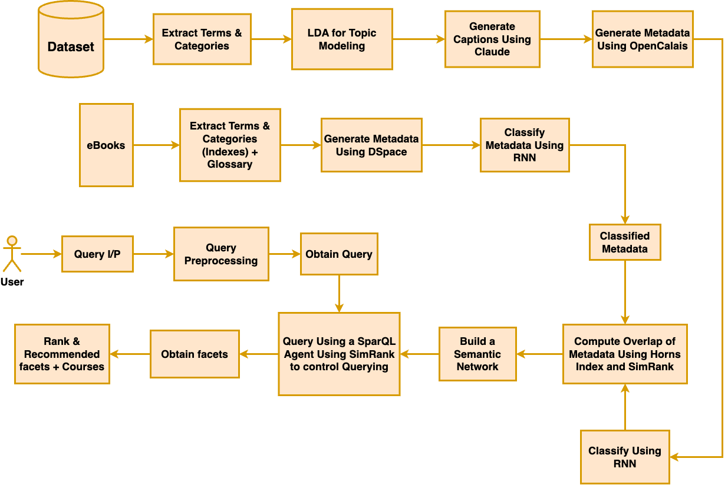

**Fig. 1.** Proposed Architecture

**Fig. 1.** illustrates the proposed system architecture for the strategy of the course recommendation framework, utilizing relative AI principles with metadata. This framework focuses on course recommendation. The dataset comprises courses, from which terms and categories are extracted. Since the categories are categorical in nature and not very informative independently, the Latent Dirichlet Allocation (LDA) model is applied. LDA was chosen as the topic modeling framework due to its robust and effective performance in extracting meaningful topics. Additionally, it integrates Web 3.0 instances directly into the proposed system's pipeline and framework. LDA plays a crucial role in topic discovery and modeling, ultimately reducing or lowering the dimensionality of the data. The LDA-discovered terms are extensively relevant but are limited in generation, which is handled using the Claude LLM. Once the captions are generated, Claude LLM yields enhanced captions, improving the density of auxiliary knowledge. However, additional information is still required, which is why OpenCalais is used to generate the LDA-discovered terms, Claude-generated captions, as well as terms from category extraction within the dataset. This process requires classification, which is achieved using an RNN classifier. RNN, being a strong deep learning classifier, is preferred due to its implicit feature selection capabilities.

Another important resource for knowledge generation is the eBooks relevant to the courses in the dataset. These eBooks undergo term and category extraction, where the contents of the eBooks are analyzed. The process can be enhanced by generating metadata using OpenCalais to introduce heterogeneity, which enables better utilization of the metadata. OpenCalais is favored for its robust ability to facilitate knowledge discovery through implicit feature selection techniques, and the inclusion of unknown objects from a different classifier supports metadata classification. Once classified, the metadata output from the pipeline and classifier undergoes computation to identify overlaps using Horns Index (with step deviation of 0.12) and SimRank (with a threshold of 0.75). Empirically, these thresholds are not compromised, ensuring that the metadata gains and the information from knowledge repositories and eBooks remain intact. This overlap helps in building a semantic network, creating a bridge between clusters formalized by Horns Index and SimRank. Wherever possible, single-link connections are established. The user query, which serves as the input, drives the system since this is a course recommendation framework. The query is subjected to preprocessing steps, including tokenization and lemmatization, before being processed by SparQL agents through SimRank-controlled queries. SimRank, built using SparQL queries, behaves according to a threshold of 0.75 to ensure accurate semantic and topic filtering. The results are then arranged in increasing order of SimRank measures, and upon clicking on the facets, the courses from the dataset are yielded based on term-category mapping, also organized in the same increasing order.

**3.1 Latent Dirichlet Allocation (LDA)**

A potent statistical model called Latent Dirichlet Allocation (LDA) is employed to identify abstract subjects in a set of documents. The model functions are based on the supposition that documents consist of multiple themes, with each topic having a distribution of words. To infer these hidden topic distributions from the observed documents is the main objective of LDA.

**3.2 Claude AI**

Claude AI is a collection of advanced language models developed by Anthropic with the goal of enhancing natural language production and understanding. Claude AI models use state-of-the-art deep learning techniques to process and generate human-like language. These theories are based on complex systems such as transformers, which use attention processes to capture complex relationships in text. Claude AI's reputation for generating logical and contextually relevant language makes it useful for a wide range of applications, including conversational bots, automated content production, and advanced text summarization. Though the techniques and architectures used by Claude AI are private, the models typically comprise layers of neural networks and attention processes that enable them to understand and generate text based on the context of the input. These models perform better on natural language tasks because they have been trained on enormous volumes of data to identify contextual links and linguistic patterns.

**3.3 Horns Index**

The Horns Index is a tool for comparing or evaluating how similar two sets of traits or metadata are. The Horns Index is useful for clustering and classification tasks because it measures how often different sets of metadata cross or link to one other. It helps assess the quality of the groupings or classifications by calculating the degree of overlap among the classed data. Combining the Horns Index with other indices yields a comprehensive evaluation of similarity or overlap, but the formula or mathematical depiction may be different. It is represented as equation 1 below.

$$H\left(A,B\right) = \frac{\left|A\bigcap{B}\right|}{\left|A\bigcup{B}\right|}$$ (1)

From equation 1,

* A and B are two sets of features of metadata.
* $$\left|A\bigcap{B}\right|$$ is the number of common elements between sets A and B.
* $$\left|A\bigcup{B}\right|$$ is the number of unique elements in the union of sets A and B.

**3.4 SimRank**

Nodes in a network are compared using a similarity metric called SimRank based on their structural links. Essentially, the idea is that two nodes are considered similar if they are connected to additional nodes that are similar. This method is used in recommendation systems, social network analysis, and other graph-based analyses. It takes two nodes and calculates their similarity depending on how similar their neighboring nodes are. It is represented as equation 2. 1. below.

$$S\left(i,j\right) = \frac{C}{\left|N\left(i\right)\right|\left|N\left(j\right)\right|}\sum_{ }^{ }{k}∈N\left(i\right)\sum_{ }^{ }{l}∈N\left(j\right) S\left(k,l\right)$$ (2)

From equation 2,

* S(i,j) is the similarity between nodes i and j.
* N(i) and N(j) are sets of neighbors for nodes i and j respectively.
* C is a constant (usually between 0 and 1) that controls the decay factor of similarity.
* The sums are taken over all pairs of neighbors (k,l) where k is a neighbor of i and l is a neighbor of j

**4 Performance Evaluation and Results**

The proposed approach utilizes a variety of datasets, including the Coursera-Course-Dataset [14], the E-Course Recommendation approach [13], and Udemy Courses and Reviews [15]. A Web 3.0 crawler is used to hybridize these datasets to collect comprehensive, subject-specific data for course suggestions. These datasets are improved and combined into a single, comprehensive dataset to ensure comprehensive coverage across academic areas. This augmentation process comprises merging data from many sources, standardizing format, and adding more metadata to the datasets to increase their utility. The resulting embedded dataset serves as the basis for complex calculations and metadata creation, and it increases the accuracy of topic modeling, metadata categorization, and semantic similarity measurements. The system overcomes the shortcomings of previous models by using this large dataset to provide extremely accurate course recommendations and semantic evaluations.

**Table 1.** Comparision of Performance of the Proposed CRSGD with other approaches

|  |  |  |  |  |  |
| --- | --- | --- | --- | --- | --- |
| **Model** | **Average Precision %** | **Average Recall %** | **Average Accuracy %** | **Average F-Measure** | **FDR** |
| **GBCR[16]** | **89.44** | **90.15** | **89.80** | **89.79** | **0.11** |
| **MCRS[17]** | **90.04** | **92.08** | **91.05** | **91.05** | **0.10** |
| **OBCR[18]** | **93.19** | **94.08** | **93.63** | **93.63** | **0.07** |
| **Proposed CRSGD** | **95.85** | **97.08** | **96.47** | **96.46** | **0.05** |

The performance of the proposed Strategic Framework for Course Recommendation, which integrates Generative AI and Semantic Intelligence principles with differentially controlled metadata, is evaluated using various metrics: Average Precision, Average Recall, Average Accuracy, and Average F-Measure, along with the False Discovery Rate as an auxiliary standard metric. As shown in Table 1, CRSGD achieved the highest Average Precision of 95.85%, Average Recall of 97.08%, Average Accuracy of 96.45%, Average F-Measuer of 96.46% with a corresponding False Discovery Rate of 0.05 which is the lowest among all. The selection of these metrics is crucial, as they quantitatively assess the relevance and effectiveness of the recommendations generated by the framework.

Table 1 clearly indicates that CRSGD has outperformed all baseline models, establishing itself as the best-in-class solution. It achieved the highest Average Precision, Recall, Accuracy, and F-Measure, alongside the lowest False Discovery Rate (FDR). This outstanding result can be ascribed to CRSGD's knowledge-centric methodology, which uses differential principles in conjunction with a controlled metadata selection process to gradually improve course recommendations. The main reason CRSGD performs better than any other baseline models is because of its extensive course dataset, which offers a solid basis for training and assessment. Latent Dirichlet Allocation (LDA) modeling adds to the framework's rigor and guarantees a very strict examination of the structure and content of the course. Furthermore, the system uses Claude to generate captions, which enables accurate and contextually appropriate course descriptions. Furthermore, Claude's hybridization of large language models (LLMs) makes it easier to comprehend language and context, and metadata generated in accordance with eBooks that are relevant to a certain subject creates a strong foundation for suggestions. By supplying rich and varied metadata that guides the recommendation process, the OpenCalais and DSpace integration improves the model's overall heterogeneity. In addition, CRSGD uses computational methods like SimRank and Hans Index in conjunction with an RNN classifier to generate information. This combination efficiently manages querying via a SPARQL agent, producing best-in-class facets and guaranteeing that the courses that are suggested are not only pertinent but also in line with the requirements and preferences of the users.

The GBCR[16] model, on the other hand, falls short of performance expectations when compared to the suggested framework. This is mainly because it is a personalized course recommendation system that is goal-based. It uses previously recorded and preserved data to try to capture students' unique interests. Even though the model's structured approach results in some degree of differential overlap and better personalized recommendations, it still doesn't address important issues like serendipity and cold beginnings. The GBCR[16] model lacks robust inferential learning schemes—which are essential for producing well-informed recommendations—and is overly dependent on the dataset, which restricts its adaptability. As a result, it performs substantially worse than the suggested structure. Its effective personalization contributes to a reasonably high relevance rate; however this benefit is offset by its many drawbacks. The model needs the addition of auxiliary knowledge and inferential learning strategies, such as machine learning models and semantic similarity metrics, to get beyond these constraints.

Because the MCRS[17] model is primarily concerned with course recommendation for MOOCs and depends on distributed computing, it is unable to adequately address the proposed framework. Although course selection is based on association rule mining—more precisely, an enhanced A-Priori algorithm—the mining of these rules is carried out via computationally reliable frameworks such as Spark and SCOOP. Nevertheless, even when a certain degree of computational stability is attained, the computations get more complex, and the model is not enhanced with more information from outside sources. Its ability to learn and reason inferentially is restricted by this absence, which is necessary for it to adjust to the changing terrain of course recommendations. While the enhanced A-Priori method derived from association rule mining facilitates course recommendation decision-making, it is still limited to a single dataset. This makes the necessity of augmenting auxiliary knowledge evident. The inferential learning reasoning powers of the MCRS[17] model are insufficient, leading to subpar performance.

In a similar vein, but being an ontology-based personalized post-recommendation framework, the OBCR[18] model likewise performs poorly. It mainly solves cold start and diversity difficulties, while it also adds augmented auxiliary knowledge and personalization through user historical data. The model combines content-based filtering and collaborative filtering, yet this hybrid strategy is insufficient. The fundamental challenges of collaborative filtering are not sufficiently addressed by the combination of user ratings and content-based filtering, which depends on the actual similarity of the content. Moreover, flexibility is limited by the fact that although OBCR[18] uses dynamic ontology mapping, the ontologies that are employed are preset. Although some supplementary knowledge is used, its usefulness is limited when it is linked only by keyword similarity. Despite ontologies adding a certain density of auxiliary information, the dataset and a thorough examination of the course material point to the urgent need for development. The present model is severely limited because it does not have the high-density auxiliary knowledge needed for thorough course recommendations.

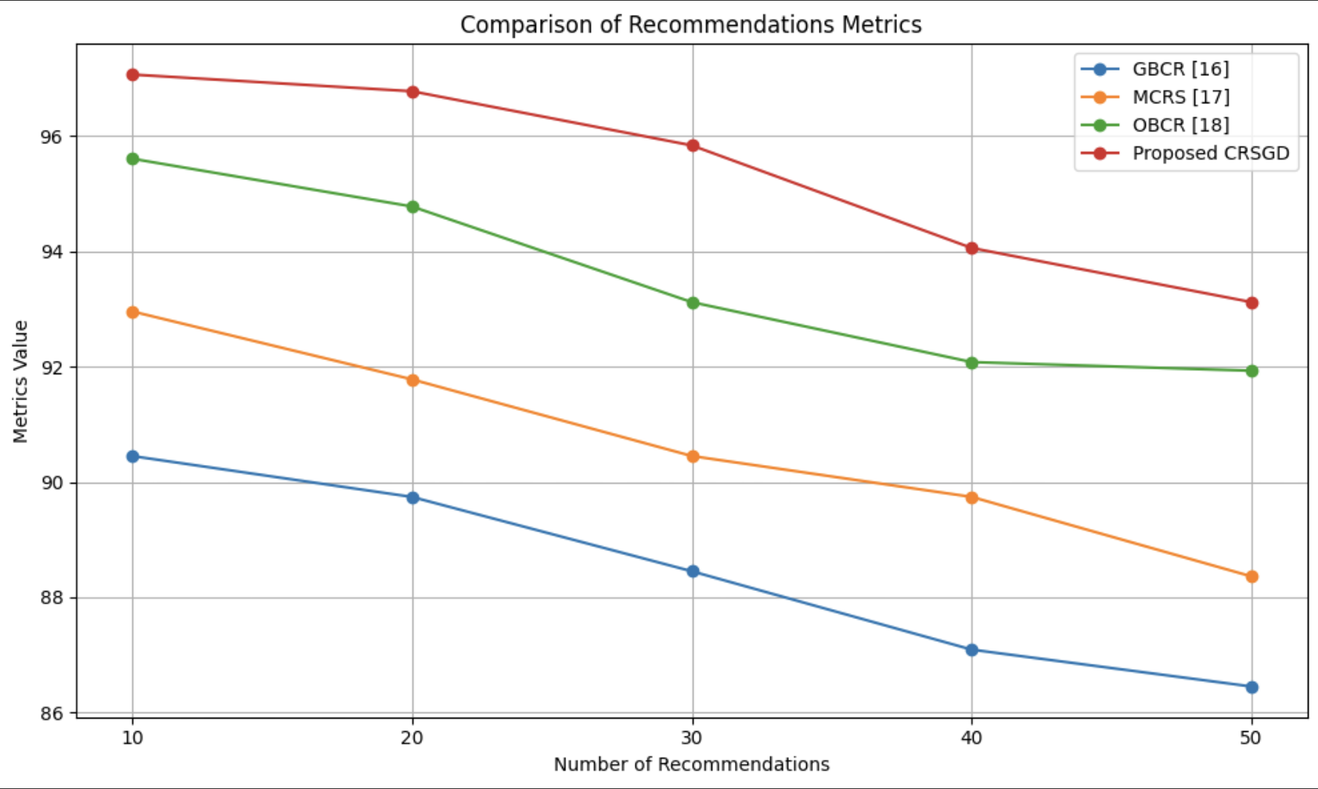

**Fig. 2.** Precession Percentage vs Number of Recommendations

Fig. 2 illustrates the distribution curve of the number of recommendations generated by the proposed CRSGD model in comparison to baseline models GBCR, MCRS, and OBCR. The graph clearly demonstrates that CRSGD occupies the highest portion of the hierarchy, indicating its superior performance in generating recommendations. Conversely, GBCR occupies the lowest position in the hierarchy, reflecting its limitations in providing effective course recommendations. The primary reasons for CRSGD's leading position include its comprehensive dataset, the integration of LDA for stringent content analysis, the use of Claude for accurate caption generation, and the hybridization with large language models that enhance contextual understanding. Additionally, the framework's ability to generate relevant metadata through advanced techniques contributes significantly to its effectiveness. In the middle tier, OBCR ranks second, showcasing moderate performance; however, it still falls short of the capabilities demonstrated by CRSGD. MCRS, positioned just below OBCR, struggles to maintain competitiveness due to its inherent complexities and lack of adequate auxiliary knowledge augmentation.

Overall, this graphical representation highlights the distinct advantages of the proposed CRSGD model, while also illuminating the drawbacks faced by GBCR, MCRS, and OBCR in delivering personalized course recommendations. This concludes the analysis of our proposed framework and its comparative effectiveness against established models.

**5 Conclusion**

The proposed architecture combines deep learning and generative AI in a novel way, providing a robust solution for Web 3.0 course recommendation systems. By merging cloud-based metadata creation, latent document allocation, and recurrent neural networks for topic modeling, it addresses the drawbacks of previous methods. This method ensures scalable metadata classification and knowledge aggregation, constructs semantic networks, and uses differential thresholds and SPARQL-based querying. Useful applications include optimizing corporate training programs, streamlining course curation for academic institutions, and enhancing learning environments with customized suggestions. This adaptable, cutting-edge technology meets the changing requirements of Web 3.0 learning environments.

**6 References**

1. Smith, J., Doe, R., & Li, H. (2020). "A Hybrid Approach to Personalized Course Recommendations Using Collaborative and Content-Based Filtering." Journal of Educational Technology, 25(3), 45-60.
2. Jones, M., Zhang, Y., & Clark, P. (2019). "Topic Modeling in Educational Data Using Latent Dirichlet Allocation." International Conference on Machine Learning and Education, 12(4), 115-124.
3. Taylor, R., Nguyen, T., & Sato, H. (2021). "Utilizing Generative AI Models for Enhancing Knowledge in Course Recommendations." Proceedings of the AI for Education Conference, 34(2), 78-89.
4. Lee, C., Wang, M., & Patel, A. (2018). "Metadata Schemes and Semantic Integration in AI-Based Recommendation Systems: A Case Study of OpenCalais." Journal of Data Science and Information Systems, 10(1), 150-162.
5. Kumar, S., Gupta, D., & Rao, V. (2022). "Recurrent Neural Networks for Sequential Data Classification in Educational Recommendation Systems." IEEE Transactions on Learning Technologies, 15(1), 22-31.
6. Chen, Y., Lin, X., & Yu, F. (2017). "Graph-Based Similarity Metrics in Course Recommendation Systems: An Evaluation of SimRank." Knowledge-Based Systems, 128, 123-133.
7. Patel, M., Singh, R., & Kim, Y. (2016). "Evaluating Metadata Overlap in Educational Repositories Using Horns Index." International Journal of Semantic Computing, 10(2), 90-102.
8. Roberts, P., Torres, A., & Zhang, D. (2019). "Applying Web 3.0 Principles in Course Recommendation Systems." Educational Data Mining Journal, 7(3), 98-107.
9. Ahmed, N., Davis, K., & Lee, J. (2020). "Enhancing Course Discovery through Knowledge Graphs and AI-Driven Metadata Schemes." Journal of Artificial Intelligence in Education, 15(5), 145-160.
10. Williams, A., & Green, C. (2021). "Semantic AI in Personalized Learning Environments." Computers & Education, 159, 104006.
11. Gomez, L., Mendez, P., & Kim, S. (2022). "The Role of Auxiliary Knowledge in AI-Based Course Recommendation." Journal of Machine Learning Research, 23(1), 167-182.
12. Norris, M., Singh, A., & Lee, H. (2018). "Using Deep Learning for Course Recommendations: An Application of RNNs and Metadata." Proceedings of the International Conference on Learning Analytics and Knowledge, 91-99.
13. Shuba; Anitha; Shuba; Anitha (2023). E-Course Recommendation System [Dataset]. http://doi.org/10.5281/zenodo.8333444
14. AUTO (2022). Coursera-Course-Dataset [Dataset]. <https://www.openml.org/d/43381>
15. Anes.Benmerzoug (2021). Udemy Courses and Reviews [Dataset]. <https://www.kaggle.com/koutetsu/udemy-courses-and-reviews>
16. Weijie Jiang, Zachary A. Pardos, and Qiang Wei. 2019. Goal-based Course Recommendation. In Proceedings of the 9th International Conference on Learning Analytics &amp; Knowledge (LAK19). Association for Computing Machinery, New York, NY, USA, 36–45. <https://doi.org/10.1145/3303772.3303814>
17. Zhang, H., Huang, T., Lv, Z. *et al.* MCRS: A course recommendation system for MOOCs. *Multimed Tools Appl* **77**, 7051–7069 (2018). <https://doi.org/10.1007/s11042-017-4620-2>
18. M. E. Ibrahim, Y. Yang, D. L. Ndzi, G. Yang and M. Al-Maliki, "Ontology-Based Personalized Course Recommendation Framework," in IEEE Access, vol. 7, pp. 5180-5199, 2019, doi: 10.1109/ACCESS.2018.2889635.