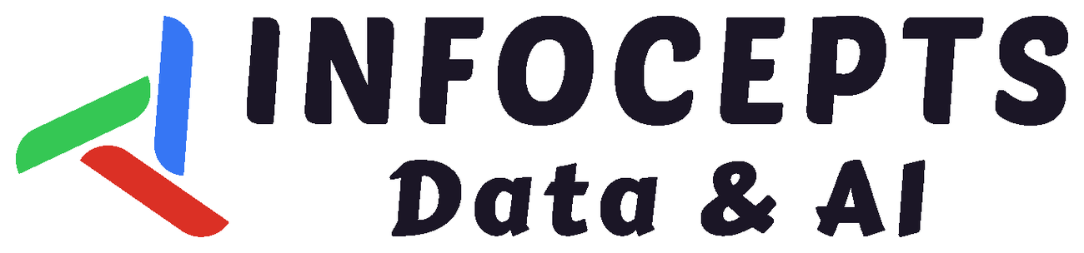
QUALITY VISION AGENT  Detect defects in milliseconds, automate quality actions, and continuously improve inspection models across plants—without moving sensitive production images off-site. | EDGE AI + CLOSED-LOOP QUALITY  From inspection to action
TARGET  UP TO 62%  fewer defect escapes | TARGET  UP TO 38%  less inspection labour | EDGE SPEED  <10 MS  ONNX/TensorRT inference | PROTOTYPE AI  0.964 / 0.971  mAP / precision
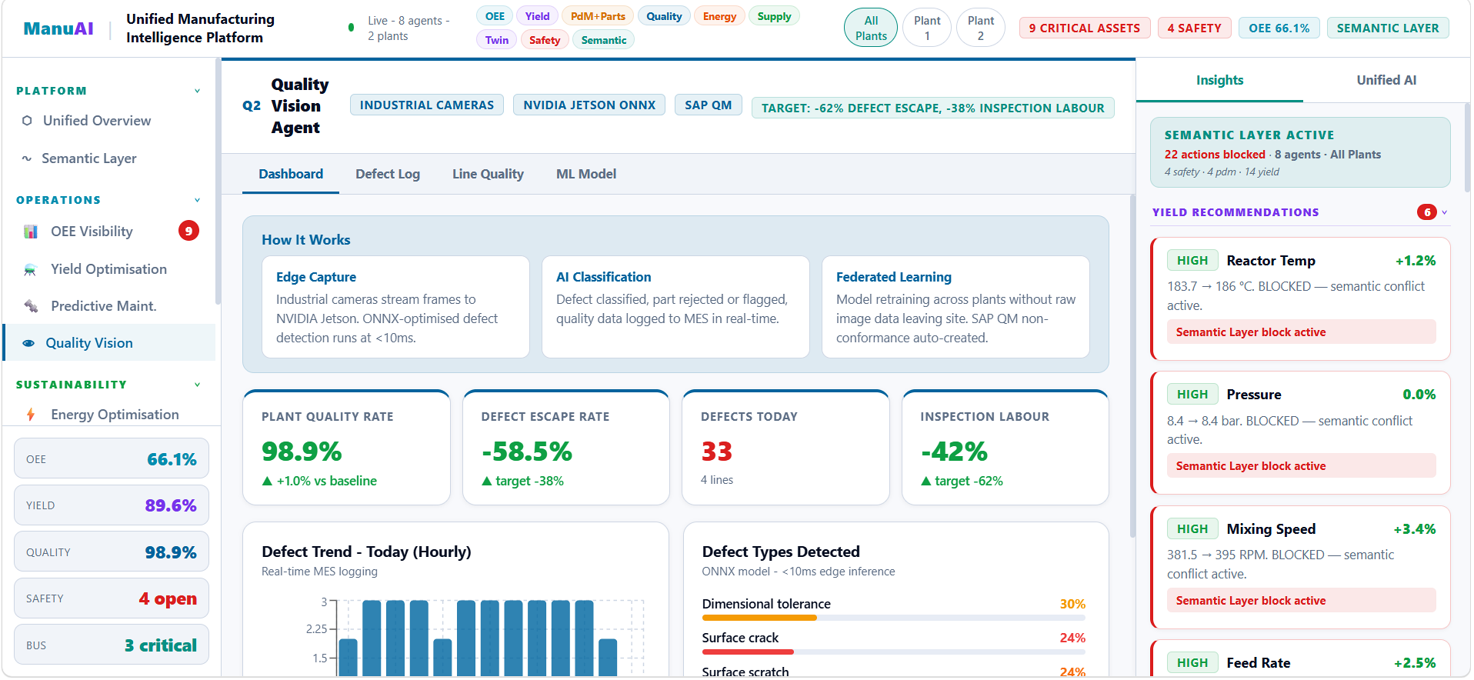
Illustrative product experience: real-time quality KPIs, defect intelligence, semantic governance and multi-plant visibility
SOLUTION OVERVIEW Quality Vision Agent unifies industrial cameras, NVIDIA Jetson edge inference, ONNX/TensorRT models, Databricks intelligence and MES/SAP QM workflows—turning every visual inspection into a traceable quality action and a continuous learning signal.
THE BUSINESS PROBLEMS  • Manual inspection is inconsistent and difficult to scale.  • Late defect detection increases scrap, rework, warranty risk and margin leakage.  • Camera, line, MES and quality data remain disconnected. | HOW IT WORKS  1 Capture: Industrial cameras stream frames to NVIDIA Jetson.  2 Detect: ONNX-optimised models classify defect type and severity.  3 Act: Accept, reject or re-inspect decisions are logged instantly.  4 Integrate: MES/SAP QM workflows create traceable quality events.  5 Learn: Federated retraining improves models across plants. | PLATFORM CAPABILITIES  • Millisecond edge inference supports in-line decisions.  • Closed-loop integration connects detection directly to quality action.  • Semantic governance can block unsafe or conflicting recommendations.  • Privacy-first federated learning keeps raw production images on-site.  • Model history, confidence and feature importance improve trust.
BUSINESS OUTCOMES
01  Improve first-pass quality  More consistent product output | 02  Reduce quality cost  Less scrap, rework and manual inspection | 03  Accelerate response  Faster NCR, containment and root-cause action | 04  Scale across plants  Standardised quality intelligence and learning
WHO BENEFITS? COO / VP Manufacturing • Head of Quality • Plant Managers • Quality Engineers • IT/OT & AI Teams
INTEGRATIONS & DEPLOYMENT Industrial cameras • NVIDIA Jetson • ONNX/TensorRT • PLC/SCADA • MES • SAP QM • QMS • Databricks
ENTERPRISE-GRADE SECURITY & COMPLIANCE Role-based access • Governance and lineage • Audit logs • Plant-level data isolation • Privacy-first federated learning
PARTNER ECOSYSTEM Databricks intelligence, NVIDIA edge infrastructure, and major MES, quality and manufacturing platforms
RESOURCES Request Product Walkthrough | Request Architecture & Integration Overview | Request Detailed Solution Brief (available on request)
READY TO MODERNISE VISUAL QUALITY INSPECTION?  Explore a guided walkthrough tailored to your production lines, quality workflows and deployment environment. | REQUEST A GUIDED DEMO →  Discuss a Pilot Opportunity • Speak with an Expert
Targets and prototype model metrics are illustrative and should be validated for each client environment, product mix and deployment scope.

